Literature Review

This research will be a literature review with the aim of reviewing the current topic of Dangerous dogs in the United Kingdom. This will include the history of Dangerous dogs in the UK, statistics of dog attacks, the reasons why these dog attacks are more in the public eye than ever. The type of dogs in which are causing the uplift in the attacks and what can and is being done to stop this increase in dog attacks.
It seems now more than ever Dog attacks are in the public eye, this is due to the recent increase in reports of dog attacks in the UK, whereby people have lost their lives due to these attacks. The main focus has been on breeds such as an American XL Bully, which have seen a huge increase in popularity in recent times. The articles in which I will be reviewing will show the increase in the attacks in the UK, and why these have been increasing year on year. The government have recently introduced a ban on XL bully type breeds in the UK, a review will be conducted in what they have done and will this bring down the rates of dog attacks in the UK or does more need to be done.
The dog has always been one of the UKs favourite pets with around 12 million dogs now in the UK in 2022, this was believed to of increased due to the Covid Pandemic. In which more than 3.2 million pets were added to homes during this period. This was believed to be down to the mental health benefits in which pets bring to humans, due to the company in which animals bring and the increase in exercise such as taking a dog out for a walk can also improve wellbeing. (Hepburn, 2022)

Dog attacks in the UK

Below shows the increase in dog attacks from 2018 until 2022.
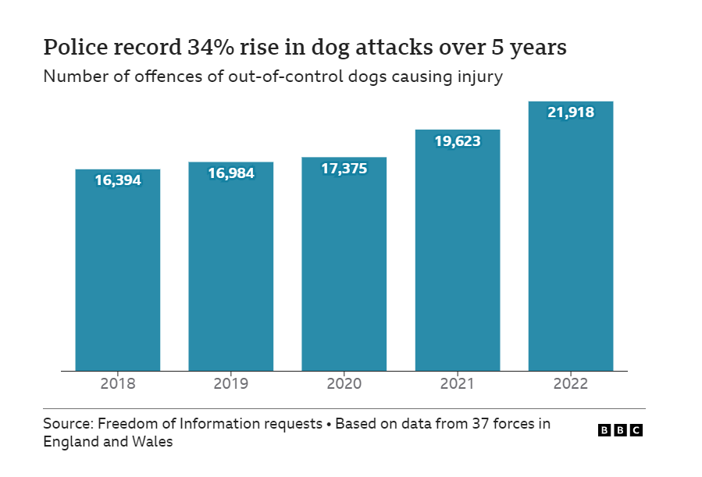

The BBC has requested a Freedom of Information request from the 37 Police Forces in England and Wales, into dog attacks in which have taken place since 2018 until 2022, this shows a 34 percent increase in the number of dog attacks in which there have been injury to a person in that period. From reviewing these statistics, the biggest increase is from 2021 until 2022. Where over 2000 more reports were made to police in regard to dog attacks. The research shows there has been an increase in the dog population to an estimated 15% at the same period as the dog attacks. The research does not show the number of dog-on-dog attacks or anti-social dog reports to police forces.
The research also shows the number of dogs in which were seized by police were up by around 36 percent, which shows an increase in dangerous dogs in public. This was around 3500 dogs, although the numbers also show dogs seized who are strays or taken from people who have gone into prison, but it is believed the majority are for dogs which are ‘out of control’. (Green, 2023)

Banned dogs in the UK
There are currently five types of dogs banned to own in the UK, these include a Pit Bull terrier, a Japanese Tosa, Dogo Argentino and the Fila Brasileiro and more recently the American XL Bully. These first four dogs were banned in 1991 after the UK government introduced the Dangerous dog act, after a increase in dog attacks and dog fighting the act states ‘ An Act to prohibit persons from having in their possession or custody dogs belonging to types bred for fighting; to impose restrictions in respect of such dogs pending the coming into force of the prohibition; to enable restrictions to be imposed in relation to other types of dog which present a serious danger to the public; to make further provision for securing that dogs are kept under proper control; and for connected purposes.’ This gave police more powers in regards to dealing with the dogs owners and seizing the dogs in order to protect members of the public from such attacks. This also made it illegal for owners to and to sell or breed their dogs. This was not limited to the above dogs and would fall in any dog in which is acting dangerously of control and the owner would face a criminal offence for allowing this. (GOV, 1991)
The American bully is a breed in which comes in three sizes, an pocket, standard and XL. It is described as a natural extension of the American pit bull terrier, which is banned in the UK. The XL Bully is believed to be crossed between an American Bulldog, English Bull dog and a OLDE English Bulldog. XL Bullys became banned in the UK on the 31st December 2023, this made it illegal to breed, sell or gift an XL bully to other person. The XL bully has to been microchipped, neutered and on a lead with a muzzle on in a public place. The XL bully has been linked to more than 10 deaths from dog bites in the last two years, which has caused the government concern and have then introduced this ban. (Clinton, 2023)
The dogs were all large build dogs and capable of hurting members of the public, all of the dogs were known for their aggression and their ability to fight and cause damage to their opponent, although dog fighting in the UK was made illegal in 1835, the sport had still carried on in a underground world of owners, where they would place bets on the dogs who would ultimately fight to the death or have injuries to which the owners would dispose of the dogs.
The Royal society for the prevention of cruelty to animals (RSPCA) disagree with the Dangerous dogs act 1991, stating these laws do not currently work and are actively looking for a change in the law. They state in the past 20 years between 1999-2019, there has been a increase of 154 percent in admissions to hospital from dog bites despite the prohibition of certain types of dogs. They state for over 32 years, dogs have been said to be dangerous based on how they look to members of the public due to their breed and that there are thousands of dogs, who behaviour pose no risk to members of the publics safety are being put to sleep due to the actions of a minority of the breed. They believe that the law needs to be urgently reviewed and reformed and that by adding more dogs to the dangerous dogs act will see history repeating itself. Between 1989 and 2017, 48 people have died from dog related incidents in the UK. 62 of the dogs involved 53 were not dog breeds which are banned in the UK.

The RPSCA believe that a three-point approach is needed to protect the public as stated here,
- Effective legislation and enforcement to tackle dog-related issues regardless of breed or type and based on their behaviour.
- Interventions including education that focus on safe behaviour around dogs.
- A better understanding of why dogs bite. (RSPCA, N.D)

Although the RSPCA have stated for effective legislation and enforcement they have not expanded on what this should be, as a small dog such as a Jack Russell is unlikely to cause as much damage if it bites someone compared with a XL bully.
The second point in which they state education on safe behaviour around dogs, they haven’t stated who would fund this training and would this be after a dog has bitten or perhaps once they have brought the dog. The third point into understanding why dogs bite would under the same category as the second point, for education to the owners as to why the dog has bitten in the first place.

Why dogs bite

Dog attack admissions in hospital 2012-2023
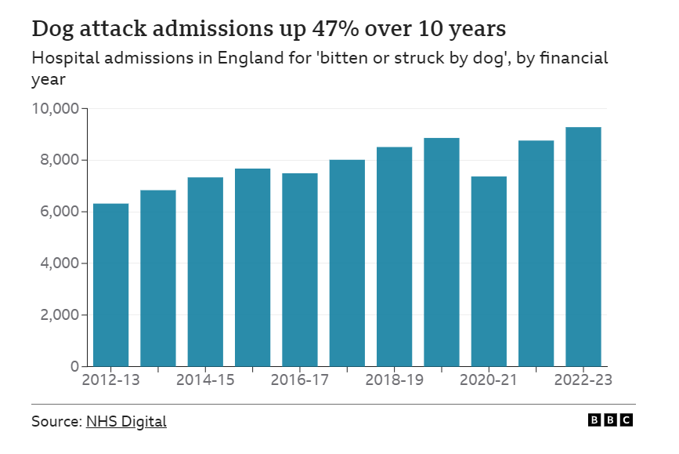
This graph above shows the number of cases in England since 2012 in which the patient has needed hospital treatment for a dog attack. The graph shows that there has been a steady increase in the numbers of admissions since the survey year on year, with almost three thousand more in 2022 compared to 2023. The only year being an exemption being 2020-2021, which would have been the year of the covid pandemic. Where it was more likely the dog was being unsocialised and not seeing any other persons not from the same household resulting in fewer attacks. Even so this was still a higher number than 2012 when the numbers were at their lowest. (NHS, 2023)
The covid pandemic is thought to be one of the reasons as to why there are more dog attacks than ever before, due to the restrictions on people’s lives during that time. Also more people were buying pets, especially dogs during covid as company for them as they had to stay at home. It has been proven that owning a pet is good for your mental wellbeing, It has benefits such as lowering depression and anxiety. This leads to greater physical health as well for things as simple as walking a dog, where as the owner may not have gone for walks before owning a dog. The social side of owning a dog, meeting other owners and a better online social network is also a factor of improving mental health amongst owners. (Powell, 2019)
However, could this be another factor as to why there has been an increase in dog attacks on members of the public, as dog owners may not have been able to socialise their dogs as they normally could have without the covid restrictions. Socialising in dogs is of huge importance without this the dog would see others as threat as per their natural instinct and potentially other humans who aren’t their owners.
Another factor is the lack of knowledge of owning and training a dog with this being unable to take their dog for any training or getting a dog trainer into support them, which for some young people this may have been there first dog since moving out from their home. Due to the owners being restricted to being at home, they have got to spend more time around their dogs, which causes issues when they would have had to go back to work and everyday life. This is called separation anxiety, which causes the dog to become in a stressed state when left alone. The effects of the owners being home with child, is also a factor as the dog may not have the rest period in which it needs causing the dog to become stressed and see the child as below them in the hierarchy in the household and then bite as a reaction to this. During covid dog walks were limited to once a day due to the potential of spreading the disease so this may of frustrated the dog.
The demand for puppies and dogs in the UK increased during the Covid period, more than 3 million dogs were brought during 2020. Due to this demand a lot of owners may not have gone to reputable breeders, which would have caused issues. Not knowing the background or breeding of the dog or the temperament of the parents. As if the puppy is released from its mother too early then this is known to cause health and behavioural issues.
Hospital admissions increased during this period to around 69 percent more cases of dog bites on children and their owners (Boardman, 2022)

Conclusion

In conclusion to the research that has been conducted, there is no clear evidence in how to deal with dangerous dogs. There needs to be more research on how the government, police and other agencies can deal with the increasing incidents involving dangerous dogs. There seems to be a knee jerk reaction in regard to dangerous breeds, instead of looking at the root cause, such as the breeders, the training in which the dog has received. The situation of the attacks was the dog defending itself against another dog and accidently bit a human in the scuffle. The research does not expand on this and is unclear on how these attacks occurred.
There needs to be a deeper understanding into how these attacks occurred for better understanding of how to prevent attacks in the future, as the dog population will keep growing and so will the attacks.

Bibliography
Boardman H, Farnworth MJ. Changes to Adult Dog Social Behaviour during and after COVID-19 Lockdowns in England: A Qualitative Analysis of Owner Perception. Animals (Basel). 2022 Jun 29;12(13):1682. doi: 10.3390/ani12131682. PMID: 35804581; PMCID: PMC9264766. (Accessed 20th January 2024)
Clinton, Jane (2023) American XL Bullys. Available at: https://inews.co.uk/news/american-xl-bully-attacks-uk-how-many-why-dog-breed-banned-deaths-2620849 (Accessed 20th January 2024)
Gov (1991) Dangerous dogs act. Available at: https://www.legislation.gov.uk/ukpga/1991/65/introduction (Accessed 20th January 2024)
Green, Ruth. BBC Dog attacks (2023) Available at: https://www.bbc.co.uk/news/uk-64798162(Accessed 20th January 2024)
Hepburn, David. Top British Pets (2022) Available at : https://www.scotsman.com/lifestyle/family-and-parenting/top-british-pets-2022-here-are-the-20-most-popular-pets-in-the-uk-from-loving-cats-and-dogs-to-fish-and-ferrets-3327012 (Accessed 20 January 2024)
NHS (2023) Hospital admissions due to dog attacks. Available at: https://digital.nhs.uk/data-and-information/publications/statistical/hospital-admitted-patient-care-activity (Accessed 20th January 2024)
Powell, L., Edwards, K.M., McGreevy, P. et al. Companion dog acquisition and mental well-being: a community-based three-arm controlled study. BMC Public Health 19, 1428 (2019). https://doi.org/10.1186/s12889-019-7770-5
RSPCA , (No date) Opposition to the Dangerous dogs act 1991. Available at: https://www.rspca.org.uk/getinvolved/campaign/bsl#form (Accessed 20th January 2024)

