Moij Gugarman (1704972)
Internet Protocol

Part 1 :- Report for IPv6 addressing.

Table of Content
Title | Page Number
1.1 Introduction | 03
2.1 Basics of IPv6 | 03
3.1 Addressing method of IPv6 | 03
3.1.1 Unicast addressing | 03
3.1.2 Multicast addressing | 06
3.1.3 Anycast addressing | 07
4.1 Differences between IPv4 and IPv6 | 08
6.1 Conclusion | 09

1.1 Introduction:
The technological advancement and more dependency on internet based communication system the demand of IP addressing is increasing day by day. The traditional IPv4 addressing is facing saturation problem where IPv6 is an effective futuristic solution in IP addressing. This report is prepared to understand the details of IPv6 and some differences with IPv4.
2.1 Basics of IPv6:
Internet protocol version 6 is an addressing system of IPs in an internet based computer networking system where hexadecimal numerical system is used to identify network interface. An IP address is like a house address which is unique and it is used to identify a particular network interface of a host, locate the interface on the network and allow the routing IP packet between hosts (Schlager, 2015). IPv6 is recognized as the successor to the first addressing structure in internet, IPv4. IPv4 actually provides 32-bit value for addressing the interfaces in internet where IPv6 provides 128-bit value that is huge address space compared to IPv4. So, IPv6 is the future of IP addressing in internet based networking system.
3.1 Addressing method of IPv6:
In most of the case IPv4 addressing method is used in internet based networking system. Still 95% IPs are addressed by IPv4 where binary numeric system and 32-bit value is used. In contrast, the basic addressing in IPv6 is classified by primary addressing system and routing methodologies which is common is any networking system like unicast, anycast and multicast addressing. In most of the cases the IPv6 protocols use a devoted link-local multicast addressing group to avoid disturbing each interface in the existing network. So the IPv6 addresses are divided into three categories as discussed below-
3.1.1 Unicast addressing:
Unicast addressing is a single network interface identifier that only recognize single interface at a time (Graham, 2011). Based on unicast addressing system an IPv6 packet is sent though the network to a unicast address is delivered to only a single interface. IPv6 unicast addresses are combined with prefixes of random bit-length as IPv4 addresses under Classless interdomain routing (CIDR). A unicast address follow the below format-
n bits | 128 n bits
Network prefix | Interface ID

The unicast addressing has different types of addressing in IPv6 as explained below-
Global unicast address: In this address the global routing prefix is a value given to a site where the subnet ID works as an identifier of a particular link within the site. At the same time, the interface ID is used to recognize an interface on a link. It is important that within a subnet prefix the interface IDs are needed to be unique. The basic format of global unicast address for IPv6 is as below-
n bits | m bits | 128-n-m bits
Global routing prefix | Subnet ID | Interface ID

Now the local use address has two classes as explained below-
Link-local addresses: Link-local address is essential on each physical interface where the addresses are structured to use for addressing a single link for different purposes like neighbor discovery, automatic address configuration or in the absence of routers. On the same link this address may be used to communicate with other nodes as well. It is important to notice that a link-local address is automatically assigned.
Figure 1: Scope zones in link-local address
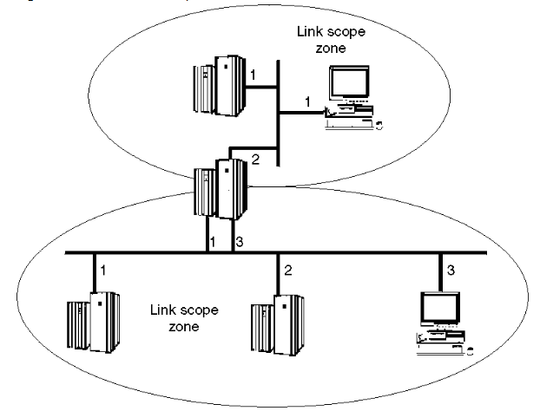
Site-local addresses: This local use addresses are designed to use addressing system inside of a site where global prefix are not required. From another site it is not possible to reach to a site-local address. According to Coffeen (2015) a site-local address that is a part of unicast addressing is not automatically assigned to a node. So, in that occasion manual configuration is required to assign to node.
Figure 2: Scope zones in site-local address
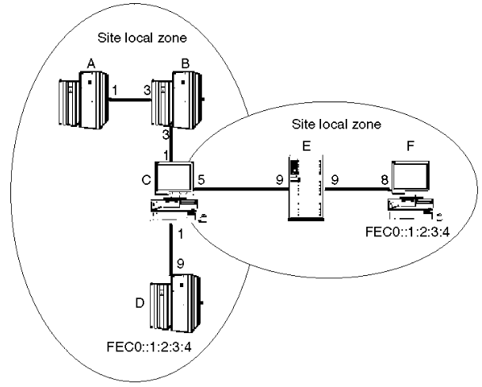

Loopback address: The unicast address which is stated like this 0:0:0:0:0:0:0:1 is also called the loopback address. This address can be assigned to any physical interface. This address is thought as a link-local unicast address which is assigned to a virtual interface or loopback interface that allows local applications to exchange messages to each other. This address cannot be used in IPv6 packets as the source address which is sent outside of a node. According to Amoss and Minoli (2012) an IPv6 packet that has a loopback destination address cannot be forwarded by an IPv6 router and cannot be sent outside of a node.
Unspecified address: 0:0:0:0:0:0:0:0 is the address which is called unspecified address and this address is not assigned to any node. This combination is actually indicates the absence of an address. For example, when any IPv6 packet is sent in the Source Address filed by an initializing host before it learn its own address then this kind of address is created. So, in that case in IPV6 packet as well as in IPv6 routing headers as destination address the unspecified address cannot be used.
IPv4-compatible IPv6 addresses: These kinds of addresses also embrace a fixed global IPv4 address like IPv4-mapped IPv6 address. They are actually used to tunnel the IPv6 packet on IPv4 dynamically. According to this technique a special IPv6 unicast address is assigned that hold an IPv4 address in 32-bits. The address format of IPv4-compatible IPv6 addresses is as below-
80 bits | 16 | 32 bits
000….000 | 0000 | IPv4 address

IPv4-mapped IPv6 address: These kinds of addresses embrace a fixed global IPv4 address where it is used to represent the IPv4 nodes addresses as IPv6 addresses so that applications can be enabled for IPv6 and are used AF_INET6 sockets. The application allows the IPv6 enabled applications to deal with IP addresses in IPv6 format. The dual-mode of TCP/IP stack is performed for the transformation of IPv4-mapped addresses to native IPv4 format. The IPv4-mapped IPv6 address is as below-
80 bits | 16 | 32 bits
000….000 | FFFF | IPv4 address

Examples:
The decimal form of IPv6-IPv4 address:
::FFFF:129.144.52.38
The compressed form of IPv6 address
::FFFF:8190:3426
3.1.2 Multicast addressing:
Multicast addressing is a set of interface identifier where the interfaces belong to different nodes (Horley, 2013). So, when an IPv6 packet is sent targeting a multicast address that is delivered to all interfaces. The multicast address is recognized in hexadecimal notation with a prefix of 11111111 or FF. In this process the address provides a way of sending IPV6 packets to multiple destinations where an interface can belong to different number of multicast groups.

Addressing format of multicast address: At the beginning of the address the binary 11111111 identifies as a multicast address. The general format of the multicast address is as belw-
8 | 4 | 4 | 112 bits
11111111 | Flags | Scope | Group ID

Multicast scope: The scope field in addressing format indicates the scope of the IPv6 inter-network towards which the multicast traffic is approaches. Here in this scope the field size is 4 bits. In terms of additional information provided by the multicast routing protocol the multicast scope is used by the router to forward the multicast traffic.
Multicast Group: Group ID basically used to identify the multicast groups permanently or temporarily, within the given scope. In this case the field side is 112 bits. Those groups are assigned permanently can use the group ID with different scope value. In that case the group will be same. On the other hand, those groups are assigned temporarily can use their group ID in any scopes that refer to different groups. From FF01:: through FF0F:: the Multicast addresses are reserved that is the well-known addresses.
3.1.3 Anycast addressing:
Anycast addressing is a set of interface identifier where the interfaces belong to a group but in different nodes and when any IPv6 packet is sent to the anycast address then the packet is delivered to a single node which one is the closest to the sender and the node is identified using routing algorithm. In anycast addressing the same address format like unicast address is used. As a result, it s not possible to differentiate between an anycast and a unicast address by just examine the address. In order to do that, an anycast address is defined administratively. The address format of anycast addressing is as given below-
n bits | 128-n bits
Subnet Prefix | 000…..000

4.1 Differences between IPv4 and IPv6

There are some fundamental differences between IPv4 and IPv6 those are given below-
Factors | IPv4 | IPv6
Address size | 32-bit number | 128-bit number
Numbers of addresses | 2³² = 4,294,967,296 | 2¹²⁸ ⁼ 340,282,366,920,938,463,463,374,607,431,768,211,456
Address format | Dotted decimal notation address is used here like  192.149.252.76 | Hexadecimal notation is used here like  3FFE:F200:0234:AB00:0123:4567:8901:ABCD
Exchange of packets | The routers and sending hosts fragments the packets in IPv4 during sending and receiving it. | In IPv6 the routers don’t fragment packets but the sending hosts support packet fragmentation.
Configuration | The address is configured manually or using DHCP. | The IPv6 addressing doesn’t need manual configuration.

5.1 Conclusion:
IPv6 overcame the limitations of IPv4 and have enhanced the capacity if IP addressing that can be an effective solution in future internet based communication system. Due to use of 128 bit value in terms of IP addressing in IPv6 instead of 32 bit value the capacity of the users in network addressing has increased and has lot to improve.

Part 2
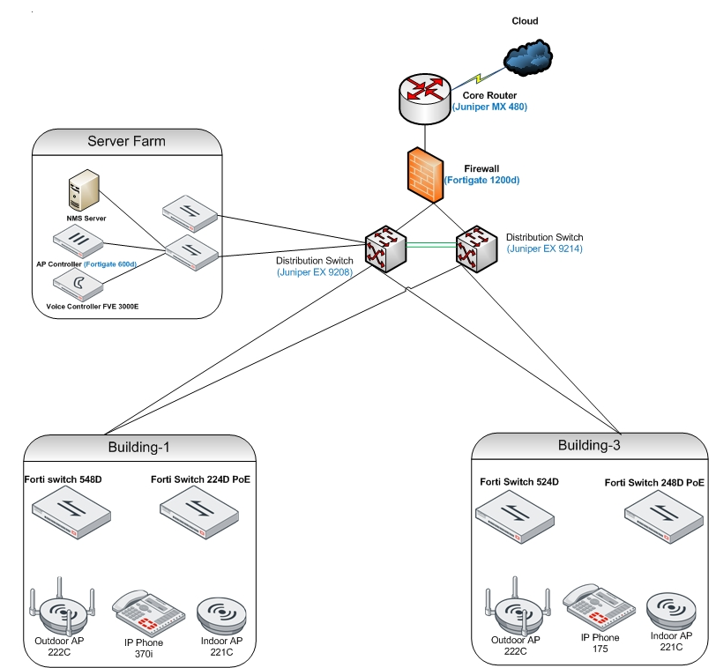

References:
Schlager, R. (2015) Ipv4 and Ipv6 Addresses: An Introduction. Createspace Independent Publications.
Graham, B. (2011) TCP/IP Addressing: Designing and Optimizing Your IP Addressing Scheme. Morgan Kaufmann.
Coffeen, T. (2015) IPv6 Address Planning: Designing an Address Plan for the Future. O'Reilly Media, Inc.
Amoss, John J. and Minoli, D. (2012) Handbook of IPv4 to IPv6 Transition: Methodologies for Institutional and Corporate Networks. CRC Press.
Horley, E. (2013) Practical IPv6 for Windows Administrators. Apress.
Graziani, R. (2011) IPv6 Fundamentals: A Straightforward Approach to Understanding IPv6. Cisco Press.
Goswami, S. (2010) Internet Protocols: Advances, Technologies and Applications. Springer Science & Business Media.
Popoviciu, C. (2010) Deploying IPv6 Networks. Pearson Education India.
Hagen, S. (2016) IPv6 Essentials. O'Reilly Media, Inc.
Peter Loshin, P. (2013) IPv6: Theory, Protocol, and Practice.
Weaver, R., Weaver, D. and Farwood, D. (2014) Guide to Network Defense and Countermeasures. Cengage Learning.

Part 2:- IP addressing scheme for school of management and engineering.

Whole Subnetting
Subnet | Host | Network ID | Broadcast ID | First Usable | Last Usable | Subnet mask
0 | School of applied computing | 172.16.0.0/20 | 172.16.15.255 | 172.16.0.1 | 172.16.15.254 | 255.255.255.240
1 | School of automotive engineering | 172.16.16.0/20 | 172.16.31.255 | 172.16.16.1 | 172.16.31.254 | 255.255.255.240
2 | School of Engineering | 172.16.32.0/20 | 172.16.47.255 | 172.16.32.1 | 172.16.47.2  54 | 255.255.255.240

School of applied Computing
Subnet | Host | Network ID | Broadcast ID | First usable | Last usable | Subnet mask
0 | Lab 308  (142) | 172.16.0.0/24 | 172.16.0.255 | 172.16.0.1 | 172.16.0.254 | 255.255.255.0
1 | Lab 301  (62) | 172.16.1.0/25 | 172.16.1.127 | 172.16.1.1 | 172.16.1.126 | 255.255.255.128
2 | Lab 309  (52) | 172.16.1.128/25 | 172.16.1.255 | 172.16.1.129 | 172.16.1.254 | 255.255.255.128
3 | Lab 304  (47) | 172.16.2.0/25 | 172.16.2.127 | 172.16.2.1 | 172.16.2.126 | 255.255.255.128
4 | Lab 306  (42) | 172.16.2.128/25 | 172.16.2.255 | 172.16.2.129 | 172.16.2.254 | 255.255.255.128
5 | Lab 303  (38) | 172.16.3.0/25 | 172.16.3.127 | 172.16.3.1 | 172.16.3.126 | 255.255.255.128
6 | Lab 302  (32) | 172.16.3.128/25 | 172.16.3.255 | 172.16.3.129 | 172.16.3.254 | 255.255.255.128
7 | Staff  (22) | 172.16.4.0/26 | 172.16.4.63 | 172.16.4.1 | 172.16.4.62 | 255.255.255.192
8 | Lab 310  (20) | 172.16.4.64/26 | 172.16.4.127 | 172.16.4.65 | 172.16.4.126 | 255.255.255.192

School of Automotive Engineering
Subent | Host | Network ID | Broadcast Id | First usable | Last usable | Subnet Mask
0 | Lab 301  (52) | 172.16.16.0/24 | 172.16.16.255 | 172.16.16.1 | 172.16.16.254 | 255.255.255.0
1 | Lab 206  (50) | 172.16.17.0/24 | 172.16.17.255 | 172.16.17.1 | 172.16.17.254 | 255.255.255.0
2 | Lab 205  (42) | 172.16.18.0/24 | 172.16.18.255 | 172.16.18.1 | 172.16.18.254 | 255.255.255.0
3 | Lab 101  (42) | 172.16.19.0/25 | 172.16.19.127 | 172.16.19.1 | 172.16.19.126 | 255.255.255.128
4 | Lab 103  (37) | 172.16.19.128/25 | 172.16.19.255 | 172.16.19.129 | 172.16.19.254 | 255.255.255.128
5 | Lab 102  (27) | 172.16.20.0/25 | 172.16.20.127 | 172.16.20.1 | 172.16.20.126 | 255.255.255.128
6 | Staff  (27) | 172.16.20.128/25 | 172.16.20.255 | 172.16.20.129 | 172.16.20.254 | 255.255.255.128
7 | Cad Lab  (22) | 172.16.21.0/25 | 172.16.21.127 | 172.16.21.1 | 172.16.21.126 | 255.255.255.128

School of Engineering
Subnet | Host | Network ID | Broadcast ID | First Usable | Last Usable | Subnet Mask
0 | An Open Access Lab  (245 PCs 5 Printers) | 172.16.32.0/22 | 172.16.35.255 | 172.16.32.1 | 172.16.35.255 | 255.255.252.0
1 | Lab 202  (82) | 172.16.36.0/23 | 172.16.37.255 | 172.16.36.1 | 172.16.37.254 | 255.255.254.0
2 | Lab 409  (82) | 172.16.38.0/23 | 172.16.39.255 | 172.16.38.1 | 172.16.39.254 | 255.255.254.0
3 | Lab 203  (67) | 172.16.40.0/23 | 172.16.41.255 | 172.16.40.1 | 172.16.41.254 | 255.255.254.0
4 | Lab 404  (47) | 172.16.42.0/24 | 172.16.42.255 | 172.16.42.1 | 172.16.42.254 | 255.255.255.0
5 | Lab 410  (47) | 172.16.43.0/24 | 172.16.43.255 | 172.16.43.1 | 172.16.43.254 | 255.255.255.0
6 | Lab 408  (30) | 172.16.44.0/24 | 172.16.44.255 | 172.16.44.1 | 172.16.44.254 | 255.255.255.0
7 | Lab 205  (27) | 172.16.45.0/24 | 172.16.45.255 | 172.16.45.1 | 172.16.45.254 | 255.255.255.0
8 | Lab 201  (22) | 172.16.46.0/24 | 172.16.46.255 | 172.16.46.1 | 172.16.46.254 | 255.255.255.0
9 | A test Center  20 PCs, 1IP phone, a printer) | 172.16.47.0/25 | 172.16.47.255 | 172.16.47.1 | 172.16.47.254 | 255.255.255.0
10 | Staff  (20) | 172.165.48.0/25 | 172.16.48.127 | 172.16.48.1 | 172.16.48.126 | 255.255.255.128

Assign an IPv6 address to six servers and for a Link between MP and ISP.

DNS | 2001:db8:acad:1::9/64
Email | 2001:db8:3c4d:0015:0000:0000:1a2f:1a2b/48
Finance | 2001:db8:3c4d:15:0:d234:3eee::
Registry | 2001:db8:acad:1::8/64
File server | 2001:0db8:3c4d:0015:0000:0000:1a2f:1a2b
A Print server | 2001:db8:85a3:8d3:1319:8a2e:370:7348
Link Between MP and ISP | Fdac:d888:f06c:bcc8::/64

