Fallingwater by Frank Lloyd Wright
Fallingwater is a house designed by Frank Lloyd Wright in 1935 and completed in 1937. The creation of this building came about after the great depression had led to a decrease in commissions for Frank Lloyd Wright, causing many to believe that his career had come to an end. However, that all changed when in 1932, Wright set up an apprenticeship program called Taliesin Fellowship and in 1934 a man named Edgar Kaufmann Jr would enrol. This would lead to his father, Edgar J. Kaufmann, approaching Wright and asking him to design a summer home for his family. This private home was designed for Edgar J. Kaufmann and his family who had a love for nature and wished for their new home to be surrounded by it. They commissioned Frank Lloyd Wright to design the home next to a 30ft water fall in Bear Run, Pennsylvania’s Laural Highlands. However, Frank Lloyd Wright made the shocking decision to build the home above the waterfall instead.
The plans show how the building is integrated with nature. The building is designed within the contours of the surrounding landscape, with the main living areas extended out over the waterfall. The boundaries between indoor and outside are seamless due to the use of cantilever balconies and large expanses of glass.
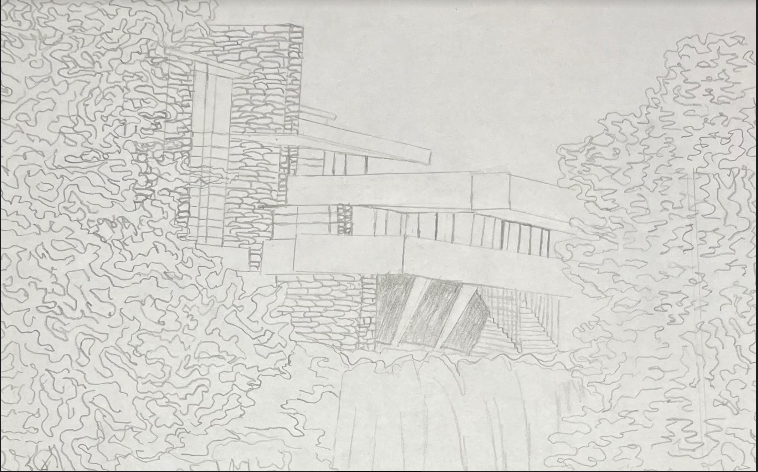
The plans and sections show how Wright used reinforced concreate beams and hidden supports within the building to achieve the impression that parts of the building are floating in the air. They show the complex cantilever design. Also, horizontal line use is shown in the plans and sections. This creates a sense of unity with the horizontal lines of the natural rock and waterfall. Spatial organisation is shown in the plans with the living areas being where the view is maximised and the workspace below. The paths have been designed to flow between outdoor and indoor.
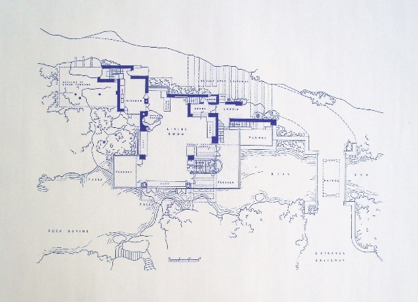
plans and sections of falling water by frank lloyd wright - Search Images (bing.com)

From a nearby quarry sandstone was used to imitate the natural forms surrounding the building. To make the house look like it was growing out of the landscape they laid the stone in rough horizontal striations. The use of local sandstone meant the outside walls blended into the landscape. For the flooring flagstone has been used both inside and out including the stairs and terraces. On the inside of the building the flagstone was waxed to imitate the water flowing below, to once again link this building back to the surrounding nature the Kaufmanns loved so much. Aside from using the stone to further immerse this building in the landscape, Frank Lloyd Wright used this building as an opportunity to utilise modern materials. Those being concrete and steel. Concrete has a strong compressed strength and steel has a high tensional strength. The use of reinforced concrete allowed the creation of the horizontal lines and balconies. The use of steel provided structural support for the cantilevered balconies and roof. The versatility of steel as a material allowed it to be shaped to support the long spans and overhangs of the building. Large amounts of glass are used to connect the indoors and outdoors. The transparency of the glass lets in natural light and a connection to the outdoor landscape. There were adaptions made to the building to combat under reinforcement of the main cantilever beams. An external post strengthening system was used to strengthen the cantilevers and any deflections in the concreate in 2001. Without this work there was a fear the structure could collapse suddenly. Due to the nature of the site conservation of the building has had to work to protect the building from water damage, humidity, and temperature change. The site needs regular repair to prevent water damage. Measures have been taken to reinforce and stabilize the cantilevered structure that include repair to the concreate and reinforcement of the cantilevered sections.
Frank Lloyd Wright first used the term ‘organic architecture’ in 1914. He is not the first architect to use the term and the meaning of the style can vary for different architects. Some key principles of what organic architecture meant to Frank Lloyd Wright include: the idea that nature on site should influence the form a building takes. In the case of Fallingwater you can see a contrast has been purposefully created between nature and the house. In other buildings designed by Frank Lloyd Wright, such as the Prairie, you can see the opposite, where the building and the site work together. The aim of organic architecture is that the line between natural and man-made should be blurred and the building should feel out of place anywhere else due to its unique relationship with the site. Fallingwater is integrated into the surrounding waterfall and forest. Wright also believed that organic architecture should provide a feeling of protection and shelter against the elements. The low sealings and central Fireplace of falling water embody this idea.
Fallingwater is an example of organic architecture that continues to inspire today. The situation above a natural waterfall and the incorporation of water into elements of the design creates the lasting sense of harmony with nature. The building is also sustainable and minimizes environmental impact by maximizing energy efficiency due to using natural ventilation and thermal mass to minimise energy consumption. The plans and sections show the integration of the principles of organic architecture. The combination of the materials used in sandstone, smooth concreate and glass creates a textural contrast which adds a visual impact to the building and the restoration work is a continuous process due to the unique natural elements of the site. Fallingwater is a unique example of how a structure can be integrated into a surrounding.

