Student Name: Salena Wallace
Student Number: 1919087
Module: Introduction to Physiology
Module Code: BMHP5003_BIRM
Lecturer: Rachael Rivers

The purpose of this report is to provide an overview of Bob's lifestyle choices and how they have affected his health and well-being, and to investigate various plans and strategies to improve Bob's health.
Bob is a 52-year-old man, D.O.B 12.03.1971, he lives alone in Birmingham City Centre.
He stands 5 feet 9 inches tall and weighs 15 stone.
He's been a smoker since he was in his early twenties. He is no longer married to his daughter Dana's mother and has been living alone for the past five years.
His only brother, mother, and father died over 10 years ago. His daughter, 27, lives in Huddersfield with her husband, Josh, and their two children, Alex and Taylor.

Bob has devoted all of his time into working, ever since his divorce, and he spends many late evenings and weekends on the road.
I'm not sure how frequently he smokes, but he did mention he's been smoking since his early twenties and enjoys it as a way to pass the time.
He used to take pride in his cooking before his divorce, but now he eats on the go and doesn't pay attention to his diet.
When he's at home, he'll drink a whole bottle of whisky (about 28 units) to help him fall asleep.
His tiredness is constant, but puts it down to ageing. He dislikes water and drinks an unhealthy amount of Coca Cola to help him get through the day.
He has trouble sleeping when on the road and becomes easily bored. His attitude is to simply get on with it and deal with it.

Diet

Bobs BMI = 31.01 and is considered overweight near to obese

Below are the World Health Organization's BMI guidelines:
BMI | Category
< 18.5 | Underweight
18.5 - 25 | Healthy Weight
25 - 30 | Overweight
> 30 | Obese
(Calculate Me, 2023)

A poor diet can cause, inflammation, poor digestion, malnutrition and sometimes unwanted weight gain, that pushes towards obesity. It can also increase your chances of chronic diseases like heart disease and diabetes, as well as, having an negative impact on your mental health.
According to C.H Robinson HGV drivers tend not to take care of their health especially when on the road.
The statistics show that truck drivers usually don’t live past the age of 61 because of their poor diet.
Obesity, lack of exercise, smoking, and sleep apnea are all common causes of ill health for truck drivers.
To improve Bobs life, he just needs a little extra help to improve his health and the lifestyle choices he makes.
HGV drivers are at risk for metabolic syndrome, which is a group of conditions that can be fatal to one's health and result in heart failure, a stroke or cancer, which we want to avoid regardless of the working environment.
Bob will make better choices if he is educated and guided to do more activities and eats healthier, as positive decisions can lead to positive outcomes. (C.H.Robinson, 2017)

The NHS Eat Well guide recommends eating at least 5 portions of a variety of fruits and vegetables every day. Meals should be based on potatoes, bread, rice, pasta, or other starchy carbohydrates, with wholegrain versions preferred whenever possible.

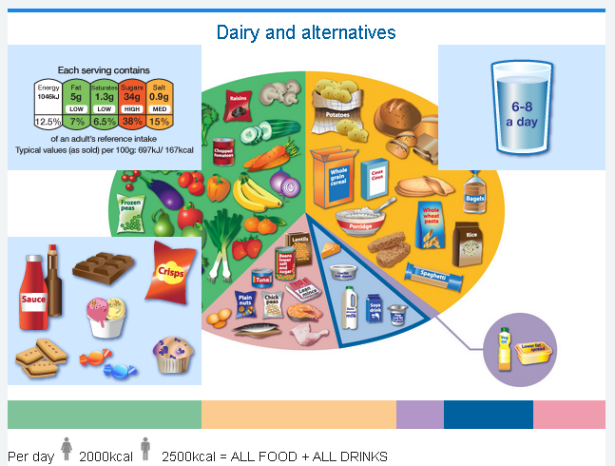 (reddit, 2023)

A balance diet comes with many options such as…
- Dairy or dairy substitutes such as soya drinks select lower fat and lower sugar options
- Beans, fish, eggs, meat, and other protein-rich foods
- Include 2 portions of fish every week, one of which should be oily. Choose unsaturated oils and spreads and consume in moderation
- Drink 6-8 cups or glasses of water per day
- Consume foods and beverages that are high in fat, salt, or sugar less frequently and in small amounts (NHS, 2021)

Physical Activity

Bob's occupation exposes him to numerous health-related risk factors, according to BMC Medicine
The UK logistics sector mentions, being an HGV driver is one of the most dangerous professions in terms of Health and wellbeing.
When attempting to make healthier choices, the environment as well as job demands can present challenges.
These challenges could be, long periods of sitting. Longer working hours causes sleep deprivation and metabolic disruptions, which promotes unhealthy behavioural choices associated with high obesity rates and cardiovascular risk.

The Structured Health Intervention for lorry drivers is a programme with a multi-component intervention lifestyle-behaviour designed, to target behaviour patterns, changes in physical activity, diet, and sitting for all truck drivers developed by the BMC Medicine.
Participants in the programme attend a development of creativity education workshops about healthy driving. (BMC Medinice, 2022)

According to research, HGV drivers are at a high risk of illness.
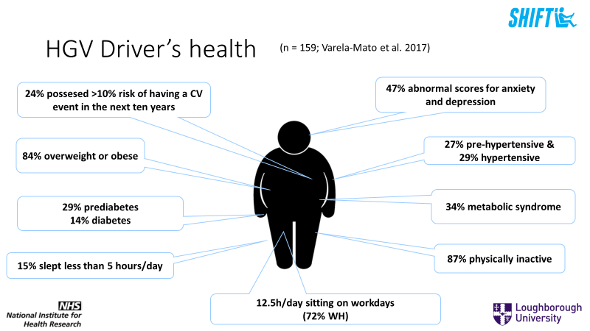 (national centre for sport & excersise medicine working for health and wellbeing, 2020)

Drivers who participate in the programme engage in a six-hour interactive education course about nutrition and fitness, they are given regular exercise, monitored to record their progression and participate in step count challenges with other drivers.

Participants are also provided with exercise equipment and an exercise program that they can use in their cab at rest stops and service stations.
The research and study are conducted by the school of sport, exercise & health sciences at the university of Loughborough and finance by the national institute for health research alongside the NHS. Their values are to prioritise and improve the health of lorry drivers.

Truck drivers like Bob that participate throughout the 12 months program will receive health assessments. These assessments include blood sugar and cholesterol levels.
Checks on your blood pressure, body fat levels and body weight and other health activities. Your results will be recorded and you will be provided with alternatives strategies to help with small and realistic changes to better further their health for the long term.

Lifestyle

Bobs poor choices can impact his life expectancy. Smoking is a problem as it can cause illness such as lung cancer. Lung cancer is extremely common and serious. Causes of cancer usually stem from smoking cigarettes. The smoke from cigarettes contains over 60 different harmful compounds (cancer-producing).
Individuals have been 25 times more likely to be diagnosed with lung cancer if you keep smoking upwards of 25 cigarettes per day than if you do not smoke.
According to research, becoming subjected to diesel fumes on a regular basis for a long period of time puts you at greater risk for lung cancer. (NHS, 2022)
Bob drinks a whole bottle of whiskey at night to help him sleep. That’s about 28 units. He is a high risk for having a stroke, high blood pressure, dementia or a heart attack. (Bitesize, 2023)

www.smarttrucking.com explains how truck drivers don’t receive the essential attention, as life on the road can damage their lifestyle, if not managed correctly. Its facts that truck drivers have shorter life span than any other profession. Common problems and obstacles that drivers go through like bob are…
- Place of work is overcrowded
- Diesel fuel as well as other chemicals inhalation
- Inadequate access to nutritionally balanced food, as well as the power and control of too many fast-food restaurants
- Unbalanced sleep schedule
- Extremely stressful situations
- lack of bodily activities

Regardless of the reason of being divorce, from being married to now being divorce can be a huge adjustment for anyone. Bob has gone from a full house to now an empty house with meals for one. Divorce can bring a lot of psychological stress.
www.medicalnewstoday.com has an article and according to the article the World Health Organisation recommends, regular physical activity is critical to all health. This helps protect against serious illnesses, by trying to regulate weight and improving insulin consumption in the body.
Regular exercise is incredibly useful for the heart because it improves heart rate, sugar levels in the blood, as well as blood vessel
Exercise also aids in the prevention of inflammation, which has been linked to cardiovascular disease. (Townley, 2018)

Your Lifestyle, gender and age can all have an impact on your wellbeing and health choices
A truck drivers life style can be impacted by their work, because they are constantly on the go. Spending long hours and days on the road can have its advantages and disadvantages.

Being on the road comes with a lot of planning. Not having the tools to eat right and to work out can be a struggle. I understand at times drivers like Bob can easily become bored.
To help with boredom HGV drivers have access to entertainment while out on the road. Satellite radio and streaming applications, videos, video games and books are readily available for all drivers. Truck stops, theatres and restaurants.

HM Government have a report about strategy for the public health in England called Healthy Lives Healthy people. The aim is to tackle the concerns of health and wellbeing throughout life, by collaborating along side volunteers and businesses to bring awareness of alcohol, food, health at work, behaviour change and physical activities.
A campaign developing a change for life. Making healthy lifestyle choices easier.

Exercising is extremely important for your mental health. Simple movements like walking and riding a bike, helps to strengthen the bones and muscles. Exercising daily or just being active will increase the blood flow and oxygen, making you feel more energetic and less lethargic.
- Regular exercise and eating well provides the benefits we need to manage illnesses like anxiety, stress and depression
- Sufficient sleep with good rest will make it easier and more comfortable to function properly
- Avoiding smoking and drinking alcohol
- Try to be more social, as a lack of communication can negatively impact physical and mental health. Socialising with friends and family members will bring stress levels down. (The Health foundation, 2023)

Eating a well-balanced diet and essential nutrients benefits the heart.
Experts suggest that vegetables and fruits are always highly recommended and to include daily avoiding process food, caffeine and sugar.
Encouraging Bob to take small steps to keep busy by doing the things that best interest him will benefit him for the long term.

High blood pressure also known as hypertension can also be a high-risk factor for male truck drivers and can be difficult to spot. If untreated will cause serious problems in the near future such as …
- An enlarged heart. A significant indicator of heart failure
- Blood vessel aneurysms, that may prove life threatening.
- Failure of the kidneys.
- Eye problems and loss of vision
- Lorry drivers are more likely than others to have high blood pressure, owing to the way they work.

High blood pressure can be caused by a variety of factors, including:
- A salty diet, eating healthy foods on the road is difficult, and so many drivers will prefer fast processed food. Sadly, the high salt content as well as absence of other nutrients are risk factors.
- Far too much alcohol, drivers have a duty to participate and understand, drugs and alcohol screening procedure and policies in place to guarantee no drinking on the job, and to learn to have control over what happens after hours.
- Lack of regular exercise, having spent almost their entire careers behind wheel of a lorry tends to leave little time for physical activity
- To be overweight or obese increases the likelihood of having hypertension.
- Anxiety and stress, long-haul truck drivers can experience significant stress when interacting with other road users

Through the health and social care profession, individuals like Bob that work as HGV drivers, training and education should be readily available, to Inform drivers more about the dangers of hypertension, and why it happens and how they might be affected. Motivate individuals to be checked and to provide straight forward, simple methods to help them take courses in order to avoid the problem. (Belek, 2018)

References
Belek, J., 2018. High blood pressure — A hidden danger for your truck drivers. [Online]
Available at: https://srfm.com/business-insurance/high-blood-pressure-a-hidden-danger-for-your-truck-drivers/#:~:text=Left%20untreated%2C%20high%20blood%20pressure%20can%20lead%20to,be%20fatal.%20Kidney%20failure.%20Vision%20problems%20and%20blindness.
[Accessed 20 march 2023].
Bitesize, 2023. Reasons why health inequalities exist. [Online]
Available at: https://www.bbc.co.uk/bitesize/guides/zdcgwty/revision/5
[Accessed 20 march 2023].
BMC Medinice, 2022. The effectiveness of the Structured Health Intervention For Truckers (SHIFT): a cluster randomised controlled trial (RCT). [Online]
Available at: https://bmcmedicine.biomedcentral.com/articles/10.1186/s12916-022-02372-7#Sec1
[Accessed 13 march 2023].
C.H.Robinson, 2017. Truck Driver Health and Fitness. [Online]
Available at: https://www.chrobinson.com/en-gb/resources/blog/truck-driver-health-and-fitness-2/
[Accessed 13 march 2023].
Calculate Me, 2023. BMI Calculate me. [Online]
Available at: https://www.calculateme.com/bmi-calculator/bmi-of-a-15-stone-person
[Accessed 13 March 2023].
national centre for sport & excersise medicine working for health and wellbeing, 2020. The Shift Study. [Online]
Available at: https://www.ncsem-em.org.uk/research/optimising-health-wellbeing/impact/the-shift-study/
[Accessed 13 march 2023].
NHS, 2021. 5 a day what counts. [Online]
Available at: https://www.nhs.uk/live-well/eat-well/5-a-day/5-a-day-what-counts/
[Accessed 23 march 2023].
NHS, 2022. causes lung cancer. [Online]
Available at: https://www.nhs.uk/conditions/lung-cancer/causes/
[Accessed 20 march 2023].
reddit, 2023. The UK's NHS "Eatwell guide" now has "Dairy and alternatives" rather than "Dairy" and has beans and pulses in the protein section. Of 47 items on the chart, 37 are vegan. Getting there!. [Online]
Available at: https://www.reddit.com/r/vegan/comments/fe4sr7/the_uks_nhs_eatwell_guide_now_has_dairy_and/
[Accessed 20 march 2023].
The Health foundation, 2023. Better policy for healthy lives. [Online]
Available at: https://health.gov/healthypeople
[Accessed 20 march 2023].
Townley, C., 2018. How do relationship breakups impact physical activity?. [Online]
Available at: https://www.medicalnewstoday.com/articles/323987
[Accessed 20 march 2023].

