

Human resource management
Assessment -1

Student name: Mohammed Azharuddin

Student ID: 2105239

Module name: Human Resource Management

Module code: LCMB7000

Lecturer name: Gladius Kulothungan

Table of Contents
Introduction 2
Background of the company 2
Critical analysis of current and predicted changes in the external environment 2
Impact of the COVID-19 pandemic on the current and predicted changes in the organisation 3
Impact of Brexit on the current and predicted changes in the organisation 5
Evaluation of the company responding to changes in the external environment 7
Responding to challenges from the COVID-19 pandemic 8
Responding to challenges from the Brexit 8
Conclusion 9
References 10

Introduction
The research paper will critically analyse the current and predicted changes in the external environment especially from the outcome of the COVID-19 pandemic and Brexit appropriately. The resourcing strategies will be discussed that would be implemented by AstraZeneca on being influenced by the Brexit and the pandemic as well over the years. Furthermore, the company selected has been evaluated and the way it will respond to the changes occurring in the external environment will be discussed. The performance growth and impact on the economy of the healthcare sector will be obtained by analysing the external environment factors of Brexit and the COVID-19 pandemic.

Background of the company
AstraZeneca PLC is the chosen healthcare organisation established in 1999 headed by Leif Johansson as the Chairman and Pascal Soriot as the CEO of the company. AstraZeneca PLC is a British and Swedish multinational organisation from the biotechnology and pharmaceutical sector with headquarters located in Cambridge, England. The company has the vision of transforming healthcare and changing the lives of billions of people all across the world for the better (Raybould et al., 2021). It is the mission of AstraZeneca PLCto addresses the challenges faced by the healthcare sector faced by the people. The ambition of the company has been stopping the progress of the debilitating, degenerative and life-threatening conditions for achieving the remissions for curing them effectively. The company has focused on being driven by innovation and its main focus has been discovering, developing and commercialising the prescription of medicines for the important areas of healthcare including respiratory and inflammation, gastrointestinal, oncology, infection, cardiovascular and neuroscience respectively (Munekawa et al., 2020). The business strategy followed by the AstraZeneca PLC is aimed towards rewarding everything that is performed in the company and helping in the creation of authentic connections for achieving the mission of the company. The company has been facing certain challenges due to the changing environment situation, which has been discussed.

Critical analysis of current and predicted changes in the external environment
The external environment has been affected by huge conditions or situations that have influenced the way the organisations in different sectors perform. The two most important conditions that influenced the performance of the AstraZeneca PLC are Brexit and the COVID-19 pandemic appropriately. The changes that have taken place due to these external events on the company have been discussed along with the predicted changes that could affect the way the business is operating effectively.

Impact of the COVID-19 pandemic on the current and predicted changes in the organisation
In the view of Zhang and Haskins (2021), the pandemic started when people started getting affected in China by an unknown infection that was air-borne. The virus infection started spreading from China to different parts of the world during the last quarter of 2019 and by March 2020 the whole world was under strict restrictions after it was announced that a pandemic had occurred (Santos, 2020). As depicted by Kirtane et al. (2020), the Corona Virus led to millions of people being affected and lakhs dying every day across the world as the doctors and scientists could not understand the cure for this infection. The entire world was brought under a global lockdown to ensure that the spreading of the virus could be contained if the people stayed in their houses (Zhang and Haskins, 2021). As stated by Santos (2020), the global lockdown led to the closing of shops and offices, which affected the people who could not afford work from home facilities and had to lose their jobs. Most of the firms were terminating their workforce as they had to income to maintain a huge workforce. As acclaimed by Iyengar et al. (2020), the pandemic had been hard on all the sectors, especially the healthcare sector. The doctors had no idea initially of how the patients should be treated and thousands of doctors started getting affected and dying on duty while taking care of the infected people (Kirtane et al., 2020).
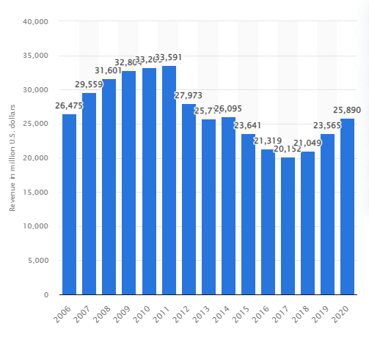
Figure 1: Rise and fall in Revenue for AstraZeneca
(Source: Statista, 2020)
In the opinion of Kaye et al. (2021), the healthcare sector faced various challenges in order to deal with the pandemic situation in the UK and across the world. The people were looking up to the doctors and scientists working at AstraZeneca PLC for hope and vaccine development. The doctors at AstraZeneca PLC used their innovative strategy and started designing the vaccine for people not just for the UK but also exported to different other nations (Kapoor et al., 2020). As denoted by Lorgelly and Adler (2020), the pandemic pressured the creation of vaccines even though the company lacked resources and knowledge initially about what should be done or prepared to end the virus. There were no money and people were getting affected every day in thousands. The people who were dying from the virus could not be tested as their bodies were burnt immediately to avoid spreading the virus further (Kaye et al., 2021). As viewed by Kapoor et al. (2020), the direct impact on the healthcare sector due to the pandemic was the loss of personnel lives and no protection or monetary help to the staff to improve the healthcare facilities and show support to the people being affected. The healthcare sector was being affected by a lack of medicines, injections, spare beds, oxygen cylinders for patients and many more (Lorgelly and Adler, 2020).
According to Preti et al. (2020), the AstraZeneca PLC had published the statement of looking for investors and conducting research using the best scientists to prepare an antidote or vaccine for the virus. The virus was known to be mutating, which is why it was becoming difficult for the doctors to develop a vaccine, which could protect people of all ages. As suggested by Lorgelly and Adler (2020), huge challenges related to financial problems and economic crises were faced by the healthcare sector, which affected the type of care medically being provided to the COVID-19 affected people. The manufacturing of vaccines took time for the scientists all through 2020 and this led to an increased toll on the mortality rate. As opined by Zhang and Haskins (2021), manufacturing disruptions took place, which delayed the vaccine production in 2020 and this affected the sales and revenue of the AstraZeneca PLC leading to a decrease in profit margins for the business. The financial challenges faced by the AstraZeneca PLC with the manufacturing of vaccines for the people against the Corona Virus were marked as an important problem for the organisation in the healthcare sector (Preti et al., 2020).

Impact of Brexit on the current and predicted changes in the organisation
In the opinion of Herveyet al. (2021), the human resources management (HRM) team of the health care sector recognised massive changes generated due to Brexit and addressed further changes formulated in the firm relatively. Additionally, the health care system identified the adverse impact of Brexit in structural and operational management such as AstraZeneca. The existing changes and further changes are incorporated within the organisations are discussed below.
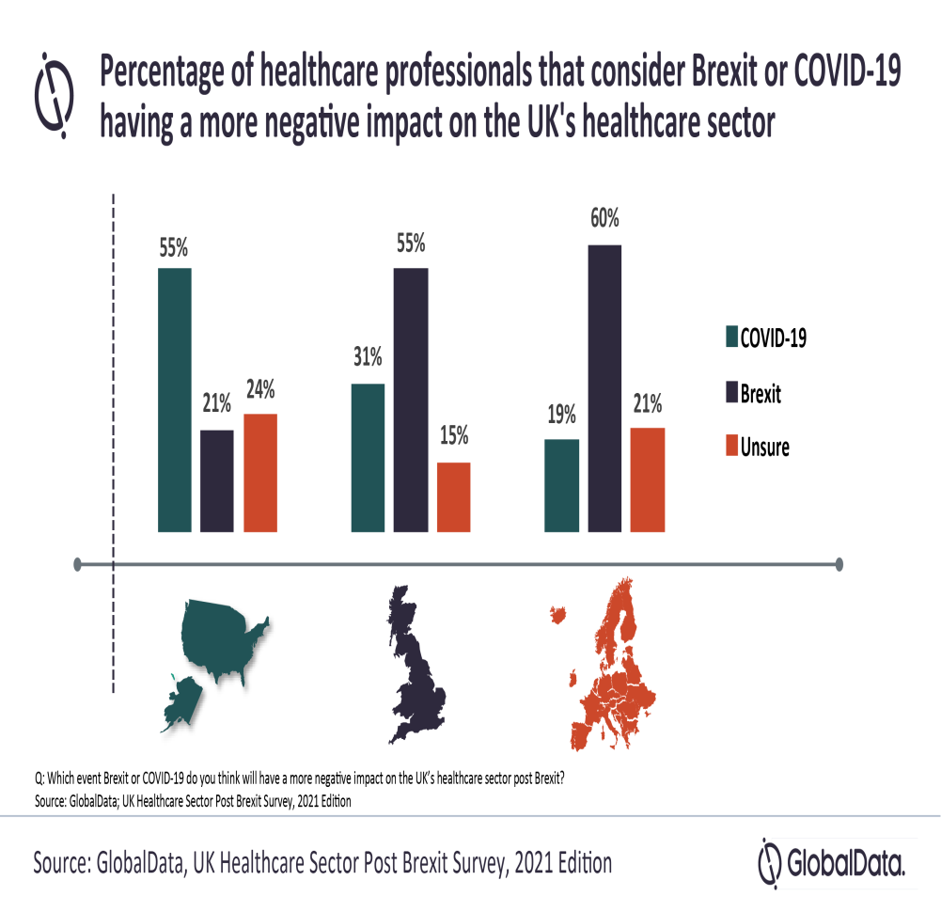
Figure 2: Impact of Brexit in health care industry
(Source: Fahy et al., 2019)
- Short-term supply of medicines: As suggested by Dayanet al. (2020), the healthcare system recognised key changes are developed in health care organisations during Brexit. Additionally, short-time supply of medicines generated a serious concern of present issues and the unavailability of medical devices evidenced of evaluating changes formulated in health care system with 60% due to negative impact of Brexit relatively. Besides, suppliers and manufacturers are unable for supplying medical equipment necessary for continuing services that generated adverse situations within the organisation following Brexit (Fahy et al., 2019). However, the UK government predicted that disruption generated in health care services and suffered from providing medical assistance to the population for securing population health significantly.
- Insufficient investment in the health care industry: As opined by Fahy et al. (2019), the supreme authority of health care organisations recognised economic downfall is generated within the industry during Brexit. Additionally, managers of AstraZeneca addressed the lack of interest in investing capital in this concerned industry relatively. However, increased cost range of supplies products generated demotivation for investing in this sector as it is recognised as a non-profitable industry after Brexit. Moreover, the UK government underlined threats of a non-framing detailed plan of mitigating these challenges and this movement evidenced of non-investing capital in this health care sector (Dayanet al., 2020).
- Changes in packaging: The HRM personnel of the health care sector such as AstraZeneca recognised key changes necessary for mitigating Brexit impact generated within the organisation (Gottlieb et al., 2019). Additionally, AstraZeneca initiated formulating changes in packaging along with obtaining a necessary license and accepting UK testing standards beneficial for drugmakers.
- Emphasised in moving stocks- In the opinion of Gottlieb et al. (2019), the health care sector identified such changes, which are necessary for managing economic adversity formulated in the organisation during Brexit. Additionally, AstraZeneca initiated moving stocks from the UK to the European distribution centre as it can be shut down in future (Hervey et al., 2021). Besides, AstraZeneca framed a functional framework for the continuous availability of stocks of the medicines as maintaining government request and attained four weeks extra stock especially for EU supply (Leonard, 2019).
- Food safety issues: the health care system struggled with food safety issues are formulated in the health care organisation in the context of Brexit (Millstone et al., 2019). Besides, unhealthy food supplies are evidenced of highlighting food safety issues in the health care sector relatively. Additionally, chlorinated chicken received media attention of underlining food issues are incorporated in AstraZeneca the UK. The UK government suffered from planning an effective plan of avoiding poor air quality, tobacco consumption and deliveries of unhealthy food for the patients(Leonard, 2019).
- Slower economic growth: As stated by Simpson (2021), the health care industry suffered from economic adversity incorporated in the organisation and initiated in designing resolving pathways of such issues formulated due to Brexit. Additionally, slower economic growth is responsible for unemployment, unavailability of medical equipment and inaccessibility of health care emergency services relatively(Millstone et al., 2019).

Evaluation of the company responding to changes in the external environment
The problems faced by the AstraZeneca PLC during the pandemic and the Brexit situation as a part of the healthcare industry have been discussed. These challenges have been evaluated and appropriate responses have been developed for dealing with the changes in the external environment for the healthcare company, AstraZeneca PLC (Millstone et al., 2019). These approaches could be implemented for overcoming the challenges and improving the situation for the business to grow and prosper for a better future effectively.

Responding to challenges from the COVID-19 pandemic
In the view ofSimpson (2021),the healthcare sector and pharmaceutical firms had been facing economic and financial problems related to a lack of resources and knowledge to manufacture or design the vaccine for curing the Corona Virus and protect the people from dying or getting infected. The government of the UK responded to this challenge by providing the required investment and resources that could be provided to manufacture the first batch of vaccines for the frontline workers. As denoted byHerveyet al. (2021), the lack of resources and medical help for the frontline workers was also a challenge for this sector, which was responded to by the government of most of the countries by providing the first dose of vaccine after creation to the frontline workforce to keep them safe so that they can treat the patients. As stated by Simpson (2021), the healthcare officials were provided with the vaccine in 2021 at first and then civilians were provided with the vaccination. The AstraZeneca PLC did not think of making profits during this manufacturing as it exported vaccines from the first batch to various nations as per their need. As suggested by Millstone et al. (2019), AstraZeneca PLC provided vaccines to people all across the world and even shared its ingredients of the vaccine with other senior healthcare officials for helping other brands to develop the vaccines as well.

Responding to challenges from the Brexit
In the view ofvan Schalkwyk et al. (2020), Brexit challenges were faced by the healthcare sector firms such as the AstraZeneca PLC, which could be improved and overcome with the implementation of some strategies. The shortage of medicines affected the growth of the business, created a serious problem for the patients, and led to the havoc created in the sector. As denoted byDuncan (2021),the UK government managed to provide funding to the healthcare businesses to arrange for the medical supplies and continue with the services for patient treatment. The disruption in the health services was created due to the lack of medical supplies in the AstraZeneca PLC due to Brexit. As acclaimed byHervey (2018), the economic downfall was noticed by the organisations due to Brexit, which generated a huge crisis within the industry. Furthermore, the management of the company raised the lack of capital invested in the AstraZeneca PLC. These problems were resolved by the investment received from the UK government to manage the medical processes and businesses to continue providing services effectively. The challenges from Brexit had affected the economy of the healthcare sector as well as the country of the UK.
As suggested byEaton (2020), Brexit led to problems related to the packaging of the medical supplies that affected the inventory management of the AstraZeneca PLC. However, the government responded to the problem by arranging for a new packaging format that would be followed by the company to handle the way license and testing standards are accepted in the UK for the drug developers. In the opinion ofMcKee and McKee (2018), Brexit has been an important event that caused the emphasis on the movement of stocks related to the healthcare industry. It has been obtained that the AstraZeneca PLC for improving the functional framework of the business moved the stocks from the UK to European distributors. This strategy helped in maintaining the business growth and did not create failure for the company. As deduced byvan Schalkwyk et al. (2020), the impact of Brexit had been challenging for the healthcare sector as the economy of the nation was affected. The lack of medical supplies and services for the patients marked an enragement among the people, which could be controlled after the government was involved and investments and funds were made to maintain the business.

Conclusion
From the above discussion, it has been concluded that AstraZeneca PLC is an important part of the pharmaceutical and healthcare sector in the UK and across the world. The innovative product development strategy has been helpful for the brand during the pandemic when the company was used for preparing vaccines to immune the people all across the world from the infection of the Corona Virus. Furthermore, it has been concluded that Brexit had a huge role to play in the change of dynamics of the healthcare sector in the UK. The current changes that have taken place in the organisation and the ones that are predicted to take place have been discussed in the report.

References
Dayan, M., Fahy, N. and Hervey, T. (2020) Understanding the impact of Brexit on health in the UK, The Nuffield Trust. Available at: https://www.nuffieldtrust.org.uk/research/understanding-the-impact-of-brexit-on-health-in-the-uk (Accessed: 12 January 2022).
Duncan, M., (2021). The implications of Brexit for healthcare in the British Overseas Territories. British Journal of Healthcare Management, 27(3), pp.76-85.
Eaton, K.A., (2020). Oral healthcare workforce planning in post-Brexit Britain. British Dental Journal, 228(10), pp.750-752.
Esmaeilzadeh, P. and Mirzaei, T., 2018. Comparison of the UK citizens’ perspectives on the consequences of different Brexit scenarios for healthcare: An experimental study. Health Policy and Technology, 7(4), pp.325-332.
Fahy, N., Hervey, T., Greer, S., Jarman, H., Stuckler, D., Galsworthy, M. and McKee, M., (2019). How will Brexit affect health services in the UK? An updated evaluation. The Lancet, 393(10174), pp.949-958.
Gottlieb, L., Fichtenberg, C., Alderwick, H. and Adler, N., (2019). Social determinants of health: what's a healthcare system to do?. Journal of Healthcare Management, 64(4), pp.243-257.
Hervey, T., Antova, I., Flear, M.L., McHale, J.V., Speakman, E. and Wood, M., (2021). Health “Brexternalities”: the Brexit effect on health and health care outside the United Kingdom. Journal of Health Politics, Policy and Law, 46(1), pp.177-203.
Hervey, T.K., (2018). Reciprocal healthcare arrangements after Brexit. BMJ, 363.
Iyengar, K.P., Vaishya, R., Bahl, S. and Vaish, A., (2020). Impact of the coronavirus pandemic on the supply chain in healthcare. British Journal of Healthcare Management, 26(6), pp.1-4.
Kapoor, A., Guha, S., Das, M.K., Goswami, K.C. and Yadav, R., (2020). Digital healthcare: The only solution for better healthcare during COVID-19 pandemic?. Indian Heart Journal, 72(2), pp.61-64.
Kaye, A.D., Okeagu, C.N., Pham, A.D., Silva, R.A., Hurley, J.J., Arron, B.L., Sarfraz, N., Lee, H.N., Ghali, G.E., Gamble, J.W. and Liu, H., (2021). The economic impact of COVID-19 pandemic on healthcare facilities and systems: International perspectives. Best Practice & Research Clinical Anaesthesiology, 35(3), pp.293-306.
Kirtane, A.J., Mehran, R., Navar, A.M. and Bonow, R.O., (2020). Heroism in the Face of the COVID-19 Pandemic. JAMA cardiology, 5(10), pp.1163-1164.
Leonard, M. (2019) AstraZeneca adjusts supply chain for no-deal Brexit, Supply Chain Dive. Available at: https://www.supplychaindive.com/news/AstraZeneca-supply-chain-adjustment-Brexit/548694/ (Accessed: 12 January 2022).
Lorgelly, P.K. and Adler, A., (2020). Impact of a global pandemic on health technology assessment. Applied health economics and health policy, 18(3), pp.339-343.
McKee, D. and McKee, M., (2018). What might Brexit mean for British tourists travelling to the rest of Europe?. The journal of the Royal College of Physicians of Edinburgh, 48(2), pp.134-140.
Millstone, E., Lang, T. and Marsden, T., (2019). Food Brexit and chlorinated chicken: a microcosm of wider food problems. The Political Quarterly, 90(4), pp.645-653.
Munekawa, C., Hosomi, Y., Hashimoto, Y., Okamura, T., Takahashi, F., Kawano, R., Nakajima, H., Osaka, T., Okada, H., Majima, S. and Senmaru, T., (2020). Effect of coronavirus disease 2019 pandemic on the lifestyle and glycemic control in patients with type 2 diabetes: A cross-section and retrospective cohort study. Endocrine journal, pp.EJ20-0426.
Preti, E., Di Mattei, V., Perego, G., Ferrari, F., Mazzetti, M., Taranto, P., Di Pierro, R., Madeddu, F. and Calati, R., (2020). The psychological impact of epidemic and pandemic outbreaks on healthcare workers: a rapid review of the evidence. Current psychiatry reports, 22(8), pp.1-22.
Raybould, M.I., Kovaltsuk, A., Marks, C. and Deane, C.M., (2021). CoV-AbDab: the coronavirus antibody database. Bioinformatics, 37(5), pp.734-735.
Santos, J., (2020). Using input-output analysis to model the impact of pandemic mitigation and suppression measures on the workforce. Sustainable production and consumption, 23, pp.249-255.
Simpson, K., (2021). National interest and public interest: Public opinion from the economic crisis to Brexit. In Ireland and the European Union (pp. 103-119). Manchester University Press.
Statista (2020) AstraZeneca revenue 2006-2020 | Statista, Statista. Available at: https://www.statista.com/statistics/266542/revenue-of-astrazeneca-since-2006/ (Accessed: 12 January 2022).
van Schalkwyk, M.C., Hervey, T.K., McCarey, M., Dayan, M., Barlow, P. and McKee, M., (2020). How will Brexit affect the healthcare workforce?. BMJ, 371.
Zhang, N. and Haskins, M., (2021). Trends of industry-leading biotechnology stocks during COVID-19. Journal of Student Research, 10(3).

