PREPARED FOR DEBORAH HUGHES
Work Based Project - ACBA 5009
Jon Phillip Langstone (2006738)
Research Proposal
2021
Table of Contents
1. Proposed Research Title 1
2. Abstract 1
3. Introduction and Background 1
4. Aims and Hypothesis 2
5. Definitions 2
6. Literature Review 2
6.1 The UK Housing Crisis 2
6.2 Modern methods of construction (MMC) 3
6.3 Focusing on Cross-laminated Timber 4
6.4 The Sustainability of Off-site CLT Construction 5
7. Research Methodology 6
8. Proposed Chapters 6
9. References 7

Figure 1 Savills – MMC (Selsey, 2020) 3
Figure 2 Conventional assembly layup of cross-laminated timber (Buck, 2016) 4

Table 1 Applications of CLT (Structural Timber Association, 2015) 5

Proposed Research Title

Is off-site cross-laminated timber construction a forward-thinking solution to the housing crisis in the UK?

Abstract

This research will seek to answer the question, whether off-site cross-laminated timber construction methods are a forward-thinking solution to the increasing demand for newly constructed homes in the UK. With a focus on off-site manufacturing methods of construction.

Introduction and Background

The researcher has been heavily involved in various types of construction in the United Kingdom and Western Canada. After many years of witnessing first-hand, the increasing demand and popularity of the use of off-site cross-laminated timber, the researcher felt it would be beneficial to further understand how cross-laminated timber has developed, and whether it is a forward-thinking solution to the housing crisis in the UK.

Aims and Hypothesis

This research aims to gain a greater understanding of how cross-laminated timber as a modern method of construction has developed, its process, and whether it is a successful method of construction used to lower the rising annual demand for constructing new homes in the UK.

Definitions

MMC – Modern Methods of Construction.
CLT – Cross-Laminated Timber.
UK – The United Kingdom.

Literature Review

The UK Housing Crisis

The United Kingdom has a housing crisis, and it has been steadily getting worse since the 1970s: Where did the problems initially come from?

Here are some of the main causes of the housing crisis:

- Lack of affordable homes.
- Difficulties for mortgages for first-time buyers.
- Supply and demand disruption.
- Social housing shortages.
- London prices imbalances.
- Lack of new home construction.
- Lack of available land on offer.
- Buy-to-let markets have grown.

With the causes mentioned above in mind, the crisis boils down to the main cause; that not enough new homes are being built in the UK, to keep up with the demand: “The demands on the residential construction sector are substantial” (Davies, 2018).

A quote from Horn also outlines the demand further:

“With England alone needing up to 345,000 new homes annually, it’s clear that fresh, innovative solutions that disrupt the market are required to bridge that significant gap.”
(Horn, 2020)

With these annual shortages outlined, the government is now looking toward the construction industry, to try and increase productivity. A major factor of the crisis is that the UK is now facing a skilled labour shortage, which certainly does not help the construction industry in its efforts to build more homes (Farmer, 2016).

Modern methods of construction (MMC)

Modern Methods of Construction MMC

MMC is best described in the following figure, by Savills research division:

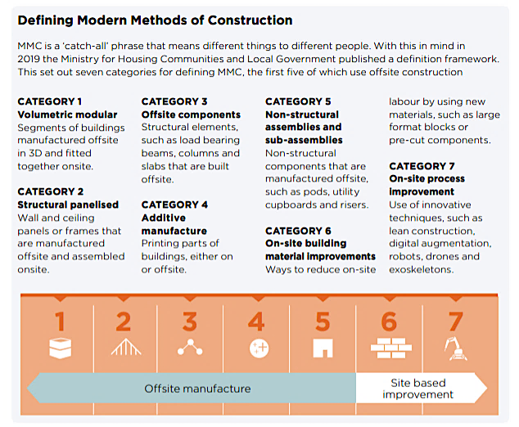
Figure 1 Savills – MMC (Selsey, 2020)

MMC can create better quality homes in a much shorter time than most traditional methods of construction. MMC was initially created to meet the urgent demand for residential buildings after World War two. It then became popular again when the housing crisis started, post 2005. (Go-Construct, 2021).

Modern Methods of construction consist of many variations, here are the major aspects:

- Pre-assembly off-site manufacturing.
- Panelised construction.
- Volumetric construction.
- Modular integrated Construction (MIC).

The benefits that come with MMC, compared to traditional methods of construction are (Rahimian, 2020):
- Greater predictability of cost
- Efficiency Savings
- Environmental Savings
- Improved construction quality
- Increased speed of construction
- Improved health and safety

Off-Site Manufacturing/Construction

For some years, offsite construction has been seen as the solution to the UK’s housing crisis. This is due to a quick and efficient way of building residential homes, that meet the ever-increasing demand (Davies, 2018).

A quote from Savill’s describes the UK government’s response to Offsite manufacturing in 2018:

“In 2018, the House of Lords Science Committee was told that the use of offsite manufacture was the only way to achieve the government target of 300,000
homes per annum.”
(Savills, 2020)

Focusing on Cross-laminated Timber

Cross-laminated timber is an engineered timber product. It is now threatening to upset the poularity of the two main structural materials in use, which are famously concrete and steel. Over the past ten years, the use of CLT in off-site UK construction techniques has risen dramatically. CLT has been used in the UK since the mid-90s. It originally came from Europe, as Germany and Austria were the biggest manufacturers of CLT at the time (Davies, 2018).

CLT developed from the ability to glue strips of timber together to make structural beams, but now it is used to create floor, walls, and roofing systems. The structural beams are known as glue-laminated or glulam beams. CLT uses the same method to engineer whole-wall panels that are both strong and beautiful in design. CLT is also relatively new in the field of timber construction. (Brinkley, 2021).

Figure 2 on the next page clearly indicates which pattern the timber is used to put CLT together:
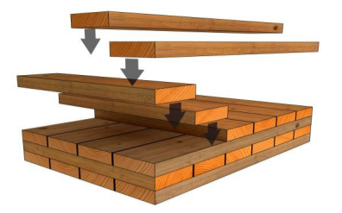
Figure 2 Conventional assembly layup of cross-laminated timber (Buck, 2016)

Table 1 Applications of CLT (Structural Timber Association, 2015)

The table above shows the applications that CLT construction can offer.

The Sustainability of Off-site CLT Construction

Over the past 20 years, there has been much global discussion on the imminent climate crisis. With the most recent conference on climate change at the COP26 in Glasgow, there has been a lot of discussion regarding Modern methods of construction, and how they may be able to reduce the construction industries’ carbon footprint using more sustainable materials, such as Timber. With the housing crisis in mind, the option of timber as a preferred material of choice for the newly built homes of Britain may well help CLT develop much further, to become the favoured method and solution of the future.

“Large-volume timber structures, such as CLT, are a natural choice of
construction where low-embodied-carbon materials are required for where the aesthetic requirements for a dimensionally stable exposed timber finish are required”

(Structural Timber Association, 2015).

Timber frame construction and off-site timber manufacturing have many advantages compared to the use of steel and concrete frame construction. They are as follows:

- Less wasteful
- Increased recyclability
- Increased Durability
- Easily demolished
- Environmentally friendly
- Less time to build
- Increase fire safety properties
- Increased airtightness

The UK construction industry still uses fat too many non-renewable resources that bring a total carbon emissions percentage of 40 per cent of the country’s emissions. CLT can be the solution to act as the sustainable option that the UK government needs to meet the net-zero target by 2050 (Ideal Modular Homes, 2020).

Research Methodology

The main source of data found for this research will be secondary data found on the internet. The research will explore the general use of cross-laminated timber in the construction industry, and how it can potentially help decrease the annual demand for newly constructed homes in the UK. There is certainly an abundance of research material regarding the chosen topic, especially off-site manufacturing processes. This wide range of research material will be collated and summarized with the use of government documents, industry reports, and carefully chosen research journals found on the world wide web.

Proposed Chapters

- The housing crisis
- The decline of traditional methods of construction
- The development of Modern methods of construction
- The rise of UK based off-site manufacturing
- Defining Cross-laminated timber
- Limitations of CLT
- Sustainable timber construction
- The future of CLT design and construction
- Conclusion

References
Brinkley, A. C. (2021, June 17). Cross Laminated Timber: How to Build With CLT. Retrieved from homebuilding.co.uk: https://www.homebuilding.co.uk/advice/cross-laminated-timber
Buck, D. &. (2016). Further Development of Cross-Laminated Timber (CLT): Mechanical Tests on 45° Alternating Layers.
Davies, A. (2018). Modern Methods of Construction. RICS.
Farmer, M. (2016). The Farmer Review of the UK Construction Model. ©COPYRIGHT Mark Farmer 2016.
Go-Construct. (2021). Modern Methods of Construction. Retrieved from goconstruct.org: https://www.goconstruct.org/educational-resources/learn-about-construction/modern-methods-of-construction/#:~:text=Modern%20methods%20of%20construction%20is,as%20alternatives%20to%20traditional%20building.&text=Creating%20paneled%20units%20in%20factories,
Horn, S. (2020, April 23). How timber frame and offsite construction meet housing demand. Retrieved from pbctoday: https://www.pbctoday.co.uk/news/mmc-news/timber-frame-housing-demand/75242/
Ideal Modular Homes. (2020, July 31). Sustainable Construction: Using CLT. Retrieved from idmh.co.uk: https://idmh.co.uk/blog-news-events/sustainable-construction-using-clt
Isherwood, K. (2020, July 8). Delivery of new-builds hits highest figure in over 20 years, despite COVID. Retrieved from buyassociation.co.uk: https://www.buyassociation.co.uk/2021/07/08/delivery-of-new-builds-hits-highest-figure-in-over-20-years-despite-covid/
Rahimian, J. S. (2020). Offsite production and manufacturing for innovative construction. Abingdon: Routledge.
Savills, R. (2020). Modern Methods. Retrieved from euro.savills.co.uk: https://pdf.euro.savills.co.uk/uk/spotlight-on/spotlight-modern-methods-of-construction-spring-2020.pdf
Selsey, R. V. (2020). Modern Methods of Construction. Retrieved from pdf.euro.savills.co.uk: https://pdf.euro.savills.co.uk/uk/spotlight-on/spotlight-modern-methods-of-construction-spring-2020.pdf
Structural Timber Association. (2015). Cross-laminated timber construction. Structural Timber Association.
Taylor, R. L. (n.d.). Cross-laminated Timber. In TRADA, Timber Frame Construction (p. 216). TRADA.
Wilson, W. (2020, February 11). Stimulating housing Supply. Retrieved from researchbriefings.files.parliament.uk: https://researchbriefings.files.parliament.uk/documents/SN06416/SN06416.pdf

