Content’s page

Page number
Section 1 3-7
Section 2 8-9
Section 3 10-13
Section 4 14- 17
Reference list 18-25

Section 1:
Children of the 21st century are submerged in a digital environment, from more traditional media’s such as televisions and radio, to more up to date digital media, such as smart phones and games consoles, giving young children a wide range of devices and opportunities to access digital media (Chassiakos,2016; Lieberman, 2009). According to Plowman, 2013, digital media can have advantages and disadvantages for children, although there is not a lot of research about young children and their use of digital media, giving limited information for debate. However, this section will look at how digital media such as the access children have to mobile phones, iPads, games consoles and how they can be beneficial and non-beneficial to children under the age of eight. Mainly focusing on how digital media can help children be more connected and communicate with people via gaming consoles and chat rooms, be it family or new friends, as well as the benefits of having the access to a world of information through the internet. As well as how do parents or cares know who their children are talking to online and do parents or carers have the knowledge and understanding on how their media use can affect their children and how to keep their children safe online. It will also look at how digital media have advance so much helping children with additional learning needs, as well as the limitation children with additional needs may have encounter accessing digital media.
Young children use digital media in many ways, such as to communicate and connect with relatives, peers, and people they may not know, this can be though email, playing within an online game and videos (Holloway, 2013) this can be on a variety of devices. Although online games can be a form of entrainment they can also have benefits to children’s learning if used in the right way, Understood.org, no date, explains how online gaming has helped children develop their reading skills as children need to follow instructions during the game to help them progress, they also go on to explain how online gaming can help build children imagination skills with game such as Minecraft, giving children the means to create a whole world in which they can develop stories. Online games can also aid children to become strategic thinkers, problem solvers, build reliance, develop their understanding of how others see the world and help learn to communicate (internet matters, 2021).it is evident that Ong (2013); Holloway et al, (2013); Collin, Richard and third (2011) all agree how online gaming on devices such as play stations, x boxes and iPads can benefit children’s social skills from a young age, giving them a way to connect with people not only in their local area or people they know but also people from al over the world. However how do parents or cares know who their children are talking to? A survey carried out on around 4000 children found that 40% of these children were talking to people online that they have never met in person through a gaming platform and social media (Ansair,2019). While Ofcom (2019) states 22% of children asked where contacted online by someone they did not know with 9%, one in ten of these children were contacted in a sexual nature. The NSPCC (2019) claims most of these children contacted were girls. The NSPCC go on to describe how during the years of 2017-2018 9,000 children have be exposed to online sexual element. According to the office of national statistics 2021, 1 in every 6 children has talked or messaged someone online who they have never met and 5% of these children have met up with someone they have met online, although many of these situations have not always ended up bad, it is still a risk that is not beneficial to children. However, children can have online friends and still be safe, Faubion 2021; NSPCC 2021 suggests parents and carers should talk openly with their children, explaining how risky it can be meeting people online, as well as insuring children know and understand the consequences of over sharing online through social media and chat rooms. Although Dewey (1920) tells how children learn from doing, Piaget also describes children as “little scientists” (Kendola,2019) both theorists suggest children need to participate in risks online to learn from the experience. With this said, parents still have a responsibility to keep their children safe online and limiting the amount of risks their children encounter and ensuring the content is age appropriate (UK safer internet centure,2021).
With this said, how much knowledge do parents or carers have on what their children can access through digital media on their devices and do they know if their children are safe or using appropriate web sites of apps for their age and understanding while accessing them on their online devices, according to Parsons, 2017, 79% of parent’s world are concerned about what their children access online with 40% of those being totally unaware of what their children are viewing. In accordance to Ofcom (2019) 16% of children up to the age 11 have reported seeing something inappropriate online that has made them feel worried. By viewing inappropriate content can leave the child feeling anxious, upset, and overwound (NSPCC, 2021). Wood, 2019, goes on to describe the internet as “a big city with no police”, this suggests children are not safe when being online, he goes on to suggest parents should not be overly concerned about their children’s privacy, if it keeps them safe. However, in accordance with the UNCRC 2016, article 16, states children have a right to privacy. However, it is unclear how this article can be fulfilled in the online world (Jasmontaite, 2015), with this said the Committee on the Rights of the Child’s General council of Europe 2018, has stated how companies online must meet their responsibility to keep children’s safe online, in accordance with the UNCRC. Although, finding the right balance to enable children to have the opportunity, risk, freedom of expression as well as keeping their rights to privacy needs different protection measures’ (Killkelly,2006). With this said the UK government have set out a white paper, to put in place a new system that makes companies more accountable for their safety regulation, the government are planning to set out a new regulatory framework for online safety giving a clear guidance to companies on how to keep people in the UK users safe in particular children (Department for digital, culture, media and sport, 2020). So, how can parents or carers keep their children safe online? as mentioned before NSPCC 2021, suggest talking openly to children if the first step in helping children keep safe online. However, child net international,2018 tell us how making the use of parental settings with supervision, and engagement can help parents monitor and go towards keeping children safe online. according to Steel, 2009, it is critical for parents to encourage online safety from an early age, going on to say children need to be monitored, parents should use the tools available to them such as, parental control that can be though their Wi-Fi provider, the apps their children use, safety setting on games consoles as well as mobile phones and iPads . Parental controls can help safeguard children, helping filter what children access when using digital media such as, what can be searched on search engines, what content they can access on games (UK Norton online, 2021).
However, digital media has aided children with additional learning needs and disabilities and English language learners (Mcglynn-stewart, 2017). The audit commissioner has reported that one in five children within Wales and England has some kind of Additional learning need and disabilities, this includes children with physical and learning difficulties, as well as children with slow development withing reading, writing and numeracy skills, also including children who have conditions such as difficulty communicating, dyslexia and emotional and behaviour difficulties (All answered limited,2018). Children with additional learning needs and disabilities have found they can have an easier time communication when using digital media such as iPad, they can also become more involved and create a more complexed output of learning (Flores, 2012; Oakly 2013). By using apps early year educator’s have found that they help support children with additional learning needs and disabilities and English language learning support their continued learning and help learners focus on extending their thinking (Mcglynn-stewart, 2017). However, children with additional learning needs and disability according to Mark, 2020 can find the tasks of schoolwork demotivating and can find a sense of achievement when being involves with online games, the games is said to help children maintain their self-esteem. However, children with physical disabilities need find it difficult to access the equipment to be able to join their peers within virtual gaming (Murphy, 2019). With this said there are a combination of technologies that can help that can support children experience digital media though the world on virtual gaming, using the technology of eye gaze, mouth controls as well as special customised controllers (Able gamers, 2018; special effects 2021). Digital media is also a tool of inclusion for children with additional learning needs, however, practitioners can become overwhelmed with the amount of advertising, information, and teaching materials (Florian, 2004; Williams 2016). On the other hand, digital media can many benefits for children who have additional learning needs such as, experimental, and creative learning (Botturi,2010; Westeryn,2005), help to develop their social skills (Escobedo,2011) and can be used as an alternative way to communicate (Light 2007). However, digital media can help children with additional needs and disabilities, it can also have issues such as cyberbullying, online grooming and exploitation, according to Zhang, 2019, parents who have children with additional learning needs and disability are more likely to receive harm or online abuse rather than parents or child who do not have any additional needs or disability. Assiter, 2018, goes on to tell us how children with additional needs and disabilities an increased chance of can have having these kids of issues, she goes on to express how these children have more limited time online due to these facts, giving children less experience on the online world. This leads the discussion towards Bruna 1978, he tells us how children learning by building on knowledge they are already know ‘Scaffolding’, so by given children with disabilities and additional learn needs online hinders their change of developing the digital media skills and resilience that their peers may already have (Assiter,2018). The UK government has set out a framework for the digital resilience, which is in place for people, organisation who are involved with people’s interaction online, with vulnerable children having additional support (UK council for internet safety,2020), with this framework parents of children with additional needs and disabilities should feel safer letting their children exploring online.
As you can see children under the age of eight, with and without additional learning needs and disabilities can have access to digital media. The access that children have can be positive and negative, but with government policies in place and parents and cares having a knowledge and understanding of what their children can access, can make the digital a world a safe and exciting place, to learn, develop and have fun with peers.

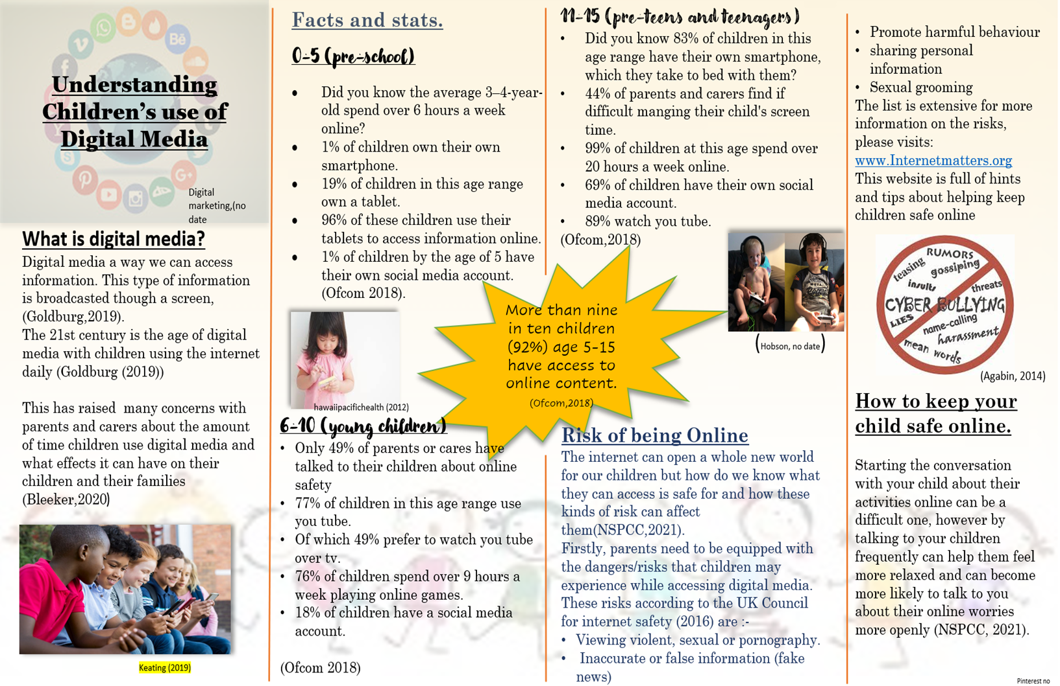
Section 2
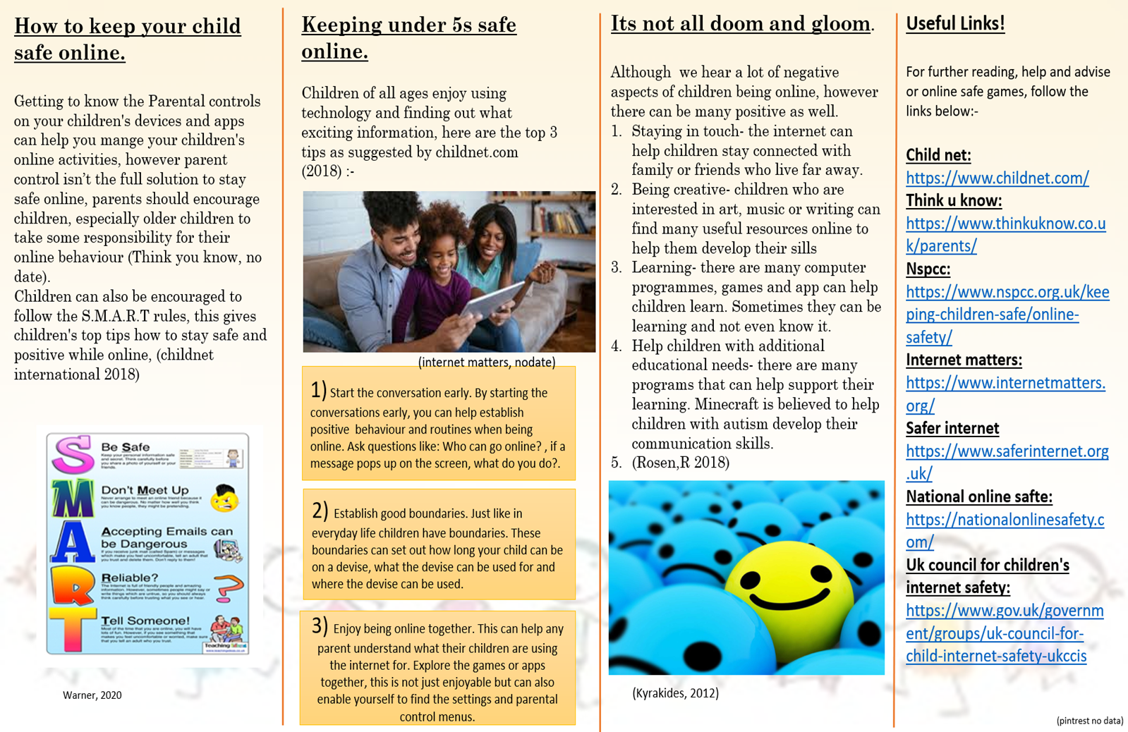

Cynllun Gweithgaredd Sgiliau Llythrennedd Digidol
Activity Plan for Digital Literacy Skills
Nifer o blant:  Number of children:6 | Oed y plant:  Age of children:7-8 | Nifer o oedolion:  Number of adults:1
Lleoliad:  Location: outside/forest school | Amser paratoi:  Preparation time:20 minutes | Amser gweithgaredd:  Activity time: 30 minutes
Adnoddau:

Resources:
3-Metal detectors
3-buckets
Recycling bag
3 clipboards
Paper
Pencils
Appropriate clothing for the weather
25 Coins
25 Metal costume jewelry
20 screws
10 Old tools- screw drivers, Allen keys, spanners
10 Tin cans
5 coke cans

Cysylltiadau â deilliannau llythrenned/cymhwysedd digidol:

Links to digital literacy/competence outcomes:
Curriculum for Wales (2020)- Health and well-being- deciding if the less desirable objects are good for social well-being.
- Humanities- why littering is not good and why we recycle.
- Language, literacy, and communication- working in pairs, talking about their finding.
- Mathematics and numeracy- counting how many items they have found in their pairs. Making a tally of how many of each item they have found, for work later in the classroom.
- Science and technology- using metal detectors and discovering how they work.
Digital competence framework:
- Producing- collect and organize data into groups,
e.g. gather data by voting or sorting and
represent in pictures, objects, or drawings.

- Interaction and collaboration- work together with a partner/partners on piece of digital work
(Gov.Wales, 2008.)
Manylion y weithgaredd:
Details of the activity:
Children will work in pairs to complete this activity. Children will work with peers of all abilities. Before the activate we will have a class discussion about how metal detectors work, what we think could be made of metal and what do the children think we might find and if they can be recycled. The class will then be split into groups of 6. The groups will take it in turns to go outside to use the metal detectors in 30 minutes sessions. In each pair the children will have 1 metal detector, clipboard, pencil, bucket, and a recycling bag will be placed by the school building, so children are aware of where it is. Children will then be given 20 minutes; 10 minutes each child. To go and find as much as they can using the metal detectors and placing the items in their bucket. Once the twenty minutes is up children will have time to count and tally up their findings, ensuring their names are on the pages. Sorting each object into groups. We will also discuss the finding of their hunt with the metal detectors and which items they think should go into the recycling bin. Each pair will place the items in the recycling in the bin. Once children have completed this they will go back into the classroom and practitioners can reset up the activities for the next group.

Section 4,
While planning this activity there was carefully consideration of the curriculum for Wales 2020 as well as the digital competence framework 2008. This has enabled the planning to be accessible for all children within the age group regardless of their abilities and development.
The planning is set up in a way children work in a collaborative way, which Donaldson (2015) outline in his successful futures report, he suggested children need to learn how to work in a “collaborative and creative way” this is thought to help children take reasonability for their own learning in the presents and their futures. Due to this report the Welsh Government has developed the New Curriculum for Wales which has collaborative learning rooted within it. The Curriculum for Wales tells us how by providing children with ability to working in a collaborative way, can help children within their early years build a strong foundation for lifelong learning (Welsh Government 2020). Collaborative working is also recognised with the Digital competency framework 2018, stating how children can work together so they can repurpose content they have discovered though digital media (Hwb.gove.wales 2018). However, the planning hasn’t taken the National literacy and numeracy framework in to consideration, with further research this framework also has an impact on the planning, within the framework under “oracy skill, developing and presenting information and ideas”, the planning call for children to not only work in pairs but at the end of the activity come together and present their findings to the rest of the group, this aspect is outline with the national literacy and numeracy framework explaining how children who are attending year 2 within school should be able to retell information in the correct sequences and also show an understanding of what they have listened to and ask or answer relevant questions. (Welsh Government 2021). By working together also encourages the pedagogical practice of cooperative learning, cooperative learning is a method that encourages children to work together within groups of different abilities. Activities are set in ways that all children can use their strengths and weaknesses, coming up with ways to overcome problems together (Twinkle, no date) cooperative learning is believed to provide children with additional learning needs and disabilities and children with who don’t have additional leaning need and disabilities a way to engage in group activities while supporting their social skills, as well as building children’s self-esteem and building positive relationships between children (Johnson 2009, Putman 1989). Donaldson (2015) points out how cooperative learning is “important in its own right” he goes on to say how cooperative learning is the unpinning of how we learn to work together. However, Kegan (1999); Gaille (2015) suggests there are many disadvantages to children working in a cooperative way such as, children who are of a higher ability are likely to do most of the work meaning the lower ability child does not learn the skills intended that should learnt within the activity, as well as children refusing to work with children who have a lower ability than themselves, which in turn can damage the lower ability child self-esteem. However, while researching for this activity I have found there are more positives to children working cooperative/ collaborative way, for both fully abled children and children with additional learning needs and disabilities.
The Activities of using metal decors is planned to be an outside activity, taking ICT outside of the classroom. The activity has been planned outside to unable children to link the outside world and ICT, enabling the children to find a connection with nature (Calill, 2015). By taking ICT outside can add a new dimension to children’s learning, giving the children more room to move about (Hollyhock.no date). However, being outdoors can have some barriers for children with physical disabilities such as the landscape, space, and design of the outdoor space (Woolley,2013), with this said there are no children within the group who have any kind of physical disability however, the area in which on the playground children will be completing the activity is accessible to children with a physical disability, in case the activity was to be reused in the future. As you can see within the activity being outside is embedded within the Curriculum of wales. The Curriculum of Wales emprises how children’s learning environment is a key enabler within the curriculum, allowing children to have learning experiences indoors and outdoors (Welsh government 2020), which will in turn influence children’s mental health and emotional well-being (Welsh Government 2014: Natural resource wales,2021). With this said health and well-being is one of the areas of learning and experiences that are the underpinning of the Curriculum for wales, Health and well-being within the curriculum is “providing a holistic structure for understanding health and well-being.” (Welsh Gov, 2021). Although the foundation stage has not been taking to account with in the planning, is present supporting children’s personal, social and emotional development, enabling them to develop skills in taking responsibility, watching, reflexion, listening and problem solving (Hollyhock ,No date). However, in wales the foundation phase framework is what the activity plan would incorporate, with that said outdoor learning is also weaved through out this framework unsure children have access to learning outdoors as well as having a wide range of ICT giving children the chances to develop their skills using a verity of equipment and software (Wesh government, 2015).
As you can see within the activity the chosen ICT equipment is a Metal decor, which can open a whole world of exploring for children, bringing in different subjects for children to lesson about such as history, science, mathematics and language skills (turrell,2022). This brings the activate of using metal decors as a way of combined approach to learning making links across different disciplines, helping children develop connections of their experience, knowledge, and skills, this is known as integrated approach (Welsh Government 2020). By using metal decors can also be linked to the Cross-curricular skill framework as the activities entails the children to use literacy, numeracy skills as well as being digital competency, the cross-curriculum is in place to ensure partitioners are using all areas of all frameworks to ensure children can develop their skills in all area of learning. Giving children the opportunities and competence to develop and apply their skills across all areas of within the National literacy and numeracy framework and the digital competency framework (Hwb.Gov.Wales, 2021).
The activity also hight lights the use of mathematics and producing the results with a tally and then later producing the work into graphs using a software on the setting iPad. The use of mathematics, producing and data and computational thinking is in line with the cross-curriculum framework (Hwb.Gov.Wales,2021) . However, Data and computational thinking has not been considered within the planning of this activity but on further research it is clear that it is present, in accordance to the Digital competency framework children with in year 2 are able to “collect and organise data in to groups” (Digital competency framework, 2010) which as you can see is evident within the planning, stating, children will sort objects in to groups as well as tallying up their findings. Data and computational thinking could also be used before the activate has starting or within the introduction, by asking children if they can predict what will happen and how much of each item they will collect. Having children predict an outcome of an activities is also present within the Curriculum for Wales (Welsh Government 2020) as well as the foundation phase framework (Welsh Government,2015).
As you can see the planning of activities has taken some of frameworks set on in wales for children within the early years, however with further research it is clear that not all aspects of each framework were carefully considered. Going forward with planning activities within ICT, I consider a lot more within the digital competency framework as well as drawing a little more on the foundation phase. Although, I do feel the activity is inclusive to all children including children with additional learning needs and disabilities with the cooperative learning. Although children who the activity is planned for have no physical disabilities it was taken into consideration for future referance. Overall, the plan has covered the framework in which I intended it to.

Referance list.
Able gamers. (2018). ABOUT ABLEGAMERS. Available: https://ablegamers.org/about-ablegamers/. [Last accessed 19th February 2021.]
Anasir, M. (2019). Survey reveals more than 40 percent of children are chatting online with strangers. Available: https://www.wave3.com/2019/09/10/survey-reveals-more-than-percent-children-are-chatting-online-with-strangers/.[ Last accessed 17th Februarys 2021.]
Agabin, P., (2014) Business are at risk of being bullied aswell. [image] Available at: http://www.paulagabin.com/internet-marketing/how-cyber-bullying-can-affect-your-brand-online/ [Accessed 13 February 2021].
All Answers Ltd. November (2018). ICT for Special Educational Needs Support. [online]. Available from: https://ukdiss.com/examples/ict-special-educational-needs.php?vref=1 [Accessed 19 February 2021].
Assiter, A. (2018). Online Safety for Learners with Special Educational Needs and Disabilities (SEND). Available: https://www.kelsi.org.uk/__data/assets/pdf_file/0011/74576/Online-Safety-for-SEND.pdf. [Last accessed 19th February 2021.]
Bleeker, K., (2020). Parenting and digital media: the importance of positive digital media role modelling for children. [Blog] LSE, Available at: https://blogs.lse.ac.uk/parenting4digitalfuture/2020/04/22/media-role-modeling-for-children/ [Accessed 6 February 2021].
Botturi, L., Bramani, C., & Corbino, S. (2010). Stories, Drawings and Digital Storytelling: a Voice for Children with Special Education Needs. Presented at the In: Online proceedings of the Workshop on Interactive Storytelling for Children at IDC 2010 Workshop on Interactive Storytelling for Children at IDC 2010, Barcelona, ES.
Bruner, J. (1978). The Role of Dialogue in Language Acquisition. In A. Sinclair, R. J.
Jarvella & W.J. M. Levelt (eds.), The Child’s Conception of Language (S.241–256).
Berlin & New York: Springer.
Calill, E. (2015). Linking Outdoor learning to the ICT curriculum.. Available: https://learningoutsidetheclassroomblog.org/2015/03/31/linking-outdoor-learning-to-the-ict-curriculum/.[ Last accessed 21st February 2021.]
Calvert, S.L., (2015). Children and digital media. Handbook of child psychology and developmental science, pp.1-41.
Chassiakos Y, Radesky J, Christakis D, et al., (2016) AAP COUNCIL ON COMMUNICATIONS AND MEDIA. Children and Adolescents and Digital Media. Pediatrics. 2016;138(5): e20162593
Childnet International. (2018). Be smart. Available: https://www.childnet.com/young-people/primary/get-smart . [Last accessed 13th February 2021.]
Childnet international, (2018). Keeping under fives safe online. [online] Childnet. Available at: <https://www.childnet.com/parents-and-carers/hot-topics/keeping-young-children-safe-online> [Accessed 19 February 2021].
Council of Europe, 2021. Policy guidance on empowering, protecting and supporting children in the digital environment. Europe: Committee on the Rights of the Child’s General, pp.14-15.
Collin, P., Richardson, I., & Third, A. (2011). The benefits of social networking services. Cooperative Research Centre for Young People, Technology and Wellbeing. Retrieved from http://www.fya.org.au/wp-content/uploads/2010/07/The-Benefits-of-Social-NetworkingServices.pdf
Curriculum for Wales. (2020). Areas of learning and experience. Available: https://hwb.gov.wales/curriculum-for-wales. [Last accessed 4th February 2021.]
Dewey, J. (1920). Reconstruction in philosophy. New York: Holt
Department for digital, culture, media and sport, (2020). Online Harms White Paper. Uk Government.
Digital marketing,(no date). Understanding digital media. [image] Available at: https://www.google.co.uk/search?q=what+is+digital+media&tbm=isch&ved=2ahUKEwj4irSq69XuAhVkgHMKHZVpAJMQ2cCegQIABAA&oq=what+is+digital+media&gs_lcp=CgNpbWcQDFAAWABgr8IGaABwAHgAgAEAiAEAkgEAmAEAqgELZ3dzLXdpei1pbWc&sclient=img&ei=LNkeYPjEFeSAzgOV04GYCQ&bih=610&biw=1280&hl=en#imgrc=R8jyD6FtBJgRMM [Accessed 6 February 2021].
Donaldson, G., (2015). Successful Futures. Independent Review of Curriculum and Assessment Arrangements in Wales. 2015, p.112.
Donaldson, G., (2015). Successful Futures. Independent Review of Curriculum and Assessment Arrangements in Wales. 2015, p.28-72
Escobedo, L., Nguyen, D. H., Boyd, L., Hirano, S., Rangel, A., Garcia-Rosas, D., et al. (2011). MOSOCO: a mobile assistive tool to support children with autism practicing social skills in real-life situations. In L. Escobedo, D. H. Nguyen, L. Boyd, Sen Hirano, A. Rangel, D. Garcia-Rosas, et al. (Eds.), (pp. 2377–2386). Presented at the the 2012 ACM annual conference, New York, New York, USA: ACM Press. http://doi.org/10.1145/2207676.2208649
Florian, L. (2004). Uses of technology that support pupils with special educational needs. In J. Hegarty & L. Florian (Eds.), ICT and Special Educational Needs: A tool for inclusion. Maidenhead: Open University Press.
Flores, M., Musgrave, K., Renner, S., Hinton, V., Strozier, S., Franklin, S., & Hill, D. (2012). A comparison of communication using the apple iPad and a picture-based system. Augmentative and Alternative Communication, 28(2), 74–85. doi:10.3109/07434618.2011.644579
Hwb.gov.wales. (2018). Digital Competence Framework guidance. [online] Available at: <https://hwb.gov.wales/storage/337437b8-cfe3-4305-ae32-f47ad82f3e76/digital-competence-framework-guidance-2018.pdf> [Accessed 21 February 2021].
Goldburg.D. (2019). What Is Digital Media and How Can It Help My Career?. Available: https://www.springboard.com/blog/digital-media/. [Last accessed]6th February 2021.
Gov. Wales, (2008). Digital Competence Framework. Wales: Welsh Government
Gaille, B. (2015). 8 Pros and Cons of Cooperative Learning. Available: https://brandongaille.com/8-pros-and-cons-of-cooperative-learning/. Last accessed [21st February 2021.]
hawaiipacifichealth., (2018). Does Your Child Need a Digital Detox? [image]. Available at: https://www.hawaiipacifichealth.org/healthier-hawaii/be-healthy/does-your-child-need-a-digital-detox/ [Accessed 6 February 2021].
Holloway, D., Green, L. and Livingstone, S., (2013). Zero to eight. Young children and their internet use, 14.
Hollyhock, j. (no date). Outdoor ICT. Available: https://www.teachearlyyears.com/enabling-environments/view/outdoor-ict. [Last accessed 21st February 2021.]
Holloway, D., Green, L., & Brady, D. (2013, July 3-5). 0-8: Young children’s Internet use. Paper presented at the Australian & New Zealand Communication Association Conference, Fremantle, Australia.
Hobson, F., (no date) What exactly should parents be teaching their kids about online safety?. [image] Available at: https://www.frankixo.com/family/what-exactly-should-parents-be-teaching-their-kids-about-online-safety [Accessed 7 February 2021].
Hwb.Gov.Wales. (2021). Cross-curricular skills frameworks. Available: https://hwb.gov.wales/curriculum-for-wales/cross-curricular-skills-frameworks/#overview. [Last accessed 21st February 2021.]
Internet matters. (2021) Family online. [image] Available at: https://www.internetmatters.org/resources/online-safety-guide-0-5-year-olds/ [Accessed 13 February 2021].
Internet Matters. (2021). How can online gaming benefit children?. Available: https://www.internetmatters.org/resources/online-gaming-advice/online-gaming-the-benefits/. Last accessed 17th Februarys 2021.
Jasmontaite, L. and De Hert, P., (2015). The EU, children under 13 years, and parental consent: a human rights analysis of a new, age-based bright-line for the protection of children on the Internet. International Data Privacy Law, 5(1), pp.20-33.
Johnson, D.W. and Johnson, R.T., 2009. An educational psychology success story: Social interdependence theory and cooperative learning. Educational researcher, 38(5), pp.365-379.
Kagan, s. (1999). Cooperative Learning: Seventeen Pros and Seventeen Cons plus Ten Tips for Success. Available: https://www.kaganonline.com/free_articles/dr_spencer_kagan/ASK06.php. [Last accessed 21st February 2021].
Keating. C , (2019) ARC Centre of Excellence for the Digital Child: Supporting children in the digital age. [image]. Available at: ARC Centre of Excellence for the Digital Child: Supporting children in the digital age - Digital Media Research Centre (qut.edu.au) [Accessed 6 February 2021].
Kendola, A. (2019). What to know about Piaget's stages of cognitive development. Available: https://www.medicalnewstoday.com/articles/325030. [Last accessed 19th February 2021].
Killkelly, U. and Lundy, L., (2006). Children's rights in action: using the UN Convention on the Rights of the Child as an auditing tool. Child & Fam. lq, 18, p.331.
Kyrakides.E, (2012) 3 Reasons Why It’s Not All Doom & Gloom In The Crypto World. [image] Available at: https://medium.com/hackernoon/3-reasons-why-its-not-all-doom-gloom-6e0d4f5b9647 [Accessed 13 February 2021].
Lieberman, D.A., Bates, C.H. and So, J., (2009). Young children's learning with digital media. Computers in the Schools, 26(4), pp.271-283.
Light, J., & Drager, K. (2007). AAC technologies for young children with complex communication needs: State of the science and future research directions. Augmentative and Alternative Communication, 23(3), 204–216. http://doi.org/10.1080/07434610701553635
Murphy, M., (2019). How technology is finally levelling the playing field for gamers with disabilities. The independent,.
Mark, R (2020). Ask the Experts: Gaming Disorder and special needs. [online] Available at: https://senmagazine.co.uk/content/support-advice/12304/ask-the-experts-gaming-disorder-and-special-needs/ [Accessed 19 February 2021].
McGlynn-Stewart, M., Brathwaite, L., Hobman, L., Maguire, N., Mogyorodi, E. and Park, Y.U., 2017. Inclusive teaching with digital technology: Supporting literacy learning in play-based kindergartens. LEARNing Landscapes, 11(1), pp.199-216.
Natural Resources Wales. (2021). Health and well-being in the outdoors. Available: https://naturalresources.wales/guidance-and-advice/business-sectors/education-learning-and-skills/looking-for-learning-resources/learning-resources-search-by-topic/health-and-well-being-in-the-outdoor. [Last accessed 21st February 2021.]
NSPCC. (2021). Online safety. [online] Available at: https://www.nspcc.org.uk/keeping-children-safe/online-safety/ [Accessed 7 February 2021].
NSPCC. (2019). Over 9,000 police-recorded online child sexual abuse offences. Available: https://www.nspcc.org.uk/about-us/news-opinion/2019/web-exploited-by-child-sex-offenders/. [Last accessed 19th February 2021.]
NSPCC. (2021). Inappropriate or explicit content. Available: https://www.nspcc.org.uk/keeping-children-safe/online-safety/inappropriate-explicit-content/. [Last accessed 19th February 2021.]
Oakley, G., Howitt, C., Garwood, R., & Durack, A. (2013). Becoming multimodal authors: Preservice teachers’ interventions to support young children with autism. Australasion Journal of Early Childhood, 38(3), 86–96.
Ofcom, (2018). Children and parents: Media use and attitudes report 2018. [online] Ofcom, p.3. Available at: https://www.ofcom.org.uk/__data/assets/pdf_file/0024/134907/children-and-parents-media-use-and-attitudes-2018.pdf [Accessed 7 February 2021].
Ong, A. (2013). What are the benefits of playing online games for children?. Available: https://www.positiveparentingconnection.net/what-are-the-benefits-of-playing-online-games-for-children/. [Last accessed] 17th Februarys 2021.]
Parsons, J. (2017). Thousands of parents STILL have no idea what their children are doing online. Available: https://www.mirror.co.uk/tech/thousands-parents-unaware-childrens-online-9698254. [Last accessed 19th February 2021.
Pinterest,( no date). PowerPoint template. [image] Available at: https://www.pinterest.co.uk/pin/561613016032920155/ [Accessed 7 February 2021].
Plowman, L. and McPake, J.,( 2013). Seven myths about young children and technology. Childhood Education, 89(1), pp.27-33
Putnam, J., Rynders, J., Johnson, R., & Johnson, D. W. (1989). Collaborative skills instruction for promoting positive interactions between mentally handicapped and nonhandicapped children. Exceptional Children, 55, 550–557.
Steel CM .(2009) Child pornography in peerto-peer networks. Child Abuse Negl.
;33(8):560–568
Special effects . (2021). It's everyone's turn to play video games. Available: https://www.specialeffect.org.uk/. [Last accessed 19th February 2021.]
Twinkle. (no date). Cooperative Learning. Available: https://www.twinkl.co.uk/teaching-wiki/cooperative-learning. [Last accessed 21st February 2021.]
Turrell,P. (2020). Why Metal Detecting is Great For Kids. Available: https://www.lpmetaldetecting.com/blogs/news/why-metal-detecting-is-great-for-kids. [Last accessed 21st February 2021.]
Think u know. (no date). Using parental controls. Available: https://www.thinkuknow.co.uk/parents/articles/Parental-controls/. [ Last accessed 13th February 2021.]
Uk.norton.com. 2021. 10 Reasons why you should use parental control. [online] Available at: <https://uk.norton.com/internetsecurity-kids-safety-top-reasons-to-use-parental-controls.html> [Accessed 19 February 2021].
Uk safer internet centre. (2021). Tips, advice, guides and resources to help keep your child safe online. Available: https://www.saferinternet.org.uk/advice-centre/parents-and-carers. [ Last accessed 17th Februarys 2021.]
Uk council for internet safety. (2016). children safety online. Available: Child Safety Online: A practical guide for parents and carers Website title: GOV.UK URL: https://www.gov.uk/government/publications/child-safety-online-a-practical-guide-for-parents-and-care . [Last accessed 13th February 2021.]
Uk council for internet safety, (2020). Digital Resilience Framework. Uk Government, p.6.
UNCRC. (2016). The rights of every child. Available: https://www.unicef.org.uk/child-rights-partners/wp-content/uploads/sites/3/2016/08/CRC_summary_leaflet_Child_Rights_Partners_web_final.pdf. [Last accessed 19th February 2021.]
Understood.org. (no date). 6 surprising benefits of video games for kids. Available: https://www.understood.org/en/school-learning/learning-at-home/games-skillbuilders/4-surprising-benefits-of-video-games. [Last accessed 19th February 2021.]
Warner, M, (2020). internet safety SMART. [image] Available at: https://www.teachingideas.co.uk/the-internet/smart-esafety-rules-posters [Accessed 13 February 2021].
Westeyn, T., Vadas, K., Bian, X., Starner, T., & Abowd, G. D. (2005). Recognizing mimicked autistic self-stimulatory behaviors using HMMs. CORD Conference Proceedings, 164–167. http://doi.org/10.1109/ISWC.2005.45
Welsh Government, (2014). Further steps outdoors. Cardiff: Welsh Government, p.12.
Welsh Government, (2020). Curriculum for Wales guidance. Welsh Government, p.166.
Welsh Government, (2021). National Literacy and Numeracy Framework. Welsh Government, p.2.
Welsh Government, (2015). Foundation phase framework. Welsh Government, p.5.
Williams, K. (2016). Digital Media in a Special Educational Needs Classroom: . Submitted in partial fulfilment of the requirements of the Degree of Doctor of Philosophy. 1 (1), 1-347.
Wood, S. (2019).10 Reasons to Monitor Your Child's Internet Activity. [Online]. [19 February 2021]. Available from: https://resources.uknowkids.com/blog/bid/159115/10-reasons-to-monitor-your-child-s-internet-activity
Woolley, H., (2013). Now being social: The barrier of designing outdoor play spaces for disabled children. Children & Society, 27(6), pp.448-458.
Zhang (2019). Inequalities in how parents support their children’s development with digital technologies. Parenting for a Digital Future. [online] Deparment of meida and communcation, pp.3-21. Available at: https://www.lse.ac.uk/media-and-communications/assets/documents/research/preparing-for-a-digital-future/P4DF-Report-4.pdf [Accessed 19 February 2021].

