Kudeja Begum
Student No. 2313856

Developing a Research Proposal
BMSW5014
Title: A Critical Evaluation of how Managers Motivate Employees to Increase Productivity at Work in Tesco, UK
Task 1
Table of Contents
1. Rationale for the Study 3
Background and significance 3
Real-world organisational practices 3
Literature gap 4
2. Aims, Objectives, and Research Questions 4
Research Aim 4
Research Objective 4
Research Question 5
3. Discussion of Key Literature Linked to the Research Question 5
Theoretical framework 5
Motivational theories and their relevance to the workplace 7
Support of literature 7
Elements of employee motivation 7
Approaches to motivate employees 8
Strategies to improve motivational provision 8
4. Description, Evaluation and Justification of Proposed Methodology and Sampling Technique 9
Proposed Research method with justification 9
Data collection and rationale 10
Sampling technique 10
5. Ethical Considerations, Reliability and Validity 11
Implications of ethical guidelines 11
Reliability and validity 11
Importance of academic integrity and ethical practices 11
Reference list 12
Appendices 14
Appendix 1: Research Instrument (to be included in the Appendices) 14

1. Rationale for the Study

Background and significance
Over time, it has been identified that motivation is one of the most effective elements that determines employees’ performance level. At the same time, from the employees’ perspective, motivation is a performance indicator that can be derived from the elements that fulfil the necessity of employees (Uka and Prendi, 2021). That is why often in organisational settings, motivation is derived in the form of high wages, salary structure improvement, gender equality, career growth potential and others. As for a different perception, employee performance and productivity are the two elements that are correlated with each other, yet carry different meanings. Performance refers to the regular output that employees reflect, and productivity refers to the level of creative value derived from employee performance. Motivation in this context plays the role of embracing individual identity and capacity to improve performance metrics for each employee to eventually generate the product value. That is why this specific context has been considered as the research topic, as competitiveness in the overall business industry is skyrocketing, which demands greater employee productivity.

Real-world organisational practices
Tesco, a UK-based retail firm, has currently gained the recognition of being a multinational retailer and one of the leading players in the industry (Tesco PLC, 2025). Currently, Tesco has been seen to operate its business through the productive range of 330,000 colleagues, while aiming to foster regular customer requirements, considering affordability, sustainability and health. In recent times, Tesco has been seen to generate revenues worth 44.38 billion British pounds, associated with an 8.1% growth rate. Tesco's diverse, inclusive and sustainable management has been effective for the firm to effectively make employees understand the essential performance metrics to shape productivity, which has resulted in the drastic business growth.
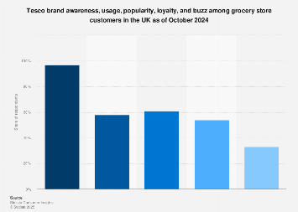
Figure 1: Brand preference of Tesco
Source: (Bashir, 2025)
Tesco has also been seen to share 97% customer preferences across the UK (Bashir, 2025). This aspect indicates that Tesco's managers have effectively exploited the talents of employees while fostering the willingness of the workforce through proper motivation.

Literature gap
In the overall context of this research, a major literature gap is seen as the lack of management-based understanding of true motivational approaches to offer to employees. Almost every organisation has employed basic employee management programmes rather than prioritising individualistic aspects to motivate them. That is why this research aims to cover the area of real-time motivational approaches to enhance the productivity of employees by considering Tesco's example. At the same time, this research work will also foster addressing strategic solutions to strengthen the motivational standpoint of Tesco's managers to create guidance for other businesses as well.

2. Aims, Objectives, and Research Questions

Research Aim
This research aims to evaluate the process by which managers motivate employees to boost productivity, considering the context of Tesco in the UK.

Research Objective
- To explore the different elements of employee motivation that managers of Tesco perceive in the UK.
- To assess the managerial approaches in Tesco that ensure employee motivation to enhance productivity in the UK.
- To identify strategic solutions for Tesco’s managers to consider for improving the motivational landscape for British employees.

Research Question
- What are the aspects of employee motivation that managers of Tesco have already perceived to enhance productivity across the UK, and which further considerations are required for improvement?

3. Discussion of Key Literature Linked to the Research Question

Theoretical framework
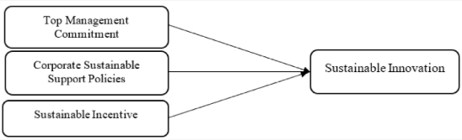
Figure 2: Concepts of Contingency theory
Source: (Yusuf et al., 2023)
According to Abedin (2022), contingency theory suggests that there is always room for considering different aspects to foster improvement in expenditure, based on situational needs. This theory prioritises analysis of a situation to pursue adaptability of proper leadership as well. That is why effective managers are seen to prioritise the motivation of employees to sustain situational needs in organisations. As for a different perception, Mahmud et al. (2021) stated that contingency theory is effective for addressing environmental pressure to handle performance in organisations. Generally, managers are bound to acknowledge competitive pressure while understanding the importance of improving employees' productivity. That is why, in certain cases, addressing the contingency leads managers to share the motivational path for employees.
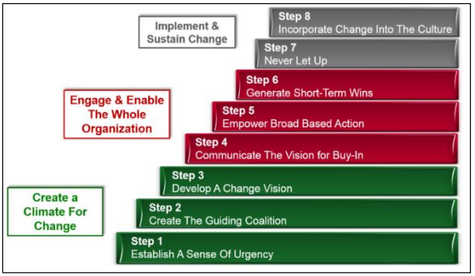
Figure 3: Kotter’s change management model
Source: (Laig and Abocejo, 2021)
According to Laig and Abocejo (2021), Kotter’s change management model effectively represents change based on an anchored and sustainable process. This framework has prepared 8 different stages, such as establishing the urgency, guiding creation, changing vision, communicating vision, empowering milestones, and others. This way, managers get to gain the proper knowledge regarding the current state of the business and future progress. That is why this framework has been adequate for managers to address the elements of setting vision for motivating employees, even to gain short-term wins at a time.

Motivational theories and their relevance to the workplace
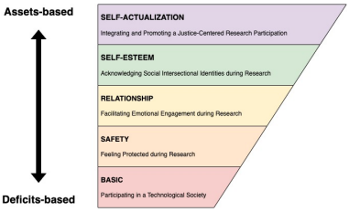
Figure 4: Maslow’s Hierarchy of Needs
Source: (Anuyah et al., 2023)
According to Anuyah et al. (2023), Maslow's hierarchy of needs theory demonstrates motivation of individuals through need-based satisfaction. In the organisational culture, employees tend to seek basic needs, such as job security, talent recognition, wages and others to eventually accomplish their psychological needs of safety and food. On the other hand, Ibrahim et al. (2023) demonstrated that Herzberg's two-factor theory indicates two major elements for employee motivation, such as motivators and hygiene. Employees' hygiene generally refers to motivation in the workplace, which is simply derived from recognition and job advancement. As for motivators, the salary structure and rewards play a part, although in both cases, managers have a direct role in sustaining the provision of the motivation.

Support of literature

Elements of employee motivation
As opined by Kapur (2022), reward management has been considered an indispensable factor to motivate employees regarding the allocated job role. Rewards encourage employees by making them feel that their efforts are being recognised and valued by the managers. This way, employees get the motivation to continue offering better productivity to get better rewards. Unilever has been one of the prime examples of offering market-competitive rewards to foster a performance culture. On the other hand, Abdalla et al. (2024) stated that over qualification of employees generates a greater range of skills and knowledge to trigger mismatched employee credentials. That is why managers often employ cross-cultural communication to balance the skill-based diversity and manage skilfulness to motivate the less skilled ones.

Approaches to motivate employees
According to Bakker et al. (2023), transformational behaviours are effective for leaders in organisations to follow the strengths of individuals to stimulate different initiatives. That is why managers often tend to adopt transformational values or acknowledge both the strengths and weaknesses of employees to shape the motivational practices. ASDA has been seen to employ transformational values in management to train colleagues, which is an investment to equally stimulate the strengths of employees to motivate them. On the other hand, Shafaei and Nejati (2024) stated that inclusiveness indicates the acquisition of a better employee experience. Therefore, often managers prioritise incivility in a work setting to equally share opportunities with talents, which motivates them for a long period.

Strategies to improve motivational provision
Haddad et al. (2023) stated that, in a highly competitive work environment, a flexible work structure has been effective for establishing the relevance of work culture, with proper motivation. Through a flexible work structure, organisations can have the capacity to reflect that the employees' physical and psychological wellnes are valued by the managers and management. It effectively encourages the intrinsic aspect of employees to feel motivated. As for a different perception, Vrontis et al. (2021) stated that emotional intelligence acts as a strategic element for managers to perceive a positive manner to motivate employees, by encouraging their self-awareness. Emotional intelligence can effectively create a bond between managers and employees to rectify personal dissatisfaction and grudges to sustain long-term motivation.

4. Description, Evaluation and Justification of Proposed Methodology and Sampling Technique

Proposed Research method with justification
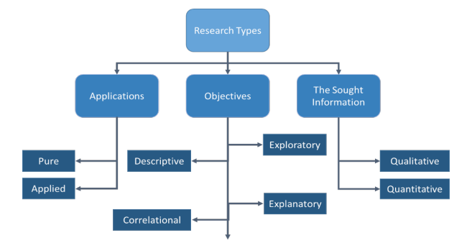
Figure 5: Types of Research
Source: (Taherdoost, 2022)
A quantitative research method will be most effective for this research work. It can be seen that there are different types of research methods, such as qualitative, quantitative and mixed methods. Among these types, quantitative research method purposefully prioritises several numerical values, extracted from effective observation (Taherdoost, 2022). Quantitative research is also seen to incorporate a proper explanation to generate meaning for statements by involving real-world scenarios. In this research context, quantitative research methods will be effective for highlighting the real-world dimension of managerial approaches and practices for motivating employees. At the same time, the numerical value will be appropriate for the research to authentically demonstrate the number of employees who have been motivated by the employed managerial practices and improved productivity. On the other hand, the meaning establishment capacity of the quantitative method will be effective for research to justify the managerial contexts, such as reward management, flexible working hours, loyalty programs and others.
The selection of the quantitative research method will be accomplished through several other methodological choices, such as philosophical standpoint, research approach, design and others. Positivist research philosophy adequately refers to factual knowledge acquisition, based on proper observation (Maretha, 2023). As this research will consider this philosophical standpoint, it will gain the capacity for addressing the facts regarding managers' intentions and application of motivational practices. That is why positivist research philosophy will be selected for this work. Deductive research approach refers to a specific generalisation that delivers an interrelation between variables and different concepts (Casula et al., 2021). Considering this trait, a deductive research approach will be employed to further describe employee retention, employee loyalty, productive performance, reward management, cross-cultural communication, ethical values and others. This research will further consider the exploratory research design and statistical data analysis. Both these tools will shape the path for this research work to incorporate a detailed and adequate way of justifying the existing research variables.

Data collection and rationale
A survey method will be incorporated in this research work to enable better data collection regarding the context. In most cases, it can be seen that a survey strategy encompasses the provision or accessibility of specific answers for the research practitioners (Goodfellow, 2023). In this research work, the survey refers to the potential of accessing answers regarding how the employees have been influenced and motivated by the managers. At the same time, the answers will also be effective for this research work to shed light on specific motivational elements that managers have perceived and worked effectively for the employees in real-time to enhance their productivity.

Sampling technique
Random sampling, which is also known as simple random sampling, will be used to target the necessary survey participants for this research and the underlying survey method. This specific sampling technique refers to an easier and unbiased access to a larger population to eventually accomplish broader purposefulness during a survey (Research Methodology, 2025). Therefore, as this research aims to assess managers' approaches in motivating employees of Tesco, in the UK, this random sampling offers the credibility to address the broader population of Tesco, considering the sampling size of 30. As for purposefulness, this sampling technique will lead this research towards acknowledging cultural and demographic elements in the case of assessing employees’ motivation.

5. Ethical Considerations, Reliability and Validity

Implications of ethical guidelines
As this research work is being suggested to employ a primary quantitative data collection method, informed consent will be the most appropriate for ethical guidance. Generally, consent is considered to be the element for managing the confidentiality of survey participants (HWANG, 2023). That is why, through employing informed consent, the researcher will not just be able to ethically seek participants' permission, but also ensure the right of each individual to have anonymity. Voluntary participation will be mentioned in the consent forms, associated with the right for individuals to leave the process at any point if they feel uncomfortable.

Reliability and validity
An MS Excel analysis reflects the process of ensuring quality control and publishing standards of data based on science, logic and statistics (Field, 2018). This research will employ a statistical analysis using MS Excel, which represents the MS Excel analysis. Therefore, this research will be able to analyse the gathered survey responses based on science and logic to ensure the rationality of the process. I will effectively reflect the nuances of data reliability used in this research. On the other hand, the gathered numerical data sets of the survey responses will be validated through identifying findings of established theories and journals to address the data authenticity, which will prove data validity.

Importance of academic integrity and ethical practices
Academic integrity and ethical principles in research work refer to the management of cultural honesty and ethical behaviours (Mohammadkarimi, 2023). In academic research work, the given statements and justifications are not just to gain marks in university courses, but also to reflect a proper level of learning and share the knowledge for future scholars. Therefore, the more honest explanations and approaches are integrated in academic research, the more it creates value for future readers as well. That is why academic integrity and ethical practices are necessary for students to reflect their sense of honesty throughout the learning process.

Reference list
Taherdoost, H., 2022. What are different research approaches? Comprehensive review of qualitative, quantitative, and mixed method research, their applications, types, and limitations. Journal of Management Science & Engineering Research, 5(1), pp.53-63.
Maretha, C., 2023. Positivism in philosophical studies. Journal of Innovation in Teaching and Instructional Media, 3(3), pp.124-138.
Casula, M., Rangarajan, N. and Shields, P., 2021. The potential of working hypotheses for deductive exploratory research. Quality & Quantity, 55(5), pp.1703-1725.
Goodfellow, L.T., 2023. An overview of survey research. Respiratory Care, 68(9), pp.1309-1313.
Research Methodology, 2025. Simple random sampling - research-methodology, [online] Research. Available at: https://research-methodology.net/sampling-in-primary-data-collection/random-sampling/ [Accessed on: 30 June 2025].
HWANG, H.J., 2023. The importance of anonymity and confidentiality for conducting survey research. Journal of Research and Publication Ethics, 4(1), pp.1-7.
Field, A., 2018. Discovering Statistics Using IBM SPSS Statistics (5th ed.)
Mohammadkarimi, E., 2023. Teachers’ reflections on academic dishonesty in EFL students’ writings in the era of artificial intelligence. Journal of Applied Learning and Teaching, 6(2), pp.105-113.
Uka, A. and Prendi, A., 2021. Motivation as an indicator of performance and productivity from the perspective of employees. Management & Marketing, 16(3), pp.268-285.
Tesco PLC, 2025. About, [online] Tesco PLC. Available at: https://www.tescoplc.com/about [Accessed on: 30 June 2025].
Bashir, U., 2025. Tesco brand profile in the UK 2024, [online] Statista. Available at: https://www.statista.com/forecasts/1335777/tesco-grocery-stores-brand-profile-in-the-uk [Accessed on: 30 June 2025].
Kapur, R., 2022. The significance of reward management in organizations. International Journal of Information, Business and Management, 14(2), pp.83-92.
Abdalla, A.A., Saeed, I. and Khan, J., 2024. Cross Culture Examination of Perceived Overqualification, Psychological Well-Being and Job Search: The Moderating Role of Proactive Behavior. Psychology Research and Behavior Management, pp.553-566.
Bakker, A.B., Hetland, J., Olsen, O.K. and Espevik, R., 2023. Daily transformational leadership: A source of inspiration for follower performance?. European Management Journal, 41(5), pp.700-708.
Shafaei, A. and Nejati, M., 2024. Creating meaningful work for employees: The role of inclusive leadership. Human Resource Development Quarterly, 35(2), pp.189-211.
Haddad, H., El Khatib, N. and Ashaal, A., 2023. The Nexus between Extrinsic Motivation and Employees’ Retention; Do Compensation Packages and Flexible Working Hours Matter?. Open Journal of Business and Management, 11(2), pp.530-551.
Vrontis, D., Chaarani, H.E., Nemar, S.E. and Dib, H., 2021. The relationship between managers' emotional intelligence and employees' performance. Journal for International Business and Entrepreneurship Development, 13(2), pp.177-196.
Yusuf, M.F., Mohamad Nasarudin, N.A.I., Sorooshian, S., Fauzi, M.A. and Kasim, N.M., 2023. Exploring the impact of contingency theory on sustainable innovation in Malaysian manufacturing firms. Sustainability, 15(9), p.7151.
Abedin, B., 2022. Managing the tension between opposing effects of explainability of artificial intelligence: a contingency theory perspective. Internet Research, 32(2), pp.425-453.
Mahmud, M., Soetanto, D. and Jack, S., 2021. A contingency theory perspective of environmental management: Empirical evidence from entrepreneurial firms. Journal of general management, 47(1), pp.3-17.
Laig, R.B.D. and Abocejo, F.T., 2021. Change management process in a mining company: Kotter’s 8-step change model. Journal of Management, Economics, and Industrial Organisation, 5(3), pp.31-50.
Anuyah, O., Badillo-Urquiola, K. and Metoyer, R., 2023. Characterising the technology needs of vulnerable populations for participation in research and design by adopting Maslow's hierarchy of needs. In Proceedings of the 2023 CHI Conference on Human Factors in Computing Systems (pp. 1-20).
Ibrahim, I.W., Ghazali, I.M., Syed, S.A., Abdullah, N.H.R., Hamid, M.H.A. and Aisyah, S.H., 2023. Exploring motivation for learning using Hertzberg's two-factor theory. International Journal of Academic Research in Business and Social Sciences, 13(3), pp.1065-1083.

Appendices

Appendix 1: Research Instrument (to be included in the Appendices)
Q1. What is your age?
- 25-29 years
- 30-39 years
- 40-49 years
Q2. What is your gender?
- Male
- Female
- Others
Q3. For how many years have you been employed at Tesco?
- 2-3 years
- 3-4 years
- 4-5 years
Q4. Are you aware of the concept of employee motivation provided by the organisational management?
- Yes
- No
- Not sure
Q5. Do you think that the managers of Tesco have prioritised the necessity of motivating employees?
- Yes
- No
- Not sure
Q6. What are the elements that Tesco’s managers have perceived to motivate the employees?
- Incentives and rewards
- Cross-cultural environment
- Talent recognition
Q7. Do you think that motivating employees is effective for boosting their productivity level?
- Yes
- No
- Not sure
Q8. How do the managers practically employ motivational approaches?
- Transformational behaviours
- Inclusive communication
- Both of the above
Q9. Do you think that there is still room for Tesco’s managers to improve their motivational activities?
- Yes
- No
- Not sure
Q10. According to your opinion and experience, which strategic path will be appropriate for managerial improvements?
- Emotional intelligence
- Flexible work hours
- Better equality proposition

