Homework sheet
- Quizlet
https://quizlet.com/_b0k2z7?x=1jqt&i=3xchpx

- Sing the song
https://www.youtube.com/watch?v=yOcHapD_xHk

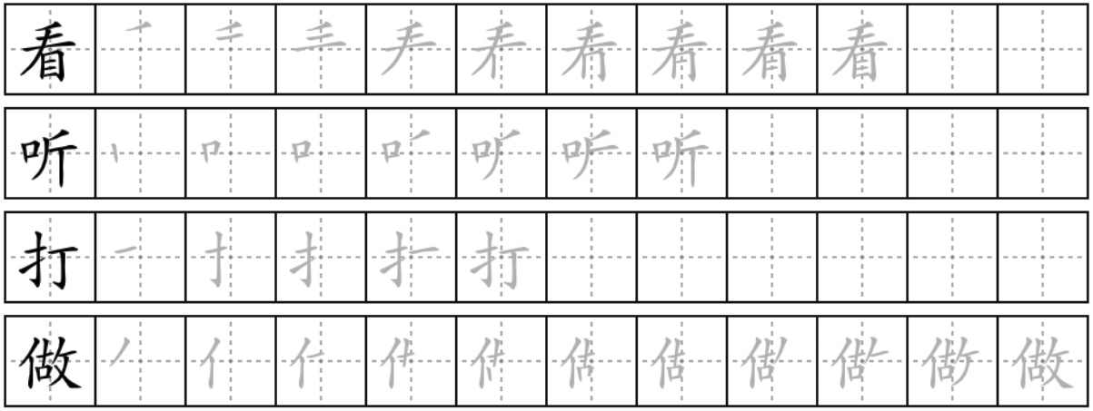
- practise your handwriting
kàn
look at

tīng
listen to

dǎ
play (ball game)

zuò
make (food)

- Fill in the blanket with the correct verb from above.
（ ）电视 diànshì
（ ）乒乓球 pīngpāngqiú
（ ）蛋糕 dàngāo
（ ）橄榄球 ɡǎnlǎnqiú: rugby
（ ）网球 wǎngqiú
（ ）篮球 lánqiú
（ ）饭 fàn
（ ）羽毛球 yǔ máo qiú: badminton
（ ）书 shū
（ ）音乐 yīnyuè
（ ）电影 diànyǐnɡ
（ ）中国菜 zhōngguó cài: Chinese food
（ ）杂志 zházhì: magazine

- Describe people’s like and dislike in Chinese
e.g: Jared xǐhuan dǎ gǎnlǎnqiú，dànshì tā bú xǐhuan zuòfàn 。
Jared 喜欢 打橄榄球，但是 他 不喜欢 做饭。

- Jared


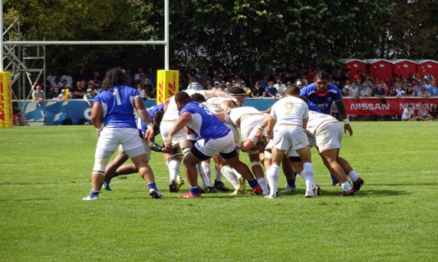
This Photo by Unknown Author is licensed under CC BY-SA


- Hannah
This Photo by Unknown Author is licensed under CC BY-NC-ND
- Dylan

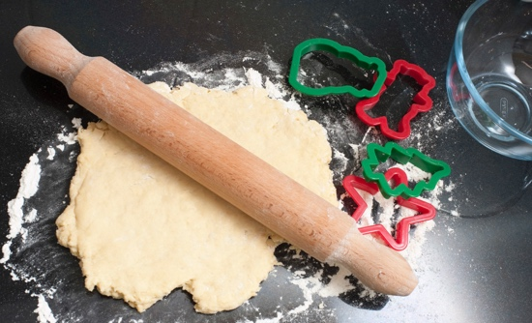
This Photo by Unknown Author is licensed under CC BY

- Extensive reading
for KS2:
https://www.youtube.com/watch?v=1NE2gcZCXwY

for KS3
https://china.usc.edu/evolution-chinas-coffee-industry-0

