LCLM5003 Project Management
A Project portfolio
Part A (Poster), Part B (Reflection) and Part C (Project Management Plan)
Project: Sustainable redesign to meet net-zero transport objectives

Student ID: 2418192
Student name: Aurel-Dumitru Cotoi
Executive summary
The purpose of this portfolio is to develop a project plan for a sustainable redesign to meet net-zero transport objectives in the UK. This project focuses on implementing transport electrification, smart logistic hubs, renewable fuel stations and using biodegradable construction materials. In this portfolio, Gantt chart, WBS and Quad Chart are developed to summarise the project activities, schedule and overview. Moreover, the plans for resource allocation, stakeholder involvement and risk mitigation strategies are also developed to complete this project successfully without any delay.
Abbreviations
WBS: Work breakdown structure
RACI: Responsible, Accountable, Consulted, and Informed
HSWA: Health and Safety at Work etc. Act 1974

Table of contents

Part A: Project proposal poster 7
Introduction 8
Quad Chart 8
Scope and Boundaries 9
Key Stakeholders 9
High-Level Risks and Trade Offs 10
Strategic Value of Project 11
Work Breakdown Structure 12
Gantt chart 12
Project Triangle 13
Conclusion 13
Part B: Reflection on feedback 14
Introduction 14
Key strengths 14
Areas for improvement 14
The way feedback informed changes to the final project management plan 14
Conclusion 15
Part C: Project Management Plan 16
1. Introduction 16
2. Project description 16
3. Scope 17
4. Work breakdown structure (WBS) 17
5. Quad Chart 18
6. Gantt Chart 20
7. Stakeholders' involvement 21
8. Allocation of resources 23
9. Risk Analysis 24
10. Conclusion 26
11. References 27

List of tables
Table 1: Resource allocation 17
Table 2: Risk matrix 18

List of figures
Figure 1: WBS of the Sustainable redesign project 18
Figure 2: Quad Chart 18
Figure 3: Project tasks, schedule and milestones 20
Figure 4: Gantt chart 21
Figure 5: Stakeholder matrix 22
Figure 6: RACI matrix 22

Part A: Project proposal poster
Poster
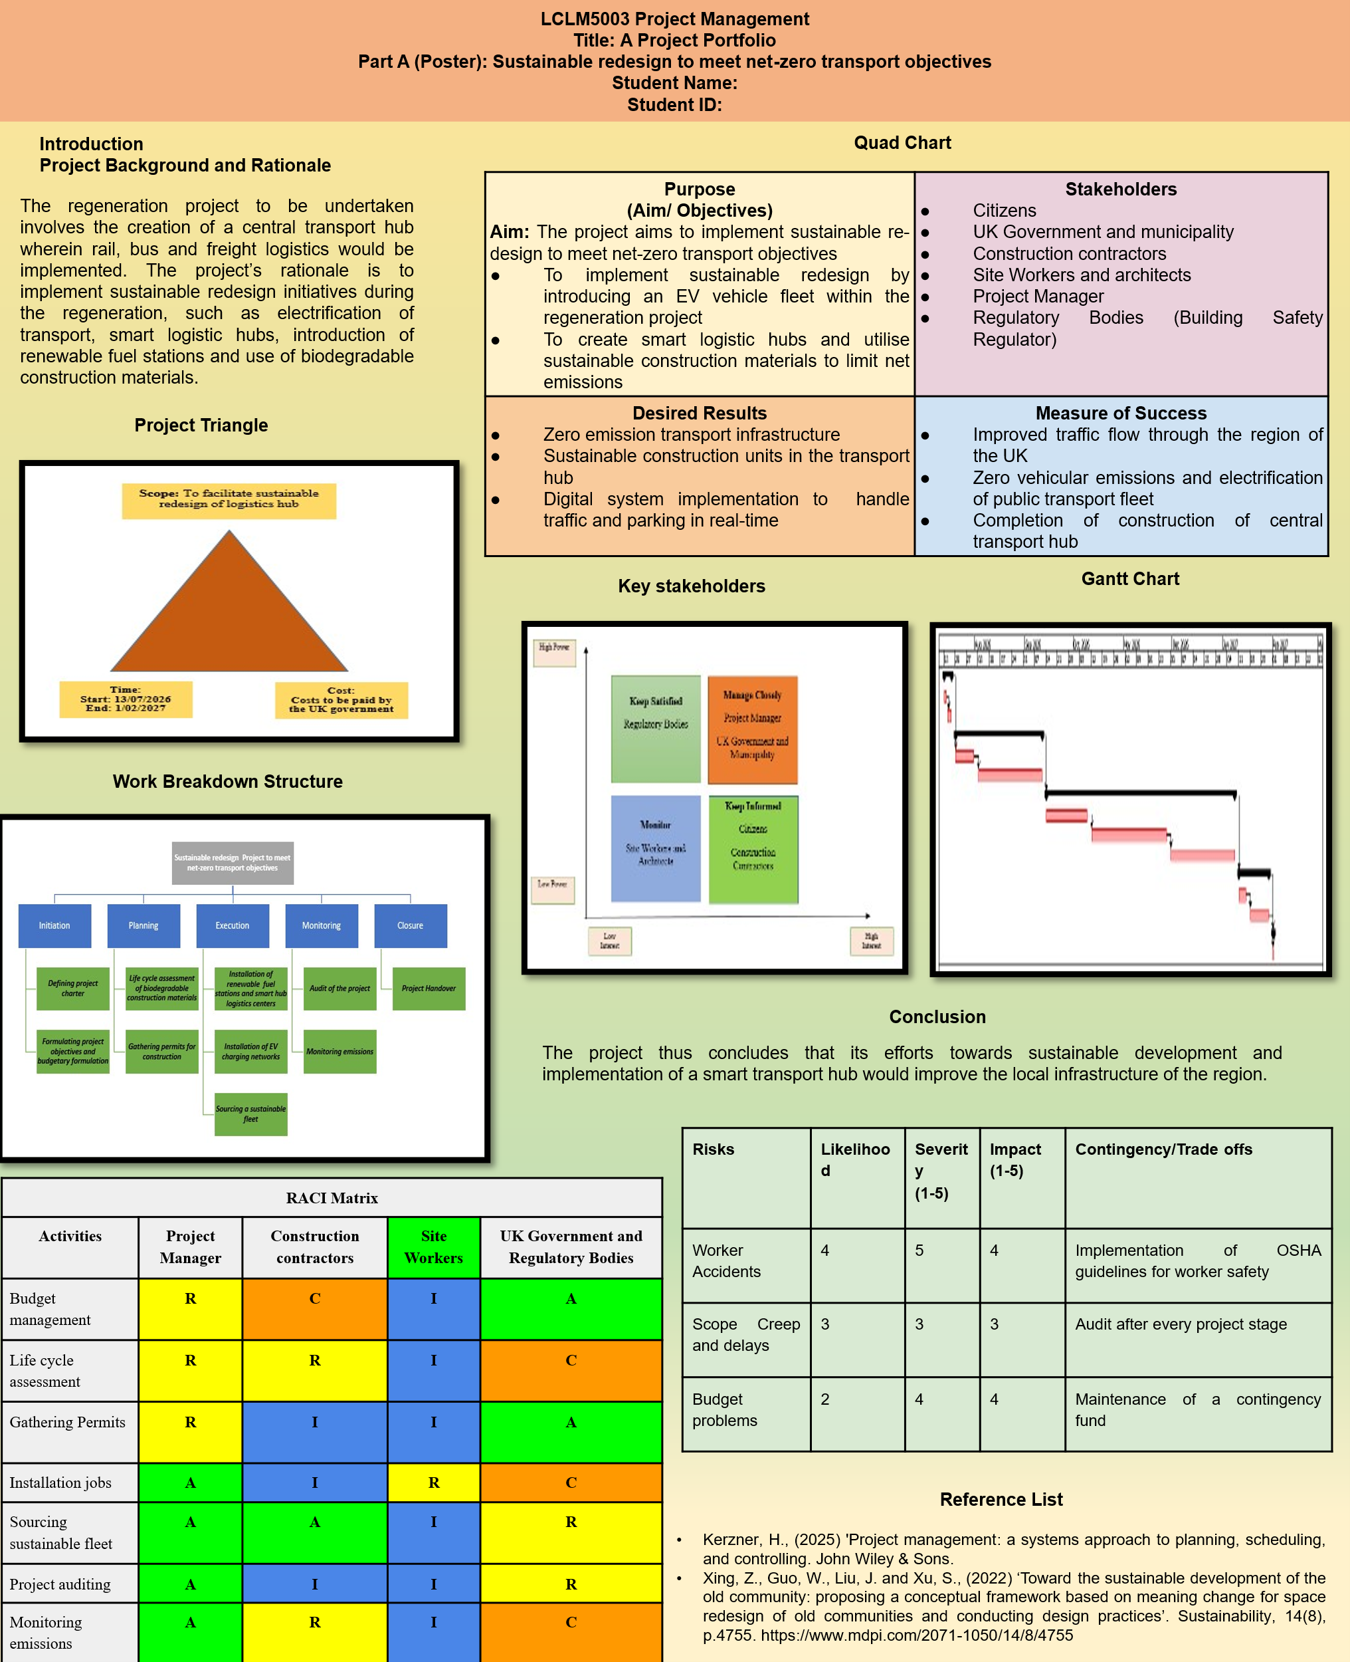

Introduction
Project Background and Rationale
The regeneration project to be undertaken involves the creation of a central transport hub wherein rail, bus, and freight logistics would be implemented. The project’s rationale is to implement sustainable redesign initiatives during the regeneration, such as electrification of transport, smart logistic hubs, and introduction of renewable fuel stations and use of bio-degradable construction materials. As per the views of Xing et al. (2022), sustainable design concepts propose energy saving initiatives and measures to reduce carbon emissions during projects Therefore, the project is aimed to meet net zero transport objectives by implementing EV vehicles and use of sustainable materials to implement circularity in the construction project.

Quad Chart
Purpose  (Aim/ Objectives)  Aim: The project aims to implement sustainable re-design to meet net-zero transport objectives  - To implement sustainable redesign by introducing an EV vehicle fleet within the regeneration project  - To create smart logistic hubs and utilise sustainable construction materials to limit net emissions | Stakeholders  - Citizens  - UK Government and municipality  - Construction contractors  - Site Workers and architects  - Project Manager  - Regulatory Bodies (Building Safety Regulator)
Desired Results  - Zero emission transport infrastructure  - Sustainable construction units in the transport hub  - Digital system implementation to handle traffic and parking in real-time | Measure of Success  - Improved traffic flow through the region of the UK  - Zero vehicular emissions and electrification of public transport fleet  - Completion of construction of central transport hub

Scope and Boundaries
The scope of a project constitutes the cumulative outline of all the work to be carried out and the tasks to be completed within a project (Kerzner, 2025). The scope of the project encompasses the five stages of the project and the tasks dictated within the Gantt chart and work breakdown structure. The geographical boundary of the research would be within the UK and the temporal boundary would be to achieve the project within a time-period of 7 months.

Key Stakeholders
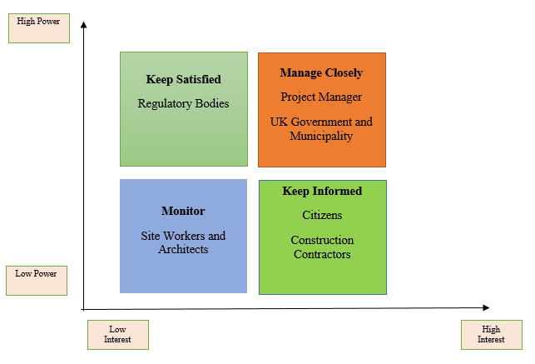

RACI Matrix
Activities | Project Manager | Construction contractors | Site Workers | UK Government and Regulatory Bodies
Budget management | R | C | I | A
Life cycle assessment | R | R | I | C
Gathering Permits | R | I | I | A
Installation jobs | A | I | R | C
Sourcing sustainable fleet | A | A | I | R
Project auditing | A | I | I | R
Monitoring emissions | A | R | I | C

High-Level Risks and Trade Offs
Risks | Likelihood | Severity  (1-5) | Impact (1-5) | Contingency/Trade offs
Worker Accidents | 4 | 5 | 4 | Implementation of OSHA guidelines for worker safety
Scope Creep and delays | 3 | 3 | 3 | Audit after every project stage
Budget problems | 2 | 4 | 4 | Maintenance of a contingency fund

Strategic Value of Project
The strategic value of the project would be the implementation of net zero initiatives into the local transport infrastructure of the UK and facilitating a sustainable fleet within the sustainable redesign project. Furthermore, the project would deliver value by re-creating the central transport hub in a sustainable manner and implement EV vehicles, charging stations and digital technologies to monitor emissions in real time.

Work Breakdown Structure
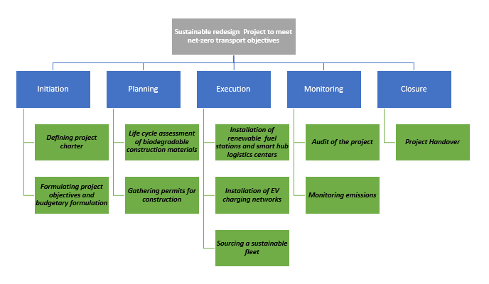

Gantt chart
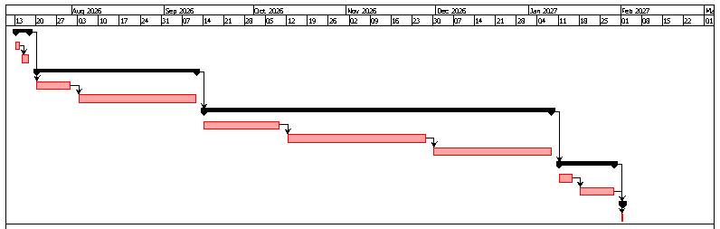

Project Triangle
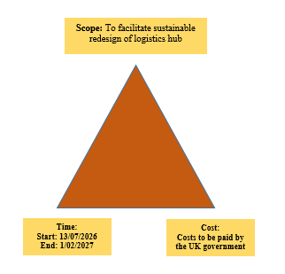

Conclusion
The project thus concludes that its efforts towards sustainable development and implementation of a smart transport hub would improve the local infrastructure of the region. The project contents would ensure that the logistics and public transport network comes a step closer towards sustainability integration and zero emission vehicles are implemented for logistics.

Part B: Reflection on feedback

Introduction
In this part of the project portfolio, I am reflecting on the feedback I have received from my tutor for Part A, poster. It will help me to explain what I did well and what areas need to be improved in the final project plan. Moreover, the changes considered for the final project management plan based on this feedback are also mentioned in this section.

Key strengths
The tutor has not mentioned any negative comments for the style, writing quality, in formation used or structure of the poster. From this point of view, I have realised that writing, poster designing, using authentic and relevant information are the key strengths of this part. Additionally, the methodology used and overall project management plan are appropriate for the final project. It has been noted that a project management plan should clearly indicate the milestones, tasks, timeline, risks and stakeholder management practices (Carboni et al., 2024). Hence, my ability to design the Gantt chart and work breakdown structure (WBS) along with a stakeholder map are also my key strengths. Therefore, I can say that developing a project management plan is one of my key strengths. Moreover, by taking the feedback into consideration, I can note that I have done the research and developed ideas well.

Areas for improvement
The feedback received from the tutor indicates that the poster should not be heavily text-loaded. From this perspective, I have understood that I needed to write less and use more relevant images or graphics to design the poster. For instance, it has also been noted that an academic poster should visually summarise a research or any project management plan (Wisanti et al., 2024). Hence, in the future, I will make improvements in overall poster design. In this context, I will use more relevant images to visually summarise the overall project management plan.

The way feedback informed changes to the final project management plan
The feedback only indicates an issue related to presentation of the project due to the use of more texts rather than visuals. However, there is no feedback for the proposed project management plan. Therefore, by considering the tutor’s feedback, I can say that the overall plan of the project (Sustainable redesign to meet net-zero transport objectives) can be considered to proceed with the final project. Due to this reason, I will not make any changes related to the proposed idea in the final project management plan. In this context, I will explain the overall plan in detail to more clearly present the project plan. However, in the future, in terms of doing any poster presentation, I will keep this feedback in my mind to visually summarise any research or plan clearly.

Conclusion
In the end of this section, I can conclude that I have completed Part A (poster) well in relation to the project management plan. However, by considering the poster design related feedback, I will focus on using more visuals in terms of making any poster in the future. However, based on the overall feedback received from the tutor, I will not make any project management plan related changes in the final project.

Part C: Project Management Plan

1. Introduction
According to the given scenario, a major metropolitan city in the UK has announced an urgent regeneration programme by considering the closure of its central transport hub in November 2025. This part of the assignment aims to develop a project plan for “a sustainable redesign project to meet net-zero transport objectives”. In this context, Gantt chart, Quad chart and work breakdown structure are developed for the proposed project. In addition to that, the involvement of stakeholders and allocation of resources are also explained for this particular project. Moreover, risk analysis is also performed to identify the potential risks and plan for mitigation strategies.

2. Project description
The purpose of this regeneration project is to create a central transport where bus, rail and freight logistics will be implemented in a sustainable manner. In this context, this project focuses on integrating sustainable re-design initiatives such as electric vehicles (EV), smart logistic hubs, and introduction of renewable fuel stations. Additionally, throughout this project, a range of biodegradable construction materials will be used to ensure reduced waste and carbon footprints. According to Morales (2023), sustainable solutions in the construction projects helps to reduce carbon emissions during the project execution practices. Similarly, this proposed project also aims to use only sustainable and green materials and methods in its construction process. From this perspective, it can be justified that this sustainable redesign project will help to the objectives related to net-zero transportation in the UK.
This project primarily aims to redesign an existing transportation hub in the UK, which was developed over 40 years ago. Due to a lack of proper maintenance and reconstruction, this hub no longer meets the modern standards of safety and accessibility. On the other hand, the closure of this hub has also resulted in significant disruption to supply chains, commuter travel as well as local businesses. It has further led to public dissatisfaction and economic losses in the transportation sector. Apart from that, the local authorities are also forced to deliver a coordinated redevelopment project for restoring transport capacity while aligning with environmental targets and digital infrastructure requirements. Hence, by considering all these aspects, a project is planned for redesigning this hub which will ensure net-zero transportation by meeting the modern accessibility, and safety standards. Due to this reason, this proposed project will emphasise the reconstruction of the hub by using biodegradable materials, implementation of EVs, renewable fuel stations and smart logistics systems.

3. Scope
The scope of this project is about developing modern transport infrastructure that will ensure zero emissions. Another scope is the implementation of advanced digital systems for efficient management of traffic and parking in real-time. Moreover, the major scope of this project is about the integration of five project management stages and allocated tasks with the WBS and Gantt chart. Thus, it is expected that this project will be completed and delivered on time by meeting all the specific requirements.

4. Work breakdown structure (WBS)
WBS is one of the most effective project management tools that divide large-scale complex projects into manageable and independent components. It helps to clarify the project scopes, assign team responsibilities, estimate schedule, budget and risks (Hillson, 2024). Due to this reason, a WBS is also developed for this proposed research to visualise the main tasks and subtasks of this project. Figure 1 shows the WBS of this proposed project related to sustainable redesign for net zero transportation. According to this WBS, there are a total of five stages including initiation, planning, execution, monitoring and closure. As per the words by Klikauer (2022), five stages of the project life cycle allows the project team members to structure work, control budgets, and meet milestones from start to finish. Due to this particular reason, these five main activities are considered for the proposed project. Additionally, a range of sub tasks are also designed under each main task. For instance, in the initiation phase, the project charter will be defined along with formulating project objectives and budget. In the second step, life-cycle assessment of the chosen bio-degradable materials are performed and permits for the construction will be obtained. The next phase focuses on project execution which will include installation of renewable fuel solutions and EV charging networks as well as sourcing sustainable fleet. On the basis of this WBS, in the monitoring phase, a detailed project audit will be conducted and emissions will be monitored to determine the project and whether there is any issue or risks. Moreover, in the last stage, the entire project will be completed and then, will be handed over to the authority. In this way, it will be possible to ensure successful project completion in a systematic and collaborative manner.
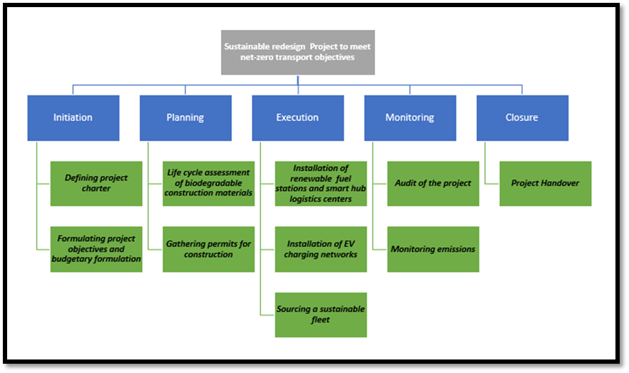

Figure 1: WBS of the Sustainable redesign project

5. Quad Chart
Quad Chart is a single page document, which is divided into four quadrants. In project management practices, Quad Chart is used to provide a visual summary of the project that further enables the project manager and other team members in rapid decision-making and maintaining clear communication (Arabpour and Silvius, 2023). Figure 2 represents the Quad Chart of the chosen sustainable redesign project for net zero transportation in the UK. It indicates the purpose, key stakeholders, desired results and success measures of the project.
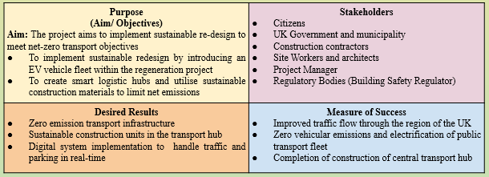

Figure 2: Quad Chart

Project purpose
According to this chart, the aim of this project is to implement sustainable redesigns in terms of meeting the net zero transport objectives. In this context, its first objective is to introduce an EV fleet within the project or the transport hub. Another objective is to develop smart logistics hubs and to use sustainable materials in construction for further limiting emissions.
Desired project outcomes
In line with the above mentioned project aim and objectives, this project is expected to deliver a zero-emission transport infrastructure. Another desired outcome of this project is the development of sustainable construction units in the particular transport hub. Furthermore, this project will also ensure the implementation of smart logistics and digital systems for more efficiently handling parking and traffic.
Project stakeholders
According to the Quad Chart, a number of stakeholders will be involved in different tasks of this project. For instance, construction contractors, project managers, site workers and architects will be the main internal stakeholders of the project. On the other hand, citizens, regulatory bodies such as the “Building Safety Regulator” as well as the UK Government and the municipality will be the key external stakeholders of this proposed project. The collaborative work of these stakeholders will help to obtain the above-mentioned expected project outcomes.
Measure of project success
It is important to measure the success of a project in terms of ensuring that the completed project is able to obtain the desired results by meeting the specific project requirements. In this aspect, as a measure of success, improved traffic flow through the specific UK region will be considered. Additionally, it will also be considered whether the project ensures transport electrification and zero emissions from the vehicles. Moreover, the timely completion of the reconstruction of the transport by meeting all the requirements and sustainable objectives will also be measured to ensure success of this proposed project.

6. Gantt Chart
Gantt chart is used in project management practices to develop and visualise the overall schedule of each task of a project. According to Kerzner (2025), Gantt charts guide the manager as well as other members of a project in clearly understanding the schedule for their allocated tasks and the specific milestones to be achieved. Hence, by taking this importance into consideration, a Gantt chart is also developed for this proposed sustainable redesign project. Figure 4 shows the detailed Gantt chart of this project which indicates the time required for each project task. Additionally, Figure 3 represents the duration, start date, end date, milestones as well as predecessors for each planned project task. Thus, it indicates the dependency between two tasks to be completed within the expected time.
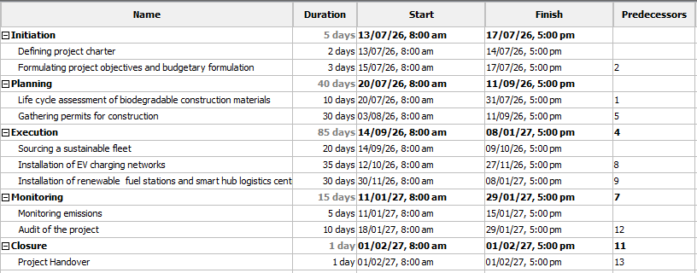

Figure 3: Project tasks, schedule and milestones
According to Figure 4, the project will be initiated on 13 July 2026 and will be completed by 1 February 2027. In this context, the tasks under the planning stage are dependent on the completion of the tasks under the initiation stage. Similarly, this Gantt chart also indicates that in order to achieve a milestone such as monitoring, it is essential to complete the tasks of the previous milestone or stage such as execution. In this way, it will be possible to complete and deliver the complete project based on the planned schedule in the Gantt chart. Moreover, this chart also highlights that execution activities will require more time as compared to other tasks.
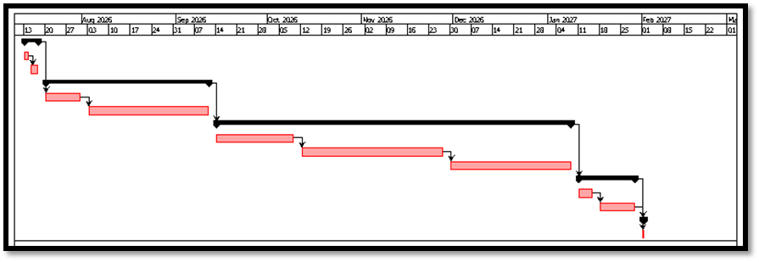

Figure 4: Gantt chart

7. Stakeholders' involvement
In order to complete a large scale project, it is essential to ensure the involvement of a range of stakeholders. It has been stated by Hwabamungu and Shepherd (2024) that stakeholders are the main human resources of a project who perform different tasks based on their expertise area. Figure 5 shows the stakeholder map for this project, which indicates the level of power and interests of each stakeholder in this project. For example, the project manager and the UK government and municipality have a high level of power and interest in this project. The project manager is involved in planning of the entire project with the municipality and the Government of the UK is responsible for indicating the requirements, objectives and standards. On the contrary, architects and site workers have low interest and power in this project, as they are involved only in executing the allocated tasks. On the other hand, regulatory bodies have high power but low interest as they only vindicate the safety, sustainability and construction regulations or standards. Furthermore, the construction contractors and citizens have high interest but low power, as they cannot change the project plan.
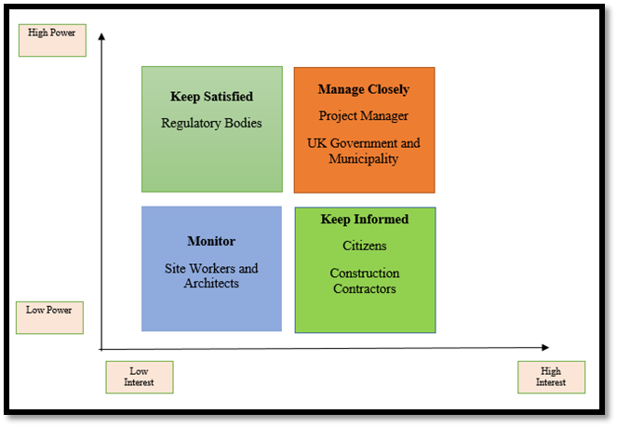

Figure 5: Stakeholder matrix
On the other hand, Figure 6 represents a RACI matrix to indicate the roles and responsibilities of the stakeholders for the planned tasks or expected deliverables. RACI is an effective project management model that mentions which stakeholders are responsible for particular tasks (Ma'arif et al., 2023; Cooke and Williams, 2024). According to the following figure, the project manager will be responsible for budget management, gathering permits and life cycle assessment of the construction materials while accountable for other tasks. On the other hand, the contractors will be consulted for judgement. The site workers will be informed for most of the activities such as auditing, budget, sourcing and life cycle assessment.
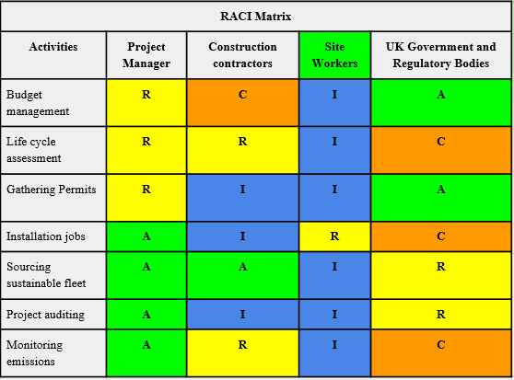

Figure 6: RACI matrix

It is also essential to ensure that the project creates values for the stakeholders. According to the “Stakeholder theory”, a project should focus on creating value for every stakeholder impacted by the project instead of only maximising profit for shareholders (Santos and Fernandes, 2024). Hence, by considering this theoretical aspect, this proposed project aims to provide a sustainable transport hub solution to create values for citizens. Additionally, the internal stakeholders such as construction contractors, site workers and architects will also be provided with remuneration for taking part in this project. Moreover, by meeting the specific net-zero transport objectives, this project will create value for the UK Government and local municipality.

8. Allocation of resources
A range of resources need to be arranged and allocated for completing the tasks planned for this proposed project. The availability of sufficient financial, material as well as human resources are essential to complete a reconstruction project (Shibani et al., 2024). Similarly, this proposed project also requires both financial and material resources along with the involvement of several human resources in order to complete the tasks on time by meeting all the requirements. For instance, policy and design guidelines are required for knowing and meeting the sustainable reconstruction or net-zero objectives. Additionally, it is also essential to allocate a sufficient amount of biodegradable construction materials to redesign the transport hub. Moreover, enough budget or financial investment along with human resources such as managers, site workers and architects also need to be involved in this project. Moreover, it is understood that enough funding is required for completing each project task. Table 1 shows the resource allocation for this project, which indicates the required resources for each project stage.

Project stages | Required resource allocations
Initiation | Project Manager, financial analyst, the UK government and municipality
Planning | Project Manager, policy and design guidelines, LCA (Life Cycle Assessment) software, construction contractors, construction materials
Execution | Fleet acquisition specialists, EVs, smart logistics system integrators, workers, construction materials
Monitoring | Emission tracking tools, project manager.
Closure | Project manager, local authorities

Table 1: Resource allocation

9. Risk Analysis
Risk analysis is one of the most important aspects of project management practices as it helps to identify the probable risks and possible mitigation strategies. Erdenekhuu et al. (2022) have noted that risk management and analysis are the process of identifying, analysing, managing and mitigating possible risks associated with a project. Table 2 shows the risk matrix for this proposed sustainable redesign project. It indicates that there are mainly three potential risks such as workers’ accidents, scope creep or completion delay and budget overrun. According to this matrix, there is a high risk due to a lack of health and safety of the site workers as this project is about reconstructing an old transport hub. However, by implementing “Health and Safety at Work etc. Act 1974 (HSWA)” guidelines, this risk can be mitigated immediately (UK Parliament, 2025). Additionally, this project may be associated with a moderate level of risk related to misalignment with scopes or delay in completion or delivery. Hence, by performing audits after achieving each project milestone, this risk can be efficiently mitigated. Apart from that, due to continuously increasing material and labour costs in the UK, there may also be a low level of budget overturn risk. In this context, by developing and managing contingency budget adequately, this risk can also be mitigated.

Risks | Likelihood  (1-5) | Severity  (1-5) | Impact (1-5) | Mitigation strategies
Worker Accidents | 4 | 5 | 4 | Implementation of “Health and Safety at Work etc. Act 1974 (HSWA)” guidelines for worker safety
Scope misalignment and completion delays | 3 | 3 | 3 | Audit after every project activities
Budget overrun | 2 | 4 | 4 | Maintenance of a contingency fund

Table 2: Risk matrix

10. Conclusion
In the end, a key conclusion can be drawn that the chosen project based on sustainable redesign for meeting net-zero transport objectives will deliver an eco-friendly and digitally advanced transport hub. Through this initiative, this project is expected to improve the overall local infrastructure in terms of overcoming economic loss while benefiting local citizens and business. However, the involvement of the stakeholders such as project manager, site workers, architects and the UK government will help to successfully complete and deliver the project in a collaborative manner. Additionally, the Gantt chart and WBS will guide the stakeholders to complete their allocated tasks within given time. Thus, the successful completion of this project will help to ensure zero emission across the transport hub in this UK region.

11. References
Part A
Kerzner, H., (2025) 'Project management: a systems approach to planning, scheduling, and controlling. John Wiley & Sons.
Xing, Z., Guo, W., Liu, J. and Xu, S., (2022) ‘Toward the sustainable development of the old community: proposing a conceptual framework based on meaning change for space redesign of old communities and conducting design practices’. Sustainability, 14(8), p.4755. https://www.mdpi.com/2071-1050/14/8/4755
Part B
Carboni, J., Duncan, W.R., Gonzalez, M., Pace, M., Smyth, D. and Young, M. (2024) Sustainable project management: The GPM practice guide. GPM Global.
Wisanti, W., Indah, N.K. and Putri, E.K. (2024) ‘Scientific digital poster assignments: strengthen concepts, train creativity, and communication skills’. International Journal of Evaluation and Research in Education (IJERE), 13(2), pp.1035-1044. https://www.academia.edu/download/121758582/41_25909.pdf
Part C
Arabpour, S. and Silvius, G. (2023). ‘Sustainability interventions of construction project managers—Establishing a minimum baseline’. Sustainability, 15(12), p.9795. https://www.mdpi.com/2071-1050/15/12/9795
Cooke, B. and Williams, P. (2024). Construction planning, programming and control. John Wiley & Sons.
Erdenekhuu, N., Kocsi, B. and Máté, D. (2022). ‘A risk-based analysis approach to sustainable construction by environmental impacts’. Energies, 15(18), p.6736. https://www.mdpi.com/1996-1073/15/18/6736
Hillson, D. (2024). Managing risk in projects. Routledge.
Hwabamungu, B. and Shepherd, P. (2024), December. ‘The influence of stakeholder involvement in the adoption of digital technologies in the UK construction industry’. In Informatics (Vol. 11, No. 4, p. 97). MDPI. https://www.mdpi.com/2227-9709/11/4/97
Kerzner, H. (2025). Project management: a systems approach to planning, scheduling, and controlling. John Wiley & Sons.
Klikauer, T., (2022). A global guide to human resource management: managing across stakeholders. Routledge.
Ma'arif, S., Putrianti, F.G., Indraswari, N.M., Nhu, D.Q., Pujianingsih, E.D., Marsinta, A.K. and Ardianti, P. (2023). ‘Stakeholder Management in Developing a Sustainable Tourism Village Based on Renewable Energy Using RACI Matrix’. Journal of Industrial System Engineering and Management, 2(2). https://www.researchgate.net/profile/Syamsul-Maarif/publication/378179949_Stakeholder_Management_in_Developing_a_Sustainable_Tourism_Village_Based_on_Renewable_Energy_Using_RACI_Matrix/links/65cc1c9d790074549783c893/Stakeholder-Management-in-Developing-a-Sustainable-Tourism-Village-Based-on-Renewable-Energy-Using-RACI-Matrix.pdf
Morales, M.A.S. (2023). ‘Modular construction: A sustainable solution for carbon emission reduction in the construction industry’. International Journal of Engineering Applied Sciences and Technology, Vol. 8, Issue 01. https://www.academia.edu/download/104160170/393_401_Tesma0801_IJEAST.pdf
Santos, J.M. and Fernandes, G. (2024). ‘Prioritizing stakeholders in collaborative research and innovation projects toward sustainability’. Project Management Journal, 55(4), pp.423-440. https://journals.sagepub.com/doi/abs/10.1177/87569728241231266
Shibani, A., Hasan, D., Saaifan, J., Sabboubeh, H., Eltaip, M., Saidani, M. and Gherbal, N. (2024). ‘Financial risk management in the construction projects’. Journal of King Saud University-Engineering Sciences, 36(8), pp.552-561. https://doi.org/10.1016/j.jksues.2022.05.001
UK Parliament (2025) Debate on accountability of the construction industry. Available at: https://researchbriefings.files.parliament.uk/documents/CDP-2025-0068/CDP-2025-0068.pdf (Accessed: 10 July 2026)

