

Programme: Certificate of Higher Education Employability Skills

MODULE NAME AND CODE: Digital Skills for Personal and Professional Growth (BMSW4008)
STUDENT NAME: Karolina Kruczynska
STUDENT NUMBER: 2330380
LECTURER: Philippa Fitzgerald
Date: 28/03/2025

Contents
Introduction 3
Task 1 Questionnaire Analysis 4
Task 2 Website and Marketing Materials 7
Task 3 Microsoft Excel 13
Task 4 Storytelling 16
References: 18

Introduction
Market research is crucial to understanding target customers and their preferences (BBC, 2025). This data in turn helps shape the business strategic decisions of the business. This report covers an analysis of a questionnaire prepared to judge consumer interest, knowledge and preferences for eyelash extension service. The analysis reveals trends and areas of potential opportunity a business can take advantage of to capture customers. The findings reveal an untapped market where people are not aware of the service and a growing interest in the service in different age groups. Additionally, the report prepares financial projections of incomes and expenses for a small business over a year, which is then put into a chart for better visualisation of the profits and losses made. The final part discusses the benefits of Microsoft Excel to businesses in improving its operations, automating repetitive tasks, data analysis, and financial analysis among others.

Task 1 Questionnaire Analysis
Market research plays an important role in understanding target customer’s preferences and in refining digital marketing business strategies (Pinto & Guarda, 2020). This analysis focuses on a survey conducted to gauge consumer interest in eyelash extension services. Here are the highlights of the questionnaire, the results and its trends and patterns.
Overview of the Questionnaire
The questionnaire comprised ten questions crafted to provide vital information on the customer like their age and their preferences regarding eyelash extensions. Here is what the questions focused on:
· Consent from customers to collect data
· Previous experience with eyelash extensions
· Interest in trying eyelash extensions
· Age of customer
· Frequency of getting eyelash extensions
· Preferred type of eyelash extensions.
These questions provided data points to be used for an in-depth analysis of consumer behaviour and market potential for eyelash extensions.
Key Findings and Analysis
· The questionnaire indicated that 18% of the respondents had never used eyelash extensions, and 82% had previously availed of the service. This indicates that a small portion of the target audience is unaware of eyelash extensions, offering an opportunity to offer services or educate them. (Sandhu, 2020) Digital businesses can benefit by deploying marketing strategies which focus on promotions and informative content to new customers.
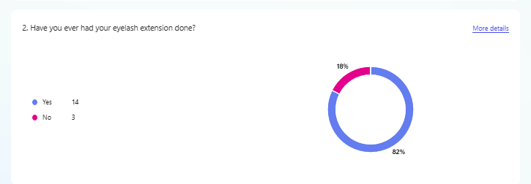
· Most of the questionnaire respondents were in the age group 25-34 years, making for 59%. 6% were 18 to 24 years old, 18% were 35 to 44 years and also 18% were over the age of 45. To target the 59% age group, marketing efforts should focus on social media platforms like Instagram and TikTok, where this demographic is most active (Quesenberry, 2024).
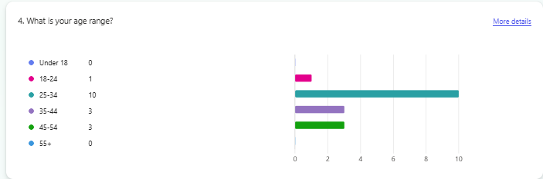
· In the group of people who previously used eyelash extensions, 41% got them three weeks, 18% got them monthly, another 18% got them occasionally, and 24% did not get them regularly. A significant portion of the respondents did not take regular appointments. (Karchin & Horvath, 2023) The opportunity here lies in loyalty and reward programs and discounts on repeat visits for this group.
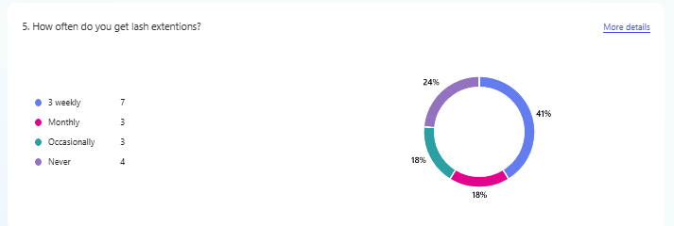

· Respondents who have undergone the service were asked about their preferred type of extension: 39% preferred classic lashes, 22% volume lashes, and 25% chose mega volume lashes. Classic lashes were the popular choice, suggesting that marketing campaigns can be launched to emphasise their benefits (Phillips, 2023). Special packages and deals can also be offered to attract classic lash users to try volume or hybrid lashes.
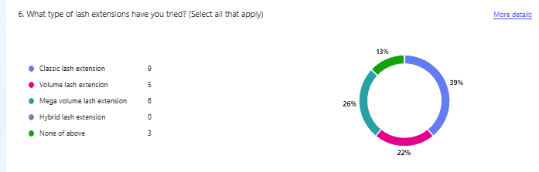
Implications for Business
From the questionnaire analysis, the following strategic recommendations arise, which can be adopted by businesses:
· Since 18% of the respondents have not tried eyelash extensions, they can be targeted by offering first-time discounts and educational content to teach about lash extensions.
· As stated in Dadwal (2019), social media can be leveraged for the marketing efforts of respondents for the age group 25 to 34 years through influencer collaborations, targeted ads and campaigns.
· Per Egan (2022), customers can be encouraged to return through loyalty and reward programs, return discounts and memberships.
· Classic and mega-volume lashes, being the most preferred, should be focused on through promotions and education about benefits.
Task 2 Website and Marketing Materials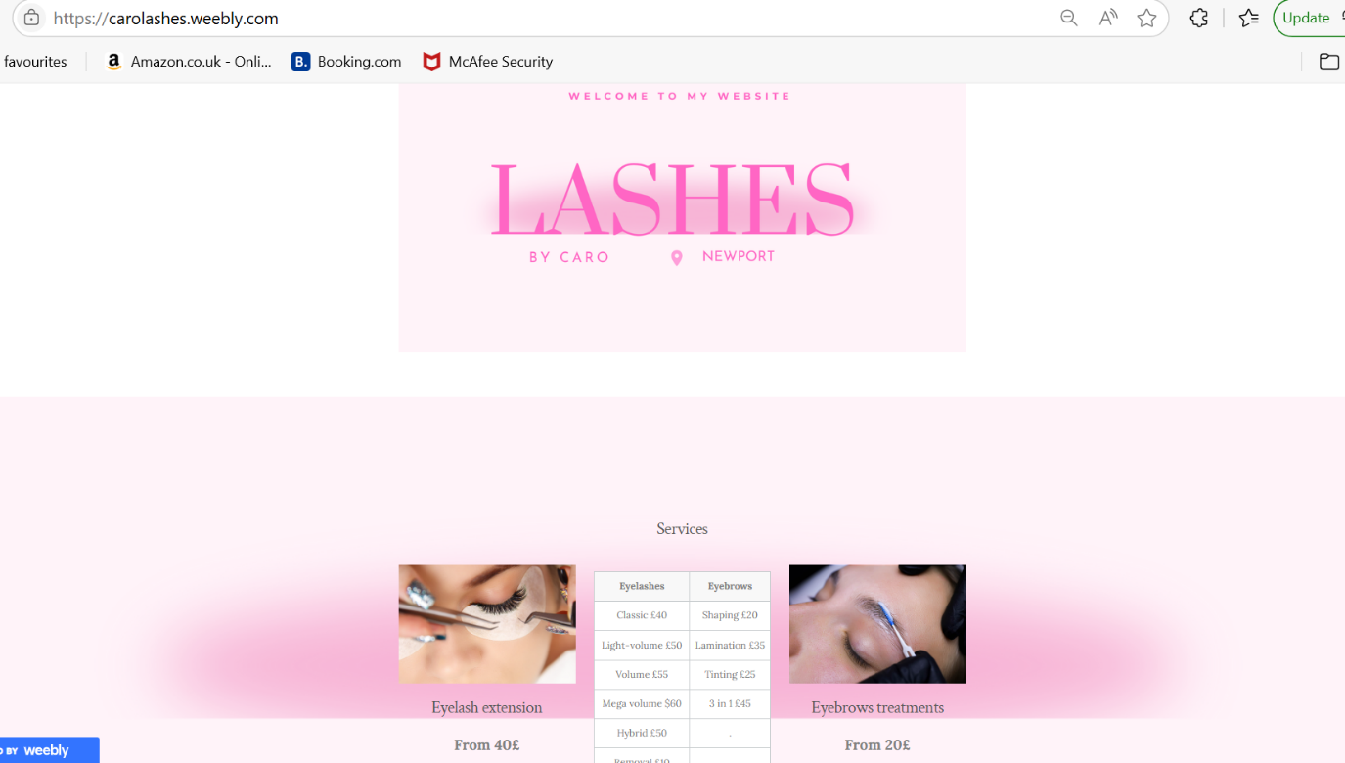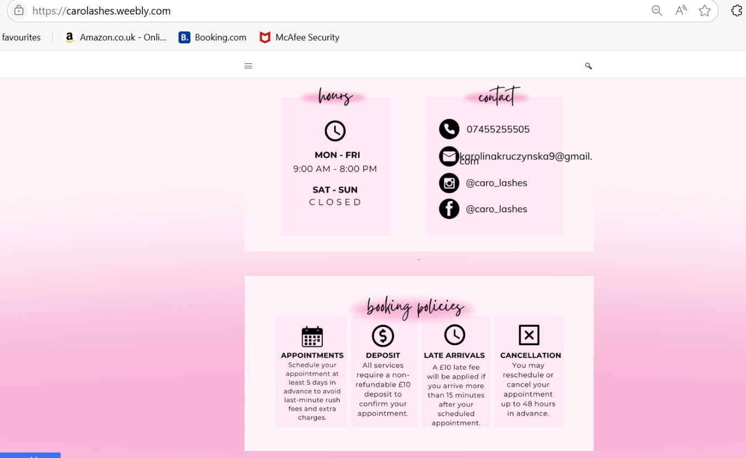
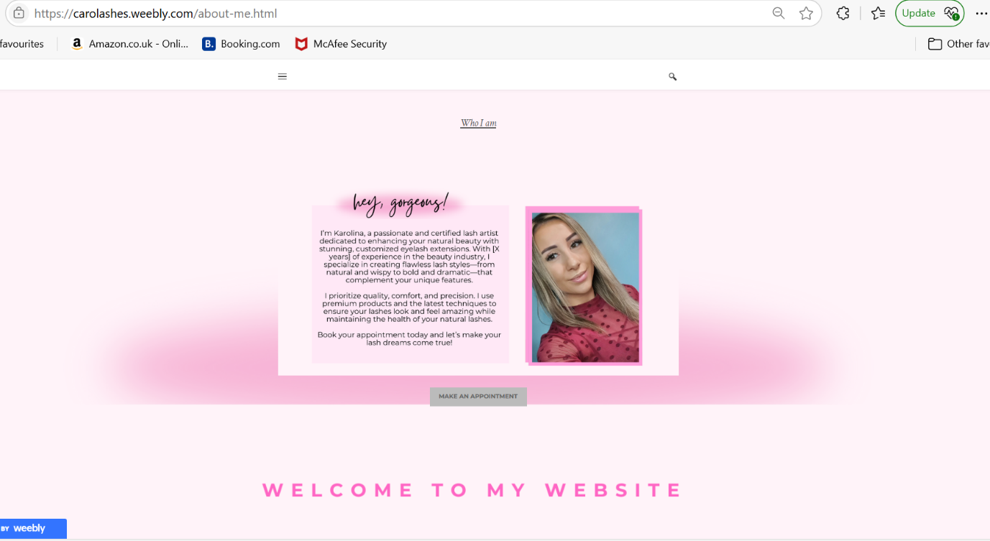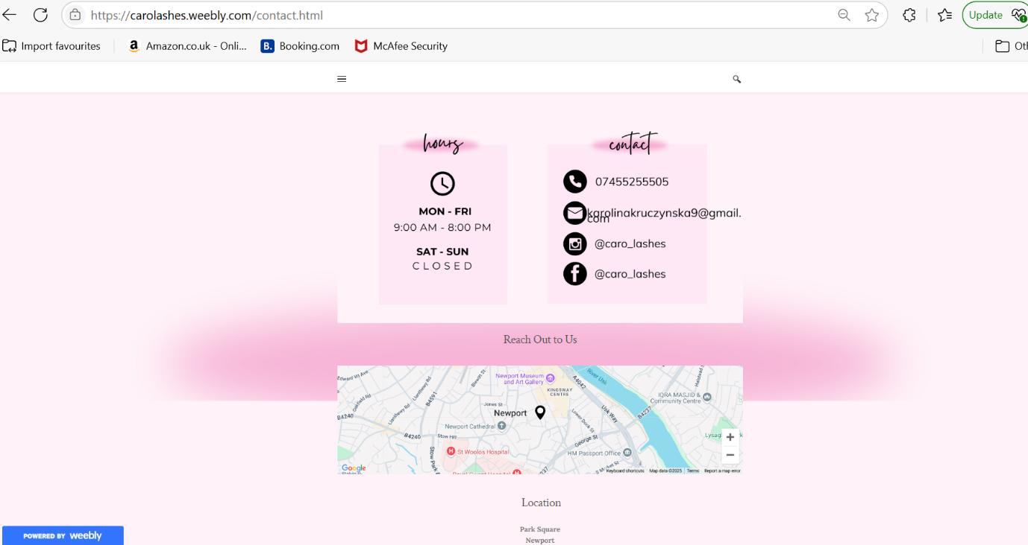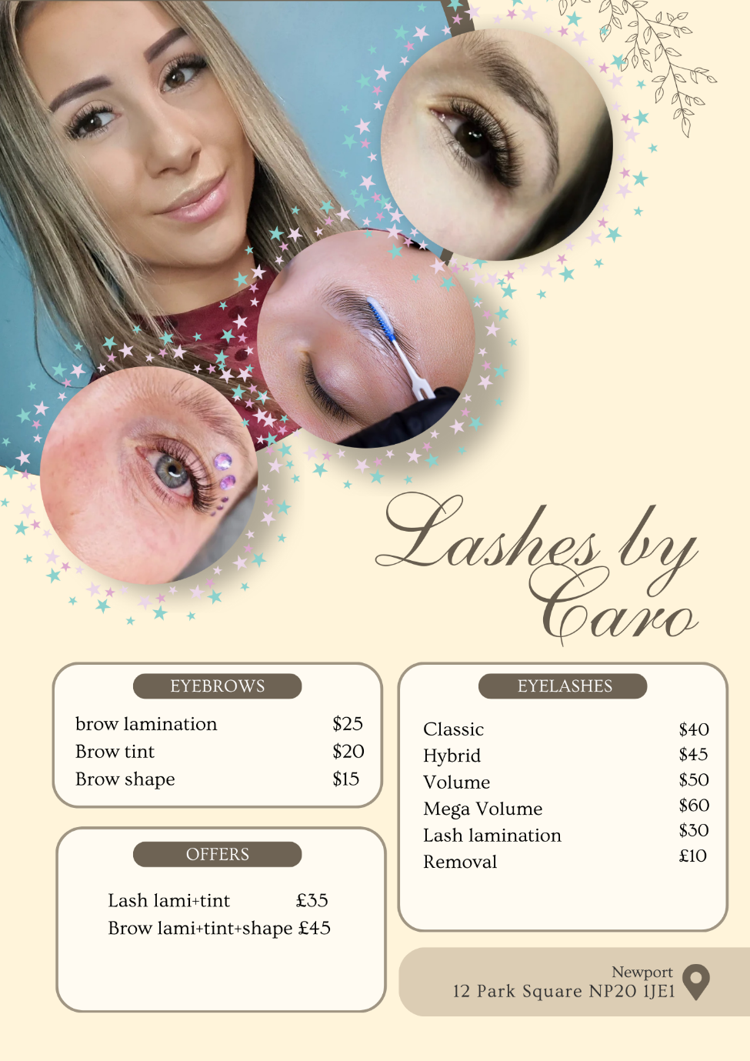(Canva,2025)
Marketing communication plays a pivotal role in creating an ecosystem that reinforces customer experience by adopting innovative marketing strategies. However, in an era wherein the customers are overloaded with information, all marketing efforts should be evolved around the customer’s demand, motivation, and expectations, as it aids in differentiating an organisation from its competitors (Pinto & Guarda, 2020). Thus, findings from questionnaires forms the basis for targeting customers and other marketing efforts. This report summarises marketing and segmentation strategies by Carolashes. It also highlights on search engine optimisation strategies adopted by the organisation to increase organic traffic and website ranking.

Overview on the Design of Website and Marketing Materials
Segmentation and targeting are the pillars that help in designing customised marketing strategies to ensure lifetime value for the organisation (Dadwal, 2020). The data from the questionnaire helped to identify and target customer segments and design those marketing activities to cater to customer preferences and expectations.
Customers Age: Since 59% of the population belongs to the age group 25 to 34 years, the opportunities in social media platforms were tapped effectively to connect with those customers (Marwic, et al., 2018). Strategies like encouraging the customers to tag the organisation in Instagram stories were incorporated into the design of the website. Further, collaborating with influencers to promote the brand was designed effectively. Further, this strategy was also be employed for the age group 35 to 54 years, as they form 18% of the population. This group were also targeted with exclusive discounts and promotions through social media to influence their decisions. Furthermore, to target the customers who are above 18 years of age, an attractive website was designed that emphasised benefits and eyelash care to leave an impact in the minds of potential customers. Additionally, the inclusion of ‘frequently asked questions’ would help to create a positive impact on potential customers.
Customer Experience: The survey uncovered that 18% of the respondents had never tried eyelash extensions or eyebrow treatments. Hence, promotions through social media were prioritised to educate the inexperienced customers, as it engages the customers effectively (Sandhu, 2020). As such, the website was designed with informative content to foster the assurance of the potential customers to try eyelash extensions and eyebrow treatments. Further, to attract the attention of both new and experienced customers to the brand, promotional discounts and loyalty programs were introduced and promoted via social media platforms. Additionally, trial services were also offered to customers who were interested in trying out eyelash extensions.
Customer Behaviour: This segmentation helped to design the website and marketing materials based on the frequency of the services availed from eyelash centres. The survey indicated the scope for designing attractive loyalty and reward programs, as part of the respondents were not keen on visiting the eyelash centre regularly. Hence, to attract new customers and retain the existing customers, campaigns and discounts were promoted through different social media platforms (Göcke, et al., 2021). Further, to establish a personal connection with customers, an appointment reminder would be sent to the customers to encourage them to book follow up sessions or try out other extensions.
Customer Preferences: The survey indicated that the customers preferred classic lashes as compared to other extension styles. Hence, marketing materials were prepared with an emphasis on the benefits of classic lashes to reach the potential customers. Additionally, opportunities in social media platforms were tapped for educating and informing the customers (Byrd, 2021). As such, campaigns were organised to inform the benefits of different extension styles to help the customers in choosing the right extension befitting them.
SEO: Optimising Website and Marketing Materials for Search Engines
Search Engine Optimisation is a marketing tactic that is aimed at increasing the visibility and credibility of the brand. Optimisation helps to enhance organic traffic as well as the ranking of the website (Das, 2021). The questionnaire has provided insight into the preferences of the customers which has helped in developing SEO strategies to enhance organic traffic and ranking.
Keywords and Content: Keywords form the basis for SEO marketing. Placing the right keywords or phrases in website content enhances the credibility and visibility of the brand (Veglis & Giomelakis, 2021). The content on the website was optimised concerning the preferences of the customers. Keywords like eyelash extensions, affordable, volume extensions, care for eyelash extensions, and brow treatments were included on the website. To make it more optimised, long-tail keywords in the form of frequently asked questions, booking policies, and information about treatments were included on the website.
Local SEO to boost the visibility of the brand: Local SEO is a strategy that aids in enhancing the visibility of the brand. It also enhances the trust and credibility of the brand, resulting in more customers visiting the store (Cutler, 2023). Since the brand has a physical presence, the strategies of local SEO were adopted by Carolashes to improve the visibility of the brand in the local area by encouraging the customers to provide testimonials and reviews to raise the ranking of the brand. Further, the business information is updated in Google Business Profile to enhance the ranking locally.
On-page optimisation: It involves the integration of different elements like titles, subtitles, descriptions, images, and content in an attractive manner on the webpage to optimise the search (Clark & Clark, 2024). The design of the web page of Carolashes ensured that all the relevant keywords in connection with eyelash extensions and eyebrow treatments were included for ease of understanding and content ranking by the search engines.
Social Media Integration: A strong presence in social media can increase the traffic to the website (Singh, et al., 2022). As such, promotions and campaigns through social media like Instagram and Facebook have been planned effectively by Carolashes. Instagram stories and collaboration with influencers are aimed at reaching the brand to the masses to enhance the brand’s exposure.
Mobile Optimisation: Since the prevalence of mobile browsing has increased, the organisation must create mobile-friendly websites. The website of Carolashes has been designed to ensure user-friendliness and ease of navigation.
SEO Audit: Regular monitoring of the performance of the website and providing proper training concerning the digital platforms for the employees has become the need of the hour (Parker & Reedy, 2017). Hence, the employees are given proper training to monitor Google Analytics as it provides valuable insight into website traffic, ranking, and customer behaviour.

Task 3 Microsoft Excel

Financial Projections of Business

Table 1: Source: Prepared by student (2025)
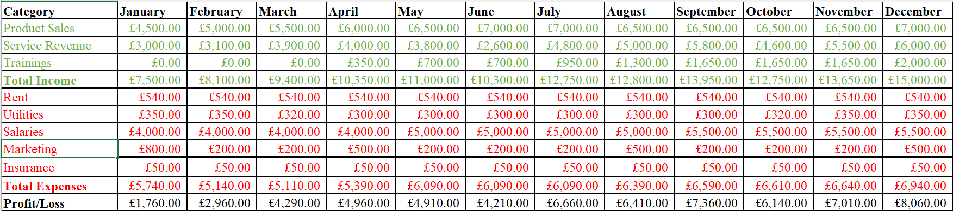
Chart 1: Source: Prepared by student (2025)
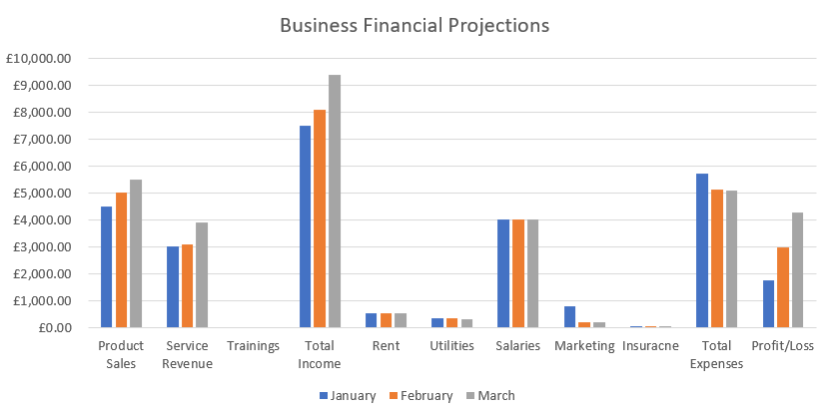

Importance of Microsoft Excel in a Digital Era
Microsoft Excel has established itself to be a powerful and indispensable tool in today’s digital offerings. It is widely used across industries for strategising, data analysis, financial management and decision-making (Wilson, 2018). The software’s versatility allows users to manipulate large sets of data, create charts and reports and visualise information for functions like marketing. Here is a summary of the importance of Microsoft Excel today:
Business Tool: Excel serves as a fundamental tool for businesses, helping structure and analyse data effectively. It is a staple in tracking key performance indicators, automating tasks, budgeting and forecasting (Byrd, 2021). Business can track their sales, make plans, and use analysed data to make informed decisions about consumer trends and inventory management. A major advantage of using Excel in business processes is that it promotes transparency in businesses, to be honest, and allows the business to scale as its operations double and there is more data being generated.
Financial Planning and Analysis: Finance professionals rely heavily on Microsoft Excel to perform their duties. It is a mainstay for budgeting, creating financial models, performing complex calculations and more (Oluwa, 2022). For businesses, Excel can help in deciding where to invest their money into or make major purchases like purchasing new equipment or expand business. Financial professionals and accountants can use the software to track expenses and incoming money to understand if the business is profitable and adjust accordingly.
Data Management: The procedure of saving, copying, and transferring various tool versions is made much easier using Excel files (Berardi, 2002). It allows users to store customer records, sales data and competitor information for analysis. Gathered data can be organised, cleaned and worked on to allow businesses to visualise large sets of data. The multipurpose tool can also access databases and has cloud storage enabling seamless data sharing across businesses.
Education and Research: Excel is not just a software benefiting businesses, it can help with education and research in universities and students completing studies. The platform’s strong functionality and visualisation tools can help academics, researchers, and students complete a wide range of tasks, from managing references, analysing statistical data, to processing data from experiments, there is a lot of Excel can do. Several universities and online education platforms have also integrated Excel into courses in subjects like science, economics, business and engineering.
Automation: With the large amounts of data businesses produce, manual processing has become hard and impossible without errors. Automating repetitive tasks like cleaning of data not only saves time but also improves productivity, and efficiency, while streamlining workflows (Brookfield, 2021). It leaves the management time to focus on other strategic decisions. Skills like macros and VBA have become in demand from new employees as it gives them an edge over others to take advantage of new technologies like AR, VR and AI.
Integration with Other Tools: Microsoft Excel today provides integration with other tools and platforms like Google Sheets, Power BI and CRM software. This is a helpful feature for businesses managing their data across many platforms, allowing better organisation and collaboration with users across the world (Chaffey & Smith, 2022). Communication and reporting become easy on large-scale projects involving many users with Excel’s integration capability. This feature also allows users to pull data from different sources, including social media, enhancing the scope of the analysed information. With the rise in AI-driven analytics, Excel continues to offer new functions that improve its relevance as the leading digital workplace.
In the digital era, Microsoft Excel continues to be an essential and go-to software for data analytics and spreadsheet editing. Its integration abilities, adaptability and computation features like pivot tables give it importance across industries (Jelen, 2021). As industries are moving towards data-driving operations, mastering Microsoft Excel has become a vital skill among professionals.

Task 4 Storytelling
https://youtu.be/Oz9P5rTuhS0?feature=shared


Storytelling has been part of human culture before development of writing (Mihaes, et. al., 2021). Storytelling is a technique for marketing that presents data in a clear an appealing manner to differentiate from competitors and increase consumer involvement (Olejnik, 2021).
This storytelling is a case study video displays a person who presents information truthfully and interacts with the audience. Analysing the storytelling video of the Caro lashes business this recording has a key character by giving the audience a story of transformation, showing struggles and choices. This storytelling aims to emotionally connect with the audience.
- Furthermore, the video shows a person performing the eyelash extension service which makes it more authentic.
- Smooth progression (e.g. introduction, application of eyelashes, aftereffects) maintain the viewer's interest.
- Brand elements such as logo, name in social media strengthen brand recognition.
- Background music adds better quality to the video, viewers will probably watch it to the end, music in the video also drowns out quiet moments.
- The photos added to the video show the key point of this recording.

- The video has a beginning, middle and an end. Narratives can be seamless and captivating when each of these three tale segments is both engaging on its own and complements the others (MasterClass, 2021).

References:
BBC (2025), Market research, Available at: https://www.bbc.co.uk/bitesize/guides/zjx92sg/revision/1 (Accessed: 20 March 2025).
Berardi, A. (2002) ‘ASTROMOD: a computer program integrating vegetation dynamics modelling, environmental modelling and spatial data visualisation in Microsoft Excel’, Environmental modelling & software : with environment data news, 17(4), pp. 403–412.
Brookfield, C. (2021), Using Microsoft Excel for Social Research, London: SAGE.
Byrd, L. S. (2021). Cultivating Entrepreneurial Changemakers Through Digital Media Education. Hershey: IGI Global.
Canva (2025), Available at: https://www.canva.com/design/DAGiqsDJMYY/FcSdj_9lvGgINvF5H4P7Qw/edit (Accessed: 25 March 2025).
Chaffey, D. & Smith, P, (2022), Digital Marketing Excellence: Planning, Optimizing and Integrating Online Marketing, Abingdon: Tayloy & Francis.
Clark, R. & Clark, R. (2024). Creating An SEO Strategy 101: Learn How to Create An Effective SEO Content, Website and Link-Building Strategy From Scratch. Baltimore, Maryland: Bounce Rank
Cutler, K. (2023). Search Marketing: A Strategic Approach to SEO and SEM. London: Kogan Page.
Dadwal, S. S. (2019), Handbook of Research on Innovations in Technology and Marketing for the Connected Consumer, Pennsylvania: IGI Global.
Dadwal, S. S. (2020), Handbook of Research on Innovations in Technology and Marketing for the Connected Consumer. Hershey: IGI Global.
Das, S. (2021). Search Engine Optimization and Marketing: A Recipe for Success in Digital Marketing. Boca Raton: CRC Press.
Egan, J. (2022). Marketing Communications. London: SAGE.
Göcke, L., Soltanifar, M. & Hughes, M. (2021). Digital Entrepreneurship: Impact on Business and Society. Hamburg: Springer International Publishing.
Jelen, B. (2021),Microsoft Excel Pivot Table Data Crunching (Office 2021 and Microsoft 365), London: Microsoft Press.
Karchin, L. & Horvath, D. (2023), Cosmetics Marketing: Strategy and Innovation in the Beauty Industry, London: Bloomsbury Publishing.
Marwic, A., Burgess, J. & Poell, T. (2018). The SAGE Handbook of Social Media. London: SAGE Publications.
MasterClass (2021), How to Structure a Story: Understanding Narrative Structure, Available at: https://www.masterclass.com/articles/how-to-structure-a-story (Accessed: 25 March 2025)
Mihaes, L.C., Andreescu, R. and Dimitriu, A. (eds) (2021) Handbook of research on contemporary storytelling methods across new media and disciplines. Hershey, Pennsylvania: IGI Global.
Olejnik, I. (2021) ‘Storytelling in business—How to increase customer engagement’, in Sustainable development: Innovations in business. 7th edn, Poland: Poznań University of Economics and Business Press, pp. 125–136.
Oluwa, S. (2022), Hands-On Financial Modeling with Excel for Microsoft 365. Birmingham: Packt Publishing Ltd.
Parker, J. & Reedy, K. (2017). Digital Literacy Unpacked. Chicago: American Library Association.
Phillips, D. M. (2023), Marketing Strategy & Management. London: SAGE.
Pinto, F. M. & Guarda, T. (2020). Digital Marketing Strategies and Models for Competitive Business. Hershey: IGI Global.
Quesenberry, K.A. (2024) Social media strategy marketing, advertising, and public relations in the consumer revolution. 4th edn. Lanham: Rowman & Littlefield Publishers.
Sandhu, K. (2020). Digital Transformation and Innovative Services for Business and Learning. Hershey: IGI Global.
Singh, A., Bansal, R. & Sharma, S. (2022). Big Data: A Road Map for Successful Digital Marketing. Berlin: De Gruyter.
Veglis, A. & Giomelakis, D. (2021). Search Engine Optimization. Basel, Switzerland: MDPI AG.
Wilson, K., Kevin P. (2018) Essential Office 365 : the illustrated guide to using Microsoft Office. Third edition. No place of publication: Elluminet Press.

