

Programme: MSc Public Health and Social Care in Practice

Module code and Title: LCHS7000 Social Epidemiology and Public Health Development

Student Name: Vibhuti Dhanrajgiri Goswami

Student ID: 2526558

Component 2 Analytical Report

Lecturer Name: Muhammad Aliyu

Words: 2700

Submission Date: 19 August 2026

Table of Contents
Task 1: Addressing Gender and Health Inequalities among Women in the United Kingdom 3
1. Introduction 3
2. Contextual Background and Underlying Factors 4
2.1 Three disease or illness rates 4
2.2 Three social issues 6
3. National Response to Reduce Health Inequalities 8
4. Organisation Supporting the Chosen Group 8
5. Conclusion 8
Task 2: Epidemiological Analysis of Dementia among Adults Aged 65 Years and Over in the London Borough of Southwark 9
1. Introduction 9
2. Public Health Measures Using the 3 Ps 10
3. Determinants and Risk Factors 11
4. Epidemiological Studies and Health Needs Assessment 13
5. Surveillance and Monitoring Systems 14
6. Public Health Impact 14
7. Proposed Health Intervention Programme 15
8. Strengths and Weaknesses of the Epidemiological Approach 15
9. Conclusion 15
References 17

Task 1: Addressing Gender and Health Inequalities among Women in the United Kingdom

1. Introduction
Gender health inequalities are the unnecessary and inequitable health outcomes, access to health services and wellbeing of people due to gender-related social, economic and cultural inequalities. This report highlights health inequalities at a gendered level and the disproportionate impact of inequalities affecting women in the United Kingdom, despite progress in the field of gender equality and improved health and care services. Although women tend to live longer than men, they often face a greater burden of mental health and chronic illness and have reduced access to health services for these conditions, especially those that are underdiagnosed or undertreated (OECD, 2025).
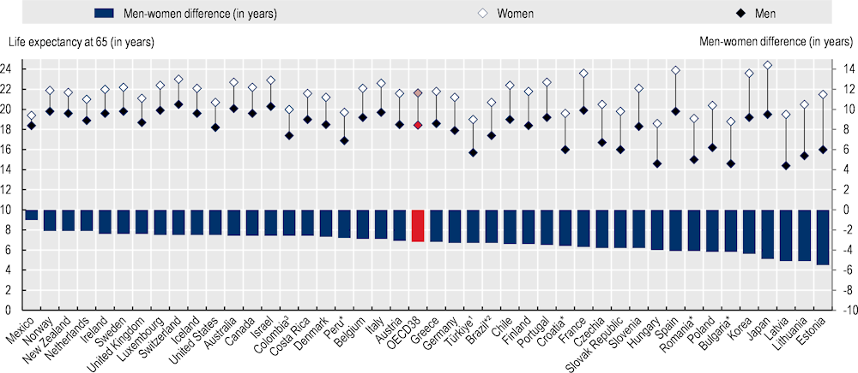
Figure 1: There is five‑fold variation in the life expectancy gap at age 65 between men and women, from about 1 to over 5 years (Life expectancy at age 65, 2023)
(Source: OECD, 2025)
Additionally, factors such as socioeconomic disadvantage, caring responsibilities, domestic violence and inequalities in work conditions have an adverse impact on health and quality of life (Ercoli, 2021). These inequalities are influenced by broader social determinants of health such as income, education, employment, healthcare access, etc. Knowing about these differences is critical to the design of interventions for public health that work to create more equitable access to health care and better health for women throughout their lives.

2. Contextual Background and Underlying Factors

2.1 Three disease or illness rates

Higher Rates of Mental Health Disorders
Mental health is a serious gender inequality in the UK, with women having greater prevalence of mental health disorders than men (Mental Health Foundation, 2022). Women are more likely to suffer from anxiety and depression due to the hormonal fluctuations, the role of caregiver, pressures in the workplace and violence against women (Granata et al., 2026). Furthermore, young women also experience greater psychological distress than young men. The negative impacts of poor mental health include on employment, relationships and overall quality of life. Addressing these inequities will be achieved by expanding timely access to psychological support, enhancing perinatal mental health services and expanding interventions in the community.

Breast and Cervical Cancer Inequalities
Breast cancer and cervical cancer are significant diseases in women in the UK. The national screening programmes have helped to improve rates of early detection, but there are also inequalities in uptake of screening among women from deprived areas and some ethnic minority groups, where uptake is lower (Bolarinwa and Holt, 2023).
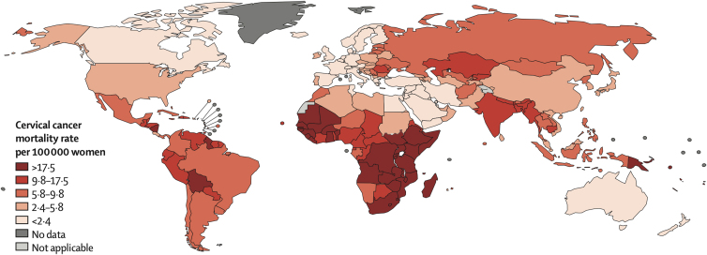
Figure 2: Global map of the age-standardized (world) mortality rates of cervical cancer in 2012
(Source: Ercoli, 2021)
Factors such as no knowledge about the disease, cultural attitudes and challenges accessing healthcare services play a part in late diagnosis and poor outcomes. Raising awareness, making screening services more accessible and delivering culturally relevant health education can help to address inequalities in cancer diagnosis and improve early cancer diagnosis (Kale et al., 2023).
Autoimmune Diseases
Autoimmune diseases such as rheumatoid arthritis and systemic lupus erythematosus are strongly associated with women, as are multiple sclerosis and some other types of neurological conditions (Motta et al., 2025). There are hormone and immune system differences that contribute to the increased occurrence in females.

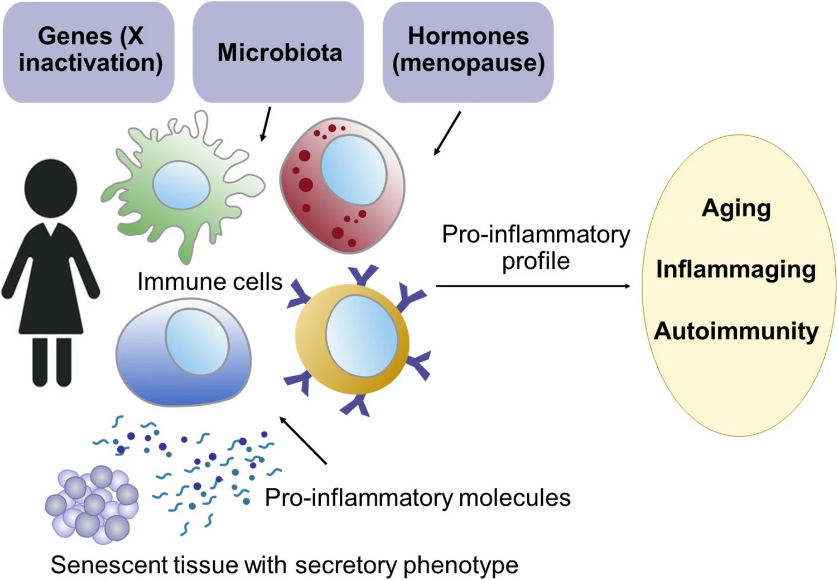
Figure 3: Schematic representation of the pathways potentially involved in the development or worsening of autoimmunity in menopause
(Source: Motta et al., 2025)
Patients may not obtain a diagnosis at an early stage due to various symptoms such as fatigue and chronic pain being underestimated (Harrilal-Maharaj, 2025). These may impact mobility, employment opportunities and mental well-being. Multidisciplinary treatment, better access to specialist services and earlier diagnosis can help to lessen disease progression and enhance quality of life.

2.2 Three social issues
Gender-Based Violence and Domestic Abuse
Gender-based violence is a prevalent public health problem experienced by women disproportionately. The effects of domestic abuse, sexual violence and coercive control are long term and can include physical harm, depression, anxiety, post-traumatic stress disorder (PTSD) and health issues affecting the reproductive system (American Psychiatric Association, 2023). Many women put off seeking treatment due to factors of fear, stigma, or economic reliance which compounds poor health. These health inequalities must be addressed through better protection for children, better identification of children at risk in routine health care and better provision of specialist services.
Gender Pay Gap and Economic Inequality
Women continue to suffer from inequality in the economy and its impact on their health and wellbeing. Women are more likely to work part-time, to be paid less than men and to take a break from work due to childcare and unpaid caring duties (OECD, 2025).
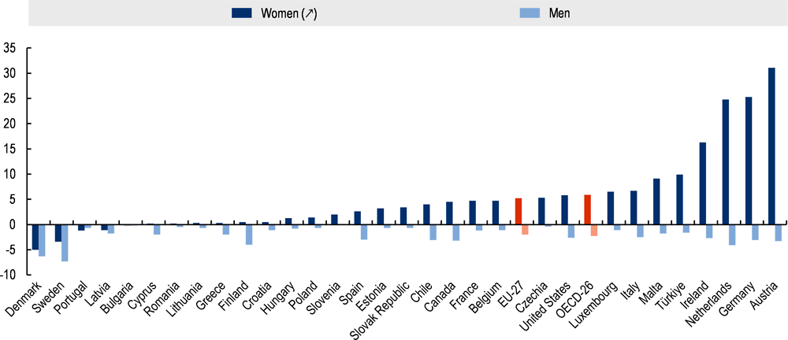
Figure 4: Women tend to work part-time more than men, with parenthood driving larger gaps
(Source: OECD, 2025)
Reduced income may restrict access to healthy food, safe living areas, and health-promoting activities, place a strain on finances and more. The socioeconomic disadvantages add to poorer physical and mental health. Gender-based health inequalities can be mitigated through policies to advance equality of pay, flexibility in employment, affordable childcare and financial support (Khan et al., 2023).
Unequal Caring Responsibilities
Women still make the majority of the unpaid care for children, older people and relatives with chronic illness or disability. Caring responsibilities benefit families and society but can be stressful, fatiguing, socially isolating and can limit employment opportunities (Mussida and Patimo, 2021).
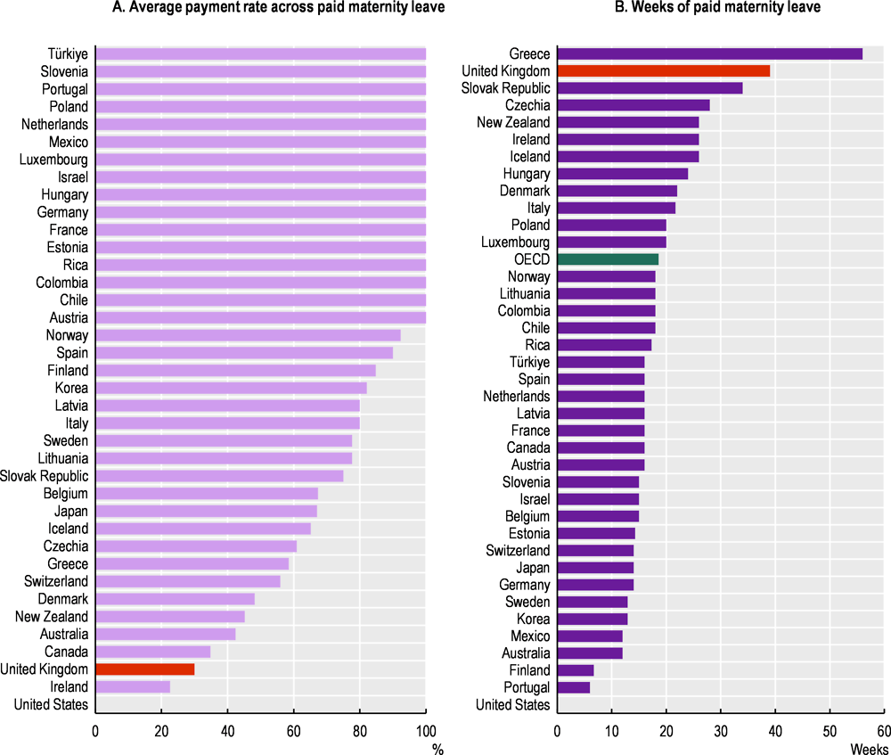
Figure 5: Statutory maternity pay is low in the United Kingdom compared to other OECD countries
(Source: OECD, 2024)
Chronic illness is more likely to develop for many female carers as they tend to put other people’s needs before their own health and neglect their own healthcare. Implementing increased respite care, flexible working hours, career support and accessible healthcare could enhance women's wellbeing and help to alleviate gender inequalities related to unpaid care (OECD, 2024).

3. National Response to Reduce Health Inequalities
There are some programmes in place in the UK Government to help minimise health inequalities between men and women. The Women's Health Strategy for England is designed to close the gender health gap across the entire lifespan, by tackling inequalities in health care, improving research on unique women's health conditions and ensuring personalised health services (Department of Health and Social Care, 2022). The strategy also aims at enhancing the provision of reproductive health, menopause and mental health services. Further, the Domestic Abuse Act 2021 also enhances victims' rights to more protection, better support, greater accountability of perpetrators and acknowledges children as victims of domestic abuse (Cleaver, 2025). These programmes focus on key social and health inequities, such as the availability of health services, early intervention and the care of vulnerable women. However, ongoing investment, public awareness and just implementation is essential for the policies to make a difference in narrowing gender gaps in health outcomes that are persistent.

4. Organisation Supporting the Chosen Group
Women's Health Concern is the patient education charity of the British Menopause Society and aims to promote the health of women by providing education, awareness and evidence-based information. The organisation offers trustworthy guidance on menopause, reproductive health, and chronic diseases, and empowers people to make well-informed choices regarding their health (Mariette, 2025). It also works with health care practitioners to encourage good practice and works for better service and research. The charity helps to tackle health inequalities and enhance the wellbeing of women in the United Kingdom by means of education and awareness campaigns.

5. Conclusion
Women in the UK still face inequalities due to factors such as biological, social and economic conditions. Measures to reduce these inequalities need to be sustained policies, accessible healthcare and targeted public health measures.

Task 2: Epidemiological Analysis of Dementia among Adults Aged 65 Years and Over in the London Borough of Southwark

1. Introduction
Dementia is a condition that involves a gradual deterioration of memory, thinking, behaviour and daily functioning. This is one of the most common causes of disability and dependency among older people globally and is most often caused by Alzheimer's disease (WHO, 2025).
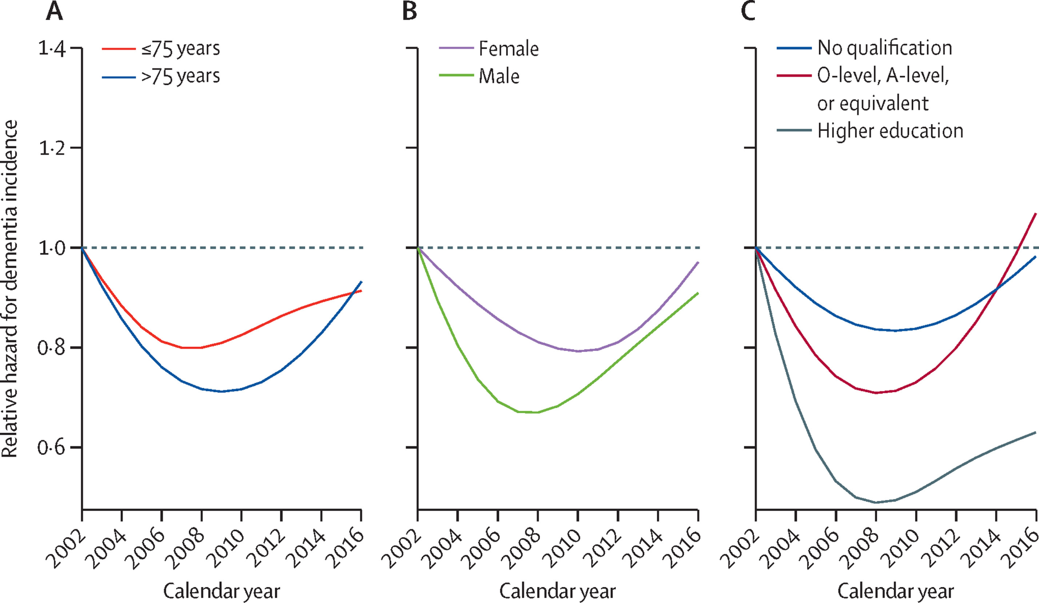
Figure 5: Age-adjusted and sex-adjusted dementia incidence ratio by (A) age, (B) sex, and (C) educational attainment
(Source: Chen et al., 2023)
Hundreds of thousands of people in the UK suffer from dementia, with numbers increasing due to the ageing population (Chen et al., 2023). This report aims to review the epidemiology of dementia amongst adults aged 65 years and over in the London Borough of Southwark, its determinants, its prevention, its surveillance and public health management.

2. Public Health Measures Using the 3 Ps
The public health approach to dementia in Southwark is a prevent, protect and promote strategy to minimise the burden of disease and enhance the quality of life for the population.
Prevention
Prevention seeks to tackle the modifiable risk factors such as smoking, obesity, hypertension, diabetes, physical inactivity and unhealthy diets through health education, NHS Health Checks and healthy ageing programmes (Tsai and Shen, 2022). The goal of these efforts is to prevent dementia through cardiovascular and brain health.
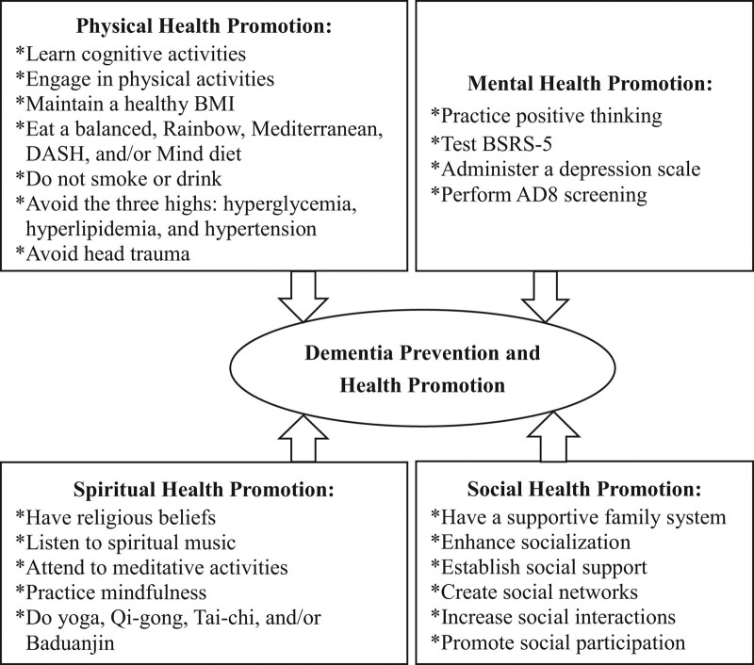
Figure 6: Framework of dementia prevention and health promotion
(Source: Tsai and Shen, 2022)
Protection
Early diagnosis and management of dementia is the basis of protection. Memory Assessment Services, regular GP assessments, timely diagnosis, medication review, falls prevention programme, integrated health and social care services all help in slowing disease progression and enabling people to remain independent (Kim et al., 2026). It protects people from unnecessary complications and hospital admissions by supporting family carers.
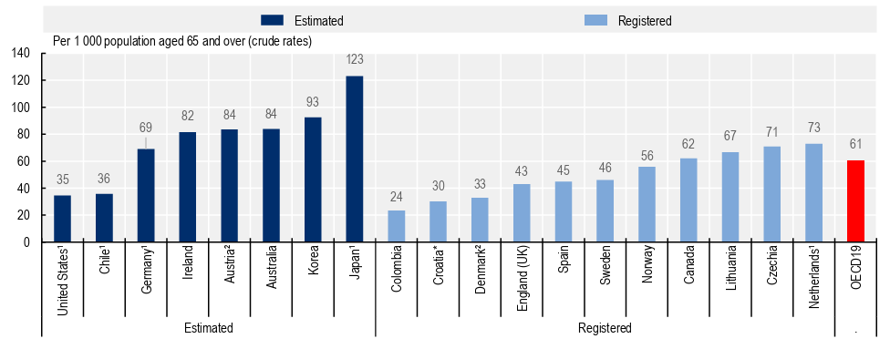Figure 7: Estimated and registered prevalence of dementia across 19 OECD and accession countries, 2023
(Source: Kim et al., 2026)
Promotion
The purpose of promotion is to enhance awareness, minimize stigma and foster community involvement. Educational campaigns at national level (Dementia Friends) and local level and social prescribing help people identify early signs and get help earlier (Pathak et al., 2025). Health promotion activities also promote social participation, cognitive stimulation and healthy lifestyles of older adults.

3. Determinants and Risk Factors
There are non-modifiable and modifiable factors that impact cognitive decline that contribute to the development of dementia. The most important is age as the majority of cases occur in people over 65 years of age. Women have a higher risk of dementia due to their longer lifespans. Family history of dementia and some genetic risk factors linked to Alzheimer’s disease also make it more likely. There are a number of disease modifying risk factors. Problems with the cardiovascular system (blood vessels) such as hypertension, diabetes, obesity and high blood cholesterol can cause damage to the blood vessels and lead to vascular dementia and Alzheimer's disease (Nordestgaard et al., 2022).
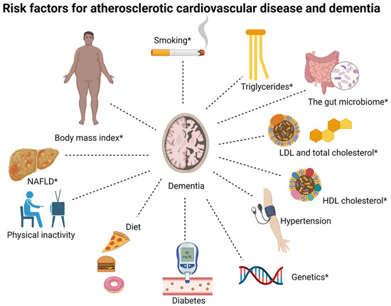
Figure 7: Overview of shared risk factors between dementia and atherosclerotic cardiovascular disease
(Source: Nordestgaard et al., 2022)
Smoking, heavy alcohol use and lack of exercise also exacerbate this risk as they have a detrimental impact on brain health. There are also several other social determinants that are linked to worse cognitive outcomes such as low educational status, deprivation, social isolation, and poor access to health care (CDC, 2024). Other modifiable risk factors associated with cognitive decline have been identified such as depression and listening impairment. Lifestyle changes, early diagnosis and identification, cardiovascular disease prevention and increased access to health care services can help diminish the risk of dementia and promote healthy ageing in the Southwark population.

4. Epidemiological Studies and Health Needs Assessment
Epidemiological studies are an important component in the assessment and planning of public health in Southwark in relation to dementia. Long-term research has indicated that a number of risk factors such as growing older, cardiovascular disease, diabetes and lack of physical activity substantially raise the likelihood of dementia developing over time. The associations between smoking, hearing loss and social isolation and dementia have been identified in case-control studies. Its prevalence estimates and inequalities have been also identified in cross-sectional studies.
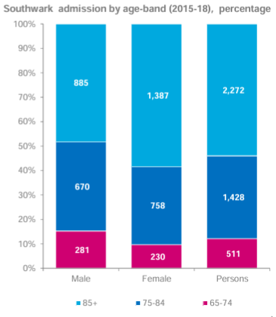
Figure 8: Southwark admission by age-band (2015-18)
(Source: Public et al., 2019)
The Health Needs Assessment (HNA) aims to identify the health needs of a local population based on demographic, epidemiological and healthcare utilisation information. The HNA shows that in Southwark adults over 65 years of age and especially those over 80 years, live alone with multiple long-term conditions as well as residents of deprived communities are more likely to be at risk of dementia. Language barriers, cultural beliefs and limited access to healthcare services can also contribute to a delay in diagnosis among ethnic minority populations. Unmet needs and service gaps are identified using Local Joint Strategic Needs Assessments (JSNAs), GP records and hospital admission data. The results inform commissioners about resource allocation, increasing memory assessment services, caring for older people and targeted prevention programmes to enhance health outcomes and reduce inequalities among older people.

5. Surveillance and Monitoring Systems
A robust monitoring and surveillance system is needed to develop an understanding of dementia incidence, prevalence and progression in Southwark. The NHS Dementia Diagnosis Rate provides a national measure of the percentage of individuals aged 65 years and over who have been formally diagnosed with dementia and is used to measure progress in earlier diagnosis. The Quality and Outcomes Framework (QOF) supports the General Practitioner (GP) dementia registers, which allow for the diagnosis of all patients with dementia and ongoing monitoring of their care and treatment outcomes (Malik and Rattray, 2025).
Further monitoring is carried out using Hospital Episode Statistics (HES) which gathers information on hospital admissions for dementia, and Office for National Statistics (ONS) mortality data, which provides monitoring of deaths and long-term trends. At a local level, the Southwark Joint Strategic Needs Assessment (JSNA) brings together health and demographic information to prioritise areas of high risk and to help determine future service needs (Southwarkstats.com, 2026). Referrals, diagnosis rates and waiting times provided by Memory Assessment Services are also helpful. Combining these surveillance systems allow public health professionals to track trends in disease, detect inequalities, assess the effectiveness of interventions, and facilitate evidence-based planning for dementia prevention, diagnosis, treatment and long-term care in the borough.

6. Public Health Impact
There are short- and long-term effects of dementia on people, families, health services and society. In the immediate term, a person with dementia may have memory loss, confusion, judgement problems and issues with daily functioning, which can make them vulnerable to falls, taking the wrong medicines and admission to emergency wards (National Institute on Aging, 2023). They need more and more health and social care as the disease advances, due to the high level of cognitive loss, communication difficulties and loss of independence. Family carers are also at significant emotional, physical and financial pressure with dementia, which can cause stress and impact on quality of life (Harshavardhan et al., 2025). As dementia becomes more common, the NHS is required to provide more services, residential care and social support from a public health perspective. Early diagnosis and effective management and community-based interventions are thus key to reducing the burden of disease and enhancing outcomes in Southwark.

7. Proposed Health Intervention Programme
A Southwark Community Dementia Prevention and Early Diagnosis Programme is proposed in order to facilitate early diagnosis and healthy ageing in adults over 65 years old. It would include public education messages, screening for cognitive changes as part of routine primary care visits and outreach to targeted communities that are at high risk, such as those with cardiovascular disease and those living in deprived areas. Healthy living, physical activity, quitting smoking, and hypertension and diabetes management seminars would be held to encourage modifiable risk factors for dementia (Bransby et al., 2023). The programme would also enhance the ability of carers to make referrals to Memory Assessment Services and education, counselling and peer support groups.

8. Strengths and Weaknesses of the Epidemiological Approach
Epidemiological approach is useful in informing the understanding of the patterns of dementia, high risk groups and public health policies. It helps healthcare professionals keep track of disease patterns, assess interventions and distribute resources effectively (Goetz, 2024). Population-based data also can assist with early detection strategies and targeted prevention programmes. However, there are some disadvantages to the method. There is incomplete surveillance due to underdiagnosis of dementia, especially in the early stages. Observational studies can have confounding variables and may not always produce causal relationships.

9. Conclusion
Dementia presents a growing public health problem, with a profound impact on older people, carers and healthcare systems. Epidemiological methods play a crucial role in the identification of disease patterns, monitoring of trends, assessment of population needs and evidence-based interventions. Systematic monitoring, early detection, and tailored prevention measures can alleviate disease burden and enhance quality of life in Southwark. Ongoing investment in the health and social care integrated approach, in community awareness and in risk reduction programmes will be a key ingredient in the solution to the increasing burden of dementia in the ageing population.

References
American Psychiatric Association., 2023. Domestic violence. [online] www.psychiatry.org. Available at: https://www.psychiatry.org/patients-families/domestic-violence
Bolarinwa, O.A. and Holt, N., 2023. Barriers to breast and cervical cancer screening uptake among black, Asian, and minority ethnic women in the United Kingdom: Evidence from a mixed-methods systematic review. BMC health services research, [online] 23(1), p.390. https://doi.org/10.1186/s12913-023-09410-x
Bransby, L., Rosenich, E., Maruff, P. and Yen Ying Lim, 2023. How modifiable are modifiable dementia risk factors? A framework for considering the modifiability of dementia risk factors. The Journal of Prevention of Alzheimer’s Disease. https://doi.org/10.14283/jpad.2023.119
CDC., 2024. Non-medical factors that affect alzheimer’s disease and related dementias risk. [online] Alzheimer’s Disease and Dementia. Available at: https://www.cdc.gov/alzheimers-dementia/php/sdoh/index.html
Chen, Y., Bandosz, P., Stoye, G., Liu, Y., Wu, Y., Lobanov-Rostovsky, S., French, E., Kivimaki, M., Livingston, G., Liao, J. and Brunner, E.J., 2023. Dementia incidence trend in England and Wales, 2002–19, and projection for dementia burden to 2040: analysis of data from the English Longitudinal Study of Ageing. The Lancet Public Health, 8(11), pp.e859-e867. https://doi.org/10.1016/S2468-2667(23)00214-1
Cleaver, H., 2025. Domestic abuse and the impact on young children: A UK perspective. Children and Youth Services Review, [online] 172(1), pp.108236–108236. https://doi.org/10.1016/j.childyouth.2025.108236
Department of Health and Social Care., 2022. Women’s health strategy for England. [online] GOV.UK. Available at: https://www.gov.uk/government/publications/womens-health-strategy-for-england/womens-health-strategy-for-england
Ercoli, L., 2021. Health and social inequalities in women living in disadvantaged conditions: A focus on gynecologic and Obstetric Health and intimate partner violence. Health Equity, [online] 5(1), pp.408–413. https://doi.org/10.1089/heq.2020.0133
Goetz, L.. 2024. Role of epidemiology in enhancing healthcare safety about the study. Med Saf Glob Health, [online] 13(2), pp.1000225–1000226. https://www.longdom.org/open-access/role-of-epidemiology-in-enhancing-healthcare-safety-109439.html
Granata, L.G., Giubilato, S., Giuffrida, C., Pavan, D., Mojoli, M., Aspromonte, N., Fumarulo, I., Marchetta, M., Sbrigata, A., Pisano, C. and Francese, G.M., 2026. Anxiety and Depression in Women’s Cardiovascular Health: Risk Modifiers, Mechanisms and Clinical Implications. Journal of Cardiovascular Development and Disease, 13(7), p.301. https://doi.org/10.3390/jcdd13070301
Harrilal-Maharaj, K., 2025. Gender bias and diagnostic delays in young women: a narrative review. Cureus, 17(12). https://doi.org/10.7759/cureus.100004
Harshavardhan, R.L., Rani, P.U., Krishna, P.P. and Sultana, S., 2025. Psychological stress among family members and caregivers of dementia patients: A comprehensive review » the international journal of Indian psychȯlogy. International Journal of Indian Psychology, [online] 13(1). https://ijip.in/articles/dementia-patients/
Kale, S., Hirani, S., Vardhan, S., Mishra, A., Ghode, D.B., Prasad, R. and Wanjari, M., 2023. Addressing cancer disparities through Community Engagement: Lessons and best practices. Cureus, [online] 15(8). https://doi.org/10.7759/cureus.43445
Khan, A., Khan, S., Khan, M.A., Zaman, K., Khan, H.R., Rosman, A.S. Bin, Indrianti, Y. and Hassan, A.A., 2023. Economic costs of gender inequality in health and the labor market: India’s untapped potential. Frontiers in Public Health, 11. https://doi.org/10.3389/fpubh.2023.1067940
Kim, S., Llena-Nozal, A., Milstein, R. and Rauet-Tejeda, J., 2026. Policies for people with dementia across OECD countries. OECD Health Working Papers. https://www.oecd.org/content/dam/oecd/en/publications/reports/2026/01/policies-for-people-with-dementia-across-oecd-countries_5d13347a/e41e6eaa-en.pdf
Malik, F.S. and Rattray, L., 2025. A holistic view: Supporting people with dementia in primary care. InnovAiT: Education and inspiration for general practice. https://doi.org/10.1177/17557380251387650
Mariette, 2025. Our work - women’s health concern. [online] Women’s Health Concern. Available at: https://www.womens-health-concern.org/about-whc/our-work/
Mental Health Foundation., 2022. Men and women: Statistics. [online] Mental Health Foundation. Available at: https://www.mentalhealth.org.uk/explore-mental-health/statistics/men-women-statistics
Motta, F., Di Simone, N. and Selmi, C., 2025. The impact of menopause on autoimmune and rheumatic diseases. Clinical Reviews in Allergy & Immunology, 68(1), p.32. https://doi.org/10.1007/s12016-025-09031-8
Mussida, C. and Patimo, R., 2021. Women’s family care responsibilities, employment and health: A tale of two countries. Journal of Family and Economic Issues, [online] 42(3), pp.489–507. https://doi.org/10.1007/s10834-020-09742-4?urlappend=%3Futm_source%3Dresearchgate.net%26utm_medium%3Darticle
National Institute on Aging., 2023. Memory problems, forgetfulness, and aging. [online] National Institute on Aging. Available at: https://www.nia.nih.gov/health/memory-loss-and-forgetfulness/memory-problems-forgetfulness-and-aging
Nordestgaard, L.T., Christoffersen, M. and Frikke-Schmidt, R., 2022. Shared risk factors between dementia and atherosclerotic cardiovascular disease. International Journal of Molecular Sciences, 23(17), p.9777. https://doi.org/10.3390/ijms23179777
OECD., 2024. Promoting Better Career Mobility for Longer Working Lives in the United Kingdom: Enhancing job quality for healthier, longer working lives. [online] OECD. Available at: https://www.oecd.org/en/publications/promoting-better-career-mobility-for-longer-working-lives-in-the-united-kingdom_2b41ab8e-en/full-report/enhancing-job-quality-for-healthier-longer-working-lives_612d7ceb.html
OECD., 2025. Persistent gender gaps in paid and unpaid work: Gender equality in a changing world. Available at: https://www.oecd.org/en/publications/gender-equality-in-a-changing-world_e808086f-en/full-report/persistent-gender-gaps-in-paid-and-unpaid-work_cb137837.html
OECD., 2025. Which diseases affect men and women differently – and why this matters: Health at a glance 2025.. Available at: https://www.oecd.org/en/publications/2025/11/health-at-a-glance-2025_a894f72e/full-report/which-diseases-affect-men-and-women-differently-and-why-this-matters_c7602de9.html
Pathak, K.P., Montgomery, A., Khanal, M.K., Gaire, T., Adhikari, C., Ranabhat, C.L., Gaire, C.P. and de Olivera, N.C., 2025. Improving knowledge, identification, support, and care for people with dementia: A scoping review of interventions. Gerontology &amp; Geriatrics Education, pp.1–23. https://doi.org/10.1080/02701960.2025.2566855
Public, H., Southwark, H. and Health, P., 2019. Dementia Prevention in Southwark Southwark’s joint strategic needs assessment. [online] Available at: https://www.southwark.gov.uk/sites/default/files/2024-10/Dementia%20Prevention%20JSNA%202019.pdf
Southwarkstats.com., 2026. Southwark | statistical databank. [online] Available at: https://www.southwarkstats.com/?p=jointstrategic
Tsai, F.-J. and Shen, S.-W., 2022. Concepts of dementia prevention in the health promotion among older adults: A narrative review. Medicine, 101(50), p.e32172. https://doi.org/10.1097/MD.0000000000032172
World Health Organization., 2025. Dementia. [online] World Health Organization. Available at: https://www.who.int/news-room/fact-sheets/detail/dementia

