Module Name: Financial Management for Hotel Industry
Module Code: BIHM 5007
Student Name: Saifun Hossain
Student ID: 2016122

Executive Summary:
The aim of this report is to compare the financial statements of the two hotels named Marriott and Hilton hotel. The total revenue of the Marriott hotel for the year 2022 was $19.296 Billion and the total revenue for the Hilton hotel was $5.78 Billion. On the other hand, the market share of the Hilton hotel was around 8% while the market share of the Marriott hotel was around 18%. The brand’s value of the Marriot hotel was lower than the Hilton hotel. The growth potentials of the Marriot hotel include brand expansion, increase the loyal customers Etc. on the other hand, the growth potential of the Hilton hotel include increase the brand presence around 30% more in the European country. After that analysing the report, it has been found that salary or wages costs reason for the higher expenses of Marriott hotel while though the brand value of Hilton is high, it could not generate enough money since lower presence. Therefore, Marriott should focus on outsourcing the employees and Marriott should focus on Market and product development.
Table of Contents
Executive Summary: 2
Introduction: 5
Main body: 5
Marriott Hotel: 5
Total Revenue: 5
Market Position of Marriott Hotel: 6
Growth Potential of Marriot hotel: 7
Brand Expansion: 7
Targeting Midrange customers: 8
Increasing the extended stay Period: 8
Financial commitment to CSR activity: 8
Recommendations: 8
Hilton Hotel: 9
Total Revenue of the Hilton Hotel: 9
Market Position of the Hilton Hotel: 10
The growth potential of the Hilton Hotel: 11
Financial commitment to CSR: 12
Recommendations: 12
Conclusion: 13
References: 14
Appendices: 17
Marriot’s Income Statement 2021: 17

List of figures:
Figure 1: Revenue of the Marriott hotel year by year 4
Figure 2: Operating income profit of Marriot hotel 5
Figure 3: Revenue of the Hilton hotel 7
Figure 4: Change of the revenue year by year 8
Figure 5: 10 most valuable Brands 9
Figure 6: Ansoff Matrix 10

Introduction:
In business, "financial management" refers to assessing how much money a firm needs and directing that money to various uses. It entails using standard techniques of management on the company's financial assets. The term "hospitality financial management" refers to managing and organising a hospitality business's financial aspects, such as a hotel or restaurant (Rob Van Ginneken, 2019). Concerns, including advertising costs, returns, and staff compensation, are common to all organisations. To correctly manage a company's financial assets is the top priority for every hospitality finance manager. When managing finances, it is essential to keep in mind the specifics of the hotel sector. The hospitality sector, for instance, is notably cutthroat, needing advanced levels of efficiency across enterprises to stay afloat. Seasonal economic shifts can also affect the industry's bottom line (Schmidgall and Damitio, 2015). This report will describe the financial issues of the Marriot and Hilton hotel in terms of total revenue, Growth potential, Market Position and financial commitment to CSR. After that, necessary recommendations will be given based on the Potential source of outsourcing and growth for the potential will be described.

Main body:

Marriott Hotel:

Marriott International, Inc. is an American hotel chain, resort, and timeshare franchisor and licensee. Bethesda is in Maryland, USA. J. Willard and Alice Marriott both played important roles in launching the company. There are more than 6,000 guest rooms at Marriott, making it the largest hotel chain in the world. The corporation has 30 brands, 8,000 hotels, and 1,423,044 rooms spread throughout 131 countries and territories. Out of these 8,000 properties, only 2,149 are under Marriott's direct management. The rest 5,493 are franchised to independent owners (Marriott, 2022). Additionally, the company manages twenty hotel reservation centres.

Total Revenue:
The fiscal quarter ending 30 September 2022 saw a $5.313B gain in sales for Marriott or an annual growth rate of 34.64%. The fiscal year ending 30 September 2022 saw a 66.59% growth in revenue for Marriott, to $19.296B (annual reports, 2021). Marriott's revenue for the entire year of 2021 was $13.857 billion, up 31.09% from the previous year (Macrotrends, 2023). The $10.571B in yearly revenue recorded by Marriott in 2020 is a decrease of 49.59% from 2019. Revenue for the entire year at Marriott in 2019 was $20.972B, up 1.03 per cent from 2018. The following figure summarises it:
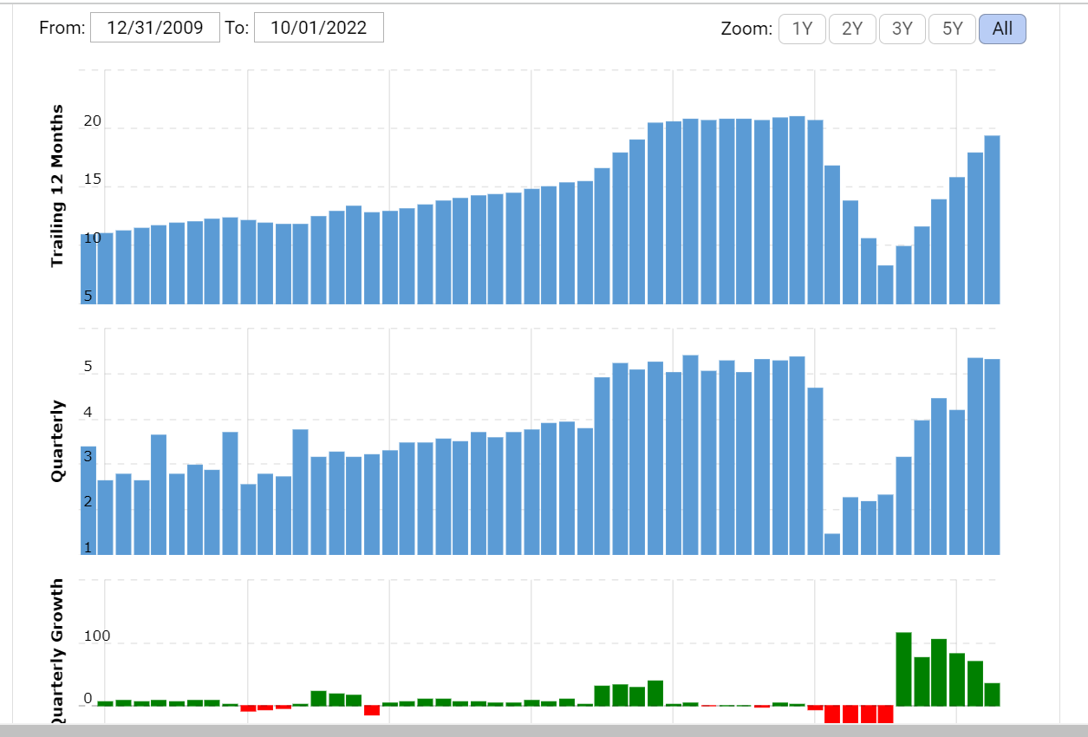
Figure 1: Revenue of the Marriott hotel year by year
Source: (Macrotrends, 2023)

Market Position of Marriott Hotel:
The competitors of the Marriot hotel include Hilton Hotel, Hyatt Hotel, Carlson and Wyndham Worldwide Corp. The market share of the Marriot hotel is 17.95% in 2022. Third-quarter 2022 revenue for Marriott International, Inc. was $ 5,313,000,000, an increase of 34.64% year-over-year.
In the Hotels & Tourism business during the third quarter of 2022, 18 other firms grew their revenue by more. While Marriott International Inc.'s 34.64% Revenue Growth in the Third Quarter of 2022 Placed It at the 804th position in the world. The company could not increase its growth up to the mark due to its high operating expenses on salary. In the third quarter of 2022, Marriott International, Inc. increased its Operating Income by 75.78% year-over-year, to $958.0 million (csimarket, 2022b).
According to the Hotels & Tourism industry figures for the third quarter of 2022, four other organisations have achieved better Operating Income growth. The company ranked just 230th in the industry (csimarket, 2022). The following figure represents it:
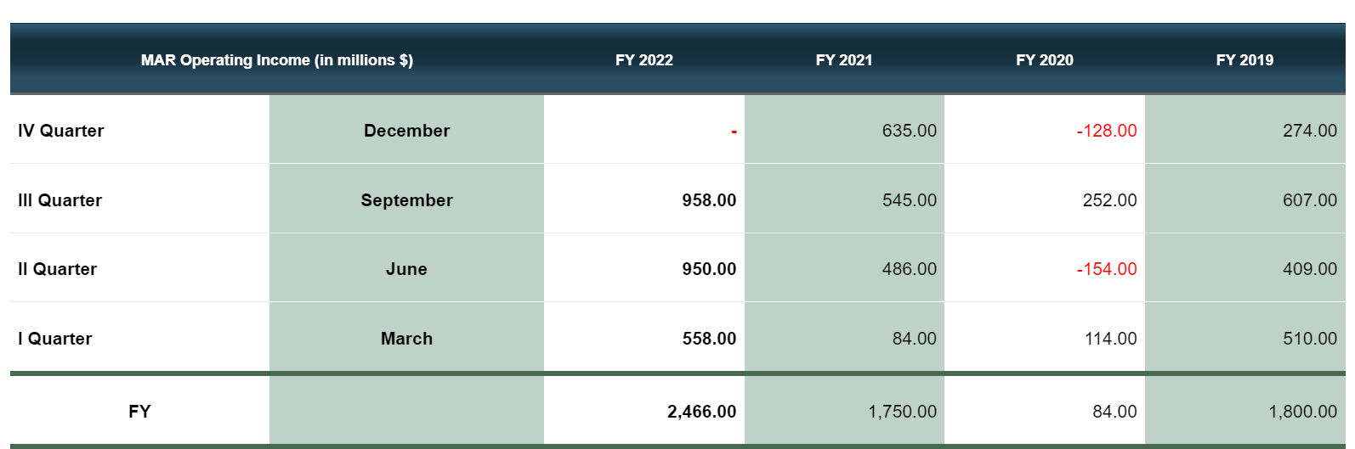
Figure 2: Operating income profit of Marriot hotel
Source: (csimarket, 2022)
The brand value of this company is $2.3 Billion. Its position is 5th in the market compared to its competitors. The position did not change compared to the previous year (brand finance, 2022).
By 2021's completion, the Marriott International system had expanded to about 8,000 hotels with around 1.48 million rooms in 139 different nations and territories. While in 2022, it will have 30 brands and 8200 locations in 139 countries and territories, providing guests with more opportunities to engage, explore, and broaden their horizons than any competitor. It can be seen that from 2021 it had increased by only 200 hotels (marriott.com, 2022). The company could not expand its business in another country due to the covid-19 pandemic.

Growth Potential of Marriot hotel:

Brand Expansion:
Stephanie Linnartz, formerly the chief commercial officer of Marriott International, reportedly gave a presentation on the company's plans for Sheraton's continued expansion. Based on this, Capuano talked about how eight other well-established Marriott brands—responsible for over 70% of the company's global distribution and 55% of its global pipeline—have been growing (news. Marriott, 2022) even if these companies' expansion has quickened during the previous three years.

Targeting Midrange customers:
Marriott recently announced its intention to join the competitive low-midrange hotel market. Marriott has negotiated with Hotels City Express, SAB de CV, to buy the prestigious City Express brand portfolio.

Increasing the extended stay Period:
As more people combine business and pleasure travels, the extended stay market has become increasingly appealing to hotel customers and owners. An all-time high percentage of the company's agreements in 2022 came from the extended stay category, which includes Residence Inn by Marriott, Element by Westin, and TownePlace Suites by Marriott. (news.marriott.com, 2023).

Financial commitment to CSR activity:
Consider the CSR committee's suggestions before approving the CSR policy and CSR spending. Spend at least 2% of average net profits over the prior three financial years on CSR activities each fiscal year, as required by the Act (marriott.com, 2022a).
The Serve360 initiative at Marriott Hotels has been the focus of extensive effort and investment. The team's stated goal is to "do good in every direction" (Marriott, 2019). This is a challenging pledge and will need effort in several areas. Today, Marriott Hotels operate in four distinct spheres:
- Growing a healthy planet
- Carrying forward with accountability
- Opening doors that lead to empowerment
- promotion of human rights
Achieving and promoting a beneficial influence on people, the environment, and business may be accomplished if these four steps are taken.

Recommendations:
Based on the above discussion, Marriot hotel has been lagging behind its competitors in gross profit growth and Operating income growth. This is because the company has money for salary expenses. The pressure on the guests is different throughout the year in the hospitality industry. From March to May, many guests visit; from September to October, many guests visit worldwide. However, at other times, guests are only available a little; in some cases, the number of employees exceeds the number of guests. Therefore, to reduce expenses, the Marriot hotel can outsource the employees during the heavy season of the guests. It has been estimated that outsourcing can assist lower operating expenses by as much as 50 per cent, giving them a significant edge against similarly situated outsourcing; businesses can adjust to changes in demand and expansion quickly and hospitality firms when businesses are efficient (Dessler, Griffiths and Lloyd-Walker, 2007).

Hilton Hotel:
As Hilton World wide’s original and most recognisable brand, Hilton Hotels & Resorts was created in 1919 and has since developed to include more than 550 properties in 67 countries on six continents. Because of the outstanding contribution of our worldwide family of Team Members, Hilton has established itself as the innovative, fashion-forward leader in the hospitality industry (hospitality net, 2022).

Total Revenue of the Hilton Hotel:
Revenue for the trailing twelve months (TTM) for Hilton Worldwide is $8.16 billion, per the company's most recent financial statements. Revenue for the year 2021 was $5.78 B, up from $4.30 B the previous year. Revenue is the sum of money a business earns from selling products and services (companiesmarketcap.com, 2022). Unlike income, costs are not deducted while calculating net profit. The following figure represents it:
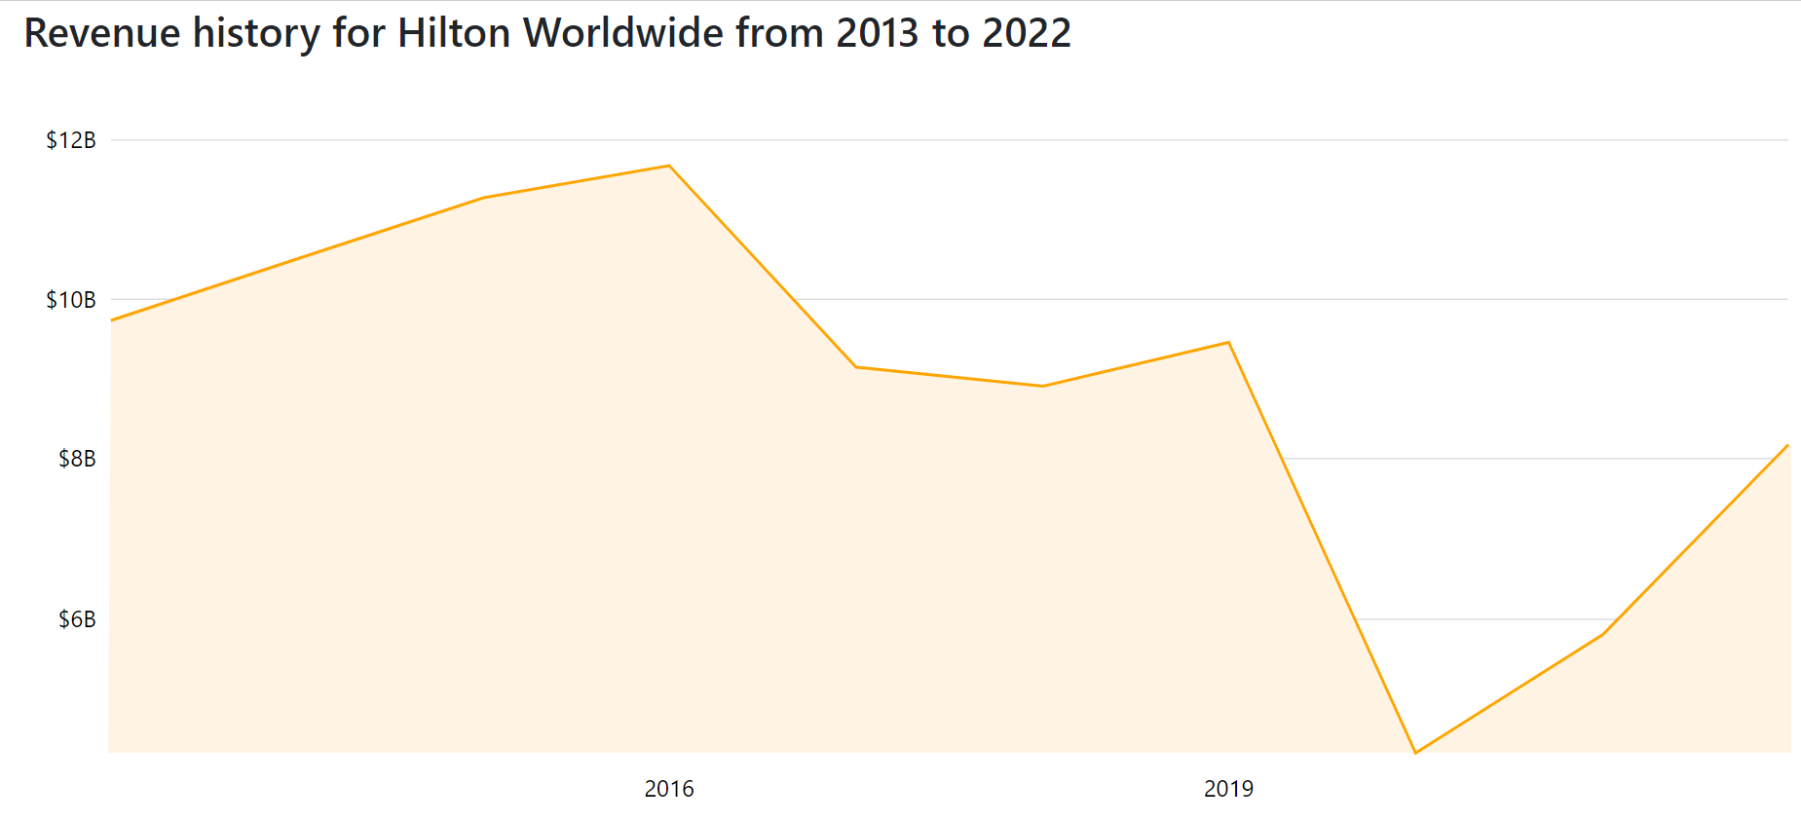
Figure 3: Revenue of the Hilton hotel
Source: (companiesmarketcap.com, 2022)
The Hilton hotel's revenue increased by 41.07% from the previous year. In the previous year, the revenue was 5.78 billion. The following figure represents year by the yearly profit of this hotel:
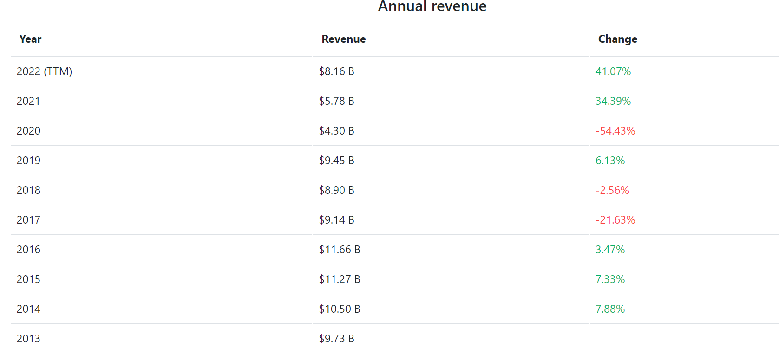
Figure 4: Change of the revenue year by year
Source: (companiesmarketcap.com, 2022)
Due to the covid-19 pandemic, tourists could not move, and the profit of this hotel has decreased since 2019. By comparing the revenue of the Hilton Hotel with its competitor, Marriot hotel, it can be seen that the profit of the Marriot hotel is 136.33% higher than Hilton Hotel (companiesmarketcap.com, 2022).

Market Position of the Hilton Hotel:
The market competitors of this hotel are Marriott hotel, Holiday Inn hotel, Intercontinental Hotel Groups, Crown Plaza Etc. The Market share of the Hilton hotel is 7.78%, while the share of its competitor, Hilton hotel, is high. The brand value of this hotel is 12.05 billion making this hotel number one hotel brand in the UK compared to Marriot hotel (brand finance, 2022). The following figure represents the brand list:
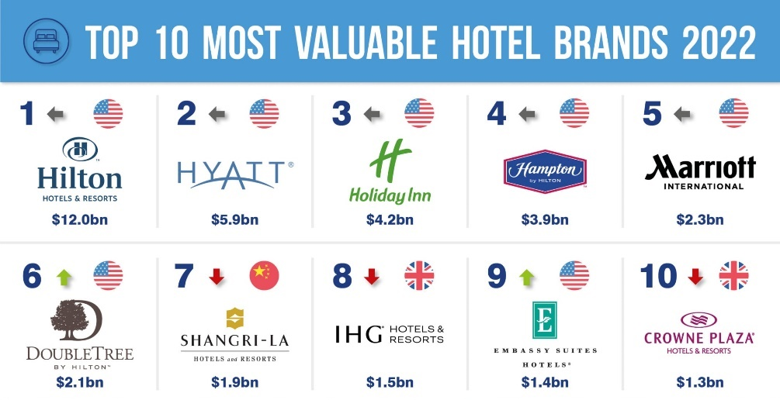
Figure 5: 10 most valuable brand
Source: (brand finance, 2022)
By comparing this, the company has done well than its competitors. The revenue growth of Hilton Hotels is higher compared to the Marriot hotel, although the Profit of Hilton is less than the Marriott hotel. On the other hand, the operating income of Hilton Worldwide Holdings for the twelve months ended 30 September 2022 was $1.923 billion, a 298.96% increase from the previous year (macrotrends.net, 2022). Although the operating income has increased in percentage and amount, the profit has decreased. More than six thousand hotels were part of the Hilton Worldwide Holdings, Inc. portfolio as of 31 December 2021. Hampton, with 2,765 properties then, was the most famous hotel chain. On the other hand, Marriott hotel owned around 8000 hotels around the hotel (statista.com, 2022). This hotel has an increasingly more significant number of hotels than Marriott hotels.

The growth potential of the Hilton Hotel:
By the end of 2023, Hilton plans a near-30% expansion of its European presence. More than 35,000 rooms are being constructed across 217 buildings by the firm right now.
Hilton's expansion in the area may be attributed mainly to the company's full-service and lifestyle brands, such as the Curio Collection by Hilton, Tapestry Collection by Hilton, and Canopy by Hilton. Hilton has increased its presence in these market niches during the past three years. Hilton's Collection and Lifestyle brands were on pace to build 15 new properties across seven European nations in 2021; the Tapestry Collection made its debut in the region earlier this year (Whyte, 2021).

Financial commitment to CSR:
Hilton Worldwide has announced that it will be making the following changes to its CSR performance going forward:
- Social Effects Caused by Workers
- Respect for the natural world and ethical manufacturing
For Hilton's corporate social responsibility efforts, 2011's "Travel with Purpose" acts as a guiding philosophy. The hotel business can do its part to reduce its environmental impact through waste reduction, recycling, food upcycling and donation. Its goal is to cut waste in all forms by half by the year 2030. In 2021, the hotel invested around 26 million in Corporate social responsibility. The company has decided to expense higher to decrease its carbon footprint (Barbara Beltran Torres, 2021).

Recommendations:
By analysing, it can be seen that the company is doing in every parameter. However, the hotel's profit has remained the same to a greater extent compared to the Marriot hotel. Therefore, the hotel needs to focus on expanding the market. Below the product-market expansion grid or Ansoff matrix is present:
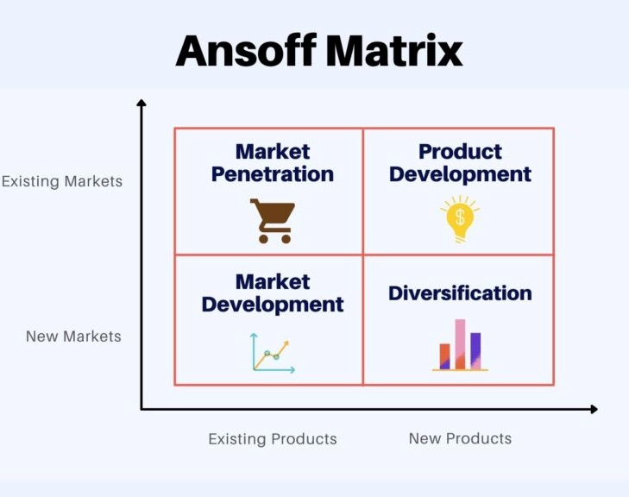
Figure 6: Ansoff Matrix
Source: (J. Harrington et al., 2019)
The company needs to focus on a market development strategy under which the company develops a new market with its existing product. There are many countries where the company did not have any hotel branch; therefore, it could not capture any market share from that country. On the other hand, the company can go for a product development strategy under which it will develop a product for its existing market. The company can offer a new product to its customers so that customers cannot move to the competitors; therefore, much investment in Research and development is required.

Conclusion:
Both Marriott and Hilton are popular hotel brands all over the world, and customers all over the world are fans of these two hotels. Though the target customers of these hotels are the same, the profit margins of these two hotels are different. Due to the high presence of the Marriot hotel, the profit of this hotel is higher than Hilton hotels; therefore, the Operating income of this hotel has also been high compared to Hilton hotels. However, compared to other market players, the profit of the Marriot hotel was less due to the excessive employee salary expenses. However, compared to the brand value, Marriot's brand value is lower than Hilton hotel. Therefore, according to their loophole’s recommendations in this report, Marriott hotel needs to outsource employees during heavy guests, and Hilton needs to develop new markets and product development. In addition, both hotels are socially responsible. Both of them expense massive amounts of money for CSR.

References:
Annual reports (2021) Marriott International, Inc. - AnnualReports.com, www.annualreports.com. Available at: https://www.annualreports.com/Company/marriott-international-inc (Accessed: 27 January 2023).
Barbara Beltran Torres (2021) Corporate Social Responsibility in the Hospitality Industry and Its Contribution to the Welfare of Local Communities. The Case of Hilton Hotels. GRIN.
brand finance (2022) Hilton Brand Value Leaps Ahead to Retain Top position, While Most Hotel Brands Remain below pre-pandemic Values | Press Release | Brand Finance, Brand Finance. Available at: https://brandfinance.com/press-releases/hilton-brand-value-leaps-ahead-to-retain-top-position-while-most-hotel-brands-remain-below-pre-pandemic-values (Accessed: 27 January 2023).
companiesmarketcap.com (2022) Hilton Worldwide (HLT) - Revenue, companiesmarketcap.com. Available at: https://companiesmarketcap.com/hilton-hotels/revenue/#:~:text=Revenue%20in%202022%20(TTM)%3A (Accessed: 27 January 2023).
market (2022a) Marriott International Inc Operating Income Growth Rates (MAR), Current and Historic Growth - CSIMarket, csimarket.com. Available at: https://csimarket.com/stocks/single_growth_rates.php?code=MAR&oper (Accessed: 28 January 2023).
csimarket (2022b) Marriott International Inc Revenue Growth Rates (MAR), Current and Historic Growth - CSIMarket, csimarket.com. Available at: https://csimarket.com/stocks/single_growth_rates.php?code=MAR&rev (Accessed: 28 January 2023).
Dessler, G., Griffiths, J. and Lloyd-Walker, B. (2007) Human Resource Management theory, skills, Application. Frenchs Forest Pearson.
hospitalitytech.com (2022) Hilton CEO Hopes to Increase Loyalty Member Occupancy to 80% within the next five years, Hospitality Technology. Available at: https://hospitalitytech.com/hilton-ceo-hopes-increase-loyalty-member-occupancy-80-within-next-5-years (Accessed: 28 January 2023).
J. Harrington, R. et al. (2019) ‘Strategic management research in hospitality and tourism: past, present and future’, International Journal of Contemporary Hospitality Management, 26(5), pp. 778–808. doi: 10.1108/ijchm-12-2013-0576.
Macrotrends (2023) Marriott Revenue 2006-2019 | MAR, Macrotrends.net. Available at: https://www.macrotrends.net/stocks/charts/MAR/marriott/revenue (Accessed: 27 January 2023).
macrotrends.net (2022) Hilton Worldwide Holdings Operating Income 2011-2022 | HLT, www.macrotrends.net. Available at: https://www.macrotrends.net/stocks/charts/HLT/hilton-worldwide-holdings/operating-income#:~:text=Hilton%20Worldwide%20Holdings%20operating%20income%20for%20the%20twelve%20months%20ending (Accessed: 28 January 2023).
Marriott (2019) csr-marriott, csr-marriott. Available at: https://serve360.marriott.com/ (Accessed: 27 January 2023).
Marriott (2022) About Marriott International | Corporate Information, Marriott.com. Marriott International. Available at: https://www.marriott.com/marriott/aboutmarriott.mi (Accessed: 28 January 2023).
marriott.com (2022a) CORPORATE SOCIAL RESPONSIBILITY (‘CSR’) POLICY FOR MARRIOTT HOTELS INDIA PRIVATE LIMITED (‘MHIPL’). Available at: https://www.marriott.com/marriottassets/Multimedia/PDF/CorporateResponsibility/CSR_Policy_India.pdf (Accessed: 28 January 2023).
marriott.com (2022b) Marriott International Expects to Introduce More Than 35 Luxury Hotels Around the World in 2023, Marriott International News center (US). Available at: https://news.marriott.com/news/2022/12/07/marriott-international-expects-to-introduce-more-than-35-luxury-hotels-around-the-world-in-2023 (Accessed: 27 January 2023).
News. Marriott (2022) Stephanie Linnartz, Marriott International News center (US). Available at: https://news.marriott.com/leadership/stephanie-linnartz (Accessed: 27 January 2023).
news.marriott.com (2023) Marriott International Marks Another Year of Strong Acceleration in Signings, Marriott International News center (US). Available at: https://news.marriott.com/news/2023/01/23/marriott-international-marks-another-year-of-strong-acceleration-in-signings (Accessed: 28 January 2023).
Rob Van Ginneken (2019) Hospitality finance and accounting: essential theory and practice. Abingdon, Oxon; New York, NY: Routledge.
Schmidgall, R. S. and Damitio, J. W. (2015) Hospitality Industry Financial Accounting. Lansing, Michigan: Ahlei, American Hotel & Lodging Educational Institute.
statista.com (2022) Hilton Worldwide hotels by brand 2021, Statista. Available at: https://www.statista.com/statistics/297753/number-of-hilton-worldwide-hotels-by-brand/#:~:text=Number%20of%20Hilton%20Worldwide%20Holdings%20hotels%2C%20by%20brand%202018%2D2021&text=As%20of%20December%2031%2C%202021 (Accessed: 28 January 2023).
Whyte, P. (2021) Hilton Targets 30% Growth in European Footprint by 2023, Hospitality Insights. Available at: https://www.hospitalityinsights.com/content/hilton-targets-30-growth-european-footprint-by-2023 (Accessed: 28 January 2023).

Appendices:

Marriot’s Income Statement 2021:
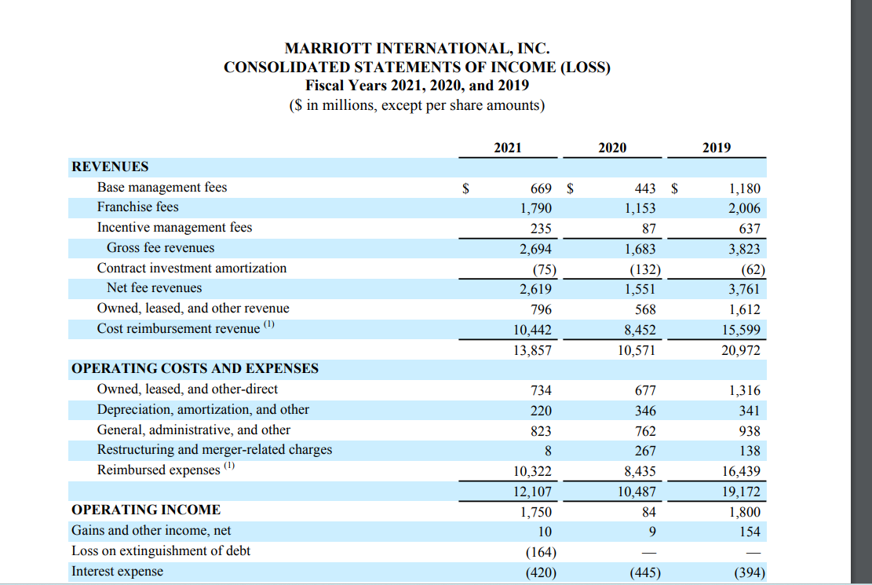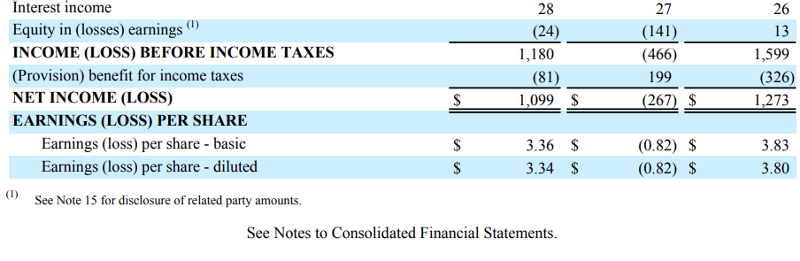
Adapted from: https://www.annualreports.com/HostedData/AnnualReports/PDF/NASDAQ_MAR_2021.pdf

Hilton’s Income Statement:
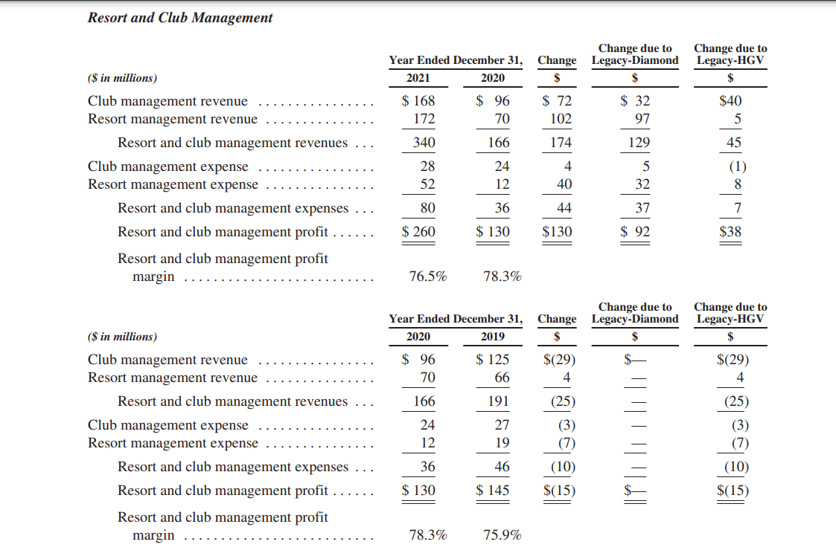
Adapted from: https://www.annualreports.com/HostedData/AnnualReports/PDF/NYSE_HGV_2021.pdf

