

Master of Business Administration
International Business pathway


Contemporary employability skills
Assessment 1: Individual report. Weight: 100%

Module name: International Business Concepts

Module Code: LCMB7034

Lecturer Name: Jean Wang

Student Name: Darshan Pansuriya

Student No.: 2526084

Word Count: 5512

Submission Date: 14th August, 2026

AI Use Acknowledgement
I acknowledge the use of ChatGPT (https://chatgpt.com/c/6a7ebd61-6b10-83ee-ad8f-a37e52ab6c2c ) on 13 August 2026 to support research, proofreading and visual development activities for my International Business Concepts assignment. I used the prompt(s):
- Help me compare the reliability and relevance of academic, government and company sources about Paytm’s potential entry into UK, focusing on the credibility, recency and usefulness of each source type for international business analysis.
- Suggest appropriate tables, charts or diagrams for presenting the PELC analysis, market attractiveness, internationalisation strategy and proposed entry-mode findings for Paytm’s potential entry into UK.
- Review my completed assignment paragraphs and identify unclear, repetitive, grammatically incorrect or poorly structured sentences without changing my original argument, meaning, evidence or academic voice.

Table of Contents
Section 1: International Market Entry Analysis 1
1. Introduction 1
2. Classification of organisations and global strategy 1
2.1 Paytm as a Multinational Enterprise 1
2.2 Bartlett and Ghoshal Classification 2
2.3 Global Footprint and Competitive Advantage 3
3. Macro-Environmental Appraisal and Market Attractiveness 3
3.1 Political Environment 3
3.2 Economic Environment 4
3.3 Legal and Regulatory Environment 5
3.4 Cultural Environment 5
4. Market Attractiveness and OLI Analysis 7
5. Entry Mode Strategy and Strategic Synthesis 8
5.1 Paytm's Historical Entry-Mode Pattern 8
5.2 Alternative Entry Modes 9
5.3 Recommended Entry Mode 10
5.4 Proposed UK Value Proposition 11
5.5 Risk Assessment 11
6. Conclusion and Recommendations 12
Part 2: Reflective Account (Gibbs' Reflective Cycle) 13
7. Reflection on the Research and Analysis Process 13
7.1 Description 13
7.2 Feelings 13
7.3 Evaluation 13
7.4 Analysis 14
7.5 Conclusion 14
7.6 Action Plan 14
References 14

Paytm’s Proposed Entry into the United Kingdom: A Critical Analysis of International Business Strategy and Market Entry

Section 1: International Market Entry Analysis

1. Introduction
For digital businesses looking to expand their growth, technology learning, and diversification of revenue streams, internationalisation has gradually taken on greater significance (Verbeke, 2022). Fintech companies face specific challenges when going global, however, as their success depends on not just technology and customer adoption, but regulation, trust, data governance and financial institution relationships. This report is an assessment of One 97 Communications Limited (OCL)'s proposed entry into the United Kingdom (UK) market for its Paytm service. The UK market is an attractive but sophisticated one due to the advanced financial-services infrastructure, fintech ecosystem, and the usage of digital payments, as well as the large Indian diaspora in the country (Financial Conduct Authority, 2025; UK Government, 2026). Concurrently, the market is intensely competitive and controlled, which would put an incredible strategic risk with the transfer of Paytm's Indian business model into Britain (Financial Conduct Authority, 2026).
The choice of the Indian multinational company Paytm for analysis makes it a perfect fit for the country, as it has established subsidiaries and operations in Singapore, the United States, the United Arab Emirates, and Nigeria, as well as other African and Asian markets (One 97 Communications Limited, 2025). Its internationalisation efforts have been directed more towards moving its technology-driven merchant-payment and financial-services operations outside of India (One 97 Communications Limited, 2025, 2026). In May 2026, Paytm also registered Paytm Europe Payments S.A. in Luxembourg, but the company said that it had not started its business (One 97 Communications Limited, 2026).
Pursuing the market segment in the UK is therefore a strategic market opportunity rather than a mature and established significant market. The analysis is based on the integration-responsiveness framework (Bartlett and Ghoshal, 1989), OLI paradigm and international entry-mode theory (Dunning, 1988; Dunning and Lundan, 2008). Political, economic, legal and cultural factors are thoroughly analyzed prior to formulating a recommended entry strategy. Central premise is that Paytm should not try to “compete” with Apple Pay, Google Pay, PayPal, Revolut and the existing banking apps in UK, by announcing a strategy of addressing every consumer wallet. Rather, it should be introduced via a partnership driven, regulated merchant-payments and open-banking offer, first of all aimed at India-related SMEs, digitally active small businesses and UK consumers with strong India-related payment needs. It would help Paytm to utilise ownership benefits without taking on regulatory and financial risk.

2. Classification of organisations and global strategy

2.1 Paytm as a Multinational Enterprise
Paytm has evolved from a purely Indian-market platform to now having a more international organisational structure (One 97 Communications Limited, 2025). One97's subsidiary network comprised entities in Singapore, U.S., Nigeria, the UAE and other markets (One 97 Communications Limited, 2025). It has focused on expanding its merchant-payment technology and financial-services distribution, rather than just exporting the consumer Paytm app, in its strategy for expansion overseas. This divide is critical as the technology and merchant network are the closest differentiators to Paytm's competitive power, not the Indian consumer offering itself.
It shows that Paytm has significant ownership benefits in FY2026. Revenue rose 22% to ₹8,437 crore, whereas the EBITDA came up to ₹502 crore and PAT stood at ₹552 crore, marking Paytm's maiden full financial year of profitability (Paytm Ltd., 2026). Merchant GMV rose by 27% year-on-year and subscription merchants hit One 97 Communications Limited's 2026 One 51 crore (One 51). Paytm has achieved scalable payment processing, merchant acquisition, data analytics, and platform capabilities, which could be exported across borders.
But technology and scale is not an automatic recipe for competitiveness internationally. One of the major drawbacks is that all of Paytm's core features have been built around India's unique QR and UPI payment system. The UK payment landscape is institutionally unique. Hence, Paytm's overseas strategy should focus on building the base capabilities and customizing the proposition and regulatory framework to the target markets.

2.2 Bartlett and Ghoshal Classification
Bartlett and Ghoshal have distinguished international strategies based on the forces of global integration and local responsiveness (Bartlett and Ghoshal, 1989). There are four widely used configurations: international, global, multidomestic and transnational. The transnational option is especially critical when companies need to realize economies and gain knowledge integration throughout the world, while adjusting to the needs of the different countries (Bartlett and Ghoshal, 1989). New studies also show that successfully reaching both dimensions is a challenge for the organization and a high demand for coordination (Verbeke, 2022).
Paytm can be said to be following the path of a transnational approach, but not yet a full-fledged mature transnational approach. The core technology, data, AI models and brand can be integrated and scaled throughout the world. Meanwhile, national legislation, consumer attitudes, banking systems and cultural norms all have a strong influence on payments. Hence, Paytm cannot simply be India ready for the UK (Bartlett and Ghoshal, 1989).
For instance, the core technology architecture, fraud-detection and merchant analytics can be seamlessly integrated worldwide. On the other hand, customer onboarding, identity verification, complaints management, pricing, data governance, payment interfaces and compliance with regulations require local adaptation. The operation in the UK should therefore be strategically differentiated and not recreated on a country-by-country basis.
The cost efficiency of a purely global strategy would be based on the assumption that the UK did not have institutional differences. A multidomestic approach would allow adaptation but might result in repeating technology and cost. Hence, the transnational approach is more suitable, which helps Paytm to focus on technology and risk management without having to manage customer and regulatory aspects centrally.Therefore, the transnational approach would be more suitable as it will allow Paytm to concentrate on technology and risk management while leaving the aspects of customer and regulatory decisions decentralized (Bartlett and Ghoshal, 1989).
However, Bartlett and Ghoshal's model must not be taken as a deterministic model. Both the literature and the author's research have shown that transnational strategies can give rise to a lot of coordination complexity and can be challenging to execute consistently by firms (Verbeke, 2022). Paytm needs to, therefore, follow a selective transnational approach: technology, cyber security, AI and platform development in the global market and regulatory regime, merchant acquisition, partnerships and customer experience in the UK.
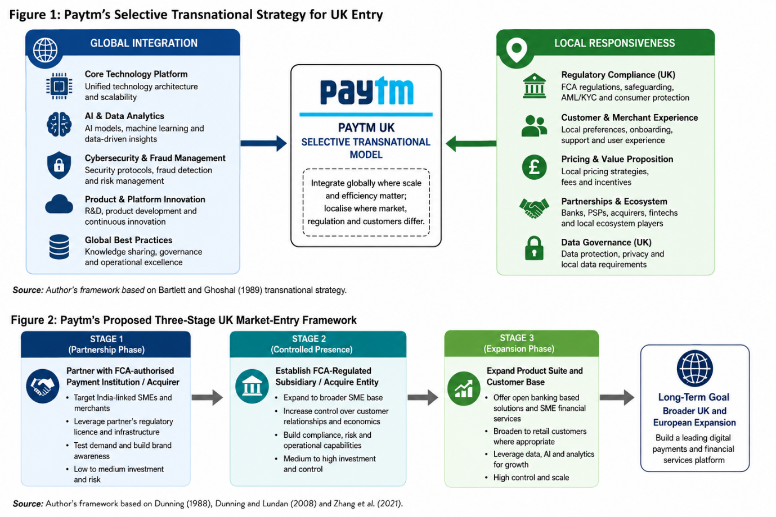
Figure 1: Paytm's Selective Transnational strategy For UK Entry

2.3 Global Footprint and Competitive Advantage
Paytm's global reach shows its transition from being an India-centric firm to one that has a global presence and is becoming more geographically-diversified (2025 One 97 Communications Limited). Apart from that, Paytm's preference is to set up controlled subsidiaries to roll out its merchant payments financial-services stack (One 97 Communications Limited, 2025; One 97 Communications Limited, 2026) across countries, with Paytm Singapore and Paytm Arab Payments being two such entities. Paytm announced the launch of Paytm Arab Payments in UAE specifically to expand and distribute its technology-based merchant-payment and financial services capabilities in April 2025 (One 97 Communications Limited, 2026).
As a result of this pattern, there are three sources of competitive advantage. First, international subsidiaries enable Paytm to maintain greater control over the IP and technology. Secondly, there is potential for local entities to build up market-specific knowledge. Third, internationalisation offers opportunities for learning for the organisation that can then enhance Paytm's global platform.
But there is complexity as well, thanks to the international reach. You'll need multiple regulatory systems' ability to be compliant and foreign operations can come at a cost in the beginning before you scale up. Paytm's entry into the European market with Paytm Europe in Luxembourg, illustrates a more targeted strategy of going European. Importantly, the disclosure dated May 2026 included the details that Paytm Europe was set up as a company on 12 January 2026 and had not yet started its operations. Paytm then gave the green flag to an additional €9 million investment to meet its business needs (One 97 Communications Limited, 2026). This means that Paytm was planning to expand to the UK but hadn't created a significant presence in the country by 1 June 2026.

3. Macro-Environmental Appraisal and Market Attractiveness

3.1 Political Environment
The UK has fairly favorable institutional conditions for fintech investments. It has a complex regulatory framework and an increasingly competitive and innovative government payments policy, with a focus on modernisation of payments infrastructure. The National Payments Vision and strategy for future payments infrastructure in the UK (UK Government, 2025) show that the UK Government has a vision for a modern, resilient and innovative payments ecosystem.
This is an opportunity for Paytm as it is matching the UK's policy focus on payment innovation in terms of technology. The UK Government in April 2026 announced further steps to help payments technology develop in the future and consolidate the UK's role as a leading payments hub in the world. As a result, there is a positive overall political climate surrounding innovative payment firms (UK Government, 2026).
Another strategic benefit is the UK/India relationship. As of the assessment cut-off date (1 June 2026), the UK Government stated that bilateral trade was valued at around £48 billion in 2025, and the importance of the UK-India Free Trade Agreement (FTA) that had been implemented but has yet to come into force. The deal was likely to boost trade between the two countries and enhance business confidence. Paytm's relationship is significant because it would be going into a market wherein India has already established sizeable commercial and cultural ties.
Political attractiveness does not necessarily equal regulatory simplicity, though. The UK government is strong proponents of fintech advancement and innovation and the regulatory framework requires extensive consumer protection, financial crime prevention and operational resilience (Financial Conduct Authority, 2026). Political support therefore ensures an enabling environment, but does not decrease compliance burden.

3.2 Economic Environment
The UK is a good market due to its high income economy, developed financial sector and large purchasing power. According to World Bank, the GDP of the UK in 2025 was around US$4 trillion with GDP growth rate of 1.4% and GDP per capita of around US$57,602 in the year 2025. The International Monetary Fund (IMF) May 2026 assessment was for UK growth of around 1.0% for 2026 as a result of higher energy prices, tighter financial circumstances and economic uncertainty.
More than that economic opportunity for Paytm is in the sophistication and scale of the UK's financial-services sector, not in its overall economic growth. Many consumers and SMEs are already used to using electronic payment methods, and London is home to a significant fintech 'hub' around the world.
One of the main concerns is market saturation. Paytm would not enter an immature digital-payment ecosystem lacking basic payment infrastructure. Instead, it would compete with bank apps, contactless cards, digital wallets and existing fintech apps, substantially raising customer-acquisition costs.
Rather than replacing existing services, Paytm’s economic justification lies in market differentiation. It may target untapped segments such as Indian-origin restaurants, retailers, travel service providers and SMEs, which need robust payment access across the UK and India, rather than convincing British consumers to stop using their existing banking apps.
The UK's trade partnership with India is also conducive to the economy. The depth of the bilateral trade relationship is reflected by the volume of trade between the UK and India, which was valued at around £47.9 billion in the four quarters to the end of 2025 (UK Government, 2026). It isn't that all the Indians will use Paytm, but it makes the addressable market for Indian financial services more promising.

3.3 Legal and Regulatory Environment
Paytm's biggest hurdle to enter the UK is legal issues. The Payment Services Regulations 2017 (PSR) and Electronic Money Regulations 2011 (EMR) regulate payment services in the UK. Most companies that offer payment services will require FCA authorization or registration. Under the regulations, the following activities are regulated: payment transactions, card issuance, acquiring, money remittance, account-information services, payment-initiation services (Financial Conduct Authority, 2026).
This will have immediate ramifications on the entry mode of the Paytm. If the Paytm UK operation was to be a standalone, a lot of regulatory work would have to be done before the launch of a regulated service. The FCA will require candidates to show appropriate governance, internal controls, risk management, safeguarding and management competence (FCA, 2026).
The safeguarding regime is especially crucial as payment firms deal with customer cash. The FCA has introduced new rules for safeguarding customer funds, coming into effect from May 2026, which will be stronger than those set out before the pandemic. It is an important lesson that Paytm itself has learnt from its regulatory journey in India: payment companies cannot treat compliance as a side-line operational activity. Compliance needs to be built into the UK business model from the start..
Money laundering is no less important than financial-crime controls. Firms offering payment services in the UK are required to meet financial crime requirements and applicants are expected to have risk-sensitive policies and procedures to mitigate the risk of money laundering and terrorist financing (Financial Conduct Authority, 2026). It will be especially important if Paytm's UK service allows for India-related transactions, as this can complicate the transaction monitoring process.
Another key requirement is consumer protection. The Consumer Duty is a requirement for the FCA for firms to take steps to ensure they provide good outcomes for their retail customers, and to ensure that they behave in a way that puts the customer first, avoids foreseeable harm and shows good faith (Financial Conduct Authority, 2026). Paytm would thus require clear pricing, easy-to-understand terms, and robust complaint resolution and product design.
Data protection is yet another challenge as Paytm has a competitive business model which heavily depends on data analytics and AI. The principles of GDPR in the UK are based on lawful, fair and transparent processing, purpose limitation, data minimization, accuracy, storage limitation and security. Paytm should, therefore, not take it for granted that the information practices created in India can be replicated without change.
In the legal environment, then, it is a threat and a competitive filter. While the regulation increases Paytm's cost of entry, it also diminishes the allure of poorly governed competitors. With robust compliance capabilities, Paytm may become so credible to regulators that it is itself a value-added ownership feature.

3.4 Cultural Environment
The opportunity and constraint of cultural factors. The UK is a culturally diverse country with a high level of experience of digital financial services. The Indian community is particularly relevant as India is one of the most important sources of overseas migration to the UK. Previous ONS figures have shown that people born in India are the largest group of foreign-born people in the UK, with around 896,000 Indian-born people in the UK in the year to June 2021 (Office for National Statistics, 2021). The Indian diaspora of around 1.9 million people has subsequently been identified as key to the UK-India links in the people-to-people sphere (UK Government, 2026).
This establishes a first customer group that has a cultural relevance. Paytm can leverage on Indian payment habits, Indian merchants and cross-border financial engagements.
But cultural similarity shouldn't be exaggerated. In general, British consumers demand high standards of consumer rights, price and ease of use. When Indian assumptions are made, the product might therefore seem unnecessarily complex. The strategy for the UK should focus on ensuring that Paytm's technological capabilities are maintained, but that local language, conventions for the interface and expectations for customer service are all incorporated.
The cultural opportunity is then the greatest when Paytm leverages India as a differentiator and not a constraint. The brand can start by targeting the Indian market and gradually move towards the larger SME and digital-payment segment.
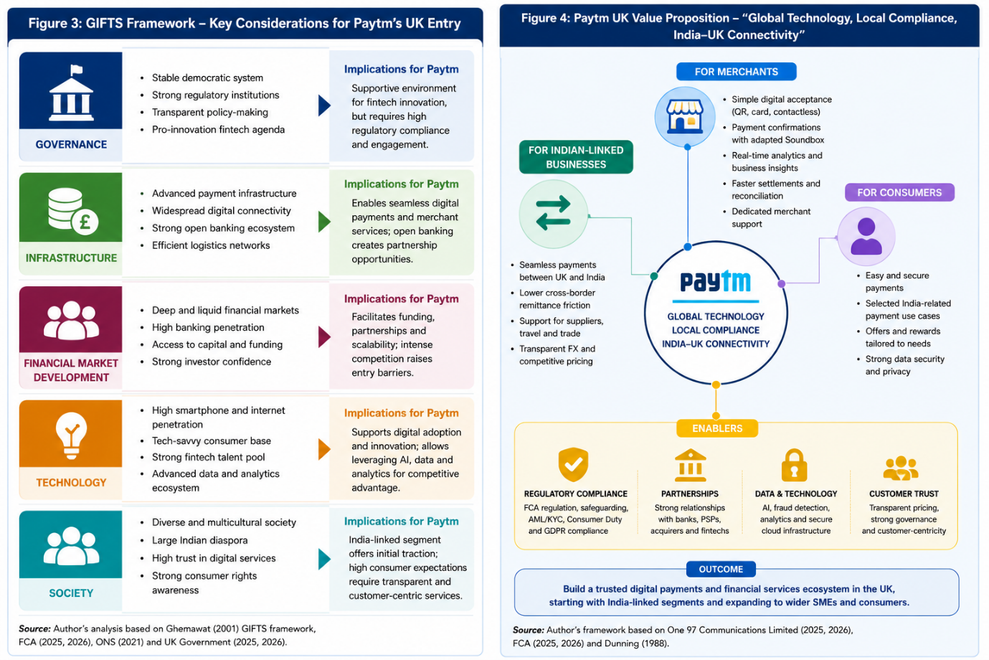
Figure 2: GIFTS Framework
Table 1. Paytm UK PELC Market Attractiveness Analysis
Factor | Key UK condition | Opportunity for Paytm | Key threat/constraint | Strategic implication
Political | Government supports fintech innovation and modernisation of payments infrastructure | Supportive environment for innovative payment services | Government support does not remove regulatory requirements | Work with UK regulatory and institutional partners
Economic | High-income economy, sophisticated financial sector and strong UK–India trade relationship | Attractive SME and India-linked payment market | Mature market and high customer-acquisition costs | Focus on differentiated SME and merchant segments
Legal | FCA authorisation, safeguarding, AML, Consumer Duty and data-protection requirements | Strong compliance can become a competitive advantage | High compliance cost and regulatory complexity | Enter through a regulated partner initially
Cultural | Large Indian diaspora and widespread digital-payment adoption | India-linked merchants and consumers provide an initial niche | UK consumers expect simplicity, transparency and strong consumer protection | Adapt customer experience to UK expectations

4. Market Attractiveness and OLI Analysis
Dunning's OLI paradigm is a useful one for assessing the decision of Paytm's internationalization into the UK market. This framework discusses the advantages both of ownership and of location and internalisation, and has continued to be applied in the analysis of multinationals. (Dunning, 1988; Dunning and Lundan, 2008)
Ownership Advantages
There are a number of ownership benefits of Paytm. These cover payment-processing technology, a big network of merchants, AI features, fraud-management know-how, and financial-services distribution – knowledge and experience with QR payment (One 97 Communications Limited, 2026). According to its FY26 results, it has 7.7 crore transacting users monthly, 1.51 crore subscription merchants and significant merchant-payment volumes (One 97 Communications Limited, 2026).
The Soundbox idea of a merchant technology is especially transferable. Paytm has evolved the device from just payment confirmation to business insights, notifications and merchant support. A UK version might offer SMEs payment confirmation, transaction analytics and customer-management capabilities.
But UPI alone is not so transferable as it is reliant on India's banking system. So, the ownership advantage is not just about “UPI”, but about Paytm's overall capabilities to build and run high volume digital-payment ecosystems.
Location Advantages
The UK offers attractive location benefits, including its high income customer base, its policy support for payment innovation and the UK financial infrastructure and fintech ecosystem. By the end of 2025, over 16 million users had engaged with open banking and open-banking payments had grown by 53% year-on-year (Financial Conduct Authority, 2025). This is important especially since Paytm would not have to create India's UPI system, but rely on open banking instead.
The UK also offers access to high-tech financial institutions, talent in technology and a huge international business environment. These benefits can help Paytm better learn in the European market, and may bolster its future expansion plans across the globe.
Internalisation Advantages
Paytm has reasons to internalize some of its capabilities as its technology, AI models, fraud-detection systems, and merchant analytics have valuable proprietary knowledge. Likely there would be problems with quality control and intellectual property rights if these capabilities were licensed to an unrelated company (Dunning, 1988; Dunning and Lundan, 2008).
However, it is not optimal at the first stage when it's fully internalized. Another area of complementary capability is that of regulation and local banking relationships and market knowledge. So, what is better is a hybrid solution—Paytm should adopt its core tech and partner for regulated infrastructure, acquire capabilities and get local distribution.
Table 2. Paytm's OLI Analysis for UK Entry
OLI element | Paytm's advantage | UK relevance | Critical assessment
Ownership (O) | Payment technology, merchant network, AI, fraud management, merchant analytics and Soundbox | Provides transferable technological and merchant capabilities | UPI itself is less transferable because it depends on India's payment infrastructure
Location (L) | UK fintech ecosystem, open banking, financial infrastructure, high-income market and UK–India commercial links | Provides a sophisticated environment for developing payment and SME services | Market saturation and intense competition reduce the attractiveness of mass-market entry
Internalisation (I) | Proprietary technology, AI, fraud detection and merchant analytics | Protects intellectual property, quality and technological control | Full internalisation is costly initially; partnerships are preferable for regulatory infrastructure and local market knowledge
Overall OLI implication | Strong ownership and location advantages with selective internalisation | Supports internationalisation | Hybrid entry is more appropriate than either complete internalisation or simple licensing

5. Entry Mode Strategy and Strategic Synthesis

5.1 Paytm's Historical Entry-Mode Pattern
Paytm's international expansion has been a showcase of a number of entry strategies, but wholly controlled subsidiaries have been a feature. Paytm Singapore is a wholly owned subsidiary set up to expand and sell the merchant-payment and financial-services stack technology. In the same way, Paytm Arab Payments was planned to be a wholly owned subsidiary, but the company has gradually shifted its approach towards a partnership model by involving an outside investor to own a minority stake (One 97 Communications Limited, 2025; One 97 Communications Limited, 2026).
For Paytm, it means that it has always preferred to have a high degree of control over its core technology that comes from overseas markets, but may be more willing to adopt partnership models when there is a compelling business case for it, whether it is from a market opportunity in its home market or a capital requirement.
The model is consistent with Dunning's internalisation logic, which finds proprietary technology valuable and hence it is not worth transferring completely via arm's length licensing (Dunning, 1988; Dunning and Lundan, 2008). But the UK situation is different as compared to markets where Paytm can play with the Indian style payment ecosystem.

5.2 Alternative Entry Modes
There are three main choices to be made.
Option 1: Wholly owned subsidiary. This will give maximum control of Paytm's brand, technology, customer data and strategic decisions. It would also aid in long-term capability development. It would require significant regulatory, financial and operational commitment, though, before the demand in the market is substantiated.
Option 2: Licensing or simple partnership. This would minimize the risk of capital but would make Paytm less dominant in customer experience, data and technology. It also may pose intellectual property and brand reputation issues.
Option 3: Strategic partnership and then a controlled subsidiary. This would add the local market knowledge to Paytm's tech powers. A combination of a UK-regulated payment institution, banking partner or established payment-acquiring organisation can deliver regulatory and infrastructure knowledge and expertise, while Paytm can offer technology, merchant solutions and AI solutions.
Table 3. Comparison of Alternative Entry Modes
Entry mode | Control | Investment | Risk | Local knowledge | Regulatory suitability | Overall suitability
Wholly owned subsidiary | High | High | High | Low–Medium initially | Medium | Medium
Licensing/simple partnership | Low | Low | Low–Medium | High | High | Medium
Strategic partnership → controlled subsidiary | Medium initially → High | Medium initially → High | Medium | High | High | High

The third is the best.

5.3 Recommended Entry Mode
Paytm needs to follow a staged strategic partnership, and then take a more significant stake once it has amassed a certain degree of knowledge and capability in the UK and is ready to navigate the regulatory landscape.
In Stage 1, Paytm needs to create its operations presence in the UK by entering into a partnership with an FCA authorised payment institution or acquiring organisation. The first offer should be geared towards merchant payments, not a consumer wallet. Target market should include Indian restaurants, convenient stores, travel companies, professional services companies, e-commerce sellers and SMEs that have customers or suppliers in India.
In Stage 2, Paytm needs to form a subsidiary entity regulated by the FCA or obtain a suitable regulated entity if economically and legally viable. This would make it easier to manage customer relationships and payment economics.
In Stage 3, Paytm may venture into open-banking products, SME financial products, and into specific consumer products.
Figure 3: Paytm's Proposed Three Stage UK Market-Entry Framework
This is a stage-by-stage approach that minimizes risk from environmental uncertainty. The study on the emerging-market multinational entry modes reveals that environment and uncertainty play crucial roles in determining between a wholly owned subsidiary and a joint venture ( Zhang et al., 2021). Therefore, Paytm should not be spending too much on resources without proving the demand and regulatory viability.
Table 4. Proposed Three-Stage Paytm UK Entry Strategy
Stage | Strategic action | Target/customer focus | Paytm's role | Main objective
Stage 1: Partnership | Partner with FCA-authorised payment institution/acquirer | Indian-linked SMEs, restaurants, retailers, travel businesses and e-commerce sellers | Technology, merchant solutions, AI and payment capabilities | Test demand and reduce regulatory/resource exposure
Stage 2: Controlled presence | Establish FCA-regulated subsidiary or acquire suitable regulated entity | Existing merchant base and broader SMEs | Greater control over customer relationships and payment economics | Build scale and regulatory capability
Stage 3: Expansion | Develop open-banking, SME and selected consumer products | Wider UK SME and consumer market | Broader financial-services ecosystem | Expand beyond the initial India-linked niche

5.4 Proposed UK Value Proposition
The Paytm UK proposition is recommended to be on the lines of "global technology, local compliance and India-UK connectivity".
The platform can offer merchants digital acceptance, QR and card payments, payment analytics and an adapted Soundbox. It may provide Indian businesses with a more streamlined payment integration with India via regulated banking and payment providers. Paytm may start offering a range of payment use cases related to the Indian market, but not run a competitor to mainstream banking apps for consumers.
This niche first approach provides a credible entry strategy to the UK market. Paytm doesn't have an apparent excuse to transform into one more generic digital wallet. What it has to offer is a better proposition of merchant technology, AI payments acumen, and financial connectivity to India.
Figure 4: Paytm UK Value Proposition

5.5 Risk Assessment
The largest risk is regulatory risk. Without the right authorisation or meeting safeguarding, AML and Consumer Duty and data-protection requirements, it may be impossible to gain market access or it could harm the brand (Financial Conduct Authority, 2026). This risk can be reduced by choosing a regulated partner and through the appointment of a compliance leadership team in the UK.
Competitive risk is the second risk. According to the FCA and PSR, the uptake of digital-wallets has grown considerably, with in 2023 29% of all card transactions taking place via a digital wallet, which is up from 8% in 2019 (Financial Conduct Authority, 2025). This is an example of the demand for a product in the market and also shows that there is a lot of competition from established platforms.
Financial risk is the third risk. If Paytm plans to go for mass-market ads, customer acquisition cost in the UK might be significant. This exposure can be lowered through a focused SME strategy.
Reputational risk is the fourth risk. The Indian regulatory issues that Paytm has faced in the past will also require a noticeable improvement in its compliance culture in the UK market. The firm's FY2026 results suggest that the profitability and disciplined compliance is improving, but this has to be reflected in the governance in the UK (One 97 Communications Limited, 2026).
The fifth risk is “strategic dilution.” These are the risks of belated expansion into loans, investments and consumer finance which may lead to a re-creation of complexity. The initial UK focus should continue to be payments and merchant technology.
Table 5. Paytm UK Risk Assessment and Mitigation
Risk | Likelihood | Potential impact | Recommended mitigation
Regulatory risk | High | Very High | Begin with FCA-authorised partner and establish UK compliance leadership
Competitive risk | High | High | Avoid generic consumer-wallet competition and focus on differentiated SME/merchant services
Financial risk | Medium–High | High | Use phased investment and targeted customer acquisition
Reputational risk | Medium–High | High | Establish strong UK governance, compliance and transparent customer practices
Strategic dilution | Medium | Medium–High | Initially focus on payments and merchant technology before expanding into other financial services

6. Conclusion and Recommendations
The analysis points to the fact that the UK is an interesting yet difficult market for Paytm. The company has significant ownership benefits, including its payment technology, merchant network, artificial intelligence (AI) and expertise in the distribution of digital financial services (One 97 Communications Limited, 2026). The UK's technologically advanced fintech industry, the development of open banking, the affluent customer base and robust economic ties between the UK and India offer location benefits (Financial Conduct Authority, 2025; UK Government, 2026). But the regulatory environment and the level of competition and saturation in the market make it unsuitable to directly replicate Paytm's Indian customer buying model.
However, according to Bartlett and Ghoshal's framework, Paytm's transnational strategy is selective, meaning that it brings in the technology, AI, and cybersecurity aspects across the globe, while adjusting compliance, partnerships, customer experience and pricing in the local markets (Bartlett and Ghoshal 1989). Dunning's OLI analysis also tends to argue for internationalisation, but in the name of selective rather than absolute internalisation (Dunning, 1988; Dunning and Lundan, 2008).
This means that the preferred option is a staged strategic partnership that culminates in a controlled subsidiary in the UK. It should focus on Indian based small business and merchant businesses as the first customers in the Indian market, with the proposition of accepting payments, providing merchant analytics and customised Soundbox. With regulatory capability and the demand from customers, Paytm can venture into open banking and other SME financial services. This is the best combination of control, flexibility and resource commitment and risk. It's also going to provide Paytm with an international space to expand its footprint in Europe without making the same strategic blunder that the UK has made by assuming it is merely another India.

Part 2: Reflective Account (Gibbs' Reflective Cycle)

7. Reflection on the Research and Analysis Process

7.1 Description
I first analysed the task requirements and the theoretical framework that needed to be used when evaluating this assessment. The most important frameworks were Bartlett and Ghoshal's integration-responsiveness model, Dunning's OLI paradigm and international entry-mode theory (Bartlett and Ghoshal, 1989; Dunning, 1988). Then I chose Paytm and UK as the company had already expanded overseas and UK seemed to be a technologically advanced and heavily regulated country to expand into.

7.2 Feelings
When I started writing the assessment, it was tough as the task was more than just gathering Paytm information. I had to see if the UK would be an attractive place to be and if what Paytm offered could be ported to a very different institution. I also realised that a descriptive PESTEL analysis would not be enough for a level 7 assessement. I have now changed my thinking around questioning the evidence and thinking about opportunities and limitations.

7.3 Evaluation
A useful aspect of the research process was investigating Paytm's current internationalisation behaviour and understanding the needs of the market in the UK. The use of subsidiaries showcased Paytm's advantage of retaining control of technology and the regulatory landscape in the UK highlighted the potential for local partnerships to be beneficial (One 97 Communications Limited, 2025; Financial Conduct Authority, 2026). This research also revealed that market attractiveness is not just to be determined by the size of the market. Regulation has the potential to have a deep impact on the viability and cost of an entry strategy (Financial Conduct Authority, 2026).
One of my shortcomings was assuming that, the more technologically scaled the company is, the more competitive it is globally.My one mistake was that I was thinking that Paytm's technological scale was enough proof of its international competitiveness. Additional study revealed that technological capacities don't remove institutional disparities. Paytm's business model in India can't be replicated without changes due to the payment infrastructure, customer expectations and regulatory requirements in the UK.

7.4 Analysis
Theories learnt during the module aided in the transformation of the factual research to strategic analysis. It was through the help of Bartlett and Ghoshal that I was able to understand the balance between global efficiency and local adaptation, and also OLI helped me to understand why Paytm should go global, why the UK is a good choice for it and what should it do to remain under the Paytm umbrella. (Bartlett and Ghoshal, 1989; Dunning, 1988). These results were then used in an entry mode theory to relate them to a practical suggestion.
The research also helped me to better understand the difference between evidence and judgement. For instance, while the growth of open banking in the UK is proof of market development, it's an assumption to assume that Paytm will take flight due to this development. The evidence, however, is more limited and suggests that open banking could offer technological and infrastructure opportunities for Paytm to act on if it offers a more differentiated proposition (Financial Conduct Authority, 2025).

7.5 Conclusion
The assessment process taught me that the integration of theory, evidence and managerial judgement is essential to the good running of International-business analysis. The key takeaway was that there is no universal rule that a market must be attractive and that it automatically has a large number of users or that it is growing fast. The strategic fit is a factor that is to be considered with regards to the match between a firm's capabilities and the host country's institutions, customer needs and competition.

7.6 Action Plan
For future international-business research I would first determine the conditions for being eligible to enter the market before gathering a lot of data on the market. I would also incorporate more formal evidence matrices to separate out facts, theoretical interpretation/recommendations. In future assignments, rather than using the theoretical frameworks to explain the findings at the end of the research, I would use them in the theoretical frameworks at the beginning of the research. This should help make my analysis deeper and more coherent and help me to make more efficient recommendations.

References
Bartlett, C.A. and Ghoshal, S. (1989) Managing Across Borders: The Transnational Solution. Boston: Harvard Business School Press.
Dunning, J.H. (1988) Explaining International Production. London: Unwin Hyman.
Dunning, J.H. and Lundan, S.M. (2008) ‘Institutions and the OLI paradigm of the multinational enterprise’, Asia Pacific Journal of Management, 25(4), pp. 573–593.
Eden, L. and Dai, L. (2010) ‘Rethinking the “O” in Dunning’s OLI/Eclectic Paradigm’, Multinational Business Review, 18(2), pp. 13–34.
Financial Conduct Authority (2025) FCA and PSR report on digital wallets.
Financial Conduct Authority (2025) Open banking: a year of progress.
Financial Conduct Authority (2026) About the Consumer Duty.
Financial Conduct Authority (2026) Apply to become an electronic money or payment institution.
Financial Conduct Authority (2026) Payment Services and Electronic Money – Approach Document.
International Monetary Fund (2026) United Kingdom: 2026 Article IV Consultation – Staff Concluding Statement, 18 May.
Office for National Statistics (2021) Population of the UK by country of birth and nationality.
One 97 Communications Limited (2025) Annual Report 2024–25.
One 97 Communications Limited (2026) Q4 FY2026 Earnings Release.
One 97 Communications Limited (2026) Disclosure regarding additional investment in Paytm Europe Payments S.A., 25 May.
One 97 Communications Limited (2026) Paytm Arab Payments L.L.C. incorporation disclosure.
UK Government (2025) UK concludes trade deal with India.
UK Government (2025) Strategy for future retail payments infrastructure.
UK Government (2026) UK trade and investment factsheet: India, 14 May.
UK Government (2026) UK Trade Secretary in New Delhi to progress next stage of trading relationship, 1 June.
Venaik, S., Midgley, D.F. and Devinney, T.M. (2005) ‘Dual paths to performance: the impact of global pressures on MNE subsidiaries’, Journal of International Business Studies.
Verbeke, A. (2022) ‘Rethinking intrapreneurship in the established MNE’, Global Strategy Journal.
Zhang, Y. et al. (2021) ‘Determinants of EMNEs’ entry mode decision with environmental volatility issues: a review and research agenda’, Journal of Risk and Financial Management, 14(10).

