Reflective report

Richard Geci
2239132
Professional career development
Submitted June 1st 2023
Word count: 1700


Requested by James Squire-Wood of university of wales trinity Saint David

Professional career development module
Deadline – 2nd of June 2023

Summary of report

This report shows the skills and experience I have gained from my time at university in the professional career development module. It covers many topics such as a S.W.O.T analysis, Kolb reflective cycle, SMART, Johari window and learning style questionnaire.
Contents
Summary – Page 2
Introduction – Page 3
S.W.O.T – Page 4
SMART – Page 5
Johari window – Page 5
Learning style questionnaire – Page 6
Kolb’s reflective cycle – Page 7
Conclusion – Page 8
List of references – Page 9

Introduction

What is a reflective report?
According to Juanjo Mena-Marcos , Maria-Luisa Rodriguez-Garcia, Harm Tilema. (18 September 2012). Student reflective writing - what does it reveal?. Taylor & Francis Online. 1(1), pp.147-163. [Online]. Available at: https://www.tandfonline.com/doi/abs/10.1080/02619768.2012.713933 [Accessed 31 May 2023].
“Some researchers claim that reflection helps student teachers to better understand their practice teaching”. Reflective writing is a way for students to get feedback on their way of learning it will help them understand how they learn and if it’s a good way for them to learn. There are many ways to learn and finding the correct way can help you achieve your goals more effectively and efficiently.

This report will use many skills to show how these learning styles and techniques work to better a students overall performance and improve their learning skills. There is one tool that we will use for the overall evaluation. This will be the Kolb reflective cycle which is used to.

“The kolb reflective cycle describes the learning style inventory and learning cycle developed by David Kolb”. James E Stice. (1987). Engineering education. Eric.Ed. 77(5), pp.291-296. [Online]. Available at: https://eric.ed.gov/?id=EJ357319 [Accessed 31 May 2023]. This article describes the kolb cycle in deep detail.

Main findings
S.W.OT

Within my time at the University I have used many tools to help me improve my skills and my learning. One of these was a S.W.O.T analysis. This makes the person using the tool think about their own Strengths, Weaknesses, their Opportunities and their Threats. I have made my own list on for my own strengths , weaknesses, opportunities and my threats they are here as followed.
Dr. Doug Leigh. (2009). SWOT analysis. Wiley Online Library. 1-3(5), p.19. Explains in a employee’s handbook the importance of doing a S.W.O.T analysis and how it is beneficial for employers and employees
Strengths
- Punctuality
- Confident
- Calm
- Multitasking
- Patience
- Leadership
- Technology
Weakness
- Presenting
- Motivation
- Time management
- Focus
- Talking to new people
- Procrastinating
- Distracted easily
Opportunities
- Social media
- Internet
- Technology
- Trends
- Working from home
- Connections
Threats
- Automation
- Ai
- Risk taking
- Robots
- Staff shortages
- Working from home
SMART

Another tool I learned to use was SMART which is a simple and effective way of setting a goal or objective that you can attain in a set time frame. SMART stands for Specific Measurable Achievable Realistic and Time bound. So for example a smart objective would be: I want to graduate university with a merit by the end of the year. The objective consists of all 5 categories of SMART. A bad objective would be. I want to graduate university. This isn’t specific or in a time frame which means that it wouldn’t fall under a SMART objective.

Johari window

The johari window is a way to see how you and others see yourself. The window consists of , 4 different categories to help you identify how you others see you and how you portray yourself to others. Below is a jahari window. The open area category is what you show others and yourself, this can be interpreted in many ways such as telling someone your strength and then agreeing with you. The blind spot is how others see you but you don’t know this, so for example you maybe very arrogant in someone’s eyes however you yourself don’t feel arrogant this would put you in the blind spot. The hidden area is things you may hide from people because you don’t know how they would react to these things you’re hiding. For example if you like a certain genre of music however your peers don’t you may choose to hide this from them. The final one is the unknown. I’m this category you yourself and others don’t know about a certain skill or characteristic about you because you haven’t tried being that certain way or tried something. For example in this situation you and others don’t know if you’re good at golf until you try it. Everyone fits into this one when they are trying new things and then move on to the other categories. This is better explained by M Terese Verklan The Journal of perinatal & neonatal nursing 21 (2), 173-174, 2007.
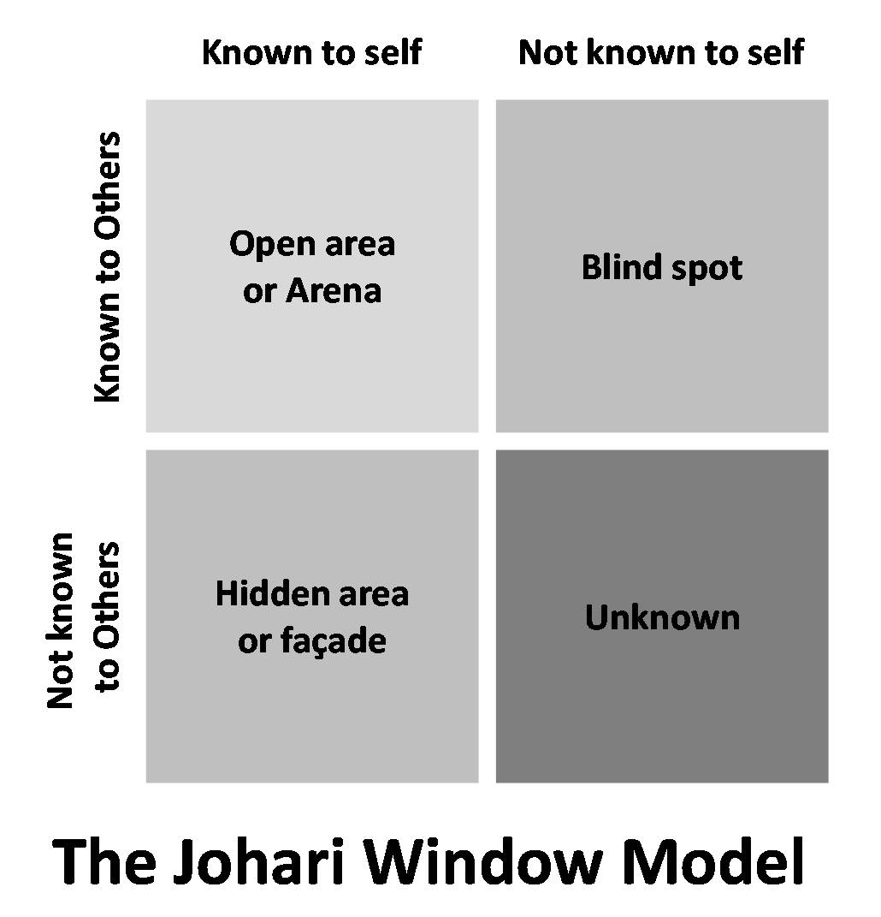
Learning style questionnaire
A learning style questionnaire shows the person who is filling out the questionnaire what kind of person and what kind of learning style they have, when taking this questionnaire the person may find that their style and the person they are is the same, however some people may find that their learning style and the type of person they are isn’t what they thought. This isn’t to say however that the way they thought before is wrong, this questionnaire should just shed light on how maybe a person should change the way they learn to compliment the type of person they are. The questionnaire consists of 4 different categories they are activist, pragmatist, theorist and reflector. When I took this questionnaire my result was that I am a theorist. This was a surprise to me as I thought I was a pragmatist and even though they were close in the final result I was surprised to see that I got a higher overall for theorist.

The importance of this questionnaire is very well explained in Harold Pashler, Mark McDaniel, Doug Rohrer, Robert Bjork Psychological science in the public interest 9 (3), 105-119, 2008 sage journals. It explains that every person has a different learning style and what is most important to the person. “The term “learning styles” refers to the concept that individuals differ in regard to what mode of instruction or study is most effective for them.”

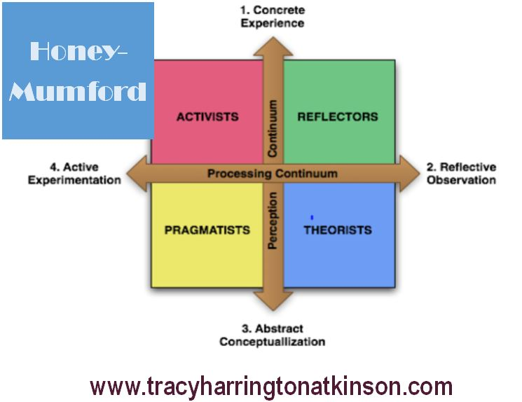

Kolb’ reflective cycle
Russ Vince Journal of management education 22 (3), 304-319, 1998 sage journals.

“These developments are intended to acknowledge additional, often omitted, aspects of learning from experience within management education and development.”

The kolb cycle describes the learning style developed by David Kolb. It consists of 4 different stages which are, reflective observation, abstract conceptualisation, active experimentation and concrete experience. These are there to show that no matter which way you learn you will go through all of these phases while learning,
The learning cycle consists of four quadrants, each of which is associated with a particular learning style or preference.” John N Harb, S Olani Durrant, Ronald E Terry
Journal of engineering education 82 (2), 70-77, 1993

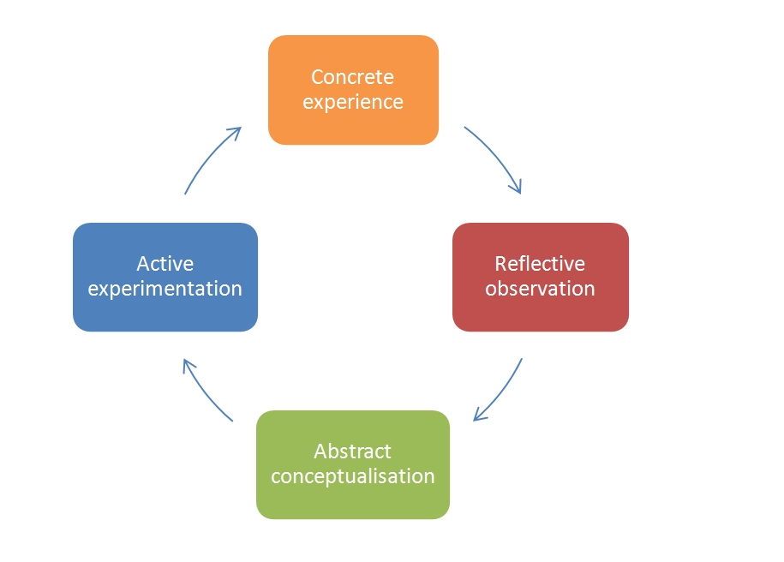

Conclusion

In this report I have included all the skills and techniques I have learned over my time at university. I have used some of these skills before in different variations before in my life however with these techniques I have honed my skills and my knowledge of what it means to have a good learning style and finding out that I am a theorist in nature was a big surprise for me. My favourite technique definitely has to be the S.W.O.T analysis, as it helped me think about all my strengths, weaknesses, opportunities and my threats. Although I have always known my strengths and weaknesses the addition of learning about the opportunities and the threats in my life have opened my eyes to new possibilities and more importantly it has shown me the abilities I posses. The fact that I have strong skills in technology is something I cherished however learning that this may also be a threat due to the inclusions of Ai and working from home which would lead to staff shortages showed me that even though something may be a good thing there are always 2 sides to a story. The more I studied upon the Johari window the more I realised how important it is for someone to know how they themselves and others perceive you. It taught me that if I don’t try something I will never know if I’m good at it, I’m addition it taught me not to show everything I am capable of as it may not be the same as I see it. Others may see me as arrogant even though I believe I am not. Doing the learning style questionnaire was fun as the questions included resonated a lot with me and I had a lot of results which were very close by one or two points in fact. The only definite category I know I don’t fall under is activist as the others I scored 11,12,13 the activist category I only scored a 6. So I may bounce around being a theorist, pragmatist or a reflector and I believe that having that balance is important as not every learning style would work for different courses and assignments. In conclusion this report and my time at the university was enjoyable, informative and engaging. Having to think hard about my qualities, skills, strengths and weaknesses in detail was very difficult but needed as now I understand more about my self.

List of references

Dr. Doug Leigh. (2009). SWOT analysis. Wiley Online Library. 1-3(5), p.19.

Harold Pashler, Mark McDaniel, Doug Rohrer, Robert Bjork Psychological science in the public interest 9 (3), 105-119, 2008 sage journals.

John N Harb, S Olani Durrant, Ronald E Terry
Journal of engineering education 82 (2), 70-77, 1993

James E Stice. (1987). Engineering education. Eric.Ed. 77(5), pp.291-296. [Online]. Available at: https://eric.ed.gov/?id=EJ357319 [Accessed 31 May 2023].

Juanjo Mena-Marcos , Maria-Luisa Rodriguez-Garcia, Harm Tilema. (18 September 2012). Student reflective writing - what does it reveal?. Taylor & Francis Online. 1(1), pp.147-163. [Online]. Available at: https://www.tandfonline.com/doi/abs/10.1080/02619768.2012.713933 [Accessed 31 May 2023]

M Terese Verklan The Journal of perinatal & neonatal nursing 21 (2), 173-174, 2007.

Russ Vince Journal of management education 22 (3), 304-319, 1998 sage journals.

