Site Investigation Case study

Table of contents
3. Introduction
4. Historical archive
7. Borehole analysis
11.Foundation
12. Conclusion
13. References
15. Abbreviations

Map of location as shown in Figure 1

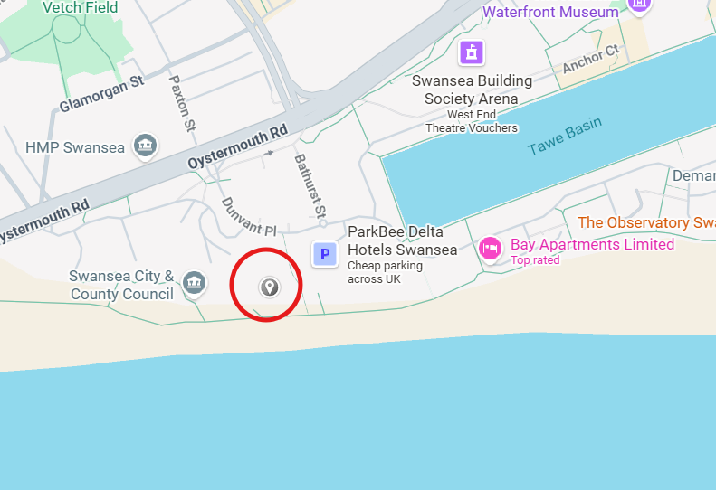
Figure 1: Swansea (Google maps, 2026)

Introduction
We have been tasked with undertaking a Desk Study ground investigation for a development site in Swansea, located adjacent to the Civic Centre on Oystermouth Road in the Maritime Quarter (SA1 3SN). Our client has proposed a two‑storey building that will incorporate a restaurant, an ice cream parlour and a dedicated manager’s apartment, creating a mixed‑use development with both commercial and residential functions.
This initial phase of work will provide the essential baseline understanding of the site’s ground conditions and any associated constraints. The investigation will include a comprehensive historical archive review and a geotechnical ground investigation, incorporating borehole drilling and in‑situ testing. The purpose of this combined approach is to establish the nature, variability and engineering behaviour of the underlying soils and strata, enabling us to determine the most appropriate and reliable foundation solutions for the proposed development.

Historical archives
According to Swansea Port Talbot Docks History (undated) the ‘cutting of the first sod’ of the South Dock began on the 26th of February 1852 and was officially opened the dock on the 23rd of September 1859. Swansea Dock was well known for played a significant role in 19th‑century trade, particularly in the export of large quantities of copper and coal. During this period, Swansea became widely recognised for its thriving copper industry, with materials transported by steam train to the former Swansea Victoria Station on the South Dock as seen in Figure 2.
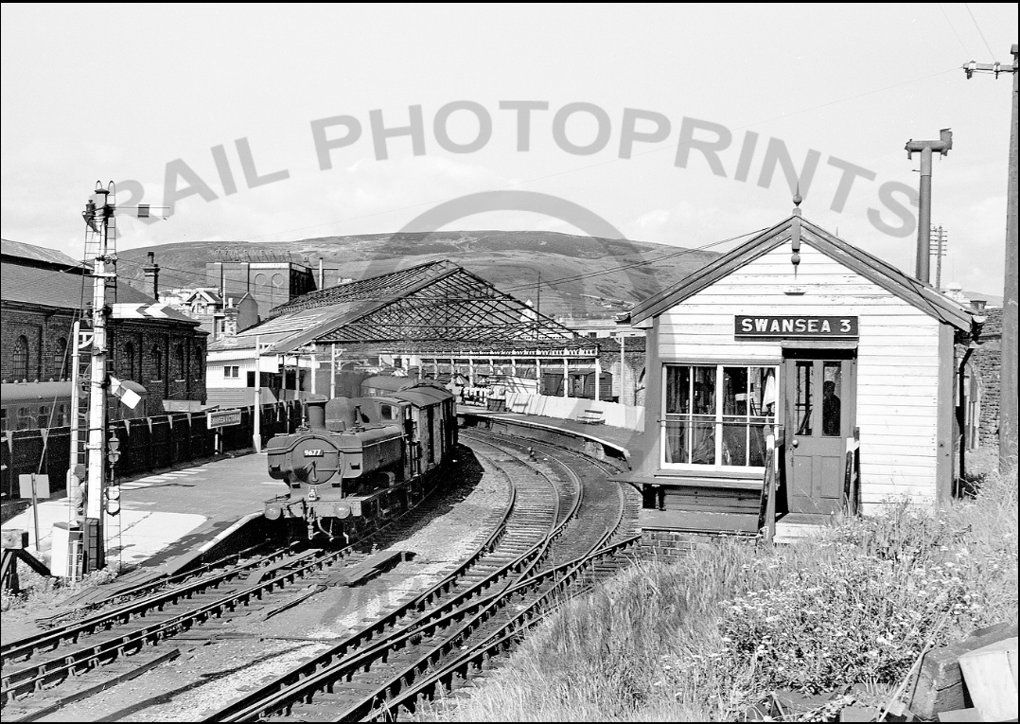
Figure 2: Train at Swansea Victoria Station (Ballantyne, 1990)
Given this industrial history, it is important to consider the potential for ground contamination associated with the former railway station and its connecting railway line. These areas commonly contain ash and slag produced through coal combustion, and such solid industrial residues can pose a risk to nearby watercourses if the ground is disturbed.
Copper itself is an essential nutrient in very small amounts, but elevated concentrations can quickly become harmful. Once copper enters the soil, it binds strongly to fine particles, particularly organic matter and clay, making it persistent and difficult to remove. If the soil becomes acidic or is disturbed through excavation or construction, the copper can mobilise, allowing it to leach into groundwater or wash into surface‑water systems, where it may affect local water quality.
Excess copper also impacts the biological health of the soil. High concentrations can damage plant roots and suppress the microorganisms responsible for maintaining soil structure and nutrient cycling. If copper reaches nearby watercourses, it can be toxic to aquatic life, further emphasising the need for careful assessment and management during any redevelopment or ground‑disturbing activities.
In historic times, the Swansea Gas Works occupied the area near the proposed development, containing large gas storage facilities as shown in Figure 3. When these gas holders were filled, the gas was compressed into a liquid state, and over time leaks may have occurred, potentially contaminating the surrounding land. In modern years, the site has been redeveloped and now accommodates a well-known food store.
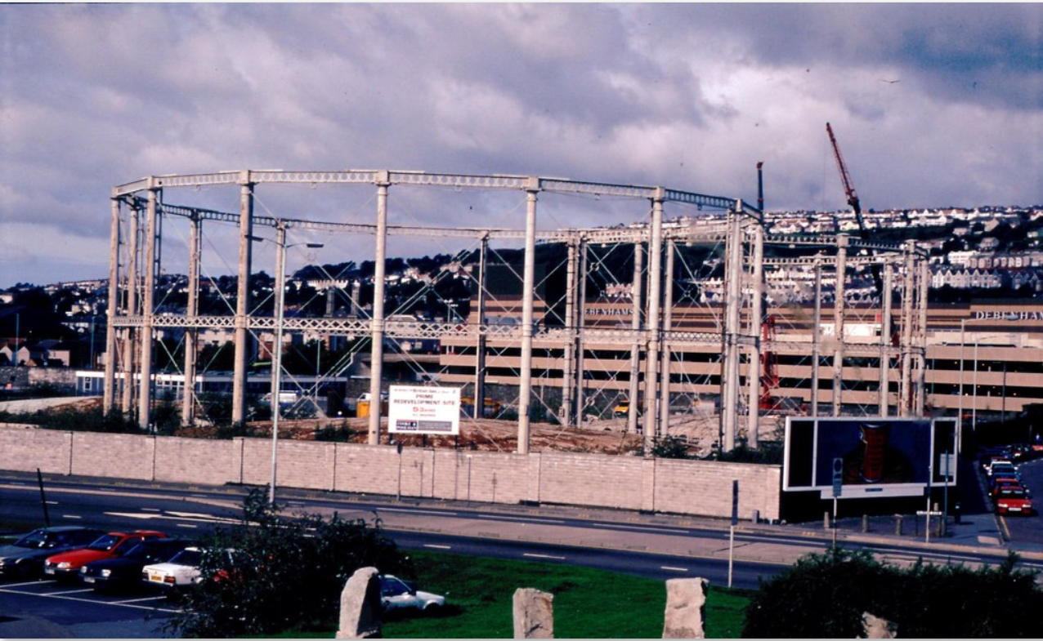
Figure 3: Swansea gas storage tanks (Williams,1990)
According to 1ST line defence, (2026), Swansea experienced around 40 air raids during the Second World War, including an especially intense three‑night bombing campaign in February 1941. Also from 1ST line defence, (2026), Unexploded Ordnance (UXO) Considerations
Before any intrusive ground investigation or construction activity is undertaken, developers and site operatives should give due consideration to the potential presence of unexploded ordnance (UXO). This is typically assessed through either a Preliminary UXO Risk Assessment or, where required, a Detailed UXO Risk Assessment. These assessments form the initial stage of a structured UXO risk‑mitigation process and should be completed at the earliest opportunity in the project lifecycle, in accordance with CIRIA C681 guidance.
Where a credible UXO risk is identified, appropriate mitigation measures must be implemented to ensure the risk is reduced to a level that is as low as reasonably practicable (ALARP). Equally, it is important to avoid unnecessary mitigation where the assessed risk does not justify such measures.
Although Swansea experienced significant bombing during the Second World War, this does not automatically mean that all development sites within the city present a high UXO risk. The level of risk is highly dependent on the specific location and its historical land use.
A robust UXO Risk Assessment will consider a range of site‑specific factors, including:
whether the site footprint was directly affected by bombing
the extent and nature of any recorded damage
historical land use and levels of human activity
the ground conditions present at the time of bombing
The assessment must also consider post‑war redevelopment, including the extent of excavation, ground disturbance, and construction activities that may have already removed or exposed any ordnance. These combined factors help determine the likelihood that UXO could have fallen on the site, remained undetected, and potentially still be present within the subsurface.

An archaeological survey is required prior to any excavation works due to the significant historical activity in the surrounding area. According to Story of Mumbles, (2012), archaeologists uncovered a preserved Bronze Age timber ‘roadway’ off Norton in Swansea Bay in 2012, estimated to be up to 5,000 years old, providing clear evidence of early human activity in the region. Additional discoveries include the remains of preserved trees, some dating back as far as 7,000 years, indicating that the area now known as Swansea Bay was once a densely wooded landscape.

Borehole analysis

Historic borehole records as shown in the below report, indicate that the first 4.95 m of ground across the surrounding area is made up ground. This upper layer is a mixed deposit made up of ashes, sand, stoney clay and fragments of brick materials commonly associated with Swansea’s long history of land reclamation. Industrial waste and demolition rubble were frequently used to raise and stabilise coastal ground, and the composition here reflects that practice.
Below this, the next 3 m consist of a substantial band of sandy gravel, with occasional pockets of sandy clay and areas of dense brown sand containing some gravel. These deposits are typical of reworked or naturally accumulated shoreline materials, which fits with the site’s proximity to the former dockside.
From around 7 m down to the final borehole depth of 22 m, the ground becomes progressively stronger. The sequence moves from stiff gravelly boulder clay into very stiff boulder clay, before finally reaching competent mudstone at the base. This transition shows a clear increase in strength and consolidation with depth, and the presence of mudstone indicates a reliable, high‑capacity stratum that would offer excellent long‑term stability for foundation design.
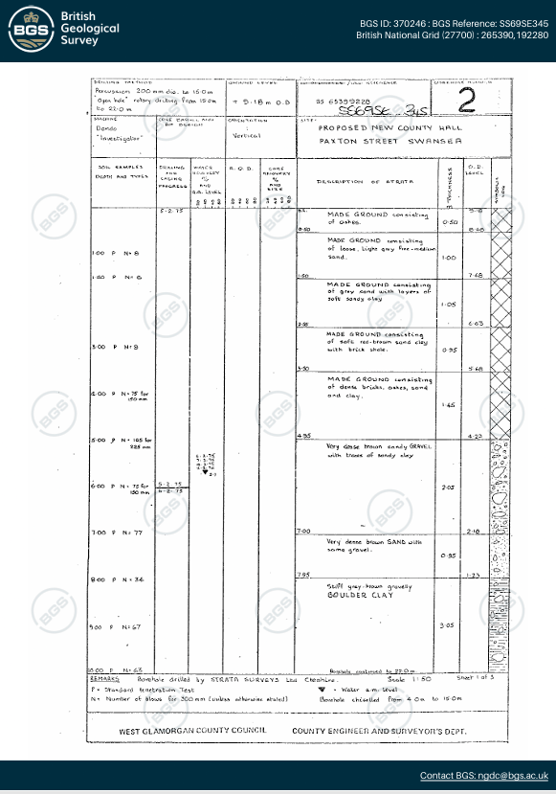
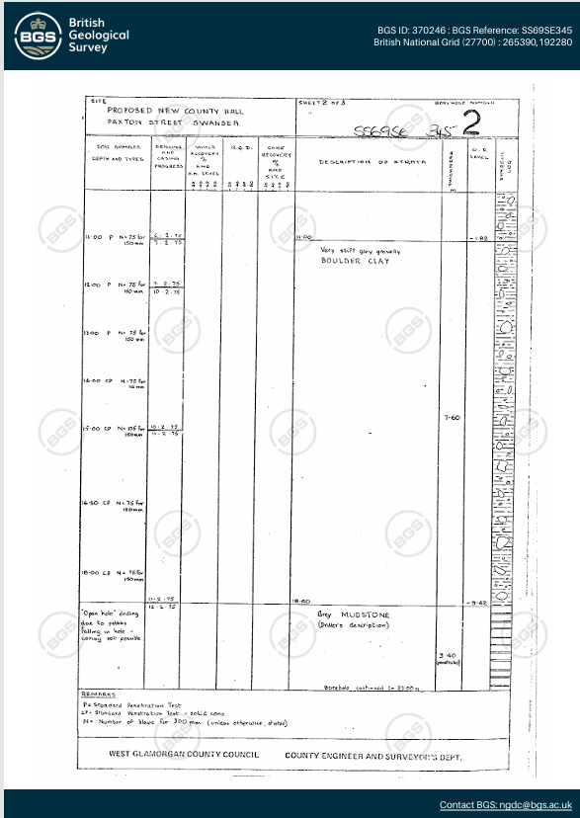
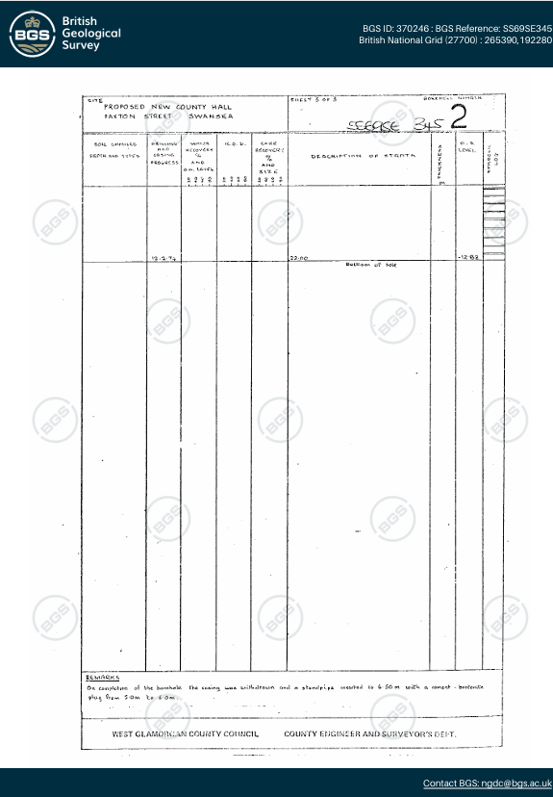
Figure 5: (British Geological Survey 1975)

Additional ground investigation at the site would be beneficial to establish a more complete understanding of the underlying ground conditions and confirm the full sequence of strata present. This should ideally be undertaken through borehole drilling, as the available information suggests that the ground is likely to be too unstable for open‑cut trial pits. The high sand content observed in previous cores indicates a risk of sidewall collapse, making open excavation both impractical and potentially unsafe without significant temporary works.
Historic photographic records also illustrate the considerable depth of excavation required during the construction of the adjacent County Hall as seen in Figure 5, further demonstrating the challenging ground conditions in this area. Attempting to undertake open‑cut excavation for a ground survey at this location would therefore be costly, require extensive planning, and necessitate a detailed risk assessment and method statement to ensure safe working practices. Borehole investigation represents a more efficient and controlled approach for characterising the subsurface at this site.
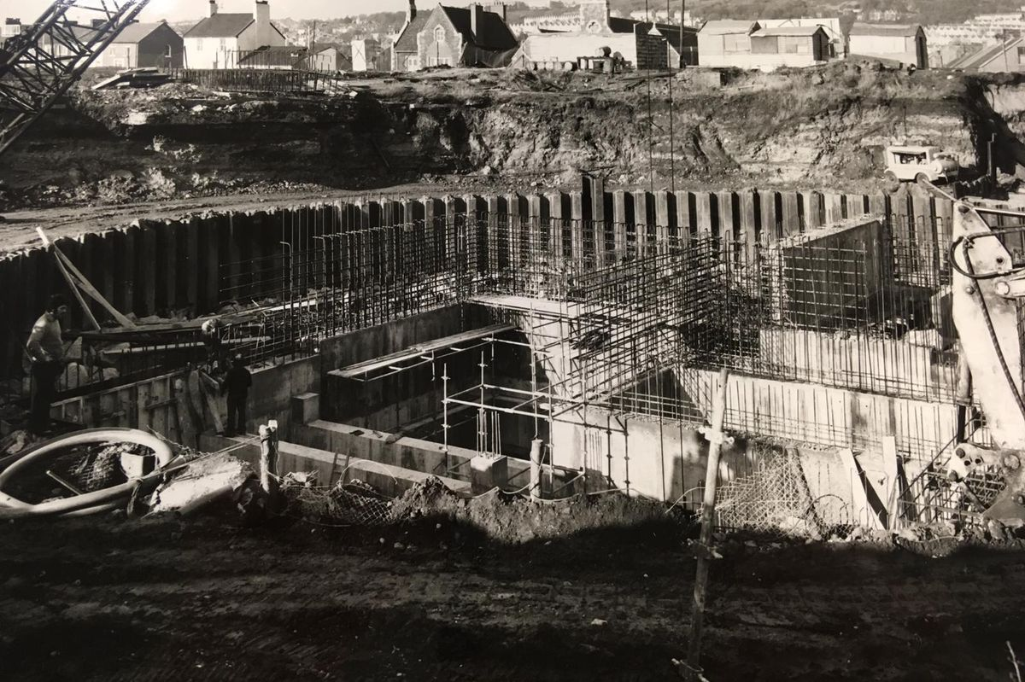
Figure 5. Swansea Council archives/ West Glamorgan Archive Service

Foundation of choice

The best form of foundation for the ground condition in this area would be a mixture of a raft foundation and a friction pile foundation.
According to Engineeringfix (2025) A friction pile is a type of deep foundation used when the upper soil layers are too weak to support a structure on their own. Instead of relying on shallow ground, a long, slender element usually reinforced concrete or steel is driven or bored to greater depths. Its purpose is to reach soil layers capable of providing resistance through surface contact. Unlike end‑bearing piles, which transfer load to a firm layer at the tip, a friction pile carries the building’s weight along its entire length. Its effectiveness depends on the frictional interaction between the pile’s outer surface and the surrounding soil.
According to LABC (2018) A raft foundation is a large reinforced‑concrete slab that sits beneath the entire footprint of a building or extension, effectively allowing the structure to “float” on the ground. By covering a wide area, this type of foundation spreads the building’s load more evenly, which reduces the pressure applied to the underlying soil compared with more concentrated foundation systems.
According to Speedeck (2025) Piled‑raft foundations provide a strong and economical solution by combining the wide load‑spreading capacity of a raft with the deeper ground support offered by piles. This integrated approach enhances overall stability, improves performance on variable or weaker soils, and offers a versatile foundation system suited to a range of ground conditions see Figure 6.
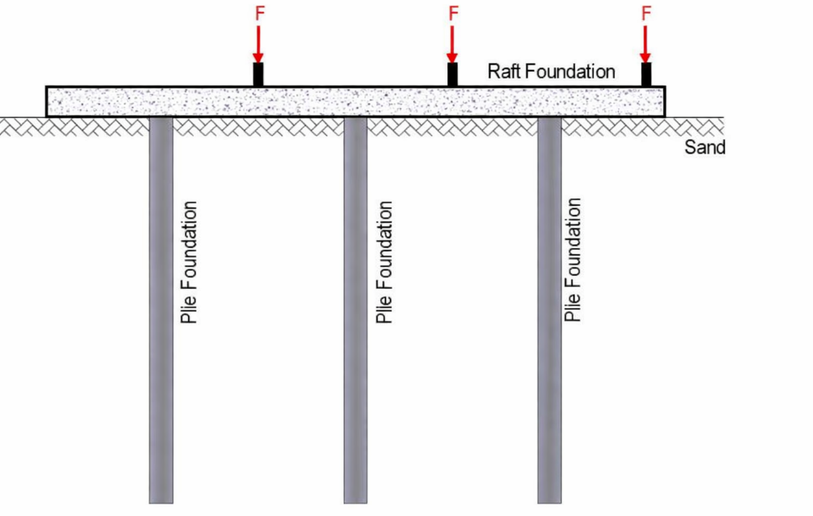
Figure 6: Design of Piled Raft Foundations (Designed by Obinna 2024)
Conclusion
The Desk Study has established that the proposed development site is situated within an area of historically reclaimed dockland, shaped by extensive industrial activity, railway operations and significant wartime events. The available evidence indicates that the ground conditions are likely to consist of variable made up ground overlying granular shoreline deposits, reflecting the long history of land‑raising and redevelopment within Swansea’s Maritime Quarter.
Historical archives highlight several potential contamination sources, including industrial ash, slag, copper residues and possible off‑site migration from former gasworks. These materials introduce uncertainty regarding soil quality, environmental risk and the potential for long‑term pollutant mobility. The presence of made ground also raises concerns regarding differential settlement, buried obstructions and variable bearing capacity. While the site is not automatically considered high‑risk for unexploded ordnance, Swansea’s documented bombing history means that UXO remains a credible hazard requiring formal assessment.
Overall, the site presents a combination of moderate geotechnical, environmental and construction‑related constraints, all of which are manageable through appropriate investigation and engineering design. The findings in this Desk study assessment provide a strong foundation for planning the next phase of ground investigation and ensuring that the proposed development can proceed safely and efficiently

Reference list
Google maps (2026) Google maps, Maritime Quarter Swansea SA1 3SN 51.613771,-3.946525 Google Maps (Accessed: 12 April 2026)
Swansea Port Talbot Docs History (undated) Available at: Swansea and Port Talbot Docks Website (Accessed: 14 April 2026)
Williams, J (1990) Swansea gas storage tanks. Available at: Gasworks before Tescos was built on the... © J WILLIAMS cc-by-sa/2.0 :: Geograph Britain and Ireland (Accessed: 18 April 2026)
Ballantyne, H (1964) Train at Swansea Victoria Station. Available at: Rail Photoprints | 1948 - 1967 Locos 9000 - 9999 (Accessed: 18 April 2026)
1stLinedefence (2026) Available at: UXO Risk in Swansea | UXO City Guide | 1st Line Defence (Accessed: 14 April 2026)
British Geological Survey: (1975) (PROPOSED NEW COUNTY HALL PAXTON STREET SWANSEA 2) SS69SE345, British Geological Survey. Available at: GeoIndex - British Geological Survey (Accessed: 14 April 2026)
Robert Dalling(2019) ‘Swansea’ Forgotten houses and the birth of one of Swansea's best known buildings captured in fascinating images. Volume 2 (March) Available at: Forgotten houses and the birth of one of Swansea's best known buildings captured in fascinating images | Wales Online Accessed: (Accessed: 18 April 2026)
Engineeringfix (2025) How Friction Piles Work: The Mechanism of Skin Friction. Available at: How Friction Piles Work: The Mechanism of Skin Friction - Engineer Fix (Accessed: 18 April 2026)
LABC (2018) Raft foundation basics. Available at: Raft foundation basics | LABC (Accessed: 18 April 2018)
Speedeck (2025) Piled Raft Foundations Explained: The Ultimate Guide. Available at: The Ultimate Guide to Piled Raft Foundations (Accessed: 18 April 2026)
Obinna, U (2024) Design of Piled Raft Foundations. Available at: Design of Piled Raft Foundations - Structville (Accessed: 18 April 2026)
Storyofmumbles (2012) Bronze Age 'roadway' in Swansea Bay. Available at: Bronze Age 'roadway' in Swansea Bay - The Story of Mumbles (Accessed: 21 April 2026)

Abbreviations
Unexploded Ordinance (UXO)
As Low as Reasonably Practicable (ALARP)

