BSc Software Development
Computer Architecture and Operating Systems
ACCA4022
Morgan Combstock
2014028

Contents
Introduction 2
Key Functions of Operating Systems 2
Command Line Interface (CLI) Commands in Windows 2
CLI Commands in Linux 4
Batch Scripts in Windows 4
Bash Scripts in Linux 5
Conclusion 5
References 6

Introduction
This report will look at what operating systems are, their key functions and highlight examples of how different command line interfaces can be utilised. It will also comment on any key findings and learning.

Key Functions of Operating Systems
An operating system is software that manages the resources of a computer [1]. It acts as an interface between the user and computer. Generally, this could be thought about with regard to using a personal computer or laptop, using a general-purpose operating system. That said, there are other types of operating systems such as mobile, network and embedded operating systems. Mobile operating systems run exclusively on small devices such as smartphones, tablets and wearables [2]. A network operating system is an operating system designed for the sole purpose of supporting workstations, database sharing, application sharing and file and printer access sharing among multiple computers in a network [3].
One of the key functions of an operating system is to manage inputs and outputs. This could include, mouse clicks and movement, touchscreen taps or outputting data to a monitor. They also have other functions like managing computer resources and executing services for application software [4]. File system management is another function OSs carry out.

Command Line Interface (CLI) Commands in Windows
As mentioned above, file management is an important function of an operating system. This can be done in the command line or PowerShell terminal. In the screenshots below, you can see navigation around the file system. Using the dir command, all the files and folders in the current directory are displayed.
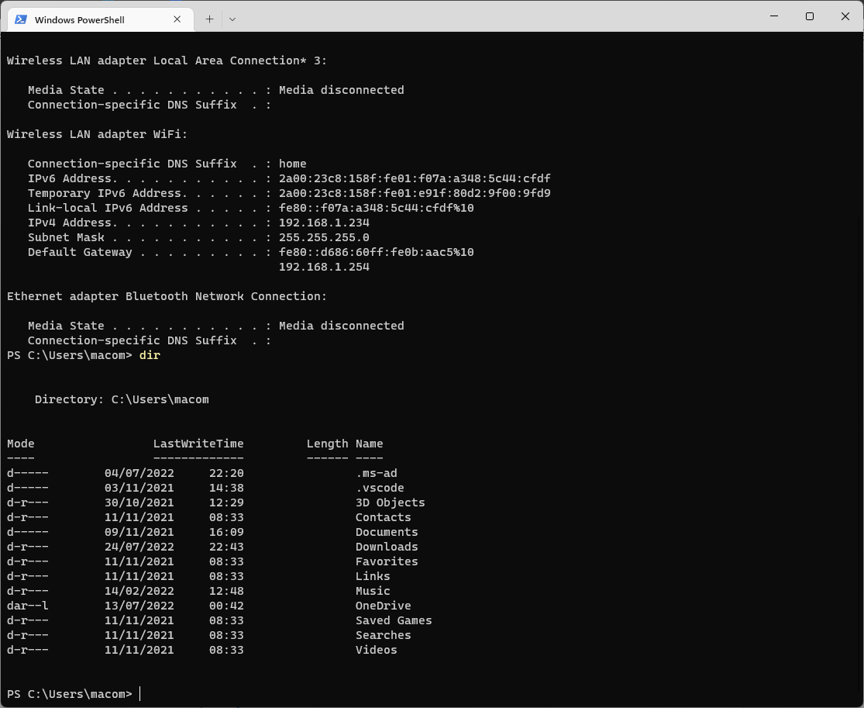
From here, you can also navigate down into directories and create files.
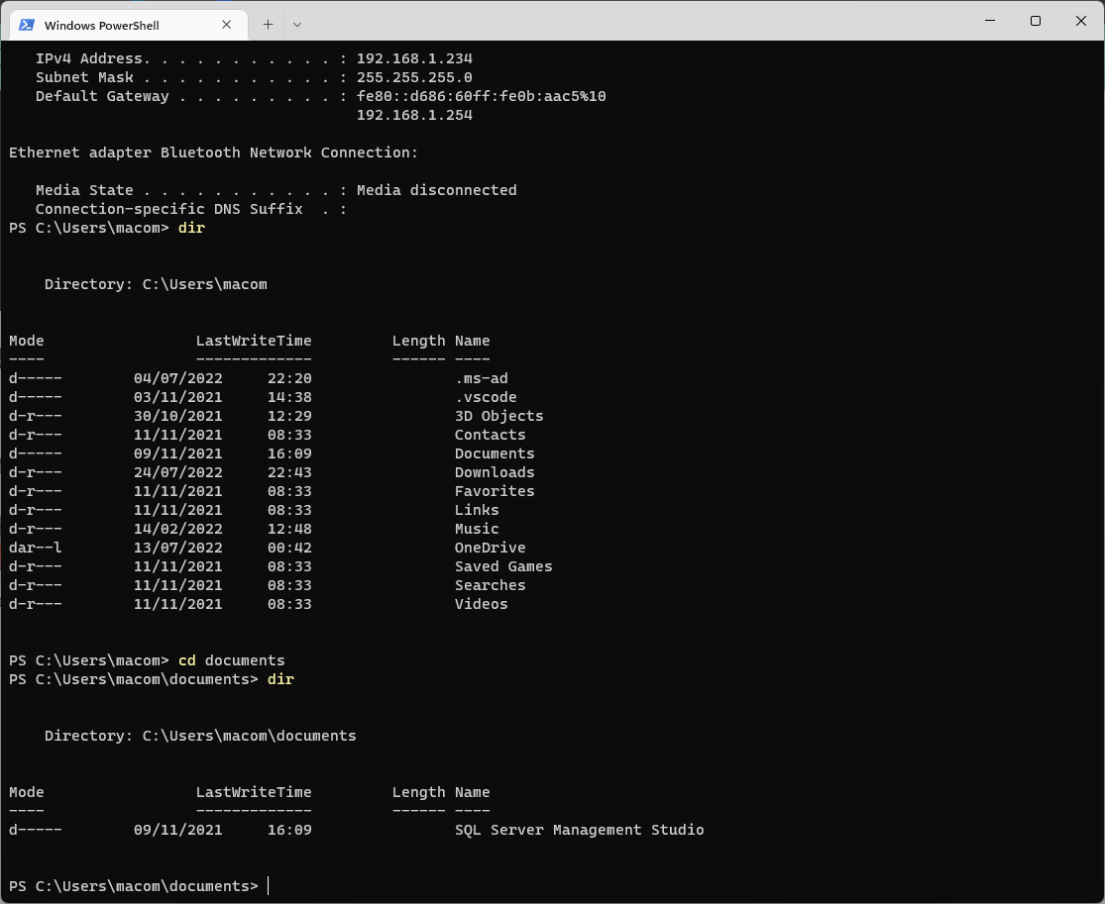
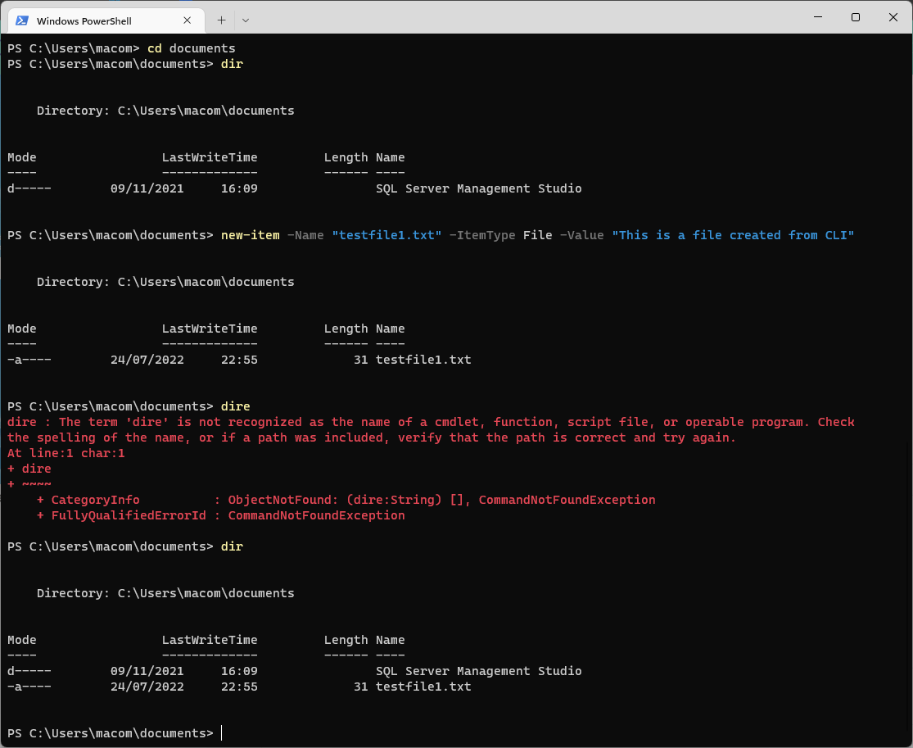
As shown above, the new item command can be used to create a file [5]. One reason you might use the CLI is because it uses less system resources than using the graphical user interface (GUI) [6]. CLI also has advanced and more powerful capabilities than native GUI.

CLI Commands in Linux
Similar to the CLI commands in windows, Linux can execute commands entered in its CLI. One advantage to using Linux is that it tends to run faster than windows OS. The linux CLI has similar commands to the windows CLI such as whoami, clear and cd. The dir function is called using the ls command in linux. It can also handle network commands like ipconfig, ping and traceroute. It can also be used to assign read, write and execute functions to a file based on user, group or other permission levels.

Batch Scripts in Windows
Batch, or bat, scripts in windows can be used to carry out many functions. They are incorporated to automate command sequences which are repetitive in nature [7]. They can be written directly into the command line or can be developed in a code editor such as visual studio or notepad++. Bat scripts are powerful as they can handle user inputs, lists or arrays, variables and loops. Shown below is a variable called _varName. This is assigned a value and then that is shown as an output.
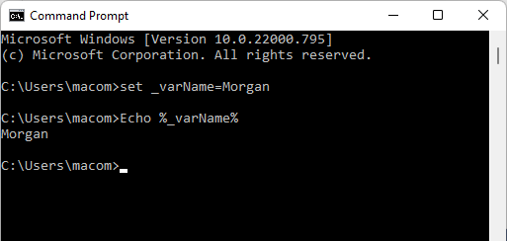

Bash Scripts in Linux
Bash scripting is essentially the equivalent to bat scripts in windows. Bash (Bourne Again Shell) is the free and enhanced version of the Bourne shell distributed with Linux and GNU operating systems [8]. Again, variables can be declared and used at other points in the script. It does however, have useful built-in functions such as let. Using the let function, a variable can be declared with an in line mathematical operation.

Conclusion
As has been shown above, operating systems are an essential part of computers, mobile devices and other systems. Operating systems allow the user to interact with the hardware and software. This can be done via a GUI or using some of the powerful command line interface commands demonstrated and mentioned.

References

[1] | GeeksforGeeks, “What is an Operating System?,” 16 06 2021. [Online]. Available: https://www.geeksforgeeks.org/what-is-an-operating-system/.
[2] | Indeed Editorial Team, “6 Types of Operating Systems (With Functions and Examples),” 18 05 2022. [Online]. Available: https://www.indeed.com/career-advice/career-development/types-of-operating-systems.
[3] | Techopedia, “What Does Network Operating System (NOS) Mean?,” 2022. [Online]. Available: https://www.techopedia.com/definition/3399/network-operating-system-nos.
[4] | CompuHoy.com, “What are the 6 main functions of an operating system?,” 17 02 2021. [Online]. Available: https://www.compuhoy.com/what-are-the-6-main-functions-of-an-operating-system/.
[5] | DelftStack, “Create Text File Using Windows PowerShell,” 06 02 2022. [Online]. Available: https://www.delftstack.com/howto/powershell/powershell-create-text-file/.
[6] | G. Domantas, “What Is CLI?,” 17 05 2022. [Online]. Available: https://www.hostinger.com/tutorials/what-is-cli.
[7] | TutorialsPoints, “Batch Script - Quick Guide,” 2022. [Online]. Available: https://www.tutorialspoint.com/batch_script/batch_script_quick_guide.htm.
[8] | P. Loshin, “bash (Bourne again shell),” Tech Target, 01 12 2021. [Online]. Available: https://www.techtarget.com/searchdatacenter/definition/bash-Bourne-Again-Shell.

