Programme: BA International Hotel Management

Module: Financial Management for the Hotel Industry

Student Name: Rezwana Laboni
Student ID: 2242894
Module Code: BMIH5007
Lecturer Name: Tristan Hawkins

Executive Summary
Shangri-La Hotels and Premier Inn Hotels are both in the hotel industry. However, their source of revenue, there potential for market growth and how they position themselves against other competitors are quite different than one another. This is particularly because one operates in luxury segment and the other operates in budget-friendly segment of the hotel industry. Both these companies are responsible for their CSR activities as well. This report will dive into many different aspects of these two hotels and their operations as well as provide recommendations on how they can increase their business further.
Contents
Executive Summary 2
Introduction 4
Total Revenue 5
Shangri-La Hotels 5
Premier Inn Hotels 6
Market Position 7
Shangri-La Hotels 7
Premier Inn Hotels 8
Growth Potential 9
Shangri-La Hotels 9
Premier Inn Hotels 9
CSR Activities 10
Shangri-La Hotels 10
Premier Inn Hotels 11
Recommendations 11
Shangri-La Hotels 11
Premier Inn Hotels 12
Conclusion 13
References 14

Introduction
In the tourism and hospitality industry, the hotel business is one of the most important ones. Due to globalization, people tend to visit different places and countries outside of their hometown or country. When visiting these new places, tourists look for hotels that will serve their needs (Nutsugbodo, 2016). Despite being in the same industry, different hotels offer different services to their customers. Some provide extravagant, luxurious service to their customers to make sure they have the best time during their stay. Others focus on providing budget-friendly service. In this report, we will focus on two such hotels, Shangri-La Hotels and Premier Inn Hotels. Although they both share the same hotel industry, each has positioned itself differently, has a different customer base and has different potential for growth.

Total Revenue
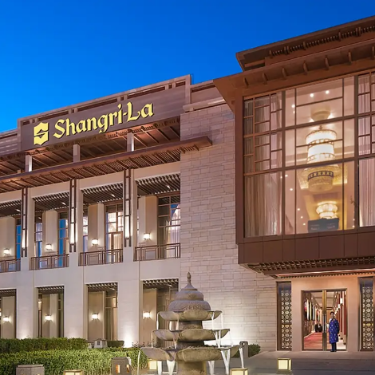  Illustration: Shangri-La Hotels | 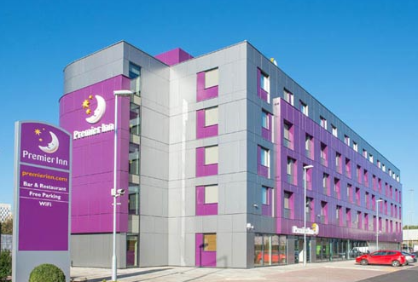  Illustration: Premier Inn Hotels
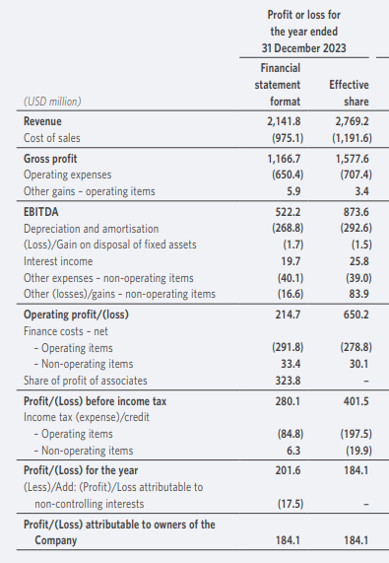  Illustration: Profit and Loss Statement of Shangri-La Hotels | 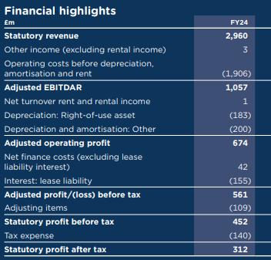  Illustration: Profit and Loss Statement of Premier Inn Hotels

Shangri-La Hotels
Shangri-La Hotels is a luxury hotel chain that targets customers who want to enjoy premium services. They offer a variety of high-end services that include room rent, spa services, fine dining, and events such as weddings and conferences (Kee et al., 2020). These helped the hotel to generate high revenue of $2141.8 million in 2023 (Shangri, 2023). Since this is a luxury hotel, they have a large number of staff to serve their clients. This high staffing level contributes significantly to the company's expenses resulting in cost of sales of $975.1 million. Also, their luxury properties have high maintenance costs (Ihsan and Alshibani, 2018). Since their clients are also people of high value, marketing the hotels' services to them also results in significant cost increases which decreased the gross profit of $1,166.7 million to $214.7 million. Expansion into new markets will also help to gain access to new customers. This will help the hotel chain to earn more profit in the future. However, political instability in different countries hinders the hotel from expanding in those countries.

Premier Inn Hotels
Premier Inn Hotels is a budget-friendly hotel that provides services to people who are not looking for luxury services. This is one of the largest hotel chains in the United Kingdom with more than 800 hotels (Premier, 2024). The room service in Premier Inn Hotels is cheaper than that of luxury hotels. Their revenue is derived from lower room services provided by the company. The revenue sources of Premier Inn Hotels include add-ons such as parking fees and wi-fi services which totaled $2960 million (Whitebread, 2023). They focus on providing services to a large number of clients with efficiency. The main cost drivers of Premier Inn Hotels include hotel maintenance fees, staff wages, and auxiliary fees which totaled $1906 million. As the hotel does not offer luxury services, they have lower depreciation cost of only (183+200) = $383 million. The revenue stream at Premier Inn Hotels has been stable because the hotel chain focuses on both business and leisure travelers who are looking for a good hotel in their budget (Premier, 2024).
There are many differences visible in the business of the two hotels. The main difference between Shangri-La Hotels and Premier Inn Hotels is the services they provide to their customers. While Shangri-La Hotels focuses on providing luxury services to a few high-value customers, Premier Inn Hotels focuses on providing service to the mass client base at a cheaper price (Qi et al., 2017). Shangri-La Hotels gets their revenue mainly from luxury demand in the market. Premier Inn Hotels on the other hand gets their revenue from a consistent budget-conscious traveler base. Each hotel has its own way of providing service to its customers and growing its business.

Market Position

Shangri-La Hotels
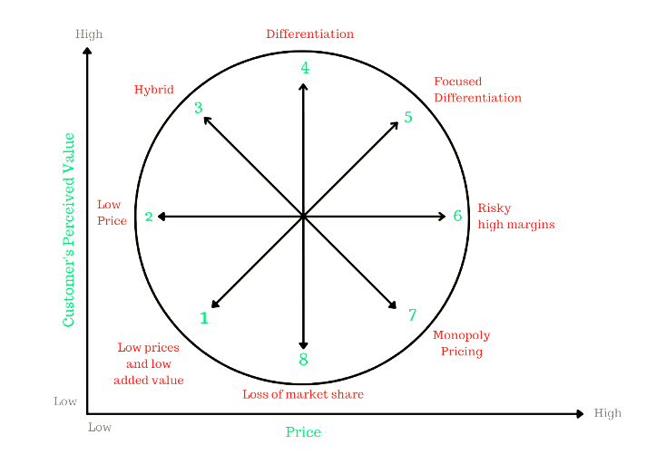
Shangri-La Hotels

Illustration: Bowman's Strategic Clock for Shangri-La Hotels
Position in Bowman’s Clock: Shangri-La Hotels is a reputed hotel chain serving the luxury hotel segment. Their main customers are the people seeking luxury services. This includes luxury travelers, business executives, and tourists seeking premium experiences in their travel. The company has a strong presence in Asia-Pacific, the Middle East, and other international markets where luxury hotel experience is in demand (shangri-la, 2023). The hotel is on differentiation and focused differentiation fraction where they focus on providing luxury service. Their luxury service has high perceived value and cost premium price. Their premium services are more appealing to the customers in the higher income bracket because of their price (Shammout, 2020). Their services are appealing to travelers who are seeking premium experiences.
Brand perception: Shangri-La Hotels is reputed as a luxury brand that is an expert in Asian hospitality and culture. Customers have a positive perception towards this hotel. Customers know they will receive premium service if they visit Shangri-La Hotels (shangri-la, 2023).

Premier Inn Hotels
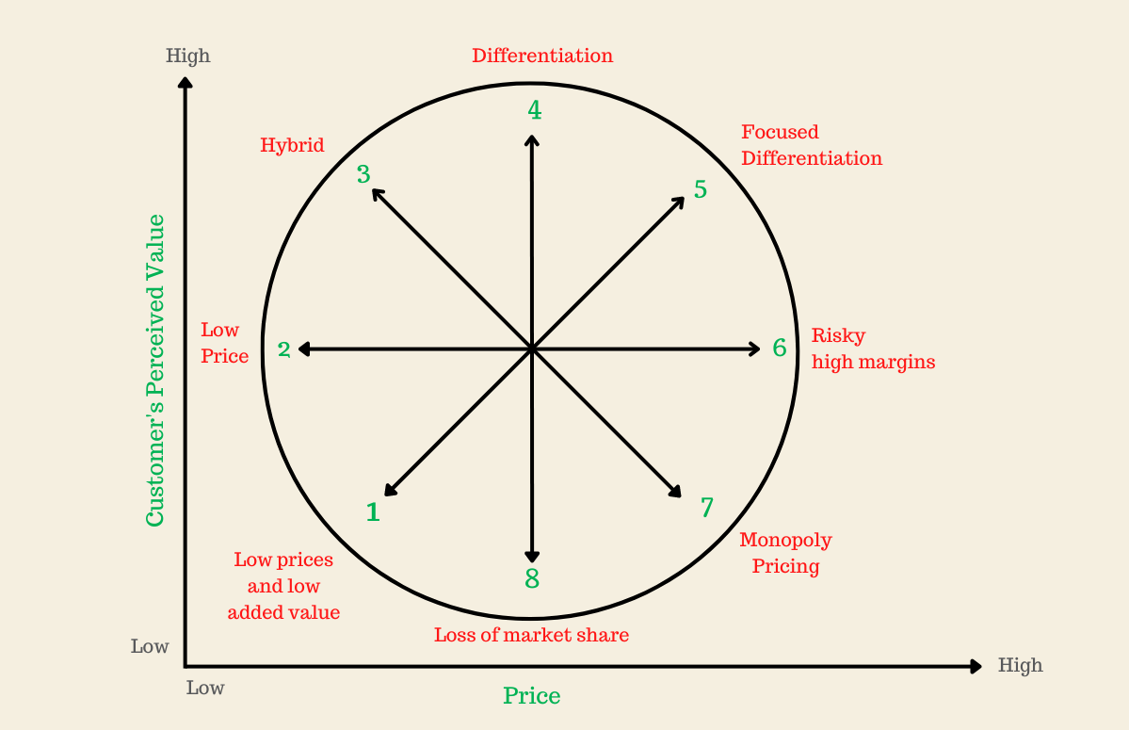
Premier Inn Hotels
Illustration: Bowman's Strategic Clock for Premier Inn Hotels
Position in Bowman’s Clock: Premier Inn Hotels is one of the largest hotel chains in the United Kingdom with more than 800 hotels throughout the country. Their competitive price with their provided service makes them popular among tourists looking for a good time on a friendly budget (Laowicharath, 2017). Their reputation in the budget-friendly hotel segment makes them popular with customers. This puts them in the low price and hybrid section. They mainly focus on being competitive with their lower price. The main competitors of Premier Inn Hotels include Travelodge and Ibis. Premier Inn Hotels customers mainly fall in the middle-income bracket (Laowicharath, 2017). These people want to enjoy themselves by themselves or with family but are cost-conscious. Also, since the hotel has many locations, they are a familiar face to the customers looking for a good time within budget.
Brand perception: Premier Inn Hotels is regarded as an affordable and reliable hotel chain to the customers. The hotel is able to provide consistent service at an affordable price. Like many budget-friendly hotels, it is associated with comfort and practicality (Subramanian et al., 2016). Their strong reputation for value for money is what makes their customers see them in a positive light.
The difference in the market position of the two hotels is quite significant. While Shangri-La Hotels is in differentiation and focused differentiation segment, Premier Inn Hotels is reputed for its good service at a reasonable price at low price and hybrid segment. Shangri-La Hotels is perceived as a provider of luxury service by its high-earning customers. Premier Inn Hotels on the other hand is perceived as a value-for-money service provider by its middle-income customers.

Growth Potential

Shangri-La Hotels
Expansion Strategies: Shangri-La Hotels has been advancing its expansion by offering its luxury service to emerging new markets in China, Southeast Asia, and the Middle East. The hotel group is also increasing their presence by opening new locations in urban areas and places where tourism is growing popular (Song et al., 2023). The long-term plan of Shangri-La Hotels is to gain a large market share by tapping into the international tourism industry while focusing mainly on luxury services and accommodation.
Market Opportunities: In the upcoming years, Shangri-La Hotels has enormous growth potential, especially throughout Asia-Pacific, particularly in China. As more disposable income is available to people, they are becoming more interested in luxury travel (Zhang, 2019). Also, as one of the biggest economies in the world, many business officials want to have a luxury travel experience opening a gateway of opportunity for Shangri-La Hotels. People around the world are becoming more aware of the environment and want hotels to provide sustainable sources for their business. Shangri-La Hotels can offer sustainable, eco-friendly services, resorts and hotels to appeal to customers.
Barriers: Shangri-La Hotels faces a variety of challenges in their business operation. The luxury segment of the hotel industry is very competitive. Competitors frequently offer new services to their customers and attempt to draw customers over. Not to mention, economic downturns and pandemics like COVID-19 can have major negative effects on business operations (Arthi and Parman, 2021). The maintenance cost of managing the luxury business is also of concern for Shangri-La Hotels.

Premier Inn Hotels
Expansion Strategies: Premier Inn Hotels is one of the biggest hotel chains in the United Kingdom. The group has more than 800 hotels in different locations to serve customers looking for affordable accommodation. To expand its operations outside of the domestic border, the group has also made an effort to operate in Germany. Their strategy is to provide affordable, standardized accommodations to customers (Premier, 2023). This makes them a popular choice among tourists.
Market Opportunities: As people are earning more, they have access to more disposable income. These new earners are looking for a good travelling experience or to have a relaxing time with their family. They want to visit places in their travel but do not want to spend too much. They offer a great opportunity to Premier Inn Hotels as the group has expertise in providing good service at an affordable price. Since the business has started operating in Germany, it has an opportunity to attract tourists there and grow Premier Inn Hotels' market share. The group is also exploring new formats, such as "Hub by Premier Inn" which is a compact efficient accommodation service (Premierinn, 2024).
Barriers: While Premier Inn Hotels operates its business by providing competitive prices, the company also has to balance its profit and cost. If the hotel asks for a higher price, competitors will take its customers (Sardianou and Kostakis, 2020). However, if the price is too low, the hotel will be unable to earn a profit. Also, the hotel has to make a balance between affordability and quality of service.

CSR Activities
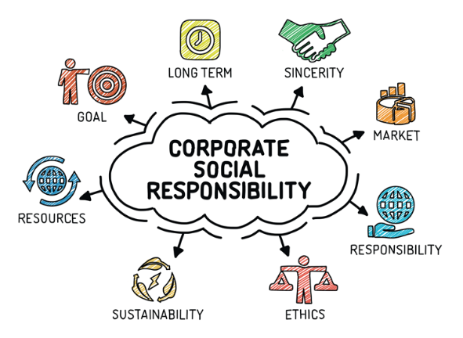
Illustration: Corporate Social Responsibility

Shangri-La Hotels
Corporate Social Responsibility or CSR activities by organizations have become an important part of business operations. The CSR activities are conducted for the betterment of the environment, customers and all the stakeholders of the company. Shangri-La Hotels is also committed to providing CSR activities (Shangri, 2012). The company is particularly cautious in areas such as sustainability, environmental conservation, and community engagement. The group also has a “Sustainability, Shangri-La’s Social Responsibility” program that focuses on energy efficiency, waste reduction, and sustainable sourcing. Shangri-La Hotels gets 75% of its seafood from sustainable sources (Shangri, 2024). Shangri-La Hotels is also committed to reducing its carbon footprint. The "Green building" initiative of the company includes building energy-efficient buildings, solar energy in various properties etc. The group is also making an active effort to not produce excessive waste for the environment. The company also provides long-term education and care for underprivileged children in many countries through its "Embrace" program. Shangri-La Hotels provides its CSR activities in the financial report of the company.

Premier Inn Hotels
Premier Inn Hotels is also concerned about its CSR activities and actively participates in many CSR programs. Their CSR programs mainly focus on environmental sustainability, community support, and ethical business practices. The group is concerned about the environment it operates in and wants to reduce its carbon footprint. Premier Inn Hotels intends to achieve net-zero status by 2040 (Premier, 2021). The company has allocated substantial resources to reduce carbon emissions and increase energy efficiency. Premier Inn Hotels has also pledged to reduce its plastic waste. For this, the hotel group has decided to lower their use of single-use plastic. Premier Inn Hotels also offers employment and education opportunities to the underprivileged. The Group has partnerships with organizations like Great Ormond Street Hospital and WaterAid. This has made a contribution to healthcare and helped provide safe water for the community. Premier Inn Hotels maintains high ethical standards and gets its ingredients and materials from sustainable sources (premierinn, 2018). In its annual reports and sustainability reports, Premier Inn, a division of Whitbread, provides information on its financial commitment to CSR activities.

Recommendations

Shangri-La Hotels
Shangri-La Hotels can offer the following to generate more revenue for their hotel:
- Shangri-La Hotels should provide eco-friendly luxury options and immersive cultural tourism in order to broaden their customer base.
- As the demand for sustainable tourism is rising, Shangri-La Hotels should invest more on green technology and renewable energy for its properties.
- Shangri-La Hotels should expand operations in high-growth emerging markets, especially in Africa and Southeast Asia.
- Shangri-La Hotels should increase their investment in advanced data analysis to identify what the customers demand and how they can offer them.

Premier Inn Hotels
Premier Inn Hotels can offer the following to generate more revenue for their hotel:
- Premier Inn Hotels should offer more hub by Premier Inn type option in high-population urban area, where customers are cost conscious.
- Premier Inn Hotels should include upsell services like meal plans to its online and offline selling points to increase revenue.
- To attract environmentally conscious guests, Premier Inn Hotels should make larger investments in renewable energy and energy-efficient structures.
- Premier Inn Hotels should also include business-friendly options like business hubs, and meeting rooms to attract diversified customer base.

Conclusion
Both Shangri-La Hotels and Premier Inn Hotels are successful companies that serve the hotel industry. Despite being in the same industry, they have positioned themselves differently based on their services. Their generation of revenue is also quite different as one focuses on luxury items while the other focuses on providing affordable goods. They each have growth potential in their own field. Both the hotels make active contributions to the environment, the community they operate in and the stakeholders as a whole.

References
Arthi, V. and Parman, J. (2021). Disease, downturns, and wellbeing: Economic history and the long-run impacts of COVID-19. Explorations in Economic History, 79, p.101381.
Ihsan, B. and Alshibani, A. (2018). Factors affecting operation and maintenance cost of hotels. Property Management, 36(3), pp.296-313.
Kee, D.M.H., Ang, Z.L., Woh, M.T., Soleimani, M., Jayant, J., Quttainah, M.A. and Pandey, R. (2020). Shangri-La Hotels and Resorts’ People and Culture Strategy in Deriving Employee Satisfaction. Advances in Global Economics and Business Journal, 1(1), pp.1-11.
Laowicharath, Y. (2017). Factors positively affecting purchase intention to stay at budget hotels of foreign customers in Bangkok.
Nutsugbodo, R.Y. (2016). Tourist accommodation. Tourism development in Ghana’s Brong-Ahafo Region: Demand and supply dynamics, pp.73-88.
Premier Inn (2021). Net zero carbon emissions. [online] www.premierinn.com. Available at: https://www.premierinn.com/gb/en/news/2021/net-zero-carbon-emissions.html.
Premier Inn (2023). Force For Good. [online] Premier Inn. Available at: https://www.premierinn.com/gb/en/why/force-for-good.html.
Premier Inn (2024). Premier Inn Home. [online] Premier Inn. Available at: https://www.premierinn.com/gb/en/home.html.
Qi, S., Law, R. and Buhalis, D. (2017). Comparative evaluation study of the websites of China-based and international luxury hotels. Journal of China Tourism Research, 13(1), pp.1-25.
Sardianou, E. and Kostakis, I.Ε. (2020). Perceived barriers to invest in renewable energy sources in the Cretan hotel industry. International Journal of Sustainable Energy, 39(3), pp.240-249.
Shammout, A.B. (2020). An empirical investigation of relational bonds on attitudinal and behavioral customer loyalty for Arabic luxury hotel customers. International Journal of Hospitality & Tourism Administration, 21(3), pp.221-241.
Shangri-la.com. (2012). Corporate Social Responsibility | Shangri-La Xian. [online] Available at: https://www.shangri-la.com/xian/shangrila/about/corporate-social-responsibility/.
Shangri-la.com. (2024). Available at: https://www.shangri-la.com/group/sustainability/.
Song, H., Qiu, R.T. and Park, J. (2023). Progress in tourism demand research: Theory and empirics. Tourism Management, 94, p.104655.
Subramanian, N., Gunasekaran, A. and Gao, Y. (2016). Innovative service satisfaction and customer promotion behaviour in the Chinese budget hotel: an empirical study. International Journal of Production Economics, 171, pp.201-210.
Whitebread, Building Building advantage on our. (2023). Available at: https://cdn.whitbread.co.uk/media/2024/05/Whitbread-PLC-Annual-Report-and-Accounts-2023_Single_pages-1.pdf.
www.premierinn.com. (2018). World Earth Day. [online] Available at: https://www.premierinn.com/gb/en/news/2018/world-earth-day.html.
www.premierinn.com. (2024). hub by Premier Inn | London Covent Garden Hotel. [online] Available at: https://www.premierinn.com/gb/en/hotels/england/greater-london/london/hub-london-covent-garden.html.
www.shangri-la.com. (2023). Shangri-La Group. [online] Available at: https://www.shangri-la.com/group/media/media_post?post=Aug30_2023InterimResults.
www.shangri-la.com. (2023.). Shangri-La Group. [online] Available at: https://www.shangri-la.com/group/media/media_post?post=Shangri-La%20Group%20Releases%202023%20Full%20Year%20Results.
Zhang, Y. (2019). Why do people travel in luxury?: a means-end investigation of Chinese luxury travelers.

