

LOCATION: Swansea | LLEOLIAD: abertawe
LEVEL 3 | LEFEL 3
EXAMINATION PERIOD | CYFNOD ARHOLIADAU
August 2020

MODULE CODE: m3x01513
SCIENCE

TIME: 2 HOURS
answer all questions

Equipment or materials required – calculator
Adnoddau neu ddefnyddiau sydd eu hangen - cyfrifiannell

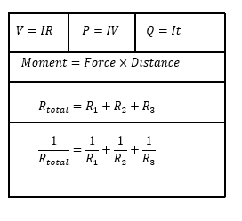
ANSWER ALL QUESTIONS

- Write down the units for the following: [5]

a) Time
b) Speed
c) Acceleration
d) Weight
e) Mass

- Given that the equation for density can be written as;

$$density=\frac{mass}{volume}$$

Write down the units of density [2]

- A body of weight 1200N rests on a rough inclined plane which is at an angle of 25⁰ to the horizontal.

a) Draw a free body diagram in your answer booklet showing the weight, normal reaction, friction and the component of weight that acts down the slope [2]

b) Calculate the magnitude of frictional force [4]
c) Calculate the magnitude of the normal reaction to the surface. [4]

- By considering figure 1

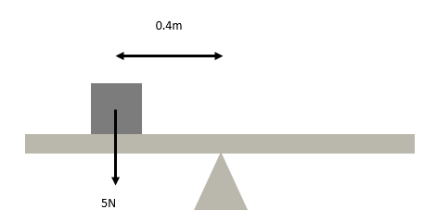

Figure 1

a) Calculate the anticlockwise moment experienced on the see-saw [2]

b) A 2.8 weight is placed on the right hand side of the see-saw to balance it. How far from the pivot should it be placed? [2]

- Figure 2 shows a 9.5m uniform beam of weight 5.25KN which is at rest. The beam is supported by two pillars. Pillar X is positioned 1.35m from the left hand side of the beam, pillar Y is positioned 2.3m from the right hand side of the beam.

X
Y
Figure 2

a) Copy this diagram on your answer booklet, showing all forces. [2]

b) Determine both support forces. [6]

6. Define the following electrical characteristics. [2]

a) Resistance
b) Power

7.
a) 15C of charge flows through a wire in 20s. What is the current? [2]

b) How much charge passes a point in a wire if a current of 0.25A flows for 2.5 minutes.
[2]

8.

a) Calculate the voltage required to cause a current of 1.6A to flow through a wire of resistance 12.5Ω [2]

b) What is the resistance of a particular wire if 0.75A flows when a potential difference of 3.5V is across it? [2]

9. The circuit shown in figure 3 shows three identical resistors placed in series.

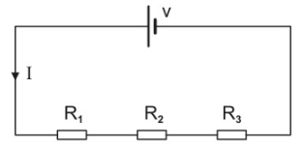
Figure 3

a) If the total resistance of the circuit is 90 Ω, calculate the value of the resistors.
b) What should be the value of V for a current of 0.45A to flow? [4]

10. A 3Ω resistor and a 5Ω resistor are connected in series with each other. The series combination is connected in parallel with a 7Ω resistor and a 3V battery of negligible internal resistance, as shown in figure 4.

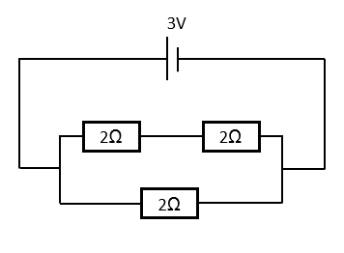
Figure 4

5Ω
3Ω
4Ω

7Ω
9Ω

Calculate:

a) the total resistance of the circuit [2]
b) the current leaving the cell [2]
c) the power supplied to each resistor [3]
d) the power supplied by the battery [2]

Diwedd/End

