

Module Name: Entrepreneurial Innovation
Module Code: BMBM4011
Assignment Name: Developing a Venture Plan for Sustainable Delivery and Longevity
Student Name: Karla Flores Feltrin
Student Number: 2503091
Lecturer: Robyn Griffiths
Deadline: 24/04/2026
Word count: 2900

Executive Summary
Brazza Pizza is a delivery-only Brazilian-style pizzeria based in Swansea, developed to address a gap in the local takeaway market for more indulgent, varied, and experience-driven pizza offerings. While the UK pizza sector is dominated by traditional Italian-style products and standardised fast-food chains, this venture introduces a differentiated concept centred on generous toppings, bold flavours, and a strong inclusion of dessert pizzas.
The business operates as a dark kitchen, allowing for reduced start-up costs, operational flexibility, and scalability. This model aligns with current consumer behaviour trends, particularly the increasing reliance on digital and online services (Office for National Statistics, 2024). By focusing on delivery during the initial phase, Brazza Pizza can minimise financial risk while building brand awareness and refining its product offering.
The target market is broad and includes students, young professionals, and families within Swansea. Rather than focusing exclusively on Brazilian consumers, the business is positioned to appeal to a wider audience seeking variety, indulgence, and value for money. A mid-premium positioning is adopted, balancing perceived quality with affordability, while avoiding direct competition with low-cost providers (Porter, 1985).
Financial projections suggest that the venture is viable, with a realistic break-even point and potential for margin improvement through pricing strategies and direct ordering channels. Over a two-year period, Brazza Pizza aims to establish a stable customer base before expanding into a physical restaurant offering a Brazilian-style rodizio experience, enhancing long-term sustainability and brand identity.

Project Overview and Market Context
Brazza Pizza is designed as a delivery-focused venture that responds to an identifiable opportunity within the Swansea takeaway market. The sector is highly competitive, with dominant players such as Domino’s and Papa John’s operating alongside independent pizzerias. These competitors primarily focus on efficiency, speed, and standardisation, often resulting in limited product differentiation and relatively predictable customer experiences. While this model ensures consistency, it leaves a gap for more distinctive and experience-driven offerings.
This competitive environment creates a clear opportunity for Brazza Pizza to introduce a differentiated concept. Brazilian-style pizza is characterised by generous toppings, bold flavour combinations, and the inclusion of dessert options, which are still relatively uncommon in the UK market. This contrasts significantly with the more minimalist and traditional approach typically associated with Italian-style pizzas. Such differentiation aligns with the concept of experiential consumption, where consumers seek emotional engagement, novelty, and sensory satisfaction in addition to purely functional benefits (Pine and Gilmore, 2011; Schmitt, 2011).
In Swansea, demand for takeaway food is supported by a diverse population, including a large student base and a growing number of young professionals. These groups tend to prioritise convenience, affordability, and variety, particularly during evenings and weekends when takeaway consumption is highest. The continued expansion of digital delivery platforms such as Uber Eats, Deliveroo, and Just Eat has reinforced this behaviour, making it easier for consumers to explore new food options with minimal effort (Statista, 2024).
Furthermore, social media has become an increasingly influential factor in shaping food consumption patterns. Visually appealing and distinctive food products are more likely to attract attention, generate online engagement, and influence purchasing decisions. Brazza Pizza’s offering, with its vibrant presentation and indulgent toppings, is well positioned to benefit from this trend.
From a strategic perspective, Brazza Pizza adopts a mid-premium positioning. Porter (1985) highlights the importance of maintaining a clear competitive strategy. By focusing on perceived value rather than direct price competition, Brazza Pizza is able to differentiate itself while remaining accessible to a broad customer base, supporting both market entry and long-term growth.

Strategy for Longevity
The long-term success of Brazza Pizza depends on its ability to balance differentiation, operational efficiency, and scalability within a highly competitive and dynamic takeaway market. To achieve this, the business adopts a strategy based on three key pillars: a delivery-focused operational model, a structured and adaptive menu strategy, and a phased approach to growth and expansion.
A central strategic decision is the adoption of a delivery-only model in the initial stage. While traditional dine-in restaurants can offer higher average transaction values and stronger brand visibility, they also involve significantly higher fixed costs, including rent, staffing, and front-of-house operations. In contrast, the dark kitchen model enables Brazza Pizza to operate with a lean cost structure, allowing greater flexibility and reduced financial risk during the early stages of the venture. This approach is particularly relevant in the current foodservice environment, where digitalisation and convenience have become key drivers of consumer behaviour . In addition, it allows the business to test its concept without committing to long-term financial obligations, which is especially important for a new entrant in a competitive market.
However, the reliance on third-party delivery platforms introduces important trade-offs. Platforms such as Uber Eats, Deliveroo, and Just Eat provide immediate access to a large customer base but charge commission fees that can significantly reduce profit margins. Moreover, they limit direct interaction with customers, making it more difficult to build brand loyalty and gather valuable customer data. An alternative strategy would be to invest in a proprietary online ordering system from the outset, which could improve margins and strengthen long-term customer relationships. Nevertheless, such an approach requires strong brand recognition and marketing capabilities, which are typically not available to early-stage ventures (Chaffey and Ellis-Chadwick, 2019).
To manage this trade-off effectively, Brazza Pizza adopts a hybrid approach. In the short term, the business will leverage third-party platforms to establish market presence and generate demand. In the medium term, it will gradually introduce incentives for direct ordering, such as discounts, loyalty programmes, and targeted social media campaigns. Over time, this strategy will allow the business to shift part of its customer base away from commission-based platforms, improving profitability while maintaining market reach. This staged transition reflects a realistic and evidence-based approach to growth, rather than an overly ambitious initial strategy.
Menu strategy is another critical component of long-term sustainability. Brazilian-style pizza naturally encourages a wide variety of toppings and combinations, which can enhance customer appeal but also increase operational complexity. Research in hospitality management suggests that menu design and product attributes influence customer perceptions and purchasing behaviour, requiring a balance between variety, quality, and operational efficiency (Bujisic et al., 2014). On the other hand, a highly limited menu may restrict customer choice and reduce repeat purchases. Brazza Pizza addresses this tension by adopting a “test-and-learn” approach, launching with a curated menu of high-performing items and expanding gradually based on customer feedback and sales data. This approach allows the business to remain responsive to market preferences while maintaining operational control.
Pricing strategy further supports the long-term viability of the business. Brazza Pizza adopts a tiered pricing model, offering pizzas in small, medium, and large sizes. This enables the business to cater to different customer segments and consumption occasions, from individual purchases to group orders. The use of tiered pricing reflects principles of perceived value and price anchoring, where customers are encouraged to choose larger sizes due to the relative value offered (Kotler and Keller, 2016). In addition, bundle pricing through combo deals increases average transaction value while providing convenience to customers. This strategy not only enhances revenue but also improves operational efficiency by encouraging higher-volume orders.
Branding also plays a key role in sustaining competitive advantage. Brazza Pizza adopts a fun, youthful, and visually engaging brand identity, which aligns with its target market and product offering. This is particularly important in a digital environment, where customer engagement is often driven by visual appeal and brand personality. Social media platforms such as Instagram and TikTok provide opportunities to showcase products, build brand awareness, and interact directly with customers. Over time, this can contribute to stronger customer loyalty and repeat business.
Looking ahead, the long-term growth strategy involves transitioning from a delivery-only model to a hybrid model that includes physical dine-in operations. Specifically, the introduction of a Brazilian-style rodízio experience represents an opportunity to further differentiate the brand and create a more immersive customer experience. This aligns with the concept of the experience economy, where businesses compete by offering memorable and engaging experiences rather than simply products (Pine and Gilmore, 2011). However, this expansion will only be pursued once the business has achieved sufficient operational stability, brand recognition, and financial performance.
Ultimately, Brazza Pizza’s strategy for longevity is defined by its ability to manage key trade-offs between cost, quality, and customer experience. By starting with a lean and flexible operational model, leveraging digital platforms for market entry, and gradually evolving towards a more integrated and experience-based offering, the business is well positioned to achieve both short-term viability and long-term competitive advantage.

Business Model Canvas
Figure 1: Business Model Canvas – Brazza Pizza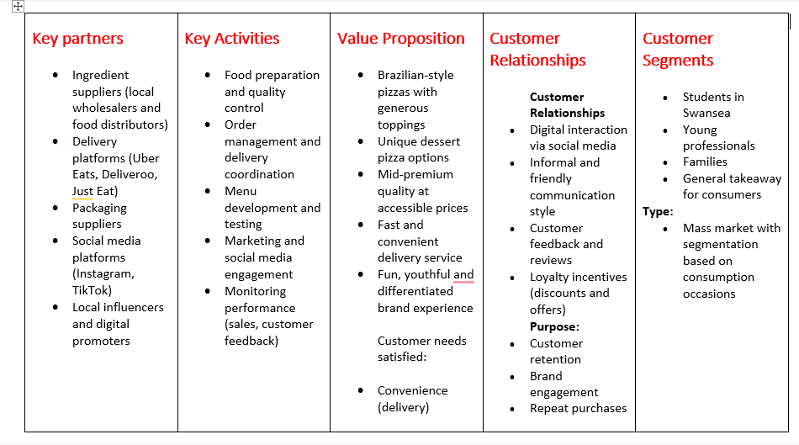
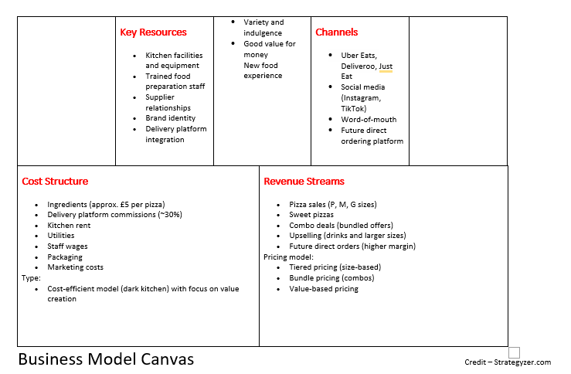
The Business Model Canvas presented in Figure 1 provides a structured overview of how Brazza Pizza creates, delivers, and captures value within the Swansea takeaway market. Each component of the model is interconnected, demonstrating how operational decisions, customer targeting, and revenue strategies align to support the overall business concept.
The value proposition is centred on differentiation through Brazilian-style pizzas, combining generous toppings, unique flavour combinations, and dessert options. This offering is supported by key activities such as efficient food preparation, quality control, and continuous menu development, ensuring consistency while allowing flexibility to adapt to customer preferences.
The use of digital delivery platforms as primary channels reflects current consumer behaviour trends, where convenience and accessibility play a significant role in purchasing decisions. At the same time, customer relationships are strengthened through social media engagement and loyalty strategies, which are essential for building repeat business in a competitive market.
From a financial perspective, the cost structure and revenue streams demonstrate a scalable and realistic model. While delivery platforms provide market access, the long-term strategy to encourage direct orders highlights an awareness of profitability challenges and margin optimisation.
Overall, the Business Model Canvas illustrates a coherent and feasible business model, where each element contributes to both short-term viability and long-term growth potential.
This integrated approach ensures that the business model is not only conceptually sound but also practically implementable.

Viability, Finance and/or Resources
The financial model of Brazza Pizza aligns with industry benchmarks for takeaway businesses, where profitability is influenced by food cost ratios, pricing strategies, and platform commissions (Parsa et al., 2020). The business adopts a cost-efficient delivery model combined with a mid-premium pricing strategy to ensure both competitiveness and sustainability.
The average selling price per pizza is estimated at £15, while the average production cost is approximately £5 per unit. This results in an initial gross profit of £10 per pizza, representing a gross margin of approximately 66%. This calculation reflects an ideal scenario before external costs are considered and provides a baseline for understanding the business’s pricing structure.
However, this initial calculation does not account for delivery platform commissions, which significantly impact net profitability. Platforms such as Uber Eats, Deliveroo, and Just Eat typically charge commission fees ranging from 25% to 35%. Assuming an average commission rate of 30%, the effective revenue per pizza decreases to approximately £10.50, reducing the profit per unit to around £5.50.
This difference reflects the impact of platform fees on overall margins, highlighting the importance of encouraging direct customer orders in the long term. It also demonstrates that profitability is not fixed but influenced by operational channels and cost structures.
In the initial phase, the business is projected to sell an average of 30 pizzas per day. Under the commission-adjusted model, this would generate a daily profit of approximately £165 and a monthly profit of around £4,950 before fixed costs.
Fixed costs are expected to remain relatively low due to the dark kitchen model. These include kitchen rent, utilities, packaging, and minimal staffing requirements. This lean operational structure reduces financial risk and supports early-stage viability compared to traditional dine-in restaurants.
Break-even analysis suggests that Brazza Pizza would need to sell approximately 20–22 pizzas per day to cover fixed costs, depending on rent and staffing levels. With a projected sales volume of 30 pizzas per day, the business demonstrates a realistic margin of safety, supporting the overall feasibility of the model.
It is also important to recognise that profitability is influenced by product mix. Pizzas with premium ingredients, such as steak or multiple cheeses, incur higher production costs and may reduce margins compared to simpler options. Conversely, lower-cost pizzas can generate higher margins even at similar price points. Therefore, overall financial performance depends not only on sales volume but also on the balance of products sold.
In the longer term, profitability can be further improved by reducing reliance on third-party platforms and increasing direct customer orders. Additionally, economies of scale in ingredient sourcing and improvements in operational efficiency are expected to enhance margins as the business grows.
Overall, the financial projections demonstrate that Brazza Pizza is a viable and scalable venture under realistic assumptions, with clear opportunities for margin optimisation and long-term profitability.
Figure 2: Financial Overview – Brazza Pizza
Metric | Value
Average price per pizza | £15
Cost per pizza | £5
Gross profit per pizza | £10
Daily sales (estimated) | 30 pizzas
Monthly revenue | £13,500
Monthly profit (after fees) | ~£4,950
Break-even point | 20–22 pizzas/day

Figure 2 presents a simplified financial overview of the business model. The projections indicate that Brazza Pizza is financially viable under realistic assumptions, with a clear margin of safety above the break-even point.

Figure 3: Estimated Profit by Pizza Size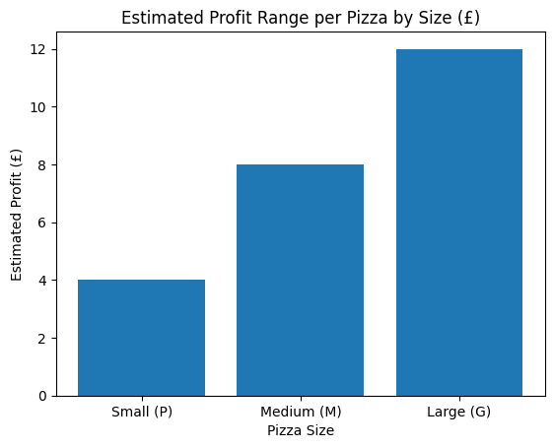

As shown in Figure 3, profit margins vary depending on pizza size, with larger pizzas generally generating higher absolute profit. However, it is important to note that profit is not fixed across all products, as ingredient costs differ depending on toppings and complexity.
Pizzas with premium ingredients, such as steak or multiple cheeses, may have higher production costs, reducing their margin compared to simpler options. Conversely, lower-cost pizzas can generate higher margins even at similar price points. Therefore, the values presented represent estimated averages rather than exact figures.
Despite this variation, the overall pricing structure supports profitability by encouraging customers to select larger sizes, which offer higher perceived value. This reflects a strategic use of tiered pricing and upselling, where customer choice is influenced by relative value rather than absolute price (Kotler and Keller, 2016).
Overall, the graph demonstrates that while margins fluctuate at the product level, the pricing model remains sustainable at the business level, supporting both revenue growth and operational viability.

Implementation and Learning Loop
The implementation of Brazza Pizza will follow a phased and structured approach to ensure operational stability and continuous improvement. In the initial phase (0–3 months), the focus will be on setting up the dark kitchen, establishing supplier relationships, and launching the business across major delivery platforms such as Uber Eats, Deliveroo, and Just Eat. Marketing efforts will prioritise social media engagement, particularly through Instagram and TikTok, to build brand awareness among the local population.
During the early operational phase (3–6 months), the business will focus on performance monitoring and customer feedback. Key performance indicators (KPIs) will include daily order volume, average order value, customer ratings, and repeat purchase rates. The target is to achieve consistent sales of at least 30 pizzas per day and maintain customer ratings above 4.5 stars across delivery platforms.
Between 6 and 12 months, Brazza Pizza will begin refining its menu based on sales data, expanding high-performing items while removing underperforming options. At this stage, the business will also introduce strategies to encourage direct ordering, such as discount codes and loyalty programmes, with the aim of reducing dependency on third-party platforms and improving profit margins.
In the longer term (12–24 months), the business will evaluate opportunities for expansion, including increasing production capacity or opening additional delivery units. If sufficient demand and brand recognition are achieved, Brazza Pizza will explore the transition to a physical dine-in location offering a Brazilian-style rodízio experience. This decision will be based on financial performance, customer demand, and operational readiness.
This continuous “learning loop” approach ensures that decisions are driven by data and customer insights, allowing the business to adapt, improve, and remain competitive over time.

Figure 4: Implementation Roadmap (0–24 months)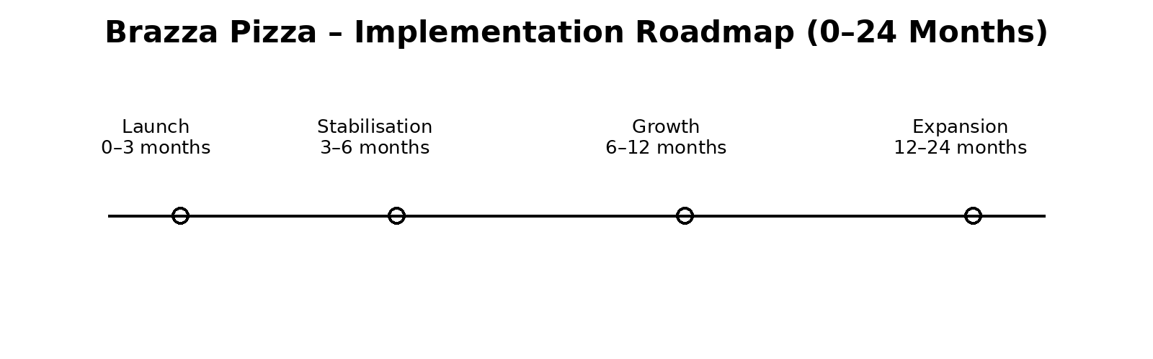 Figure 4 illustrates the phased implementation roadmap of Brazza Pizza over a 24-month period, highlighting how the business progresses from initial setup to potential expansion. The structured timeline reflects a risk-managed approach to growth, where each stage builds on the outcomes of the previous one.
In the launch phase (0–3 months), the focus is on establishing operational foundations, including supplier relationships, kitchen setup, and platform integration. This stage is critical in ensuring that the business can deliver a consistent and reliable service from the outset.
The stabilisation phase (3–6 months) emphasises performance monitoring and operational efficiency. During this period, customer feedback and sales data play a key role in identifying areas for improvement. Achieving consistency in product quality and delivery speed is essential before moving to the next stage.
In the growth phase (6–12 months), the business begins to expand its offering and strengthen its market position. This includes refining the menu, increasing brand visibility, and introducing strategies to encourage direct ordering. This phase reflects a shift from operational focus to strategic development.
Finally, the expansion phase (12–24 months) represents a potential transition to a physical restaurant model, such as a rodízio-style dining experience. This decision is dependent on financial performance, customer demand, and operational readiness. By delaying expansion until the business is stable, Brazza Pizza reduces risk and increases the likelihood of long-term success.
Overall, the roadmap demonstrates a logical and staged approach to growth, ensuring that decisions are informed by performance data rather than assumptions. This supports both sustainability and scalability within a competitive market.

Conclusion
Brazza Pizza represents a viable and scalable business opportunity, combining cultural differentiation with an efficient delivery model. Through a phased growth strategy and continuous adaptation based on customer insights, the venture is well positioned to achieve long-term sustainability and establish a strong presence within the Swansea food market. The integration of strategic planning, financial viability, and continuous learning provides a strong foundation for sustainable growth.

Reference List
- Bujisic, M., Hutchinson, J. and Parsa, H.G. (2014)
‘The effects of restaurant quality attributes on customer behavioural intentions’,
International Journal of Contemporary Hospitality Management, 26(8), pp. 1270–1291.
Available at: https://doi.org/10.1108/IJCHM-04-2013-0162
(Accessed: 18 April 2026).

- Chaffey, D. and Ellis-Chadwick, F. (2019) Digital marketing: Strategy, implementation and practice. 7th edn. Harlow: Pearson.
Available at: https://pt.scribd.com/document/960017381/Chaffey-D-Ellis-Chadwick-F-2019-Digital-Marketing-7th-Ed-Pearson-Education-Limited (Accessed: 18 April 2026).

- Kotler, P. and Keller, K.L. (2016) Marketing management. 15th edn. Harlow: Pearson.
Available at: https://pt.scribd.com/document/521879984/Marketing-Management-15th-Edition-by-Phi (Accessed: 18 April 2026).

- Office for National Statistics (2024) Internet sales as a percentage of total retail sales (Great Britain).
Available at: https://www.ons.gov.uk/businessindustryandtrade/retailindustry/timeseries/j4mc/drsi (Accessed: 18 April 2026).

- Parsa, H.G., van der Rest, J.P.I., Smith, S.R., Parsa, R.A. and Bujisic, M. (2015) ‘Why restaurants fail? Part IV: The relationship between restaurant failures and demographic factors’, Cornell Hospitality Quarterly, 61(3), pp. 312–326.
Available at: https://www.researchgate.net/publication/269990249_Why_Restaurants_Fail_Part_IV_The_Relationship_between_Restaurant_Failures_and_Demographic_Factors

- Pine, B.J. and Gilmore, J.H. (2011) The experience economy. Updated edn. Boston: Harvard Business Review Press.
Available at: https://books.google.co.uk/books?hl=en&lr=&id=edtOyzyKgXUC&oi=fnd&pg=PR7&dq=%E2%80%A2%09Pine,+B.J.+and+Gilmore,+J.H.+(2011)+The+experience+economy.+Updated+edn.+Boston:+Harvard+Business+Review+Press.&ots=2oqHAMNtyM&sig=kbBT5YIra4kJKel3EKv2ONMypFQ#v=onepage&q&f=false (Accessed: 18 April 2026).

- Porter, M.E. (1985) Competitive advantage: Creating and sustaining superior performance. New York: Free Press.
Available at: https://pt.scribd.com/doc/182427398/122247076-Competitive-Advantage-Creating-and-Sustaining-Superior-Performance-Michael-Porter-1985-1 (Accessed: 18 April 2026).

- Schmitt, B. (2011) Experience marketing: Concepts, frameworks and consumer insights. Foundations and Trends in Marketing, 5(2), pp. 55–112.
Available at: https://www.nowpublishers.com/article/Details/MKT-009 (Accessed: 18 April 2026).

- Statista (2024) Online food delivery market in the United Kingdom.
Available at: https://www.statista.com/outlook/dmo/eservices/online-food-delivery/united-kingdom (Accessed: 18 April 2026).

