Introduction to Health & Social Care
Nabila Pathan
2432777
Module LCHS4003
Lecturer: Azida Zainol

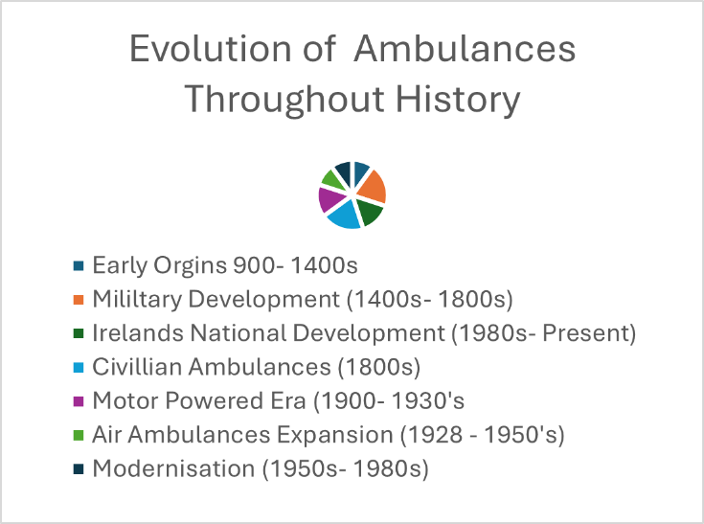
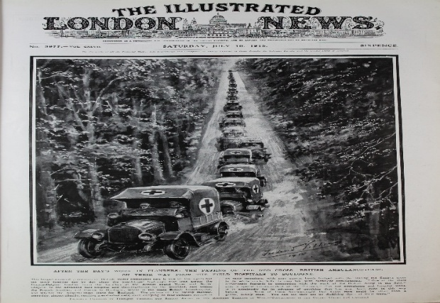
The London Ambulance Services was created in1965 when nine services merged. During that period staff completed an eight-week training course only, had 2,500 employees, and transported only basic equipment such as oxygen and stretchers. Today, paramedics hold degrees, the workforce has grown to 4,400, and crews carry advanced medical tools and around 30 drugs. Women now make up 44% of staff, compared to 6% in 1965. The service responds to millions of emergency calls all over the UK each year and operates a diverse fleet of ambulances, cars, motorcycles, bikes, and helicopters, with paramedics serving in senior leadership roles across the organisation.
NHS ambulance service provides emergency medical care, patient transport, medical assistance to those in need.
The service is treated part of the urgent and emergency care system with standards set for response time, ensuring the sickest patients get priority. In addition, responding to 999 {emergency} calls, some ambulance services also offer non-emergency services {patient transport} and support for NHS 111 advice.
The NHS ambulance service is used by members of the public with emergencies and urgent health needs. Transportation is also available, non-emergency for patients who may be struggling to attend for hospital or treatment independently. The ambulance service also supports integrated care systems, collaborating with hospitals, primary care, and community health services. It is delivered by NHS trusts with oversight and coordination at national and reginal levels. In England there are currently 10 regional NHS ambulance trusts {some are which now foundation trusts}. The service is delivered across the entire UK: across England, Scotland, Wales, and Northern Ireland. Each trust has defined regional boundaries. Paramedics attend emergencies wherever they occur {homes, roads, workplaces} to deliver care on site and stabilise patients. En route to hospitals or alternative destinations, inter- hospital transfers and non-emergency transport. NHS ambulance service operates 24 hours a day, every day {365 days} The service is important for medical intervention to save lives as the service brings medical expertise and equipment to the patients wherever they may be. It is also free, and people are not dismayed from seeking help due to cost barriers. Ambulance services a vital link between communities and healthcare facilities and increasingly function as triage and are coordinators. Patients with instability and serious conditions require monitoring and intervention during transport: the ambulance service is equipped for that. Good ambulance response and triage can reduce unnecessary hospital admissions and help manage in emergency departments. The ambulance service is part of the wider emergency response and civil contingency frameworks {for example major incidents, disasters, pandemics}. In England alone, in February 2024 ambulance services answered over 828,000 calls to 999 {about 26,721 per day} and managed about 755,000 incidents. The NHS ambulance service is funded through UK government’s taxation system £££.

The History of the Ambulance Service 🚑Ambulance Service is one of the most significance meaningful service in this world. We are very fortuitous to have hardworking paramedics equipping rapid aid around the clock, many of us would be helpless in medical emergencies. Ambulances have evolved over hundreds of years to become what they are today.

UK Ambulance Service
The UK ambulance service is a core NHS emergency service equipping urgent medical response, pre-hospital care, and patient transport across England, Scotland, Wales, and Northern Ireland {London Ambulance Service, NHS England,2025; NHS Digital,2024}. 🚑
The Evolution of the UK Ambulance Service: History, Regions & Modern Trends

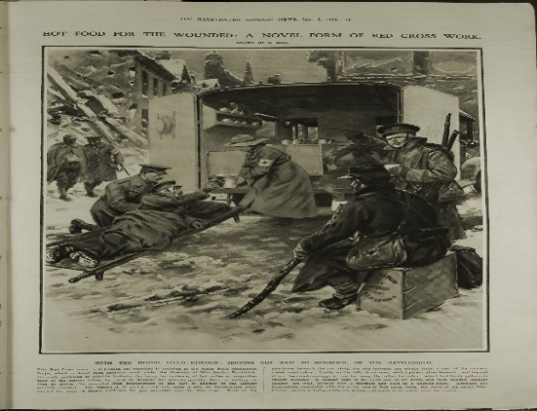
T
Cardiac arrests outside hospitals are one of the most severe emergencies managed by 60,000 people in the UK. The precision in which cardiac arrests are dealt with outside hospitals relates back too how 999 call handlers lead and action first response teams giving the patient the best chance of survival. Methods data obtained from NHS trusts and local ambulance trusts for all cases of suspected or actual out of hospital cardiac arrests (OHCA) or imminent medically witnessed cardiac arrest (MWCA) which then leads to for a one-year period (1/7/2013–30/6/2014 one of the study hospitals. (Gibson et al., 2017, p (27)

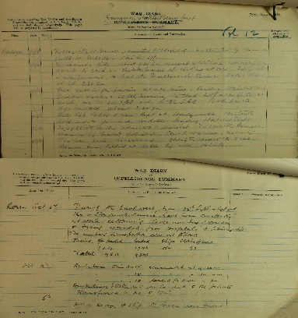
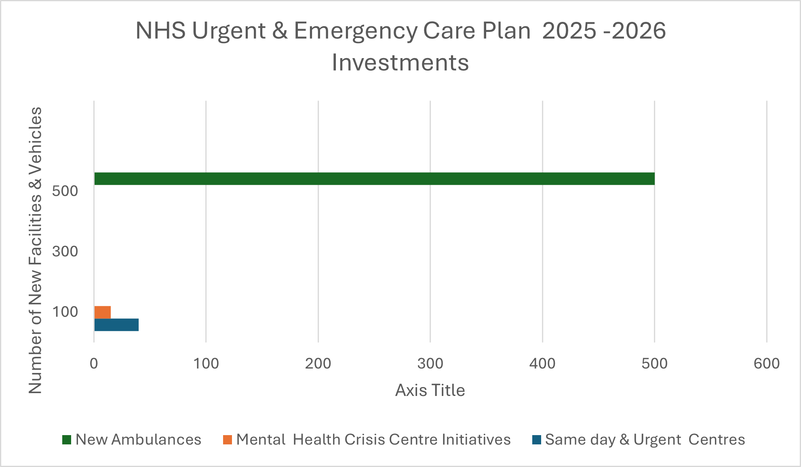
Requirement for ambulances in the UK has increased. Even though the overall number of incidents that require an ambulance response is the same as 2018/19, the capacity requiring the most resource are those that are life threatening or in an emergency – has increased from 69% to 78%. To reduce further strain on services more investment into local services within communities will ease the burden on the service before illnesses such as mental health reach a crisis point.
At a recent roundtable, we convened alumni from our Clinical Directors programme to discuss what the 10 Year Health Plan means for clinical leadership. Planning suggests by 2036 that the NHS will not need as many staff thanks to AI & automation. Some entries feel that this magical thinking. Clinical leaders didn’t just critique at the roundtable – they offered a simple blueprint for reform: relational leadership over rigid hierarchies compassionate realism over magical thinking workforce wellbeing over managerial compliance neighbourhood care backed by equity and standards technology that serves people, not replaces them , trust based accountability, not transactional oversight. These are not just reflections; they are a call to co-create reform grounded in the lived realities of staff and patients.

This Graph shows the current Emergency care plan for 2025-2026 in reference to ambulances required to refrain from pressure on the A&E departments and modernise the ambulance fleet too tackle both response times and patient outcomes.

War ambulance diary dating back to 1916

During the war Sir William Beveridge who was the economist and former director of the London School of Economics was commissioned by the war time government to write a report focusing in exploring strategies to address these social problems. The Beveridge report was released in November 1942. After WW11 on July 5th, 1948, was a notable day in our history. On this day the National Health Services {NHS} were commence with the National Health Service Act 1946 coming into force. Activated by the Beveridge Report {1942} and the requirements for stable access to healthcare was tackling the “five giants” of Want, Disease, Ignorance, Squalor and Idleness {Beveridge, 1942}. Its planting regulation were carefree at the point of use. Health minister Aneurin Bevan established a publicly funded system based on three principles: that healthcare should be universal access, and funding through taxation, comprehensive and free at the point of use {Parliament, 1946}. It employs 144,000 members of staff including doctors, nurses, pharmacists, opticians and dentists with GP’S remaining independent.
The NHS operates separately across England, Scotland, Wales and Northern Ireland. The Health and Social Act 2022 made considerable changes to the structure of the NHS in England. The Act established 42 integrated care systems {ICS} across England, which took on the responsibility of local NHS services from 1st July 2022. The ICSs is made up of combined services to help arrange and deliver within local communities covering social care, mental health, and hospital services.
NHS England provides national leadership and oversight for the health service, Providers of NHS services, is made up of NHS trusts, foundation trusts, primary care organisations, and private and voluntary providers. The Care Quality Commission (CQC) is responsible for patient safety and is the regulatory body to oversee the level of service provided alongside inspecting and rating services delivered in health and social care settings. The National Institute for Health and Care Excellence (NICE) is an independent public body that publishes guidance on health and social care, to help patients make informed decisions, along with improving communication between patient and health professionals at crucial times.
NHS England has along integrated with NHS digital and Health Education England (HEE). This know gives NHS England responsibility for NHS digitals operations and activities around planning, recruitment, education and training. The Guidance for these merged care systems can be found at NHS England website. Funding for health services comes from the total budget for the Department of Health and Social Care (DHSC). In 2022/23, the total allocated DHSC resource budget was £169.9 billion for England. Much of this budget (£153 billion) was transferred to NHS England with the remainder divided between DHSC’s other agencies and programmes, including funding for arm’s length bodies like the Care Quality Commission (CQC) and the National Institute for Health and Care Excellence (NICE). On 22 May 2023 Labour Leader Keir Starmer set out his party’s plans for NHS reform, in three broad areas: Shifting services out of hospitals and into the community, so that “the NHS becomes as much a Neighbourhood Health Service as it is a National Health Service”. Expanding the NHS workforce and harnessing digital technology, data, and research to improve services. Focusing on prevention, and a ‘health in all policies’ approach, to improve the wider determinants of health – the social, economic, and environmental factor. A June 2023 report by the King’s Fund compared the UK health system with other countries. 56 The report suggested that most countries have aimed to provide better health care for their populations by reforming their existing models of health care rather than by adopting systems from other countries.

Ambulance transport - The National Archives
A new home for the Q community
a-history-of-the-nhs-workforce-in-england-a-timeline-1948-2023-digital-nov2024.pdf

GIBSON, J.M.E., JONES, S.P., HURLEY, M., AUTON, M., LEATHLEY, M.J., SUTTON, C.J., BANGEE, M., BENEDETTO, V., CHESWORTH, B., MILLER, C., O'SHEA, D., QUINN, T., MACKWAY-JONES, K., CURRAN, A., NIROSHAN SIRIWARDENA, A., DAVIS, D., PRICE, C., DEWITT, D., BARRON, T., FOX, P. and WATKINS, C.L., 2017. PP27 Terms used to describe key symptoms in out-of-hospital cardiac arrest by people calling 999 emergency medical services: a qualitative analysis of call recordings to two UK ambulance services. Emergency Medicine Journal: EMJ, 34(10),.
Home - London Ambulance Service NHS Trust
NHS England » Ambulance Response Programme
Our plans for the future - London Ambulance Service NHS Trust
Search | The King's Fund
The History of the Ambulance Service – Emergency Services Journal
The Ambulance Service - How is it Funded and Is It Privatized?
The foundation of the NHS - The National Archives
Work of an ambulance unit - The National Archives
What we do - London Ambulance Service NHS Trust
www.londonambulance.nhs.uk/about-us/commercial-services/london-ambulance-service-historic-collection/
£450m capital boost for NHS urgent and emergency care
10 Facts about London Ambulance Service - London Ambulance Service NHS Trust
20250410-Note-Statistical-AQI-1.pdf
CBP-7206.pdf

