
Database Analysis and design
Assignment

Jack Pasquantonio
Student Number – 2100962
Course Title – Computer networks and Cybersecurity

Table of Contents
Introduction 1
Design Techniques 2
Context Diagram 2
Level 0 DFD 2
Entity Relationship Diagram 3
Documentation 4
Use of additional MS-Access functionality 5
Calculated Reports 5
Master and Embedded Forms 7
References 8

Introduction
During this report I shall be covering the design of a database which is based on a bookstore. This report contains diagrams such as the logic, these are diagrams like a context diagram, etc. I shall be recording all types of documents which shall be implemented. I will suggest what is needed to reach the requirements for the user.

Design Techniques

Context Diagram
Context diagram is used to analyse the external entities which are set in the database. this where you must think through the logic and understand how it will all come together this includes relationships.
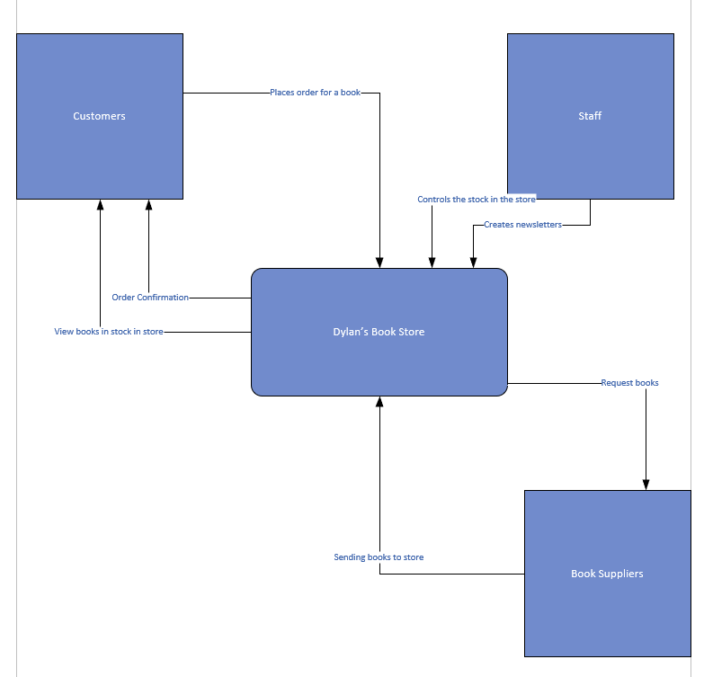

Level 0 DFD
The level 0 DFD requires 6 datapoints which will be included in my tables inside the database. The 6 datapoints which will be included in level 0 dfd will be customer details, staff, book stock, book suppliers, newsletter, and customer orders. These are all relevant to the scenario and they make sense in terms of a working database. The design for the level 0 show how an external entity would enter their data and show how they would help the logic and the understanding of a data being recorded.
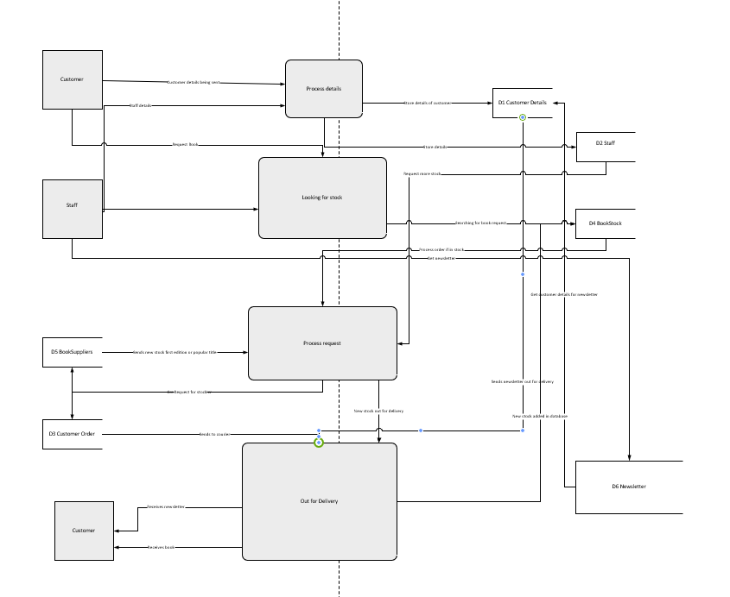

Entity Relationship Diagram
An entity relationship diagram links together the entities I choose that are relevant to the scenario. These were Customer details, Customer orders, Staff, book stock and the book suppliers. Those were the core entities which can be used to link through the database. The higher the degree of a relationship is the more connections it has to other tables, in my ERD CustomerOrder has 3 separate relationships and this tells us this is degree of 3 this is known as tenary. I shall implement something called membership class this means that the relationships which have relations to other tables they need input data as the data will be coming from different tables as well.
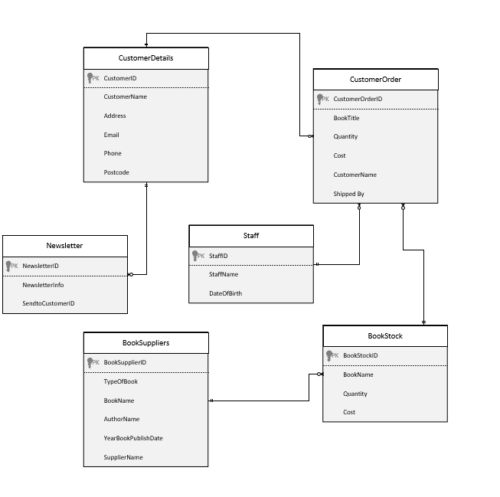

Documentation
For the tables which are relevant for the database I made tables called CustomerDetails, CustomerOrder, Staff, BookStock and BookSuppliers these were all relevant in having a working database. For the fields in the tables CustomerDetails will require a user to enter the customer's name, address, email, phone, and postcode this will then be stored, so if a customer request’s an order for a book the database will grab the customer details and automatically link the data to the CustomerOrder table. These are foreign keys there is one from the BookStock table and the primary key in this table is BookStockID any foreign key within the CustomerOrder table needs its own unique ID, and this is different to any other ID. The second foreign key will come from CustomerDetail table as it holds all the data that is needed to send the order to the right person, the primary is CustomerID so we take this.
I had to think of how the relationships will work within the database, one example is CustomerDetail and CustomerOrder a customer should be allowed to make more than one order, so this becomes a one-to-many relationship as this allows the data to be requested multiple times. Alternatively, BookSuppliers and BookStock, suppliers should be allowed to send more than one book, so this must also be a one-to-many relationship this allows the logic to work for it to make sense in the real world.
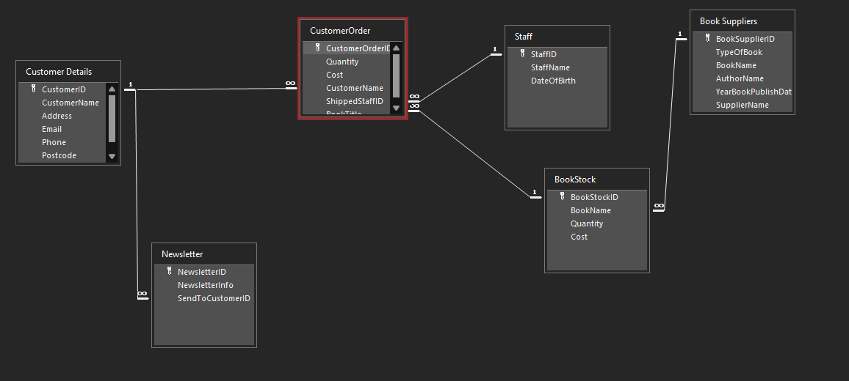
The requirements which are needed for a user can add and delete information this could be for a correction issue. Other features asked for was for a user to be able to view BookStock, Orders and CustomerDetails for this to work I created the tables and then related them to the first requirement so the user can add or delete from the tables. One of the design requirements is to have buttons in the forms to allow for navigation around the database.
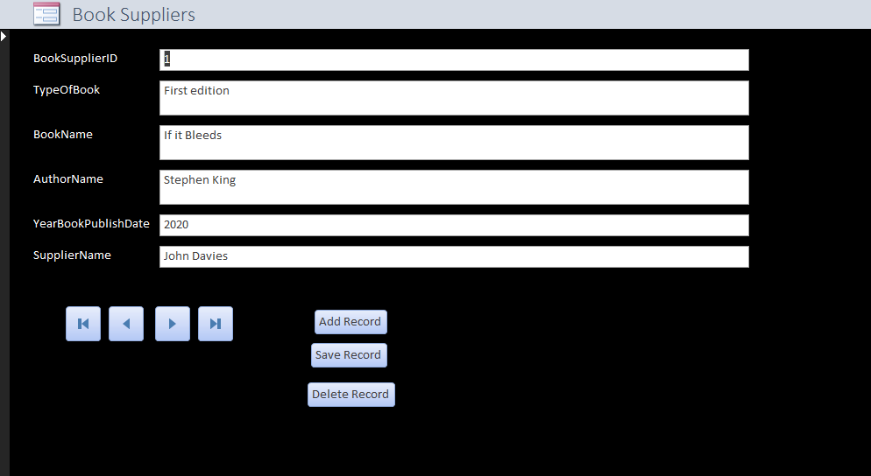

Use of additional MS-Access functionality

Calculated Reports
This report calculated the grand total, the average and percentage of sales that contributed to the grand total. This is useful because it, shows a user what types/genres are popular and allow the store to stock up on these titles some more.
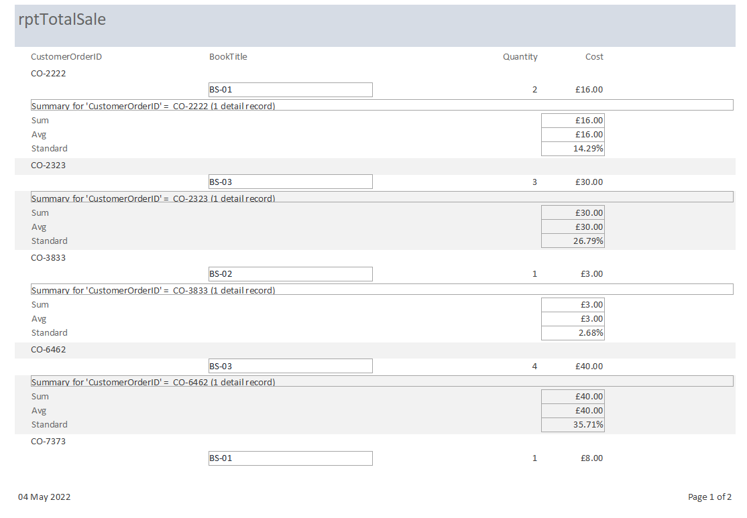
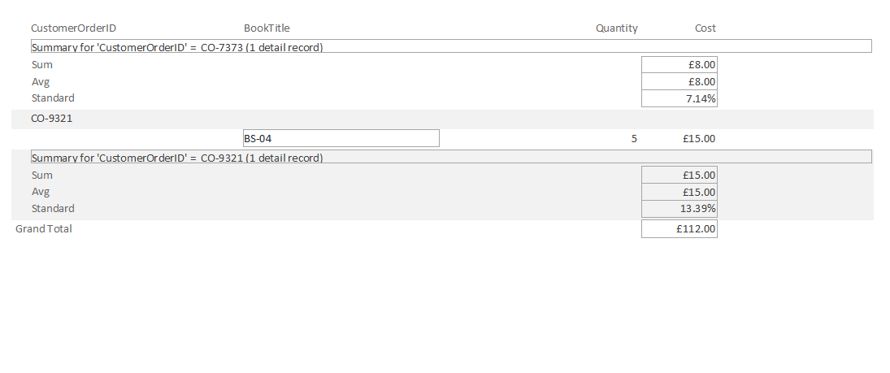

This shows that the availability of books is in stock and this is useful to a store because it allows them to analyse the information, and if stock is low, they are able to request more stock from the suppliers.

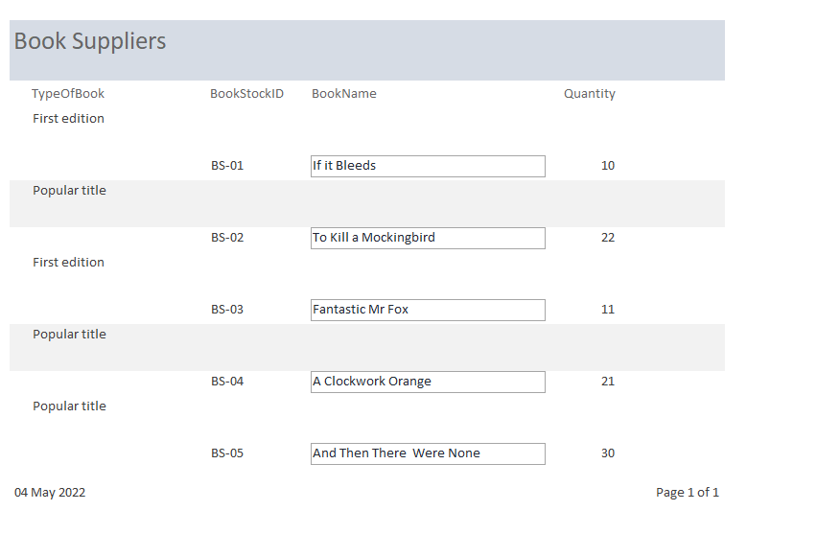

Master and Embedded Forms
One of the master and sub forms on the database is that a user is can filter the book stock and view orders which are placed and see if that specific order is ready to go and also see if it popular to order more if needed, all of these can be viewed in the statistics in sales.
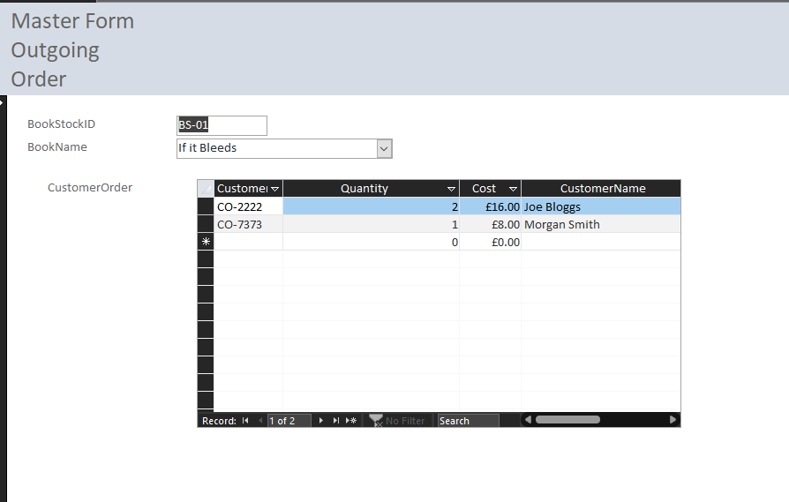
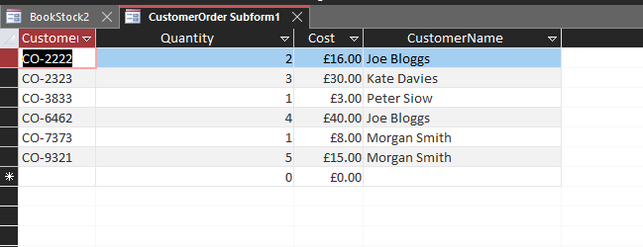

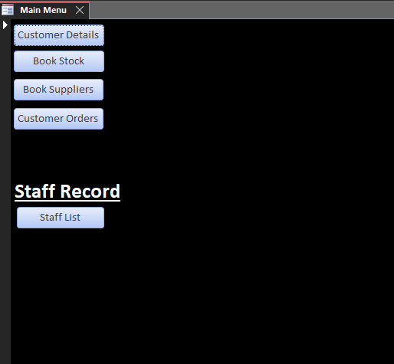

References
[1]T. J. Teorey, Database modeling and design logical design, 5th ed. Amsterdam ;: Morgan Kaufmann Publishers, 2011.

