Assignment 1

Essay on Community Engagement

Module Name: Community Engagement
Module code: LCBB4002

Student: Marius Scorcea (1921886)
Lecturer: Dr Toyin Adisa

Contents
Abstract 2
Introduction 3
What is Community Engagement and why is important? 3
Who are the stockholders in a community engagement project? 4
Main Body 4
Community engagement models 4
Challenges and benefits of community engagements 5
Community engagement Principles 8
Community engagement standards 10
Social Media – best tool to engage the public and stakeholders 11
CONCLUSION 12
REFERENCES 13

Abstract
This report is an essay about Community Engagement as a complex process meant to bring people together and build a better future for the community. The report is introducing the concept of community engagement, which are the principles and standards that guides the peoples involved in this process.
There are many activities which implies community engagement, starting with simple blood donation and going on with volunteering to clean the town, to plant trees in the parks, to offer tuition to children that are part of the community in order to rise their academic level, any activity that is meant to improve the life standard of the people, to motivate and make a real difference for them. Who are the stakeholders and how they can be engaged?
A very important question as any community engagement project needs support and this support can be achieved using the right engagement methods. Social media platforms are very important instruments and this report will introduce them as well. It is important to find out the right avenues to advertise the community engagement projects in order to get the public participation.

Introduction

What is Community Engagement and why is important?
According to Renata Schiavo (2022), community engagement plays a key role in public health and healthcare, communication and the communities’ development. It is only about giving information and organizing surveys, is the definition of collaborations and empowering citizens. Community engagement means empathy with the people, recognize their skills and choose leaders among the community members. It is the way to gain the trust and build long-term relationships, make sure people care and are involved in the projects, looks for methods of implementation and evaluation and also to celebrate with the community the success of an project.

Who are the stockholders in a community engagement project?
In a community engagement project the stakeholders might be internal and external and they may include the Council, staff, govern ants, town and parish councils, businesses, community groups, interest groups, volunteers, local people, landowners, developers, planning agencies, social care agencies, healthcare agencies, social services, schools etc. (West Devon Borough Council, 2014).
The stakeholders can be engaged through tactics of communication, negotiation, compromise and by building a relationships according to mutual interests.

Main Body

Community engagement models
There are several types of community engagement, each type has a different purpose, all of them are meant to bring people together for a greater purpose.
Building Community
This is the type in which people get to know each other, as parts of the same community.
Community organization
This purpose of this type is to unite people under the same umbrella in order to solve community problems.
Community education
Is the way through which the public is educated in order to participate in engagement projects.
Planned dialogue
Is the way to address the differences and the conflicts between members of the same community.
Direct Service
The type that a service or a product is provided to the community, such as becoming a volunteer or creating a website for the community.
Economic growth
The type that deals with the sustainability of a project that will develop the area economic point of view.
Engaged research
This type is related to the community mapping assets, community challenges or just finding solutions for existing issues.
Institutional Engagement
The projects through which Universities, Schools as institutions are involved in the community development.

Challenges and benefits of community engagements
CHALLENGES
Building relationships might not seem so difficult especially if we speak about short-term projects with limited scopes. The challenge is to create relationships and maintain them on long-term, to collaborate in order to fulfill the purposes of a whole community. (Fryer, n.d.)
The most common challenges in community engagement are:
Finding funds
This challenge is the most frequent in all community engagement projects as the funds needs to be available and continuous. If a projects benefits of funds, then people can allocate more time and their engagement is increased, not to mention that in case of a science projects, fundings plays the role.
Engagement
There are several issues that may affect a public initiative such as: academic engagement (the researcher have different ways of working and engaging people, some more efficient that others), community engagement where stakeholders goals differs, audience (it is hard to engage a large public, specific to a community engagement project), interest (not all groups are willing to involve in a community engagement project)
Time – is difficult to find the right balance between community work and personal activities. And when the resources are limited is even more difficult to dedicate time to a project.
Recognition – in order to involve stakeholders like government, community groups, organizations in the community engagement work trust need to be built, the vision and mission of the project must be clearly introduced to make them participate.
Communication – there are academic and non-academic stakeholders and somehow is difficult to create a liaison between them as they speak different ‘languages’. A common ground has to be found.
Capacities and skills – Finding people with knowledge and skills, especially in the IT field might be difficult sometimes, This is the way to address the differences between natural and social sciences.
Expectations – is hard to meet expectations for all the participants, considering that a community engagement projects involves citizens and organizations. (Web Team, 2019)
BENEFITS OF THE COMMUNITY ENGAGEMENT
Community engagement can be considered a decision-making initiative of any stakeholder that participates in the project and the impact that may have on the community might be huge and positive. (Bates, 2019).
An effective community strategy will:
* Bring an increased understanding of the community desires and necessities
Community engagement is a two-ways street where people are communicating continuously, all the parts that are involved will get a clear picture of what the people wants for their community, the environment where they are living and raising their kids.
- Creates opportunity for the lower voices, the people that does not have the courage to speak for themselves
An ideal community engagement strategy will create fair opportunities for all and appropriate avenues for people to be heard from all the ‘corners’ of community.
- Community engagement brings clarity
The community needs transparency regarding the decision-making process and the community members needs the see that their suggestions and arguments were considered,
- Community engagement .makes thing run smoothly
Keeping an eye on what all the stakeholders priorities is the key to make everybody happy and that the funds allocated to the projects are used appropriate.
- Develops the feeling of ownership
Being part of a community means to know the history, the technical and scientific achievements and the culture of the community. Sharing this with all the stakeholders will make everyone not jus well informed but also will give confidence and trust on whole levels.
- Opportunities to enjoy
Community engagement projects are the best way to interact with neighbors, to meet and participate to brainstorm sessions, communicate and share each other’s dream.

Community engagement Principles
The community engagement principles are the ones that are giving value to a project and brings unity among its participants.
They are equally important in different phases of the projects and they are split in 3 categories: the needs before starting, the needs to engage and the needs for the projects to be successful.
- Clear purpose, goals and participants – decide in advance what is the purpose of the project, establish the vision and who will be engaged in the activity, which are the criteria in choosing them (age, gender, geographic boundaries).
- Learn about the community – it is important to know about the community cultural, economic, historical and social point of view. Asses if the community is ready and willing to participate in a community engagement project.
- Get in touch with the community – for a project to be successful, the community members have to be part of the project, first through the community leaders and then expanded to a wider community mass, such as local businesses, church, schools.
- Collective self-determination is important – the organizators need to determine the community members to put on the table their issues, implement strategies and evaluate the results.
- Establish community partnerships – effective community engagement means to create fair community partnerships where all the decisions and discussions are transparent.
- Respect community diversity and culture – diversity is about economics, education, employment or health, culture is about language, race, ethnicity, age, gender, literacy or other personal interests. Both may influence the community participation in the project. Diversity and culture may affect individual and community participation in the engagement process. There are strategies and techniques that may remove the cultural barriers and bring satisfaction to all community members.
- Use community’s members skills and help them grow and develop. Many things are affected during a project, but community assets may be used properly in order to give a boost to the project.
- Flexibility. It takes flexibility to adapt to all the changes that may occur within a community engagement strategy. Flexibility is the key to a long-term collaboration.
- Commitment to collaboration. The longevity of a project depend on the strategies that are used in order to collaborate and going further.

Community engagement standards
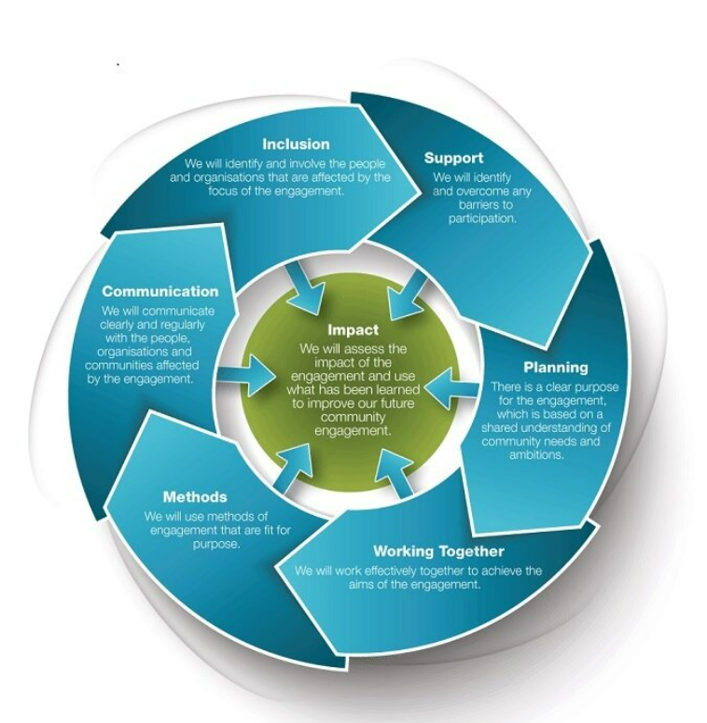
Community engagement standards are the practices that are applied in order to develop the community engagement process.
This standards are:
- Inclusion
- Support
- Planning
- Working together
- Methods
- Communication
- Impact
The main beneficiaries of this standards are:
- Public sector groups and elected representants which will know how to plan and involve local communities in engagement strategies in a fair and efficient way.
- Third sector organizations and community groups – as the main representatives of the community, the ones that makes all the voices heard
- The private sector that deals with the agencies and businesses involved in the project as the part that is planning the development an is mapping the services.

Social Media – best tool to engage the public and stakeholders
There are many ways to engage the participants of a community project such us newsletters, billboards, letters, leaflets but social media is one of the most powerful one as the speed and the number of the people that are reached is phenomenal.
Social media will get in touch with distinct collectives in the same time. (Forbes, 2021)
There are several ways to reach out and communicate with people:
  - Live broadcast – the message is sent immediately and becomes transparent and authentic for the public.
  - Use various social media platforms (Facebooks, Twitter, LinkedIn) to enhance the message.
  - Design a toolkit or a pattern message with a link and hashtag so that the stakeholder can share and use on media platforms.
  - Use the video connection to relate to people, to produce emotions
  - Get in touch through a multichannel approach
  - Post images and messages of the managers of the project on social media platform for a stronger impact.
  - Empower the community members – choose the ones that can understand and deliver a message by telling a story, an impressive one
  - Delegate more that one person to be responsible by sharing the key messages through social media platforms
  - Use the Hashtags as those are very powerful tools of social media
  - Use the lives on Facebook – 20 minutes are more than enough for a message to be conveyed.
  - Ask the public to share your content in order to reach to more people, the information will go viral
  - Share the News via Social Media – the followers will always look there for information

CONCLUSION
Community engagement is a complex process. The fact that can change communities at 180 degrees by changing and improving community’s members life makes it even more precious. However, analyzing it deeply, it takes a lot of knowledge to touch people life. There are specific strategies that needs to be followed, principles to apply and standards to meet so that a community engagement process becomes reality.
Involving people and bringing them opportunities to grow and develop by achieving new skills is the essence of the community engagement strategy. Making use of the right tools, for instance social media platforms, it will be easier to get in touch with people and convince them that they deserve a better life, a better environment for them and their families.

REFERENCES
Bates, O. (2019), 6 Reasons Why Public Participation and Community Engagement are Important, Available at:
https://www.socialpinpoint.com/blog/6-reasons-to-participate-community-engagement/, (Accessed: 15 August 2022)
Forbes, (2021), 15 Social Media Tips To Reach Both Stakeholders And The Public, Available at:
https://www.forbes.com/sites/forbescommunicationscouncil/2021/05/11/15-social-media-tips-to-reach-both-stakeholders-and-the-public/?sh=50fbbc647e6b, (Accessed: 12 August 2022)
Schiavo, R. (2021), What is true community engagement and why it matters (now more than ever), Available at: https://www.tandfonline.com/doi/full/10.1080/17538068.2021.1935569, (Accessed: 12 August 2022)
Schlake, M.R. (2015), Community Engagement: Nine Principles, Available at: https://digitalcommons.unl.edu/cgi/viewcontent.cgi?article=1726&context=agecon_cornhusker, (Accessed: 15 August 2022)
University of Minessota MOrris, (N.D), Types Of Community Engagement, Available at:
https://students.morris.umn.edu/community-engagement/types-community-engagement, (Accessed: 12 August 2022)
Voice, (nd), Good-Practice Principles To Support Community Engagement, Available at: https://www.voicescotland.org.uk/, (Accessed: 15 August 2022)
West Devon Borough Council, (2014), Community and Stakeholder Engagement Strategy , Available at: https://www.plymouth.gov.uk/sites/default/files/CommunityEngagementStrategySouthHams.pdf, (Accessed: 12 August 2022)
Web Team, (2019), Ten Challenges and Barriers to Public Engagement and Citizen Science, Available at:
https://research.reading.ac.uk/openupsci/2019/01/16/challenges-and-barriers-to-public-engagement-and-citizen-science/, (Accessed: 15 August 2022)

