HEALTH AND FITNESS
EVALUATION
REPORT


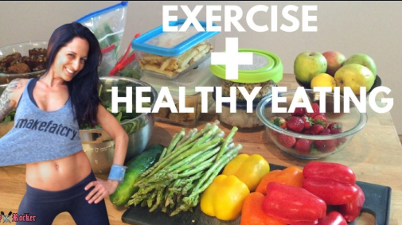
By Tambudzai Chipamhadze
24/04/2019

CONTENTS
Title Page
Introduction………………………………………………………………………………………………………………………..1
Evaluation……………………………………………………………………………………………………………………………2
Conclusion…………………………………………………………………………………………………………………………..5
Appendices………………………………………………………………………………………………………………………….6
Reference………………………………………………………………………………………………………………………….13

Introduction
According to the Department of Health (2014), it is important to regularly evaluate the health and wellbeing of individuals to help in early diagnosis and prevention of diseases. Early diagnosis, prevention and suitable treatment interventions can reduce healthcare burden in terms of cost and care interventions. Outcomes of evaluating health and wellbeing have influence over the delivery of appropriate services. This report will analyse and evaluate the health, fitness and lifestyle habits of an individual based on a questionnaire. The questionnaire is provided in appendix (form 1a). An analysis of Government strategies in relation to improving health and wellbeing will be evaluated. To conclude, recommendations on how to improve their overall health and wellbeing will be highlighted.
The identity of the student being questioned will remain anonymous. In terms of the Legislation.gov.uk (1998) Data Protection Act 1998, it is indicated that researchers should protect the identity of participants. This is done to protect their right to privacy and avoid compromise on their dignity (ABMU Health Board, 2010). The participant in question will be identified as Mary. A written informed consent was obtained before conducting the questionnaire. According to The London School of Economics and Political Science (2019) a written consent provides clear evidence that the individual was willing to participate and serves as evidence if questions arise. A consent form is provided in the appendix (form 1b).

1

Evaluation
Nutall (2015) defines Body Mass Index (BMI) as a measure of the body’s fatness in relation to weight and height. At a BMI of 23.6, in line with the NHS (2018), Mary is overweight and is at risk of developing heart disease and type two disease considering her age as well. Mary is advised to lose five percent of her body’s weight and consume 1.212 to 1.559 calories a day.
Mary is dependent on her car to take her from one point to another, although convenient, it is not doing her justice on her physical well-being. On average Mary spends around 80 minutes of light exercise. This is way below the recommended hours of physical activity set by the United Kingdom Government. In line with Gov.uk (2011), adults are encouraged to keep active on a daily basis. Thus two and a half hours of moderate exercise or one hour fifteen minutes of vigorous exercise a week is recommended. Individuals are also encouraged to limit the amount of time spent on being inactive. For example, on weekends Mary spends huge amounts of time sitting watching television for prolonged periods of time.
In the Global action Plan for the prevention and control of non-communicable diseases 2013-2020 by WHO (2013), physical inactivity was identified as one of the major risk factors causing death. Guthold et al (2018) agrees with WHO (2013) and further indicates that frequent physical exercise has many health benefits which includes a reduced risk of non-communicable diseases such as hypertension, cardiovascular diseases, diabetes, colon and breast cancer. In addition, exercising regularly, improves mental wellbeing thereby reducing the risk of young onset dementia and helps with maintaining a healthy body weight. Gov.uk (2011) and NHS (2018) share the same view that practicing a daily active life improves self-esteem, reduces symptoms of anxiety and depression and also enables you to perform daily activities with ease. Indicated by NHS (2018), Mary is encouraged to take up exercise such as swimming, brisk walking, cycling, football, or muscle strengthening exercise such as digging lifting weights or push-ups. This is vital for building and maintaining strong bones, blood sugar and glucose regulation and for all daily movement.
Like smoking lack of exercise kills 1 in 6 people in UK (Public Health England, 2014). To tackle the low levels of physical inactivity in UK and improve the mental and physical wellbeing, economic, social and community development of individuals in UK, the government, Gov.uk (2015) has come up with the strategy Sporting Future. Individuals from all backgrounds including the disabled can take part in any sporting activity that is suitable for them. With this programme people can attend fitness classes, train for triathlon or even attend a sporting event or volunteering.
The Welsh Government (2009) has also set up a strategy, Climbing Higher which aims to promote physical activity and encourage people in the community to pursue active lifestyles through various support programmes. Staying physically active promotes better education and learning. The Welsh Government through the Swansea Council in Wales Sports has set up a programme to support people with physical activity and sports.
Although Mary consumes the recommended fruit portions, her diet is based more towards sugary, fried and salty foods. For diet improvement, the Welsh Government (2016) recommends the eatwell plate (refer to form 1c in appendix). The eatwell plate acts as a guide to help encourage individuals to eat healthy. Mary should consider the eatwell plate as contains all essential nutrients needed for a healthy body. It is essential
2
to consume a third of fruit and vegetables in your diet per day. The fruit and vegetables can be dried, juiced, canned, frozen or fresh. Good examples of fruit and vegetables are banana, pear, orange, raisins, carrots, mushroom, onions and cucumber but not limited to these.
Cobiac et al (2016) suggests that starchy foods such as wholegrain bread, whole wheat pasta and brown rice should be a third of food eaten on a daily basis. Whole grain is important as it contains fibre that makes us feel full for longer. For a source of vitamins and proteins milk and dairy products should be added to your diet, for example, cheese and low fat milk. Calcium in vitamins and proteins helps to keep our teeth and bones healthy and strong. Mary should avoid purchasing sweetened dairy foods. Foods such as beans, lean meat, eggs and mince are another source protein and vitamins.
Saturated fats such as low fat spreads, vegetable oil, olive oil and rapeseed oil help to reduce cholesterol levels. Foods high in fat, sugar and salt should be avoided or consumed in less amounts. Schulze et al (2018) highlighted that there is a high risk of type two diabetes if sugary foods and drinks are consumed. Fluid consumption is very essential for keeping hydrated. Six to eight glasses of fluid is recommended each day, this comprises of low fat milk, water, sugar free coffee and tea. Fruit juices and smoothies should not exceed 150ml each day.
The British Heart Foundation (2019) and Schulze et al (2018) agree that healthy eating prevents the risk of developing diabetes, high blood pressure and heart disease. They further add that fruits and vegetables lower the risk of cancer, stroke and coronary heart disease.
On a stress scale of one to ten, one being low stress levels and 10 being very high stress levels, Mary rated herself 5, meaning that she sometimes feel stressed. This may be because she finds time to relax, which is one way of dealing with stress according to NHS Direct Wales (2018). Stress has adverse effects on mental and physical health and should be avoided. Bhui et al has indicated that stress can cause chest pain, restlessness constipation and muscular aches. It can have an impact on mental health such as depression, anger, anxiety and changes in behaviour. NHS (2018) has suggested several ways of dealing with stress which are, relaxation, increasing fluid intake, healthy eating, sleep, exercising, breathing deeply, quit smoking and drinking reasonable alcohol.
To lower her stress levels, Mary can access services offered by National Health Services (NHS). The NHS (2019) has come up with a strategy called Stress Control to help people to deal with stress. The programme is made up of class sessions where by you are taught better and different ways of controlling problems that cause stress such as anxiety, depression, poor sleep and low self-confidence. Another programme called Activate Your Life is a stress management course by NHS designed to assist you to understand yourself better. In Activate Your Life, the Acceptance and Commitment Therapy approach will be used to tackle issues affecting your mind that increase stress levels.
NHS also offers a range of programmes to help with stress management, these are counselling, support groups, cognitive behavioural therapy (CBT) and medication. In anger management you receive expert help to identify when you are angry and learn to calm down thereby reducing stress levels. Support groups offer support and help you to reduce stress and are available in communities. Medication intervention is also available especially if there are signs of depression and anxiety. Counselling sessions are also offered when referred by your general practitioner (NHS Direct Wales, 2018).
3
Mary likes eating sugary foods, sweetened fizzy drinks and salty foods. Coupled with light exercises, this poses a higher risk to her health. If Mary continues with this diet she risks getting obese. According to NHS (2016) obesity is caused by eating too much sugar, drinking too many sugary drinks and fats with less exercise and poor physical activity. Obesity is a major cause of chronic diseases such as cardiovascular diseases, diabetes and cancer. Stroke, high blood pressure, osteoarthritis and kidney diseases are other diseases caused by being obese. Welsh Government (2019) states that obesity can also cause depression, anxiety and low self-esteem. Although genetic conditions can cause obesity NHS (2016) emphasises that losing weight should be considered. Mary should consider the eatwell guide as recommended by the Welsh Government (2016) for advice on what to eat for a health diet and follow the UK physical active guidelines to help maintain good body weight and lower the risks of getting obese (Gov.uk, 2011).
The Welsh Government (2016) has come up with a strategy, The All Wales Obesity Pathway, which was launched in 2010 to assist individuals achieve a healthy weight. Community based prevention gives people the knowledge and opportunity for them to maintain a healthy body weight. Early intervention services for people identified by doctors with a high risk of obesity and want to lose weight. The specialist weight management service helps people who try to lose weight but with no success.
NHS (2018) highlights that too much salt in food has negative implication on an individual’s health such as high blood pressure, stroke and increases the chances of getting heart disease, kidney disease and dementia. Studies have shown that there is a strong link between high consumption of salt and high blood pressure. According to Blood Pressure UK (2008), Mary can cut down on salt by shopping for foods with low salt content, not adding salt at the table even when cooking eating foods with potassium and avoiding to take supplements.
Mary smokes three cigarettes a day. Regardless of how less she smokes, Cancer Research UK (2019) and NHS (2019) state that smoking is a major cause of death and ill health in UK. Around 78.000 people die in UK because of smoking related diseases. There are more than fifty health conditions that can be caused by smoking, these are lung cancer, heart attack, stroke, coronary heart disease among others. NHS (2019) claims that the chances of quitting smoking using NHS support are 300% better than doing it alone. Help me quit is a service provided by NHS to help smokers to quit. Services include friendly and confidential support from a smoking specialist, support in group capacity or one to one. Assistance can be through a phone call or face to face. Your progress is also monitored and you are provided with medication as well. Mary can benefit from these services.

4
Conclusion
In conclusion, it is essential to lead a healthy lifestyle in order to lower the risk of developing health complications and diseases. Physical activity is important to keep active to reduce the risk of getting obese and developing communicable diseases. It is recommended to spend 150 minutes of exercise such as walking and swimming to maintain a healthy weight (Gov.uk, 2011). Spending extended periods of inactivity and consuming sweetened and salty foods should be avoided. The All Wales Obesity Pathway is a government initiative to assist people with overweight and obesity issues (Welsh Government, 2016). Sporting Future and Climbing Higher are other Government strategies to in place to help people to be physically active (Gov.uk, 2011).
The Welsh Government (2016) states that for prevention of diseases and staying healthy it is recommended to consider the eatwell guide for a nutritious diet. In adopting the eatwell plate risks of developing diabetes and heart disease are lowered. Individuals are encouraged to rest, exercise, get enough sleep and drink the recommended amount of fluids as stress management mechanisms. There are programmes that re provided by the NHS Direct Wales (2018), Stress Control and Activate Your Life, which can which can assist in giving expert advice and therapy to deal with stress related issues. With fifty health conditions related to smoking, NHS (2019) recommends giving up smoking. Using the Help Me Quit service by NHS increases your chances of quitting by 300% compared to attempting to quit alone.
There is enough support available provided by the UK Government the NHS to help individuals to stay healthy and physically active.

5
Appendix
Form 1a
Health Questionnaire
Date ___/___/___

Name: Surname:
Age: Gender:
Weight: Height:

Occupation
What is your present occupation? ___________________
Does your occupation involve much exercise? Yes or no
If yes, which exercise? _____________________

Sleep and rest:
Average number of hours you sleep at night _________
Do you have trouble falling asleep? Yes or no ____________
Do you feel rested upon waking? Yes or no __________
Do you have problems with insomnia? Yes or no _________
Do you use sleeping aids? Yes or no __________

Smoking
Do you smoke? Yes or no _______
If yes, quantity/day ______
How long have you smoked? ____________________
Have you ever attempted to quit smoking? Yes/no
If answer is no on question 1, do you live with someone who smokes? Yes/no

Dietary
Fruit and Vegetables
How many portions of fruit and/ or vegetables do you eat a day? 6
1 2 3 4 5
How many different types of fruits and vegetables do you eat a week? _______
Fat
Do you opt for low fat products? Yes or no_____________
Do you choose meat with visible fat? Yes or no ___________
Which food do you prefer?
Steamed Baked grilled fried

Starchy Foods
Do you eat whole meal or white bread?
Are your main meals based around starchy foods? Yes or no __________
For example, rice, potatoes, bread, pasta
Are pulses a part of your diet? Yes or no ____________
For example, beans, lentils
Sugar
Do you add sugar to your cereals? Yes or no __________
How often do you drink sweet fizzy drink? Yes or no __________
Do you usually consume sweet things? Yes or no _________
For example, cakes, biscuits, sweets, jam, pudding
Salt
Do you enjoy food with more salt? Yes or no ________
How many times a day do you eat savoury snacks? Yes or no ________
Once twice three times four times
Do you get checked for blood pressure? Yes or no _________
Drinks and Alcohol
How many glasses of water do you drink a day? __________
Do you drink alcohol? Yes or no _________
If yes, how many units per day? _________
1 Unit = 100ml
7
Eating Habits
Do you skip meals? Yes or no ________
Are you big on snacking? Yes or no _________
Do you know the amount of calories you eat a day? Yes/ no
If yes, how many? _____________
At work do you buy or bring food? ___________
Do you eat late at night? Yes/no

Stress
Do you find it difficult to meet work or life targets? Yes or no ________
Do you give yourself time to relax? Yes or no _________
Do you bottle up your feelings if annoyed? Yes or no ________
Do you have dependency on drugs, nicotine, alcohol or caffeine? Yes or no _________
Do you give yourself time for hobbies? Yes or no _________
Do you have friends? Yes or no ___________
How many times a week do you socialise? _________
Is your memory impaired? Yes or no ________
On a scale of 1 to 10, how would you rate your stress levels?
(1=very low and 10=very high) _______________

Physical activity
What type of exercise do you do? _____________
For Example: walk, run, swim, dance, hike, sport
How would you rate your exercise levels? _________
(1=too low and 10=very high)
On average how many hours a week do you exercise? _____________

Family History
Do you have a close relative, (father, mother, brother, sister) who has had a heart attack or stroke before the age of 60? yes/no ___________
8
Health
Do you have any existing health problems? yes/no
If yes, please specify. __________________________________________________
__________________________________________________
Do you think you are overweight? yes/no ___________
If yes, by how much? _________________

9
Form 1b
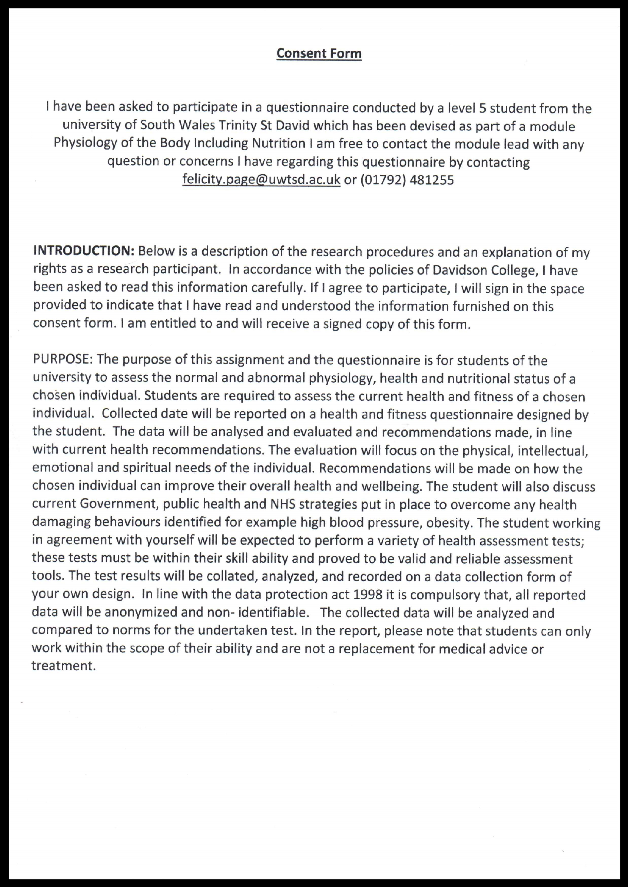
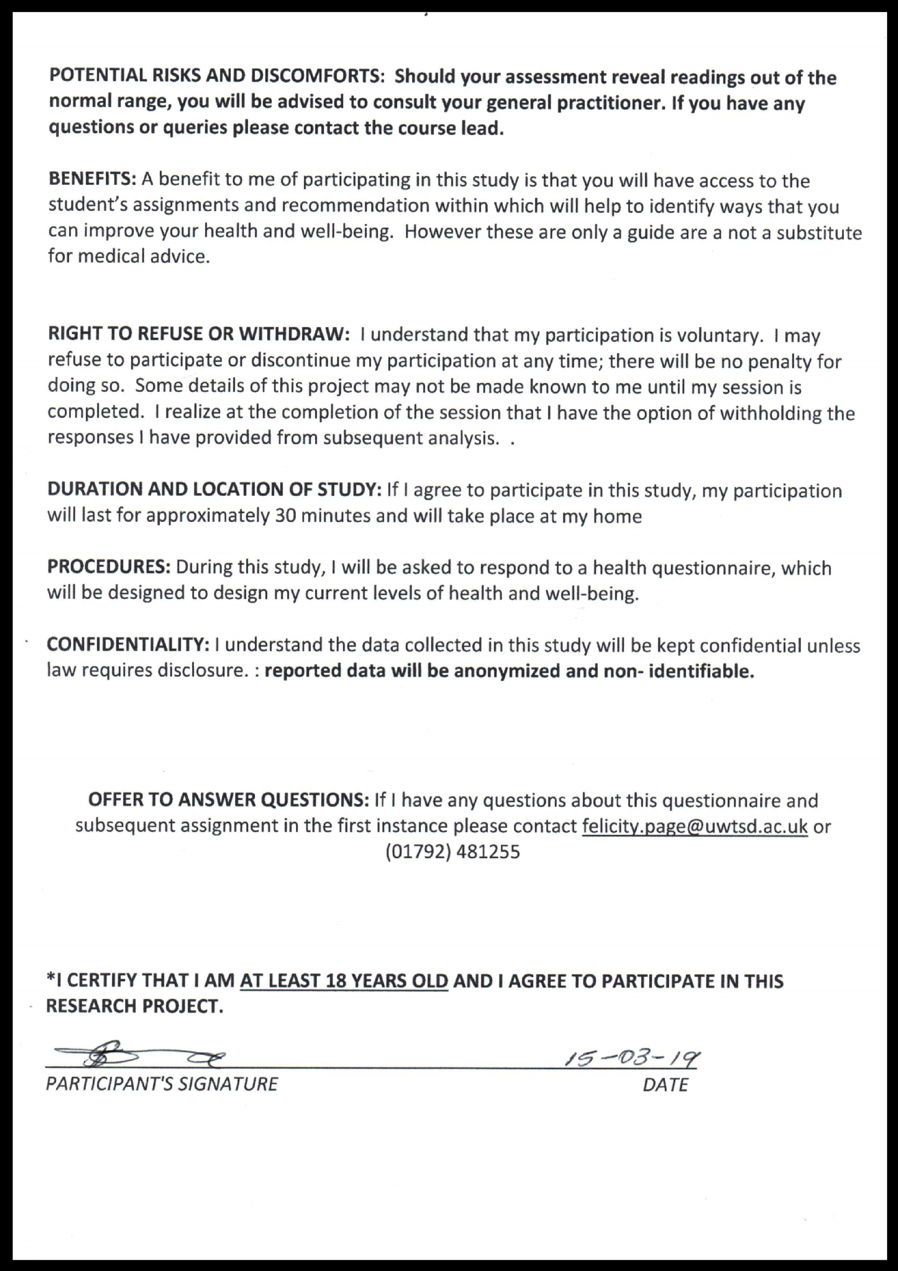

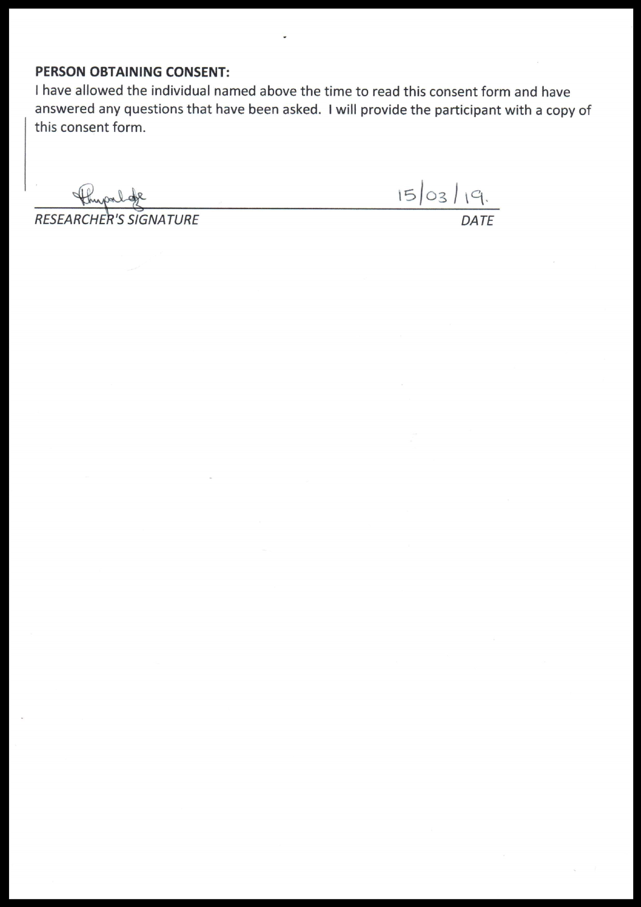
12

Form 1c
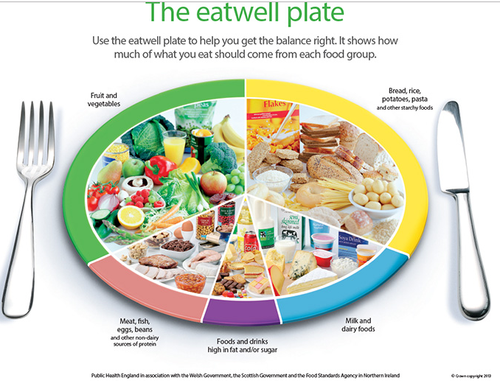

References
ABMU Health board (2010) Data protection and confidentiality policy . Available at: http://www.wales.nhs.uk/sites3/documents/950/ABMU%20Data%20Protection%20and%20Confidentiality%20Policy.pdf (Accessed: 21st April 2019)
Blood Pressure UK (2008) Salt and blood pressure. Available at: http://www.bloodpressureuk.org/microsites/salt/Home/Whysaltisbad (Accessed 22nd April 2019)
British Heart Foundation (2009) Available at: http://www.devonhealthandwellbeing.org.uk/wp-content/uploads/2012/10/BHF-How-healthy-is-your-diet-questionnaire1.pdf (Accessed: 21st April 2019)
British Heart Foundation (2019) Healthy Eating. Available at: https://www.bhf.org.uk/informationsupport/support/healthy-living/healthy-eating (Accessed : 22nd April 2019)
Cancer Research UK (2019) Tobacco Statistics. Available at: https://www.cancerresearchuk.org/health-professional/cancer-statistics/risk/tobacco (Accessed 22nd April 2019)
Cobiac, L. J., Scarborough, P., Kaur, A. and Rayner, M. (2016) The Eatwell Guide: Modelling the Health Implications of Incorporating New Sugar and Fibre Guidelines. Plos One .pp. 1(12).
Department of Health (2014) Wellbeing: Why it matters to health. Available at: https://assets.publishing.service.gov.uk/government/uploads/system/uploads/attachment_data/file/277566/Narrative__January_2014_.pdf (Accessed: 23rd April 2019)
Freeman, D., Sheaves, B., Goodwin, G. M., Yu, L., Nickless, A., Harrison, P. J. and Oxon, D. M. (2017) The effects of improving sleep on mental health (OASIS): a randomised controlled trial with mediation analysis. The Lancet Psychiatry. 4(10) P749-758
Gov.uk (2015) Sporting Future - A New Strategy for an Active Nation Available at: https://www.gov.uk/government/publications/sporting-future-a-new-strategy-for-an-active-nation (Accessed: 21st April 2019)
Government Legislation UK (2012) The Tobacco Advertising and Promotion (Display of Prices) (Wales) Regulations 2012. Available at: http://www.legislation.gov.uk/wsi/2012/1911/regulation/4/made (Accessed: 18th April 2019)
Government UK (2011) Physical activity guidelines for Adults (19–64 years). Available at: https://assets.publishing.service.gov.uk/government/uploads/system/uploads/attachment_data/file/213740/dh_128145.pdf (Accessed: 21st April 2019)
Guthold, R., Stevens, G. A., Riley, M. L. and Bull, C. F. (2018) Worldwide trends in insufficient physical activity from 2001 to 2016: a pooled analysis of 358 population-based surveys with 1·9 million participants. The Lancet Global Health. 6(10). pp.1077-1086

Harris, F., MacKintosh, A. M., Anderson, S., Hastings, G., Borland, R., Fong, G.T., Hammond, D. and Cummings, K. M. (2006). Effects of the 2003 advertising/promotion ban in the United Kingdom on awareness of tobacco marketing: Findings from the International Tobacco Control (ITC) Four Country Survey. Tobacco Control.
13
Help Me Quit (2019) WHAT CHOICES DO I HAVE TO STOP SMOKING? Available at: https://www.helpmequit.wales/what-choices-are-there-for-me/ (Accessed: 23rd April 2019)
Kamaldeep S. Bhui, Sokratis Dinos, Stephen A. Stansfeld, and Peter D. White(2012) A Synthesis of the Evidence for Managing Stress at Work: A Review of the Reviews Reporting on Anxiety, Depression, and Absenteeism. Journal of Environmental and Public Health
Kuipers, A. G. M., Beard, E., Hitchman, S. C., Brown, J., Stronks, K., Kunst, A. E., McNeill, A. and West, R (2015) Impact on smoking of England's 2012 partial tobacco point of sale display ban: a repeated cross-sectional national study.BMJ. 26(2)
Legislation.gov.uk (1998) Data Protection Act 1998. Available at: https://www.legislation.gov.uk/ukpga/1998/29/contents (Accessed: 21st April 2019)
Miller, M. A., (2015) The Role of Sleep and Sleep Disorders in the Development, Diagnosis, and Management of Neurocognitive Disorders. Frontiers in Neurology. 6(224)
NHS (2018) Eat well. Available at: https://www.nhs.uk/live-well/eat-well/5-a-day-what-counts/ (Accessed: 22nd April 2019)
NHS (2018) Healthy eating may not offset harmful effects of a high-salt diet. Available at: https://www.nhs.uk/news/food-and-diet/healthy-eating-may-not-offset-harmful-effects-high-salt-diet/ (Accessed 22nd April 2019)
NHS (2018) Healthy Weight. Available at: https://www.nhs.uk/live-well/healthy-weight/bmi-calculator/ (Accessed: 23rd April 2019)
NHS (2018) LIVING LIFE WELL PROGRAMME- 2018. Available at: http://www.wales.nhs.uk/sitesplus/documents/863/LLW%20information%20pack%202018%20%282%29.pdf (Accessed: 22nd April 2019)
NHS (2019) Physical activity guidelines for adults. Available at: https://www.nhs.uk/live-well/exercise/ (Accessed: 21st April 2019)
NHS (2019) What are the health risks of smoking? Available at: https://www.nhs.uk/common-health-questions/lifestyle/what-are-the-health-risks-of-smoking/ (Accessed: 22nd April 2019)
NHS 2019 Loneliness in older people. Available at: https://www.nhs.uk/conditions/stress-anxiety-depression/loneliness-in-older-people/ (Accessed 22nd April 2019)
NHS Direct Wales (2018) Insomnia. Available at: https://www.nhsdirect.wales.nhs.uk/encyclopaedia/i/article/insomnia/ (Accessed: 22nd April 2019)
NHS Direct wales (2018) Stress Available at: https://www.nhsdirect.wales.nhs.uk/livewell/stress/ (Accessed: 22nd April 2019)
NHS Public Health Wales (2017) Stop Smoking Wales. Available at: http://www.wales.nhs.uk/sitesplus/888/page/43913 (Accessed: 16th April 2019)
NHS University Health Board (2019) NHS Stress Control and Activate your Life Courses. Available at: http://www.iawn.wales.nhs.uk/stress-control-and-activate-your-life (Accessed: 22nd April 2019)
14
NHS Wales (2018) Sleep and tiredness. Available at: https://www.nhs.uk/live-well/sleep-and-tiredness/why-lack-of-sleep-is-bad-for-your-health/ (Accessed: 22nd April 2019)
NHS Wales (2019) Physical Activity. Available at: https://www.wales.nhs.uk/healthtopics/lifestyles/physicalactivity (Accessed: 22nd April 2019)
NHS(2016) Obesity. Available at: https://www.nhs.uk/conditions/obesity/causes/ (accessed: 22nd April 2019)
Nuttall, F. Q. (2015) Body Mass Index: Obesity, BMI, and Health A Critical Review. Nutrition Today. 50 (3). pp. 117–12
Potter, D. G. , Cade, J. E. and Hardie, L. J. (2017) Longer sleep is associated with lower BMI and favourable metabolic profiles in UK adults: Findings from the National Diet and Nutrition Survey. Plos One. https://doi.org/10.1371/journal.pone.0182195
Public Health England (2014) Protecting and improving the nation’s health: An evidence-based approach to physical activity. Available at: https://assets.publishing.service.gov.uk/government/uploads/system/uploads/attachment_data/file/374914/Framework_13.pdf (Accessed: 22nd April 2019)
Public Health Wales (2018) More smokers in Wales are quitting using NHS services. Available at: http://www.wales.nhs.uk/sitesplus/888/news/49232 (Accessed: 17th April 2019)
Schulze, B. M., Martínez-González, A. M., Fung, T. T., Lichtenstein, A. H. and Forouhi, N. G. (2018) Food based dietary patterns and chronic disease prevention. BMJ. 361. https://doi.org/10.1136/bmj.k2396
The London School of Economics and Political Science (2019) Informed Consent. Available at: https://info.lse.ac.uk/staff/services/Policies-and-procedures/Assets/Documents/infCon.pdf (Accessed: 21st April 2019)
The Welsh Assembly (2012) Explanatory Memorandum to the Tobacco Advertising and Promotion (Display) (Wales) Regulations 2012. Available at: http://www.assembly.wales/Laid%20Documents/SUB-LD8909-EM%20-%20The%20Tobacco%20Advertising%20and%20Promotion%20(Display)%20(Wales)%20Regulations%202012%20-%20Explanatory%20Memorand-16052012-233926/sub-ld8909-em-English.pdf (Accessed: 19th April 2019)
Varney, J. (2018) Is lack of sleep affecting your work. Available at: https://publichealthmatters.blog.gov.uk/2018/01/30/is-lack-of-sleep-affecting-your-work/ (Accessed: 22nd April 2019)
Wakefield, M. (2007) ‘The effect of retail cigarette pack displays on impulse purchase.’ Addiction: November 2007.

Watson, F. N., Badr, M. S., Belenky, G., Bliwise, D. L., Buxton, O., Buysse, D., Dinges, D. F., Gangwisch, J., Grandner, M. A., Kushida, C., Malhotra, R.K., Martin, J. L., Patel, S. R., Quan, S. F. and Tasali, E. (2015) Recommended Amount of Sleep for a Healthy Adult: A Joint Consensus Statement of the American Academy of Sleep Medicine and Sleep Research Society. NCBI. 38(6): 843–844.
Welsh Assembly Government (2009) Climbing Higher Next Steps. Available at: http://www.assembly.wales/Meeting%20Agenda%20Documents/Supporting%20Document%20-
%20Climbing%20Higher%20Next%20Steps-18102006-44844/bus-CHAMBER-8372afa76794e030012217410e11e597-English.pdf (Accessed: 22nd April 2019)
Welsh Government (2016) The All Wales Obesity Pathway. Available at: https://gweddill.gov.wales/topics/health/improvement/obesity/?lang=en (Accessed: 22nd April 2019)
Welsh Government (2016) The eat well Guide. Available at: https://gov.wales/sites/default/files/publications/2019-02/eatwell-guide.pdf (Accessed: 22nd April 2019)
Welsh Government (2019) Actions to address the greatest public health challenge of our generation – obesity – announced. Available at: https://gov.wales/actions-address-greatest-public-health-challenge-our-generation-obesity-announced-0 (Accessed: 22nd April)
WHO (2013) Global Action Plan for the Prevention and Control of NCDs 2013-2020. Available at: https://www.who.int/nmh/events/ncd_action_plan/en/ (Accessed: 21st April 2019)
WHO(2019) Obesity. Available at: https://www.who.int/topics/obesity/en/ (Accessed: 22nd April 2019)

