1902340
Sarah Grossey
Design Craft
Coexistent Perspectives (ADAA7000)

To what extent does the exhibition enact a situated counter-archive, and how do its curatorial strategies destabilise hierarchies of craft, authorship and historiography within the British Museum?

Word Count :
ILLUSTRATIONS

Figure 1 – The Tomb of The Unknown Craftsman, Ship
Wikiwand.com. (2021). Grayson Perry - Wikiwand. [online] Available at: https://www.wikiwand.com/en/articles/Grayson_Perry#/media/File:The-Tomb-of-the-Unknown-Craftsman_Grayson_Perry.jpg
Figure 2 – A closer look at The Tomb of The Unknown Craftsman, Ship
https://www.mca.com.au/files/documents/1_Classkit_GP_PDF.pdf

Figure 3 – Grayson Perry’s Alan Measles, illustrating the role of the figure as an archival object within Perry’s work.
https://daily-norm.com/2012/01/06/grayson-perry-tomb-of-the-unknown-craftsman/

Figure 4 – Chancay Doll, Peru, AD 900–1430. Textile and wood. Museum of World Cultures, Sweden.

British Museum Images. (2025). The British Museum Images. [online] Available at: https://www.bmimages.com/preview.asp?image=01005139001

Figure 5 – Grayson Perry, Tomb Guardian, 2011. Glazed ceramic.

Perry, G. (2011). Tomb Guardian [Ceramic sculpture]. In: The Tomb of the Unknown Craftsman, British Museum, London. Courtesy of the British Museum.

ABSTRACT
How does the Grayson Perry’s 2011 show The Tomb of the Unknown Craftsman reinvent an archive in a museum? By incorporating personal objects--most famously, Alan Measles, the teddy he owned as a child--Perry challenges conventional hierarchies of value in archival display. Influence and memory take over from traditional chains of historical legitimacy, the essay contends that Perry foregrounds "the individual" meaning. Juxtaposing present works of art with ancient objects like the Chancay Doll demonstrates how significance is created by similarity and repetition, and also curators' choices in process. Ultimately, Grayson Perry in this way turns the archive from a neutral repository into a narrative space reminiscent of both very personal myths and broader cultural criticism.

When the topic of archive enters the discussion, most people collectively, and perhaps unknowingly, relate this with the modern episteme; where knowledge is organised in museums and institutions alike. Epistemes are ‘rules of formation’, what information is considered permissible or valid in a particular cultural period (Han-Pile. B, 2016). However, similarly to the Bible, archives too have missing or misrepresented chapters (Walton, J. H., Sandy, B. 2013). Knowledge is produced and issued by those in control of the dominant discourse within an archive. Who, then, determines what is correct and true?
By extension, our own ancestry and personal records are preserved and retained to hold a future memory to our predecessors; through family heirlooms, mortgage agreements, birth certificates, and photographs that may no longer correspond to our present lives. Over time, these objects, once full of meaning, are discarded as the connection to them fades, rendering them obsolete. These personal archives, though informal, are often treated as the only proof of familial legacy (Harrison, 2012). Their eventual loss—through neglect or irrelevance—highlights how archives are emotionally selective, bound to what still feels meaningful rather than what is factually complete. These artefacts suggest that forgetting is as integral to archival practices as remembering (Basu, 2022).
Scholars often refer to this concept of the ‘archive’ when discussing collective and historical memory, specifically its representation in contemporary art. Alternatively, when referring to ‘the archive’, as proposed by Jacques Derrida, a more subjective and fragmented understanding of memory and history is explored (Derrida, 1996). This concept of the archive is more focused on the act of archiving itself, Derrida defines archiving as ‘a selective procedure’(van Alphen, 2023, p.017), and investigates the implications of what is included or excluded in the archive. Additionally, challenging the notion of the archive as a space of conservation and power, exploring memory, forgetfulness and the control that exists in the selection of what is considered an archive (Mauthner, Gárdos, 2015). Similarly, Michel Foucault emphasises this idea in his writings in The Archaeology of Knowledge (Foucault, 1972, .p.6), demonstrating the argument that archives are not neutral places. They are directly linked to the power structures that classify, construct, and ultimately shape our understanding of knowledge, and altering our perception. Both personal and institutional archives play an active role in determining what is remembered and what is forgotten. In Ariella Azoulay's 2019 book Potential History: Unlearning Imperialism, she argues that archives have a dark, tendentiously conservative and even violent political dimension. This is done by methods like leaving alternative histories out through simply omitting them and failing to include them in official records (Azoulay, 2019, p.300). Critiques like Azoulay's challenge the traditional perception of the archive as a neutral repository- one which in memory and folklore studies is often mythologized as these are places where historic events occur objectively. Archiving is exposed instead, as a process filled with the interstices between fact and fiction.
Museums are beginning to confront the gaps in their imperial collections, acknowledging that cultural memory has been shaped by erasure as much as preservation. At this charged moment, Grayson Perry’s exhibition The Tomb of the Unknown Craftsman (The British Museum, 2022) intervenes directly in the politics of display, placing 170 historical artefacts in conversation with his own objects.
This essay asks: To what extent does the exhibition enact a situated counter-archive, and how do its curatorial strategies destabilise hierarchies of craft, authorship and historiography within the British Museum?
It argues that The Tomb of the Unknown Craftsman functions as a counter-archival assemblage that simultaneously unsettles—and depends upon—the British Museum’s colonial epistemology, exposing the contradictory labour of decolonising the archive from within.
Drawing on Derrida, Foucault, Azoulay, Bennett and Ingold, the discussion first maps the politics of the archive, then analyses Perry’s curatorial practice, before turning to the material properties of his work and their implications for memory and power.
Archives are typically defined by a collection of historical records relating to a place, organisation, or family (Swire, 2015). These collections of artefacts, live as evidence to our ancestry, serving as valuable sources of information for education and research (The National Archives, 2023). However, such a definition assumes neutrality and completeness. The word ‘archive’ is derived from the Greek word ‘archeia’, meaning ‘public records’ (Ovenden, 2020, p.6) implying a sense of authority, permanence, and importantly, truth. However, following the thesis that archives are shaped via often exclusionary, and biased selective processes - what makes them truly ‘public’? Furthermore, this underscores the programs put in place through institutions, Pitt Rivers and alike, as it confronts this idea that the archives have an implicit claim to objectivity. Through highlighting and addressing these practices, it is not only reshaping its use of archive, but also re-examines what it is that defines, ‘public record’.

However, the archive, whose supposed neutrality is seen as a safe depository of historical documents, has been reimagined, as a site of power and place to curate narratives. Michel Foucault’s, The Archaeology of Knowledge (1972) emphasises that the archives are not passive storage of information, rather, they are a practice of discursiveness, that determine what can be known, what can be said, what can be remembered in a society (Foucault, 1972, pp.128-129). He builds on the idea that knowledge is not an impartial account of facts, but shaped by authority and classification. These systems operate within broader structures he calls “epistemes” — the historical a priori conditions for knowledge production. According to Foucault, archives are devices of power that define what narratives are included and excluded. These systems draw boundaries between what is accepted and what is unaccepted, exercising control over which narratives are legitimised and which are excluded.
He writes,’
in that area where, in the past, history deciphered the traces left by men, it now deploys a mass of elements that have to be grouped, made relevant, placed in relation to one another to form totalities.’ (Foucault, 1972, p.7)

Jacques Derrida takes this further in Archive Fever (1996) where he implies that the archive is a purifying protocol, claims that archives have a complex ideological nature, that it both enables a form of institutional power, and acts as a resource for resistance and re-interpretation (Derrida, 1996, p.17). The archive, by its very nature, operates in tension with itself. He emphasises the ideological tension between preservation and destruction, suggesting that “the archive always works, and a priori, against itself” (Derrida, 1996, p.12). He also argues, “There is no political history without control of the archive, if not of memory” (Derrida, 1996, p.4), suggesting that instead of an archive of objective truth, the archive is a creator of meaning, through lacuna - the gaps or absences that remain unfilled, leaving room for interpretation.

Ariella Azoulay heightens this critique by arguing that the archive should be regarded as an instrument of imperial violence from which dominant ideologies are strengthened through the forgetting of diametrically opposed histories (Azoulay, 2019, pp. 39-43). Even one’s most personal archives — family keepsakes, photographs, birth certificates — are susceptible to degradation through the process of time, illustrating the fragility and artifice of memory, on both an individual and collective plane. As Adolf Hitler chillingly understood, it is not only important to remember, but also to control how memory is shaped, who shapes it, and for whom. “Hitler was a perverse genius in understanding that it mattered to remember European Jewry, and even more importantly, that it mattered how they were going to be remembered, who would shape this memory and for whom” (van Alphen 2023, p. 91). This underscores the violence inherent in archiving processes — a violence not only of omission but of shaping remembrance itself. This theoretical gaze conceptualizes the archive as emphatically not a dead repository of the past but as a very active demonstration of historical legitimacy and cultural representation – a dynamic key to understanding Grayson Perry’s intentions with The Tomb of the Unknown Craftsman.

Archives are not neutral; they actively shape our understanding of history and identity (Jimerson, 2006). Narrative and archive are deeply interconnected and influence one another. In the context of historical archives, narrative does not solely shape the archive; the archive also shapes narrative (Ketelaar, 2012). From a historical standpoint, significant periods of the past were recorded and curated by the people living in those times. This means they had control over the narratives that we, in the present day, perceive and understand. Similarly, the way we display and curate archives today alters the narratives we present. By deciding what to include, emphasise, or omit, we shape how future generations will interpret history (Ketelaar 2012). This theoretical lens provides a crucial foundation for examining how Grayson Perry's The Tomb of the Unknown Craftsman engages with the archive as a site of institutional power and cultural exclusion.

These theoretical critiques, as described by Foucaut, Derrida and Azoulay, as a politicised system offers a valuable perspective for understanding contemporary artistic engagements with memory, history and material culture (Derrida, 1996). Greyson Perry’s, The Tomb of The Unknown Craftsman (Perry and British Museum 2011) is a good example that highlights the roll institutional narratives have played in the curatorial realm. Installed at the British Museum, a location that holds symbol of institutional authority, which responds directly to this tension (Shales 2012; Hemingway and Starkey 2024)., Perry’s installation debates the notions of authorship and cultural value, weaving together his own works, to create a personal and collective memory. His exhibition of archives foregrounds the forgotten makers of history, whilst challenging the systems in place that historically overlooked them. In the next section, we will explore how Perry's curatorial practice counters institutional narratives and affirms craft as a legitimate source of historical knowledge.
Greyson Perry is a leading British artist widely known for his work in ceramics and tapestries, gaining attention for its bold and subversive qualities. Such practices often engage with these very questions of history, memory, and the archive. Perry blends a technicolour of expertise, knowledge and craftmanship, employing these traditional medias in a reactionary way (Perry, 2014, p.55) Perry, a self-proclaimed "conceptual artist masquerading as a craftsman" (Perry, 2014, p. 55), combines traditional craft techniques with contemporary imagery to critique modern society. His work falls somewhere between historical and contemporary influences, interrogating the hierarchies between fine art and craft.
In this exhibition, The Tomb of The Unknown Craftsman (2011), Perry reimagined the archive by exhibiting historical artifacts with his own works. Subsequently, creating a contrast that highlighted the contributions of anonymous artisans throughout history. In this display, which featured some 170 objects chosen to pay tribute to the forgotten craftsmen and products of a ‘distinct civilisations’ (Perry and British Museum 2011, p.12), the collection also serves as an exploration of the archive as a site that constructs and contests history. Perry utilized archival practices to challenge his own personal experiences and archive, while recontextualizing artifacts from throughout history that respond to, and echo, his own works and style (Perry and British Museum 2011, p. 11). Perry explains how within the British Museum collection, unlike an exhibition of artworks, ‘we know very few of people who actually made the objects that we saw’ (Perry, n.d.) and so similarly to how other cultures have a tomb of the unknown soldier, Perry too wanted to celebrate these unrecognised skilled craftsman. The curatorial decisions help this collection play as a homage to these unknown craftsmen who made great contributions shaping history, but have overtime been forgotten. Perry writes,

I found myself choosing objects not just because of their historical or cultural significances but because I felt they fitted into the world that produced The Tomb of The Unknown Craftsman. I have no facts to bolster my choices, only the hopes that others enjoy the poem that I have woven with them.’ (Perry and British Museum, 2011, p.12).

This selection process exemplifies an act of archival authorship, wherein emotion and intuition override conventional curatorial taxonomies.
This selection process is an act of archival practice, as Perry chose objects that resonated with his themes and ideas of which were displayed alongside his works. The exhibition's centrepiece, a large iron ship named, The Tomb of the Unknown Craftsman (Perry and British Museum, 2011), as shown in Figure one, serves as a metaphor for the journey of the artist and the anonymous craftsman whose work is often subsumed into larger historical narratives (British Museum, 2011). This central feature for the exhibition, reiterates this through a visual representation of the pilgrimage he has taken,
‘and so we come to the tomb itself – an iron ship sailing into the afterlife. The ship is also a pun, a craft for the craftsman. It is hung with casts of the fruits of his labours and carries a cargo of blood, sweat and tears’ (Perry an British Museum, 2011, p.185).
The work is rendered in Iron and features exquisite details that marry Perry’s modern sensibility with references to historical objects and motifs. It is decorated with items and totems that reflect a mix of individual and shared histories weaving together Perry’s own creations with objects and images from the British Museum’s vast archives.
Sitting at the ship’s helm is Alan Measles (while not physically positioned at the ship’s helm), Perry’s childhood teddy bear and a reoccurring character in his work, cast metaphorically as both a spiritual navigator and an embodiment of personal history (Perry and British Museum, 2011, p. 10). Circling the vessel are objects that reflect the artisan ship of nameless creators from various regions and eras. These tools, ornaments and relics underscore the breadth of human creativity and embody the theme of pilgrimage. The ship recognises the labour of craftsman throughout history whose often anonymous works nurture the sinews of culture and history. In this connection, Perry’s practice acts as a narrative focus, intertwining past legacies with present debates to frame the exhibition as a space for thought and holistic engagement (Spalding, 2012).
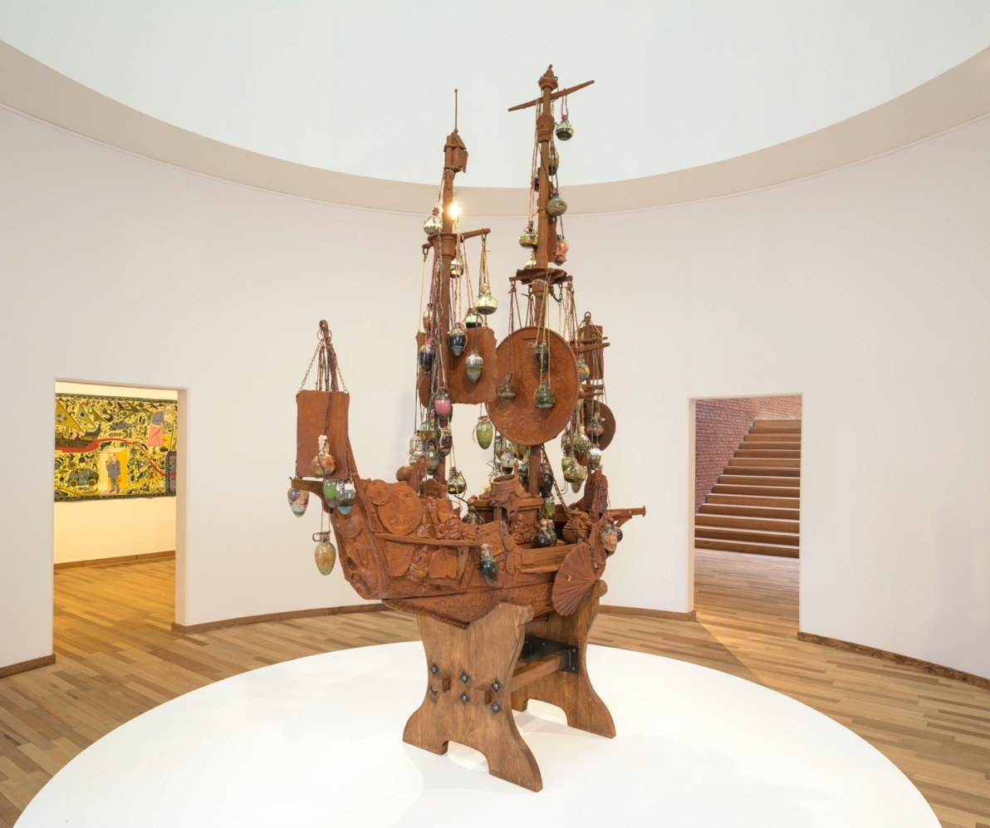

Figure 1 The Tomb of The Unknown Craftsman, Ship by Grayson Perry

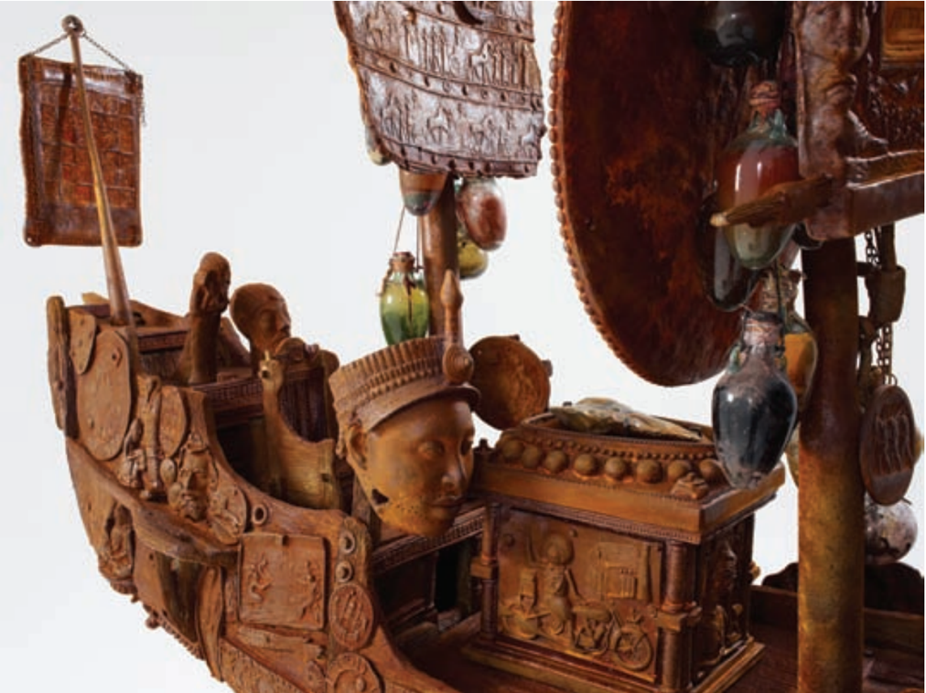

Figure 2 Closer view of The Tomb of The Unknown Craftsman

Perry’s framing of the exhibition as a pilgrimage allows him to subvert the ways that museums have traditionally displayed objects, which tend to be seen as both static and neutral. This parallel both provokes and prompts the viewer to pause and consider their outlook on the past and their agency as producers of cultural and historical significance (Fisher, 2011; Lewis, 2012). The ship serves as a visual metaphor for cultural journeys, its form evoking craft, voyage, and the afterlife.

Even the materiality of the ship (figure 1) itself reflects the industrial and artisanal roots of human progress, a slight nod to the ancient crafts used by our ancestors, to the enduring and transformative power of craft. The material objects within an archive are laden with narratives that inform and sometimes redefine our understanding of history. Perry’s artistic curation aligns objects from different eras, creating dialogues that innovate archival displays and interpretations. The flint axe (figure 2) described by Perry as “not a masterwork made for some king but a common tool,” holds narrative power in its simplicity (Perry and British Museum, 2011, p. 25). It highlights the role of mundane objects in narrative construction within archives, emphasizing their ubiquity and significance across human existence. According to Jacques Derrida, the notion of the archive underlines that the process of gathering and categorisation of things is idiosyncratic; archivists (or curators) decide what to preserve, how to categorise it, and in what contexts it will be presented (Derrida, 1996). And so, like the flint axe, ‘mundane’ artefacts can historically challenge the notion that only grand or prestigious objects are deserving of preservation. By contextualizing the flint axe within an artistic narrative, Perry elevates its status within the archival practice as a symbol of universal human experience, showcasing how narrative can transform the archival value of an object from mundane to monumental (Hemingway, Starkey, 2024).

Glenn Adamson (2007) argues that craft has long been marginalised within the art world, positioned as amateur, decorative, or domestic (Adamson, 2007). Perry contests this hierarchy by presenting craft as a site of critical engagement, positioning the anonymous artisan as equal to the celebrated artist (Perry and British Museum, 2011). His curatorial choices echo Derrida’s (Derrida, 1996) claim that archiving is inherently selective and political. Perry has made absence a visible and potent presence in the display.
These institutes of museums and education have often excluded items from display, frequently prioritising the narratives that align with Western perspectives (Macdonald, 2013). This occurrence is particularly evident in recent years, as establishments face growing scrutiny over their curatorial practices. For example, Pitt Rivers efforts to decolonise the displays (Pitt Rivers Museum, 2020) due to the violent and inequitable nature of obtaining such items. This is an instance of modern episteme; a necessary exclusion as it is from a time where prioritising narratives that aligned with colonial power structures. The Pitt Rivers’ efforts to challenge these alterations in spaces of established knowledge, encourages the public to reflect on how these exclusions have impacted our understanding of history and today's culture. By questioning the neutrality of its collections, they are effectively transitioning the space into one that mirrors contemporary epistemic values of equity and inclusion.
Perry’s personal history further complicates traditional archival narratives. Alan Measles, his childhood teddy bear, recurs throughout his practice as a symbol of protection, leadership, and rebellion—qualities Perry felt he lacked growing up. In The Tomb of the Unknown Craftsman, Alan Measles is rendered not just as a companion, but as a relic and saintly protector. Through this, Perry elevates personal memory to institutional recognition. Halbwachs’ theory of collective memory suggests that personal memories are always shaped within a social context (Halbwachs, 1992). Perry’s installation visualises this: his imagined narratives become part of public memory, challenging the archive’s boundaries.
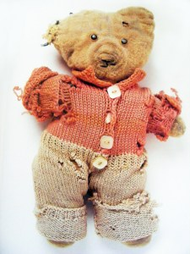

Figure 3 Alan Measles, Grayson Perry’s childhood teddy bear.

Through Alan Measles, Perry also exposes how personal and imagined histories can be woven into broader cultural memory. Perry selected artifacts to echo and respond to works that he has already created (Perry and British Museum, 2011.). In Perry’s imagined world, Alan embodied the stereotypical male qualities of leadership, strength, protection and rebellion; all the things Perry felt he may have lacked during his childhood and absence of his father (Perry and British Museum, 2011.). This personal artifact has been placed onto such a pedestal that it has become a main focal point for this exhibition and imagery of the bear’s adventures and challenges are consistent throughout.

Alan Measles, a profoundly individual memory-object, becomes a conduit of personal memory that sheds light on neglected narratives. This approach challenges conventional archives, which often overlook intimate or subjective histories. Rather than presenting archives as factual repositories, Perry reframes them as fluid spaces of personal and collective storytelling (Perry and British Museum 2011; Perry 2014). Derrida’s concept of ‘archive fever’ critiques how grand historical narratives are privileged over intimate, idiosyncratic ones (Derrida, 1996). Alan Measles, as product of personal archive, unsettles the coherence of institutional narratives and reveals their contingent, constructed nature. This playful disruption of curatorial objectivity, in Derrida’s terms, becomes a ‘supplement’—something that both adds to the archive and reveals its structural limits (Derrida, 1996).

While Alan Measles is not a "historic site" in the traditional sense, he serves as a "locus" where Perry’s personal history intersects with broader narratives of craft, religion, and identity. The interjection of Alan Measles as a form of “relic” within a revered cultural institution, Perry sets up a locus of memory (Perry and British Museum, 2011), inviting reflection on how archives are constructed. Perry’s use of playful curatorial strategies dismantles the assumption of objectivity behind museum displays. Drawing on Derrida, Alan Measles functions as a the teddy is a supplement – an unforeseen, disruptive element that renders the official narrative fanatically incohesive (Derrida, 1996). He also enables a Foucauldian understanding of episteme: the historically contingent lens of what knowledge counts as meaningful, gives us power and place, and so what stories are told and what stories are ignored (Foucault, 1970). By featuring an unassuming childhood item instead of a grander object, Perry exposes the way museum curation is part of an episteme that often celebrates “official” histories at the expense of “ordinary” or personal stories. In other words, Perry’s intervention here confirms the Derridean observation that archives produce both presence (what they show) and absence (what they ignore). And so, the museum stands as a site of interpretive power, confirming Derrida’s argument that archival access determines what is remembered culturally.

Meaning in Derrida’s deconstruction is never fixed but is always shaped through context, difference, and repetition (Derrida, 1996). By placing the teddy bear at the centre of an institution, Perry underscores this contingency: the meaning of history itself is always in the process of becoming — and this constructed meaning is shaped by the decisions of those who control the archives throughout history. Alan Measles through his repeated appearance and evolving symbolism, transforms from an personal momento into a cultural artefact. Alan could potentially be seen as a part of cultural repertoire, therefore becoming a memory shared by those who engage with Perry’s work. It holds the potential to become sustained and circulated through art-world discourse, social media, and academic commentary (Assmann, 2011). In this way, Perry not only inserts his own mythology into the historical record but also reshapes the narrative for future generations.

Alongside these depictions of an imagined history, are artifacts that echo very similar traits, yet are centuries older. This becomes particularly evident in Perry’s pairing of the Chancay Doll (Peru, AD 900–1430) with his own Tomb Guardian (2011). The Chancay Doll, with its infantile face, visually echoes Alan Measles and highlights how memory is shaped by resemblance, projection, and cultural overlap. As Walter Benjamin notes in Theses on the Philosophy of History, history is formed in the moment of its retelling, always mediated by the present (Benjamin, 1940). Perry’s reframing of the Chancay Doll through personal myth destabilises fixed historical meanings. In openly acknowledging subjectivity, Perry participates in a model of archival practice that embraces the curator’s role in shaping narratives, rather than concealing it (Jones, 2011). His deliberate and sometimes eccentric pairings — such as the Chancay Doll with Tomb Guardian — highlight how personal memory can unsettle and even rewrite institutional frameworks of value and significance.
Foucault (1986) describes heterotopias as “real places… which are something like counter-sites,” in which incompatible spaces are layered and cultural meanings are destabilised. Perry’s exhibition can be understood as a heterotopia: a curated space where personal relics like Alan Measles are elevated to museum status, religious symbols are parodied, and canonical history is questioned. This heterotopic framework allows Perry to collapse temporal, cultural, and narrative distinctions—revealing how institutional authority is constructed and how it might be disrupted
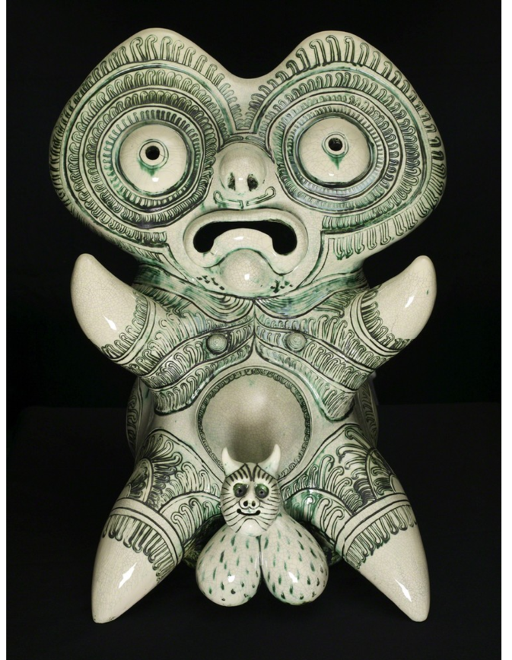
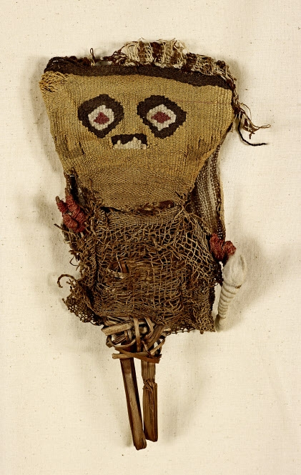
Figure 5 Grayson Perry, Tomb Guardian, 2011
Figure 4 Chancay Doll, Peru, AD 900–1430. Textile and wood. Museum of World Cultures, Sweden.

In doing so, Perry performs what Assmann describes as a transition from communicative to cultural memory: an individual symbol (Alan Measles) becomes part of shared repertoire through repetition, world circulation, and public engagement (Assmann, 2011). His approach echoes Dipesh Chakrabarty’s critique of Western epistemologies in Provincializing Europe (Chakrabarty, 2000), which often impose dominant frameworks on non-Western objects. Perry instead foregrounds subjectivity and myth-making.

The same principle applies to the other objects throughout The Tomb of the Unknown Craftsman (Perry and British Museum, 2011), where Perry pairs ancient artifacts like the Chancay Doll (Figure 4) with his own works, such as the Tomb Guardian, 2011 (Figure 5). These items are critical to Perry’s deconstruction of archival authority, prompting contemplation on the processes that elevate these and other items into the realm of sacred archival objects while others are relegated or made trivial. For reference, figure 4 the Doll Found In a Grave, AD900-1430, (Perry and British Museum 2011) which is a Chancay Doll from Peru, it mirrors features of Alan, highlighting how memory is shaped by resemblance, projection, and cultural overlap. As Walter Benjamin notes in Theses on the Philosophy of History, history is formed in the moment of its retelling, always mediated by the present (Benjamin, 1940). As Perry writes,

I think of the history of culture as an infinitely complex game of ‘Chinese whispers’, where images and ideas are changed by passing through the hands of various craftsman... each idea becomes something new… because creativity is often a series of innocent mistakes. (Perry and British Museum, 2011, p. 11).

This proposes the idea that meaning is not static, nor fixed in time.

A ceremonial object from Peru, it was at first thought of in its own cultural and spiritual context, but has now been reframed, in the museum context, through Perry’s curatorial lens. This reframing aligns with Assmann’s (Assmann, 2011) observation that memory is upheld and circulated through shared participation, be it that of art-world, social media, or academic critique. Perry instead foregrounds subjectivity and storytelling.

Perry’s Tomb Guardian further illustrates this ethos. A sculptural depiction of Alan Measles, it is rendered in a saintly pose, combining religious iconography with cartoonish exaggeration. It parodies sacred relics while acting as a serious meditation on guardianship, history, and memory. As Assmann (2011) notes, cultural memory thrives on repetition and shared recognition—qualities that Perry’s work embraces through visual recurrences and narrative layering.

The Tomb of the Unknown Craftsman by Grayson Perry is an example of a provocative curatorial intervention, questioning the control and impartiality of the institutional archive. By constructing a counter-archive inside the walls of the British Museum—Britain’s hollow epicenter of colonial power and cultural validation—Perry recasts the museum as more than a place where historical objects are returned to the stage of history but becomes a place where cultural memory, political conflict, and imaginative renewal manifest themselves.

Through his curatorial method, Perry creates a counter-archive—one that pays homage to forgotten labourers, values craft and promotes personal mythology as a valid form of historical narration. In that, he unseats the institutional authority of the British Museum from within, revealing the power principles that underlie how memory, knowledge, and cultural value are controlled.

By incorporating his own objects, notably Alan Measles, an intensely personal object, at the centre of the showcase and ancient artefacts such as the Chancay Doll and the Flint Axe, Perry highlights the randomness of what is kept, made canonical or forgotten. He restores the archive as a site of affective, personal memory rather than a disinterested record. His choices reveal the gaps in the conventional historical narrative and reiterate the criticisms of theorists such as Derrida, Foucault, Azoulay — who have all emphasized the fact that the archive is implicated in the construction, omission, politicization of memory.

In the end, The Tomb of the Unknown Craftsman illustrates how art can resist the power of official tales by proposing a competing model of cultural memory, one hinged on feeling, making and the ways in which it is possible to be a part of the memory of the many. Perry’s work shows the archive to be not a fixed space of truth but an ever-changing terrain, one open for re-reading, re-making, remembering otherwise.

BIBLIOGRAPHY

- Adamson, G. (2007). Thinking Through Craft. Oxford: Berg.
- Assmann, J. (2011). Cultural Memory and Early Civilization: Writing, Remembrance, and Political Imagination. Cambridge University Press. Available at: doi:https://doi.org/10.1525/aft.2008.36.1.30.1. [Accessed 22 Jan. 2025]
- Azoulay, A. (2019). Potential History: Unlearning Imperialism. United Kingdom: Verso Books. Available at: https://www.are.na/block/14261487 [Accessed 20 Jan. 2015]
- Basu, R. (2022) ‘The Importance of Forgetting’, Episteme, 19(4), pp. 471–490. doi:10.1017/epi.2022.36. Available at: https://www.cambridge.org/core/journals/episteme/article/importance-of-forgetting/62F3162009892011E6CCA49ACB6A416A [Accessed: 25 April. 2025]
- Benjamin, W. (1940). Theses on the Philosophy of History. In Illuminations (H. Zohn, Trans.). New York: Schocken Books.
- British Museum (2011) The Tomb of the Unknown Craftsman. Exhibition curated by Grayson Perry. London: British Museum.
- Brown, R. H., & Davis-Brown, B. (1998). The making of memory: the politics of archives, libraries and museums in the construction of national consciousness. History of the Human Sciences, 11(4), 17-32. Available at: https://doi.org/10.1177/095269519801100402 (Original work published 1998)
- Carlson Hasler, L. (2019). Archival Historiography in Jewish Antiquity. United Kingdom: Oxford University Press. Available at: https://www.google.co.uk/books/edition/Archival_Historiography_in_Jewish_Antiqu/A5jFDwAAQBAJ?hl=en&gbpv=0
- Chakrabarty, D. (2000). Provincializing Europe: Postcolonial Thought and Historical Difference. Princeton: Princeton University Press.
- Chlebowski, I.S. (2008). Archive Fever. Afterimage, 36(1), pp.30–30.
- Derrida, J. (1996). Archive fever : a Freudian impression. Chicago: University of Chicago Press. Available at: https://monoskop.org/images/e/ef/Derrida_Jacques_Archive_Fever_A_Freudian_Impression_1996.pdf [Accessed 5 Nov. 2024]
- Fisher, M. M. (2011)
Open Enrollment: The Tomb of the Unknown Craftsman. Art21 Magazine. Available at: https://magazine.art21.org/2011/12/28/open-enrollment-the-tomb-of-the-unknown-craftsman/ [Accessed 28 April. 2025].
- Foucault, M. (1970). The Order of Things: An Archaeology of the Human Sciences. London: Tavistock Publications.
- Foucault, M. (1972) The Archaeology of Knowledge. Translated by A. M. Sheridan Smith. New York: Pantheon Books. Available at: https://monoskop.org/images/9/90/Foucault_Michel_Archaeology_of_Knowledge.pdf [Accessed 11 Dec. 2024]
- Halbwachs, M. (1992) [1950]. On Collective Memory. (L. A. Coser, Ed.). University of Chicago Press.
- Han-Pile, B. (2016). Foucault, normativity and critique as a practice of the self. Cont Philos Rev 49, 85–101 Available at: https://doi.org/10.1007/s11007-015-9360-2 [Accessed 10 Jan 2025]
- Harrison, R. (2012) ‘Forgetting to remember, remembering to forget: late modern heritage practices, sustainability and the ‘crisis’ of accumulation of the past’, International Journal of Heritage Studies, 19(6), pp. 579–595. Available at: https://www.tandfonline.com/doi/abs/10.1080/13527258.2012.678371 [Accessed 25 April. 2025]
- Hemingway, C.A. and Starkey, K. (2024) ‘Authenticity, Craftsmanship, and Character in the Artworks of Grayson Perry’, Business Ethics Quarterly, 34(4), pp. 686–693. doi:10.1017/beq.2024.20. Available at: https://www.cambridge.org/core/journals/business-ethics-quarterly/article/abs/authenticity-craftsmanship-and-character-in-the-artworks-of-grayson-perry/CE5BC1CA6EEACAE2A0D4197ABF5DB18C [Accessed 2 April. 2025]
- Jimerson, R. C. (2006) ‘Embracing the power of archives’, The American Archivist, 69(1), pp. 19–32. Available at: https://cedar.wwu.edu/cgi/viewcontent.cgi?article=1065&context=history_facpubs [Accessed 23 March. 2025]
- Jones, S. (2011). The Defining and Shaping of the Contemporary Art Curator. [PDF] Available at: https://www.academia.edu/75034948/The_Defining_and_Shaping_of_the_Contemporary_Art_Curator
- Ketelaar, E. (2012) ‘Cultivating archives: meanings and identities’, Archival Science, 12(1), pp. 19–33. Available at: https://link.springer.com/article/10.1007/s10502-011-9142-5 [Accessed 28 March. 2025]
- Lewis, R. (2012)
Grayson Perry: The Tomb of the Unknown Craftsman. Museum Ethnographers Group Blog. Available at: https://museumethnographersgroup.blogspot.com/2012/01/grayson-perry-tomb-of-unknown-craftsman.html[Accessed 28 April. 2025].
- Macdonald, S. (1998). The Politics of Display: Museums, Science, Culture. London: Routledge. Available at: https://www.taylorfrancis.com/books/edit/10.4324/9780203838600/politics-display-sharon-macdonald [Accessed 28 April. 2025]
- Major-Poetzl, P. (2017). Michel Foucault's Archaeology of Western Culture: Toward a New Science of History. United States: University of North Carolina Press. Available at: https://www.google.co.uk/books/edition/Michel_Foucault_s_Archaeology_of_Western/r_s4DwAAQBAJ?hl=en&gbpv=0 [Accessed 10 April. 2025]
- Mauthner, N. S. and Gárdos, J. (2015) ‘Archival Practices and the Making of “Memories”’, New Review of Information Networking, 20(1–2), pp. 155–169. Available at: https://doi.org/https://doi.org/10.1080/13614576.2015.1114825[Accessed: 10 Jan. 2025]
- Nora, P. (1989). “Between Memory and History: Les Lieux de Mémoire.” Representations, 26, 7–24. Available at: https://www.jstor.org/stable/2928520 [Accessed 25 April. 2025]
- Ovenden, R. (2020). Burning the Books: A History of the Deliberate Destruction of Knowledge. United States: Harvard University Press. Available at: https://www.hup.harvard.edu/file/feeds/PDF/9780674249509_sample.pdf [Accessed 8 Jan. 2025]
- Perry, G. (2014) Playing to the Gallery: Helping Contemporary Art in Its Struggle to Be Understood. London: Particular Books.
- Perry, G. (n.d.) Tomb of the Unknown Craftsman [Audio guide]. Nasjonalmuseet. Available at: https://www.nasjonalmuseet.no/en/guide/grayson-perry2/lyshallen/tomb-of-the-unknown-craftsman/ [Accessed 28 April. 2025]
- Perry, G. and British Museum (2011) The Tomb of the Unknown Craftsman. London: British Museum Press.
- Perry, G. and British Museum (2011). The tomb of the unknown craftsman. London The British Museum Press.
- Pitt Rivers Museum. (2020). Critical Changes. Available at: https://www.prm.ox.ac.uk/critical-changes [Accessed 5 May 2025].
- Popkewitz, T. S., Brennan, M. T. (1997). Foucault's Challenge: Discourse, Knowledge, and Power in Education. United States: Teachers College Press. Available at: https://www.google.co.uk/books/edition/Foucault_s_Challenge/ziNeDwAAQBAJ?hl=en&gbpv=0[Accessed 29 April. 2025]
- Radstone, Susannah and Bill Schwarz. Memory: Histories, Theories, Debates. Fordham University Press, 2010. Project MUSE. Available at: https://muse.jhu.edu/pub/93/oa_edited_volume/chapter/2331510[Accessed 20 April. 2025]
- Schwarz, B. (2010). ‘Acts of Memory and Mourning: Derrida and the Fictions of Anteriority’ ‘in’ Radstone, S., Schwarz, B., Memory: Histories, Theories, Debates. New York: Fordham University Press Available at: doi:https://doi.org/10.1353/book.66748. [Accessed 20 Feb. 2025]
- Shales, E. (2012) ‘The Tomb of the Unknown Craftsman’, The Journal of Modern Craft, 5(2), pp. 237–240 Available at: http://researchgate.net/publication/274679217_The_Tomb_of_the_Unknown_Craftsman [Accessed 2 April. 2025]
- Spalding, F. (2012) 'Grayson Perry: the Tomb of the Unknown Craftsman', Art and Christianity, (69), 11. Available at: https://link.gale.com/apps/doc/A313796394/AONE?u=anon~dec93413&sid=googleScholar&xid=6c15da7a [Accessed 10 Jan. 2025].
- Swire, E. (2015). An introduction to... archives | APGRD. Available at: http://www.apgrd.ox.ac.uk/learning/introductions-to/an-introduction-to-archives#:~:text=archive%2C%20noun.&text=a%20collection%20of%20historical%20documents,which%20such%20documents%20are%20stored. [Accessed 7 Jan. 2025].
- The British Museum. (2022). What is the role and value of crafts today? [online] Available at: https://www.britishmuseum.org/blog/what-role-and-value-crafts-today?.com [Accessed: 26 Jan. 2025].
- The National Archives (2023). The importance of archives - Archives sector. Archives sector. Available at: https://www.nationalarchives.gov.uk/archives-sector/advice-and-guidance/running-your-organisation/large-scale-projects/large-cultural-infrastructure-projects/guidance-for-bid-and-creative-teams/the-importance-of-archives/ [Accessed 7 Jan.2025]
- Van Alphen, E. (ed.) (2023) Productive Archiving: Artistic Strategies, Future Memories, and Fluid Identities. Amsterdam: Valiz
- Van Seters, J. (2006). The Edited Bible: The Curious History of the "Editor" in Biblical Criticism. United States: Pennsylvania State University Press. Available at: https://www.google.co.uk/books/edition/The_Edited_Bible/NN5-AKqBzsQC?hl=en&gbpv=0
- Voyce, M. (2017). Foucault, Buddhism and Disciplinary Rules (1st ed.). Routledge. Available at: https://doi.org/10.4324/9781315582856
- Walton, J. H., Sandy, B. (2013). The Lost World of Scripture: Ancient Literary Culture and Biblical Authority. United Kingdom: InterVarsity Press. Available at: https://www.google.co.uk/books/edition/The_Lost_World_of_Scripture/KbFyAgAAQBAJ?hl=en&gbpv=0[Accessed 29 April. 2025]

