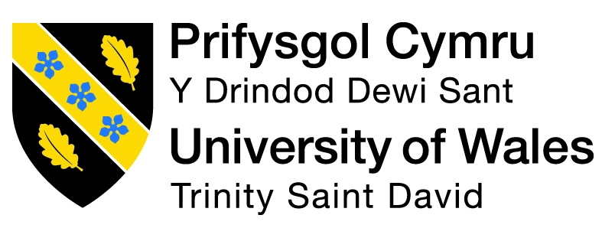
Master Of Business Administration

Student Name: Vivek Bharatbhai Odedara
Module Name: Human Capital Management
Module Code: LCMB7023
Student ID: 2505516
Project Title: INDIVIDUAL REPORT
Professor Name: Gladius Kulothungan
Word Count: 2511
Submission Date: 14th November 2025

Executive Summary
This report examined the changing global labour markets and how technology, demographic and geopolitical factors are transforming HR and IHRM strategies. It pointed to the fact that Artificial Intelligence and automation are turning the processes of work and require constant training of employees and ethical control. The HR challenges in workforce planning, inclusion and talent retention have been aggravated by demographic changes that include ageing, population increase in migration and geopolitical tensions. The solutions of strategic HRM such as ongoing learning, professional growth, employer branding, and recruitment globally are needed to seal the skills gaps and overcome the shortage of talent. The report ends with a self-reflection on personal global skills, taking the form of digital adaptability, leadership and lifelong learning to remain employable and successful in an organisation.

Table of Contents
1. Introduction 4
2. Technological Advancements and their Impact on Labour Markets 4
2.1 Technological Advancements 4
2.2 Implications for HRM 5
2.3 Implications for IHRM 6
2.4 Theoretical Model Application 7
3. Demographic and Geopolitical Influences on Employment Markets 8
3.1 Demographic Factors Affecting Labour Markets 8
3.2 Geopolitical Factors Influencing Global Employment 8
3.3 HR Challenges Arising from Demographic and Geopolitical Shifts 9
4. Addressing Skills Gaps and Talent Shortages through Strategic HRM 11
4.1 Strategic HRM to Address Skill Gaps 11
4.2 Strategic HRM to Address Talent Shortages 12
4.3 Theoretical Model to Support Strategic HRM 12
5. Reflective Report: Personal Capabilities in Global Context 13
5.1 Technology Use and Digital Adaptability 13
5.2 Communication in Cross-Cultural Environments 13
5.3 Teamwork and Collaboration Skills 13
5.4 Leadership Skills in Global Contexts 14
5.5 Self-Directed Learning and Continuous Development 14
5.6 Personal Action Plan for Professional Growth 14
6. Conclusion 15
References 17

1. Introduction
The report examines the impact of the changes in the labour market on the HR strategies and employability. The world of labour is rapidly evolving because of technology, societal migration, and international developments. The HRM and IHRM practices of the contemporary organisations are heavily influenced by technology, demographics, and geopolitics. There are four sections of the report, namely technology, demographics, skill gaps, and personal reflection.

2. Technological Advancements and their Impact on Labour Markets

2.1 Technological Advancements
Artificial Intelligence (AI)
AI is reshaping the way business organizations handle employees and conduct business decisions. Artificial intelligence also eliminates repetitive jobs and generates other positions based on technology (Weforum, 2025). It implies that businesses rely increasingly on data and digital talent towards managing workers.
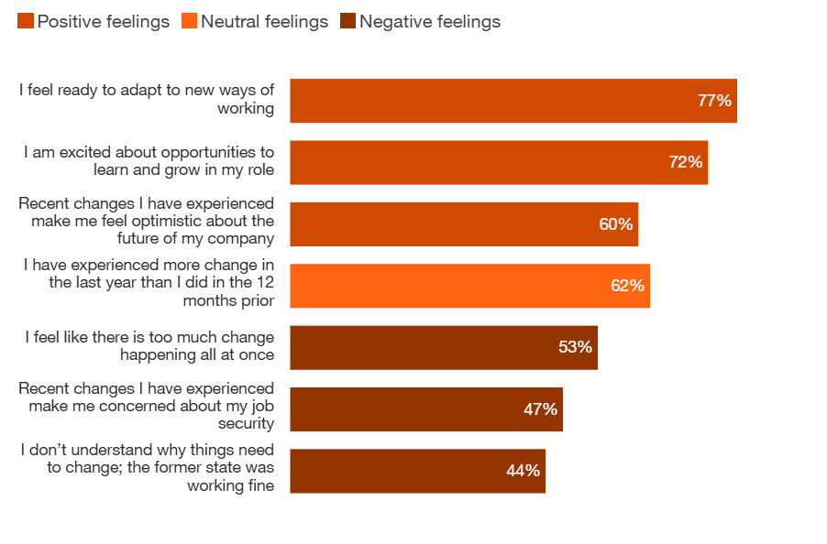
Figure 1: Employee Sentiments Toward Workplace Change
(Source: PWC, 2025)
The figure shows that though 77% of employees are ready to adapt to new changes, 44-53% of employees show negative sentiment towards the workplace change. Hence, AI is a challenge and an opportunity to enhance productivity and innovation in organisations.
Automation and Robotics
Industries, such as manufacturing, and logistics are transforming the way work is carried out with the use of automation and robotics. By 2030, almost 30% of working activities will be automated (McKinsey, 2025). This demonstrates that more monotonous work can be performed by machines and employees are able to concentrate on creative and problem-solving work. Automation is therefore altering the job positions mandating the employees to adjust themselves by training and enhancing their skills.

2.2 Implications for HRM
AI and HR Decision-Making
AI assists the HR team to make more rapid and data-driven hiring choices. The AI recruitment tools enhance precision however, in some cases, they mirror biased information about hiring trends of the past (Albaroudi et al. 2024). This implies that HR should strike a balance between efficiency in technology and ethical accountability and make employment fair. Thus, HR specialists should exercise caution in applying AI and ensure its biasness in every decision.
Automation and Employee Development
Automation enhances efficiency in the workplace but creates job insecurity amongst workers. In most instances, workers experience insecurity when machines take over regular jobs, as 2.5% employees are potentially exposed to automation (International Labour Organisation, 2025a). This implies that HR should aim at reskilling and upskilling initiatives to keep employees up to date. Therefore, HR is important in ensuring that workers adapt favourably to technological change.

2.3 Implications for IHRM
AI and Global Workforce Management
AI can enable the international HR manager to run operations in different countries more effortlessly and effectively. AI enhances coordination among international companies but there are legal and cultural dissimilarities across nations (OECD, 2025a). This implies the international HR needs to adjust technology to meet the local information legislation and ethics.
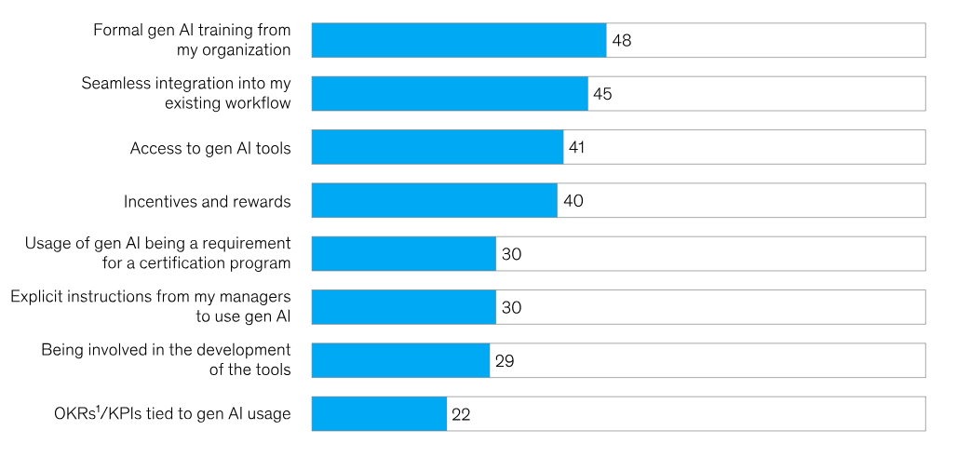
Figure 2: Factors Supporting Employee Adoption of Generative AI
(Source: McKinsey, 2025)
The above figure demonstrates that 48% of employees depend on formal AI training, showing that structured learning is a crucial driver for AI adaptation in global workplaces. Thus, IHRM needs to find the balance between global and regional flexibility when applying AI tools.
Automation and Global Job Shifts
Automation assists international firms to retain the quality of production even in different production sites. Many developing regions lose low-skill jobs as the developed countries gain (World Bank, 2025). It implies that IHRM needs to deal with global inequality by assisting with retraining and remote employment opportunities. Therefore, IHRM should apply automation in a responsible way to facilitate the development of a diverse global workforce.

2.4 Theoretical Model Application
The Technological Adaptation Model is used to understand how organisations and their employees need to adapt gradually to the new technologies to stay effective. In order to uphold this notion, it connects the use of technology to business objectives and employee welfare (Shamsi et al. 2021). It implies that innovation and people-centred strategies are the way to become an HR success. Hence, the integration of the models contributes towards the development of sustainable and ethical technological integration in organisations by the HRM and IHRM.

3. Demographic and Geopolitical Influences on Employment Markets

3.1 Demographic Factors Affecting Labour Markets
Ageing Population
Most developed nations are experiencing the aging population which is diminishing the active labour force. It has been observed that the age of sixty-years and above constitute a sixth of the total population (WHO, 2025). This direction implies that organisations should re-strategize their retirement, healthcare and training policies in order to be able to retain older employees. Finally, the ageing demographics require new HR policies that would allow maintaining productivity.
Migration Patterns
Migration has emerged as a prime source of labour in the developed as well as the developing countries. It has been found that almost 5% of the world workforce is made up of migrants (International Labour Organisation, 2025b). Such migration of individuals enhances employment heterogeneity that calls on the HR departments to handle issues of cultural assimilation and legal aspects of employment significantly keenly. Altogether, migration transforms the labour markets and enhances the diversity of the working forces on the global scale.

3.2 Geopolitical Factors Influencing Global Employment
Trade Wars and Economic Sanctions
The conflicts between nations due to trade have brought confusion in the job market global market. Supply chains have been upset as tariff differences between key economies have cost the job prospects related to export (OECD, 2025b). This indicates that international politics directly affect business stability, and HR departments are compelled to change workforce strategies in a short time. Thus, HR faces trade tension challenges to develop flexible global workforce strategies.
Global Conflicts and Political Instability
Millions of workers have been displaced in different places due to wars and political tensions. More than 123 million individuals were displaced as a result of conflict (UNHCR, 2025). Such upheavals reform the labour markets and it is more difficult to recruit stable and skilled employees in the regions affected. Therefore, it means that conflicts require dynamic HR solutions in international workforce stability.

3.3 HR Challenges Arising from Demographic and Geopolitical Shifts
The world is undergoing significant threats to human resource management due to demographic and geopolitical changes. The ageing populations, migrations, trade tensions, and conflicts are among the factors that are disrupting the stability of the workforce and the availability of talents in different regions.

Figure 3: HR Challenges raised due to Demographic and Geopolitical Shifts
(Source: Influenced by Ng et al. 2025)
Overall, the figure shows that to cope with global labour issues, HR needs to be flexible, inclusive, and forward-thinking.
Challenge 1: Managing an Ageing Workforce
The ageing workforce poses a problem in productivity and workforce renewal. The elderly employees are usually not accustomed to new technologies (PWC, 2025). In order to retain experience and prepare the younger employees to be leaders, the HR managers are forced to design continuous training programs. In conclusion, HR needs to close the divide between generations with the help of effective lifelong learning programs.
Challenge 2: Handling Migrant Workforce Integration
Cultural integration is becoming complicated by the increasing number of migrant workers. Multicultural teams are characterized by tension, which is usually caused by communication barriers and legal differences (International Labour Organisation, 2025c). In order to sustain an inclusive workplace and a harmonious environment, HR departments have to encourage inclusion, language training, and fair policies. Conclusively, university HR practices guarantee cohesiveness and performance among diverse teams.
Challenge 3: Workforce Planning During Trade Disruptions
Trade wars bring about uncertainty which directly impacts hiring and retention. Numerous companies hesitated to get new staff hired because of the uncertain international relationships (Jones et al. 2023). In order to counter geopolitical shocks, planning of flexible staffing models and remote systems of work are mandated by the HR teams. Hence, strategies of flexible workforce, assist organizations to withstand turbulent global environments.
Challenge 4: Talent Shortages Due to Conflicts
Armed conflicts often destroy industries and drive skilled workers to safer countries. Crisis situations rob many areas of professionals such as engineers and healthcare providers who are vital (Feldman and Spence, 2025). Talent gaps should be filled by international recruitment and online employment activities that should be adjusted by the HR professionals. Therefore, international hiring and teleworking can assist in alleviating shortages of talent.

4. Addressing Skills Gaps and Talent Shortages through Strategic HRM

4.1 Strategic HRM to Address Skill Gaps
Training and Continuous Learning Programs
Organisations can also curb the occurrence of skills gaps through investment in training and continuous learning programs. The productivity of employees and retention are enhanced by the companies that provide organized training (OECD, 2025c). This indicates that building of employee skills based on continued learning assists in aligning the ability of the workforce to business objectives.
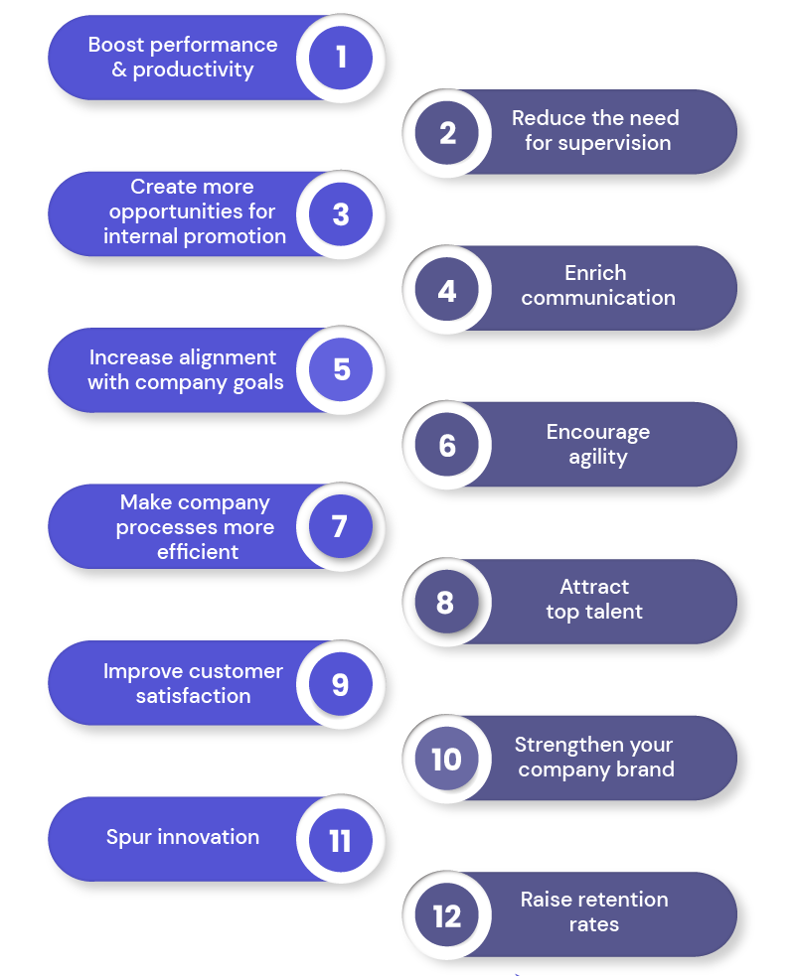
Figure 4: Key Benefits of Employee Training
(Source: Influenced by Yusuf et al. 2024)
The above figure shows that training programs help to boost productivity, retention, work quality, agility and other skills among employees. In conclusion, continuous training keeps the employees abreast with emerging technology and market demands.
Career Development and Internal Mobility
Strategic HRM encourages career development in order to assist employees to experience growth in the organisation. Internal mobility schemes enhance employee involvement and lower the expenditure of hiring (International Labour Organisation, 2025d). This implies that when employees perceive career opportunities, they acquire new skills and do not leave the organisation. Therefore, the development of a career assists in the enhancement of skills as well as the stability of the workforce in the long run.

4.2 Strategic HRM to Address Talent Shortages
Employer Branding and Employee Value Proposition (EVP)
Employers with a high employer brand appeal to well-qualified professionals even in competitive sectors. 75% indicates that three-quarters of job seekers pay attention to company reputation before putting in an application (Siler, 2022). It implies that the companies that foster positive culture, career prospects, and diversity will have access to a more extensive talent pool. Thus, talent shortages can be surmounted by using employer branding as an efficient HR strategy.
Global Recruitment and Workforce Diversity
Strategic HRM promotes international hiring in order to address the most critical talent scarcities. International recruitment assists companies to locate talent with specialisation that is not found in the home country (World Bank, 2025). The strategy generates a better global competitive workforce as it produces a more diverse and innovative workforce. Therefore, overseas recruitment enables organisations to address the talent requirement and contribute to the inclusion of cultures.

4.3 Theoretical Model to Support Strategic HRM
Talent Management Cycle describes the process of attracting, developing and retaining skilled employees in organisations. Successful talent strategies are based on continuous learning and career development (Urme, 2023). This implies that long-term ability and dedication is guaranteed by investing in individuals via organised HRM programmes. Thus, an incorporation of the Talent Management Cycle will assist the HR to create flexible and future-oriented work forces.

5. Reflective Report: Personal Capabilities in Global Context

5.1 Technology Use and Digital Adaptability
I believe in the usage of HR software and AI-based tools in the process of data analysis and decision-making. I am also a fast learner of new technology such as virtual learning and digital communication systems. But at times, my efficiency is hampered by the inability to follow through on the frequent updates in the software. Finally, enhancing my technical consistency is another aspect that will make me find it easier to operate in a global digital setting.

5.2 Communication in Cross-Cultural Environments
I possess good skills in written communication which assist me to be clear in my ideas when I am in a professional environment. I am also an active listener who acknowledges differences in culture when working with international colleagues. Nevertheless, I do not always find it easy to make adjustments to various cultural situations. Finally, the cultivation of cultural awareness in communication will contribute to the advancement of my teamwork skills on a worldwide scale.

5.3 Teamwork and Collaboration Skills
My relationship-building skills are also strong, and I can cooperate with other people in groups effectively. I also play my part well in organising tasks as well as team goals. I however, do not always speak up when there is a disagreement which restricts influence. Finally, I will be a more assertive person when I participate in group discussion as this will enhance my performance towards teamwork.

5.4 Leadership Skills in Global Contexts
I demonstrate leadership by being emphatic and impartial so that team members feel that they are assisted. I also make ethical judgments and have responsibility in teamwork. Nevertheless, I sometimes have difficulties with time management when being a leader of numerous tasks at the same time. Finally, my planning and delegation areas need to be enhanced to make me a better global leader.

5.5 Self-Directed Learning and Continuous Development
I am also self-directed to acquire new skills and I often take online courses in order to advance professionally. My personal goals are also very clear and I also am tracking my progress. Nevertheless, I occasionally struggle to combine education and day-to-day life. Finally, the improvement of scheduling and discipline will assist me in sustaining unremitting professional growth.

5.6 Personal Action Plan for Professional Growth
My personal action plan that can be used to enhance my global career development by enhancing the most important professional skills is presented in the following table.
Development Area | Action Steps | Purpose | Application Strategy | Timeline
Technology Proficiency | Enrol in advanced digital HR and AI training courses. | Improve efficiency and adaptability in tech-driven work environments. | Apply new skills in digital HR tasks and analytics projects. | 3–6 months
Cross-Cultural Communication | Attend intercultural communication and negotiation workshops. | Enhance confidence and adaptability in diverse workplaces. | Practice cultural sensitivity in online meetings and written communication. | 4 months
Assertive Team Participation | Join leadership or teamwork skill-building sessions. | Strengthen influence and contribution during team discussions. | Apply techniques for constructive debate and decision-making in groups. | 3 months
Time Management for Leadership | Use digital planning tools and prioritisation frameworks. | Improve organisation and leadership efficiency under pressure. | Implement structured timelines for team projects and reports. | 2 months
Continuous Learning Discipline | Create a fixed weekly study schedule for professional development. | Maintain steady learning and skill improvement. | Follow a self-directed learning plan using online academic platforms. | Ongoing
Table 1: Personal Action Plan for Professional Growth
(Source: Self-developed)
Thus, this action plan will serve to work on my overall improvement as I will be able to become more flexible, competent, and able to work internationally.

6. Conclusion
In conclusion, this report mentioned the role of technology, demographic changes, and geopolitical factors in changing the global labour markets and redefining HR and IHRM strategies. The organisations should adapt to encourage the theme of continuous learning, ethical use of AI, and dynamic planning of the global workforce. Strategic HRM is important in decreasing the skill gaps, recruiting talents, and maintaining innovation in industries. Also, personal self-reflectiveness on such competences as digital adaptability, communication, teamwork, leadership, and self-directed learning facilitates career development in the long term. Through alignment of strategic HR practices and continuous professional growth, individuals and organisations would be able to stay competitive and resilient in the rapidly changing global world.

References
Albaroudi, E., Mansouri, T. and Alameer, A., (2024). A comprehensive review of AI techniques for addressing algorithmic bias in job hiring. ai, 5(1), pp.383-404.
Feldman, C.L. and Spence, N.Z., (2025). Responsibilities of Medical Professionals Amidst Geopolitical Conflict. Journal of General Internal Medicine, 40(5), pp.1169-1174.
International Labour Organisation. (2025a), Global Employment Trends for Youth 2024 Available at: https://www.ilo.org/sites/default/files/2024-11/GET_2024_EN_web4.pdf [Accessed on 7th November 2025]
International Labour Organisation. (2025b), ILO Global Estimates on International Migrant Workers Available at: https://www.ilo.org/sites/default/files/wcmsp5/groups/public/@dgreports/@dcomm/@publ/documents/publication/wcms_808935.pdf [Accessed on 7th November 2025]
International Labour Organisation. (2025c), Transforming enterprises through diversity and inclusion Available at: https://www.ilo.org/sites/default/files/wcmsp5/groups/public/@ed_dialogue/@act_emp/documents/publication/wcms_841348.pdf [Accessed on 7th November 2025]
International Labour Organisation. (2025d), World Employment and Social Outlook Trends 2023 Available at: https://www.ilo.org/sites/default/files/wcmsp5/groups/public/@dgreports/@inst/documents/publication/wcms_865332.pdf [Accessed on 7th November 2025]
Jones, K., Ksaifi, L. and Clark, C., (2023). ‘The biggest problem we are facing is the running away problem’: recruitment and the paradox of facilitating the mobility of immobile workers. Work, Employment and Society, 37(4), pp.841-857.
McKinsey. (2025), Jobs lost, jobs gained: What the future of work will mean for jobs, skills, and wages Available at: https://www.mckinsey.com/featured-insights/future-of-work/jobs-lost-jobs-gained-what-the-future-of-work-will-mean-for-jobs-skills-and-wages [Accessed on 7th November 2025]
Ng, E.S., Stanton, P., Umeh, C., Bamber, G.J., Stone, D., Lukaszewski, K., Aw, S., Lyons, S., Schweitzer, L., Ren, S. and Özbilgin, M.F., (2025). Megatrends affecting the world of work: Implications for human resource management. Personnel Review.
OECD, (2025c), Reviving productivity growth: A review of policies Available at: https://www.oecd.org/content/dam/oecd/en/publications/reports/2024/10/reviving-productivity-growth_936a1da3/61244acd-en.pdf [Accessed on 7th November 2025]
OECD. (2025a), The Adoption of Artificial Intelligence in Firms Available at: https://www.oecd.org/en/publications/the-adoption-of-artificial-intelligence-in-firms_f9ef33c3-en.html [Accessed on 7th November 2025]
OECD. (2025b), Economic Security in a Changing World Available at: https://www.oecd.org/en/publications/2025/09/economic-security-in-a-changing-world_78f3b129/full-report/economic-security-and-vulnerabilities-in-international-supply-chains_dc88aefa.html [Accessed on 7th November 2025]
PWC. (2025), Global Workforce Hopes and Fears Survey 2024 Available at: https://www.pwc.com/gx/en/issues/workforce/hopes-and-fears.html [Accessed on 7th November 2025]
Shamsi, M., Iakovleva, T., Olsen, E. and Bagozzi, R.P., (2021). Employees’ work-related well-being during COVID-19 pandemic: An integrated perspective of technology acceptance model and JD-R theory. International Journal of Environmental Research and Public Health, 18(22), p.11888.
Siler, J. (2022), The Importance Of Branding Your Recruiting Process Available at: https://www.forbes.com/councils/forbeshumanresourcescouncil/2022/09/09/the-importance-of-branding-your-recruiting-process/ [Accessed on 7th November 2025]
UNHCR. (2025), Global Trends Available at: https://www.unhcr.org/global-trends [Accessed on 7th November 2025]
Urme, U.N., (2023). The impact of talent management strategies on employee retention. International Journal of Science and Business, 28(1), pp.127-146.
Weforum. (2025), Why AI is replacing some jobs faster than others Available at: https://www.weforum.org/stories/2025/08/ai-jobs-replacement-data-careers/ [Accessed on 7th November 2025]
WHO. (2025), Ageing and health Available at: https://www.who.int/news-room/fact-sheets/detail/ageing-and-health [Accessed on 7th November 2025]
World Bank. (2025), Skills and Workforce Development Available at: https://www.worldbank.org/en/topic/skillsdevelopment [Accessed on 7th November 2025]
Yusuf, S.O., Abubakar, J.E., Durodola, R.L., Ocran, G., Paul-Adeleye, A.H. and Yusuf, P.O., (2024). Impact of AI on continuous learning and skill development in the workplace: A comparative study with traditional methods. World Journal of Advanced Research and Reviews, 23(2), pp.1129-1140.

