Module: Foreign Languages & Cultural Awareness
Module code: BMIH5003

Student Name: Elena-Petronela Ciubotariu
Student ID: 2219782
Lecturer Name: Lisa Bassler
Executive summary
The present report has shed light on the various aspects of the business of the hospitality industry. Impact of the cultural differences on the business field of the hospitality organisation has been effectively discussed in the study. Apart from the difference of the various types of leadership in the business context also has been taken into account. The global project score of the selected country for the best business location of the 5star inclusivity hotel also has been vividly mentioned in the study. Finally, effective recommendations have been provided for the proper understanding of the issue as well as taking the necessary approach for overcoming the challenge.

Table of Contents
Introduction 1
Main body 1
Conclusion 4
Recommendations 4
References 5

Introduction
In the present study, the differences in the culture of two specific countries in terms of the hospitality industry will be taken into account. The business of 5strar inclusivity hotel and spa will be evaluated in relation to the culture. Apart from this, the challenges of intercultural leadership in the hospitality industry will be identified. The probable recommendations also will be provided in this respect.

Main body
There is a striking difference in culture between the two countries Germany and England. Both the country is very attractive in the recent business market for successful development of the business as well as providing the necessary services to the people who visit the places. The striking differences between the countries in terms of cultural differences can be discussed as follows -
As far as the concept of language is concerned, England is based on its English language. On the other hand, Germany has focused on German luggage. In spite of the presence of the German language, the German people do not face any problem in speaking English as they have already been taught about English at the primary level. The adoption of the language of the English people, therefore, has helped the people of Germany to mitigate the challenge of the language barrier (Christiansen et al., 2020). Another important thing that is also notable is the regulations of the road traffic regulations. In Britain, people drive from the left side of the road whereas in Germany and the rest of Europe, people drive from the other side of the road.
Another important aspect that also can be taken into account is the German people are widely known for their punctuality as well as diligence and directness (Hossain et al., 2021). In a simple word, it can be said that the people of this country are well-disciplined. On the other hand, Britons are considered to be less directed but more polite and they are very much able to communicate with others very effectively (Dashper, 2020). Although British people follow the way of communication for entertaining people Germans are not fond of this particular way of communication (Alphatrad.uk, 2024). Germans are straightforward and they directly communicate with people without any hesitation. The effectiveness of the German culture has made its citizens able to become clearer in their way of dealing with people without any rudeness. The inclusivity hotel which is headquartered in London, England must have to adopt the culture of the German country. The employees of the 5-star hotel have to adopt the necessary approaches for the effective organising of the business of the hotel in Germany. Another notable custom of Germany is that the country emphasises on contracts.
An employee will be effectively familiarised with a workplace using this contract as well as he or she can use it for reference later (Boelmann et al., 2021). On the contrary, the UK is also not lagging in any kind of such thing. The country also has taken the necessary initiatives in dealing with customers. As far as business opportunity is concerned, Germany provides the best working amenities to a worker and it also paves the way for an organisation to effectively operate its business operations in this particular country to get effective benefits (Maheshkar and Sharma, 2018). The country has provided the opportunity for business start-ups and it has been found in the research data that there is a 55% increase in the number of start-ups in different locations in Germany. The effectiveness of the business opportunity has labelled Berlin as the Silicon Valley of Europe. From, the discussion it can be said that though the UK is effective in providing employment, Germany provides better opportunities for people (Jefferies, 2020). Apart from the cultural differences mentioned above, there are also some customs related to etiquette as well as other cultural aspects. While the UK follow lucid and frank behaviour with others, Germans are strict as well as very restricted while dealing or communicating with others.
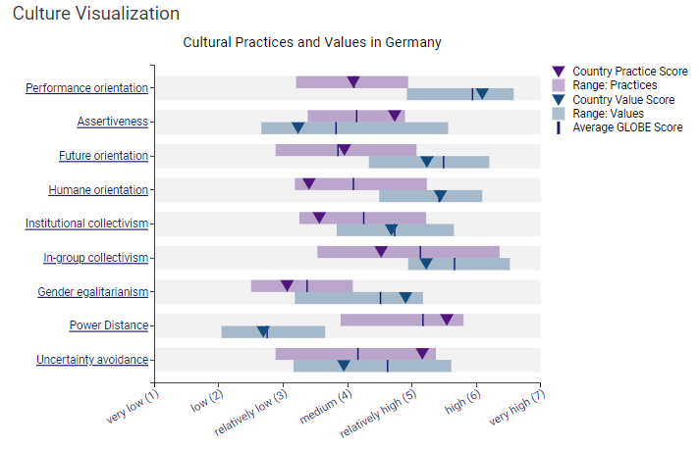
Figure 1: Globe project score of Germany in culture visualisation
(Source: Globeproject, 2024)
The figure mentioned above has portrayed the various aspects of the culture of Germany. In the figure, as per the globe project the different aspects of culture have provided different types of scores as per their efficiency. Performance orientation, assertiveness, future as well as human orientation and others have been effectively mentioned in the graph as per their relevant scores (Globeproject, 2024). As far as cultural visualisation is concerned, performance orientation has received the highest score from the globe project. On the other hand, the graph mentioned below represents the score of the different leadership in Germany. In this context, charismatic leadership has attained the highest score from the globe project.
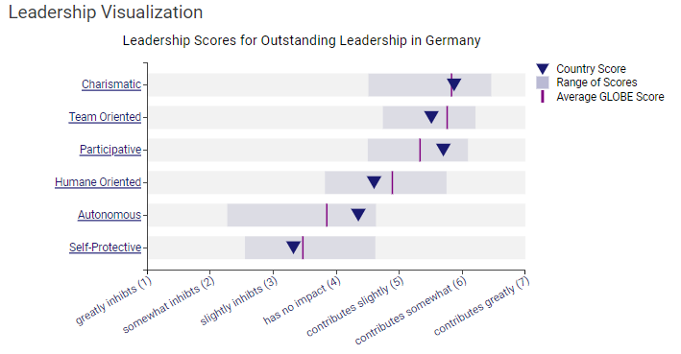
Figure 2: Leadership visualisation of Germany as per Globe project score
(Source: Globeproject, 2024)
In the field of hospitality industry, there is a group of challenges that the leadership can face are - communication barriers, conflict resolution, cultural misunderstanding and others. There are the most important challenges that can be effectively taken into account in the mentioned countries. Since there is a gap in the language communication will vary and it also will create obstacles for people (Abramson and Moran, 2018). The impact of different cultures also has the chance of misunderstanding and conflicts.

Conclusion
From the discussion of the study, it can be said that the 5-star inclusivity hotel organisation has to adopt the new cultures of the new location of the hotel. The new location of the hotel in Germany will be helpful for the organisation after the successful adoption of the various important things. The differences in the culture as well as the leadership of the UK and Germany have been well discussed in the study.

Recommendations
- An organisation has to provide the opportunity to its customers to learn a foreign language to avoid the issue of communication barriers (Kazhan et al., 2020). In the present scenario, the 5-star inclusivity hotel has to deliver the opportunity to its customers to learn the German language.
- Proper understanding of the culture and becoming aware of the different types of culture is another important thing that also has to be adopted by the hospitality organisation.
- Effective communication as well as teamwork also has to be taken into account by the organisation for the effective resolution of conflicts.

References
Abramson, N.R. and Moran, R. 2018. Managing Cultural Differences: Global Leadership for the 21st Century. 10th Ed. Abingdon: Routledge.
Alphatrad.co.uk, 2024. Cultural differences between Germany and Great Britain. [online] Available at: <https://www.alphatrad.co.uk/news/cultural-differences-germany-great-britain> [Accessed on: 17th Feb. 2024]
Boelmann, B., Raute, A. and Schonberg, U., 2021. Wind of change? Cultural determinants of maternal labor supply.
Christiansen, B., Branch, J.D. and Karmowska, J. .2020. Cultural Factors and Performance in 21st Century Businesses. Hershey : IGI Global.
Dashper, K., 2020. Mentoring for gender equality: Supporting female leaders in the hospitality industry. International Journal of Hospitality Management, 88, p.102397.
Globeproject, 2024. Germany Results. [online] Available at: <https://globeproject.com/results/countries/DEU%3Fmenu=list.html> [Accessed on: 17th Feb. 2024]
Hossain, M.S., Kannan, S.N. and Raman Nair, S.K.K., 2021. Factors influencing sustainable competitive advantage in the hospitality industry. Journal of Quality Assurance in Hospitality & Tourism, 22(6), pp.679-710.
Jefferies, M., 2020. Imperial Culture in Germany, 1871-1918. Bloomsbury Publishing.
Kazhan, Y.M., Hamaniuk, V.A., Amelina, S.M., Tarasenko, R.O. and Tolmachev, S.T., 2020. The use of mobile applications and Web 2.0 interactive tools for students' German-language lexical competence improvement.
Maheshkar, C. and Sharma, V. 2018. Handbook of Research on Cross-Cultural Business Education. Hershey: IGI Global.

