University of Wales Trinity Saint David

Programme: Certificate of Higher Education in Skills for the Workplace

Student name: Albena Bareva
Student ID number: 2007102

Module: Psychology in Health and Social Care
Module code: BMHP4003

Internal Verifier: Dr Mark Gallagher
lecturer: Rebecca Kavanagh

Assignment Title: Case study report

Table of Contents
Introduction 2
Social Learning Theory 2
Overview 2
Processes of the Social Learning Theory 3
Contributions of the Social Learning Theory 4
Theory of Attitude Development 4
Overview 4
Factors of Attitude Development 5
Theories for Attitude Development 6
Theory of Planned Behaviour 6
Overview 6
Evaluation 7
Conclusion 7
References 9

Introduction
The clinical commissioning group, known as the CCG, has recently observed that the obesity cases have been increased in patients in particular to younger ones. This report will be outlining the different social and biological factors which cause the development of unhealthy eating behaviours with the analysis of three particular theories. The first theory will be the social learning one, the second is the theories of attitude and development of attitude while the last one is the theory of planned behaviour.
Current reports on obesity in the United Kingdom show that in 2019 the reported percentage of adults that are obese are 28% well 36% are above their normal weight (Commons Library Parliament, 2021). Obesity is defined by the body mass index which is reportedly above 30 or equal to 30. The body mass of a person which is aborted between 25 and 30 is classified as an overweight state.
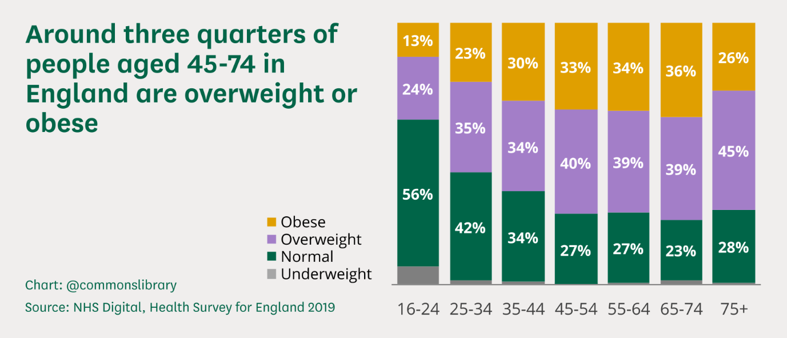
Source: Commons Library Parliament (2021)
The above diagram shows that the problematic age group which is most likely to be overweight or obese is between 45 and 74 years old. The percentage of individuals which are young between the ages of 16 to 24 have shown an increase on average in terms of transition from normal to overweight or obese. There can be many different reasons why people develop unhealthy eating habits which result in overweight or obesity which range from stress to improper parenting on the right nutrition, genetic problems and so on.

Social Learning Theory

Overview
The social learning theory assumes that social behaviour is learned by observing and imitating the behaviour of others (Bandura, 1977). Analyst Albert Bandura supported the theory for social learning as an option, unlike the previous work of individual therapist BF Skinner, known for his impact on behaviourism. While the social science of the brain focuses on the importance of climate and support for behaviour, Bandura points out that people can learn behaviour through perception.
The social learning theory makes people mimic the behaviour they see in their current circumstances, especially if that behaviour is built into others (Pratt et al., 2010). For example, if a child notices their parents going to work every day, chipping in a public place in the social space, and helping their life partner perform tasks around the home, it is likely to reflect these practices. Whenever they are compensated, these practices become supported and undoubtedly reconsidered.
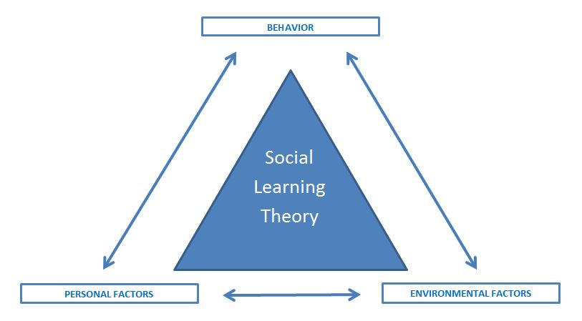
(e-Roll Call Magazine, 2021)

In the likelihood of parents weird unhealthy eating habits, the child will grow up in this home is also more likely to model those behaviours and to apply them towards their own eating habits. The child can observe the behaviours of their parents or siblings in the environment and to also have personal factors including stress if present in the household which encourages them to adopt unhealthy eating habits.

Processes of the Social Learning Theory
The social learning theory has four mediation measures that help decide whether other behaviour has occurred (Bandura, 1977):
Consideration: how much we notice the behaviour. A behaviour must attract our attention before it can be imitated. Given the number of practices we notice and do not reflect each day, we demonstrate that it is important to understand whether a behaviour affects self-presentation. If a household or another environment shows many individuals who are overweight or obese and a new one joins in, they are likely to consider that behaviour to be more normalised as time passes.
Support: How well we remember the behaviour. We cannot play the behaviour if we do not remember the behaviour. Thus, if behaviour can be seen, unless memory is formed, the observer will not play the behaviour. Moreover, as social learning is not fast, support is needed to conduct demonstrations. In the likelihood of a parent encouraging their child to eat more than they should at home or outside, the child is likely to develop also unhealthy eating habits which may lead to obesity later.
Reproduction: The ability to play out behaviour. This is the ability to recreate the behaviour we notice. This affects our choice of whether to try to play the behaviour. In any case, when we want to imitate observed behaviour, we are limited by our actual capabilities. It is easy for individuals majorly to adapt to unhealthy eating habits which may be also a reason for the increase in younger people being reportedly obese.
Means of motivation: The will to imitate behaviour. This mediation interaction is hinted at as a substitute support. It involves learning by noticing the results of activities for others, rather than through direct insight. It is very likely that in the presence of fast food or other convenient source of food and child fix and healthy choice and overtime adapt to it.
The rewards and discipline that follow will be concentrated by the observer. In case the viewer sees that the rewards are more remarkable than the costs (discipline), at that moment they will undoubtedly present themselves for the behaviour. Assuming that, anyway, the deputy's support is not sufficiently appreciated by the viewer, they will not demonstrate the behaviour. The form of reward that can come with unhealthy eating habits may be about the taste or even parental approval which only encourages children and young people to develop more solidified and healthy eating habits in the future.

Contributions of the Social Learning Theory
One of the essential qualities of the theory for social learning is its adaptability in clarifying the differences in the behaviour or learning of the individual, ie. An additional strength of the social learning hypothesis is that it considers different teaching methods. One can learn through perception or direct encounters (Liotti and Gilbert, 2010).

Theory of Attitude Development

Overview
In brain research, attitude refers to a host of feelings, beliefs, and practices toward a particular object, individual, thing, or occasion (Cheng et al., 2018). The psyche is a regular consequence of participation or childhood, and they can have an incredible impact on behaviour. While the mentality suffers, they can also change. Clinicians characterize perspectives as a learned tendency to evaluate things for a specific purpose. This may include assessments of individuals, questions, articles, or occasions. Such assessments are regularly certain or negative but can sometimes be questionable.
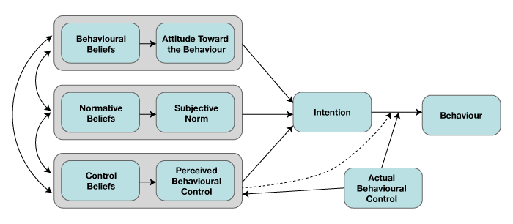
(Opentextbc.ca, 2014)

Attitudes of individuals can be influenced severely by the presence of more stress and young people are more likely in the modern world to develop and healthy habits such as smoking, drinking or use of drugs. This category may also include unhealthy eating habits that can lead to obesity.

Factors of Attitude Development
There are various aspects that can affect how and why they structure perspectives. Here is a more intense look at the structure of perspectives (Cheng et al., 2018):
Experience
The psyche is structured directly due to engagement. They can occur due to direct insight near the home or may be the result of perception.
Social variables
Social jobs and accepted practices can affect the mentality. Social jobs are identified by how people should act in a particular job or environment. Normal practices include guidelines from society as to what practices are considered correct.

Perspectives
Perspectives can be learned in different ways. Think about how sponsors use old-style melding to influence your behaviour toward a particular subject. On a TV plug, you see youthful, delightful people having fun on a tropical beach while engaging in a game drink. This alluring and engaging symbolism makes you encourage a positive connection with this specific refreshment.
Forming
Operant shaping can also be used to influence the way they create the mentality. Imagine a young man who has just started smoking. At any moment, he lights a cigarette, people whine, scold him, and want him to leave their area. This negative criticism from everyone around him eventually led him to encourage a horrible assessment of smoking, and he decided to give up the addiction.
Perception
Finally, people also learn perspectives by noticing people around them. The moment someone you respect incredibly adopts a specific mentality; you have a duty to cultivate such beliefs. For example, young people invest a lot of energy, noticing the mentality of their people and usually begin to show comparative positions.

Theories for Attitude Development
Learning Theory
Old-style shaping, operant shaping, and observation may be accustomed to achieving a change in mentality. Traditional shaping can be used to make good passionate responses to an element, individuality, or occasion of a partner's good mood with an objective article (Kaiser, Oerke and Bogner, 2007).
Operant shaping can be used to enhance positive perspectives and exhaust annoying ones. In the same way, people can change their perspectives after noticing the behaviour of others.
Elaboration Likelihood Theory
This theory of influence recommends that people adjust their perspectives twice. First, they can be inspired to tune in and consider the message, resulting in a change of location. Or again, they may be affected by the attributes of the speaker, which will lead to a brief or superficial change in behaviour. The messages, which are interesting and appeal to the justification, will inevitably lead to permanent changes in perspectives (Kaiser, Oerke and Bogner, 2007).

Theory of Planned Behaviour

Overview
The Planned Behaviour theory began as a contemplative activity hypothesis in 1980 to predict a person's goal of engaging in behaviour at a specific time and place. The hypothesis was designed to clarify all the practices that people may seek to control (Ajzen, 2011). The vital segment of this model is the social goal; the goals of the behaviour are influenced by the disposition regarding the probability of the behaviour to have a normal result and the abstract assessment of the dangers and advantages of this result.
Inventions which drive people towards unhealthy eating habits, especially at the younger age where people are still realising themselves can be especially malleable. This means that young people are more likely nowadays to be influenced by what they see or observe to contemplate and apply an unhealthy way of life through food.
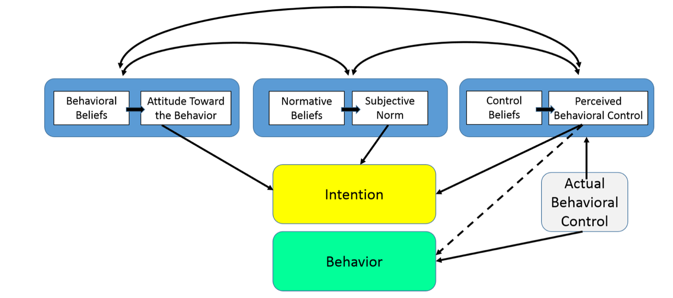 (LaMorte, 2019)

Evaluation
Three hypotheses can be valuable about how a friend's influence can affect youth-related practices, especially food intake and active work. To begin with, the social assistance hypothesis suggests that the simple presence of others may improve certain behaviours. A change in nutrition and actual work design due to the quality of satellites has been shown in past studies. Second, the social training hypothesis states that that people change practices in the light of behaviour. The children showed that they were affected by the type (empowerment / unhealthy) or measure of food intake and active work shown by their friends. Third, the impression that the board is recognized as inspiring a person to change their diet or actual behaviour.

Conclusion
In conclusion, there can be various factors that can influence a person especially at a young age to develop and healthy eating habits that can later also lead to obesity. Schools are recognized as an important environment for implementing programs to combat fullness, as participation is almost universal.6 Several audits justify that school-based projects can be viable to prevent youth in the short term. Nevertheless, the derived adequacy of these projects remains unclear, perhaps due to a lack of thought for logical impacts that can combat or sabotage the impact of the program, such as existing school meals and real working conditions.
There are several theories which can explain to some extent the changing or constant behaviours of people and how their choices are influenced by the environment or their personal values. For example, the social learning theory can present the argument that in the presence of an unhealthy environment externally which normalises unhealthy eating habits for a given young person, it is likely that this young person will also adapt to those same habits by modelling behaviour.
The theory of planned behaviour can argue that a person can have intentions which are especially malleable at a young age which can drive them towards the adoption of unhealthy habits including not only having unhealthy lifestyle in terms of food but also others such as smoking. How did your theories can explain the development and solidification of character of a person and how they can be influenced from factors such as stress that can be one of the primary reasons why people have unhealthy eating habits? By educating the youth of the importance of preserving well-being, both mental and physical, the numbers of obesity may not be fully reduced. Therefore, apart from education it is also necessary for people to understand more social aspects about behaviours.

References
Ajzen, I. (2011). The theory of planned behaviour: Reactions and reflections. Psychology & Health, 26(9), pp.1113–1127.
Commons Library Parliament (2021). Obesity Statistics. commonslibrary.parliament.uk. [online] Available at: https://commonslibrary.parliament.uk/research-briefings/sn03336/. [Accessed: 20/07/2021].
Bandura, A. (1977). Social learning theory. [online] Englewood Cliffs, N.J. Prentice-Hall.
Cheng, H.-L., Wang, C., McDermott, R.C., Kridel, M. and Rislin, J.L. (2018). Self-Stigma, Mental Health Literacy, and Attitudes Toward Seeking Psychological Help. Journal of Counseling & Development, 96(1), pp.64–74.
e-Roll Call Magazine. (2021). e-Roll Call Magazine. [online] Available at: https://andragogytheory.com/ [Accessed 13 Jul. 2021].
Kaiser, F.G., Oerke, B. and Bogner, F.X. (2007). Behaviour-based environmental attitude: Development of an instrument for adolescents. Journal of Environmental Psychology, 27(3), pp.242–251.
LaMorte, W. (2019). The Theory of Planned Behaviour. [online] sphweb.bumc.bu.edu. Available at: https://sphweb.bumc.bu.edu/otlt/MPH-Modules/SB/BehavioralChangeTheories/BehavioralChangeTheories3.html. [Accessed: 15 Jul. 2021].
Liotti, G. and Gilbert, P. (2010). Mentalizing, motivation, and social mentalities: Theoretical considerations and implications for psychotherapy. Psychology and Psychotherapy: Theory, Research and Practice.
Manstead, A.S.R. and Parker, D. (1995). Evaluating and Extending the Theory of Planned Behaviour. European Review of Social Psychology, 6(1), pp.69–95.
Opentextbc.ca. (2014). Exploring Attitudes – Principles of Social Psychology – 1st International Edition. [online] Available at: https://opentextbc.ca/socialpsychology/chapter/exploring-attitudes/ [Accessed 12 Jul. 2021].
Pratt, T.C., Cullen, F.T., Sellers, C.S., Thomas Winfree, L., Madensen, T.D., Daigle, L.E., Fearn, N.E. and Gau, J.M. (2010). The Empirical Status of Social Learning Theory: A Meta‐Analysis. Justice Quarterly, 27(6), pp.765–802.

