
Module Name: Entrepreneurship
Component 1
Module Code: LCBB5001
Student ID: 2242725

BUSINESS PLAN: Petal Bloom

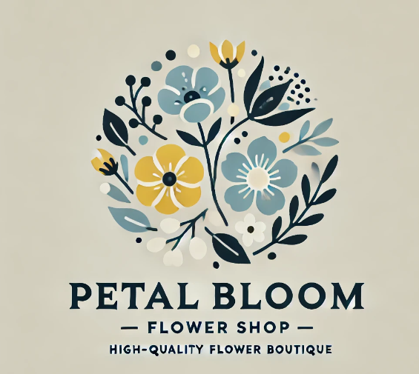

Executive Summary
Petal Bloom, Birmingham’s Flower Store, delivers the finest, freshest, and sustainable flower arrangements for weddings, corporate events, and day-to-day uses. Our vision is to bring a greater joy to our customers through exquisite flowers and top-notch customer service. We want to be local as well as digital customers and hope to make it profitable in the first year of operation.

Table of Contents
Executive Summary 2
Introduction 4
Business overview 4
Market Analysis 5
Marketing strategy 6
Operations plan 7
Financial plan 9
Conclusion 11
References 11

Introduction
A business plan is a planning document that includes financial projections, strategy, and goals for a company (Barringer, B.R. and Ireland, R.D., 2010). It acts as an operating manual that outline how to establish, run and scale a company, and it helps attract potential investors or stakeholders. Starting at £25,000, our plan is to have a small store on the doorstep and a very robust online order and delivery platform. The business plan gives Petal Bloom, a new florist in Birmingham, a detailed view of the marketplace, consumer demographics, and a system to set up a boutique as well as an online brand. It includes operating procedures, marketing plans and forecasts in order to ensure the business is profitable within the first year. With its corporate vision, Petal Bloom strives to be the market leader for quality, eco-friendly floral products in the area (Drummond, Ensor and Ashford, 2008).

Business overview
The Birmingham-based flower shop start-up Petal Bloom is run as a Private Limited Company (Petal Bloom Ltd). We were a firm that specialized in offering fresh flower bouquets, bespoke floral bouquets (eg. for weddings and business meetings), plant subscriptions and same-day delivery for a huge array of flowers products and services. Additionally, we believe in providing high quality, natural flowers that are delivered from locally sustainable vendors, keep them fresh, and encourage local businesses. Also, the business cater to corporate customers who want floral designs for an event or private customers who want flowers for any event. Our strategically positioned Birmingham boutique targets walk-in customers, and our online shop makes ordering and delivery simple for a wider demographic (Storey, 2014).
Therefore, we emphasize bespoke, custom-made floral arrangements and offer subscription services to customers who want seasonal deliveries throughout the year to set ourselves apart from others. We strive to bring the most unique moments to our customers through beautifully curated floral design and ecological living. However, when we combine a well-thought-out marketing strategy and superior customer support, we will be able to build a repeat business and turn a profit within the first year of operation (Kraus, Mahto and Walsh, 2021).

Market Analysis
Petal Bloom sits in Birmingham’s flourishing floristry district, backed by a mixed building-residential mix. Particularly when it comes to weddings, conferences, and special occasions, Birmingham’s rising population, thriving cultural life, and its status as a business hub make it an ideal location for high-end floral accessories. Additionally, eco-friendly shopping is on the rise because individuals and businesses increasingly want products made ethically, which is where Petal Bloom is looking to appeal (Cafferkey, et. Al., 2018).
Target market:
- Individual consumers are regular users of flowers for private birthdays, anniversaries and other events.
- Business clients people who want formal flowers for a meeting, office or business.
- People who need a reliable and innovative flower suggestion for their clients’ weddings Event Planners and Wedding Coordinators.
Evaluation of Competitors: Birmingham has many big-name florists; however, most are not focused on being environmentally friendly, so Petal Bloom offers a unique selling point. What sets us apart from other florists is that we specialize in hand-crafted and personalized designs and use a modern online store for faster ordering and delivery (Jobber and Ellis-chadwick, 2020).
SWOT analysis
Strengths:
- Sustainability; diverse product range; perfect spot for maximum reach and exposure; online presence for general reach.
Weaknesses:
- Lack of early brand recognition; reliant on local suppliers which in turn impacts supply and price.
Opportunities:
- Growing consumer demand for eco-friendly products; working with companies, wedding consultants, and event planners; expanding product offerings to include plant subscriptions and seasonal discounts (Kitsios, et. Al., 2022).

Threats:
- Competition among local and online flower delivery services; economic downturns impacting discretionary expenditures.
So, in focusing on customer loyalty and brand reputation through superior service and sustainability, Petal Bloom would like to capture a large portion of the Birmingham floral industry by capitalising on our strengths and opportunities (Dessyana and Riyanti, 2017).

Marketing strategy
Petal Bloom sets itself apart as a top flower shop in Birmingham with a full-spectrum marketing approach that employs the 4Ps of Product, Price, Place, and Promotion.
Product:
- We offer a wide variety of floral products and services that can be tailored to suit the diverse requirements of our customers. Our offerings include flower arrangements from the garden, special arrangement flowers for a special occasion (weddings, business events), Plant subscriptions, and special deals.
- All of the flowers are harvested sustainably, providing environmentally friendly offerings to eco-conscious consumers. In addition, to add value to the client experience, we offer optional extras including personalized greetings and gifts.( Albrecht, Green and Hoffman, 2023).
- Customizing flower bouquet selections allows us to meet particular client’s requests, thereby delivering unique and superior service.
Price:
- Although we are competitive, our pricing is the consequence of the higher quality of our products. We offer competitive price structures for multiple types of customers.
- Simple bouquets are affordable and perfect for frequent gifts.
- Top-of-the-line choices for conferences, meetings and weddings imply better organization. (Kotler and Armstrong, 2010).
- All priced in a way that encourages continued use through return offers and subscription plans. This way we can meet multiple customer budgets and make it available without sacrificing quality.

Place:
- The physical shop is situated in an active Downtown Birmingham, drawing in walk-in customers and offering more exposure.
- What is more, we have a strong online presence to help us scale across borders. Their intuitive website allows easy browsing, ordering and placing same-day or future orders through their online store to customers. (Kotler and Armstrong, 2010).
- In order to accommodate mobile visitors, we offer a mobile-friendly version of the site.
- By integrating the power of an e-commerce system with a physical presence, we improve the customer experience and take advantage of multiple markets.
Promotion:
- Our marketing approach includes digital marketing, collaborations, and community outreach.
- Online Marketing: We use targeted advertising, display our floral bouquets on social media (Facebook and Instagram) and reach out to our followers through contests and promotions. Email campaigns also offer seasonal offers and rewards schemes that reward repeat purchases.
- Partnering with small businesses, venues, and planners helps us leverage their audiences and spread our footprint.
- We show up at local markets and community gatherings to build brand recognition and strong regional presence. Retention strategies and initial customer promotions help increase return visits and word-of-mouth referrals. (Kotler, 1997).
However, Petal Bloom seeks to build a repeat customer base, boost brand awareness, and set Birmingham apart as a leading floral provider by combining these strategies. Our sustainable, intuitive and customer-centric orientation ensures that we win the market.

Operations plan
Petal Bloom is structured to bring in walk-ins while helping to maintain our online order processing and delivery platforms from a centrally located boutique in Birmingham. Operation strategy focuses on three main functions: Human Resources, Supply Chain Management, and Facilities and Equipment.
Facilities and equipment
Our boutique will be located in a highly visible, high-traffic area of Birmingham, which will maximize brand awareness and foot traffic. The shop will be approximately 800 square feet in size and will have enough room for a showroom, a floral design studio, and a small supply and inventory room. We will acquire high-end refrigeration systems to keep the flowers fresh, and a variety of floral equipment and tools for making unique arrangements. Also, we shaped the shop’s interior to be fresh and open, improving the experience of the customers and setting a welcoming tone for flower-arranging classes and small private meetings. (Stevenson, et. Al., 2007).
Supply chain management
To maintain our commitment to sustainability and freshness, we will partner with regional and local flower farms that adopt environmentally sustainable farming methods. This ensures the highest quality flowers for our bouquets and encourages small-scale farmers. Additionally, to ensure quality and supply consistency, we will establish direct relationships with these suppliers. (Farias, et. Al., 2019). We even get seasonal flowers through our supply chain to reduce costs and provide a wide variety of designs that match the market and the tastes of the customer. Therefore, we will work with trustworthy exporters in line with our environmental guidelines to deliver seasonal or specialty blooms not available in-house. Also, we will continue to network with several retailers and establish a reserve inventory of bestselling flowers when demand is high to prevent the possibility of price changes or supply issues. (Stevenson, et. Al., 2007).
Staffing:
Our team will be composed of well-trained professionals who love customer service and floristry. The initial crew set-up will require:
- The owner or manager is in charge of day-to-day functioning, cash management, supplier correspondence, and quality control.
- Two trained florists will be on site to handle the orders, produce unique bouquets, and serve walk-in clients. These workers will also set up flowers for advertising events and social media to facilitate marketing efforts (Gupta and Starr , 2014).
- Two delivery employees handle scheduled and same-day deliveries to ensure that the flowers arrive fresh and on time. They will also help with online order management and customer care queries.
- This part-time sales associate will support in-store sales and digital consumer outreach during high-demand periods.
Professional customer services
- To streamline operations and ensure compliance, we will use experts like an accountant to plan and keep accounting, and legal counsel to oversee contracts and regulatory oversight. (Gupta and Starr , 2014).
- We will also work closely with a marketing specialist to design and implement our digital marketing efforts on a project-by-project basis.
Technology and systems:
- Purchasing a POS solution that connects to our e-commerce platform would allow us to manage inventory, track sales and fulfil online orders without breaking the bank.
- Distribution scheduling algorithms will also be utilized to optimise the delivery routes.
However, by integrating a healthy supply chain, skilled employees and technology, Petal Bloom provides an efficient experience that meets our sustainability goal, enhances customer satisfaction, and drives growth.

Financial plan
The £25,000 seed investment will allow Petal Bloom to launch and run the company for one year. Cash flow forecasting should be very accurate in monthly flows and withdrawals to ensure profitability and expansion.
Cash Inflows:
- Startup capital: Month 1 indicates an initial loan of £25,000, which is sufficient to establish and commence operations.
Sales Revenue:
- We expect sales to start at £1,500 in a single month while we grow the client base. Once our marketing and online presence start producing results, we should earn an extra £500 a month. By the 12th month, sales revenues are estimated to be £7,500.
- Business meetings, weddings etc are expected to bring in an additional £1,000 in the 3rd Month alone.
These net cash flows steadily add up in order to ensure healthy cash flow expansion and cover operating expenses.
Cash outflows:
- Rent and Utilities: The boutique shop in central Birmingham will spend £1,200 per month on rent and utilities. We pay about £300 a month in utilities, including water and electricity.
Salaries:
- £1,000 /month owner/manager.
- Two floral designers are paid £1,200 a month.
- Two full-time delivery drivers earn £800 a month each.
- They budget £500 a month for a part-time sales employee to help out in busy periods.
Supplies and Inventory:
- Flowers and consumables are bought for £2,000 per month, increasing by £500 during high demand times such as wedding season in Months 4, 5 and 10, to deal with increased sales volumes.
Marketing and promotion:
- The marketing costs per month for social media, promos and partnerships is £500. The larger month-end campaign £1,000 targets sales growth over the Christmas period.
Emergencies:
- We offer £300 a month to cover for unexpected costs and keep the organisational capacity flexible.
Based on our modelled inflows and outflows, we expect to break even in Month 8. The company also shows promise in its ability to generate and sustain profitability and is predicted to net profit of approximately £6,000 by Month 12.
However, Petal Bloom operates on a healthy budget, with initial capital and revenue supporting its growth. Once we can achieve stability and profitability in our first year, we will be able to align the operating and marketing objectives with a carefully designed cash flow projection and careful oversight (Nain, et. Al., 2020).
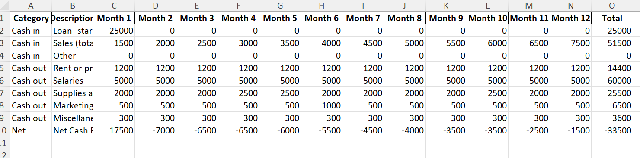

Conclusion
Combining excellent floral arrangements with eco-friendly, high-quality customer service, Petal Bloom will quickly be Birmingham’s leading floral retailer. In an effort to appeal to a rising number of customers, by prioritizing sustainable practices and plants grown in our backyard, we aim to attract a growing customer base who value environmental responsibility first and foremost. With physical and digital channels optimized for scale and ease, our integrated marketing and operations model ensures successful engagement with both individual and business customers. Financial estimates show that a £25,000 initial investment will enable the company to be set up and scale, making it profitable in its first year. Making personalisation, quality and sustainability at the core of our business will ensure that we are building a loyal client base and Petal Bloom is a trusted and trustworthy brand in the Birmingham floral industry. However, the focus will be on growing alliances with businesses and planners, ramping up online advertising, and exploring other offerings such as seminars and flower subscriptions to diversify revenues. Petal Bloom’s strong foundation and vision assist the company in a way that will ensure ongoing success and expansion.

References
- Albrecht, M.G., Green, M. and Hoffman, L., (2023). Principles of marketing.
- Barringer, B.R. and Ireland, R.D., (2010). Successfully launching new ventures.
- Cafferkey, K., Heffernan, M., Harney, B., Dundon, T. and Townsend, K., (2018). Perceptions of HRM system strength and affective commitment: the role of human relations and internal process climate.
- Drummond, G., Ensor, J. and Ashford, R., (2008). Strategic Marketing: Planning and Control Third edition.
- Dessyana, A. and Riyanti, B.P.D., (2017). The influence of innovation and entrepreneurial self-efficacy to digital startup success. International research journal of business studies, 10(1), pp.57-68.
- Farias, L.F., de Araújo, P.P.P., Carneiro, T.D.C., Araújo, S.B. and da Silva, L.A., (2019). Organizational Behavior of Supply Chain Management: A Case Study Carried Out in a Textile Industry in the Northeast Brazil. International Journal of Business Management & Economic Research, 10(3).
- Gupta, S. and Starr, M.K., (2014). Production and operations management systems (Vol. 4). Boca Raton: CRC Press.
- Jobber, D. and Ellis-chadwick, F., (2020). Principles and Practice of Marketing.
- Kotler, P. and Armstrong, G.,( 2010). Principles of Marketing.
- Kotler, P., (1997). gary Armstrong. Principles of marketing, 250.
- Kraus, S., Mahto, R.V. and Walsh, S.T., (2021). The importance of literature reviews in small business and entrepreneurship research.
- Kitsios, F., Kyriakopoulou, M. and Kamariotou, M., (2022). Exploring Business Strategy Modelling with ArchiMate: A Case Study Approach. Information 2022, 13, 31.
- Nain, S., Mail, R., Lajuni, N. and Sondoh Jr, S., (2020). Customer satisfaction through management accounting practices in the hotel industry. International Journal of Academic Research in Accounting Finance and Management Sciences, 10(3), pp.510-526.
- Storey, D.J., (2014). Understanding the small business sector: reflections and confessions. P. Braunerhjelm (ed.), 20, pp.21-33.
- Stevenson, W.J., Hojati, M., Cao, J., Mottaghi, H. and Bakhtiari, B., (2007). Operations management. McMcGraw-Hill Irwin.

