THE INFLUENCE OF FLEXIBLE HOURS ON JOB SATISFACTION: A SURVEY OF UBER DRIVERS

Student name: Flavius-Florin Filimon
Student number: 2208335
2025
Word count: 8499

Dissertation submitted as part of the requirements for the award BA DEVELOPING LEADERSHIP AND MANAGEMENT

Declaration

This work has not previously been accepted in substance for any degree and is not being concurrently submitted in candidature for any degree.

Signed Flavius-Florin Filimon
Date 11th July 2025

STATEMENT 1
This dissertation is being submitted in partial fulfilment of the requirements for the degree of BA.
Signed Flavius-Florin Filimon
Date 11th July 2025
STATEMENT 2
This dissertation is the result of my own independent work/investigation, except where otherwise stated. Other sources are acknowledged by footnotes giving explicit references. A bibliography is appended.
Signed Flavius-Florin Filimon
Date 11th July 2025
STATEMENT 3
I hereby give consent for my dissertation, if accepted, to be available for photocopying and for interlibrary loan, and for the title and summary to be made available to outside organisations.
Signed Flavius-Florin Filimon
Date 11th July 2025
STATEMENT 4
I hereby give consent for my dissertation, if accepted, to be available on the university’s IT system to those who have consent to use the system.
Signed Flavius-Florin Filimon
Date 11th July 2025

Acknowledgement

While developing the research on the topic “THE INFLUENCE OF FLEXIBLE HOURS ON JOB SATISFACTION: A SURVEY OF UBER DRIVERS”, I have come across different people for whom my bag of knowledge over the subject is filled. Firstly, I can say that my mentor Rebecca Francis-Davies has supported me wholeheartedly in completing the research thoroughly. Secondly, my friends and my parents always encouraged me a lot to be engaged in each stage of the research and collect data relevant to my topic. Lastly, I have knowledge on discussing the topic with my relatives also.
With regards,
Flavius-Florin Filimon
Abstract

Chapter 1 of this research paper has focused on discussing the objectives and research questions in an illustrative way. Further this chapter has also discussed the rationale behind conducting this project and its significance and contributions for further researcher papers. In chapter 2, it can be observed that the existing literature relevant with the research topic have been discussed. In this section of the research paper, it is observed that flexible working hours can be quite effective in enhancing the job satisfaction of Uber drivers quite significantly. Further, it is also observed that Flexible-Firm Model and Self-Determination Theory can be quite beneficial in maintaining the work-life balance for the employees quite effectively in the long run. Chapter 3 of this dissertation has focused on discussing different methods and strategies such as positivism philosophy, deductive approach, quantitative research method and both primary and secondary data collection processes. In this section, the random sampling technique has also been discussed quite extensively which further ensured elimination of bias in the best possible ways. Chapter 4 of this research paper has focused on analysing and interpreting the primary quantitative data collected through the means of a survey. In this case, a proper sense of diversity has been maintained throughout the data collection process which also enhanced the overall authenticity and reliability of the entire research project. Chapter 5 summarises the key results derived from the analysis and discussion. It confirms the impact of the research by checking if the set objectives are met or not. The flexibility of Uber enhances productivity, autonomy, and work-life balance when supported effectively. The chapter links and outlines future research opportunities and presents practical recommendations for Uber to strengthen the retention and performance within its flexible workforce model.

Table of Contents
Chapter 1: Introduction 8
1.1 Research Background 8
1.2 Research aim, objectives and questions 8
1.3 Research rationale 9
1.4 Research significance 10
Chapter 2: Literature Review 11
Introduction 11
Overview of flexible working hours 11
Job satisfaction in the non-traditional work settings 12
Interplay between job satisfaction and flexible working hours 13
Theoretical aspects 14
Literature Gaps 18
Summary 19
Chapter 3: Research Methodology 20
3.1. Introduction 20
3.2. Research Onion 20
3.3. Research philosophy 21
3.4. Research Approach 21
3.5. Research Method 22
3.6. Data Collection and Analysis 22
3.7. Sampling Techniques 23
3.8. Ethical Considerations 23
3.9. Limitation 24
3.10. Chapter Summary 24
Chapter 4: Results, Findings and Discussion 25
4.1. Primary Data Analysis 25
4.2. Discussion 33
Chapter 5: Conclusion and Recommendations 37
5.1 Overall Conclusion 37
5.2 Linking with Objectives 37
5.3 Future Scope 38
5.4 Recommendations 38
References 40
Appendices: 46
Appendix 1: Questionnaire 46
Appendix 2: Ethics form 47

List of Figures

Figure 2.1: Flexible-Firm Model 15
Figure 2.2: Self-determination Theory 16
Figure 2.3: Job Characteristics Model 17
Figure 2.4: Work-Life Balance Equilibrium 18
Figure 3.1: Research Onion 20
Figure 4.1: Impact of job satisfaction in enhancing performance levels 25
Figure 4.2: Impact of flexible working hour on productivity 25
Figure 4.3: Impact of flexible working hours on work-life balance 26
Figure 4.4: Impact of flexible working hours on stress levels 27
Figure 4.5: Role of flexible working hours in retaining employees 27
Figure 4.6: Additional benefits and improvements for Uber 28
Figure 4.7: Satisfaction with working hours 29
Figure 4.8: Recommendation for family member 30
Figure 4.9: Preference of continuing driving with Uber 30
Figure 4.10: Influencing factors to job satisfaction 31

Chapter 1: Introduction

1.1 Research Background
In recent years, the rapid expansion of the gig economy has entirely changed traditional work arrangements as ride-hailing services like Uber have emerged as important employers. Compared with conventional jobs, gig work can be characterised by extensive flexibility in operational autonomy and scheduling. Such flexibility is allowing the current employees to select when and how much they work, which theoretically can improve their job satisfaction while making a better work-life balance (Paudel et al., 2024). However, the nature of flexible working hours in this specific context also represents some challenges related to work intensity, income stability as well as job security.
Uber drivers act as independent contractors, and they are also provided with temporal flexibility. A certain extent of autonomy during work can easily lead to a sense of empowerment and satisfaction (Orlowska and Laguna, 2023). However, it has also been observed that the absence of fixed hours may result in unpredictability and stress due to fluctuating demand and the burden of managing multiple income streams. The purpose of conducting this study is to bridge this specific gap in the existing literature while properly investigating the relationship between flexible working hours and job satisfaction among Uber drivers, and both the limitations and benefits of such work arrangements will be assessed.

1.2 Research aim, objectives and questions
The aim of conducting this research is to understand and analyse the influence of flexible hours on employee job satisfaction. The following objectives will be used to address the research aim.
Objectives
- To identify the importance of employee job satisfaction in enhancing organisational performance of Uber drivers
- To examine the impact of flexible working hour of Uber drivers on different aspects of job satisfaction, such as productivity, work-life balance and individual stress levels
- To assess the impact of flexible working hours on wider organisational aspects of employee retention and workplace culture of Uber drivers
- To make recommendations to Uber highlighting the benefits of flexible working hours on employee productivity
Research questions
- Why employee job satisfaction is important in managing and improving organisational performance of Uber?
- What is the impact of flexible working hours of Uber drivers on different aspects of job satisfaction, such as productivity, work-life balance and individual stress levels?
- How flexible working hours are impacting wider organisational aspects, including employee retention and workplace culture of Uber?
- What are some recommendations to Uber highlighting the benefits of flexible working hours on employee productivity?

1.3 Research rationale
The rationale behind conducting this study is associated with the need to critically evaluate the different benefits of flexible work schedules from the perspective of ride-hailing service companies like Uber. Continuously increasing reliance on gig workers is raising important questions about the true nature of work satisfaction in such an environment that is both highly precarious and autonomous (Cropanzano et al., 2023). Despite the fact that workplace flexibility is often associated with increased job satisfaction of the employees, emerging evidence suggests that lack of clear career pathways, structural support as well as financial predictability sometimes counterbalance such extensive advantages (Kottwitz, Daibel and Otto, 2025).
This research is motivating and important for several reasons. Firstly, there has not been any research that clearly and specifically examines the influence of flexible working hours on the job satisfaction levels of Uber drivers. According to Berber et al. (2022), flexible working hours can enhance job satisfaction for employees. Most of the existing researches tend to focus on broader and extensive labour market trends as well as traditional marketplaces instead of uncontrolled workplace environments, which can be observed in organisations like Uber. Additionally, since labour organisations and policymakers are debating about the implications of the gig companies, it has become important to understand how the promises associated with workplace flexibility actually translate into work-life satisfaction for the gig workers.

1.4 Research significance
The research is quite significant because it has a multifaceted aspect that can impact academic, practical as well as policy domains. From an academic perspective, the study helps to address a notable literature gap regarding the effects of flexible work hours on the satisfaction levels of gig workers. After focusing on the Uber drivers, the research intends to offer an effective lens through which the impact of flexible working hours on the gig workers can be assessed. For employees of any organisation, the importance of job satisfaction and work motivation has been continuously increasing in recent times so that competitive advantages can be maintained by the companies (Smolarek et al., 2024). Therefore, it is necessary to know how flexible working hours, and its associated aspects can increase or even decrease the motivation levels of gig workers.
From a policy perspective, this research has the potential to inform some regulatory debates about gig work reforms and labour protections. Since governments are grappling with the challenges of ensuring some fair labour practices in the existing economic landscapes, some appropriate empirical evidence on flexibility and worker satisfaction can easily guide the proper development of policies so that better flexibility can be ensured for the employees. As per the statements by Adebayo et al. (2024), fair labour practices can help in avoiding government compliances quite significantly over the period of time.

Chapter 2: Literature Review

Introduction
The literature review can be described as one of the most important chapters of an entire dissertation because it is associated with collecting some information regarding a research subject which was previously conveyed by other scholars and researchers. In the current times, flexible working hours have become an important point of contemporary research because of its association with job satisfaction. Since non-traditional work patterns and arrangements are gaining adequate prominence, it is necessary to understand how proper scheduling of workplace flexibility influences the performance and attitudes of the employees. In this literature review, critical examination will be done for examining the multifaceted impact of flexible working hours on job satisfaction, exploring themes such as productivity, work–life integration, and mental well-being. Additionally, some effective and theoretical perspectives and research gaps will also be identified in this literature review section.

Overview of flexible working hours
According to Radovan (2024), flexible working hours are one of the defining characteristics of the existing work environment, specifically in the non-traditional workplace settings. Unlike the traditional workplace models, extensive flexibility in scheduling helps employees to decide when to commence as well as conclude their work. This level of autonomy is also linked with increased job satisfaction. This is because Paulišić et al. (2024) described that workers can be better aligned with their personal priorities and professional tasks if they are provided with proper autonomy during work. When the employees have some higher levels of control over their schedules, they generally experience some greater sense of self-determination and empowerment, making positive contributions to the overall well-being and motivation (Bocean et al., 2023).
However, it is also necessary to keep in mind the fact that the benefits of flexible work are not experienced uniformly. There are also some important differences between involuntary and voluntary flexibility. As per Yaroshenko et al. (2024), voluntary flexibility is associated with such aspects when employees opt for some non-standard work hours for accommodating personal preferences and this can help in improved work-life balance and higher satisfaction rate. However, when workplace flexibility is initially imposed by economic pressure and organisational necessity, it generally leads to feelings of uncertainty while reducing job security and increasing stress levels. Additionally, Jurek et al. (2021) described that the absence of clearly defined boundaries between leisure time and work can easily contribute to overwork, which can further complicate the influence on employee satisfaction.
The productivity levels of the employees can also be impacted as well as influenced with the help of flexible schedules in the current times. This is because Kossek et al. (2021) described that flexible working can easily foster efficiency as well as creativity, which allows employees to work in such periods when they are in a state of alert. However, a lack of proper workplace structure easily undermines accountability, which can lead to inconsistent performance as well as procrastination. Laebens and Lührmann (2023) described that despite flexibility being generally heralded as a means to improve work–life integration, its overall efficacy is entirely contingent upon the ability of individuals to manage self-time appropriately while setting appropriate boundaries. Due to this complex duality, it is underscoring the necessity of further inquiry into how flexible working is shaping the diverse aspects of job satisfaction in the current times.

Job satisfaction in the non-traditional work settings
In any non-traditional workplace setting, job satisfaction can be described as a multi-dimensional construct that can be easily influenced by a range of different factors like work–life balance, recognition, financial stability and autonomy (Sarfjoo et al., 2025). According to Siippainen et al. (2023), extensive flexibility offered by non-standard work schedules can help the workers to have some proper level of control over their daily routines. Therefore, it improves their sense of autonomy among the employees, which can help to improve the intrinsic motivation level of the employees. This is associated with the aspects of Self-Determination theory as well. In the current time, autonomy is allowing the employees to specifically tailor their work environments as per their basic needs. This generally improves the productivity and morale of the employees so that they can be better in terms of handling pressurised working situations.
However, Karsili et al. (2021) described that the influence and positive impact of flexible working hours on job satisfaction-related aspects are not entirely positive. This is because the removal of the conventional work boundaries can sometimes lead to facing challenges in terms of demarcating personal and professional time. Some of the employees are even facing challenges while trying to maintain a proper separation between leisure and work duties, which can easily result in conflicted work and family. Such extensive conflict can easily increase stress while decreasing overall job satisfaction. This is because Olding et al. (2021) described that individuals may find themselves to be overburdened by their personal and professional responsibilities. Additionally, despite the fact that flexible work arrangements can easily facilitate increased work-life balance, the overall benefits are extensively relying on individual time-management skills. According to Pindek et al. (2021), employees who can properly structure their workdays tend to report some higher levels of job satisfaction in the current times. However, employees who struggle with appropriate self-regulation can experience increased burnout and anxiety (Bakker and de Vries, 2021). Additionally, the absence of traditional and contemporary supervisory structures in the flexible work environment can easily lead to feelings of isolation. Furthermore, it can also decrease the chances of getting feedback. This is quite important for professional recognition and growth (Trzebiatowski and Henle, 2023).
Research is indicating the fact that there are some financial implications of flexible scheduling as well, specifically when properly linked with irregular work hours. This can easily impact the job satisfaction level of employees. According to Liu et al. (2024), a perceived lack of financial security and income instability may easily counteract the positive psychological effects of flexibility and autonomy. The existing tension between the potential pitfalls of unstructured work time and the advantage of self-determination is underscoring the need for some more nuanced investigation about the specific conditions under which flexible working hours are contributing or detracting from job satisfaction. These types of investigations have become important for developing some specific strategies where worker wellbeing can be enhanced with increasingly flexible work environments in the current times. Therefore, such investigations are important for developing strategies so that worker well-being can be improved with flexible work environments.

Interplay between job satisfaction and flexible working hours
The overall relationship between job satisfaction and flexible working hours is quite multidimensional and complex, which involves a proper interplay of work-life balance, stress management as well as productivity. As per Hartner-Tiefenthaler et al. (2023), flexible working schedules sometimes act as a double-edged sword in the current times. Yet, this positive outcome is not guaranteed for all. In many instances, the freedom to set one’s schedule without the constraints of traditional time structures can lead to an absence of routine. The lack of structure may result in difficulty in prioritizing tasks, leading to procrastination or a tendency to extend work hours into personal time. Consequently, the blurred lines between work and leisure can diminish overall job satisfaction by increasing stress and reducing the quality of personal life (Kumar, 2024).
Additionally, the aspects of job satisfaction are easily influenced by different individuals and the overall degree of support available in the existing work environment. According to Aeon et al. (2021), employees who have a higher and stronger degree of time-management and self-discipline skills are more likely to have the benefits of flexible work arrangements. Furthermore, it has also been observed that employees who generally struggle with self-regulation may find that the added flexibility is exacerbating the feelings of being overwhelmed and socially isolated. As per Rusilowati (2022), while some workers reported having better experiences like reduced stress levels and improved work-life balance as a result of flexible working hours, others have reported the opposite because flexibility sometimes contributes to burnout and increased workload.
Furthermore, it is necessary to assess that the relationship between productivity and flexibility can be mediated by an individual’s perception of control. When the employees believe that they are empowered by their working flexibility, they grow the tendency of viewing their work as meaningful, which can increase their overall satisfaction level (Azhar et al., 2024). Different interplays between the factors are suggesting the fact that the benefits of flexible working hours on the areas of job satisfaction are extensively contingent on contextual, organisational and personal variables (Marino and Capone, 2021).

Theoretical aspects
The literature around the topic of the impact of flexible working hours on job satisfaction is further enriched by different theoretical frameworks that can include appropriate insights into the behavioural and psychological mechanisms at play. The most important theoretical aspects in this literature review include self-determination theory, job characteristics model and theories of work-life balance.
Flexible-Firm Model
Flexible-Firm Model was coined by John Atkinson in the 1980s in order to make different organisations able to make their workforce flexible and utilise the same as per the changes in the market for better results (Bal and Izak, 2020). As mentioned by Austin-Egole et al. (2022), flexibility within the workforce can turn out to be quite effective in terms of adjust8ing with the changing market conditions. In this case, handling a challenging situation can turn out to be quite easy for the concerned organisation while deriving the best possible outcomes at the same time. Hence, it can be stated that with the implementation of this particular model, the chances of gaining a competitive edge in the market can get easier quite significantly in the long run.
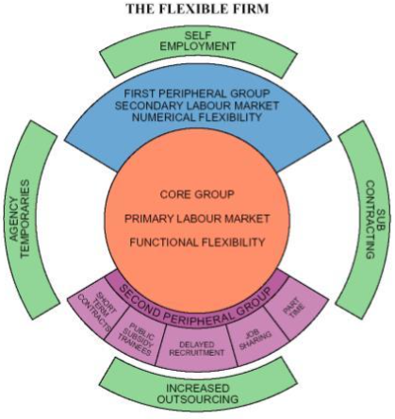
Figure 2.1: Flexible Firm Model
(Source: Atkinson, 1984).
Flexible work for Uber drivers gives them the power to choose when, where, and for how long they want to work. Unlike traditional jobs where time is fixed, Uber drivers can log in to the app whenever it suits them, whether it is a couple of hours in the mornings, late at night, or just at weekends. This allows drivers to fit in their work around their life, family timetable, or other professions. It also means that they can experience fluctuations of non-work whenever needed and can drive whenever needed (Hood, 2017).
Self-Determination Theory
According to Self-Determination Theory, autonomy can be described as a fundamental human need that, when properly satisfied, can easily lead to improved intrinsic motivation as well as psychological well-being (Business and Research, 2024). As per Gagné et al. (2022), flexible working hours are offering some different opportunities for employees so that they can exercise their choice as well as control over their personal work schedules. With the help of such autonomy, it is possible in the current times to have some higher levels of satisfaction, performance and overall engagement. However, SDT theory also mentions that autonomy needs to be balanced with relatedness and competence, which are the specific needs that sometimes be compromised if the added flexibility is leading towards overburden or feelings of isolation. Therefore, this theoretical foundation is quite important in terms of understanding the duality of flexible and effective work arrangements (Gkiolnta, Roy and Fragulis, 2025).
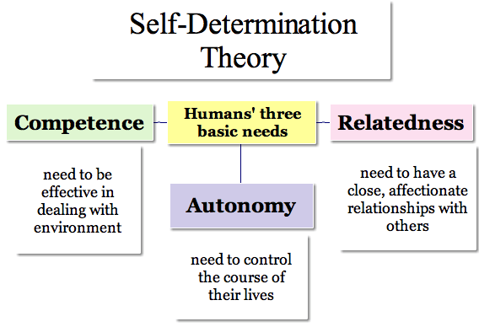
Figure 2.2: Self-Determination Theory
(Source: Ackerman, 2018).

Job Characteristics Model
JCM or the Job Characteristics Model suggests the fact that job satisfaction can easily be influenced by the core job dimensions like task significance, feedback and autonomy. According to Glowacka (2021), autonomy is one of the most important aspects of flexible working hours which can improve the meaningfulness of work. However, this model also warns about the fact that inadequate structure in flexible working can easily lead to stress and ambiguity. This model has been quite effective in providing a proper framework that can examine how different aspects of flexible working conditions can contribute to improved performance and job satisfaction. This emphasises the need for making a balanced approach towards flexibility.
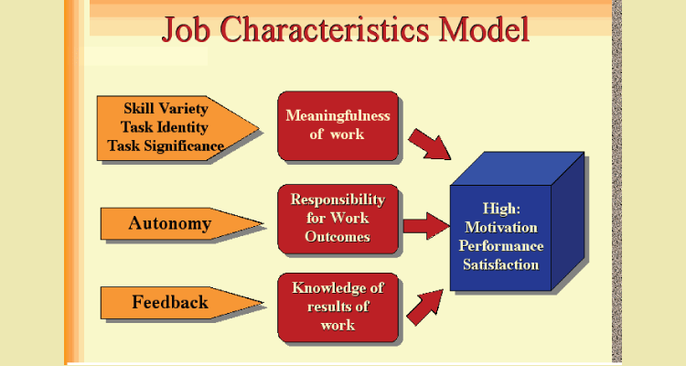
Figure 2.3: Job Characteristics Model
(Source: Makiwa, 2025).

Work-Life Balance Theories
There is a range of different theories that focus on the proper integration of personal life and work. The Work-Life Balance theories argue that the overall ability to manage different competing demands from family and home is important for managing and maintaining the overall well-being of individuals (Zulkiflee, Rashid and Razak, 2024). According to Kossek et al. (2023), flexible working hours are generally promoted as the specific strategies of achieving better work-life integration. However, it has also been observed that the outcomes are heavily dependent on organisational time management skills as well as individual time-management skills. It is also necessary to keep in mind that a proper balance between everything must be managed in order to increase the effectiveness of current working aspects.
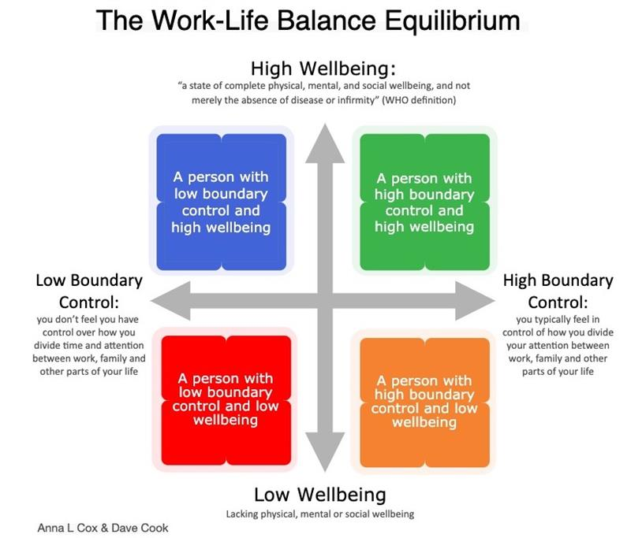
Figure 2.4: Work-Life Balance Equilibrium
(Source: A definition of Work-Life Balance for Policy Makers – eWorkResearch, 2025).

Literature Gaps
Despite the growing body of literature on flexible working hours and job satisfaction, several significant gaps remain. First, while extensive research has examined the individual effects of autonomy on job satisfaction, few studies have simultaneously addressed how flexibility impacts multiple dimensions such as productivity, work–life balance, and stress. Much of the existing work has focused on singular outcomes rather than adopting a comprehensive, integrated approach that considers their interdependencies. This oversight limits our understanding of the complex interplay between various factors in non-traditional work environments.
Second, many studies have concentrated on traditional or semi-structured work settings, leaving a notable void in the literature regarding highly flexible or self-managed work arrangements. The unique challenges faced by employees operating outside of conventional organizational frameworks such as the absence of supervisory oversight or standardized feedback mechanisms are underexplored. Consequently, there is a pressing need for research that specifically examines how self-regulation and individual differences mediate the effects of flexible work hours on job satisfaction.
Third, the majority of research in this field has relied on cross-sectional methodologies. These approaches provide valuable snapshots of employee attitudes at a given moment but fail to capture the dynamic, evolving nature of job satisfaction over time. Longitudinal studies would enable researchers to observe how flexible working arrangements affect job satisfaction in the long run, accounting for factors such as career progression, changing personal circumstances, and evolving organizational practices.
Finally, while theoretical models like the Self-Determination Theory and the Job Characteristics Model offer important insights, there remains a need for more integrative frameworks that account for the diverse outcomes associated with flexible working hours. A comprehensive model that simultaneously addresses productivity, work–life balance, and stress would greatly enhance our ability to design policies that promote sustainable job satisfaction. Addressing these literature gaps is essential for both academic advancement and the development of practical interventions that support workers in increasingly flexible employment contexts.

Summary
With the help of the literature review, it is possible to examine the overall influence of flexible working hours on aspects like job satisfaction, and the main focus is on important themes like work-life balance, stress and overall productivity. Despite the fact that flexible working is able to offer a range of different advantages, there are also some threats related to income variability, stress as well as self-management.

Chapter 3: Research Methodology

3.1. Introduction
In this chapter of the research paper, the methods and strategies within this research paper will be discussed in an appropriate manner. In the research onion, different strategies and methodologies will be portrayed that can be used in a research paper for better outcomes and results in the long run. Further, this chapter will also focus philosophies, approaches, designs, methods, data collection methods, sampling techniques that are appropriate for this project. Further, an ethical consideration will also be discussed that has been maintained throughout this research paper in order to comply with the guidelines and data safety protocols.

3.2. Research Onion

Figure 3.1: Research Onion
(Source: Saunders et al., 2019)
In the research onion, it can be observed that there are several strategies and concepts that can be applied within a research paper for ensuring better conduction and execution of the project. The research onion has portrayed the various philosophies, approaches, methods and data collection processes that can enhance the end result of the project quite significantly in the long run. According to the viewpoints of Abdelhakim (2021), research onion portrays the methods that can be implemented within a research paper.

3.3. Research philosophy
This study utilises a positivist research philosophy to examine the influence of flexible working hours on the job satisfaction rate of Uber employees. Positivism research philosophy approach is adopted for this particular study as the research seeks to recognise measurable relationships between specific variables - working hours (independent variable) and job satisfaction (dependent variable) (Park et al., 2020). This philosophy supports the usage of structured methods such as surveys or statistical analysis to produce objective, quantifiable results, ensuring reliability and generalisability across a larger population (Maksimovic and Evtimov, 2023). The key reason behind the selection of positivism lies in its emphasis on observable and empirical data. In the context of Uber’s flexible work model, employee satisfaction can be effectively measured through standardised instruments, enabling a scientific approach to analyse trends and correlations. On the other hand, interpretivism was considered but deemed less suitable. Interpretivism focuses on subjective experiences that can be valuable but does not align with the aim of the study to establish broad and data-driven conclusions (Pervin and Mokhtar, 2022).

3.4. Research Approach
This study adopts a deductive research approach to investigate the influence of flexible working hours on the job satisfaction rate of Uber employees. The deductive approach is suitable as it begins with established concepts and theories- particularly those related to job satisfaction and work flexibility- and tests specific hypotheses derived from these theories (Yuwono and Rachmawati, 2023). For example, based on the Job Characteristics Model, it can be hypothesised that increased flexibility positively correlates with higher job satisfaction.
This approach aligns well with the positivist philosophy, as it allows the researcher to test hypotheses through quantitative data collection methods such as structured surveys and statistical analysis, The goal is to confirm or reject the hypothesis utilising empirical evidence, making the findings generalisable and replicable. Alternative approaches such as inductive and abductive reasoning were considered but found less appropriate. Inductive research focuses on developing theories from qualitative observations that may not provide the structured testing required here. On the other hand, abductive reasoning moves back and forth between data and theory and lacks the clear hypothesis-driven structure required for this study (Cronholm et al., 2023).

3.5. Research Method
This study employs a quantitative research method, utilising a structured survey to assess the influence of flexible working hours on the job satisfaction rate of Uber employees. A quantitative approach is appropriate given the positivist philosophy and deductive research design used in the study, that aims at measuring relationships between variables using numerical data and statistical analysis (Zyoud et al., 2024). The survey is designed with closed-ended questions, using likert-scale items to assess the perceptions of respondents regarding flexibility, satisfaction levels, and related workplace factors. The questionnaire is distributed online to a sample of Uber drivers across various regions to ensure diversity and broader generalisability. Participants are selected using random sampling to capture variation in working hours and demographic backgrounds (Noor et al., 2022). Gathered data are analysed using statistical methods to test the hypothesis that flexible working hours positively influence job satisfaction.

3.6. Data Collection and Analysis
Collection of data and information is one of the most important parts within a research paper as it helps in justifying the topic and the objectives in the long run. There are mainly two kinds of data collection methods that can be implemented within a research paper namely primary and secondary. In this project, the focus has been on using the primary data collection method where a survey has been conducted which consists of 100 Uber drivers. This data collection strategy will surely turn out to be quite beneficial in ensuring a diverse range of data and perspectives in the long run. In this regard, Taherdoost (2021) mentioned that conducting a survey within a research project can help gather a diverse range of data. Therefore, ensuring authenticity and reliability has been quite easy for the research paper in every way. The data will be collected using Google Forms for its increased convenience. In order to analyse the collected data, a simple statistical analysis technique has been followed which will play a crucial role in representing the collected data in the best possible ways. In other words, this statistical data will also prove to be quite helpful for the audience to have a clear understanding of the collected information through surveys.

3.7. Sampling Techniques
Sampling has also been one of the crucial factors in this research paper which has played a very important role in collecting data and information in the best possible ways. With the aim of receiving at least 50 responses, the survey will be shared via a WhatsApp group that includes more than 500 Uber drivers in Bristol. On the other hand, a random sampling has been implemented in this project which will further turn out to be quite beneficial in terms of accessing readily available samples in the best possible ways, hence saving cost and time at the same time. Nuwagaba et al. (2023) have stated that random sampling can help in saving time and money for a project. Further, this sampling technique has also proved to be quite helpful in eliminating bias and promoting equality within the entire data collection process, hence ensuring inclusivity at the same time.

3.8. Ethical Considerations
Maintaining ethics and integrity has been one of the most integral parts of this research paper to earn be trust and confidence of the respondents and the audience in the best possible ways. According to the viewpoints of Fisher et al. (2021), maintaining ethics in a research paper can help in earning trust of the respondents and audience. Proper consent forms are provided to the respondents for maintaining transparency so that they can have a clear understanding of the survey and the topic along with the pros and cons of the same. In this case, it is ensured that none of the respondents are asked any personal questions apart from those that are relevant with this project. Further, it is also ensured that the collected data is used for only academic purpose and not for any commercial purposes. Data protection and privacy has also been prioritised in this project so that the interventions of any third party and cyber criminals can be minimised in the long run. In this context, the guidelines and provisions of the General Data Pro6tection Regulations (GDPR) 2018 have been followed and implemented. The collected data have been encrypted in password protected devices and cloud storages which can be accessed only by the researchers and the respondents. This factor has certainly played a crucial role in earning the trust and confidence of the respondents while encouraging them to participate in the survey.

3.9. Limitation
Only relying on quantitative data collected from the survey is one of the main limitations of this research. Considering a mixed method of data collection and analysis could have increased the viability and depth of the research, but collecting qualitative data from the Uber drivers would require more time and cost. Additionally, obtaining valid consent from the Uber drivers for asking open-ended questions is quite time and resource-intensive, which is why a survey has been designed for the entire data collection process. Relying on only one form of data collection can be challenging if the respondents do not provide valid responses. However, the survey questions have been designed to address the research question and this will help in decreasing the limitation.

3.10. Chapter Summary
In this chapter of the research paper, it is observed that there are several methods and strategies that can be incorporated within a research paper for better execution in the long run. Positivism philosophy and deductive approach have been used in this research for ensuring a proper base and better outcomes. Further, a quantitative method has been applied in this research project for gathering a diverse range of data. In this regard, a survey has been conducted which has proved to be quite effective and beneficial in gathering a diverse data relevant with the research topic and objectives. Random sampling has proved to be quite beneficial in terms of eliminating the chances of biases while promoting equality at the same time. Maintaining ethics has also been one of the integral parts in this research paper.

Chapter 4: Results, Findings and Discussion

4.1. Primary Data Analysis
Question 1: How significant is your overall job satisfaction in enhancing your performance as an Uber driver?
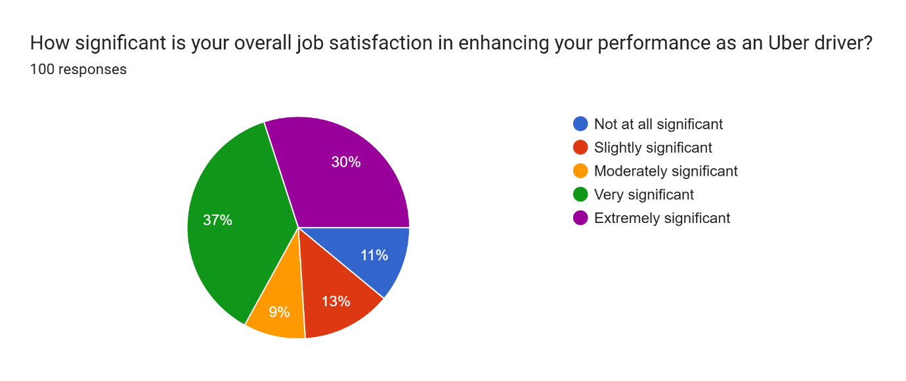

Figure 4.1: Impact of job satisfaction in enhancing performance levels
(Source: Survey)
Analysis: Considering the above question, it can be observed that around 37% and 30% of the respondents have stated that they are quite satisfied with their job role of being an Uber driver which further encourages them to enhance their performance levels. On the other hand, 11% of the participants have stated that their job role is not at all significant while 13% of them have stated their jobs being slightly significant. According to them, it becomes quite difficult to balance personal and professional lives being an Uber driver.

Question 2: To what extent do you agree with the following statement? ‘Flexible working hours help improve my productivity on the job’
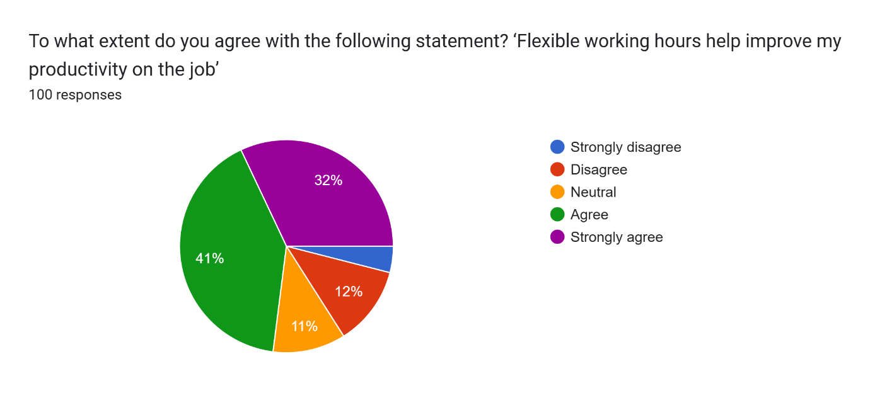

Figure 4.2: Impact of flexible working hour on productivity
(Source: Survey)
Analysis: 41% of the respondents have strongly agreed while 32% of them have agreed with the fact that flexible working hours plays a crucial role in improving their productivity. According to these respondents, flexible working hours can prove to be quite beneficial for them in terms of maintaining a proper balance between their personal and professional lives. On the contrary, 12% of the participants are of a different opinion as they disagreed with the role of flexible working hours in increasing productivity.
Question 3: How would you rate the impact of flexible working hours on your work-life balance?
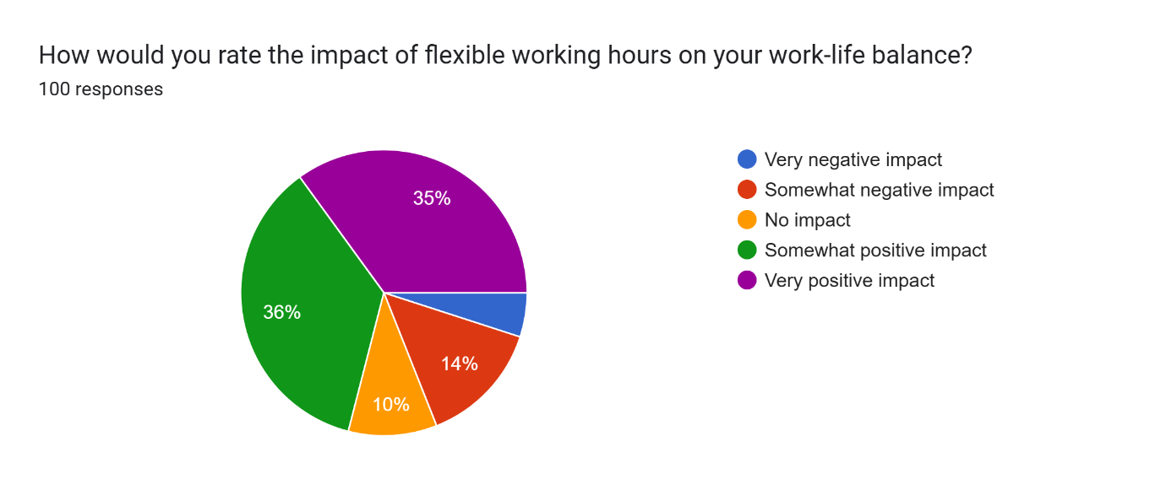

Figure 4.3: Impact of flexible working hours on work-life balance

(Source: Survey)
Analysis: Taking the above question into consideration, it can be observed that 35% and 36% of the respondents have mentioned flexible working hours to be extremely impactful in ensuring a proper work-life balance. On the contrary, 14% of the respondents have stated that flexible working hours can have negative impact on their work-life balance as it can disrupt their routine quite significantly.
Question 4: Compared to fixed schedules, how do flexible working hours affect your stress levels?
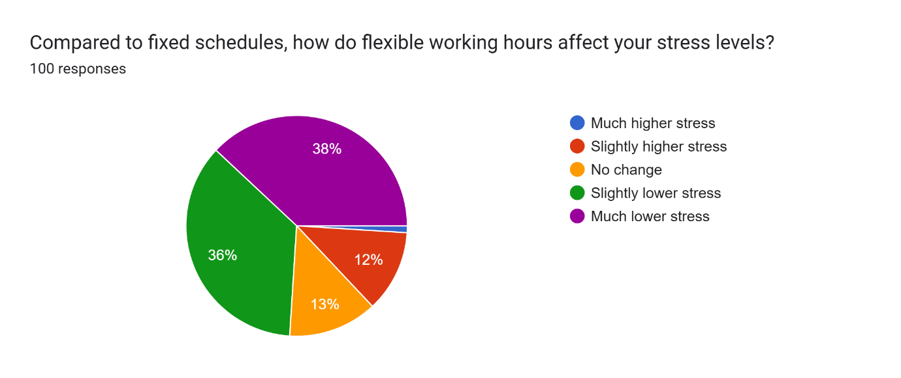

Figure 4.4: Impact of flexible working hours on stress levels
(Source: Survey)
Analysis: While comparing fixed schedules with flexible schedules, it can be observed in the above statistics that 38% of the respondents have stated that flexible working hours can ensure much lower stress levels at the workplace as well as personal life. On a negative note, 12% of the participants have stated flexible working hours to create slightly higher stress. As per their opinion, managing time can get difficult for them as a result of flexible working hours which further reduces their overall productivity quite significantly.
Question 5: In your view, how do flexible working hours contribute to employee retention and a positive workplace culture among Uber drivers?
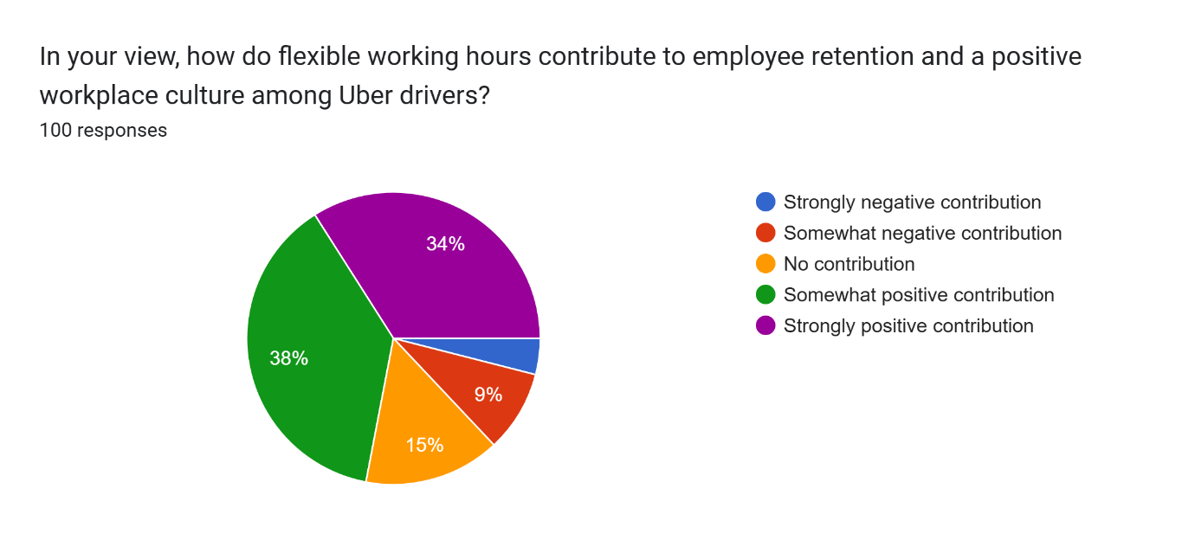

Figure 4.5: Role of flexible working hours in retaining employees
(Source: Survey)
Analysis: Considering the role of flexible working hours in contributing towards employee retention, it can be found in the above statistics that 34% of the participants are of the opinion of strong positive contribution, and 38% of them have stated that flexible working hours have somewhat positive contribution in retaining the employees and ensuring a positive work culture. On the negative side, 9% of the respondents have stated that flexible working hours have negatively contributed in creating a positive work culture, hence increasing the employee turnover rate quite significantly.

Question 6: What additional benefits or improvements do you believe Uber could achieve by further implementing flexible working hours? (Please select all that apply)
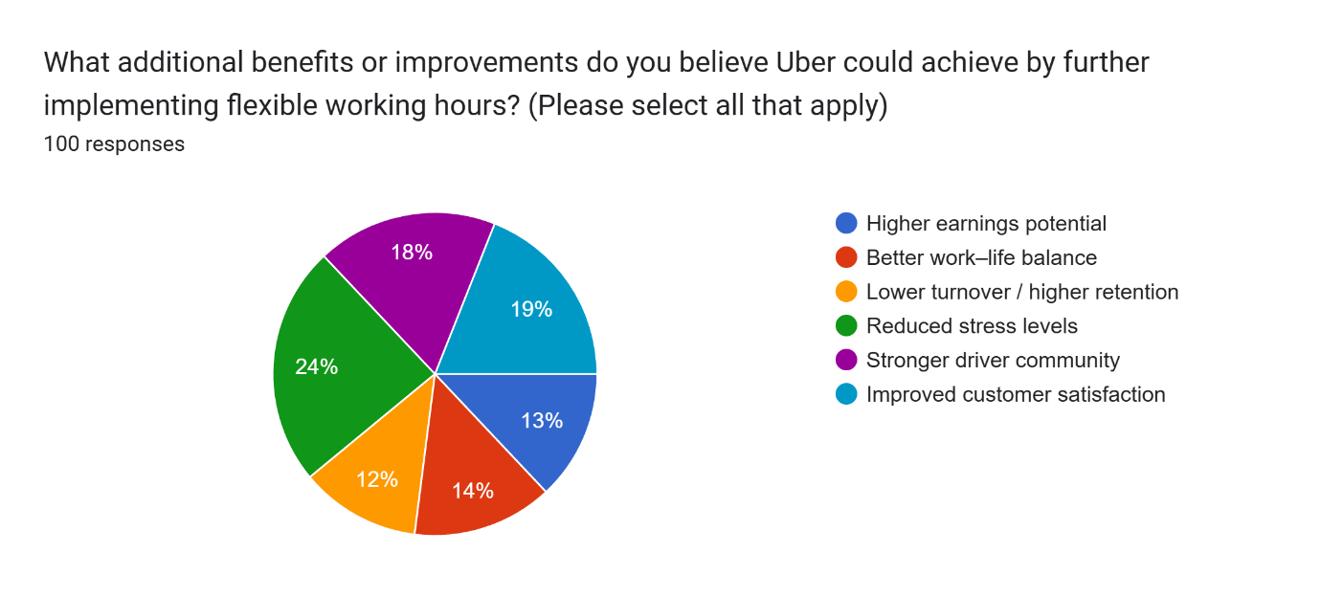

Figure 4.6: Additional benefits and improvements for Uber
(Source: Survey)
Analysis: Considering the above statistics, it can be stated that 24% of the respondents have found reducing stress levels to be the most important improvement that Uber can achieve by implementing flexible working hours. On the contrary, 19% of the respondents believe that customer satisfaction is the improvement that Uber needs to focus on. Further, 18% of the participants have mentioned that there is a need for Uber to develop a stronger driver community so that collaboration can be ensured in the long run. 14% of the participants have argued that there is a need for Uber to ensure the employees with better work life balance so that their engagement levels can be enhanced quite significantly.

Question 7: How satisfied are you with your existing level of autonomy in selecting working hours?
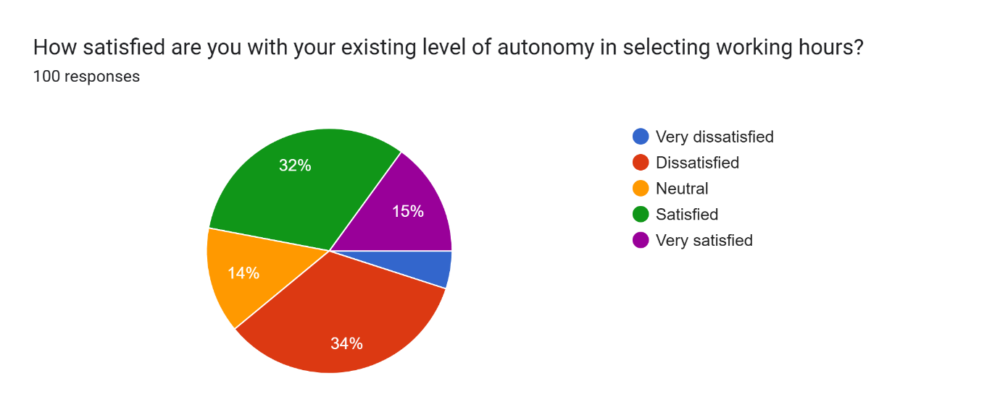

Figure 4.7: Satisfaction with working hours
(Source: Survey)
Analysis: 32% of the participants have expressed their satisfaction levels while 15% with their extreme satisfaction levels with the autonomy they get while selecting their working hours in Uber. In this case, these respondents have stated that they are free to maintain a proper work life balance while working in Uber. On the other hand, 34% of the respondents have stated that they are quite dissatisfied with the lack of autonomy they get while choosing their working hour.
Question 8: On a scale of 1 to 5, how likely would you recommend any family member or friend to drive for Uber? (5 extremely likely and 1 not likely at all)
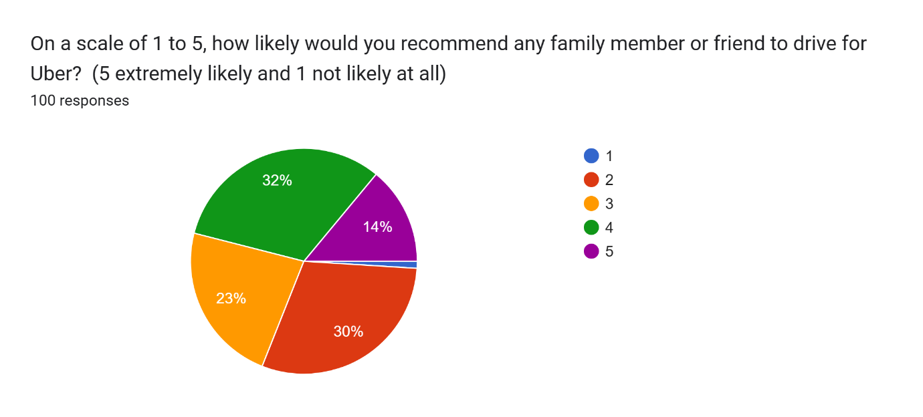

Figure 4.8: Recommendation for family member
(Source: Survey)
Analysis: Taking the above statistics into consideration, it can be observed that 32% of the participants are more likely to recommend a family member to drive for Uber. In this case, these respondents have stated that maintaining a proper work-life balance becomes easier while working in Uber. On the other hand, 30% of the respondents have mentioned that there is no discretion for the drivers to select their working hours while driving for Uber, hence will not recommend any of their family members in future.
Question 9: How likely are you to continue driving for Uber in the next 12 months?
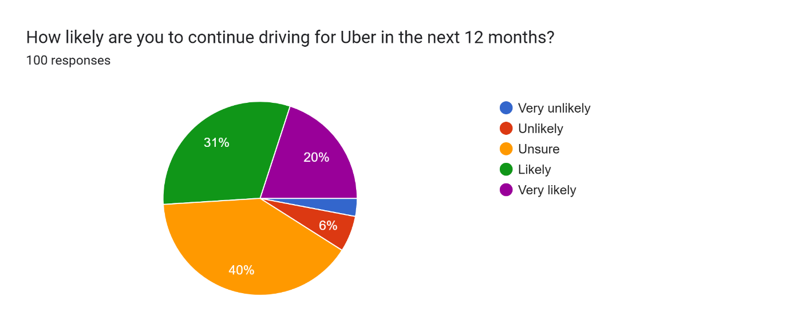

Figure 4.9: Preference of continuing driving with Uber
(Source: Survey)
Analysis: As far as continuing driving for Uber in the next 12 months is concerned, the majority of the respondents which is equal to 40% are unsure. On the other hand, 31% and 20% of the respondents are likely and very likely respectively to continue their careers as a driver in Uber for the next 12 months. In this case, they have mentioned about the flexible working hours in Uber that have ensured a better work-life balance for the employees. According to them, this factor in Uber has played a very important role in enhancing the overall engagement levels of the employees.
Question 10: Which of the following factors influences the most to your overall job satisfaction while working on Uber?
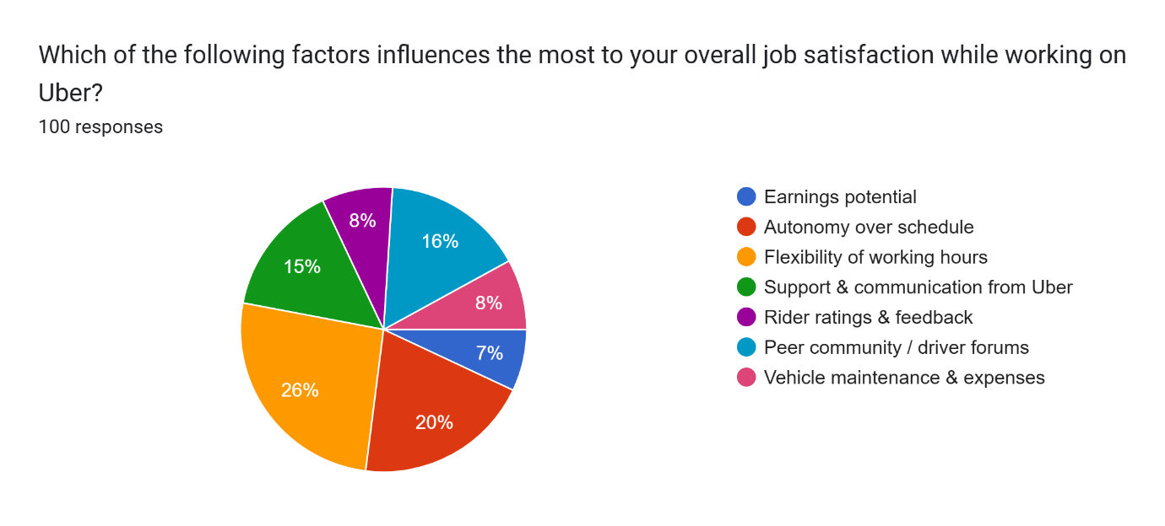

Figure 4.10: Influencing factors to job satisfaction
(Source: Survey)
Analysis: 26% of the respondents have stated flexible working hours to be the main factor that has influenced the overall job satisfaction in a positive way. On the contrary, 20% of the respondents have stated autonomy over schedule to the most important factor influencing the overall job satisfaction levels in Uber. In this case, these respondents have mentioned about their discretion in selecting their working schedules and hours which have empowered them to enhance both their personal and professional lives in an effective way.

4.2. Discussion
Research Question 1: Why employee job satisfaction is important in managing and improving organisational performance of Uber?
Job satisfaction for employees is one of the most crucial factors that plays a very crucial role in managing as well as enhancing the overall organisational performance. As mentioned by Siippainen et al. (2023) in the literature review section, ensuring flexibility in working hours can empower the workers to set their daily routines in the most effective manner. Moreover, the aspect of self-determination theory has also been discussed in this section of the literature review which provides autonomy to the employees. As can be seen in question 3 of the survey, 35% and 36% of the respondents have stated flexible working hours to be the most important factor in ensuring a proper work-life balance. On the contrary, in question 1 of the survey, it can be observed that 37% and 30% of the respondents are satisfied with their job role as a Uber driver with flexible working hours, which further enhances their performance levels quite significantly in the long run. In this case, the findings of Olding et al. (2021) have stated that a person can find himself or herself in a much-overburdened situation as a result of their personal and professional responsibilities. In the literature review section, it is observed that workplace flexibility influences the overall performance and attitudes of employees quite significantly over the period of time which further is reflected in the outcomes of the organisation.
Considering the importance of flexible working hours, it can be seen in the literature review section that it is one of the defining characteristics of the existing workplace environment which also showcases the culture in the best possible way (Radovan, 2024). On the other hand, Yaroshenko et al. (2024) have argued that flexible working hours can be quite beneficial for the employees to adjust their personal works and preferences, hence improving work-life balance with a higher satisfaction rate in the long run. In this regard, question 3 of the survey has portrayed that 35% and 36% of the participants have stated that flexible working hours to be the main reason behind a proper maintenance of work-life balance. In this regard, the findings of Jurek et al. (2021) have also found in the literature review section that an absence of defined boundary between leisure time and work can easily lead to overworking which further results in dissatisfaction of the employees.

Research Question 2: What is the impact of flexible working hours of Uber drivers on different aspects of job satisfaction, such as productivity, work-life balance and individual stress levels?
Flexibility in the working hours has been the key factor for the Uber drivers as far as enhancing their job satisfaction is concerned. As can be found in question 7 of the survey that 32% and 15% of the respondents have expressed their extreme satisfaction with the autonomy provided at the time of selecting their working hours while working as a driver in Uber. Taking work-life balance into consideration, it can be observed in the statements of Rusilowati (2022) that reduced stress and work-life balance is the outcome that can be assured with flexible working hours at the workplace. Taking this factor into consideration, it can also be noticed that, the implementation of flexible firm model can ensure flexibility within the workforce quite significantly over the period of time. In question 10 of the survey, it can be observed that 26% of the respondents have stated flexible working hours to be the main reason that influences job satisfaction in Uber. Taking flexible working hours into consideration, it can be observed that the benefits of flexible working hours are not uniform but scattered in different factors such as job satisfaction, productivity, work-life balance and lowering the overall stress levels. In question 4 of the survey, around 38% of the respondents have stated that flexible working hours can turn out to be the key factor behind reducing the stress levels of the employees. On the contrary, question 7 of the survey has also portrayed the opinions of the respondents where 32% of them are of the opinion that flexible working hours can reduce stress quite significantly over the period of time. Regarding this, the findings of Kossek et al. (2021) in the literature view section have found that flexibility in the working hours can easily foster innovation, efficiency and flexibility among the employees which is extremely important in terms of enhancing the overall performance of the concerned organisation.
Research Question 3: How flexible working hours are impacting wider organisational aspects, including employee retention and workplace culture of Uber?
In order to retain the employees, ensuring flexible working hours becomes one of the most crucial factors for organisations. In the case of Uber, it can be observed that the company has been providing proper flexible working hours for the drivers so that they can accommodate both their personal as well a professional lives in the most effective manner. In this context, question 5 of the survey has portrayed that 34% and 38% of the participants have stated that flexible working hours have a positive influence and contribution in creating a positive workplace culture while retaining the employees at the same time. In the case of Uber, it has been observed that flexible working hours for the drivers have proved to be quite beneficial in terms of providing the drivers with a window of adjusting their personal and professional lives in the best possible ways. This factor has also played a crucial part in reducing the levels of stress among the drivers working in Uber. It has been observed that creating a positive working culture within the workplace can be quite crucial in fostering a proper collaboration with the employees while ensuring them with proper autonomy to enhance their performance quite extensively in the later stages. Further, it is also observed that flexible working hours for the employees can encourage the drivers to be more innovative and creative in their approach which further enhances their performance and productivity quite significantly over the period of time. In that case, the chances of enhancing organisational productivity also increases quite extensively in the long run. In the case of Uber, it can be observed that providing the drivers with flexible working hours and autonomy in selection of their schedules have proved to be quite beneficial in terms of deriving the best possible outcome from them.
Research Question 4: What are some recommendations to Uber highlighting the benefits of flexible working hours on employee productivity?
As far as the recommendations for Uber in ensuring a flexible working environment is concerned, it can be observed in question 6, it can be observed that 24% of the respondents have mentioned about the reduction of stress levels that the management of Uber can ensure in order to secure flexible working hours for the employees in the long run. On the contrary, 19% of the participants have suggested better customer satisfaction levels for Uber which can ensure better results and outcomes in the form of gaining a competitive edge in the concerned market. Moreover, 18% of the respondents have mentioned that there is a need for better community for the drivers in Uber so that a proper collaboration can be ensured within them in the long run. Among these respondents, 14% have expressed their concerns about the requirements of proper work-life balance in order to ensure flexible working hours for the employees in the long run. All these factors will certainly prove to be quite effective in terms of enhancing the overall engagement levels of the drivers while improving their performance levels in the best possible ways. Further, it can also be stated that all these steps and strategies by Uber will prove to be quite beneficial in enhancing its reputation and brand image in the market while ensuring a competitive edge over the rivals companies in the best possible ways. On the other hand, it is also observed that providing the employees with flexible working hours, the management of Uber will certainly become able to retain the workforce in an effective manner which becomes very important in terms of maintaining the overall productivity and performance in the competitive market. Since the employees of Uber will have a window to adjust their personal and professional lives, the possibilities of enhancing their engagement levels will also increase quite significantly. In that case, generation of innovative and creative ideas and concepts will increase among the drivers of Uber which further will be enhancing their performance an productivity in the best possible ways.

Chapter 5: Conclusion and Recommendations

5.1 Overall Conclusion
Conclusively, the above evaluation has exhaustively examined the effects of flexible working schedules on employee job satisfaction with a particular reference to Uber. Based on prominent theories which possess influence in the studies, including the Self-Determination Theory, Job Characteristics Model, and the work-life balance theories, the research reflects autonomy, flexibility and work-life balance as central determinants of job satisfaction. The 'Flexible-Firm Model' furthered the relevance of flexibility to organisational enhancement of adaptability and performance. The primary data obtained from 100 Uber drivers has shown that flexible hours have a positive influence on productivity, decrease stress, and help to improve work-life balance among most of the respondents.
Nevertheless, some problems of unpredictability, fluctuating income and the absence of support by managers continue to occur. The whole result indicates that even though flexibility encourages autonomy and engagement, it has to be supported by structures to enjoy long-term and sustainable job satisfaction. This study has been able to address an existing gap in the literature since it specifically focused on the dynamics of satisfaction among the gig workers in the context of operations of Uber.

5.2 Linking with Objectives
Objective 1: Through literature, the relevant insights have reflected that motivated and committed workers are more satisfied and therefore contribute towards good service quality. The results of the Q1 & Q10 supported the aspect when drivers have experiences that can be on the level of satisfying. The result has led to meaningful engagement; they have less chance to do their task inconsistently and go out of line with organisational goals. Therefore, Objective 1 is achieved by evaluating the effect of job satisfaction on organisational performance in the gig economy, and specifically among the Uber drivers.
Objective 2: The objective 2 was fulfilled by carrying out a detailed investigation of the influence of flexible working hours on the main aspects of job satisfaction, including productivity, work-life balance, and stress. As opined by Gagné et al. (2022), the Self-Determination Theory supports a prominent insight into discussing the positive effect of autonomy scheduling and intrinsic motivation on emotional well-being. It is discussed that, although flexibility gives individuals more control, it may also lead to a lack of distinction between work and life to facilitate sound mental states and work satisfaction.
Objective 3: Objective 3 is very well achieved in the research as it also clarified the relation of flexible hours (Q5) to wider organisational points mentioned, like employee retention and workplace culture. The Flexible Firm Model was able to provide a context within which the concept that long-term engagement can be achieved through assorted workforce approaches is developed. Flexibility is also more likely to produce a positive and inclusive work environment when organisational support and a sense of community among workers are attained (Buick et al. 2024).
Objective 4: The achievement of Objective 4 has been possible because specific places where Uber can benefit with flexible scheduling have been identified. It also came up with recommendations to improve the level of employee productivity with improved levels of communication, referral support mechanisms, and controlled autonomy. These ideas are compatible not only with the theoretical concepts but also with the real-life situations of Uber drivers.

5.3 Future Scope
Despite meeting the main research objectives, in the future, it is possible to investigate long-term implications of flexibility on the career development of Uber drivers, their financial security, as well as their psychological well-being. Mixed methods design involving qualitative interviews may provide a further understanding of subjective experience and personal narratives, which would not otherwise be available. Oppegaard et al. (2025), opined that the comparison of Uber with other gig platforms could broaden the understanding of industry-wide patterns. Future studies may also comprise longitudinal studies to monitor changes in job satisfaction over time.

5.4 Recommendations
Based on the findings of this research, the following recommendations are proposed to Uber to enhance employee job satisfaction and productivity through improved flexible work strategies:
- Implement Structured Flexibility: Although flexibility is the main upside of it, most drivers have difficulties in dealing with routines. Uber, to achieve the best correlation of income and autonomy, can consider implementing opportune suggestions for schedules during optional peak hours (Katsabian and Davidov, 2023).
- Driver Support Systems: The use of a special support team to deal with driver issues on real real-time basis will help eliminate that feeling of isolation. The existing in-app communication has to be improved so that feedback can be delivered in a faster and clearer manner between the company and drivers (Wiener et al. 2023).
- Promote Community Engagement: Uber may organize frequent virtual or local drivers’ gatherings and driver-to-driver support programs. Establishing a better driver network will enhance teamwork, alleviate the stress factor, and generate a more inclusive workplace environment.
- Mental Wellbeing and Skill-Building: Offering the intense aspect of the training in terms of time management, financial planning, and mental health can help drivers to cope with the issues of flexible job organization (Koivusalo et al. 2024).
- Incentive-Based Recognition: Contributing to the merit of long-term investment or receiving good scores for services with some bonus or incentives will raise engagement and retention, leading to the loyalty of the workforce.

Some of the above-mentioned recommendations can have cost implications as steps such as incentives and skill building can consume both capital as well as time. In such a situation, there is a need for the concerned organization to frame proper budgets and financial plans so that any kind of financial need or crisis can be handled in the best possible ways.

References
A definition of Work-Life Balance for Policy Makers – eWorkResearch (2025). Available at: https://www.eworkresearch.org/the-work-life-balance-equilibrium/.
Abdelhakim, A.S., (2021). Adopted Research Designs by Tourism and Hospitality Postgraduates in The Light‎ of Research Onion. International Journal of Tourism and Hospitality Management, 4(2), pp.98-124.
Adebayo, V.I., Paul, P.O. and Eyo-Udo, N.L., (2024). Sustainable procurement practices: Balancing compliance, ethics, and cost-effectiveness. GSC Advanced Research and Reviews, 20(1), pp.098-107.
Ackerman, C. (2018) Self-Determination Theory of Motivation: Why intrinsic motivation matters, PositivePsychology.com. Available at: https://positivepsychology.com/self-determination-theory/.
Aeon, B., Faber, A. and Panaccio, A., (2021). Does time management work? A meta-analysis. PloS one, 16(1), p.e0245066.
Austin-Egole, I.S., Iheriohanma, E.B.J. and Iheanacho, J.I., (2022). Flexible Working Arrangements (Fwas) and Organizational Performance: An Empirical Comparative Analysis of Production Companies. International Journal of Applied Research in Social Sciences, 4(4), pp.131-146.
Atkinson, J. (1984). Manpower strategies for flexible organisations. Personnel Management, p. 28-31.
Azhar, D., Sethi, S., Shad and Bibi, N.M., (2024). Adapting To Change: The Impact of Flexible Work Models on Employee Engagement and Retention ‘Proposing a Conceptual Model for Further Exploration’. The critical review of social sciences studies, [online] 2(2), pp.1639–1656.
Bakker, A.B. and de Vries, J.D. (2021). Job Demands–Resources Theory and self-regulation: New Explanations and Remedies for Job Burnout. Anxiety, Stress, & Coping, [online] 34(1), pp.1–21.
Bal, P.M. and Izak, M. (2020) ‘Paradigms of Flexibility: A Systematic Review of Research on Workplace Flexibility’, European Management Review, 18(1).
Berber, N., Gašić, D., Katić, I. and Borocki, J (2022). The mediating role of job satisfaction in the relationship between FWAs and turnover intentions. Sustainability, 14(8), p.4502.
Bocean, C.G., Popescu, L., Vărzaru, A.A., Avram, C.D. and Iancu, A. (2023). Work–Life Balance and Employee Satisfaction during COVID-19 Pandemic. Sustainability, 15(15), pp.11631–11631.
Buick, F., Blackman, D.A., Glennie, M., Weeratunga, V. and O’Donnell, M.E. (2024). Different approaches to managerial support for flexible working: Implications for public sector employee well-being. Public Personnel Management, 53(3), pp.377-405.
Business, G. and Research, M. (2024). The impact of self-determination theory on work motivation: A critical review. An International Journal, [online] 16(4s). Available at: https://gbmrjournal.com/pdf/v16n4s/V16N4s-118.pdf.
Cronholm, S., Göbel, H. and Cao, L. (2023). Abductive design science research: The interplay between deduction and induction.
Cropanzano, R., Keplinger, K., Lambert, B.K., Caza, B. and Ashford, S.J. (2023). The organizational psychology of gig work: An integrative conceptual review. Journal of Applied Psychology, 108(3), p.492.
Fisher, C., Flew, T., Park, S., Lee, J.Y. and Dulleck, U. (2021). Improving trust in news: Audience solutions. Journalism Practice, 15(10), pp.1497-1515.
Gagné, M., Parker, S.K., Griffin, M.A., Dunlop, P.D., Knight, C., Klonek, F.E. and Parent-Rocheleau, X. (2022). Understanding and shaping the future of work with self-determination theory. Nature Reviews Psychology, 1(7), pp.378-392.
Gagné, M., Parker, S.K., Griffin, M.A., Dunlop, P.D., Knight, C., Klonek, F.E. and Parent-Rocheleau, X. (2022). Understanding and shaping the future of work with self-determination theory. Nature Reviews Psychology, 1(7), pp.378-392.
Gkiolnta, E., Roy, D. and Fragulis, G.F. (2025) ‘Challenges and Ethical Considerations in Implementing Assistive Technologies in Healthcare’, Technologies, 13(2), p. 48.
Glowacka, M. (2021). A little less autonomy? The future of working time flexibility and its limits. European Labour Law Journal, 12(2), pp.113-133.
Hartner-Tiefenthaler, M., Mostafa, A.M.S. and Koeszegi, S.T. (2023). The double-edged sword of online access to work tools outside work: The relationship with flexible working, work interrupting nonwork behaviors and job satisfaction. Frontiers in Public Health, 10, p.1035989.

Hood, U.U. the (2017). Quantifying the Value of Flexibility for Uber’s Driver-Partners, Uber Under the Hood. Available at: https://medium.com/uber-under-the-hood/quantifying-the-value-of-flexibility-for-ubers-driver-partners-29395a3f1888.
Jurek, P., Piotrowski, A., Olech, M. and Eldridge, E. (2021). Lack of control over work and organizational citizenship behavior: overwork climate as a suppressor variable. Health Psychology Report, 9(1), pp.31-38.
Karsili, H., Yesiltas, M. and Berberoglu, A. (2021). Workplace flexibility for sustainable career satisfaction: case of handling in the aviation sector in North Cyprus. Sustainability, 13(12), p.6878.
Katsabian, T. and Davidov, G. (2023). Flexibility, choice, and labour law: The challenge of on-demand platforms. University of Toronto Law Journal, 73(3), pp.348-379.
Koivusalo, M., Svynarenko, A., Mbare, B. and Perkiö, M. (2024). Globalization, platform work, and wellbeing—a comparative study of Uber drivers in three cities: London, Helsinki, and St Petersburg. Globalization and Health, 20(1), p.18.
Kossek, E.E., Gettings, P. and Misra, K. (2021). The future of flexibility at work. Harvard Business Review, 28.
Kossek, E.E., Perrigino, M.B. and Lautsch, B.A. (2023). Work-life flexibility policies from a boundary control and implementation perspective: A review and research framework. Journal of Management, 49(6), pp.2062-2108.
Kottwitz, M.U., Daibel, N. and Otto, K. (2025). Being Pushed or Pulled? The Role of (In)voluntariness of Solo Self-Employed Individuals’ Career Path in Self-Fulfillment or Precariousness. Administrative Sciences, [online] 15(5), pp.156–156.
Laebens, M.G. and Lührmann, A. (2023). What halts democratic erosion? The changing role of accountability. In Resilience of Democracy (pp. 40-60). Routledge.
Liu, J., Xu, R. and Wang, Z. (2024). The effects of psychological capital, work engagement and job autonomy on job performance in platform flexible employees. Scientific Reports, 14(1), p.18434.
Makiwa, T. (2025). The job characteristic model: everything you need to know, The Human Capital Hub. Available at: https://www.thehumancapitalhub.com/articles/the-job-characteristic-model-everything-you-need-to-know.
Maksimovic, J. and Evtimov, J. 2023. Positivism and post-positivism as the basis of quantitative research in pedagogy. Research in Pedagogy, 13(1), pp.208-218.
Marino, L. and Capone, V. (2021) ‘Smart Working and Well-Being before and during the COVID-19 Pandemic: A Scoping Review’, European Journal of Investigation in Health, Psychology and Education, 11(4), pp. 1516–1536.
Noor, S., Tajik, O. and Golzar, J. 2022. Simple random sampling. International Journal of Education & Language Studies, 1(2), pp.78-82.
Nuwagaba, I., Hofisi, C., Tshombe, L.M., Ochora, A., Nduhura, A. and Molokwane, T. (2023). Demystifying Simple Random Sampling Technique under Public, Private Public (PPP) Projects and Value for Money (VFM) studies: Benchmarking from Uganda National Roads Authority (UNRA). Journal of Somali Studies (JoSS), 10(3).
Olding, M., Boyd, J., Kerr, T. and McNeil, R. (2021). “And we just have to keep going”: Task shifting and the production of burnout among overdose response workers with lived experience. Social science & medicine, 270, p.113631.
Oppegaard, S., Alfonsson, J., Rasmussen, S. and Immonen, J. (2025). Trajectories of Platform-mediated Gig Work in Nordic Taxi and Food Delivery Industries. Nordic Journal of Working Life Studies.
Orlowska, A. and Laguna, M. (2023). Structural and Psychological Empowerment in Explaining Job Satisfaction and Burnout in Nurses: A Two‐Level Investigation. Journal of Nursing Management, 2023(1), p.9958842.
Park, Y.S., Konge, L. and Artino Jr, A.R. (2020). The positivism paradigm of research. Academic medicine, 95(5), pp.690-694.
Paudel, R., Kunwar, V., Ahmed, M.F. and AYedgarian, V. (2024). Work-life equilibrium: Key to enhancing employee job satisfaction. Educational Administration: Theory and Practice, 30(7), pp.1146-1159.
Paulišić, M., Vizjak, M. and Elhawari, M.M. (2024). Workplace Flexibility: Identifying New Trends and Directions from the Grey Literature Sources. Organizacija, 57(2), pp.127-138.
Pervin, N. and Mokhtar, M. (2022). The interpretivist research paradigm: A subjective notion of a social context. International Journal of Academic Research in Progressive Education and Development, 11(2), pp.419-428.
Pindek, S., Zhou, Z.E., Kessler, S.R., Krajcevska, A. and Spector, P.E. (2021). Workdays are not created equal: Job satisfaction and job stressors across the workweek. Human Relations, 74(9), pp.1447-1472.
Radovan, M. (2024). Workplace Flexibility and Participation in Adult Learning. Sustainability, 16(14), p.5950.
Rusilowati, U. (2022). An analysis of employee views and the effectiveness of implementing flexible work arrangements in improving work-life balance on employees of life insurance companies. International Journal of Artificial Intelligence Research, 6(1.2).
Saunders, M., Lewis, P. and Thornhill, A. (2019). Research Onion. Research methods for business students.
Siippainen, A., Närvi, J. and Alasuutari, M. (2023). The puzzles of daily life: The temporal orders of families when parents have non‐standard work schedules. International Journal of Social Welfare, 32(3), pp.291-305.
Smolarek, M., Dzieńdziora, J., Rzepka, A., Czerwińska, M. and Boiko, J. (2024). Impact of Job Satisfaction on Competitive Advantage in SMEs. European Research Studies Journal, 27(Special B), pp.379-394.
Taherdoost, H. (2021). Data collection methods and tools for research; a step-by-step guide to choose data collection technique for academic and business research projects. International Journal of Academic Research in Management (IJARM), 10(1), pp.10-38.
Trzebiatowski, T. and Henle, C.A. (2023) ‘Remote but Not Forgotten: Ameliorating the Negative Effects of Professional Isolation Through Family Supportive Supervisor Behaviors and Schedule Flexibility’, Journal of Business and Psychology, 38(6), pp. 1267–1286.
Wiener, M., Cram, W.A. and Benlian, A. (2023). Algorithmic control and gig workers: a legitimacy perspective of Uber drivers. European Journal of Information Systems, 32(3), pp.485-507.
Yaroshenko, O.M., SEREDA, O., HARASHCHUK, V., MOHILEVSKYL, L. and YUSHKO, A. (2024). Non-fixed working hours in the context of globalisation: the impact of international trends on national legislation and employers' practices. Revista Jurídica Portucalense, pp.238-260.
Yuwono, M.A. and Rachmawati, D. (2023). Combined Methods. Can This Solve The Differences Between Deductive and Inductive Methods in Qualitative Research?. Moroccan Journal of Quantitative and Qualitative Research, 5(3).
Zulkiflee, H., Rashid, W. and Razak, A. (2024) ‘Literature review on theories of work-life balance / Hazuana Zulkiflee, Wan Edura Wan Rashid and Norfadzilah Abd Razak - UiTM Institutional Repository’, Uitm.edu.my [Preprint].
Zyoud, D.M.M., Bsharat, D.T.R. and Dweikat, D.K.A. (2024). Quantitative Research Methods: Maximizing Benefits, Addressing Limitations, and Advancing Methodological Frontiers. ISRG Journal of Multidisciplinary Studies (ISRGJMS), II (IV), pp.11-14.

Appendices:

Appendix 1: Questionnaire
- Question 1: How significant is your overall job satisfaction in enhancing your performance as an Uber driver?
- Question 2: To what extent do you agree with the following statement? ‘Flexible working hours help improve my productivity on the job’
- Question 3: How would you rate the impact of flexible working hours on your work-life balance?
- Question 4: Compared to fixed schedules, how do flexible working hours affect your stress levels?
- Question 5: In your view, how do flexible working hours contribute to employee retention and a positive workplace culture among Uber drivers?
- Question 6: What additional benefits or improvements do you believe Uber could achieve by further implementing flexible working hours? (Please select all that apply)
- Question 7: How satisfied are you with your existing level of autonomy in selecting working hours?
- Question 8: On a scale of 1 to 5, how likely would you recommend any family member or friend to drive for Uber? (5 extremely likely and 1 not likely at all)
- Question 9: How likely are you to continue driving for Uber in the next 12 months?
- Question 10: Which of the following factors influences the most to your overall job satisfaction while working on Uber?

Appendix 2: Ethics form




