

MANAGING ENTERPRISE IN THE 21st CENTURY
(BMSW 4006)

LECTURER: DR JOHN DAVIES

Student 1 - Irina Peixoto Fernandes 1906509

Student 2 - Elsa Almeida (Team Leader) 1906940

Student 3 - Aikaterini Mitrousi 1906173
Student 4 - Muhammed Jawaad 1905704
Student 5 - Camelia Melente 1906945

BUSINESS PLAN
FOR
QUEEN MUFFIN CAFE

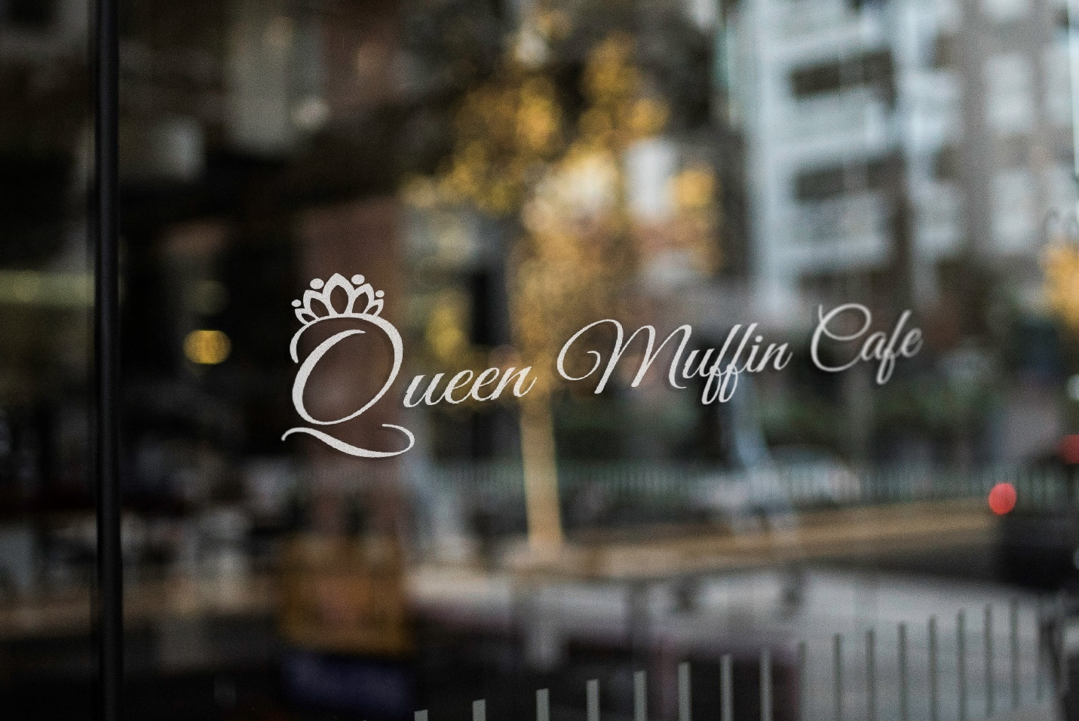Photo made by: Marisa de Almeida

TABLE OF CONTENTS
Cover letter …………………………………………………………………………5
Executive Summary ……………………………………………………………….6
- Description of product and services …………………………………6
- Summary of objectives ………………………………………………..6
- Description of the market ……………………………………………..7
- Justification for viability (comparing with competition) …………….7-8
- Growth Potential ……………………………………………………….8
- Funding Requirement ……………………………………………........8
- Operations ………………………………………………………….......8-10
- Technology …………………………………………………………….10
Profiling ……………………………………………………………………………..11
- Our skills and experience …………………………………………………….11-13
- Business description and History ……………………………………………13-14
2.1 Business and objectives ………………………………………………….14
- Business Structure …………………………………………………………….15

Marketing and marketing Strategy …………………………………………..16
- Products and Services ………………………………………………………..16-17

- Market Analysis and Needs …………………………………………………..17
5.1 Target Customers …………………………………………………………17-18
5.2 Market and competitors …………………………………………………..18-19
5.3 Competitors Analysis ……………………………………………………..19-21
5.4 Marketing and sales plans ……………………………………………….21
5.5 Promoting the business …………………………………………………..21-22
  - Promotional key activities …………………………………………………22
6. Operations and management ………………………………………………….23
6.1 Importance of operation management …………………………………..23
6.2 Premises …………………………………………………………………….24
6.3 Staff and management …………………………………………………….25-26
6.4 Suppliers …………………………………………………………………….27
6.5 Legal requirements …………………………………………………………29
6.5.1 License …………………………………………………………………….29
6.5.1 Insurance ………………………………………………………………….30
7. Technology Plan …………………………………………………………………30-32
8. Management and Organization ………………………………………………..33
9. Social Responsibility and sustainability ……………………………………….34
10. Financial plan …………………………………………………………………..35
10.1 Importance of the financial plan ………………………………………35
10.2 Sources of Finance …………………………………………………….35
10.3 Startup costs ……………………………………………………………36
10.4 Personal Survival Budget ……………………………………………..37
10.5 Cash flow statement and sales forecast …………………………….37/38
10.6 Balance sheet …………………………………………………………..39
10.7 Business ratio/ break even analysis ………………………………….40

Conclusion ……………………………………………………………………….41
References ……………………………………………………………………….42-45
Appendix (PowerPoint Presentation) ………………………………………… 46-56

(Student 1)
COVER LETTER

Dear Mr. Davies
Address: Canary Warf
Email: Queenmuffincafe.hotmail.co.uk

Dear Mr. Davies
We are writing this letter regarding our willing to open a business. We are a group of friends with many years of labor in hospitality carrying many skills obtained during this time where we would like to use in our own favor to create our financial freedom.
Part of this skills is related with food industry – coffee shops and restaurants – management and finance knowledge. Our group has training and awareness in baking, as baristas, accounting, operations and IT. Moreover, our group analyzed individual skills and came up with the idea of combine skills to open a Coffee Shop where we intent to start our finance independence and do what really gives us pleasure which is serve fresh cakes, products and coffee with high quality and sympathy.
We are convinced that our project will be very successful, and we are convinced as well of the reliability of the team which skills can be beneficial for us as will be for many customers that we will serve. We would like to be interviewed regarding our business where we could explain our business plan. Thank you for your consideration.
We are looking forward to hearing from you.
The team that makes the difference,
Yours Sincerely,

Irina Fernandes, Elsa Almeida, Camelia Melente, Muhammad Jawad, Aikatarini Mitrousi

Student 1
EXECUTIVE SUMMARY

- Description of product and services:
The consume of coffee is growing around the world and UK in not exception (Cerb, 2018) says that the consuming of coffee grows each year more.
Canary Warf considered a luxury area is well known for the large range of Companies operating in that area. Moreover, everyday Canary Warf is crossed and invaded by thousands of people that choose it to work or for a walk. All these facts make Canary Warf a suitable place to open a business especially Coffee shops. Our coffee shop project called Queen Muffin Café was inspired on the fact that England still have a Queen who represents very well the Country and the consume of Muffins in the country along with the necessity in market of having homemade products available for all type of consumers.
We are committed to offer a high quality of products in a competitive price. The products will be composed by drinks; pastries; homemade sandwiches, cakes and muffins. The drinks will be a variety of coffee-based drinks and tea-based drinks; as well drinks such as soft drinks, fresh orange juice, smoothies and milkshakes. Other products available will be a variety of sandwiches suitable for vegetarians and vegans too; croissants, sliced cakes and muffins homemade and baked daily. The customer service that we pretend to provide was thought as approachable, friendly, helpful and quick; where must have the combination of sympathy and efficiency on the service offered. The options of consuming of the products are in-store, as take-away or can be delivered in a certain range of distance.

- Summary of objectives:
It is pretended with this project:
- Meet the needs and preferences of the clients to grow the customers satisfaction in our business,
- Make the necessary modification of or in the products and services in order to increase the customer satisfaction.
- Create finance independence to the partners in the business by employing all members of the partnership,
- Increase the margin of the profit by enlarging the clients list and reducing expenses in all areas of the business where is possible.

- Description of the market:

The coffee shop will be located in Canary Warf a luxury area that is more visited by tourist and workers because of the numerous offices and other commerce located in the area as well as for a small and privileged group of residents.
Also, it has a large number of station of trains and a well-connected line of buses going and crossing the area where will be implemented the business.
This district in 2016 had 55 million of passengers travelling through the underground station and around 40,000 passengers travelling through the DLRs stations (CW traffic). Also accommodated 120,000 worker and 40,000 travellers every day in 2019 (Borough profile, 2018). For all this reason Elisabeth Line that will cross Canary Warf was the choice made to open the business.

The target market of our business are coffee lovers and coffee drinkers. Also, population that take breakfast outdoors and people that like homemade cakes and muffins. Moreover, our target are people that like to grab their goods quickly but at same time people that like to seat to have their goods calmly; or because they are having a break from work or because their want a break after a good walk, like per example the tourists. Our future customers can be as well people that want to have a quick lunch composed by simple and quick meals. And to finalize, people that are crossing to take others transports and would like to have coffee or something fast to take with them along the journey.

- Justification for viability (comparing with competition)
Queen Muffin Café identified two potential competitors which are Pret a Manger and Paul Baker. Those two shops provide fresh and homemade goods just as we will do, however, we will invest on healthier, fresher and diversified products suitable for vegan and vegetarians too. It is described above our SWOT analyses about the business that we pretend to open, and the competitors found:
- Straights: Our business will be an innovation in the area because will join quality and low price in order to be affordable, the creation of webpages to impart our business and our take-away service.

- Weakness: The concept of homemade and fresh sandwiches made almost at the order time is quite new in the market. The lack of technology resources is expected to be improved with the implementation of new sources of marketing and sell strategies.

- Opportunities: The new brand has potential to develop and make profit which increases the employment opportunities. Also, potential to expand created by the growth of the profit.

- Treats: Unexpected economic changes can increase the price of the products from the supplier. Other treat can be the competition or disagreements between partners.

- Growth Potential
First year is not expected growth in the business but is expected profit during the last semester. This period will be used to stablish properly the roles in the team, analyses methods and suppliers as well as build up number of clients. Also, generate wages for the team. According with our financial projection is expected that the business grows through the year and reach an annual profit of £121,414.
After one year is expected that the business starts to have cash flow to cover expenses, wages and net profit to share with all co-founders. Furthermore, other objective is the improvement of customer service, marketing and technologies to reach new potential customers.
Three to five years should be enough to have our own clientele and we should be able to start to expand the business by opening new brands in other areas.

- Funding Requirement:
The capital to start a business is £125,000 and will be sponsored in equal parts of £25,000 each by all 5 partners involved, flowing from individual savings. Then, if in the future we need a funding, we will submit a proposal to Loan to Government Funding Circle. Initially, £34,300 will be spent on chairs and table to make seated places, on equipment and Ikea essential material to serve the products to the customer. Part of the money will be spent on bill as the first rents, utilities bills; as well as in insurances, licenses and permits. Moreover, after first month if is no profit coming in, will be useful to pay staff’s wages.

- Operations:
Bellow we have the information of legal requirements as licenses and permits needed to open the store, plus run the business smoothly and successfully:
- Food Business registration. We must apply 28 days before the opening at the local Authority that the Business belong.
- Food hygiene rating scheme (FHRS)
- Licence for playing playback music
- Health and safety Legislation
- Fire safety legislation
- Register with HMRC
- Food Hygiene certificate
- Risk assessment
- Pest control
- Class A1 licence
Apart of legal requirements, it was contracted the necessary insurances to cover the expenses if accidents happen:
- Product liability
- Premises Insurance
- Stock insurance:

The coffee and key equipment’s will be supplied by Lavazza Rosa Coffee; water, soft drinks cleaning material by L.C.Supplies and milk by Freshways/dairypouch.

The tasks and roles within the business will be divided for the 5 partners because in the beginning is not intended hire staff.
Aikatarini Mitrosi will be responsible to supervise stocks, the conservation of the store and equipment’s, look after files making sure that the legal regulations is followed and make sure that the store achieve maximum potential of activity.
Irina Peixoto Fernande’s role in the business is centralized on executive part where the supervision of daily activity in-store will be made in order to generate new plans of action to develop the business and as consequence grow the profit. She will help manage financial department on areas such as financial projects and budgets for the next 3 to 5 years and organization of filing business information.
Elsa Almeida will take care of marketing department as responsible of advertising and social media points as well as on the design of new marketing plans and ideas to promote the business. Elsa is also responsible for the homemade products’ recipes.

Muhammad Jawad will be responsible for the technological demands of the business around social media websites thought to reach more people. Additionally, Jawad will be responsible of the recruitment and training of new employee.

Camelia Melente will be responsible for the administration of reports, financial business targets, matters related with budgeting, payrolls and the control of the cash flowing in and out the business.

Moreover, to complement each partner roll, we have a group of daily tasks that will be executed by all members of the team which are: serve customers, re-stocking, baking, stock take, daily shopping, etc.

- TECHNOLOGY:

Technology part fits the purpose of running the business, solve problems quickly and trade what it is offered in store through technological tools. Moreover, the technology plan will stablish platforms to perform tasks, to create finance control, take care of details such as WIFI and music system, to provide the perfect environment for our customers. In preparation for the opening of the store, some services and software have to be purchased and installed to create the necessary technological conditions to be easier deal with daily operations.
It was identified a couple of tools very convenient and practical for our business, which are:
- Merchant processor provide customers several options of payment;
- Inventory Software give the possibility of tracking, revising and place the order achieving maximum productivity with minimum wasted effort or expense.
- Point of sale facilitate customers to place orders, the tracking of the amount of sales and the customers preferences because POS store data.
- Online orders give the possibility to place orders online reducing the waiting time in the store.
- WIFI is very appreciated by customer because they use to access through mobile phone or laptop everything that they need or want while they are in the store.
- Website is built as marketing strategy, providing to the customers all the information about the business-like open hours, location, services and menus available.
- Social Media reaches lots of people every day, being that way more easy to introduce the business to the public.
- Online review: Controlling the reviews of our customers give the change to understand which areas of the business are important to improve and it gives an indirect but positive message for potential customers.
- Software help to control of the transactions done in the store’s account.
- Cloud storage: will helps us save in money, time and paper as is easier to access and go through records and information needed. Also, can be used to store the music played in the store.
Technologies update is crucial for the development of the business in order to grow and most importantly in order to be competitive in the market.

(Student 1,2,3,4,5)
PROFILING

- Our skills and experience:

Irina Fernandes (Student 1)
My experience related with coffee is extensive. I worked more than 10 years in coffee--shops and restaurants as barista, waitress and in further position in particular team leader/manager. My duties were preparing and serve variety of coffees drinks, sandwiches, pastries, natural juices along with other products in a empathic and understanding way. Thus, my customer service was very praised by my managers and customers because of my sympathy and friendly service. Moreover, I have experience in financial audit from a previous job in a Shopping Centre where I was team leader responsible for rotas and final reports to be presented in meetings. Furthermore, I have 15 years of management experience from 4 previous jobs where I was given management duties and positions. Nevertheless, I served as Economic Buyer in which I was responsible for weekly purchases for the restaurant I was working for.
In Tesco I received health and safety, cash office and tills training to be able to deal with self-service machines technical issues, running reports and moving in and out money from them and other tasks related with cash machines. In addition, I took part of stocktake a couple of times while I was employed in Tesco. The qualification achieved in England are GCSE in English and Maths, Level 2 in IT course, plus The Certificate of Academic and Employability Skills that complement the experience in management, business and team-working, gained in workplace.
I bring to the business transferable skills such organization skills, adaptability and time management that will help me on my role into the business. Moreover, I have qualities such as resiliency, punctuality, problem spotter and solving that I believe bring positive advantage to the groupwork along with all work experience mentioned above.
The lack of knowledge in baking will be addressed by planning some session of training with my other partners in the business.
My role in the business is centralized on executive part. I will supervise daily activity in-store to create new plans of action in order to develop the business and as consequence grow the profit. I will also help manage financial department on areas such as financial projects and budgets for the next 3 to 5 years and organization of filing business information.
Elsa Almeida (Student 2)
My name is Elsa Almeida, and I was in a completely different area of employment before I moved to London. I was the owner and Manager of a Beauty salon, doing everything related to the business, even the accountancy of the business. I speak several languages. For the last 5 years I have been working in Pret a Manger, 4 years as a Barista, having obtained an ICQ Level 2 Barista Skills diploma and for 1 year as Team Leader, having obtained an ICQ Level 3 Leader Skills diploma, I was performing hot chef duties as well, so I have all the necessary skills to handle the hot food in our business, like baking the croissants and baking the cakes and muffins. I have an Emergency First Aid at Work Certificate. All this experience that I have acquired in the last 5 years will be very helpful towards running the business. I have excellent customer, which will be a bonus. I have a passion for decorating cakes, this skill will be applicable to what we intent to do with the cakes we intent to sell. I am always open to do any further training so I can thrive in perfecting any performance within the business.

Aikaterini Mitrousi (Student 3)
I am a driven person who works hard to achieve her goals. Together with my skills will play important role in the business, as I have very good organization skills, communication skills, and leadership skills. My experience in hospitality is over 15 years, when my first job was to work as a barista, serving customers and making coffee. My next job that bring the most experience relevant to our business it was a restaurant manager when I worked for 10 years. My duties there were to hire new stuff or fire the existing one due to performance. Creating weekly rota. Making the weekly report, where I had to send to the head office by analyzing our staff and manager performance, customer satisfaction, budgeting and the weekly forecast. Organizing and managing shift were an everyday duty, Ordering, communication with other stores for stock transfer. Manage wastage, by checking daily sales, for proportioning.
Managing the customer satisfaction and complains, motivating the staff to follow the standards policy of the food, and creating a great atmosphere in the restaurant. I was voted 3 times manager of the year, due to my contribution in the business.
My qualification regardless to our business are connected ,as I have a level 2 customer service certificate ,Business administration bachelor from Greece ,level 2 on It and a certificate on Skills for the workplace, And I attend to follow a quick 3 weeks training on how to run a business .

Muhammad Jawad (Student 4)
I’m from Pakistan I have done intermediate ( i-com) from my home country, In London I have done some English courses from Merton college ,then my level 4 course I started butt I dropped out because I cannot afford fees, and start working full time, I have 2 year work experience in local off license shop for two years, I have a lot of experience with retail , after off license shop I have worked in B&Q for 8 months I have worked in Argos night deliveries assistant for 3 years and I was a store manager in Tesco for 2 and half years other than that I have a security line experience as well, for this I have done a course for door supervisor from a private college to get my door supervisor license, I worked as security guard 1 year different offices retail, construction site, and clubs as a bouncer, then I open my own security agency called k4s Security. With one contract, Now I’m doing sub-contracting for different companies and I have about 80 contracts and four direct contracts, I have 860 employees working for me every day ,I’m doing this business from four years now, because of my business nature I have done some extra courses with private college I have done health and safety course I have done fire marshal course, with all my life experiences I have improved my a lot of skills , with my experiences I have improved most communication, and managing, skills.

Camelia Roata ( Melente) ( Student 5)

- waitress for 1 year / barista for 10 years / bar manager for 4 years / sales assistant for 2 years / human resources for 2 years
During the last 12 years she had developed many skills thank to the jobs above. However, she worked in the retail camp for long time, managing the Coffee Shop and hiring staff. furthermore, she uses to manage also the incomes and outcomes of the Coffee Shop from invoices and after presenting to the local accountant. Now she is working as Sales Assistant, managing orders and sales.

- Business Description and History
(Student 5)
The Queen Muffin Café which is situated in Canary Warf, will be the coffee shop for people who came and go with the jubilee line or district line and for the one who are established in the zone, proving the higher quality of our Lavazza Coffee and the products to the customers to a reasonable price and not just that. We are are going to put love and respect in what we are doing, providing happiness to anyone who had choose us.
As we have many competitors, we decide to introduce our products (home-made) such us cakes and muffins, in order to increase our sells , being long term objectives and provide services such as delivery for fixed customers which works into the over ground and around it. Therefore, we will do meetings weekly in order to discuss the growth of the company and the strategy to apply each month to can manage the competition.
Our prices and home-made products are 2 of our strengths and the fact that most of us has experience in the camp give us advantage to manage risks. We are focused just in long term objectives as we strongly believe that this business is going to grow very fast.
Thus, the Queen Muffin Café is going to be a complete success in the open market with wide range of products and hot drinks.

  - Business and objectives: (Student 1)

- Describe the business outlining the different products and services:

-Short Term: It will be sold a variety of coffees, teas, drinks based in coffee and tea as well as soft drinks and water. Also, will be available homemade muffins and cakes, sandwiches and croissants that can be filled with a many ingredients.
The services offered will be in-store and will be possible place orders by telephone or Facebook complemented with the possibility of being delivered which will depend the distance.

-Medium Term: Understand and change the menu accordingly with customers preferences and implement new online services such as the software that allow customers place orders from any device.

-Long Term: Introduce new products to the menu and upgrade all services available at the store. The store location can be moved to a bigger facility that hosts more customers.

- Business Structure
(Student 2)

As our business Queen Muffin Café will be an equal partnership, the roles will be equally divided between the 5 partners. Even though each one will have a different role in the business, all the members will be serving customers, making coffee and helping with the daily duties, like the shopping, the restoking of the necessary products on display, the banking at the end of the day, the cleaning. Apart from that, each one has his role:
Irina Peixoto Fernandes is the Executive Manager, and as an executive manager she will be implementing policies and the procedures, and establish the budgets; (Careertrend,2020)
Elsa Almeida is the Marketing Manager, and as a marketing manager, she will be analyzing the trends and demands for products and services in the market, overlook the advertising in the business;(Careertrend,2020)
Aikatarini Motrousi is the Operations Manager, and as operations manager she will be analyzing ad improve the process of the quality and productivity;(Careertrend,2020)
Muhammad Jawad is the Technology Manager, as technology manager he will be responsible to implement and maintain the technology infrastructure;(Careertrend,2020)
Camelia Melente will be the Financial Manager, and as the financial manager she will be responsible for the financial report, investment, and developing long-term financial goals. (Careertrend,2020)

Student 2
Marketing and marketing strategy

- Products and Services
Our coffee shop will be offering coffee, tea, cold drinks. It will also be selling homemade pastries and sandwiches prepared freshly at the time according to the customer’s choice, the customers will benefit from eating a homemade away from home kind of breakfast, lunch or just an afternoon treat.
The prices we offer will be competitive with our competitors and offer our regular customers with loyalty rewards.
We will be buying most of the vegetable that we use for our sandwiches freshly from local markets. At the beginning we will get our supplies from a cash and carry.
1.DRINKS:
Coffee (Expresso/ Latte/ Cappuccino/ Flat White/ Americano’s)
Cold Coffee drinks
Variety of teas
Cold tea drinks
Soft drinks
Fresh orange juice (squeezed on request)
Smoothies
Milkshakes
2.PASTRIES:
Croissants (that will be bought from suppliers, but baked in the shop)
Homemade muffins (freshly baked every day in the shop)
Homemade cakes (freshly baked every day in the shop)
3.SANDWICHES: A variety of sandwiches made with the ingredients that the customer chooses from and made when ordered (including vegetarian or vegan options)

We will be offering counter (take away), table (eat in) and delivery within a certain radius.

- Marketing Analysis and Needs

5.1 Target customers:
The area where we pretend to open the coffee shop is in Canary Warf, near the new Elisabeth Line station, Canary Warf is mainly an office area, so we pretend to serve the customers that come for their morning coffee, breakfast, lunch or and an afternoon snack. Our pretend target customers are the working office people. The main customer profile will be office workers from the surrounding area, probably aged between 22 and 60,(Towerhamlets2020) and these are the kind of people that normally all drink coffee during the day, because coffee normally keeps the working class awake, during long office hours, maybe some tourist that visit Canary Warf and maybe some of the residents, even though there aren’t many residential buildings at the moment, Canary Warf is expanding as a residential area too.
Canary Warf is the second central business district of London, they estimate that Canary Warf has a daily 120 000 working population, but is will be higher but the end of 2020. The estimation for the Elisabeth Line in Canary Warf is of 68 000 per day. (Crossrail, 2020)
We aim to serve these customers needs by providing them with a better quality coffee than our competitors, we will have freshly made pastries like croissants, homemade muffins and cakes, variety of hot and cold drinks, freshly pressed orange juice and freshly made on demand sandwiches with the ingredients the customer chooses, with vegan and vegetarian options.
We want to be perceived as a coffee shop that has a superior quality of daily fresh made food, thinking about the needs of our customers. We will excel where our competitors fail. Providing amazing customer service and creating an enjoyable atmosphere in our shop is.
Our pricing will be just a little bit below the average market prices, so that we can attract more customers, knowing that we have quite a lot of competitors around in that area.

Product per unit | Our price | Range of competitor price
Expresso | £ 1.50 | £ 1.75
Latte/ Cappuccino | £ 2.50 | £ 2.65
Flat White | £ 2.50 | £ 2.65
Black/ White Americano | £ 1.75 | £ 2.20
Teas | £ 1.50 | £ 2.10
Pastries | £ 1.20 /£ 1.50 | £ 1.75
Sandwiches | £ 2.50 /£ 3.50 | £ 4.00 or more
Can drinks | £ 1.20 | £ 1.20
Bottle drinks | £ 1.50 | £ 2.00
Water | £ 1.00 | £ 1.20
Fresh Orange juice | £ 2.00 | £ -

The reason for the difference in price is, so that we can be more competitive. A customer that eats out every day, will obviously prefer to go to a cheaper place, and if the quality of the food is better, it is guaranteed that they will come back after their first visit.
And looking at the prices of our competitors, most of the prices they charge is overpriced compared to the quality of what they have to offer

5.2 Market and competitors

The area where we pretend to open the coffee shop is in the retail area of Canary Warf Elisabeth Line Station, Canary Warf is mainly a financial office area, there is around 1,500,000 square meters of office and retail space in Canary Warf. (Home-Canary Wharf Group, 2020)
I have visited the area where we pretend to open the coffee shop, and knowing that it is mainly a business area and that many people eating in the cafes and restaurants, especially at breakfast and or lunchtime, I thought that an innovated concept of homemade pastries and freshly made sandwiches on request, would be a great and rentable idea. Especially if the prices are reasonable.
After visiting the area where we pretend to open our shop, I conducted an online research, about the other coffee shops in the immediate surroundings and I found that there are two coffee shops that can be our main competitors, Pret a Manger and Paul Bakery, I read all about what kind of reviews they had and believe that we can surpass in terms of quality what they are offering.
I know both the competitors, because I have visited them on regular basis before and believe that we have something completely different to offer, especially healthier and fresher.

5.3 Competitor Analysis

Even though there is a vast variety of coffee shops in the area, like Notes Coffee Roasters, Caffe Nero, 640East, Black Sheep Coffee, Taylor St., Café Brera, Paul Bakery Canary Warf, Costa Coffee, Le Pain Quotidien, Neama Café, Ole & Steen, Pret a Manger, Taylor St. Baristas London, just to name a few.
We think that our main competitors will be Pret a Manger and Paul Bakery, both are like our pretend concept, but not identical, to our coffee shop. Pret a Manger is definitely a household name and has been around for 36 years, they have an extensive variety of products, both for breakfast, lunch and for the rest of the day. Pret a Manger became a British pride. They have many loyal customers. Their sandwiches and salads are extremely elaborated but contain too much ingredients, which can lead to certain people having allergy’s. (Pret,2020)
Paul Bakery opened its first shop in London 20 years ago. They have their own bakery that distributes homemade bread freshly every day to their shops. They have a vast variety of pastries, cakes and filled croissants, they have premade sandwiches with various ingredients. (PAUL Bakery,2020)

Competitor 1 – Pret a Manger

Competitor 2 – Paul Bakery

Queen Muffin Cafe

5.4 Marketing and sales plan

Using promotion activities is a cheaper way of promoting the business and achieving profit. Offering free wi-fi in the shop is a good way of attracting customers. Creating attractive drinks, that catches the eye is always appalling. Getting to know your customers and providing a good customer service is of extreme importance for the business. Creating loyalty cards, giving random free coffees to customers, who doesn’t love freebies. Having suppliers marketing material is also a good marketing strategy, some suppliers give you their brands coffee cups for eat in for example, that is a way customer’s know what brand of coffee they are drinking. Very important is the layout of the coffee shop, the more attractive it looks, the better atmosphere you can create, the better customers are going to feel inside the shop. Having branded take away cups, is another form of marketing the shop, it is a free method of advertising our brand.

5.5 Promoting the business
Website information - Creating a website to promote our coffee shop, where all the information related to the coffee shop will be available, like an explained to detail of the menu, our prices, and the type of services that will be available in the shop, new products that we will be having in future
Advertising online – As a way of marketing our coffee shop with promotional messages for our customers, advertising promotions that we might have
Search engine marketing - (internet marketing) where you pay for your adverts to appear in search enquiries, search engines like google for example
(What is a search engine marketing or SEM? Definition and examples,2020
Social media – Creating a profile for our coffee shop on social media, is a great way of becoming known to the public, like creating a Facebook page, an Instagram page, Twitter account, where we can update daily, upload pictures of our products as a way to promote our business and let the customers know about our specialties or daily promotions
Leaflets – We will print out some flyer’s introducing the coffee shop and hand them out around the stations in Canary Warf, this way we let the commuters know that a new coffee shop is opening in the area, even though many of them will probably trough them away immediately, there will always be some people that will be curious to try out a new place, leave some flyer’s in some of the retail shops in the area.
A-board – Using a A-board by the coffee shop entrance is always a good way to draw attention and most of the time it triggers people’s curiosity.

5.6 Main promotion activities

Student 3

Operations and management

Why is the operation and proper management very important within a company?

Operation and management are responsible for the actions that transmute inputs products and services that will add more importance to the customers. Operation manager must build regulations in the proper management of materials, technology and labour to create the best products and services which will bring profit to the company. Operation manager are responsible for looking after the daily development of the business. (Kanya, 2019).

Importance of operation management

Operation management is the administration of the operational process in the company in where they establish the highest level of productivity.

Operation management convert materials and labour into good and services

Operation management is responsible for balancing the cost with revenue for greater profit.

Understanding the trend and customer needs, they are responsible for attracting providers who can give the best prices and have the potential to produce the product according to the business need.
Delivery of goods to customers, by managing the ordering in the correct timing and customers satisfaction about the business product.
Operation management set up new systems while assessing currents procedures. organization and efficiency are two key elements which need flexibility and creativity. (Kenton, 2019)

If we would like to make the operation management in a template for our coffee shop it will be by using the right product with the right employees to give the right and the best, quality service to our customers and keep a long term relationship with their suppliers .
.Author

Premises/Location and Justification

Researches has shown that 79% of British people bought a hot drink in a coffee shop in 2017, while in the coming years sales will be reach £3.7 billion in the coffee shop industry. Italian coffees are still in the top list in the UK. (Mintel, 2018).
The first thought of choosing the location was a busy environment although it was the risk of the very high rent that we would have to pay. We believe that our business will be successful that why we choose, one of the busiest tube stations. The location of our shop will be in Canary Wharf. With a yearly 1.3 billion footfalls of passengers across the network in the wester Concourse which connects Canada place and jubilee place malls. The area it is a famous destination for shopping. According to Wikipedia around 105.000 people working in canary wharf, in some of the biggest banks and other organizations, the aim of our location is to approach and have a good relationship with the busiest location for opening a coffee shop.
The shops are a big opportunity to capture trade from the super high footfall through the station all year. Rent will depend on the turnover of the business if it is going to be higher than the rent, we will have to pay a monthly percentage of the turnover. The retail premises are available on a 5-year lease. (Tfl, 2020).

Staff and management

At the time being we will not hire any staff. According to our hospitality experience that we all have in London and it is more than 5 years with Managerial position and extra qualifications in accounting ,business administration and ,some level 4 courses on business we cover all the position that a coffee shop need ,with a professional manner. We created the chart according to our experience, where we can efficiently work on that part.

Author

Key Responsibilities of the staff regarding their experience in hospitality

Aikaterini Mitrousi,
- Stock management
- Effective operation of the coffee shop
- Updating all the files, through the legal regulations that are required in the business.
- Maintenance of the shop and equipment

Irina Peixoto Fernandes.
- Ideas of how we could make more profit
- Create new strategies for the coffee shop
- Supervise day-day activities
- Supervise financial operation

Elsa Almeida.
- Managing the marketing and advertising of the business
- Update on social media products offers, and pictures of our products
- Creating loyalty cards, discounts
- Designing new Marketing ideas for the benefit of our business
- Promotions
- Responsible for Muffin recipes

Muhhamad Jawad.
- Founding’s (Bank)
- Establish the needs of the business
- Responsible for hiring and training new staff (for the future)
- Improving online marketing

Camelia Melente
- Create daily reports
- Analyse the business targets
- Controlling cash flow
- Managing the budget
- Accounting services, payroll

We will bring in our business the experience that we have on running a business, Leadership skills, and the best knowledge of how to make the customers satisfied with your product. With our working experience all of us have organizational skills, analytical skills, keen of detail, knowledge of the product and the market .Our desire and passion for this shop to success will take out of us more skills and the hard work that we all have to do to make profit.

Suppliers

The Lavazza Rosa Coffee is an Italian trademark, with unique aroma ,well rounded and made of Brazilian arabica and Robusta Africans, it is situated in the city of Turin from1895, which provides coffee and all the necessary equipment that you need for your coffee shop, with just the purchase of the coffee, everything paid monthly adding 10% on the invoice of your purchase .After one year of usage they give you a 10% discount on coffee, this mean that as long as you are using the brand the equipment are free of use. (lavazza, 2020)
We choose Lavazza as first choice for the quality that the coffee has, it is a well-known and respected brand. We Believe that one of the most important approach to our business is the taste of coffee and Lavazza will give the best for our customers

Fresh ways/dairy pouch After a lot of researches about the milk supply in our coffee shop and talking to local cafes about their milk supplier we decide the Fresh way brand, it is very good quality and in a low price. One of the biggest independent companies in the country, and all their milk comes from cows in UK. (Freshways, 2020).

To avoid the food wastage we decided to do the rest of the shopping ,that we would need to cook our cupcakes and make our sandwiches, at cash and carry (Metro), when our sales will come to an appropriate level we will consider to have a supplier who will deliver the product that we will need to us.
Regardless to our suppliers we would like our food to come in the right temperature and not damaged, we would like to have a strong relationship with our suppliers as the business success depend on their products, for that reason we choose the best suppliers and we will buy the fresh vegetables and good quality .

Water Filters it is as much important as the taste of coffee, filters help water to have the right balance of minerals no chlorine and a balanced ph. Helping the equipment the work better as reducing the minerals, there is no limescale (Aquacure, 2020)
With our main suppliers we will have a traceability which will contain rules ,that we are getting the right food and we track all the delivery history ,invoices and can make withdraws in case the food it’s not in high standards. (Rouse, 2016)

Equipment

Equipment |  | Price
Display fridges |  | £2,164.00 / monthly payment of £ 30  £ 400 upfront
Ice machine |  | £462.00
Dishwasher and glasswasher |  | £1,078.80 / monthly payment of £ 24  £ 120 upfront
Freezers |  | £358.00
Blenders |  | £310.80
Display case |  | £480
Dough mixer |  | £1,138.80 / monthly payment of £ 20  £ 130 upfront
 | Heated display | £298.80
 | Oven | £1,438.80 / monthly payment of £ 25  £ 150 upfront
 | Water Boiler | £274.80
 | Orange juice Machine | £349.99
 | Café epos system | £349
Author

Extra Essential that we will need for our coffee shop we will buy from Ikea.
The prices are cheap and the design that they have it suits more the decoration of our coffee shop. (Ikea, 2020).
Latte cups pack of 12 | £12
Teapot pack of 4 | £24
Mugs pack of 12 | £12
Espresso cup set of 12 | £21
Teacup set of 12 | £33
Cutlery 48 pieces | £20
Author

Furniture

Table 6 | £431.4
Chairs 20 | £898
Stool 2 | £55.8
Author

Legal requirements

We are going to run a General partnership; we all are contributing the same amount of money to set up the business and will be responsible for the debs and the running of the business.
I would like to mention all the legal requirement that we will need to get before opening our coffee shop and during the opening (Gov.Uk, 2020)
- Food Business registration. We must apply 28 days before the opening at the local Authority that the Business belong.
- Food hygiene rating scheme (FHRS)
- Licence for playing playback music
- Health and safety Legislation
- Fire safety legislation
- Register with HMRC
- Food Hygiene certificate
- Risk assessment
- Pest control
- Class A1 licence

Insurance

It is very important and one of the most important legal requirements to have an insurance for your business. Depends on the budget that you want to spend you can choose you what do you want to cover. A restaurant will benefit if it has a cover of public liability Insurance, product liability insurance, premises insurance and stock insurance. Best on customers reviews and the lowest price we choose Lloyds Bank as our insurance company. (Lloyds, 2020).

Student 4

- TECHNOLOGY PLAN

TECHNOLOGY PLAN: -
Technology allows organizations to improve their performance overall effectiveness of products, with the help of technology you can expand your business and avoid different kind of human error, Now a days in every business people are using more technology, such as machines and tools to solve problems. Some of technologies we can use in coffee shop to expand our business and solve problem. Having the right technology is an important part of running efficient business, here are some solution that can help you best manage your coffee shop. (Baylor University)
I am describing some technologies which can be useful in business below taken from (TECHNOLOGY GUIDE FOR COFFEE SHOPS & CAFÉ).

MERCHANT PROCESSOR: -
Now a days everyone is using different methods to pay, if we have more payment option’s rather than only cash or debit card we can get more customers, because some customers like to carry only cash some like to carry card or some customers pay by phone, if we don’t have flexibility payment options we can lose this customers, merchant processor can be used to charge any major credit or debit cards and you can also process apple pay which is biggest payment type now a days.

INVENTORY SOFTWARE: -
With the help of this software you can track your stock and easily and place your orders with vendors, with this technology in your business you can avoid so many errors like extra orders , you can track your most selling item and order again instead of returning a customer’s with bad impression that you have run out of stock with your menu item.

POINT OF SALE: -
With the help of this technology you can easily select menu items and customer orders, this system makes easy to delivered the order to customer, in quick and easy way its easy for customers as well to collect menu items straight away, Another huge benefit of (POS) POINT OF SALE is that its collect data, so you can track your sales as well in this whenever you want.

ONLINE ORDERING: -
Online ordering is another way to improve our sales, in this coffee shop we are doing online order for fix customers who are working on rail station and have limited time breaks to they can order before and collect it to save their time and improve our sale.

WI-FI: -
In coffee shop good wi-fi is very important, because most of people they like to work on their computer or check their emails or some other different things which required internet connection while they are having coffee or tea, and these days not so many people use portable wi-fi they like to chose that shop which have a wi-fi, with this you can attract young people as well as now a days we have a social media trend everyone on different kind of social media and most people need wi-fi. Specially on train station where people have a signal problem as well, so they buy coffee to get access to wi-fi.

WEBSITE: -
Websites make things easy for customers, to check menu’s your location your opening and closing hours, and important information about your coffee shop, with the right website you can attract more customers, you can also use your website as a showcase, which makes your coffee shop unique.

SOCIAL MEDIA: -
Instead of website social media is a big platform now a days to expand the business if you have active social media accounts and people can see your activities and new products pictures which attracts customers.

ONLINE REVIEWS: -
Now a days people check online reviews about that place what kind of place is this, environment of place, food quality all shows in customers review, don’t be shy to ask customers for reviews, if your service was good it’s a good opportunity to get good review butt don’t give people different offers to make a good review this way you get reviews in unnatural way and its all contain same statement and same day which can be easily identified and not good reputation.

ACCOUNTING SOFTWARE: -
It is very important for successful business to track and manage finance, with this technology you can process accounting transactions within functional modules like accounts payable accounts receivable, ledger etc. you can also connect this to your online banking, so you can keep you records always up to date, now a days its so many software like fresh books , quick books etc. you can find cheapest one as well now a days and with help of this software we can save a lot of time making accounts

PAYROOL SOFTWARE: -
With the help of this software we can manage all employees’ hours, weekly or monthly bases this software count employee pay by its record automatically, it also used to manage records of any kind of employee’s benefits.

BILL PAYMENT SOFTWARE: -
In business employers can forgot bills due date and pay which can cause a different kind of problem, With the help of this software you can always stay on top of your bills and it’s a big part of maintaining a healthy cashflow, this software monitor for you all kind of your due bill dates and you can pay online,

CLOUD DOCUMENT STORAGE: -
With the help of cloud storage we can go paperless and we can keep all kind of records and it is very easy to access whenever you need, it was very difficult to keep all records bills, receipts, bank statement, they pile up on a desk or get sorted in a filing cabinet where they are quickly forgotten. Another benefit of cloud storage that when your financial documents are available online it helps bookkeeper to update records bills are paid on time etc.

RECIPT APP: -
With the help of this app we can even record a little expense we made just simply putt this detail in app and it will all recorded you can use this app on your phone so you can do it anywhere. You don’t have to be in café or home.

STREAMING MUSIC: -
If you create good atmosphere, you can get more customers and they can sit in your café for long time and ordered more than 1 coffee, with music you can create a good atmosphere and make your customers happy.

- MANAGEMENT AND ORGNIZATION

The process of organizing, planning, leading, and controlling resources within an entity, with the overall aim of achieving its objectives. The organizational management of a business needs to be able to make decisions and resolve issue to be both effective and beneficial (Business dictionary).
Management is a sum total of several activities making plan, setting up organization, giving order and directions motivating the employees coordinating and controlling various functions of the enterprise, With the help of organization the management perform their duties well, efficient management is depended on strong organization.(YOUR ARTICLE LIBRARY)
Management and Organization is very important for any business, it helps team to achieve their maximum goals, people work as a group so they can achieve their target in less time, reduce cost. With this fundamental we can create an environment which helps individuals and their organizations (THE HORSLEY GROUP.LLC)
With our coffee shop for now we are not hiring any worker because we all have experience of working in London and different countries in different fields we all have enough qualifications to start a business and we can handle on this level. Most of our team members are managing shops or managing different stores in retails some of it had business experiences as well, all of team members are studying level 4 course diploma, this is the reasons we all think we can handle our jobs in professional manner in coffee shop , we divided our jobs with our experiences so we can play our role efficiently in coffee shop.

Roles of partners in business: -

MUHAMMAD JAWAD I am dealing with everyday needs of business, also I am working on daily basis to improve our online marketing, and I will be responsible to hire or train new staff but at the moment we are not hiring anyone so I can give attention to other things like founding’s etc.
Aikaterini Mitrousi She is dealing with stock management she ordered and look after all stock also she is dealing with effective operations of coffee shop, updating all files through legal regulations, on daily basis also she is looking after all kind of maintenance of the shop and all equipment’s.
CAMELIA MELENTE She is handling most of accounts work like cash flow, Accounting services, payroll, wages, managing the budget, also she analyses our business targets and she make daily reports.

IRINA PEIXOTO FERNANDES She is supervising financial operations, day to day activities in shop, new strategies for coffee shop to make it better and new ideas on daily basis to improve profit.
ELSA ALMEIDA She is promoting business on social media our recipes products offer, she also does marketing advertisement, creating loyalty cards, discounts, she also design new ideas of marketing to get more customers and increase profit, she also responsible for muffin recipes.

- SOCIAL RESPONSIBILITY & SUSTAINABILITY

Social responsibility means that act which is beneficial to society and environment now a days it become a very important for investors and consumers who seeks the investment is not for only profit butt also a contribute to the welfare of society and environment. Social responsibility in business known as (CSR) corporate social responsibility. All my team taking part in different type of social responsibilities. And we are maintaining this part in charity work as much as we can, all my coworkers and staff are very helpful and motivated for social responsibilities. (AKHILESH GANTI, 2019)

SUPPORT A CHAIRITY FINANCIALLY: -
We raise a charity for a hospital its called the children’s trust hospital they help children’s who have serious brain injuries they treat them, we always collect charities for them we have a little pots in café with their name logo people putt money in that and after one month a guy come from that hospital to collect this ports with thank you cards. Sometimes we specially raise money for them by telling customers about them and customers contribute in their charities. They hold many functions to raise a charity if its an event we provide a coffee and over café food to them and that’s how more people come to know about our café and this is help us to improve our sales and get more loyal customers.

SPONSER A LOCAL EVENT: -
We help national rail staff when they are holding any charity events on stations to get charities we provide free drinks to passengers on behalf of national rail who is donating this way more people donate and they come to know about our café

STAFF PAID TIME OFF: -
We promote our staff to work as a volunteer in different local schools charity events, we give them paid time off so they can easily do voluntary work, sometimes we provide our staff transport service if its necessary to motivate them to work as a volunteer.

MEMBER OF STAFF CHOSE CHARITY: -
We help our local charities also one by one member of staff chose a charity which is in their local area or they know them to help that charity and get donations for them, this way we can help more people and motivate our staff to work for charities more

Student 5

- Financial plan

  - Importance of a financial plan

This is the most important heading from the business plan, showing how the business will grow. However, the financial plan helps the company in future loans or investors, ensuring balance statements, cash flow and sales forecast for 1-year time or more. This financial plan has been created to show the future of our business by providing all the financial statements to ensure ourselves by researching and calculating the outcomes and possible incomes for 1-year time, that we are going to grow in near future and that this business idea is the best one in the market. Therefore, the financial plan will be presented to an accountant for more accuracy.
According to (Lasher W. and Ph. D, 2010), the financial plan is a set of financial statements which shows the future of the company (Lasher W. and Ph. D, 2010).

  - Sources of finance

As our is a common idea and our calculation for the growth of the business it could go up to more than that we presumed will be, therefore we decide.
The starting budget is £ 125,000. As we are five of us, and all of us having money saved from previous jobs, we are going to use peer to peer borrowing, this money being owned from our previous savings, every one of us having £ 25.000 to invest. The money will be refunded to each person from the company profit, which could be in 2 – 3 years’ time.
However, if will be necessary for a loan, we are going to apply for a loan on Government Funding Circle which can provide us a loan up to £ 150.000 which we are going to repay in 2-3 years’ time, with an interest of 10% APR (Resources | Funding Circle UK., 2017).

  - Start-up costs

The start-up costs are the expenses which the new entrepreneur is going to spend for the launch of the new business idea for settle this in the open market (My Accounting Course, 2019).
Start – up costs expenses total is £ 34.300 for the first month. I establish a list of expenses that the business will need for the first month by estimated costs.

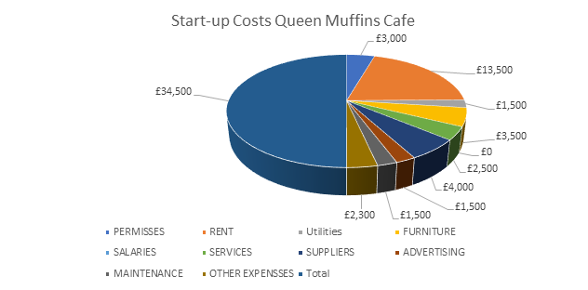
- £ 1.500 will be used for maintenance
- £ 1.500 for advertising (see Marketing and Sales Plan)
- £ 1.500 for the utilities (water, electricity, internet, phone, and council tax)
- £ 2.300 for other expenses such as unforeseeable costs which could not be calculated before starting
- £ 2.500 will be used for the permits and licences, such as Food and Drinks Business Registration, Hot Food and Hot Drinks premises approval, Health and Safety Certificate and Handbook (HCCP), and Liability Insurance.
- £ 2.500 will be used for services, such as Eat in, Take Away, and Delivery
- £ 13.500 for the rent, which is £ 4.500 per month plus 2 months of deposit
- £ 4.500 for furniture (bar counter, chairs, and tables) and equipment (uniforms, microwaves, toaster, undercounter glasswasher, smoothie machine)
- £4000 will be used for suppliers (coffee (glasses, napkins, spoons, coffee grinder and coffee machine are included with the purchase of the coffee), croissants and drinks.
The first month is going to be more expensive because of legal fees and all the expenses requirements that the company need before opening. However, the first month we are not going to take any salaries, that money helping us to go on, with the start of the Queen Muffins Café.

  - Personal survival budget

Managing risks is part of our plan. Thus, are many factors that can affect our business, most of them being external factors, natural or political and we are aware of this, starting with Brexit which would happen on 1 January 2021. Thus, we are VAT registered company, which according to Gov.UK., 2020, is of 20%, being paid to HMRC (GOV.UK, 2020).
This is going to affect our budget if no deal will be made with the UE, increasing the costs (VAT) of our supplier of coffee and border taxes. However, the solution that we find for this risk is: if this will happen, we are going to increase the price of our products in order to pay the difference of the costs and to do not affect our profit.
Furthermore, another risk, which seems to be more common, is missing of customers. We are trying to do our best in customer service, products, and price, but this could not be enough for the start of the company for the next 6 months. However, if this would happen, we intend to apply to Funding Circle for Unsecured Business Loan, providing loans up to £150.000 and having the lowest interest rate, of 10% APR (www.fundingcircle.com., 2020).
Moreover, other external factors could be Natural and economic disasters with immediate impact such as Brexit, environmental factors or Geopolitical and environmental changes with long-term impact such as political decisions or war (Harvard Business Review, 2014).
In order to identify those external risk factors, we need to use analytic approaches, and most of them, if they are with immediate impact, we cannot analyse them until is not happening. However, we are aware of this, and we will try to find out the best solution to manage those risks for the health and safety of our business.
Thus, in order to manage the risks that could come in the future and to protect our business, in case that something goes wrong as we can be covered, we are going to open a new account different from the business one, that we can use it at any time we would need, putting away £ 2000 every month for 1-year time.

  - Cash flow statement and Sales Forecast

Cash Flow statement is showing the financial status of the business, including income and outcome of the company, and the gross and net profit (Hertenstein and McKinnon, 1997).
However, I create a Cash Flow Statement to show our financial status in 1-year time including income and outcome statements.
According to Maund et al., (2017), the investors want to see the financial statements in order to have an overview of the business future.
We are expecting to open in July 2020, with a start of 150 customers per day, with a spend per customer of £ 6.50. Moreover, we are going to pay VAT just for coffee which is 21% (the coffee been from Italy) + 10% on the invoice, 20% on hot drinks and hot food and 13,80% on salaries and wages. We decide that the days showed below is going to be closed, because the transport is not going to work.
1st day of the year (JAN) – Closed
1st day of Easter (APR) – Closed
1st day of Christmas (DEC) – Closed

Cash Flow | Fixed Price | Month 1 | Month 2 | Month 3 | Month 4 | Month 5 | Month 6 | Month 7 | Month 8 | Month 9 | Month 10 | Month 11 | Month 12
 |  | Jul | Aug | Sep | Oct | Nov | Dec | Jan | Feb | Mar | Apr | May | June
Customers/day |  | 150 | 150 | 150 | 200 | 200 | 200 | 200 | 200 | 200 | 200 | 200 | 200
Spend/Customer | £6.50 | £6.50 | £6.50 | £6.50 | £6.50 | £6.50 | £6.50 | £6.50 | £6.50 | £6.50 | £6.50 | £6.50 | £6.50
Days/Month |  | 31 | 31 | 30 | 31 | 30 | 30 | 30 | 28 | 31 | 30 | 31 | 30
Sales |  | £30,225.00 | £30,225.00 | £29,250.00 | £40,300.00 | £39,000.00 | £39,000.00 | £39,000.00 | £36,400.00 | £40,300.00 | £39,000.00 | £40,300.00 | £39,000.00
Cost of Sales |  | -£8,463.00 | -£8,463.00 | -£8,190.00 | -£11,284.00 | -£10,920.00 | -£10,920.00 | -£10,920.00 | -£10,192.00 | -£11,284.00 | -£10,920.00 | -£11,284.00 | -£10,920.00
Gross Profit | 72% | 21762 | 21762 | 21060 | 29016 | 28080 | 28080 | 28080 | 26208 | 29016 | 28080 | 29016 | 28080
Legal |  | -3000
Advertising |  | -1500 | -1500 | -1500 | -1500 | -1000 | -1000 | -1000 | -1000 | -1000 | -1000 | -1000 | -1000
Salaries &Wages |  |  | -8784 | -8784 | -8784 | -8784 | -8784 | -8784 | -8784 | -8784 | -8784 | -8784 | -8784
Rent | -4500 | -4500 | -4500 | -4500 | -4500 | -4500 | -4500 | -4500 | -4500 | -4500 | -4500 | -4500 | -4500
Utilities |  | -1500 | -1500 | -1500 | -1500 | -1500 | -1500 | -1500 | -1500 | -2000 | -2000 | -2000 | -2000
Accountant |  |  |  |  |  | -600 |  |  |  |  |  |  | -600
Operating Expenses |  | -10500 | -16284 | -16284 | -16284 | -16384 | -15784 | -15784 | -15784 | -16284 | -16284 | -16284 | -16884
Operating Cash Flow |  | 11262 | 5478 | 4776 | 12732 | 11696 | 12296 | 12296 | 10424 | 12732 | 11796 | 12732 | 11196
Furniture/equipment | -4500
Maintenance | -1500
Other Expenses | -2300
 |  | -8300
Net Cash Flow |  | 2962 | 5478 | 4776 | 12732 | 11696 | 12296 | 12296 | 10424 | 12732 | 11796 | 12732 | 11196
Opening Cash |  | 0 | 3260 | 8738 | 13514 | 26246 | 37942 | 50238 | 62534 | 72958 | 85690 | 97486 | 110218
Cash Flow |  | 2962 | 5478 | 4776 | 12732 | 11696 | 12296 | 12296 | 10424 | 12732 | 11796 | 12732 | 11196
Closing Cash Flow |  | 3260 | 8738 | 13514 | 26246 | 37942 | 50238 | 62534 | 72958 | 85690 | 97486 | 110218 | 121414

  - Balance sheet
The balance sheet as (Milesi-Ferretti and Moriyama, 2004) says, is a financial statement compost by assets of the business (current or non-current), budget and liabilities.
Thus, the assets of the business are the company’s property and the liabilities are belonging to external business relation (Karelskaya and Zuga, 2012).
According to Karelskaya and Zuga (2012), the balance sheet is calculated as the assets and the liabilities should always equals the budget balance (Karelskaya and Zuga 2012).

However, I create the balance sheet of Queen Muffins Café for 2020-2021, according to the theory of (Karelskaya and Zuga, 2012) which says that A + E = I + P (A from assets, E from Expenses, I from Income and P from Liabilities).

Balance Sheet Queen Muffins Café
ASSETS | £ | £
Non- Current Assets
Cost | 4500
Less: accumulated depreciation | -2000
 |  | 2500
Current Assets
Inventory | 106251
Trade Receivable | 0
Cash | 241266
 |  | 347517
 |  | 350017
CAPITAL AND LIABILITIES
Capital | 91200
Capital Introduced | 34300
Add: profit for the year | 69360
Less: drawings | 0
 |  | 194860
Long Term Liabilities
Loan |  | 34300
Current Liabilities |  | 120857
 |  | 350017

  - Business ratio/Break Even Analysis

Ratio analysis is applied to the financial statements to show to investors or banks, the performance of the business, if its financial healthy. However, Break Even Analysis is a method adopted by the businesses and organizations to identify (in our case), how much we might sell to ensure that we are not losing money and that all the costs are covered (Investopedia, 2019).
Furthermore, as we are a good management team this will help us to have a managerial control on our business.
We intend to Break Even by adding new product line, changing selling price with variable costs, which according to Settler ( 1962), once the costs are variable we can reach a greater profit, but with the fixed-costs instead, we can have a trade-allowance in order to obtain sales, which might be lost, providing a big loss for the business.
However, we are expecting to sell after 3 months’ time more than 125 coffee/ day, more than 250 sandwiches and homemade pastry (all together), and more than 100 drinks/day(water, can drinks, bottle drinks), which leading us to a rational profit for the first year. Therefore, we create the cash flow with a minimum number of customers, but if this is not enough as I said above, we are going to increase our prices or create other products as we have homemade in. We have many choices of new products for add as we can break even and make profit.

Student 2
Conclusion

To conclude this business plan, regarding Queen Muffin Café I would like to highlight the fact that this a different kind of concept for a coffee shop, since everything we will be selling is freshly made, and the sandwiches will be made on customer request, and with the ingredients they choose.

Our shop will be located in Canary Warf, our market strategy is to attract mainly to our shop the financial area office working people, normally these individuals consume a lot of coffee during the day, they eat breakfast, lunch and some of them a pre-dinner snack. Even though there is a vast variety of coffee shops in the area, we feel that our home-made products will attract many customers, our coffee quality will also be superior to the other coffee shops in the area. We will have take-away and eat in service, but also delivery granted it is within a certain radius. We will be practising affordable prices for our products.

This is an equal partnership, we will not be hiring staff, and all partners will have equal involvement in running the business. The suppliers were chosen to meet our expectations, regarding good quality of the products, and all the legal requirements were analysed and taken care of.

Furthermore, we have an excellent technology plan prepared, and all the social responsibility and sustainability is well planned, we will be supporting a charity chosen by all the partners and support local events.

Finally, this report will also present the financial plan, drawn up. We have sufficient funding’s among us partners to support the start-up costs, the money to buy all the equipment, to pay for the rent of the premises, and our source of finance, will function as a peer to peer borrowing.

References
(Student 1,2,3,4,5)

Student 1:
Canary Wharf (2019) Canary Wharf Fact Sheet. Available from: https://group.canarywharf.com/wp-content/uploads/sites/2/2019/02/canary-wharf-media-canary-wharf-factsheet-feb-2019.pdf - accessed on 2nd May 2020
Tower Hamlets (2018) The borough’s overall connectivity is high with its surrounding areas but less so within its boundaries. Tower Hamlets [online]. Available from : https://www.towerhamlets.gov.uk/Documents/Borough_statistics/Research-briefings/BP2018_12_Transport.pdf [accessed on 2nd May 2020]

Student 2:
Career Trend (2020) Job Description Of An Executive Manager. [online]
Available at: https://careertrend.com/about-6507018-executive-manager-job-description.html
[Accessed 8 May 2020].
Career Test: Free Tests & Quiz for Students and Adults. (2020) What Does A Marketing Manager Do.
How To Become A Advertising, Promotion, And Marketing Manager [online]
Available at: https://www.yourfreecareertest.com/marketing-manager/
[Accessed 8 May 2020]
Chef, T., Chef, T. and Chef, T., (2020) 5 Tips For Coffee Shop Marketing. [online] Restaurant Insider. Available at: https://upserve.com/restaurant-insider/coffee-shop-marketing/
[Accessed 4 May 2020].
DreamaLatte, (2020) Coffee Shop Business Plan: Market & Industry Analysis - Dream|A|Latte. [online]
Available at: http://www.dreamalatte.com/coffee-shop-business-plan-market-and-industry-analysis/ [Accessed 1 May 2020].

How to Open a Coffee Shop. (2020) How To Open A Coffee Shop Business | Coffee Shop Startups.
[online] Available at: <https://coffeeshopstartups.com/>
[Accessed 8 May 2020].
How to Open a Coffee Shop. (2020) How To Start A Coffee Shop In 30 Steps | Open A Coffee Shop Business. [online] Available at: https://coffeeshopstartups.com/how-to-start-a-coffee-shop-in-30-steps/ [Accessed 1 May 2020].
Crossrail. (2020) Canary Wharf Station. [online] Available at: https://www.crossrail.co.uk/route/stations/canary-wharf/ [Accessed 2 May 2020].
Maund, A., Schrieck, M. and Tinkler, P.K. (2017). Certificate in higher education: skills for the workplace student yearbook. London: Sage Publications.

Student 3:

Aquacure, 2020 Best water for Coffe. Aquaqure.co.uk [Online]
Available at: https://aquacure.co.uk/knowledge-base/best-water-for-coffee
[Accessed 27 Aplril 2020]
Freshways, 2020. Freshways.co.uk. [Online]
Available at: https://www.freshways.co.uk/dairypouch/
[Accessed 29 April 2020].
Gov.Uk, 2020. www.gov.uk. [Online]
Available at: https://
[Accessed 1 May 2020].
Ikea, 2020. Ikea.co.uk. [Online]
Available at: https://www.ikea.com/gb/en/search/products/?q=coffee%20mugs
[Accessed 30 April 2020].
Kanya, 2019. hashmicro.com. [Online]
Available at: https://www.hashmicro.com.blog/operation-management/
[Accessed 1 May 2020].
Kenton, W., 2019. investopedia.com. [Online]
Available at: https://investopedia.com/terms/o/operations-managment.asp
[Accessed 8 May 2020].
lavazza, 2020. LAvazza.co.uk. [Online]
Available at: https://www.lavazza.co.uk/en.html?utm_source=google&utm_medium=cpc&utm_campaign=google_cpc_regno+unito_GB_pure-brand-bmm_sea_07-2019_txt&utm_term=%2Blavazza&gclid=EAIaIQobChMI-szGofSN6QIVTe3tCh218AlvEAAYASAAEgLcHvD_BwE&gclsrc=aw.ds
[Accessed 29 April 2020].
Lloyds, 2020. lloydsbank.com. [Online]
Available at: https://www.lloydsbank.com/business/retail-business/insurance/public-liability/types-of-liability-cover.html
[Accessed 1 May 2020].
Mintel, 2018. Mintel.com. [Online]
Available at: https://www.mintel.com/press-centre/food-and-drink/latte-levy-uk-coffee-drinkers-want-to-go-green-but-price-is-a-barrier
[Accessed 1 May 2020].
Rouse, M., 2016. Whatls.com. [Online]
Available at: https:searcherp.techtarget.co/definition/traceability
[Accessed 29 April 2020].
Supplies, L., 2020. lcsupplies.co.uk. [Online]
Available at: https://www.lcsupplies.co.uk/
[Accessed 18 April 2020].
Tfl, 2020. tfl.completelygroup.com. [Online]
Available at: https://tfl.completelygroup.com/property/Canary-Wharf-undergroung-Station-London/106363
[Accessed 1 May 2020].

Student 4:
Business, W., 2020. What Does It Mean to Be A Leader In Business? [online] Baylor University MBA Online Degree Program. Available at: <https://onlinemasters.baylor.edu/articles/what-does-it-mean-to-be-a-leader-in-business.aspx> [Accessed 9 May 2020]
Team, B. and Team, B., 2020. A Technology Guide for Coffee Shops and Cafes — Bookkeeping Express. [online] Bookkeeping Express. Available at: <https://www.bookkeepingexpress.com/blog/2016/6/8/a-technology-guide-for-coffee-shops-and-cafes> [Accessed 9 May 2020].
BusinessDictionary.com. 2020. What Is Organizational Management? Definition and Meaning. [online] Available at: <http://www.businessdictionary.com/definition/organizational-management.html> [Accessed 9 May 2020].
Your Article Library. 2020. Difference Between Organization and Management. [online] Available at: <http://www.yourarticlelibrary.com/organization/differences/difference-between-organisation-and-management/69994> [Accessed 9 May 2020].
Horsley, D., Horsley, D. and Horsley, D., 2020. Why Is Organizational Management Important? — The Horsley Group Consulting. [online] The Horsley Group Consulting. Available at: <http://www.thehorsleygroup.com/blog/2016/8/23/why-is-organizational-management-important> [Accessed 9 May 2020].
Dictionary.cambridge.org. 2020. SOCIAL RESPONSIBILITY | Meaning in The Cambridge English Dictionary. [online] Available at: <https://dictionary.cambridge.org/dictionary/english/social-responsibility> [Accessed 9 May 2020].
Investopedia. 2020. Social Responsibility Definition. [online] Available at: <https://www.investopedia.com/terms/s/socialresponsibility.asp> [Accessed 9 May 2020].
nibusinessinfo.co.uk. 2020. Corporate Social Responsibility: Local Community. [online] Available at: <https://www.nibusinessinfo.co.uk/content/corporate-social-responsibility-local-community#> [Accessed 9 May 2020].

Student 5:
Fundingcircle (2020) Unsecured Business Loans & Secured Business Loans. Funding Circle [online]. Available at: https://www.fundingcircle.com/uk/businesses/secured-unsecured-loans [Accessed 29 Apr. 2020].
Harvard Business Review. (2014). Managing Risks: A New Framework. [online]
Available at: https://hbr.org/2012/06/managing-risks-a-new-framework. [Accessed 25 Apr 2020].

Hertenstein, J.H. and McKinnon, S.M. (1997). Solving the puzzle of the cash flow statement. Business Horizons, [online] Vol. 40(Issue 1). Available
at: https://go.gale.com/ps/i.do?v=2.1&it=r&sw=w&id=GALE%7CA19369688&prodId=AONE&sid=googleScholarFullText&lat=51.664698699999995&lng=-0.284171&userGroupName=anglia_itw. [Accessed 29 Apr. 2020].

Investopedia. (2019). Break-Even Analysis. [online] Available at: https://www.investopedia.com/terms/b/breakevenanalysis.asp .[ Accessed 25 Apr 2020]
.
Karelskaya, S. and Zuga, E. (2012). BALANCE-SHEET THEORY OF A.P. ROUDANOVSKY. [online] ISSN 2029-9338, pp.38–44. Available at: http://dx.doi.org/10.5755/j01.em.17.1.2249 [Accessed 2 May 2020].
Market Business News. 2020. What Is Search Engine Marketing Or SEM? Definition And Examples. [online] Available at: https://marketbusinessnews.com/financial-glossary/search-engine-marketing-sem/amp/
[Accessed 5 May 2020]

Maund, A., Schrieck, M. and Tinkler, P.K. (2017). Certificate in higher education: skills for the workplace student yearbook. London: Sage Publications.

Milesi-Ferretti, G.M. and Moriyama, K. (2004). Fiscal Adjustment in EU Countries: A Balance Sheet Approach1. [online] citeseerx.ist.psu.edu. Available at: http://citeseerx.ist.psu.edu/viewdoc/download?doi=10.1.1.613.2338&rep=rep1&type=pdf [Accessed 2 May 2020].

My Accounting Course (2019) What are Startup Costs? - Definition | Meaning | Example. [online]. Available at: https://www.myaccountingcourse.com/accounting-dictionary/startup-costs. [Accessed 24 Apr 2020].

Ph. D, W.L. (2010). The Perfect Business Plan Made Simple: The best guide to writing a plan that will secure financial backing for your bus iness. [online] Google Books. Crown. Available at: https://books.google.co.uk/books?hl=ro&lr=&id=p1TP18Ia64sC&oi=fnd&pg=PT3&dq=financial+plan+for+your+small+business&ots=ByIDPeGp1S&sig=L1ove9R7LF3KG20yp6I-60FVArw#v=onepage&q=financial%20plan%20for%20your%20small%20business&f=false [Accessed 22 Apr. 2020].

Resources | Funding Circle UK (2017) Interest rates explained. [online] Available at: http://resources.fundingcircle.com/interest-rates/ [Accessed 29 Apr. 2020].

Stettler HF. (1962). Break-Even Analysis: Its Uses and Misuses. Accounting Review.; 37(3):460. [Online] Available at: https://search-ebscohost-com.ezproxy.uwtsd.ac.uk/login.aspx?direct=true&db=bth&AN=7098806&site=ehost-live . [Accessed 25 Apr 2020].

APPENDIX (PowerPoint Presentation)
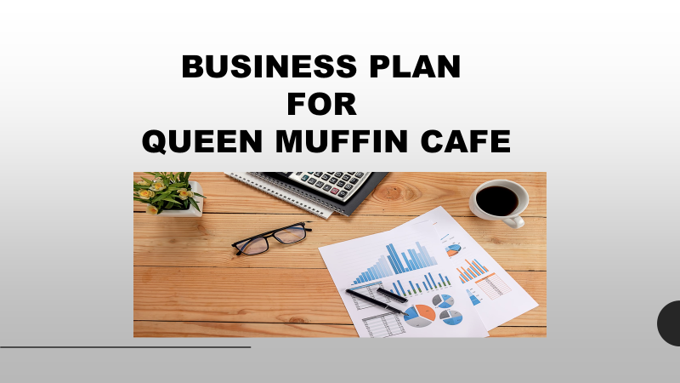
Student 1
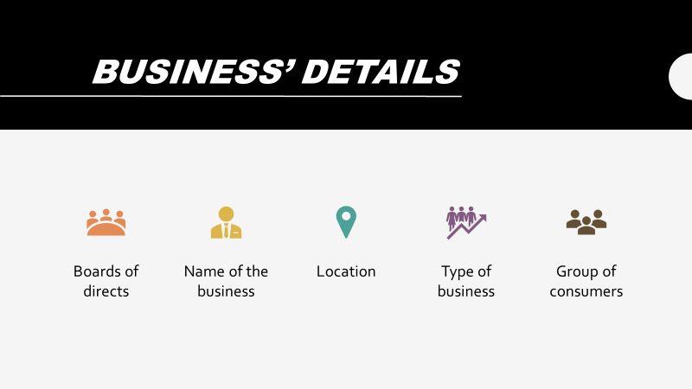
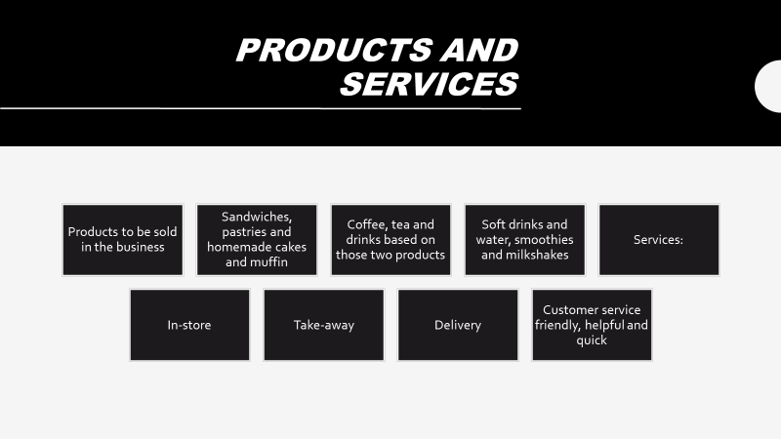

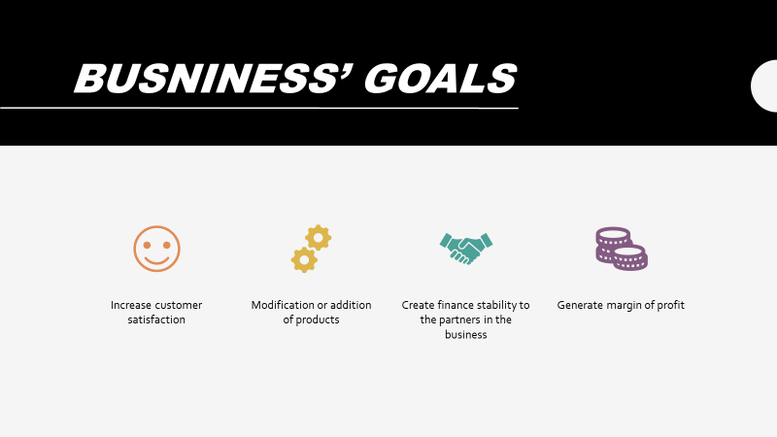
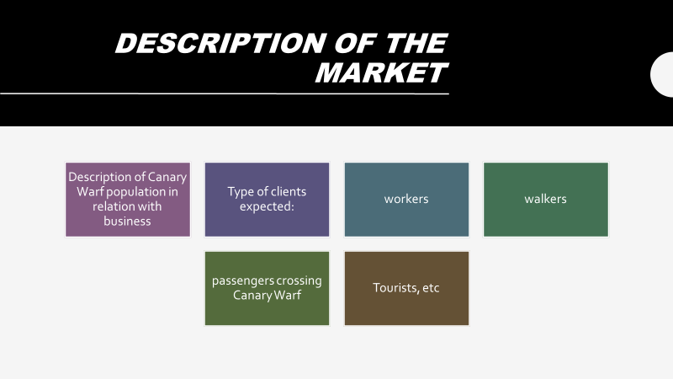
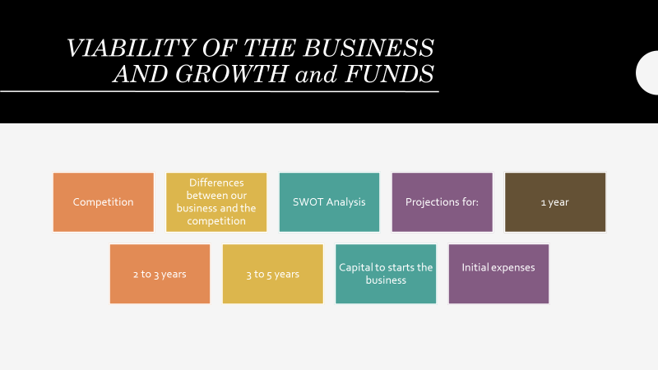

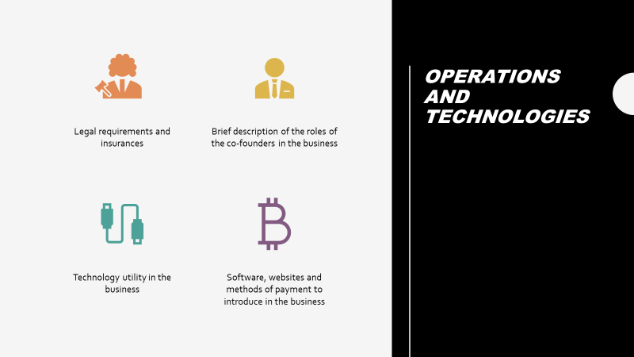
Student 2
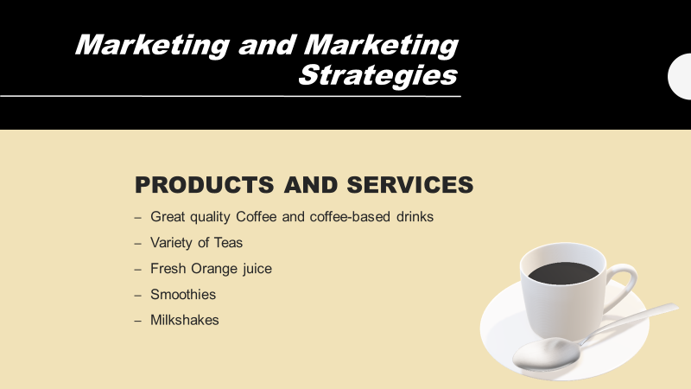
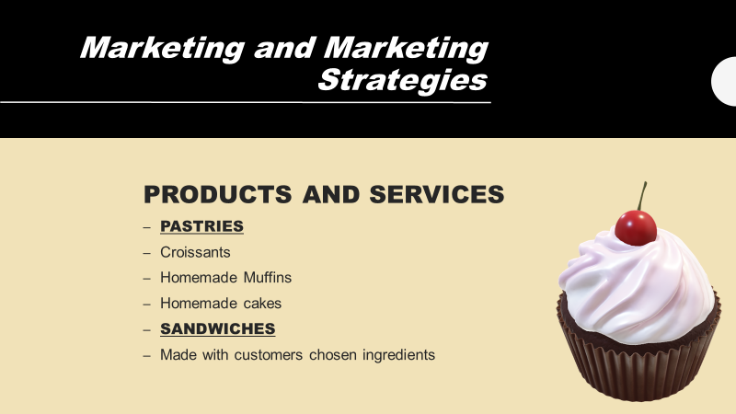
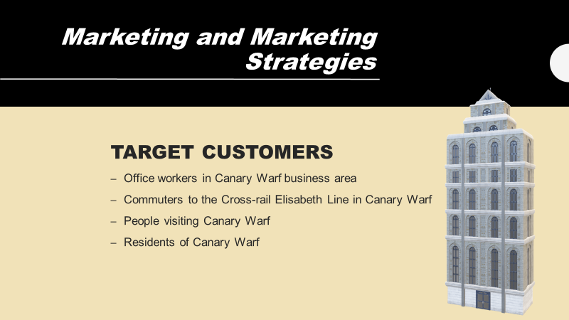
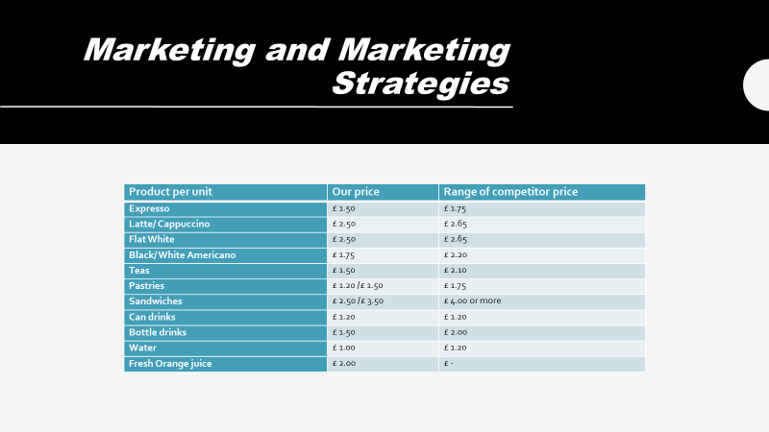
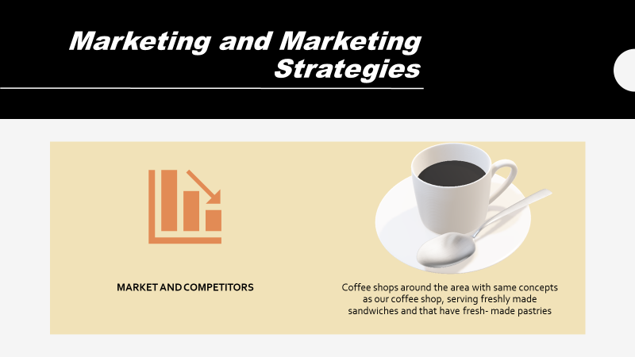

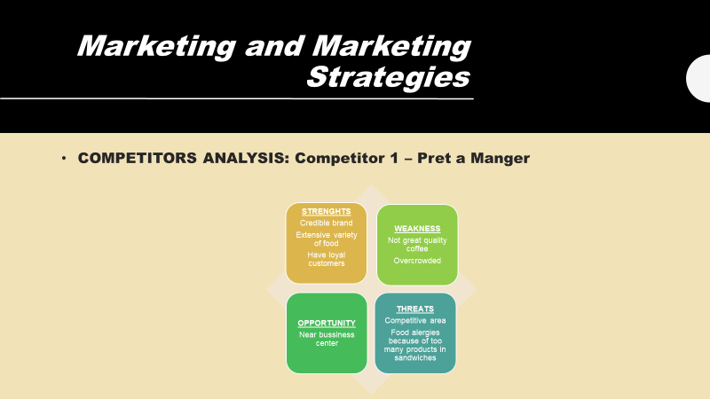
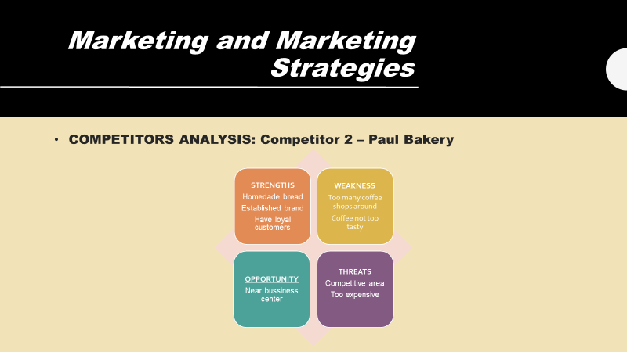
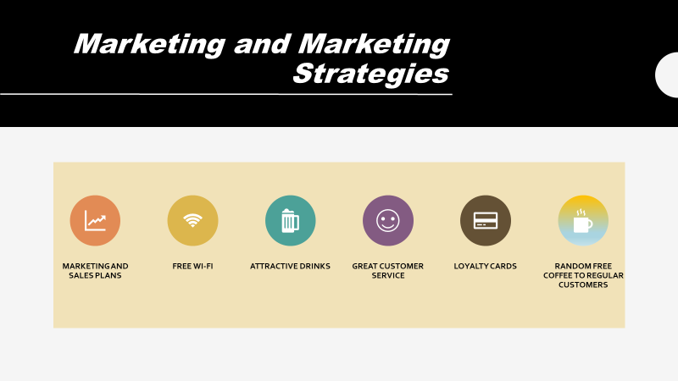

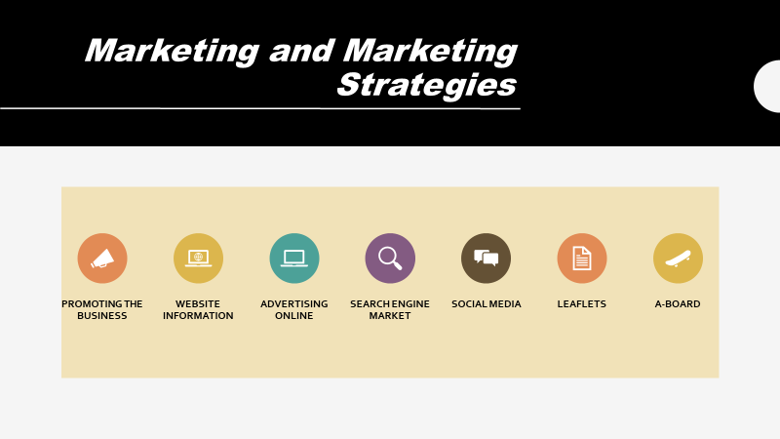
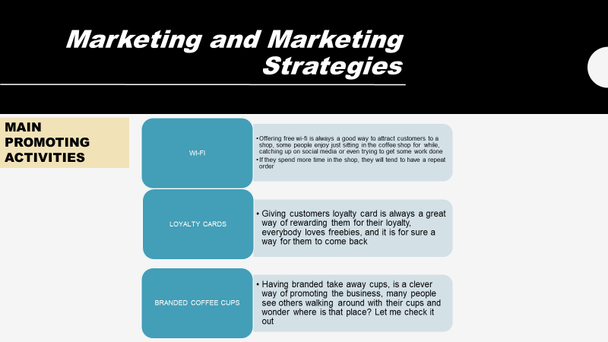
Student 3
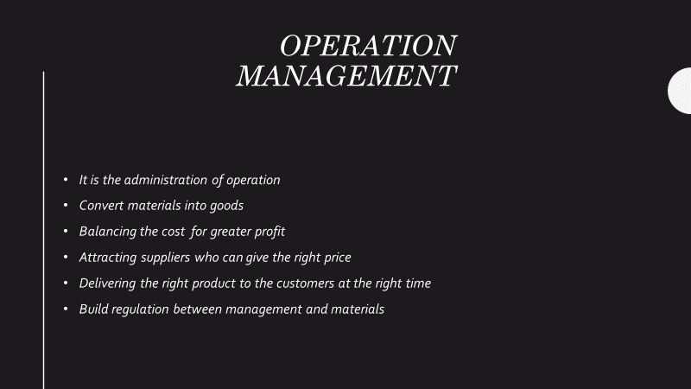
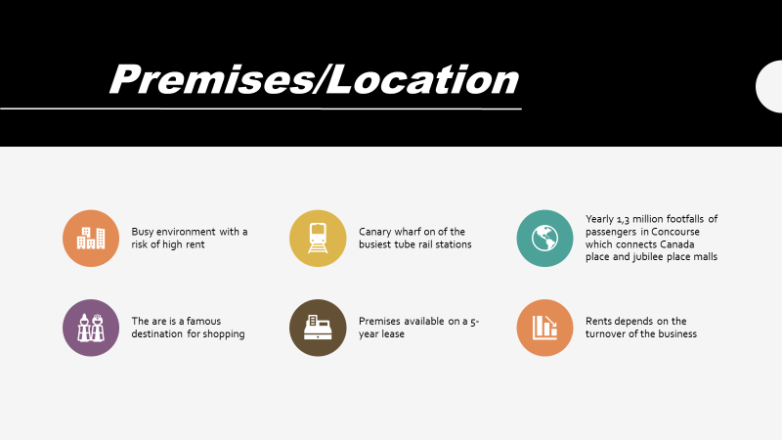
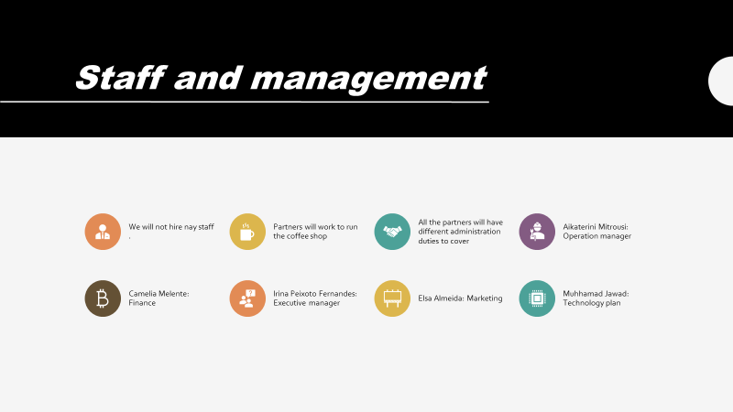
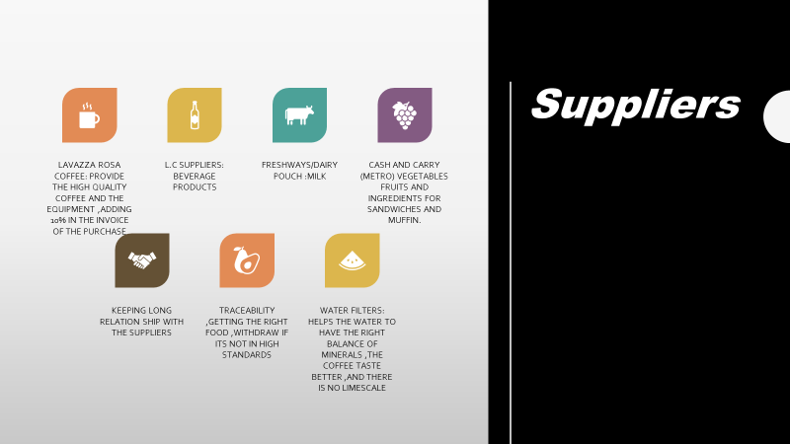
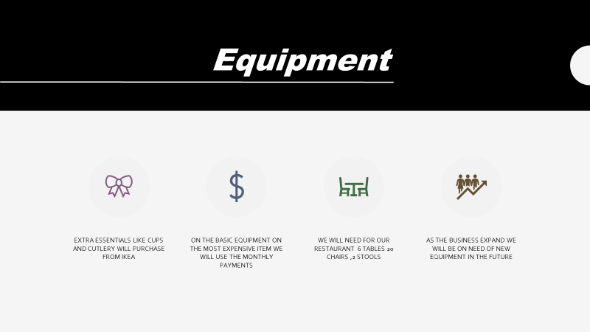
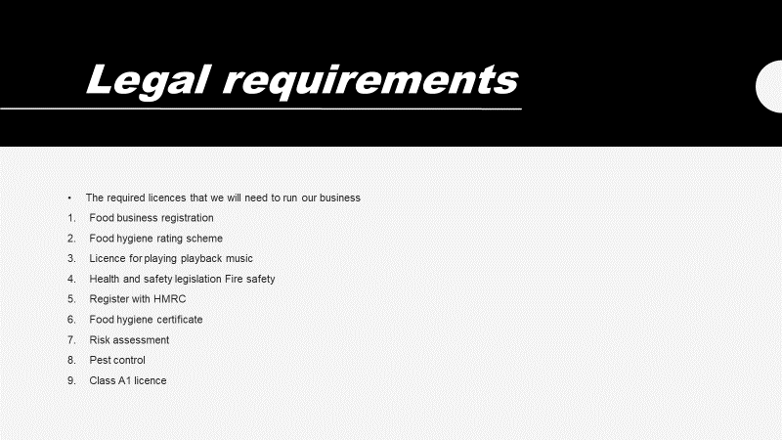
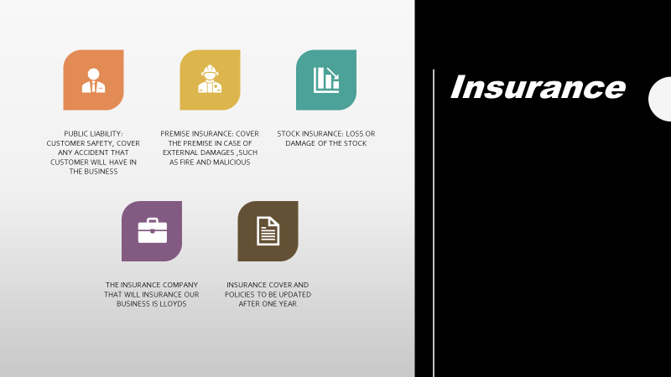
Student 4
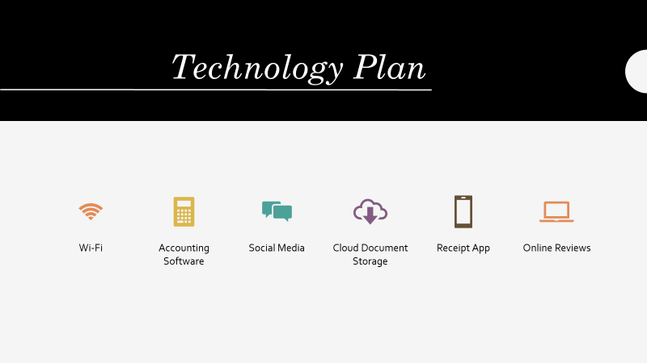
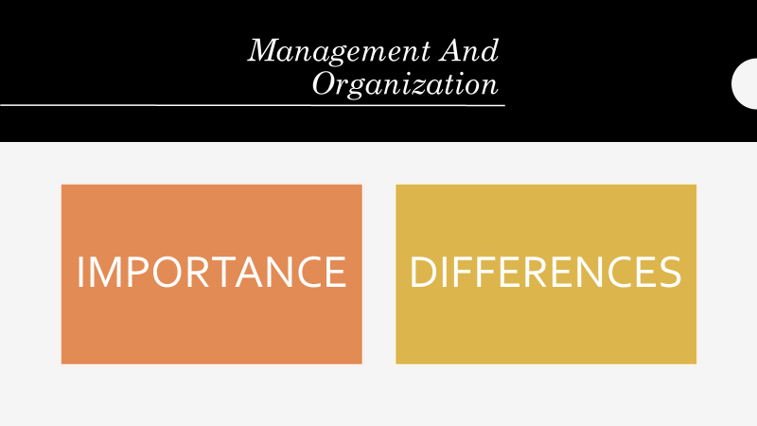
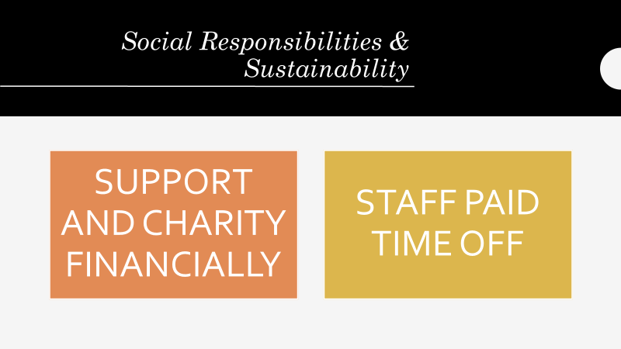
Student 5


