University Of Wales Trinity St David

Placement: Developing Culinary Skills
BMGM 5002
Level 5
Antoinette Milne BA (Canada), Dip WSET

Ayesha Amir
2306141
Word Count: 1763
I confirm that I have not presented any AI generated text as my own work. I confirm I have copies of my drafts, notes, and other resources I used before, and after the use of AI tools which I may be asked to provide in evidence.

In this portfolio, I will discuss supply and stock management, the challenges I faced, and how to store the products in the correct order, along with the importance of storing. Also, I will discuss the developments in cooking the meat, such as using a grill, oven, stove, etc., and how I keep the storage system after cooking, like a cook chill freeze system or sous vide. Discuss the experience I got from the placement, the techniques I used, and how I developed my skills while learning. I will discuss the preparation and plating. What I learnt from my placement, from plating starters to mains to dessert, and the experience I gained over the months and what techniques I have used and developed over the time. Along with my overview of reflections on the experience I had or what could be changed or could be done to make my experience better. My version of the future after the experience and where I see myself after the graduation.

Firstly, the restaurant I was placed in was called Morgan Hotel; it’s located at Somerset Place near My University and Sainsbury's. It’s a very beautiful location in the Swansea for new tourists and guests. Morgan Hotel holds about 42 rooms for guests, but for the restaurant, around 40 seats. Morgan Hotel has a private room for a party or occasion and takes bookings for big events. However, Morgan Hotel only does breakfast menus, as I have shown in (figures - 12, 15, and 16). The Morgan Hotel has stopped doing lunch due to lots of waste and not many customers booking (Morgan Hotel, 2024).

The stock and supply management in the Morgan Hotel is very systemic, before the end of the shift. The head chef and sous chef note down the number of products used in the kitchen on the day and make it easy to track the storage system and what needs order for the upcoming weeks (figure - 10). Morgan Hotel keeps track of the local suppliers’ prices near the walk-in fridge. It has a list of prices of products (figure 6). The suppliers that Morgans Hotel uses are (Howell Butchers, 2008., Castell Howells, nd,. and Arthur David, 2024). As shown in (figure 4). Howell Butchers supplies meats and poultry along with halal meat. (Figure – 5 and 10) that show the certification of halal meat. If we run out of halal meat, what will the Morgan Hotel do? Well, if we run out of halal meat for an event, then I would inform the head chef so he can order halal meat directly on the day, change the recipe to something else that everyone can eat, or use meatless meat to cover up the recipe. However, every 3-5 days the products and meats get delivered by a local supplier that handles the meat, fish, shellfish, and other products. I came across this article where he/she says that to have a successful business, you must have effective stock that ensures operational efficiency, minimises waste, maximises profitability, and delivers excellent customer service. Stock control involves managing deliveries, tracking inventory, and conducting regular stocktakes. that how you will successful business (Capcon Limited, 2024). If you follow all of those correctly. Small labelling is used before storage (figure – 1). As it’s compulsory to label before storing inside the fridge for 3 days.

On my placement, I was given spicy chorizo already diced from pre-ready; I just need to fry to cook. I fried the spicy chorizo with a little oil to not let the chorizo stick to the pan till the chorizo was ready. However, if I added lots of oil to chorizo, it would be very oily, and chorizo also leaves the oil itself while cooking. It wouldn’t be nice, and it will taste very greasy in the chorizo coquettes, and the mash will break while frying. Another thing I learnt during placement was how to make a steak, as there are varieties of steaks, but steak is cooked on a pan to give the searing to get them a caramelised golden look with flavours of herbs and butter over the stove and has a few flavours. After that, it’s baked in the oven for 10-20 min till cooked at 200º, then checked with a thermometer at 75º to be served. However, sous vide is another technique used, which is a meat in bags with flavours like herb butter or spices and vacuum bag overnight till the raw meat has picked flavours in the bag over the night, then the vacuum bag meat is cooked in the hot water till the meat is cooked in the water bath, then the meat is taken out of the bag and cooked for colour on a hot pan with oil and butter for the caramelised colours (Figures 18 and 19). I came across this video where Ramsay, G. (2019) explains in this video how to make the perfect steak and what you need to do to make it best. He gives small tips, like taking the meat out of the fridge before cooking. Let the protein sit and leave it at room temperature before cooking for at least 10 minutes. He also gives a tip about safety in this video, letting the steak rest before coming out of the pan to cut to the temperature you would like. Meat is stored in the fridge at a temperature of -18º after cooking and chilling (figures 2 and 3). I came through a page on my research (The Healthline Editorial Team and Jewell, T., 2016) that gives tips on how to store meat and for how long, for example, an uncooked chop or steak should be in the refrigerator for 3 days but in the freezer for 4 months. The breakfast in the Morgan Hotel is grilled, like bread, sausages, and black pudding. To dry and heat the items and cook and to give a little charcoal look before serving to customers. (Figures 13 and 17), as shown in the pictures. Cook The chill method is used for meat to cool down fast so it’s easy to store, and then vacuuming can be done and frozen. I researched this book, which explains how to cook and chill the product after cooking. (Cousins, J., & Weekes, S., 2020) and this book (David Foskett et al., 2021). It’s important to keep the report of temperature of the meats.

Preparation and plating in the Morgans hotel on the Beaujolais night was done like Monday. I prepared the starters—soup, cut the vegetables, made the stock out of bones, then added the vegetables into the trays to get the vegetables roasted to be added to stocks. cooked till stock and vegetables were cooked. Then Next day I braised the beef ready for Beaujolais night; it just needed to heat. I layer the beef on the trays, along with stock juice to make it tender and some vegetables for the juice and put it in the oven and let it cook. after the meat was cooked. I took out the meat in a separate tray and poured the juice and vegetables in a pour to cook for jus. after the beef was covered and placed in the fridges with labels for Beaujolais. I blended the soup for next Beaujolais night and labelled and placed it in the fridge. The dessert was prepacked. I just needed to take them out of the box and lay them on the big box, ready to be plated on Beaujolais night. On Wednesday all vegetables were trayed ready to go into steamers and labelled and dated for the next day. On Beaujolais Day, everything was out and heated in the over-ready for event. The dessert was platted on a big table for the quick service. Pick and go for waiter and waitress. (Figures 7, 8, 12, 14, and 15). For the desserts the techniques I used are pouring the sauce to create the design or to add small decoration on top on lemon tart and it was my amazing experiences so far.

My reflection on experience is that I have picked up a lot of speed from doing the same thing, which is chopping or other things, and I get to do what I like to do, and that is the dessert area as decorations. I haven't had any negative impact so far from the placement I am currently on. However, I really enjoyed it.

In the future, I see myself opening something or being in a company as an event manager or something good. I will be guiding others, giving ideas, and helping in the dessert area because I love desserts. However, the area I need to improve is getting myself confidence working in front of the house and getting more involved in banqueting or the event side because I enjoy laying tables for big events or giving ideas.
Appendices

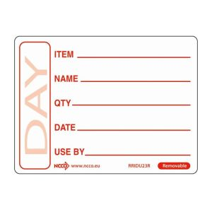
Figure 1 -

Figure 2 -
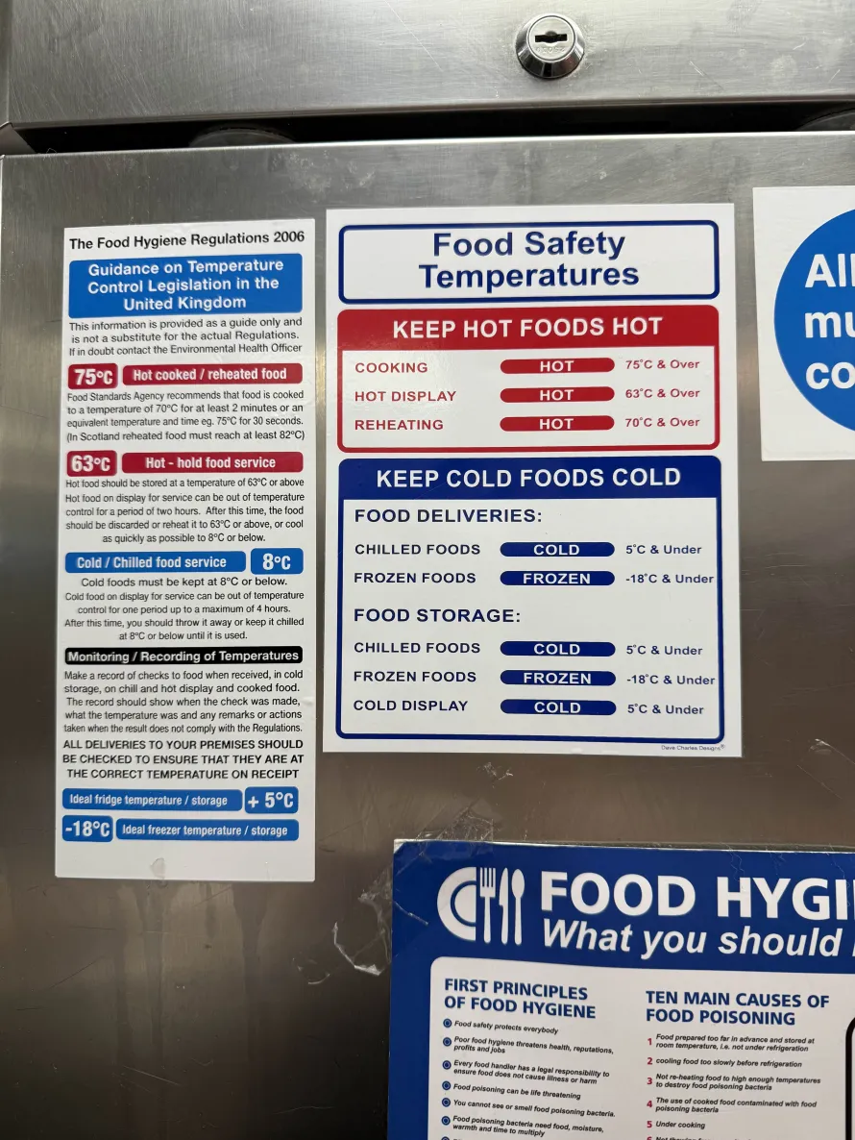

Figure 3 -
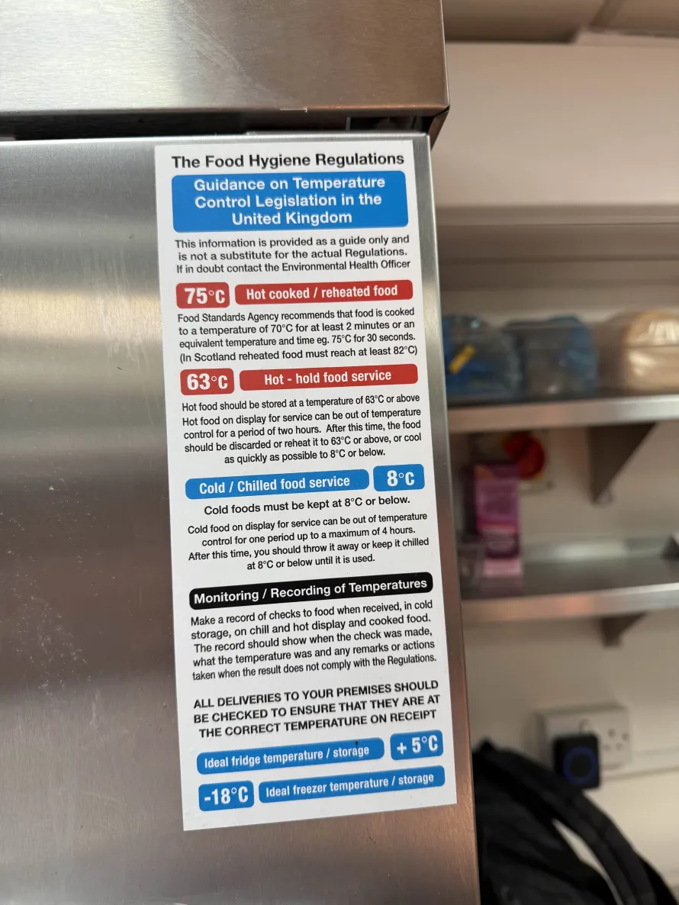

Figure 4 -
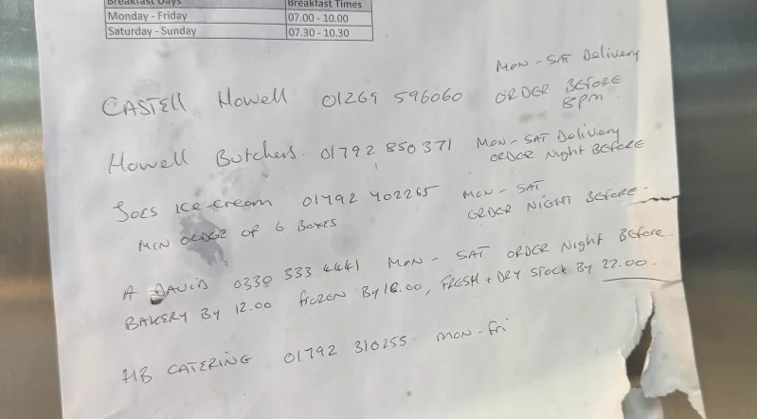

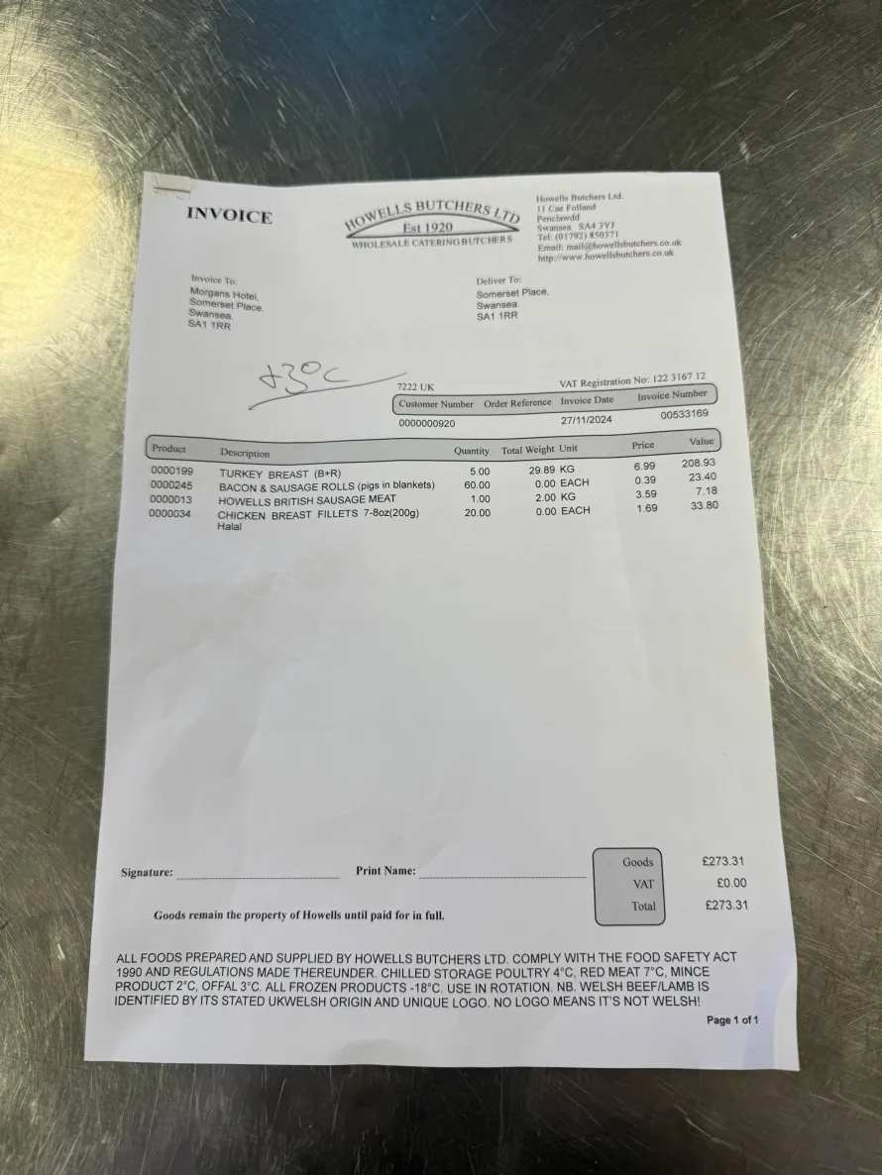
Figure 5 –

Figure 6 -
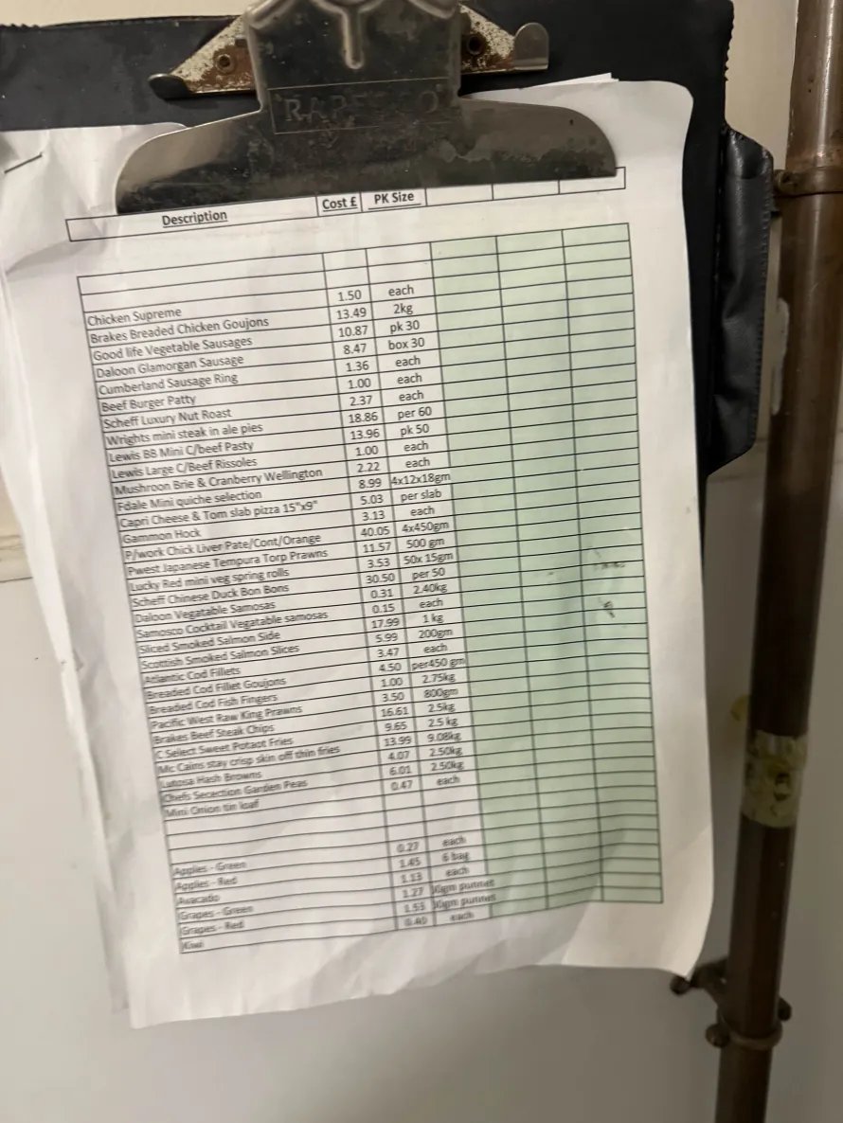

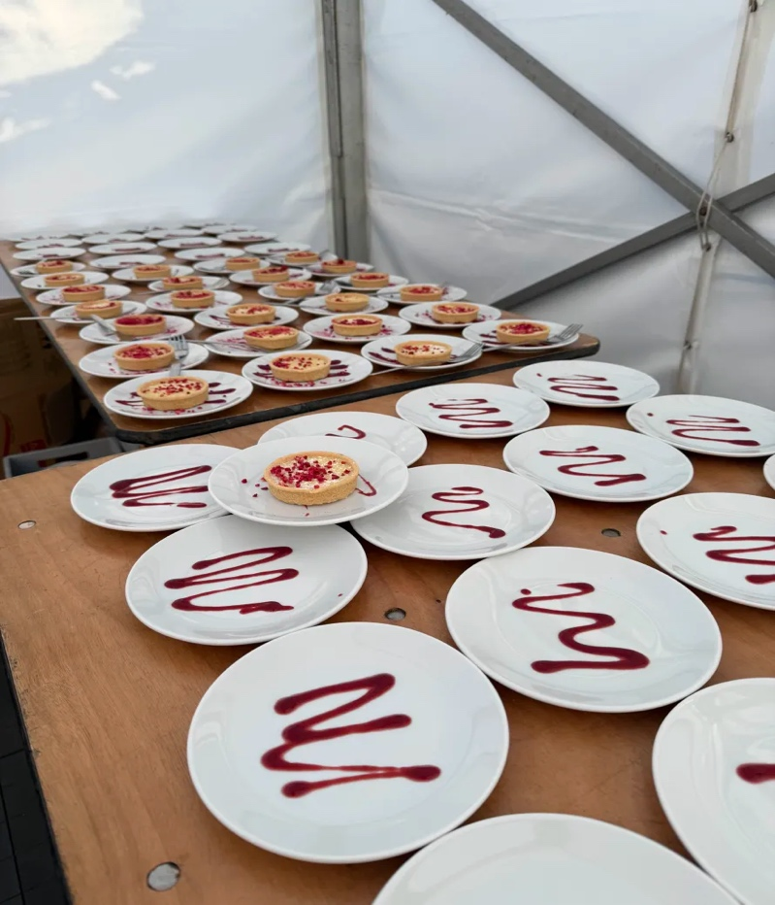
Figure 7 -

Figure 8 -
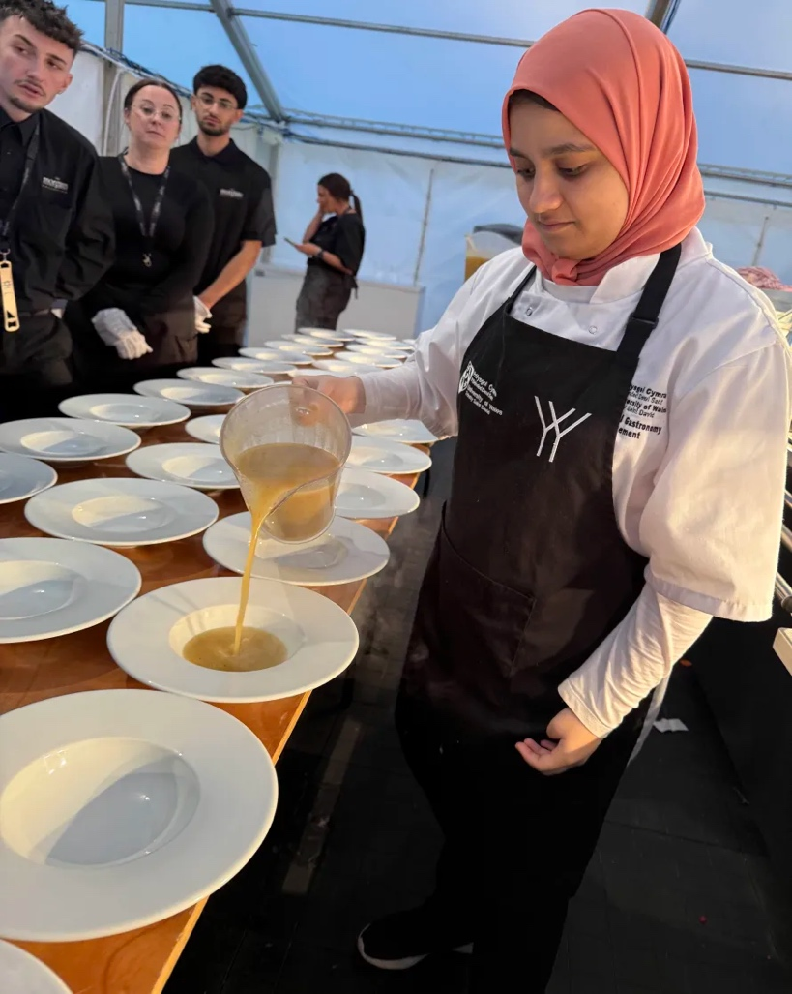

Figure 9 –
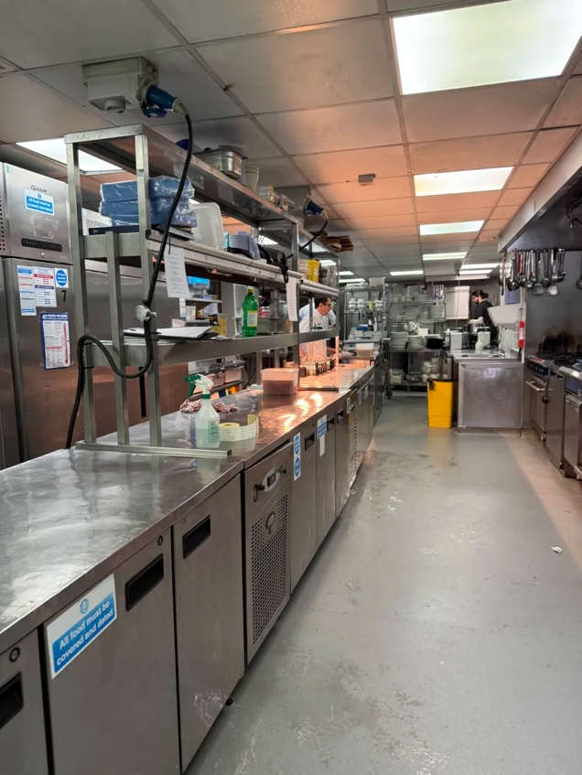

Figure 10 –
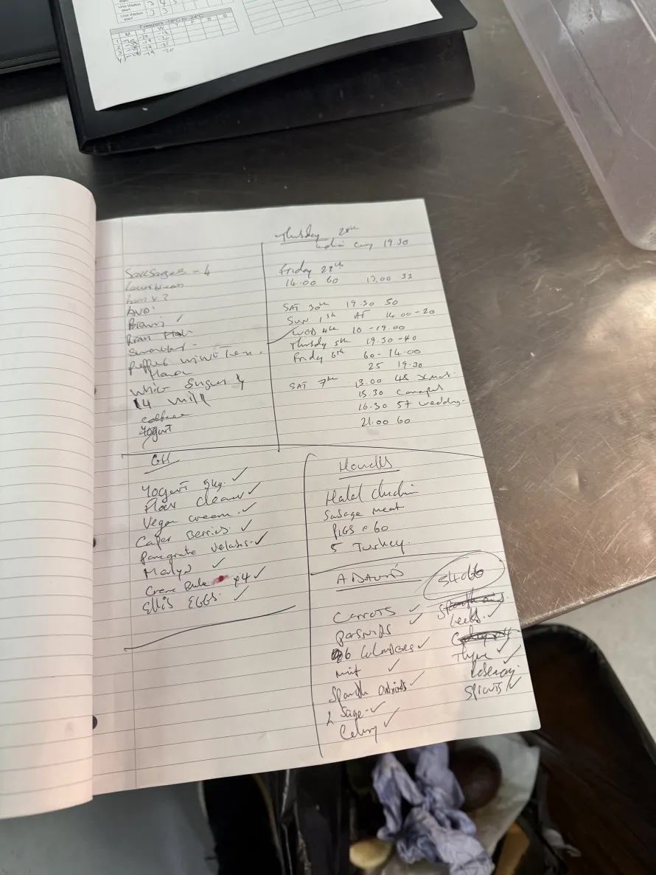

Figure 11 -
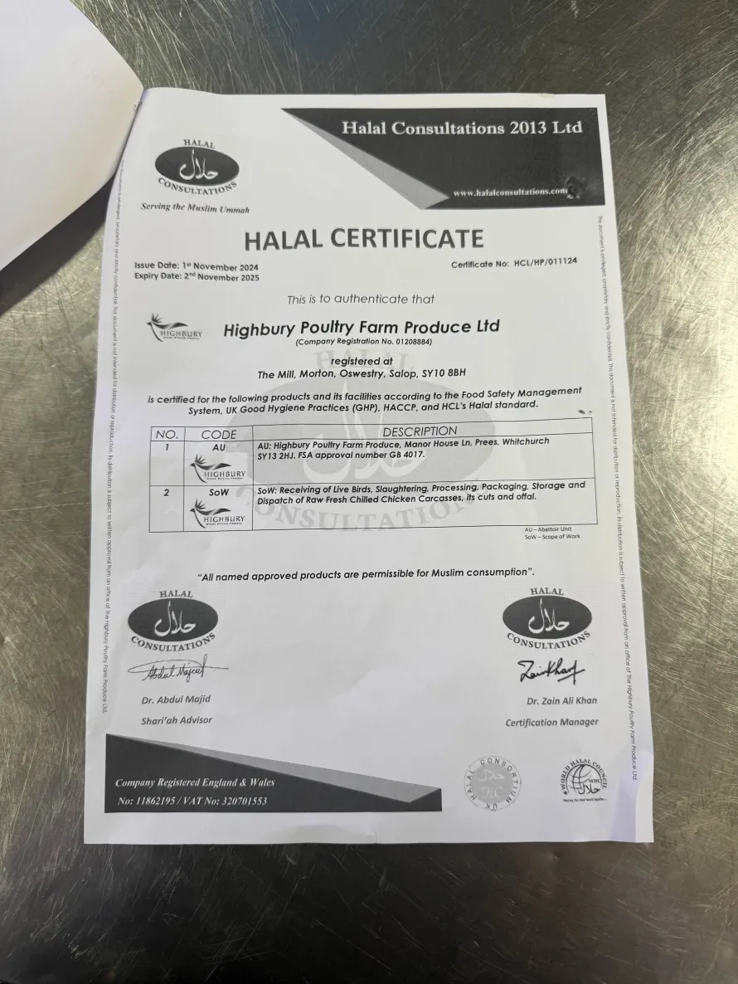

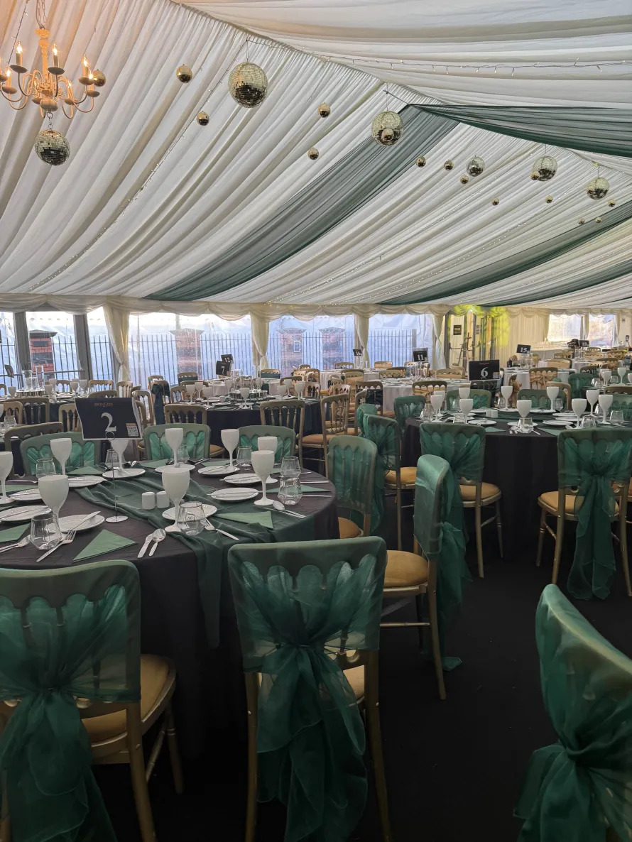
Figure 12 -

Figure 13 -
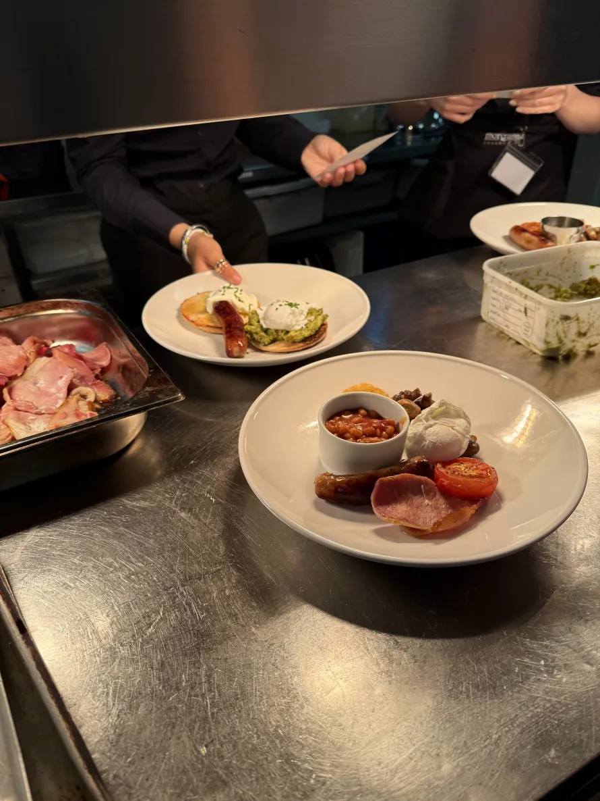

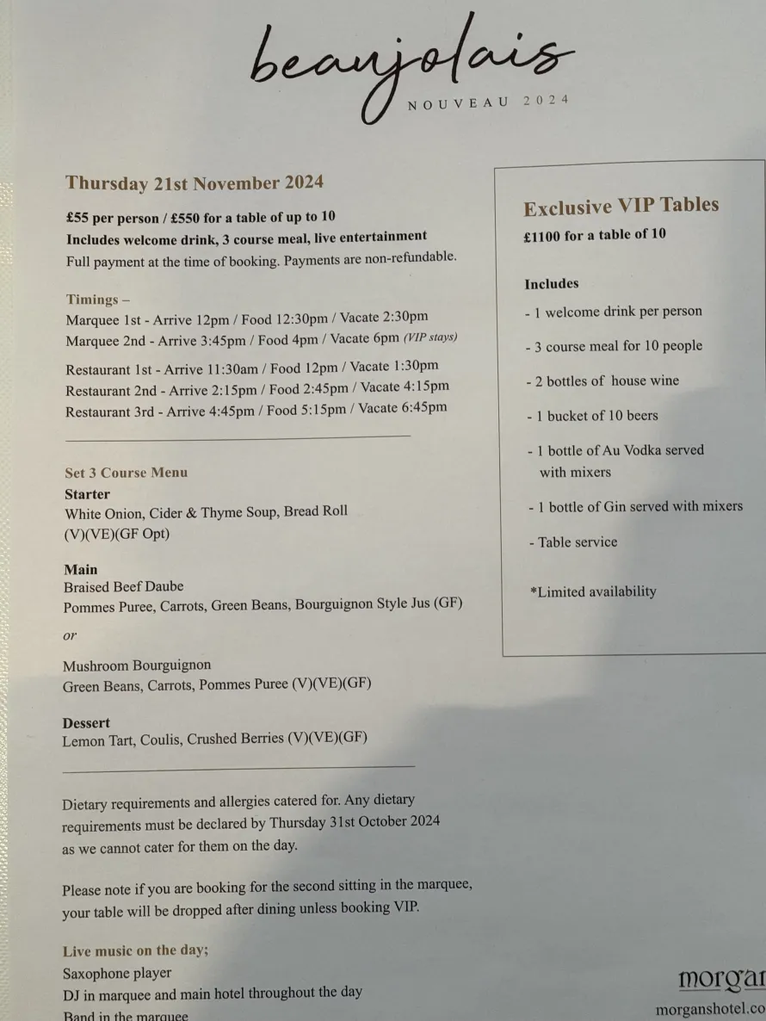
Figure 14 -

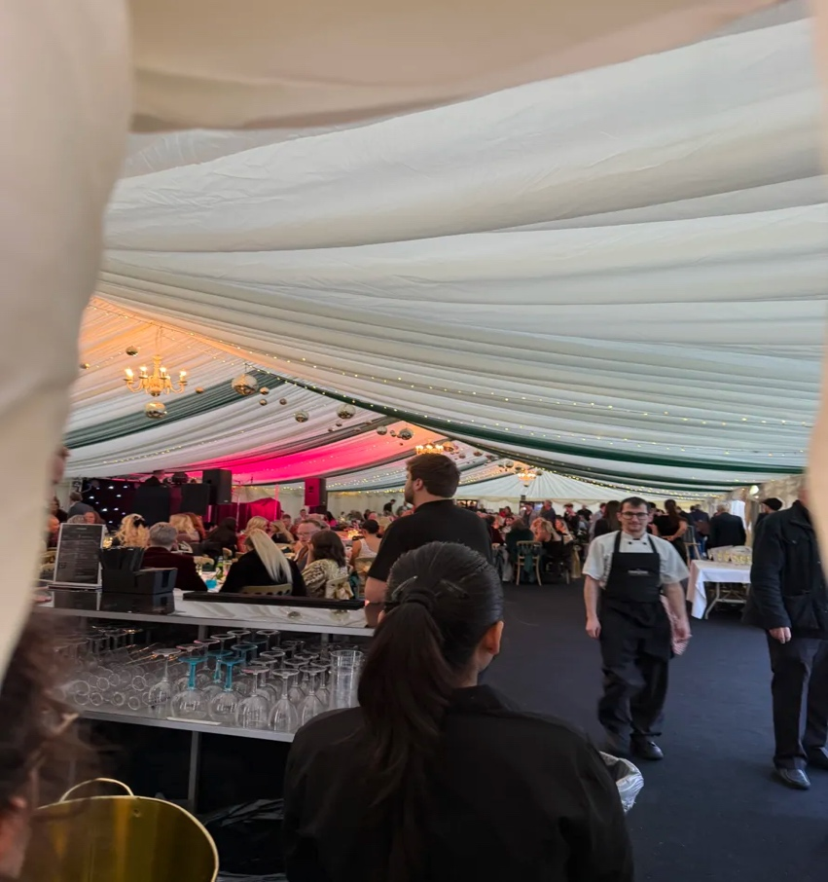
Figure 15 -

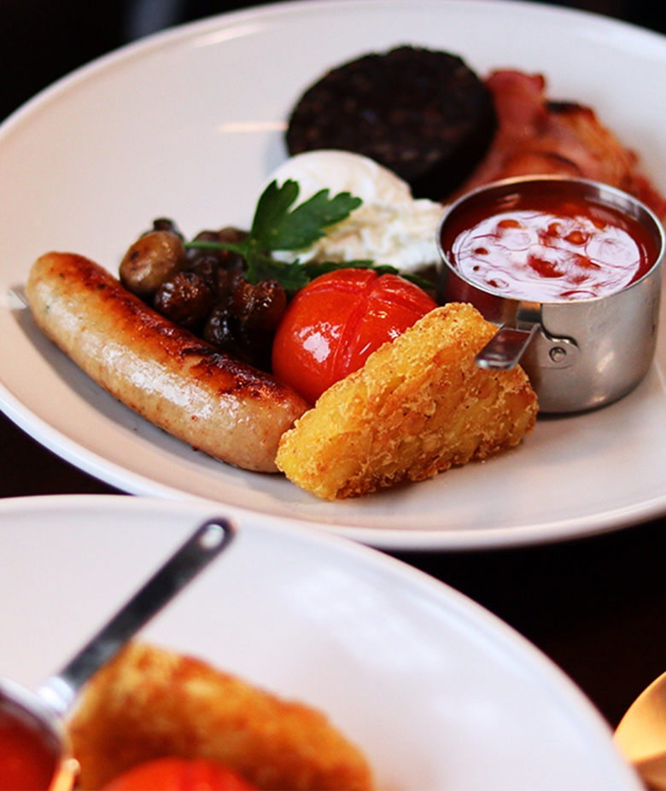
Figure 16 -

Figure 17 -

Figure 18 –
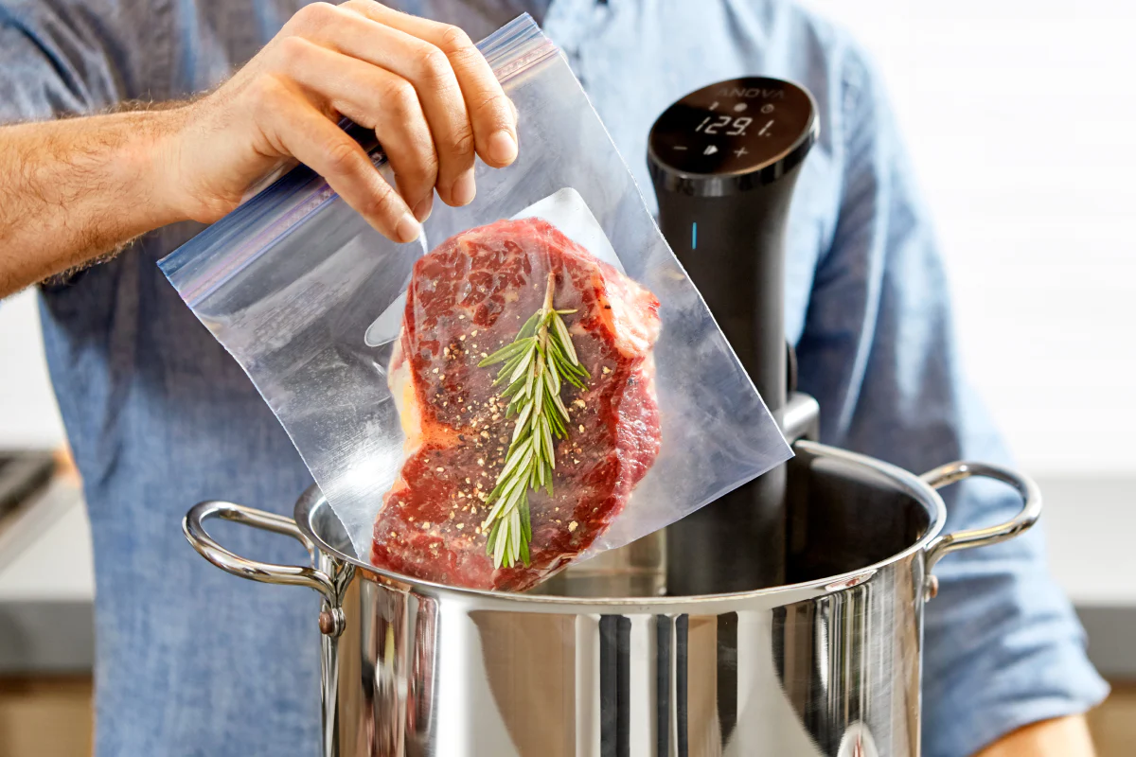
Figure 19 –
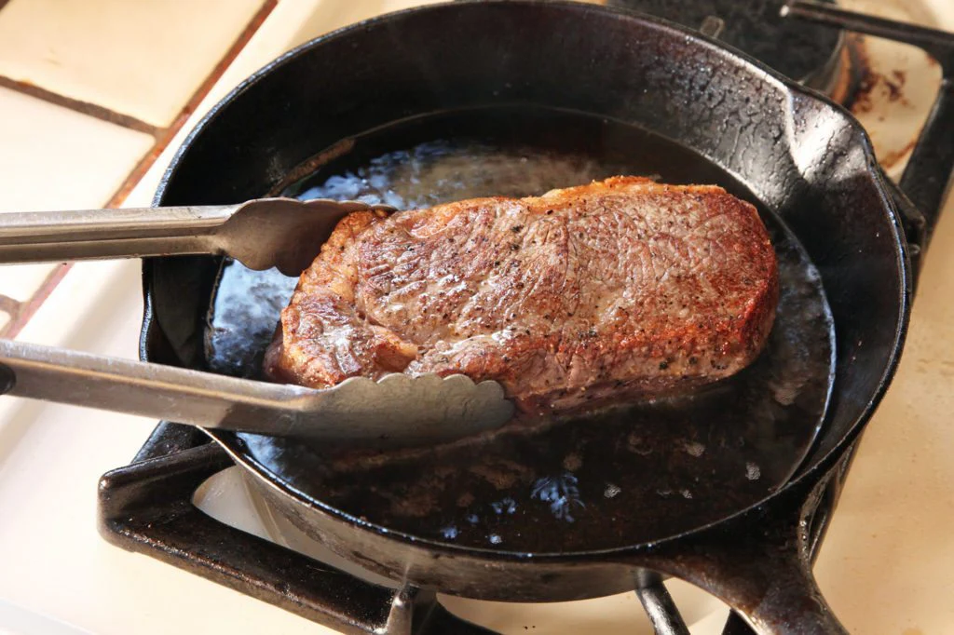
Reference

Arthur David (2024). Arthur Davids Products. Available at: https://www.arthurdavidonline.co.uk/product-catalogue?signups=true (Accessed: 28 November 2024).

Capcon Limited (2024). The importance and benefits of training in stock control.
Available at: https://www.ukhospitality.org.uk/the-importance-and-benefits-of-training-in-stock-control-for-the-hospitality-sector/ (Accessed: 29 November 2024).

Castell Howell (n.d). Castell Howell. Available at: https://www.castellhowellfoods.co.uk/ (Accessed: 28 November 2024)

Cousins, J., & Weekes, S. (2020). Food and Beverage Service, 10th Edition, Hodder Education Group, London, p.97. Available at:
https://ebookcentral.proquest.com/lib/trinity/reader.action?docID=6354742
(29 November 2024).

David Foskett et al. (2021). The Theory of Hospitality and Catering, 14th Edition. London: Hodder Education, p.63. Available at https://viewer-ebscohost-com.ezproxy.uwtsd.ac.uk/EbscoViewerService/ebook?an=2985202&callbackUrl=https%3a%2f%2fresearch.ebsco.com&db=nlebk&format=EB&profId=ehost&lpid=&ppid=&lang=en&location=https%3a%2f%2fresearch-ebsco-com.ezproxy.uwtsd.ac.uk%2fc%2fonvpsy%2fsearch%2fdetails%2flebk2lnncf&isPLink=False&requestContext=&profileIdentifier=onvpsy&recordId=lebk2lnncf/ (Accessed: 29 November 2024).

Gordon Ramsay (2019). Gordon Ramsay's Top 10 Tips for Cooking the Perfect Steak. 15 December. Available at: https://www.youtube.com/watch?v=YIjWwZwlHQg/

Howells Butchers (2008). Howell Butchers. Available at: http://www.howellsbutchers.co.uk/ (Accessed: 28 November 2024)

Morgan Hotel (2024). Breakfast Menu. Available at: https://www.morganshotel.co.uk/wp-content/uploads/2024/10/Morgans-Breakfast_Menu.pdf (Accessed: 28 November 2024).

The Healthline Editorial Team and Jewell, T (2016). ‘Meat Safety: Storing and Handling Meat, Poultry, and Fish’, Healthline. Available at: https://www.healthline.com/health/food-safety-meat (28 November 2024)

