AUTOMOBILE INDUSTRY IN EUROPE
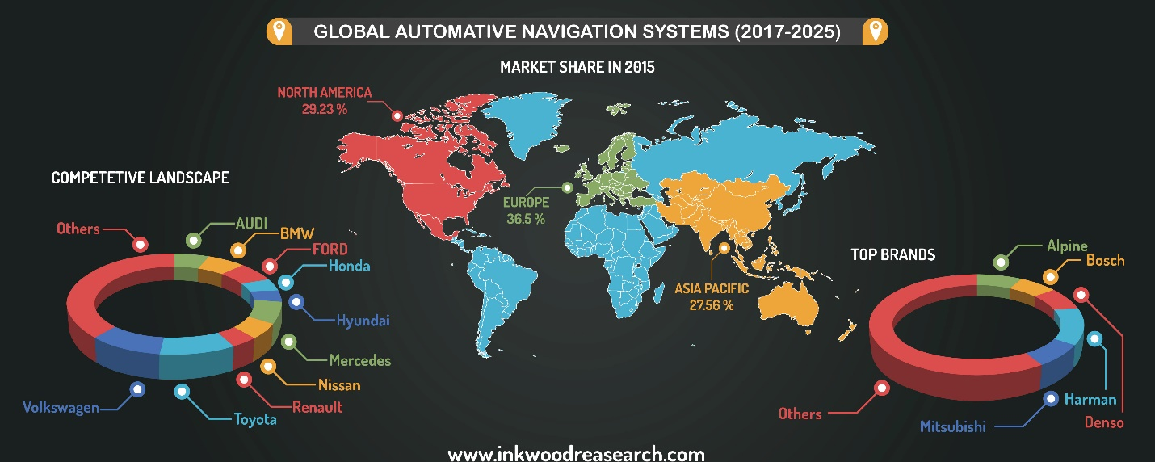

Student: Horhocea Cristiana-Mara
Student no: 1604608
Module: Global Business Environment
Assignment title: Environmental Analysis of an industry
Tutor: John-Paul Okeke
University of Wales, Trinity Saint David, London Campus

- INTRODUCTION
The automobile industry is truly a very large sector, and it still comes up with a lot of new inventions (the self-driving trucks, electric cars & others). According to ACEA (European Automobile Manufacturers’ Association), which represents Europe’s car, van, truck and bus makers, the European automotive employment reaches now more than 12.5 million Europeans and it accounts for 5.7% of the EU’s GDP. 11% of Europe’s manufacturing employment is represented by the 3.3 million manufacturing jobs in the automotive manufacturing.

- PESTEL Analysis
The PESTEL Analysis is a short for Political, Economic, Social, Technological, Legal and Environmental factors. It is also a framework which explains the exact macro-environment factors of an industry. The macro-environment is one of the Business Environment’s levels which comprises general forces and trends rather than specific organisations (macro-economic environment; political environment; social and cultural environment; demographic environment; technological environment). According to PESTEL, an industry can find out its impacts which may affect the business. The PESTEL Analysis is also known as ETPS, PESTEL, PESTLEE, PESTLIED, SLEPT, STEP, STEPE, PEST-G, PEST-E and STEEPLE.
I will implement and briefly explain every factor of the PESTEL Analysis referring to the automobile industry in Europe.

  - Political
The political environment involves political decisions which affect the economic environment and influence the country’s socio-cultural environment. Also, the politicians can influence the rate of emergence of new technologies and the acceptance of new technologies as well. As political factors we can mention bureaucracy; corruption; wars, terrorism and conflicts; government policies; inter-country relationships and so on.
It has a direct impact on the automobile industry’s profitability. The political factors are generally not controlled by businesses except for seeking to influence. Companies need to administrate their costs, and the political factors are playing a significant role in this area. For example, the reason for China becoming a favourite of various car brands is the low labour cost which is caused by the lenient salary regulation. The import and export which is variable across nations can also be a big problem for car factories in care of the nations where import laws are stark.

  - Economic
The economic factors are related to economic policies, economic forms and to what extent the economy influences the business. Some of the economic factors are: inflation; import/export ratios; international exchange rates; taxation; industry growth. These factors affect the automobile business process in various ways. The economic environment refers to the economic factors in whole as resources available.
The economic sector has been hit hard by the recent economic crisis. The sales of vehicles are decreasing if the economic conditions are not good. The inquiry for luxury or high priced vehicles is also swollen during poor economic conditions. Furthermore, the taxes on the high priced automobiles are high in several markets. The sales of automobiles may remain high if the economic conditions are good, that is why the sales are generally higher in the more developed countries.
There are various ways to analyse the relevance of the economic factors for the industry, but the most used way is the purchasing power of the customers. Industries are heavily subordinate to the purchasing power of the customers.
  - Social (Socio-Cultural)
As social factors we can refer to ethical issues; lifestyle trends; demographics; major events and influences, and others. These elements represent attitudes, aspects that will concern the inquiry for a firm’s products and how the company operates. The socio-cultural forces are deeply influencing the market. Every year, new models of vehicles are released, keeping people's preferences in mind. Besides, there are specific styles preferred in certain cultures.
Another important factor that vehicle makers should keep in mind while targeting the consumers is the age distribution in the various populations. Apart from it, we all know that people’s style and preferences also differ from culture to culture. The result is that if a particular model is being sold in a market, it might not be as wanted and popular in others. Older vehicle models may be considered outdates by changing the trends.
  - Technological
Technological factors such as maturity of technology, intellectual property issues, competitor technology development and information and communications, relate to technological aspects.
The more advanced, original and innovative the company, the higher is its market share. Brands like Toyota and Tesla are investing in environment friendly vehicles, such as electric cars. Toyota is even planning to release a driverless car in the near future. In present technological innovation has remained a greater foundation of differentiation for the automotive makers. And that is because the customers’ attention shifted towards fuel efficient and high mileage vehicles.

  - Legal
When we say legal, we think about laws, legislation and regulation. And these 3 factors affect the way the business works. Some other legal factors are future and current legislation; employment law; tax regulations; health and safety regulations; money laundering regulations.
Law is an important factor which affects the performance and profitability of the vehicle brands. Automobiles sold in the international market are related to product quality and safety through law. The exported vehicles overseas need to pass a strict emission control. Lately Toyota had to retire its vehicles because of its defective airbags; that would put passengers’ safety under question. Governments felt forced to make stricter laws related to passenger safety, due to such accidents. Besides, environmental laws, tax laws and a couple other laws that the automobile companies have to deal with while working in the international market.
  - Environmental
As environmental factors, we can mention ecological factors, reduction of carbon footprint, sustainability and impact of adverse weather, that can affect the way a business works and the inquiry for a company’s products.
The laws related to environment amity and carbon emissions are inflexible growing around the globe. So all the big players in the vehicle industry had to concentrate over low emission vehicles. Government and law favours the low on emission and low on fuel consumption vehicles and they are also receiving tax subsidies. The pollution tests have increased severely and certain markets like EU and UK allow only vehicles passing these pollution tests. Governments have started concentrating heavily on the pollution control and that is why environment amity has become an important test for the vehicle companies in the 21st century.

- PORTER’S FIVE FORCES

This tool was created by Harvard Business School professor Michael Porter with the purpose of helping people understand the competition with direct competitors in order to make most profit. Since 1979 it has become one of the most popular business strategy tools.
Porter’s five forces helps us to look at the drivers of competition in an industry. It is a powerful framework which helps people in understanding the competitiveness of the business.
Porter’s five forces is a very useful tool, because it is essential for us to understand the forces in our environment or industry that can have an impact on our profitability, and it helps us to improve the strategy thereupon.
Michael Porter had identified five forces that devise the competitive environment and which may degrade profitability. These are:

  - Competitive Rivalry
The industry could be very competitive as it could be profitable. The power of competition here could be high or low as the fight for market share could be fierce. With the appearance of new foreign competitors it the 70’s and 80’s, competition in the automobile industry has become more powerful as firms compete on both prices and non-prices measures. Serious competition began to appear in the 1990’s with a ravage of new vehicles, designs and concepts (Adam, Brock 2005.) The fact that the automobile industry is a full-grown one means that the competition is savage and competition will only increase over time. Exit companies are high because these businesses have already made the investment in equipment and that makes more sense for them to stay in the industry and constantly decrease prices. The market seems to be requesting innovative designs that are in accordance with appearing socio-cultural trends, and the winning competitors are going to be those who use lately available technologies to capitalize on this trend.

  - Supplier Power
They are powerful, get most of the profits, unions that support the supply of labours. This could be high or low. The power of suppliers is reduced by the number of possible existing suppliers in the automobile industry, but manipulating costs are high because setting out part designs and specification involves a fair initial investment. For example, Ford was depended on various suppliers for different parts but soon there were a problem with the value of equipment and consistency of parts made by various manufacturers became too expensive compared to buying from suppliers. Like most other manufacturers, Ford followed the Japanese lead by bereaving themselves of their organic parts makers. If a manufacturer is secure on one supplier almost exclusively, this devises a monopolistic situation that demands that the producer keeps the supplier satisfied, particularly if they are exploring other manufacturing right set of circumstances with the rivals. In conclusion, the supplier power is mean – not especially high, but not so low either.

  - Buyer power
Customers are price sensitive, they can shift preferences easily. They are willing to pay less. Buyer power is similar to the output of individual customers to discuss prices that take profit from the seller. With just a few exceptions, buyers have the power to quit a purchase that they do not want anymore and put their purchase somewhere else to a dealer of the same manufacturer or to a completely different one. Dealers are another factor of the buyer equation. In the case of Ford, dealers acquest their stock-in-trade through Ford Motor Credit. Consequently, the power of buyers is high. Buyers of new vehicles like to shop around, to collect a lot of lately informations from the internet and to use them to argue with many dealers. In addition, because manipulating costs are low and new designs are well distinguished, it is very possible that market trends hook large shares of the buyer market from one manufacturer to another. The effect of buyer power is high. The challenge is how to do so in the face on customers who do not always know what they want and rivals who are very quick to imitate any differentiation. The answer lies in understanding that rather than a competition to meet some prespecified customer objective, rivalry becomes a struggle to influence what customers know as a result, how they behave. A company and its customers have inherently distinct perspectives, so market research is employed to get over the gap between them.

  - Threat of Substitution
The availability of substitutes, such as in the car industry, trains, public transport, cycle. Friendly city provision. This could be high or low. The threat of substitutes does exist. People felt forced to use the public transport because of the increasing of fuel prices. However, if this trend will continue the vehicle manufacturers will not be able anymore to provide a more cost-efficient solution, so this threat will increase. FORD Motor Company did put effort into facilitating the pressure of replacements like public transport. In 2010, Ford released six-speed transmissions and nine new engines. There is no other realistic substitution of motor vehicles, excepting the large scale of transportation that railways provide. Since almost 100 years ago, the population worldwide became increasingly more reliant on motor vehicles. Transportation by automobiles exceeded other ways of personal travel and the movement of manufactured goods, with a constant supply of motor vehicles becoming available after World War II.

  - Threat of new Entry
New businesses can come in and threaten those already in the industry by taking their customers. The target could be high or low. There are some high barriers to entry this industry and that is making the threat of new entrances lower. The automobile industry requires a high capital investment to raise manufacturing facilities and that means that only a few new entrepreneurs are capable of undertaking into the automobile industry. Plus, the fact that there are already so many multi-national great competitors benefit from economics of scale and scope makes it very hard for new entrants to offer a competitive pricing. It takes many years for new entrants to build a strong enough reputation in order to be competitive. All of these factors make the threat of new entrants in this market very low. With so many companies chasing the same market, innovation and making new consumers has become necessary for survival.

4.0 Automobile smart inventions
There are some remarkable inventions in the automobile industry which may have a positive impact on this industry’s future and on the business world. Here are some of them:
4.1 Electric cars
The electric cars in UK can be found under the name of ‘green cars’ as well. Over the last few years, the number of electric cars on the road has increased and reached the number of 100,000 cars, which is very good compared to 2013, when there were only 3,500 vehicles.
If people are going to use the electric cars more than the ones using petrol, this thing is going to have a really good impact on the environment, because the pollution percentage will decrease and of course there will be less disasters, hurricanes and so on, caused by the dangerous pollution nowadays.
Therefore, my opinion is that the electric cars represent a step forward in technology’s future.
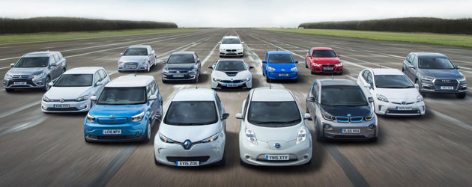

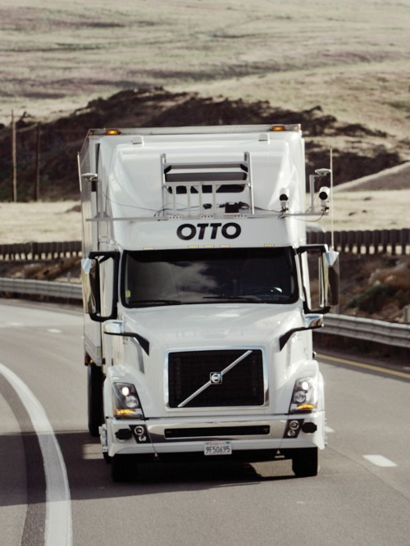
4.2 Self-driving trucks
The popular self-driving trucks are going to be available in approximatively 5 to 10 years from now, according to David H. Freedman. People claim that the self-driving trucks are going to be safer and less costly, even if there are still some unresolved technical problems. Otto and other companies have to prove that the sensors and the code can match the awareness of the situation of a professional truck driver.
In my opinion, self-driving trucks may be a progress of technology in the future, but on the other hand, it may affect people in some bad ways. For example, if these trucks won’t need drivers anymore, a lot of people will not have a job as driver anymore as well. And this may be upsetting.
5. CONCLUSION
I can honestly say that I have always been curious to learn more about the automobile industry not only in Europe but worldwide and now I had the chance to. It was a nice experience to do some research about auto vehicles, the automotive industry and the important strategy tools, PESTEL Analysis and Michael Porter’s Five Forces. Now I have a richer knowledge about lately automobile innovations, past creations, the biggest manufacturers. Writing my assessment have always been a great opportunity for me to learn new things that I was interested in.
I tried to do my best in writing this one.

6. REFERENCES
- www.acea.be/automobile-industry/facts-about-the-industry
- www.autoexpress.co.uk/best-cars/86169/best-electric-cars-on-sale-2017
- https://www.cheshnotes.com/2016/09/automotive-industry-pestel/
- www.ec.europa.eu/growth/sectors/automotive.ro
- www.inkwoodresearch.com/reports/automotive-navigation-system-market
- www.mindtools.com/pages/article/newTMS_08.htm
- www.nextgreencar.com/electric-cars
- www.pestleanalysis.com/what-is-pestle-analysis
- www.processpolicy.com/pestle-analysis.htm
- www.professionalacademy.com/blogs-and-advice/marketing-theories-pestel-analysis
- www.technologyreview.com/s/603493/10-breakthrough-technologies-2017-self-driving-trucks
- https://www.ukessays.com/essays/marketing/five-forces-of-the-automotive-industry-marketing-essay.php

