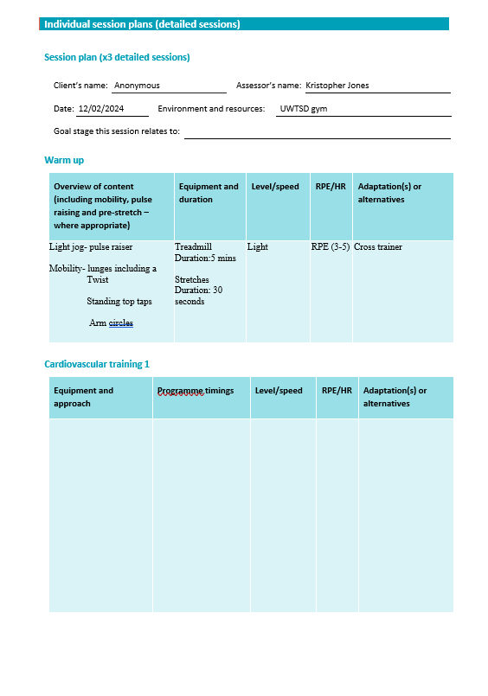

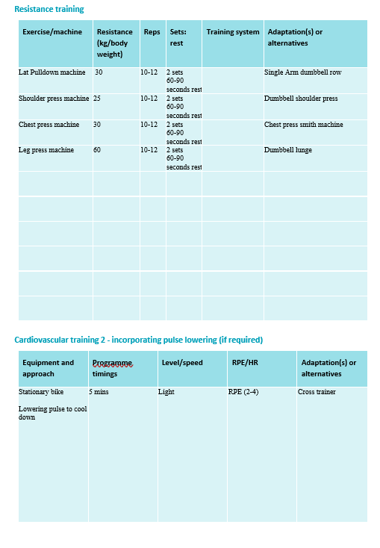

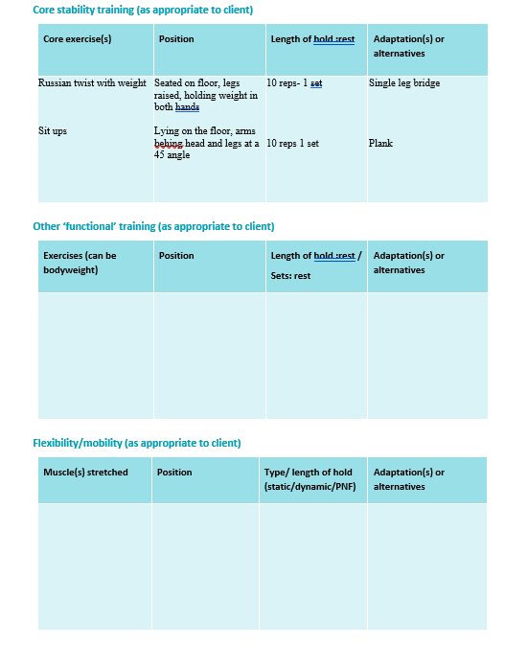

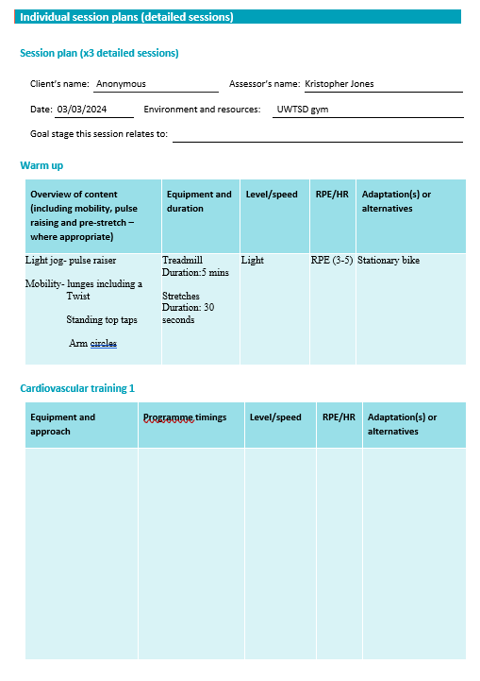

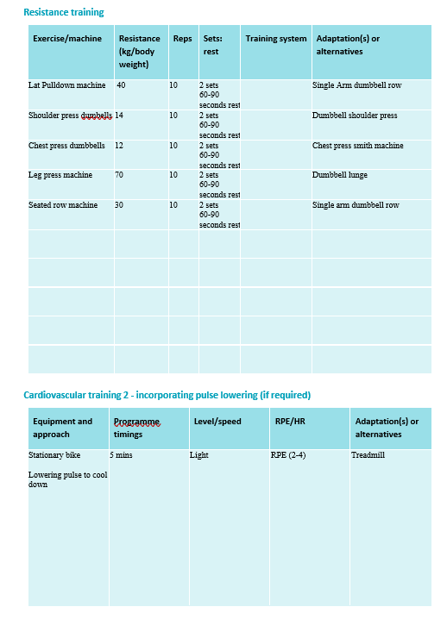

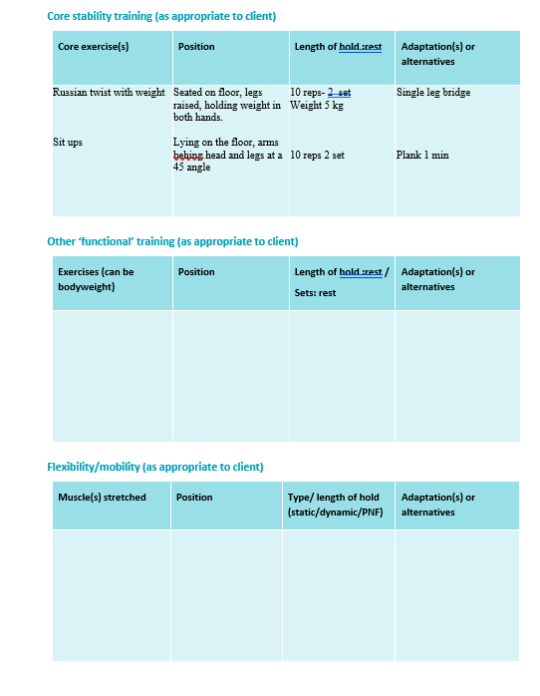

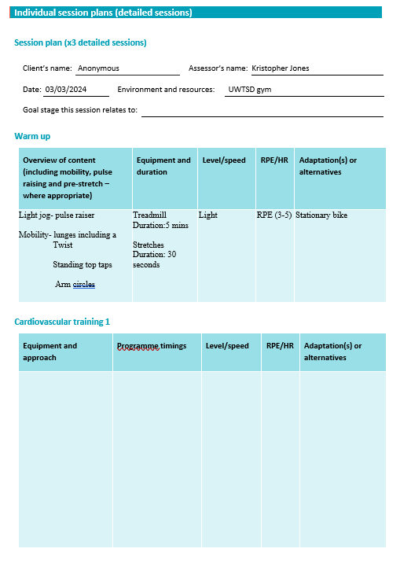

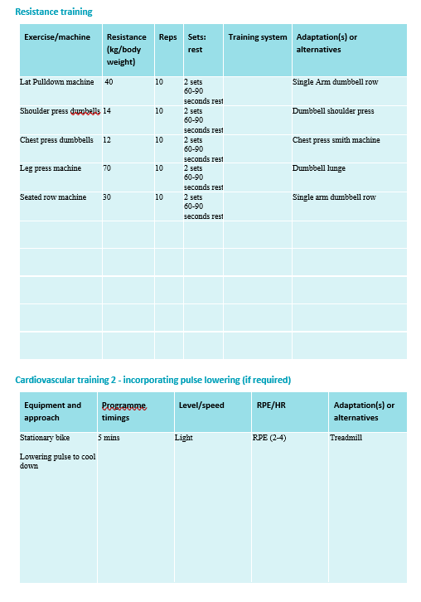

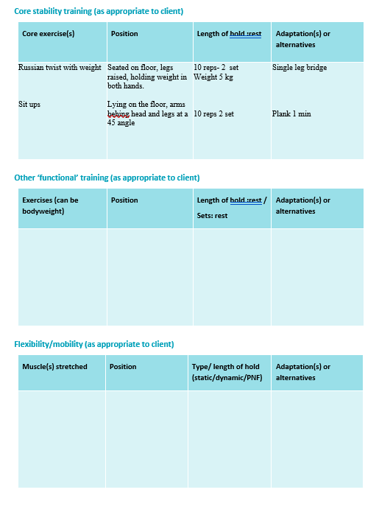

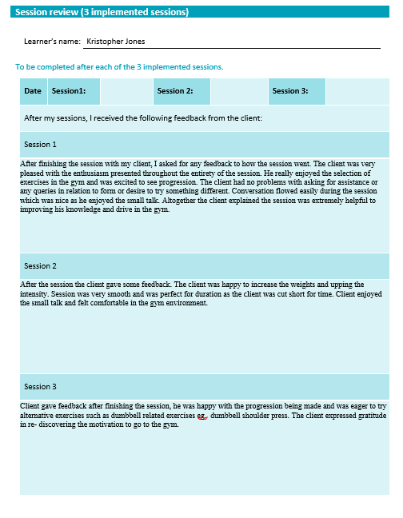

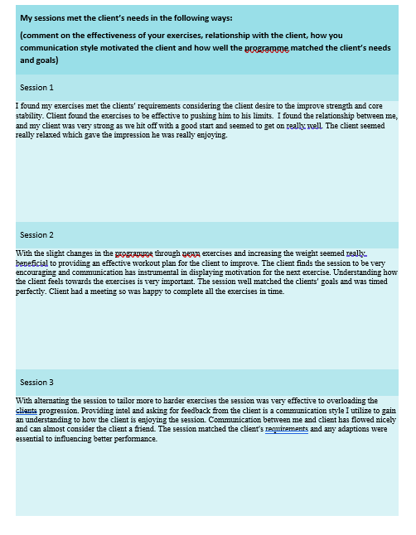

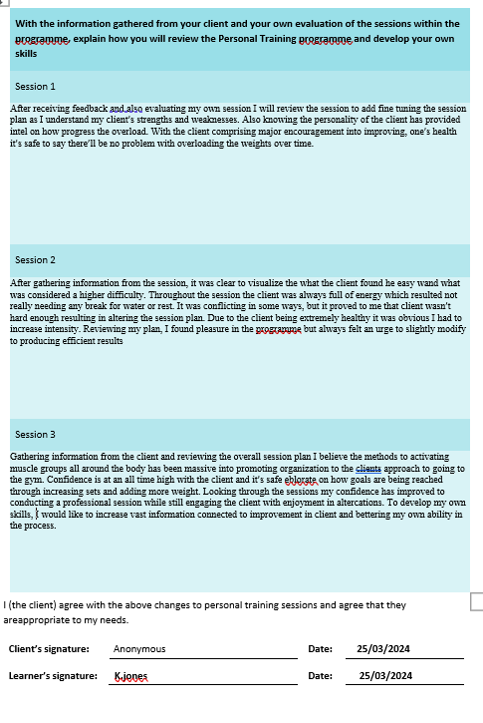
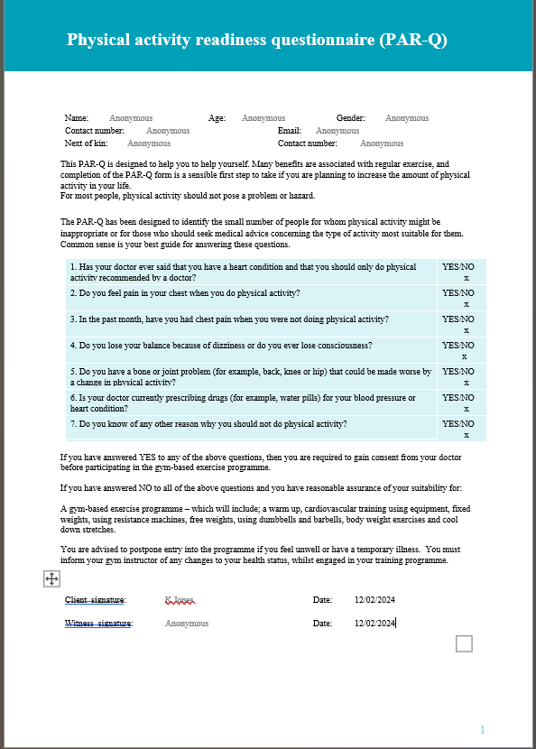
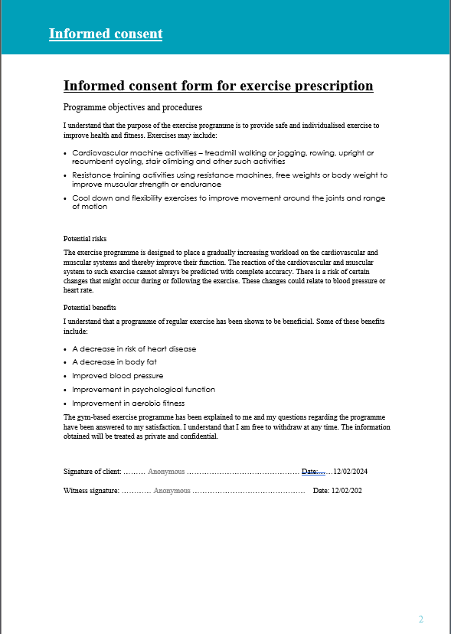
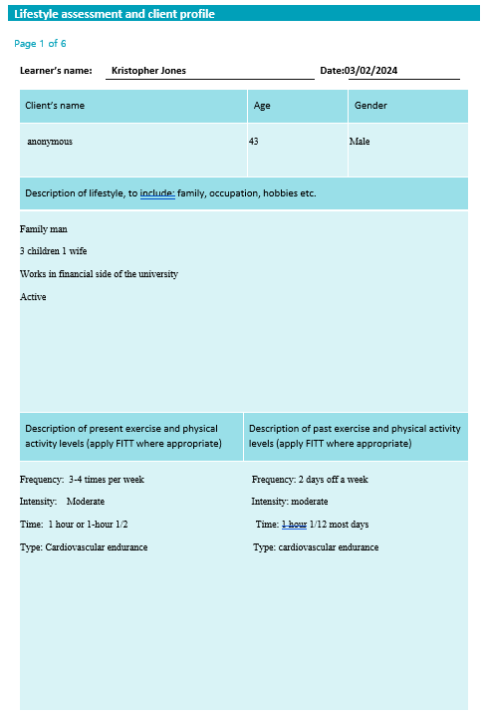
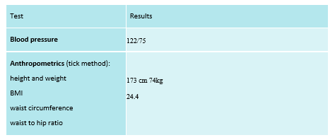
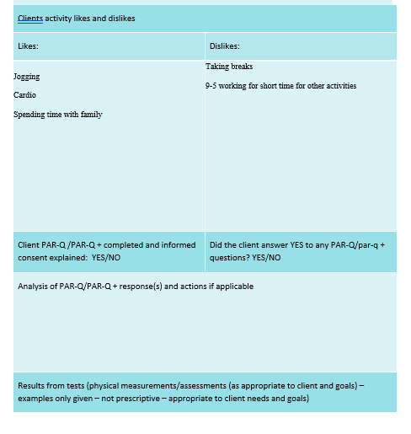

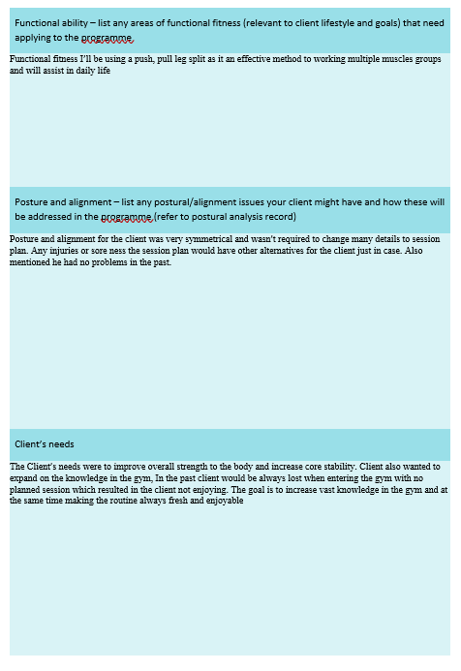

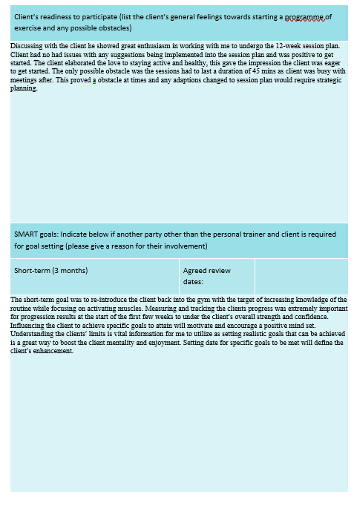

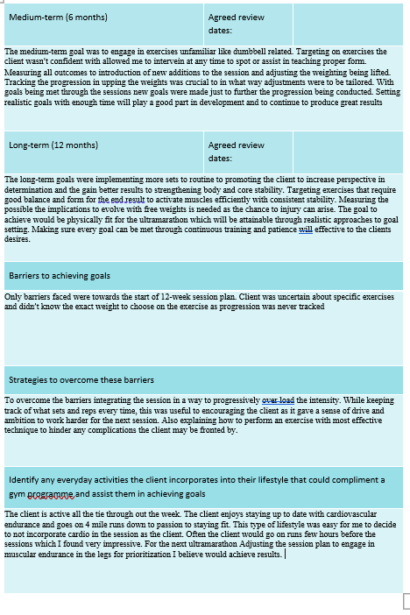

Rationale

The design of the session plan was prioritised to develop overall strength and core stability. After discussing with the client about the goals they desire and information on their day-to-day life, it was clear to see that the client was physically fit and active. The client mentioned and that he’s apart of running club and was soon to be attempting an ultramarathon for the first time. This information was extremely useful to creating the session plan as prioritising cardio wasn’t necessary considering the client is going on runs weekly. The overall structure of the first few weeks of the session plan was to engage the client and focus on re-introducing him into the gym. Utilizing the resistance machines felt perfect for these sessions as they are exceptional for someone starting the gym with little experience and free weights are recommended not for novices (Aerenhouts and D’Hondt). Having correct form is very important for conducting exercises, implementing machine exercises allows the client to be safe while learning the fundamentals (localleapsupport). The start of every session the client was required to endure a warmup for 5 mins at a low RPE (3-5). With the ultramarathon coming up the client was given alternatives for equipment to use but felt at home using the treadmill. The aim of the 5 min warm up was to increase the client’s pulse in readiness for the session. Warming up is crucial in a session plan as it’s great way to negate any injuries from occurring with the prioritization to activating muscles, while also increasing heart rate to prepare the client mentally and physically for the session (Leuvenink). After the warmup I incorporated some stretches before starting the resistance training. I thought this would be beneficial to the client as stretching is vital in ensuring the client is up for the task by activating muscles through movement. Stretching indicates if the client is carrying any issues or soreness which will dictate how the session is planned out (Shrier). Adjusting or always having a back plan is essential to the clients potential as different clients will have different needs and boundaries.

For the resistance training I decided to for a total body work out as the client didn’t go gym regularly. With the total body session, it felt right for the client as it allowed me to visualise how the client performs and what are their strength and weaknesses. With some experience in the past utilizing a total body work out was beneficial to promoting confidence while hitting multiple muscle groups with intention to focus on full body force (Davies) This provides advantages as it gives me the chance to correct form and answer any questions the client was unsure about. The session plan contained the structure of push, pull, legs split. This type of training is functional to working multiple areas of muscle in the body and especially convenient for people who don’t have enough time to work out. First exercise I chose was the lat pulldown machine, this exercise is staple to targeting and developing the back muscles. This exercise is extremely versatile for muscle activation and practical to daily life as everyday situations require functional movements such as pulling. The exercise focus strength and muscle endurance but also huge benefits towards hyper trophy (Ronai). Second exercise I opted for was shoulder press machine, Not feeling very confident with free weights I believed using the resistance machine would be efficient stepping stones to further the client’s progress. Shoulder press is without a doubt a definitive exercise to strengthening the upper body and increasing muscular endurance (Luczak et al.). Third exercise I decided for the session plan was chest press machine. The exercises primarily work the chest muscles with the addition of the triceps, the exercise is another method in strengthening upper body and is effective in association to progressive overload with stable movements. (Ferreira et al.)
Allowing the resistance machine to guide the client will prove useful as the client can remain focused on engaging the targeted muscles. Next exercise was prioritising the clients leg strength, I chose the leg press machine. Leg press machine seemed appropriate for the client as bar bell squats or free weights was slightly out of the client’s comfort zone. The machine was great to ensuring safety while also allowing the client to overload weight with less pressure and is great to improving functional fitness into the programme (Migliaccio et al.).
After resistance training, I added exercises in relation to core stability since the client specified the need to improve their core strength. Adding sit ups and Russian twists were implemented into the session plan as they are both reliable methods to engaging the core through time and tension (Schultz). Nearing towards the end of every session the last task was to cool down the client. Offering alternatives like the stationary bike or cross trainer will be for the client to decide. The client will use either equipment for a duration of 5 minutes at RPE (2-4) to lower the pulse and relax the muscles. The importance of cooling down after exercising is crucial to removing any evolving threats such as injury risk while incorporating muscle recovery (Olsen et al.) Cooling the client down is essential to the client’s performance for future sessions considering the positive aspects it possesses. Overtime I adapted the session plan throughout the weeks to progressively overload the programme. Increasing the weights being lifted overtime was the focus and slightly alternating the reps in the sets from 10-12 reps to 10 to influence progression to strength while allowing the client to maintain stability though the technique. Second and third stage of the 12-week session plans I Added more exercises to the resistance training to further progress the client’s strength and muscular endurance which I felt was right as the client was showing promising results. Other adjustments were established to the session plan like swapping certain exercises to dumbbell exercises. Having learnt the correct form the client felt like it was time progress to exercises that displayed harder difficulty which required steady balance. Without the assistance of the resistance machine the client will struggle to adapt quickly but over time through consistent training technique will shine and core stability will drastically increase due to balancing the dumbbells (Anderson and Behm). Changing the session was crucial in engaging the client, the client mentioned struggles to find motivation to go gym which was down to doing the same exercises and losing interest. Providing variety and alternating session plans will be a main goal into the client’s progression and enjoyment.

Reflection

The whole journey of taking a client through a session plan has been a really fulfilling experience and a great insight into the future of personal training. I was really blessed to have a good client considering the communication and motivation was exceptional throughout the sessions. The client mentioned he has experience in the past with the gym, but I noticed he needed advice to enhancing form/technique. I recall the first session the client attempted the lat pull down machine he showed me his technique he used to do. He mentioned he always felt he was working his shoulders rather than his back muscles. With a few visual representations and advice to allowing the body to stretch the back in the up phase of the rep and other small adjustments. The client quickly learnt and gave feedback to feeling the exercise more in the back. Informing the client the appropriate technique and gaining good feedback brought satisfaction to me as the session started off with major progress being made. With a few minor adjustments the client has made amazing progress, and the form has drastically improved. The real modifications made to the session plan were to overall increase the weight over time. By integrating overload overtime the client will be see great improvement to gaining muscle, applying this method is a fundamental for a session plan to getting the best out of the client to surpassing limits and ability. Always striving to keeping the routine fresh and enjoyable was in consideration constantly as it allowed me to be creative and provide variation to chosen exercises. With client expressing boredom towards the gym from replicating the same routine I made sure to spice up the session plan still hit all body parts with sprinkle of options to continue client’s interest. I was content with how the session plans went, first few sessions I felt nervous as it was my first time conducting a programme for a client. As weeks went on my nerves had relinquished when meeting my client which was down to creating a solid connection. In my eyes the programme was successful in reaching the clients goals but at the same there’s always room for improvement personally. If I had longer duration with the client, I felt would’ve been perfect for more prioritization to core stability with additional sets being added to the whole session. Throughout the course of taking the client my skills have effectively developed. Being given the chance to take on a client and provide education in in a gym/ workout environment has established experience into the real perspective of a personal trainer. My organisational skills have gradually improved since I wanted to help the client at full capacity with the best routine specialised for them. Communication skills have improved in general as feedback was a main source of adapting the session plan and understanding how the client feels mentally and physically. I believe the client has amassed valuable information from the sessions and can be feel confident he can still follow these routines in the future with ease and obvious overload to continue good progression.

References

Aerenhouts, Dirk, and Eva D’Hondt. “Using Machines or Free Weights for Resistance Training in Novice Males? A Randomized Parallel Trial.” International Journal of Environmental Research and Public Health, vol. 17, no. 21, 26 Oct. 2020, p. 7848, https://doi.org/10.3390/ijerph17217848.
Anderson, Kenneth, and David G Behm. “The Impact of Instability Resistance Training on Balance and Stability.” Sports Medicine, vol. 35, no. 1, 2005, pp. 43–53, https://doi.org/10.2165/00007256-200535010-00004.
Davies, Daniel. “4 Tried-And-Tested Full-Body Workouts That Burn Fat and Build Muscle, Fast.” Men’s Health, 17 Dec. 2020, www.menshealth.com/uk/building-muscle/a28433729/full-body-workouts/.
Ferreira, Diogo V., et al. “Chest Press Exercises with Different Stability Requirements Result in Similar Muscle Damage Recovery in Resistance-Trained Men.” Journal of Strength and Conditioning Research, vol. 31, no. 1, Jan. 2017, pp. 71–79, https://doi.org/10.1519/jsc.0000000000001453. Accessed 4 Oct. 2019.
Leuvenink, Henri G. D. “Warming Up—Not Only Essential for Athletes?” Transplantation, vol. 100, no. 1, Jan. 2016, pp. 10–11, https://doi.org/10.1097/tp.0000000000000952.
localleapsupport. “The Importance of Proper Form and Technique in Your Workouts.” Circuit 31 Fitness, 16 Jan. 2023, www.circuit31fitness.com/the-importance-of-proper-form-and-technique-in-your-workouts/.
Luczak, Joshua, et al. “Shoulder Muscle Activation of Novice and Resistance Trained Women during Variations of Dumbbell Press Exercises.” Journal of Sports Medicine, vol. 2013, 2013, pp. 1–6, www.ncbi.nlm.nih.gov/pmc/articles/PMC4590897/, https://doi.org/10.1155/2013/612650.
Migliaccio, Gian Mario, et al. “Corrigendum: Leg Press vs. Smith Machine: Quadriceps Activation and Overall Perceived Effort Profiles.” Frontiers in Physiology, vol. 9, 21 Dec. 2018, https://doi.org/10.3389/fphys.2018.01856.
Olsen, Olav, et al. “The Effect of Warm-up and Cool-down Exercise on Delayed Onset Muscle Soreness in the Quadriceps Muscle: A Randomized Controlled Trial.” Journal of Human Kinetics, vol. 35, no. 1, 1 Dec. 2012, pp. 59–68, content.sciendo.com/view/journals/hukin/35/1/article-p59.xml, https://doi.org/10.2478/v10078-012-0079-4.
Ronai, Peter. “The Lat Pulldown.” ACSMʼs Health & Fitness Journal, vol. 23, no. 2, 2019, pp. 24–30, https://doi.org/10.1249/fit.0000000000000469.
Schultz, Rachael. “How to Do a Russian Twist the Right Way.” Women’s Health, Women’s Health, 25 Jan. 2019, www.womenshealthmag.com/fitness/a26011033/russian-twist/.
Shrier, Ian. “Warm-up and Stretching in the Prevention of Muscular Injury.” Sports Medicine, vol. 38, no. 10, 2008, p. 879, https://doi.org/10.2165/00007256-200838100-00006.

