The Internet of Things, Smart City Security Issues & Analysis of Potential Threats, Risks and Attacks

Shay Friel
Advanced Cybersecurity
Module Code: ACCA6000
Swansea, Wales
Sfriel.151758@student.uwtsd.ac.uk

Table Of Contents
Introduction………………………………………..1
Related Work……………………………………...2

Analysis of Lab Exercises…….…………..……….5
Implementation..……………………………..…..10
Results/Findings and Discussion…….…….……..12
Conclusion……………………………………….15
References………………………………………..15
Bibliography………….…………………………..16

Abstract— The Internet of Things has changed the world, allowing the creation of advanced computing communication technologies, smart cities, smart devices and many more in production smart systems, enhancing quality and performance of communication devices around the world. It is not all benefits that come with the Internet of Things, this statement echoing cybercrime and cybersecurity. Over 90% of data breaches are caused by phishing attacks, meaning human error is the biggest factor when it comes to email phishing. This report focuses on the potential threats, risks and attacks against smart cities and a newly built UWTSD (University of Wales Trinity St David) smart campus in the heart of Swansea.

Introduction
The growth of the Internet of Things (IoT) has benefited the world of technology in many ways, allowing any time access to information anywhere in the world with the use of network devices such as a smartphones, tablets, laptops and any devices with internet connection. IoT has also produced interconnected network devices, enhancing quality and performance of communication devices with more transparency, which reduces inefficiencies and provides easier communication between people, businesses and organizations. These are a few examples of how individuals and organizations have prospered with the IoT, however one key factor that hasn’t been mentioned is cybersecurity.

Cybercrime has been a dilemma since IoT became popular around 2004, where each year the amount of cyberattacks deployed against businesses is rising in numbers rapidly. There are threats everywhere, abusing the benefits IoT have brought into the world, and exploiting every device/network they can with malicious cyberattacks like phishing, malware, SQL injection, denial-of-service (DoS) and distributed denial-of-service attacks (DDoS). These attacks are executed in order to steal information, passwords, emails, credit card credentials, destroy or manipulate data, anything that the attacker wants access to. These are just a few examples of the most common types of cyberattacks that are deployed against businesses and organizations today, who are in desperate need for solutions to help prevent and/or detect vulnerabilities, threats and attacks.

Cybersecurity is one of the fastest growing industries in the world today, with organizations employing graduates studying cybersecurity straight from universities in order to help combat the highly sophisticated cybercriminals. Cybersecurity organizations are working hard, building security infrastructures for businesses, to provide protection for sensitive information and data running over their network. However, cybercriminals come up with new attacks every day, trying their best to exploit the target systems and bypass the security to gain access to information.

Smart cities and buildings are in the process of being designed and built for cities suffering with the lack of resources to carry out essential work such as healthcare, education, transportation, government and safety. These newly designed cities will include cloud-based services, interconnected devices and intelligent computing systems to benefit cities with smart computing technologies, allowing people to advance with technology in order to provide more efficient services and reduce cost. Many benefits come with smart cities, however there are several security issues that need to be addressed and analyzed in order to prevent threats and attacks.

This report is going to focus on the work of other researchers working in the cybersecurity field, including the Internet of Things and smart city security issues, computer/communication networks and infrastructures security issues and future trends in cybersecurity. This report will also contain the analysis of 4 different lab exercises from class including social engineering phishing, browsing the internet anonymously using CyberGhost, foot printing and reconnaissance and cryptography. The knowledge gained from the research and the analysis of the 4 lab exercises will be used to design and implement some security countermeasures, to help protect resources such as network hardware, servers and databases on the IQ building at the UWTSD smart campus. We will also be using Kali Linux and tools such as Wireshark to analyze any potential threats, attacks and network traffic.

Related Work

Internet of Things and Smart City Security Issues

Over the last 15 years, the Internet of Things has been the gateway for many new technologies and allowed communication between people without physically seeing one or another. Two or more computer systems communicate with each other, with sensors embedded into physical objects with network activity allowing communication between people, businesses and organizations. These systems were just the beginning of what was to become of smart computing technology, with countries planning on big investments to build much larger systems.
Whilst these communication systems and devices have been popular for almost 20 years, some countries have moved on to larger projects, designing and building smart cities. An article online by Verdict [1] explains that Los Angeles was the first to develop a smart city, but many people class Amsterdam as one of the first smart cities built, in 1994 where the creation of a virtual digital city was developed, being citizen friendly and sustainable. As the city proved to be sustainable and efficient, in 2005 Cisco invested $25 million across 5 years of research into smart cities. This was later followed by IBM Smarter Planet Project in 2008, where they explored the use of sensors, network and analytics into urban issues. Over the years leading up to date in 2020, other cities such as Barcelona, Yokohama, London and Hanoi have all been inspired and started investing to work on new billion-dollar smart cities.

As stated earlier in the introduction, smart cities are benefiting countries, businesses, organizations and people, creating more sustainable cities utilizing resources and creating better living for residents. However, many security threats are among the cities and if they are not managed then the systems and devices within the cities will be vulnerable to threats and cyberattacks.

The 4 main security characteristic concerns of an Urban Environment (Smart City) are Privacy, Integrity, Availability and Interoperable Security. A journal by Felipe Silva Ferraz and Carlos Ferraz [2] discusses Information Security in a smart city environment, where the privacy concept is an act of only allow permission to the correct individual with the correct details seeking entry to specific information or data. The integrity concept relates to information and data cannot be changed without authorized access. If there are attempts to change the data, then the rightful owner will be notified. Under the context of Information Security, the availability concept matches with privacy, where information will only be available to the person with authorized access. The final security concern is interoperable security, which relates to the act of keeping the system working even if one point in the system has failed.

Felipe Silva Ferraz and Carlos Ferraz [2] also discuss in their journal some of the security issues within a smart city, beginning with access to information from applications. Here they explain how packets could be accessed in different ways and locations through network devices, creating local copies of the packets. For example, an attacker intercepting the packets of a user trying to gain access to personal information, this impacts the security concerns of privacy and integrity. Another security issue within the context of a smart city, is user/citizen data theft. The use of IoT devices such as smartphones, tablets, laptops and other devices run data across the smart city network, containing a wide range of sensitive data and information including messages, images, bank details, contacts and more, leading to the issue of valuable data being intercepted across the network by an attacker.

The main security vulnerabilities within a smart city infrastructure are the weakness of sensor security. They are easily targeted by attackers and are never given enough attention when implementing cybersecurity. An article on Infosec [3] stated the vulnerabilities of manipulation of 200,000 traffic control sensors in large cities such as Washington D.C, New York and London. With figures like this, it evidences the lack of cybersecurity within smart cities, which leaves the citizens vulnerable to lack of data privacy, integrity and availability.

Smart cities are going to accommodate large enterprises, universities and businesses, meaning that these organizations will be part of the smart computing technology the city has to offer. The problem with this is the cyberattacks businesses attract with them, meaning more security issues within the cities. For example, one of the most alarming attacks is ransomware, they bring highly technical integration and effect the interdependencies that exist inside the smart cities. For instance, attackers can cause a huge chain reaction of destruction by forcing people out of work by disabling their transportation, maybe corrupting the train times or malfunction the subways. This leads to people being unable to report to work which would have a negative impact on their finances. [3]

An article [4] by Richard Peto and Daniel Tokody discuss a range of potential harmful events within a smart city, including the dangers of compromised CCTV. Every CCTV camera that connects to the internet is easy accessed by virtually anyone, with the aid Internet of Things search engines like Shodan. If these security systems were compromised, attackers would be able to leak classified information or analyze security schemes of organizations, which leads to further attacks.

R.Peto and D.Tokody also explained the stages of establishing security inside a smart city. See figure 1. Components of protection are illustrated in the security pyramid shown in figure 1, expressing how each step is built on top of one another with different missions.
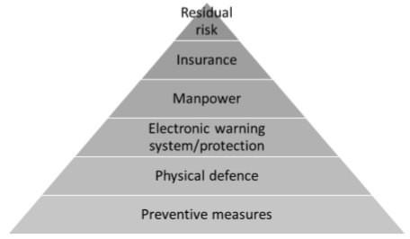
Figure 1 [4]

Cyberattacks are more common in large urban cities around the world because of the lack of security and vulnerable devices everywhere, meaning attacks such as phishing, Man-in-the-Middle, malware, ransomware and denial-of-service attacks are deployed daily. Although the cities may not benefit the users with high level security, they can secure their own devices and networks by always choosing strong passwords, installing anti-virus software on their devices and using the think before you click protocol. Most email phishing attacks are highly sophisticated and almost impossible to detect if they are legitimate or not, so always use software like email tracer to find out if the email is legitimate. Another way of securing your device is using a virtual private network (VPN), but never connect to public VPN’s as they could be a silent hacker’s network.

Computer/Communication Networks and Infrastructures Security Issues

The most highly anticipated issue with computer/communication networks is cyberattacks, and according to an online article [5] by K.Austin, some of the most common but dangerous attacks are distributed denial-of-service attack (DDoS), SQL injection attack, phishing, Man-in-the-Middle attack and drive-by attack. The aim of these attacks is usually to destroy or manipulate data, steal personal information, bank details, username and passwords.

In the case of DDoS attack, the attacker aims to compromise multiple systems using botnets, flooding the system with traffic in order to disable or temporary disrupt the user’s machine for a long period. There are many reasons why attackers want to execute this attack, this could be for revenge, blackmail and activism. In an article by Victor Santoyo [6] he explains how a DDoS week-long attack can be bought for just $150 on the dark web, and over 2000 DDoS attacks are executed every day. Santoyo also discusses how you can activate a web application firewall (WAF) to prevent the attack, where a layer of protection is inputted between the website and the network traffic. Another way to help combat DDoS attacks is to monitor the website traffic for any potential threats like peaks, that usually lead to DDoS attacks.

SQL injection attack is a data-driven attack, where the attacker aims to inject malicious code into a victim’s database for example, corrupting the system or device. According to an article [7] by B. Yamini, the types of SQL injections attacks are SQL login bypass, blind injection, error-based attack and union-based attack. A successful SQL injection could even impact a business and result in compromising a list of names, values, checks and payment details. These attacks are usually executed to gain unauthorized access, steal data or compromise organizations. B. Yamini explains how using a web vulnerability scanner which scans for vulnerability scripts inside the application will detect and prevent SQL injection attacks. Additionally,using a firewall can also provide high accuracy against web vulnerabilities.

Phishing is a cyberattack where the attacker seeks to steal sensitive information such as passwords, credit card credentials, emails and any related personal information by mimicking a trustworthy identity. Usually attackers send fraudulent emails to victims and pose as their bank, requesting their personal details. A journal [8] by R. Fatima explains how phishing emails are so highly sophisticated today, it’s almost impossible for the victim to detect if the email is legitimate. The only way not to fall into deception of the scams is to either ignore the emails or use software to detect where the email came from and if it contains malicious links. The everyday person will not go that far into finding out where an email came from, this is why phishing still remains as one of the most successful cyberattacks in 2020, with 90% of data breaches caused by phishing attacks and over 76% of businesses are victims. [9]
A Man-in-the-Middle attack is where an attacker places himself in between two parties communicating, intercepting any network traffic that the two send to each other. For example, a user sends a message containing bank details across the network intended to arrive to a familiar user, but before the message arrives the Man-in-the-Middle intercepts the message and gains access to the user’s bank details. One form of Man-in-the-Middle attack is ARP spoofing, where the attacker sends forged ARP messages over the network in order to link their MAC address with the IP address of a familiar device on the network, granting them access to the network traffic. Presently, there is no working security mechanism to prevent ARP spoofing. However, in an article [10] which takes an approach to mitigating ARP spoofing by Seung Yeob Nam, he proposes a new security mechanism to counteract ARP spoofing by protecting new nodes from ARP spoofing through fair voting among neighbors. He quoted “The key idea is that even a new node can be protected from an ARP cache poisoning attack if the mapping between an IP and the corresponding MAC addresses is resolved through fair voting among neighbor nodes under the condition that the number of good nodes is larger than that of malicious nodes.”

Drive-by attack is where an attacker injects malicious code into a legitimate website, compromising the browser and then waits for a victim to click on the website in order to install malware and other viruses onto their PC. This can lead to data theft, stolen personal information and even ransomware. The attack is called ‘Drive-by’ because the user doesn’t have to click anything on the corrupt website for the attack to work and the victim is also oblivious to the attack. An online blog [11] by Brian Laing explains that even though it’s important to keep your devices updated to weaken the chance of being a victim of a drive-by download, cybercriminals always find new security flaws in the updates and exploit them. This means it’s inevitable that attackers will always corrupt some legitimate web servers. However, some web servers have strong security and attackers seem to always exploit the same servers repeatedly. Laing listed some prominent systems and applications that are commonly exploited such as Adobe Reader, Adobe/Shockwave Flash (ActiveX), old operating systems (Windows XP), Oracle Java and out of date browser plug-ins.

To conclude, the three most common network security issues is data loss, security breaches and malicious cyberattacks. These threats and attacks will always exist due to attackers finding security flaws and exploiting them, making it impossible to be one hundred percent secure when connecting to an online network. However, users can prevent or weaken the threats and attacks by using firewalls and anti-virus software, encrypting data, implementing security settings on the router to block unauthorized access, and training staff with security countermeasures to prepare them for any threat in the future.

Future Trends in Cybersecurity

Over recent years cybersecurity has been a major factor in networks all over the world and the Internet of Things devices. Businesses are suffering from thousands of cyberattacks a day, with a cyberattack taking place every minute. In 2019 there was an estimate of more than 20 billion devices to be connected by 2020. Cybersecurity is one of the fastest growing industries in the world today, employers seeking more cybersecurity engineers to help them protect their businesses from threats and attacks by cybercriminals. Due to the threat, cybersecurity will be trending for many years to come with so many people, businesses and organizations suffering from cyberattacks.

Z. Banach posted an online blog [12] discussing some of the future cybersecurity trends to look out for in 2020, with the top result being data breaches as cybercrimes worst threat. Organizations are spending millions every year ensuring data is secure and private, however there are reports that data breaches continue to be the biggest cybercrime threat to businesses and organizations with valuable information and data which attracts criminals. Banach also discusses how the cybersecurity skills within small businesses are increasing, with cybersecurity automated security tools such as online vulnerability management solutions are provided to workers to allow them to tackle any future threats and attacks, providing the companies with good security posture.

An online article by Dorit Dor [13]
Discusses the rise of artificial intelligence (AI), where it is being used as a proxy for crime, accelerating the detection of cybercrime threats and helping prevent attacks quickly before spreading. However, anything that the virtuous can use, the corrupt will use also, meaning cybercriminals have responded to the use of AI by taking advantage of the techniques used to help detect vulnerabilities and create more ambiguous malware. Another future cybersecurity trend Dor has discussed is the development of 5G, where she explains how a flood of 5th generation cyberattacks will attack the 5G network and exploit more vulnerabilities than ever before. Even without the installation of the new 5G networks, new cyberattacks and threats are developed every day, this will only result making IoT devices more vulnerable to cyberattacks when most devices switch over to the new 5G network.

To conclude, this part of the report has discussed the Internet of things and smart city security issues, computer/communication networks security issues and analysis of the most common types of cyberattacks, and some future trends in cybersecurity. The next section of the report will be an analysis of 4 different lab exercises from class, analyzing some potential solutions to prevent certain cyberattacks.

Analysis of Lab Exercises

This section of the report will focus on four lab exercises provided in class to analyze potential threats/attacks and vulnerabilities and some potential prevention and detection of cyberattacks.

Social Engineering

The first lab exercise used was social engineering, where the attacker uses email phishing to steal personal information such as username and passwords. This attack was set up in Kali Linux using the social engineering toolkit, as seen in figure 2. The steps used in the Social Engineering Toolkit (SET) was 1. Social-Engineering Attacks. 2. Website Attack Vectors. 3. Credential Harvester Attack Method. 4. Web Templates. 5. Input IP address of destination host. 6. Choose Google to setup fake Gmail login webpage. 7. Wait for victim to input credentials.
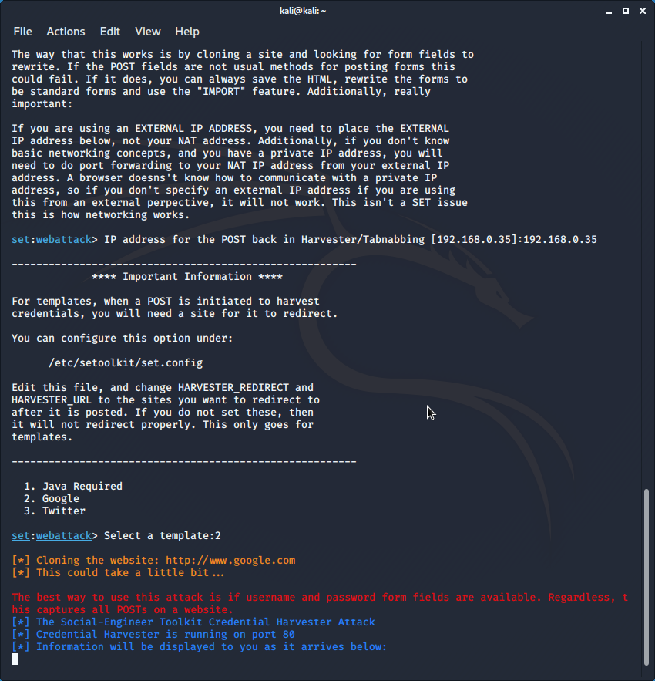
Figure 2

The next phase in conducting the attack is creating a fake email disguised a weapon and send it to the victim. See figure 3.

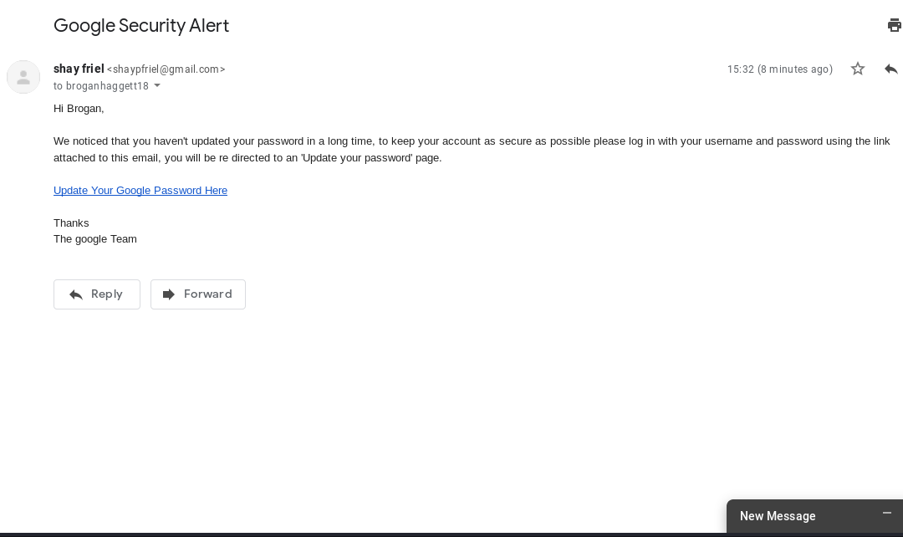
Figure 3

After the link in the email is opened and the victim logs into the fake Gmail website, the credentials input are sent back to the attackers PC/Laptop and the attacker now has access to the victims Gmail account, accessing all emails and possible sensitive information within the emails. Username found = broganhaggett18@gmail.com. Password found = haggett200haggett. See figure 4.

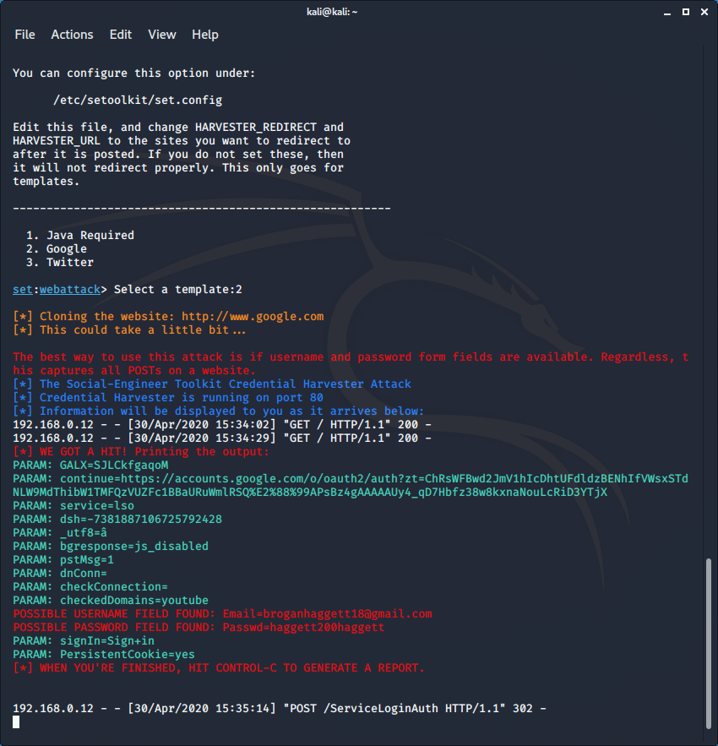
Figure 4

This social engineering lab shows how easy it is for attackers to steal usernames and passwords from vulnerable users who don’t think before they click. This lab has provided the solution to prevent email phishing attacks in the future, reinforcing sensitive information should not be shared via email. Banks and social media accounts never request personal information over email, only within the organization they allow you to input personal information. This also demonstrates why it’s a good reason to trace suspicious emails, software such as Email Tracer can provide you with the exact IP address and the location the email came from, allowing you to see if they email is legitimate or not.

Browsing Anonymously with CyberGhost

Many people and businesses suffer with the lack of privacy when browsing the internet, and even more suffer with threats and attacks because of the lack of security. Browsing the internet today is no longer safe with the threat of location sniffing and spying. One solution to securing privacy when browsing the internet is using a virtual private network (VPN), and the VPN demonstrated in this lab exercise is CyberGhost. This software provides enhanced internet traffic security, allowing users to display fake locations and IP addresses if an attacker tries to sniff out their location, allowing the user to browse anonymously and maintain data privacy.
In the first step of this lab exercise, CyberGhost prompts the user to pick a server destination, which will display that the user is currently in that country. In this case, the chosen destination is Australia. See figure 5.

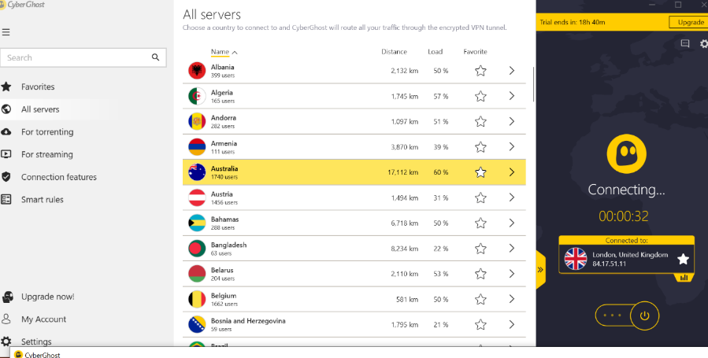
Figure 5

Figure 6 shows that the chosen proxy server (Australia) has connected successfully and provided the user with the IP address 103.13.101.172 and location of Sydney, Australia. The user can now browse anonymously.

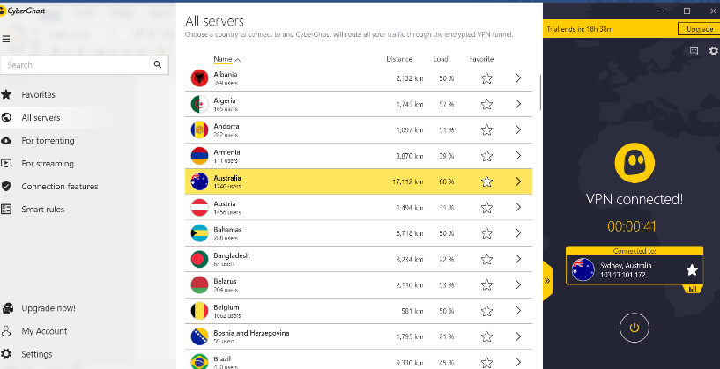
Figure 6

Now that the VPN has successfully established a connection, the next step in the lab exercise was to check if it was working correctly. Figure 7 and 8 demonstrates the user opening a web browser and searching for the desktops IP address, which provides the geolocation map for 103.13.101.172, Australia.

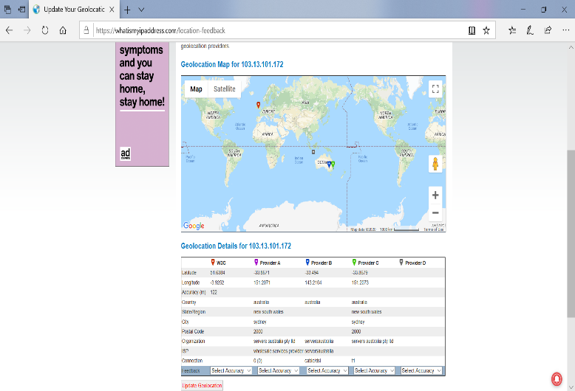
Figure 7

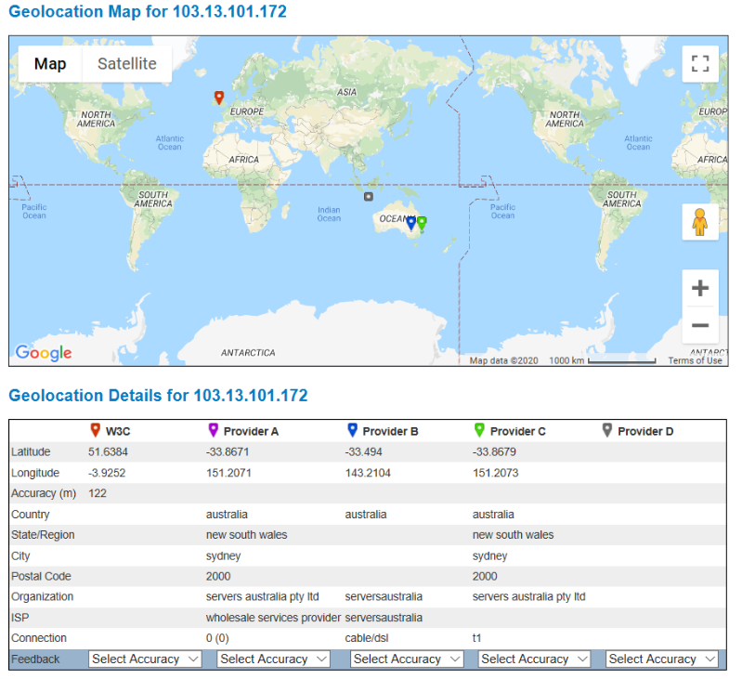
Figure 8

This lab exercise can assist many people and businesses struggling with data privacy whilst browsing the internet, providing internet traffic security and safety. Virtual private networks can offer enhanced security, remote control, online anonymity, bypass filtered websites and provides network scalability. Although most VPN’s are secure, never trust a public VPN as attackers usually attract users with weak Wi-Fi connection and exploit their devices stealing sensitive information as soon as they connect, therefore only use trustworthy VPN’s or use your own.

Tracing Emails with Email Tracer Pro

Attackers always target employees in order to compromise big organizations, for example using highly sophisticated phishing emails to steal information. A large amount of these employees or even the every day user are vulnerable to these attacks and it’s important to know how to compare suspicious emails to legitimate ones. This lab exercise focuses on using an email tracer, analyzing email headers to extract the information of the email such as the location, date, IP address and time.

The first step of this lab exercise is to setup a fake email and send it to the victim, in this case the attacker is saying she’s from Halifax bank and wants to know the bank details of the victim in order to setup online banking. See figure 9.

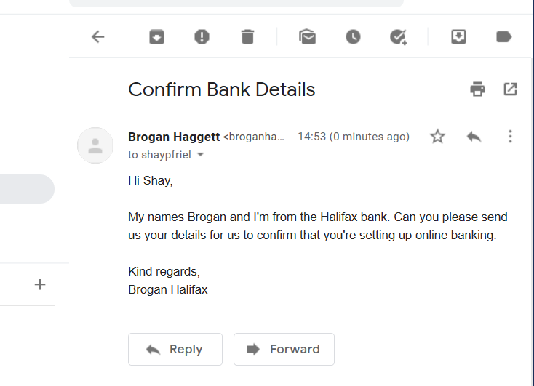
Figure 9

The next step in the lab exercise was to play as the victim. The victim opens Email Tracer Pro and clicks the option ‘Trace an email I have received’, and then copies the email header from the suspicious email and pastes it in the email headers section in Email Tracer Pro. See figure 10.

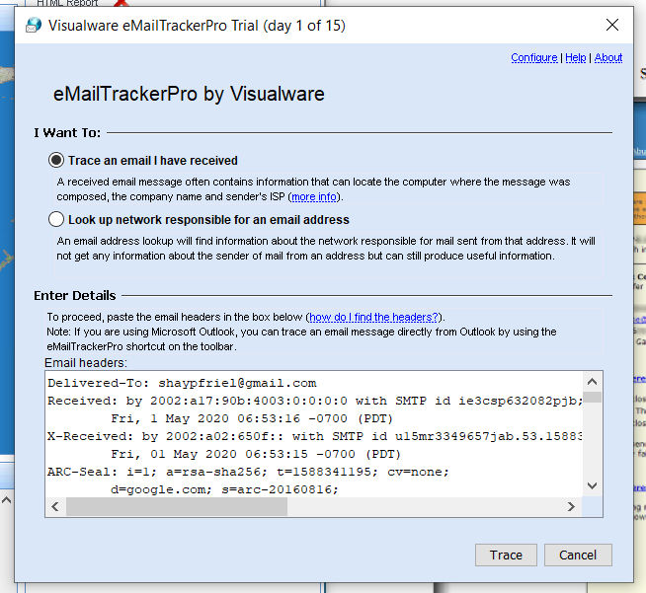
Figure 10

Figure’s 11 and 12 show the results of the trace, displaying the IP address of the email and the geolocation map which shows the email came from USA. The trace also displays the hop name of the router, which is ‘SkyRouter.Home’, this provides evidence that the email did not come from the Halifax bank and therefore is a scam. The trace has also provided details saying that the email is possible spam, and maybe connected to familiar phishing emails.

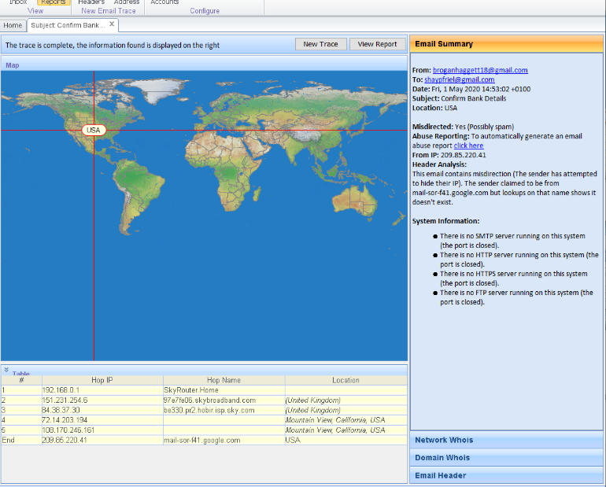
Figure 11

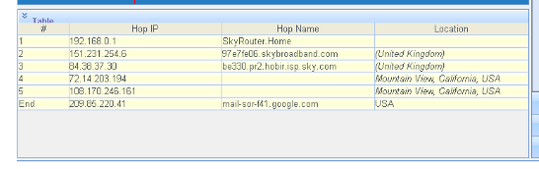
Figure 12
To conclude the email trace, a generated report showing in figure 13 detects that the computer 209.85.220.41 was located and was trying to hide their IP address, and the email ‘broganhaggett18@gmail.com’ is most likely fake so it shouldn’t be treated as conclusive.

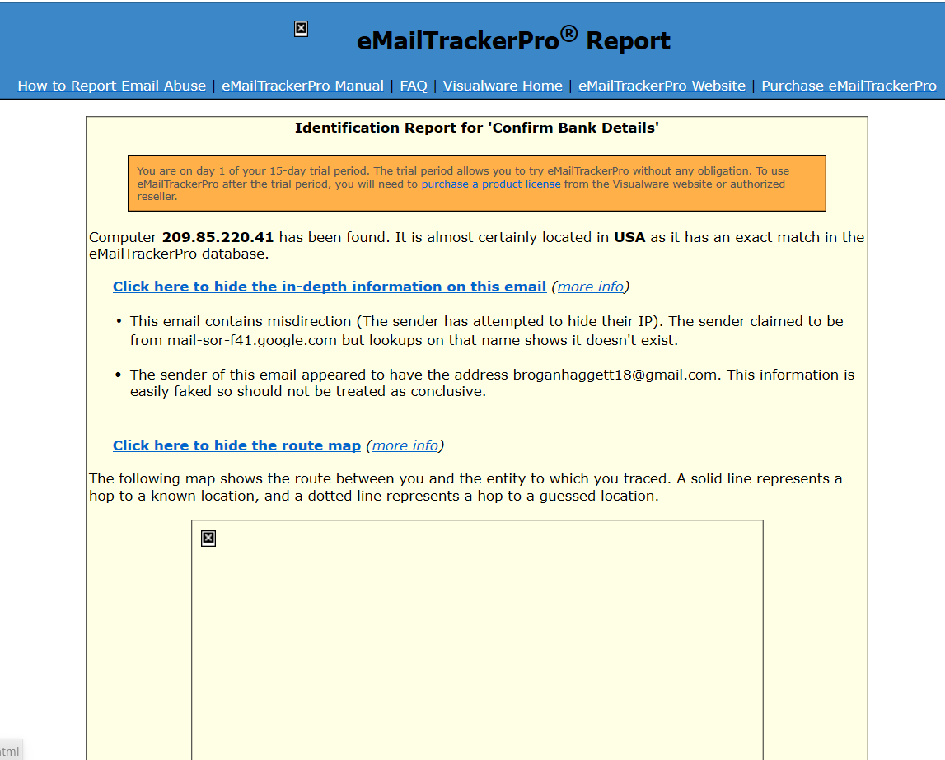
Figure 13

This lab exercise can assist organizations suffering from data loss and breaches by instructing employees to use software such as Email Tracer Pro to detect possible email scams and threats.

Cryptography

Cryptography is widely used by large organizations sending sensitive information over a network, for instance either via email or message. Cryptography is a secure communication technique that only allows access to the sender and the intended recipient, where the data is encrypted by hash values only the sender and intended recipient can decrypt using a key entry. This is a very important security technique to use when transmitting sensitive information or data with the amount of data breaches in 2020. In this lab exercise, we will learn how to use CrypTool to encrypt basic data and send it to a recipient to open with an entry key.

The first step in the lab exercise is to create a new document and input some sensitive information. To encrypt this information using the software CrypTool, we must select ‘Encrypt/Decrypt’ and chose symmetric (modern) RC2 encryption, and then finally input a key entry to allow the recipient to decrypt the message. In this case the entry key is 05. See figure 14.

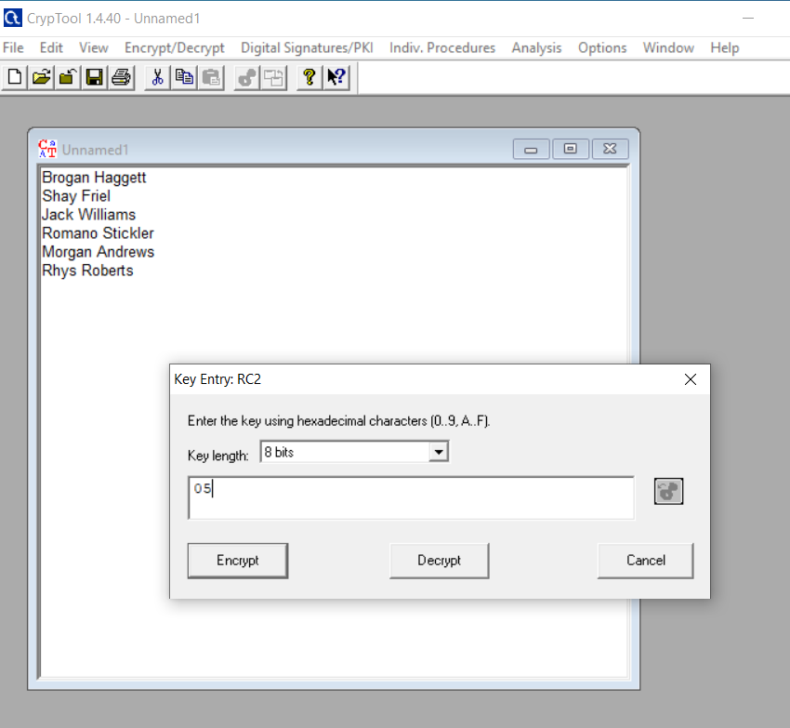
Figure 14

Figure 15 shows the RC2 encryption, demonstrating that anyone that has access to this message will be shown this encryption. This may be the difference between data theft or data privacy, it’s always important to encrypt your sensitive data.

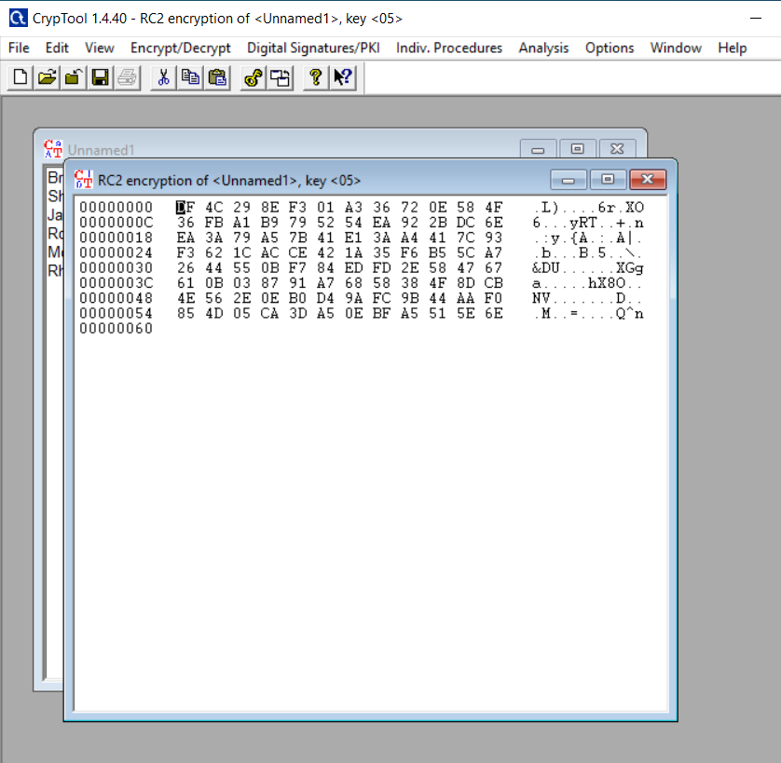
Figure 15

The next step in the lab exercise was to send the encrypted message to the intended recipient, providing them with the hex value to decrypt the information which is 05. See figure 16.

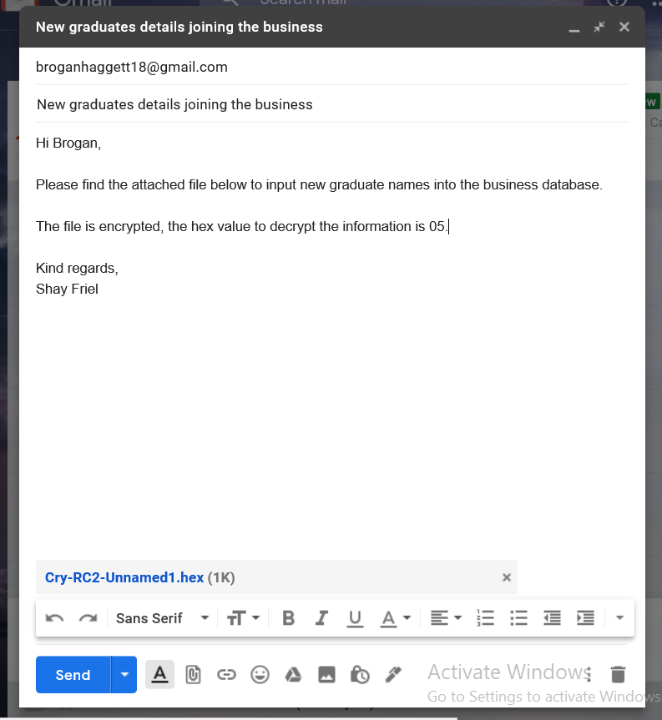
Figure 16

Figure’s 17 and 18 shows the recipient opening the RC2 encrypted message in CrypTool and using the hex value 05 to decrypt the message.


Figure 17


Figure 18

This lab exercise can aid or assist anyone sending personal information or private data across a network, by following simple steps to encrypt information shared with an individual in a secure manner, preventing attackers intercepting the message and stealing data.

Implementation

The newly built UWTSD smart campus plays a vital role connecting all networks, systems and devices through the Internet of Things. Resources such as hardware, servers and databases are connected to allow communication between smart computing technology, staff and students. This section of the report is going to discuss the design and implementation of certain areas of the smart campus, providing security countermeasures to secure the resources and services on the university campus.

Figure 19 shows the network designed using Packet Tracer, including 6 different areas on the smart campus.

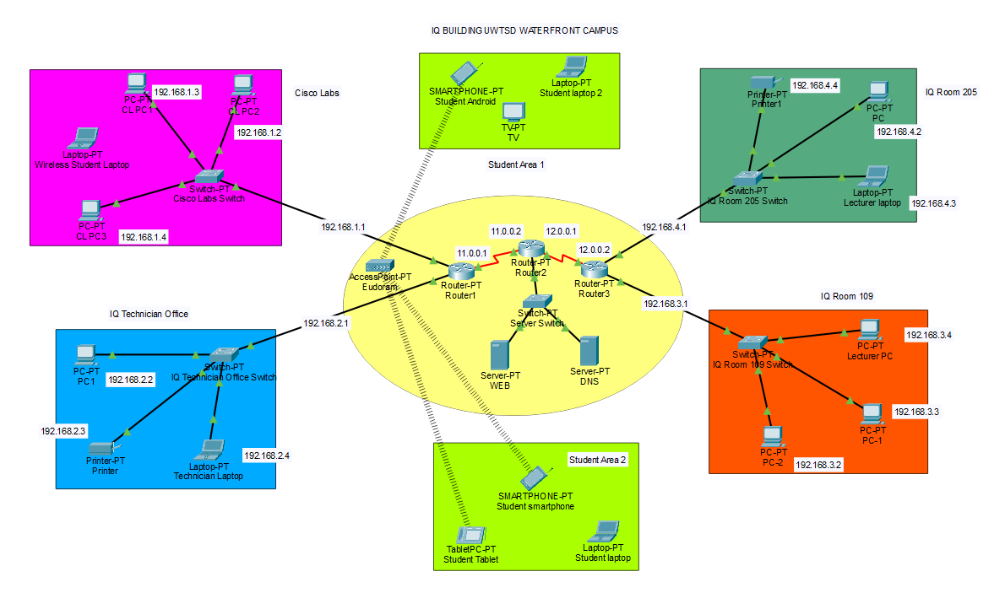
Figure 19
The first stage in designing the network was to implement 3 routers, 5 switches, an access point and 2 servers (Web and DNS) in order to connect each area. Each network device was provided with an IP address and connected through Fast Ethernet ports. The first area designed was the Cisco lab (Purple box), where 3 PC’s and a student laptop is connected to a switch, which is connected to the router. Each PC was given an IP address and a default gateway to the router which is 192.168.1.1. The second area designed was the technician office (Blue box), where 1 PC, 1 laptop and 1 printer were connected to the switch which connects to the router. The next part of the design was 2 students’ areas (Green boxes), where students could relax before class or use the space as a common room. The devices connected are 2 smartphones, 2 student laptops, a TV and a smart tablet. These devices connect to the Eudroam Wi-Fi via student email and password. The area inside the Red box is IQ room 109, where 3 PC’s are connected to the switch which connects to the router with an IP address of 192.168.3.1. The final area designed was IQ room 205, where 1 PC, 1 student laptop and 1 printer were implemented connecting to the switch which connects to the router with the IP address of 192.168.4.1.

Now that the design of the smart campus has been implemented, the next phase was to implement some security measures to protect the networks hardware and servers. The first security countermeasure implemented was basic router and switch configuration settings, providing all university devices connected to the routers and switches with password encryption and no unauthorized access prohibited. See figure’s 20 and 21.


Figure 20

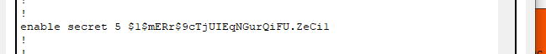
Figure 21

The next security countermeasure implemented was firewalls. These firewalls were configured on every university PC in order to monitor incoming and outgoing network traffic, blocking any unauthorized packets from outside the network. See figure 22.

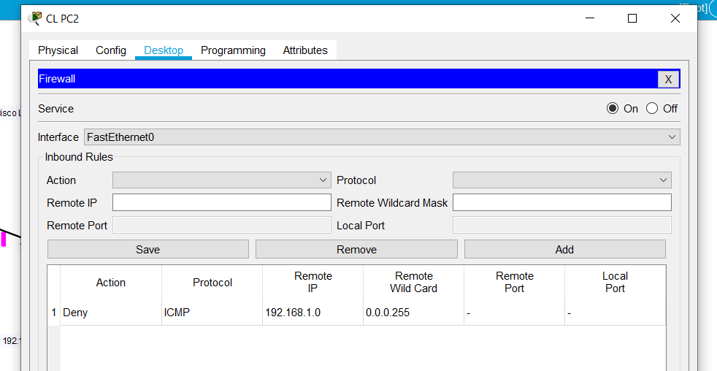
Figure 22

The final security countermeasure implemented on all routers in the network was Access Control Lists (ACLs). This is a layer of security for routers which acts as a firewall, controlling the traffic in and out of one or more subnets. Figure 23 and 24 show the configuration of an ACL setup on the router, and in this design creating a firewall rule to deny the host 192.168.2.2 to test if the ACL is working correctly.

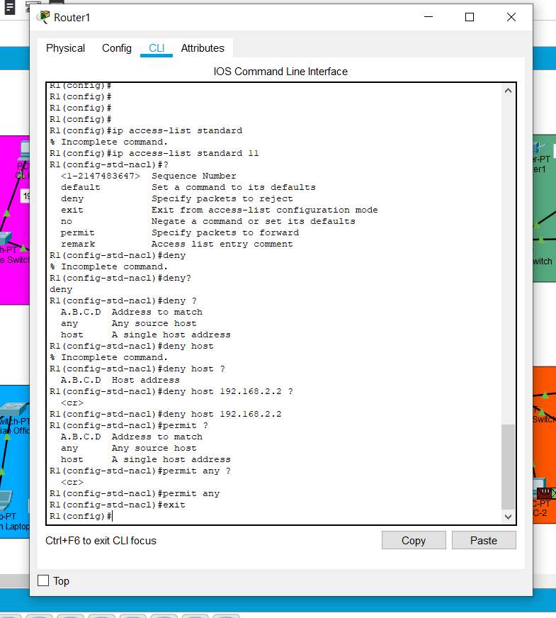
Figure 23

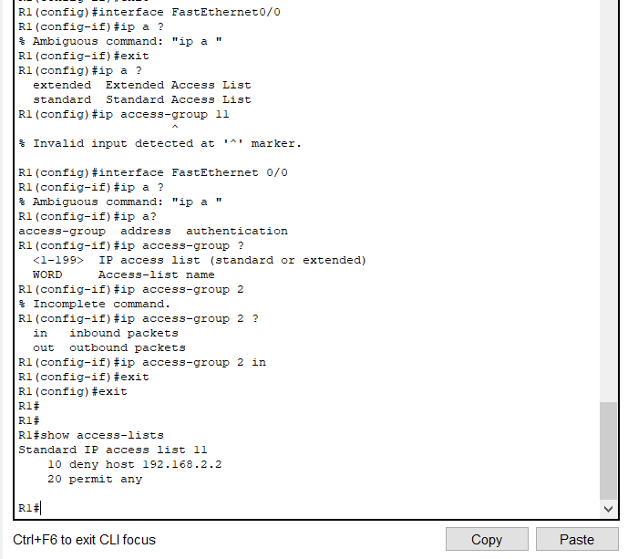
Figure 24

These security countermeasures implemented into the design of the smart campus were an example of some solutions to secure a network in order to prevent the threat of cyberattacks. The next part of the report will discuss and analyze some potential risks, threats, attacks and network traffic using Kali Linux penetration testing software.

Results/Findings and Discussion

This part of the report will analyze the results and findings found using Kali Linux to create some potential threats, risks and attacks against the network designed in the Implementation section.

Email Phishing

The first attack executed was another email phishing attack, even though this attack was discussed earlier on in the report, attackers tend to target school/university students knowing how easy they succumb to the scams and reveal their personal information. As seen in figure 19 which shows the smart campus network design, there are many students connected to the network and vulnerable to phishing attacks. Attackers can identify hosts on a network of a school/university by using tools such as Nmap to discover IP addresses and use them in attacks like email phishing. Figure 25 demonstrates the phishing website being developed in Kali.

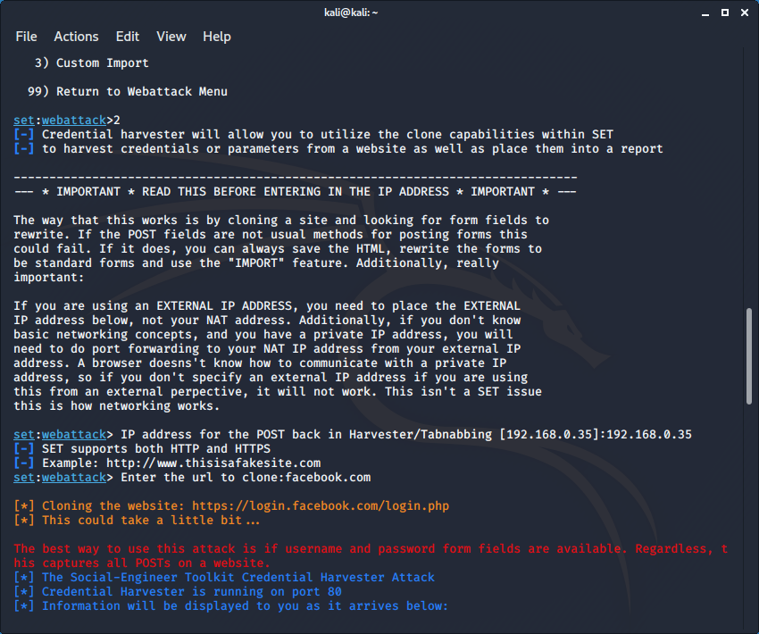
Figure 25

Figure 26 shows the victims scenario where she clicks on the link and inputs her Facebook details thinking she’s logging into the legitimate Facebook page.
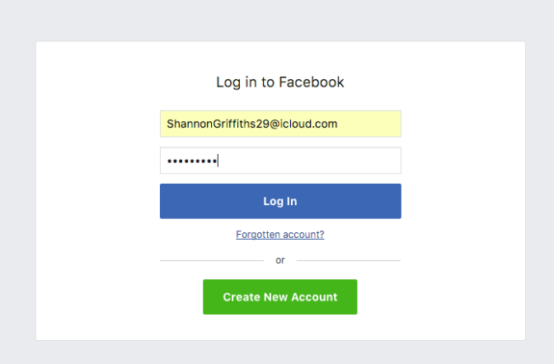
Figure 26

Figure 27 shows the attackers laptop/PC where he harvests the credentials of the victim. Username found = ShannonGriffiths29@icloud.com. Password found = Berty1996.

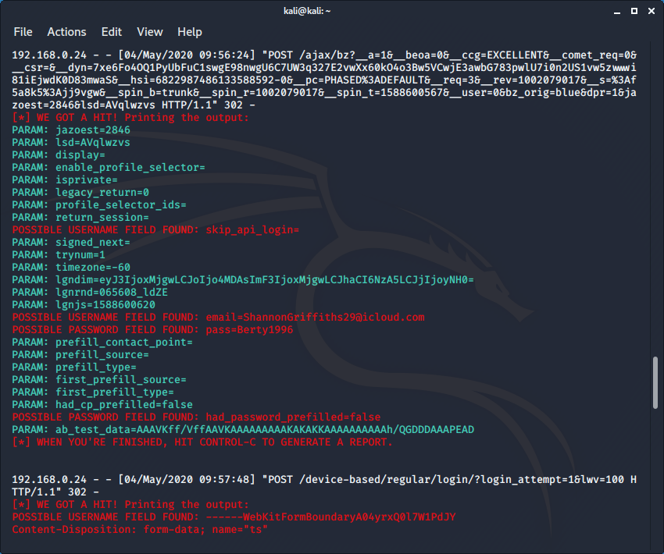
Figure 27

Denial-of-Service (DoS) Attack

The next attack performed in Kali was a Denial-of-Service (DoS) attack, where the attacker aims to take down a website by flooding the network traffic with botnets. In this scenario, the attack wasn’t aimed at the UWTSD website because it’s illegal and the website shouldn’t be used as an example to penetrate with a cyberattack, therefore the website used to penetrate in this attack was permitted by the owner. Referring to the smart campus network design, there are many reasons why attackers would aim to disable the UWTSD website, for instance an attacker could seek to disable all entry on the website in order to perform blackmail or ransomware against students or staff.

Figure 28 shows the configuration in Kali to create a Denial-of-Service attack, where thousands of botnets are ready to flood www.AberdareTownFc.co.uk network traffic, disabling the website and compromising security postures.

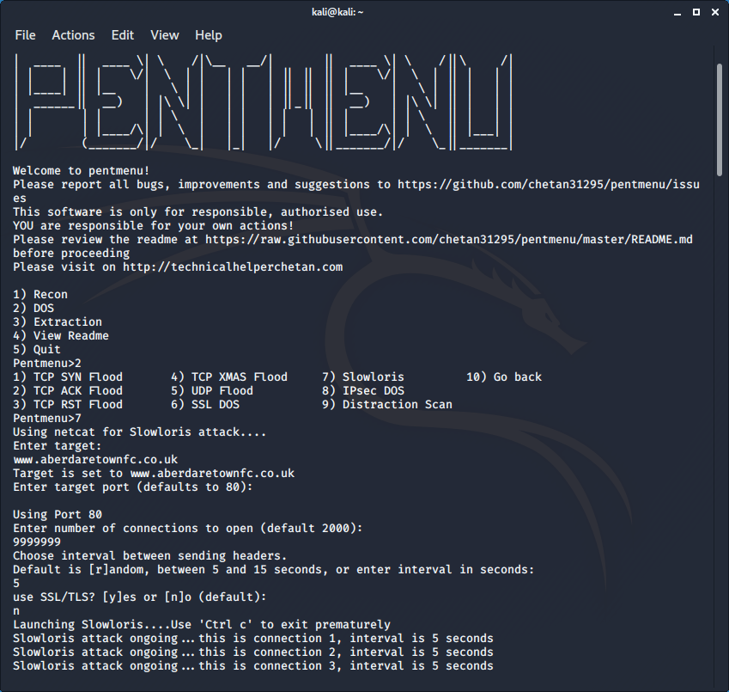
Figure 28

Figure 29 shows the Aberdare Town Football Club website working correctly and figure 30 shows the website disabled and not working after the attack has been deployed.


Figure 29

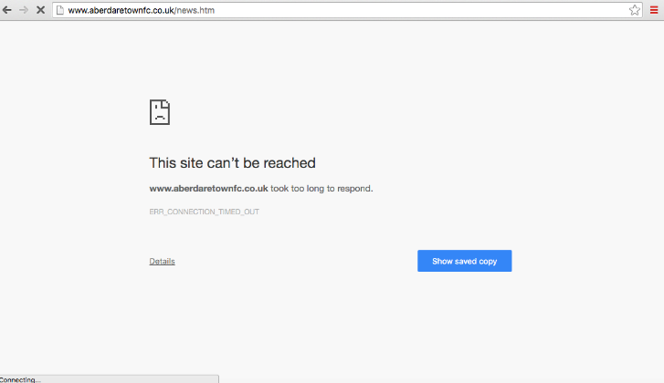
Figure 30
These attacks can be very malicious and harmful, however with the security countermeasures in place inside the smart campus network, the threats from Denial-of-Service attacks should be minimized.

Man-in-the-Middle ARP Spoofing

The final attack used in Kali was a Man-in-the-Middle APR spoofing attack, as discussed earlier in the report. There is no real security mechanism to prevent ARP spoofing attacks, therefore most hosts on the UWTSD network are vulnerable to these attacks.

To begin this attack in Kali, we must first scan for hosts on the network connected to the ARP cache table by using the command ‘ARP’. We also used a Nmap scan to identify the hosts IP address we are targeting (192.168.0.24). See figure 31.

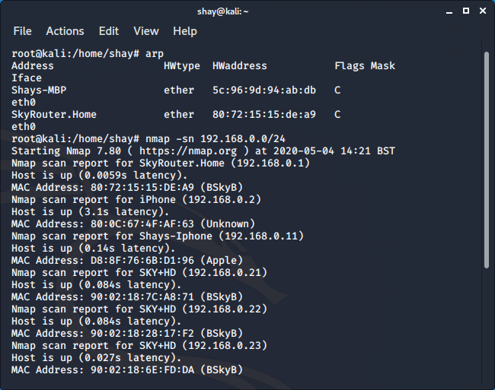
Figure 31

The next step was to use ARP spoofing commands to send forged ARP messages over the network in order to link the attackers MAC address with the IP address of a familiar device on the network, granting the attacker access to the network traffic. See figure’s 32 and 33.

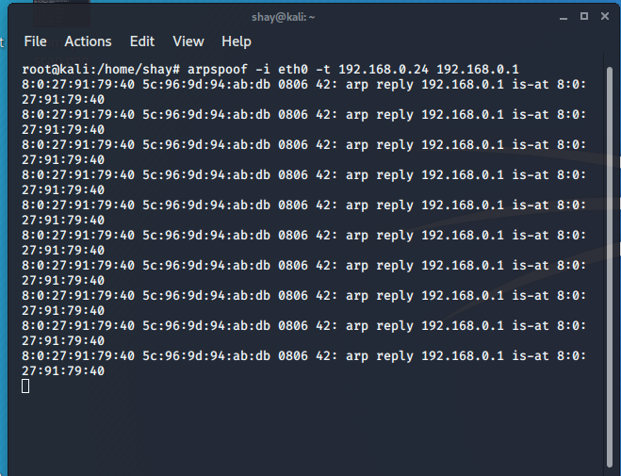
Figure 32

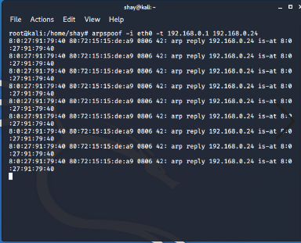
Figure 33

The next step in this attack was to use Wireshark to sniff the victim’s packets going across the network, to spy on the victim and watch their every move on their device. See figure 34

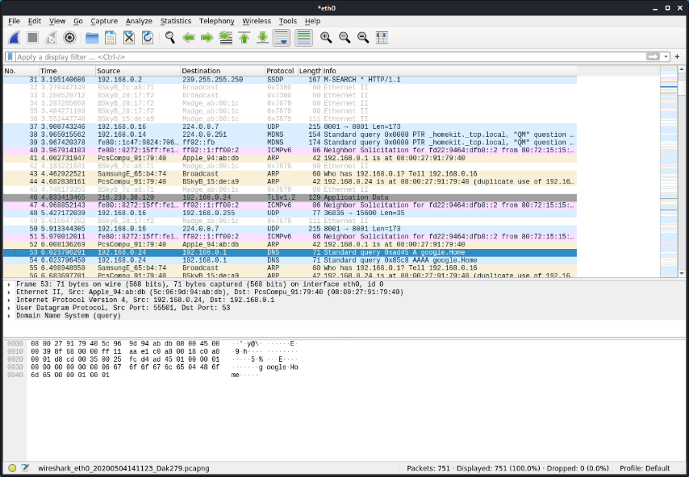
Figure 34

To conclude, this section of the report has analyzed some of the results of attacks performed in Kali Linux to display the potential risks, threats and attacks against the smart campus network designed.

Conclusion

To summarize this report, they key parts of research were the Internet of Things and smart city security issues, computer/communication networks security issues and some future trends in cybersecurity. One of the key points includes cybersecurity, which is the fastest growing industry in the world, attackers are exploiting more devices than ever before with new attacks being developed every day. An interesting statistic found in the research was that 90% of data breaches are caused by phishing attacks, making it clear that humans play the biggest role in data loss and theft.

This report has also analyzed 4 different lab exercises from class, providing solutions to prevent some phishing attacks, how to browse the internet anonymously, how to trace a suspicious email asking for personal information and how to encrypt information through using cryptography tools.

Finally, we discussed the design and implementation of the UWTSD smart campus, analyzing the security countermeasures implemented ready to combat some of the potential threats, risks and attacks discussed in the final chapters of the report.

References

- Verdcit. Online article, History of smart cities: Timeline. February 28th, 2020
Available: https://www.verdict.co.uk/smart-cities-timeline/

- Silva Ferraz, Felipe. Guimaraes Ferraz, Carlos Andre. More than Meets the Eye in Smart City Information Security: Exploring Security Issues Far beyond Privacy Concerns. Conference Paper. 2014

- Ifeanyi Egede. Top Cyber Security Challenges in Smart Cities. Online article. Infosec, February 28th, 2019.
Available: https://resources.infosecinstitute.com/top-cyber-security-challenges-smart-cities/#

- Peto, Richard. Tokody, Daniel. Building and Operating a Smart City. Article, 2019.

- Kevin Austin. 15 Most Common Types of Cyber-attacks That Small to Large Businesses Face. Online article. March 21st, 2019.
Available: https://aboutssl.org/most-common-types-of-cyber-attacks/

- Victor Santoyo. How to Stop a DDoS Attack & Prevent Future Attacks. Online article. July 29th, 2019.
Available: https://blog.sucuri.net/2019/07/how-to-stop-a-ddos-attack-prevent-future-attacks.html

- Yamini, B. Brindha, L. Arthi, S. Prevention of DDoS and SQL Injection Attack By Prepared Statement and IP Blocking. March 2018.

- Fatima, Rubia. Yasin, Affan. Liu, Lin. Wang, Jianmin. How persuasive is a phishing email? A phishing game for phishing awareness. Journal, 2019.

- Retruster. 2019 Phishing Statistics and Email Fraud Statistics. Blog, 2019.
Available: https://retruster.com/blog/2019-phishing-and-email-fraud-statistics.html

- Nam, Seung Yeob. Djuraev, Sirojiddin. Park, Minho. Collaborative approach to mitigating ARP poisoning-based Man-in-the-Middle attacks. Article, 2013.

- Brian Laing. Drive-by Downloads and How to Prevent Them. Online blog. September 21st, 2017.
Available: https://www.lastline.com/blog/drive-by-download/

- Zbigniew Banach. Top 10 Cybersecurity Trends to Look Out For in 2020. Online blog. November 19th, 2019.
Available: https://www.netsparker.com/blog/web-security/top-10-cybersecurity-trends-to-look-out-for-in-2020/

- Dorit Dor. These will be the main cybersecurity trends in 2020. Global agenda. Online article. January 7th, 2020.
Available: https://www.weforum.org/agenda/2020/01/these-will-be-the-main-cybersecurity-trends-in-2020/

Bibliography

- Anna Visvizi. Miltiadis D. Lytras. Smart Cities: Issues and Challenges. Book, 2019.

- Michael P Papazoglou. Web services & SOA: principles and technology. Book, 2012.

marking criteria and Student FEEDBACK

This section details the assessment criteria. The extent to which these are demonstrated by you determines your mark. The marks available for each criterion are shown. Lecturers will use the space provided to comment on the achievement of the task(s), including those areas in which you have performed well and areas that would benefit from development/improvement.

Common Assessment Criteria Applied (Assignment 1) | Marks available | Marks  awarded
1. Engagement with Literature Skills
Extent of research and/or own reading, selection of credible sources, application of appropriate referencing conventions.
You have discuss key concept. However, a number of areas lack referencing while some could be more referenced. You need to use peer reviewed articles to help enhance the credibility of your work. (Grade mark: 77.78%) | 45 | 35
2. Knowledge and Understanding Skills
Extent of knowledge and understanding of concepts and underlying principles associated with the discipline.
3. Cognitive and Intellectual Skills
Analysis, evaluation and synthesis; logic, argument and judgement; analytical reflection; organisation of ideas and evidence
A very good introduction just lacking referencing. You have demonstrated very good knowledge in the research aspects. You have discussed the lab exercises very well and how they could aid individuals and organisations. (Grade mark: 77.78%) | 45 | 35
4. Practical Application Skills
Deployment of methods, materials, tools and techniques; application of concepts; formulation of innovative and creative solutions to solve problems.
5. Transferable Skills for Life and Professional Practice
Attributes in professional practice: individual and collaborative working; deployment of appropriate media; presentation and organisation.
A very presentable work, try to avoid contraction grammar. (Grade mark: 70.00%) | 10 | 7

Assignment Mark (Assessment marks are subject to ratification at the Exam Board. These comments and marks are to give feedback on module work and are for guidance only until they are confirmed. ) | Late Submission Penalties (tick if appropriate) |  | 77%
 | Up to four weeks late |  | 77%
 | First Attempt? |  | 77%

marking criteria and Student FEEDBACK

This section details the assessment criteria. The extent to which these are demonstrated by you determines your mark. The marks available for each criterion are shown. Lecturers will use the space provided to comment on the achievement of the task(s), including those areas in which you have performed well and areas that would benefit from development/improvement.

Common Assessment Criteria Applied (Assignment 2) | Marks available | Marks  awarded
1. Engagement with Literature Skills
Extent of research and/or own reading, selection of credible sources, application of appropriate referencing conventions.
2. Knowledge and Understanding Skills
Extent of knowledge and understanding of concepts and underlying principles associated with the discipline.
You have shown appropriate understanding of the subject area but at least some could utilise information by the latest research of scholarly content. (Grade mark: 75.00%) | 20 | 15
3. Cognitive and Intellectual Skills
Analysis, evaluation and synthesis; logic, argument and judgement; analytical reflection; organisation of ideas and evidence
Excellent documentation of the physical packet tracer design. How does this implementation combat or enhance challenges to the University; this should be interrelated in your discussion. (Grade mark: 75.00%) | 20 | 15
4. Practical Application Skills
Deployment of methods, materials, tools and techniques; application of concepts; formulation of innovative and creative solutions to solve problems.
Your practical design though labelled for ease of understanding there was no redundancy considered. Relevant security measures in place. When tested, no pings were successful. (Grade mark: 66.67%) | 60 | 40
5. Transferable Skills for Life and Professional Practice
Attributes in professional practice: individual and collaborative working; deployment of appropriate media; presentation and organisation.

Assignment Mark (Assessment marks are subject to ratification at the Exam Board. These comments and marks are to give feedback on module work and are for guidance only until they are confirmed. ) | Late Submission Penalties (tick if appropriate) |  | 70%
 | Up to four weeks late |  | 70%
 | First Attempt? |  | 70%

