Work Based Learning Project

Sarah Bolton

Table of Contents
Context 2
Justification 3
The intended impact 4
The outlined intention 4
Ethics and insider research 5
Expected learning outcomes 5
Literature Review 6
Methods 9
Findings 12
Quantitative Data 12
Qualitative Data 17
Lessons Learnt 22
Overall Comments 24
References 25

Context

The researcher works for the West Wales Care Partnership Team. The Team oversees the continued transformation and integration of health, social care and wellbeing services across West Wales. The Team brings together the three local authorities in West Wales (Carmarthenshire County Council, Ceredigion Council and Pembrokeshire County Council), Hywel Dda University Health Board and representatives of the third and independent sector. The Team works to the Regional Partnership Board, established to meet the requirements of the Social Care and Wellbeing (Wales) Act 2014. Users of care and support services sit on the board with carer representatives.
The teams remit involves the creation of a Population Needs Assessment. This provides high-level strategic analysis of care and support needs of citizens and support needs of carers across West Wales. The team have also created the first market stability report for West Wales, which brings together partners from local government, the NHS, third and independent sectors with users and carers with the aim of transforming care and support services in the region.
The Team employs several Programme Managers who have a portfolio of work relating to specific population groups. For example, people living with Dementia, Carers, People with Autism, Older People, Children and Young People. The Regional Partnership Boards and support teams occupies a strong oversight and coordinating role, for driving innovation and new models of seamless health and social care. To do this, the Regional Partnership Board must have a continuous approach to engagement across all population groups, allowing opportunity for people to have a voice in service planning and the care and support they receive.
The researcher is aiming to review the West Wales Regional Partnership approach to engagement and make recommendations for:
- Strengthening engagement practice across all population groups.
- Identifying cross cutting themes, where partners can work together to engage with their citizens.
- Improving engagement resources

Justification

The history of engagement with population groups has been minimal, with engagement often only undertaken as a token gesture or after thought. With the introduction on the Social Care and Wellbeing (Wales) Act 2014 this highlighted the importance of improving the well-being of adults and children who need care and support, and for transforming the way care and support is provided now and in the future.
The act aims to address the importance of integration between Health and Social Care, encouraging people to become independent to give them a stronger voice and control over their lives, give people greater freedom to decide what support they need and promote consistent, high-quality services across the country. The act specifically talks about the need for ‘Co Production’ this means encouraging individuals to become more involved with the design and delivery of services that they need. To do this however, there must be suitable methods providing citizens the opportunity to have their say and get involved.
Prior to 2020, engagement with citizens was insignificant. Across the region, stakeholder groups may have existed for some population groups, but there was limited options for sharing information amongst partners, actual service change achieved and limited resources available to actively engage with population groups.
The Covid-19 pandemic shifted Health and Social Care’s way of working overnight. The introduction of using virtual platforms such as google classroom, teams, zoom and many more meant there was a new way of reaching out to individuals. Whilst this placed many people under immense pressure, it was a learning curve for organisations to become tech savvy and use virtual platforms to keep engaged with their population groups. At the time, meeting in this way became the norm and thinking back, I don’t think at the time organisations could see the innovative new ways of working that could have an impact to achieving better engagement. Community participation can be perceived as a social process (Newport & Jawahar, 2003), where vulnerable groups collaborate for everyday needs and requirements. Their studies have also mentioned that to make it successful, such a community also needs related institutions like private organizations, and sometimes the Government. This can be termed a supportive construct for community engagement (Yodmani, 2001, Paton & Johnston, 2001).
The pandemic has since come to an end, and Health and Social Care services are now more than ever needed to support people following the pandemic, with new health needs and increased demand on support services. The need for organisations to change with the input of citizens is required now more than ever.
The researcher will undertake a review to see how the region is currently performing engagement duties with all population groups across West Wales.

The intended impact
By undertaking this work project, the researcher will research a variety of approaches to engagement, look at key policies in Wales that place emphasis on public involvement and engagement to make recommendations for ensuring a continuous engagement approach is endorsed across the region.
The impact of the review will support and encourage the principles of co-design and co-production and identify issues not immediately apparent to policy makers to improve decision making. The review will involve all in the process and ensure there are opportunities for continuous engagement and not the reliance on formal consultation except in the circumstances where changes to services are subject to statutory duties or controversial.
The ramifications of this project will be a regional approach to a continuous engagement. The review will explore how partners currently engage with population groups and identify areas that can be strengthened by encouraging stronger partner relationships and better methods for working together.

The outlined intention
The outlined intention is to undertake a mixed methods approach for this review. This approach recognises that the world is not qualitative or quantitative, it is not either / or a mixed world (Cohen et al 2018). The researcher hopes that by collecting different data on the same topic, will help the credibility of findings and provide plenty of opportunities for making recommendations for improvement, whilst highlighting good practice taking place regionally already.
The researcher’s intention is to form a ‘continuous engagement steering group’. Members of the group will involve members from Local Authority, Health and Third/Community Sector. The researcher will look to appoint a Chair of the steering group and develop a term of reference.
The researcher will survey the partner organisations who attend the steering group and wider, if necessary, via questionnaire to obtain qualitative and quantitative data. This method will provide the researcher with reliable data and understanding of organisations approach to engagement with populations groups and establish the current level of engagement taking place in organisations.
Questionnaires will be drafted by the researcher and approval will be obtained from the steering group Chair prior to distribution. The researcher aims to create a short video to accompany the questionnaire that sets out:
- Purpose of engagement
- What the researcher aims to achieve from questionnaire
- Deadline for completing the questionnaire and how to complete and return.

The researcher aims to complete this by end of February 2023. Partners will have four weeks from distribution to complete and return. The approximate completion will be March (Appendix I Gantt Chart).

Ethics and insider research
The researcher has developed this work-based project in line with ethical principles in mind. Bell et al (2017) states to guard against both intentional and unintentional harm to participants, it is essential that researchers are ethical in the way they conduct their research, treat participants and write up their research with objectivity.
The work-based project does not require access to an ethics panel review and ethical approval has been sort by the university. Within West Wales Care Partnership, the review is required due to:
- uncertainty around how much continuous engagement is taking place already across the region.
- the impact engagement is having on service transformation.
- if partners are working together and sharing knowledge to enhance engagement.
- if there are stakeholder groups already established that can be shared within the partnership
- are the region using a continuous engagement approach or are they consulting with people as and when required.
- understand partners perception of the term ‘co-production’ and assess if it is truly being used.
- How citizen voice can be featured as part of the Regional Partnership Board discussions.
The researcher recognises there are benefits to being an insider researcher having experience engaging with parents, children and young people. The researcher has a sound understanding from training and work based experienced as to what it means to use a co-productive approach to working. Saidin (2017) suggests that some people argue that becoming and insider researcher could lead to a loss of objectivity and bias.

Expected learning outcomes
By undertaking this work-based project, the expected personal learning outcomes will be:
- Develop an understanding for using a mixed method approach to research. This is the researcher’s first time for leading a piece of research. The researcher has limited experience collating qualitative and quantitative data to analyse.
- Write and deliver a work-based presentation focusing on the strategic aspects, using persuasive techniques to inform system change.
- Create an effective and useful action plan as a result of the research for the steering group to adopt as their work plan.

Literature Review
Over the past couple of years, the topic of engagement with our population groups when developing Health and Social Care Services appears to have become more explicitly an area of popularity. Maile et al (2014) said that worth of public engagement initiatives in the current political and economic climate, one that is dominated by neoliberalism and the market. It is suggested that we need to retain a sense of the different values and imaginaries brought to bear on public engagement. Fagen et al (2018) suggests engagement is needed to help generate awareness that problems exist and pinpoint the factors that contribute to these problems, which can increase the efficiency and effectiveness of prevention work. As researcher working in the Health and Social Care sector I would agree with this and believe by undertaking engagement opportunities with groups who will use services themselves of for their family, its makes sense to improve the efficiency by involving them.
The Social Services and Well-being (Wales) Act 2014 was created and published during April 2016. Whilst the act provides the legal framework to ensure the improvement of the well-being of people who need care and support, it also places a large emphasis on transformation of social services across Wales.
The act was created following a white paper published by Welsh Government in 2011, that highlighted several challenges faced by services in Wales. Changes included increased numbers of people who may need to access care and support and economic crisis and changes to the demographic areas. The aim of the act is to address these issues and give people greater choice and control and freedom to decide what care and support they need. The intended purpose promotes high quality and equitable services across local authority footprints. The intended purpose of the act is supported by academic research such as Bermingham (2007) who states engagement with communities is necessary both to identify needs but also to convert understanding of needs into interventions, resources and practices that may bring about change.
The are a number of key principles in the Social Services and Well-being (Wales) Act 2014 including:
- The act supports people who care and support to achieve well-being
- People are at the heart of the new system by giving them an equal say in the support they receive.
- Partnership and co-operations drives service delivery
- Services will promote the prevention of escalating need and the right help is available at the right time
Social Services and Well-being (Wales) Act 2014 The Essentials
During the literature review, research showed there are many Welsh publications that list engagement at the heart of their policy. Welsh Government programme for government (2021) states the well-being objectives consider all ongoing engagement with social partners and stakeholder groups, ensuring that the insight they provide is reflected in their approach. Section 183 of the NHS (Wales) Act 2006 places a statutory duty on Local Health Boards (LHB) for public involvement and consultation stating:
Local Health Boards must make arrangements to secure that people to whom it provides those services are (directly or through representatives) involved in and consulted the planning of services, development and consideration proposals for service change and in decisions affecting the operation of services.
Further literature featured within the guidance for engagement and consultation on changes to health services place emphasis on the need for a continuous engagement approach. In the introduction it states
The most important point in the interim guidance was the emphasis on the need for a new approach to changed based on continuous engagement, rather than perfunctory involvement around specific proposals. It indicated that the Welsh Assembly Government would expect organisations in the reconfigured NHS to pay considerably more attention to continuous engagement to ensure that all organisations are responsive to the needs and views of their citizens.
Guidance for Engagement and Consultation on Changes to Health Services (2011)
The researcher discovered during reviewing this document that there is an expectation for NHS service to change and this will be based on continuous engagement rather than perfunctory involvement around specific proposals.
Allen et al (2006) described national government and health-based initiatives rarely include the perspective of the local community and they may stray too far from a centralised approach and community issues may be through to culturally sensitive. The researcher tends to agree with this and has experienced working with colleagues who fail to engage with their population groups, typically young people and this resulted in services that were not suitable for children’s needs.
A review of the Social Care and Well-being (Wales) 2014 act revealed co-production as one of the main principles of the act. This means working with and involving population groups to make sure care and support services are the best they can be whereas the Community Health Council Regulations (2010) summarises that local health boards must involve community health councils from inception regarding the planning of services, development and decisions. It does not delve into the importance of citizen engagement to shape service change.
The importance of involving people with an interest achieving the well-being goals and ensuring those people reflect the diversity of the area which the body service is stated in the Well-being of Future Generation (Wales) 2015 and the National Principles for public engagement in Wales state:
- Engagement is effectively designed to make a difference
- Encourage and enable everyone affected to be involved if they chose to do so
- Engagement is planned and delivered in a timely appropriate way
- Work with relevant partner organisation
- The information provided with the jargon free, appropriate, and understandable
- Make it easier for people to take part effectively
- Engagement is given the right resources and support to be effective
- People are told the impact of their contribution
- Learn and share lessons to improve the process off engagement
As part as part of the literature review the researcher felt it was important to consider the approach to continuous engagement in other areas. Research proved that most of the literature in England is Health based. The Health and Social Care Partnership Strategic Clinical Networks (2018) focuses primarily on the working relationships between both sectors with reference to better working relationships and ensuring the outcomes for people are met. Limited information other than commitment towards improving relationships between public services and residents, communities and businesses is documented, however unlike many of the Welsh policies, it does not go into detail about what the key priorities for engagement are.
An integrated care partnership engagement summary (2012) focused on the lessons learnt following the COVI-19 pandemic, highlighting the positive shift towards integrated ways of working between NHS, Local Authorities and partners. Like Welsh legislation, engagement was a key theme, however targeted more engagement with professionals in the Health and Social Care sector to better improve processes. There is limited information other than continuation to engage with stakeholders and ensure voices of people are heard.
The researcher undertook a review of the Care Act England (2016) against the Social Care and Well-being Act (2014). Both acts with some similarities such as assessment process, required to identify the care and support of citizens and a focus on providing support early on and developing preventative services. The researcher also identified key differences. The Social Care and Wellbeing Act (Wales) 2014 places greater emphasis on children and safeguarding. It also stresses the importance to improve integration between social care and push towards using a co productive approach to planning and arranging services for people via effective engagement with population groups.
The researcher has chosen to undertake this work-based project to identify how the Welsh legislation is being implemented across the region. It is evident from the literature review, there is a strong emphasis towards including population groups when reviewing, planning services and understand what support they require early on. The researcher felt it was also important to consider engagement techniques are utilised to capture people’s attention and engage with them in an ever-changing modern world, that is fine for more technical members of the population but does not necessarily work for people with disabilities or older population. Research undertaken reviewed Deepika et al (2020) and Harjanto et al (2021) regarding what they felt were pioneering methods of delivery, such as training and learning opportunities through platforms like Microsoft Teams, and Zoom. They advised that more research was required to determine their effectiveness. However, some of these methods have been used in a variety of organisations for many years (Burgess 2008). Whilst this research was specific to a learning environment, the researcher felt this was integral research regarding how organisations potentially engage with population groups, and consideration to their effectiveness should be given when planning future engagement activities.
A questionnaire will be used to gather information from partners across the region for analysis. The results of the information gathered will be shared amongst the continuous engagement steering group to establish a workable work plan to improve engagement, shared good practice and make recommendations for improvement. Linnell et al (2013) suggests a barrier that may emerge throughout the engagement timeline is that communication methods that are effective during the anticipation phase are not effective in the response phase. During the anticipation phase, a lack of communication may result in poor preparedness and chaos when an emergency does occur, as community members are most likely first responders to an emergency.

Methods
In the literature review there was a lot of Welsh legislation that evidences the requirement for the Health and Social Care to have effective systems to engage with citizens. The project will test how different partners are implementing a continuous engagement approach. There is no right or wrong answer, therefore it will be subjective in ontology and interpretive in epistemology.
It is expected the impact of the review will result in changes and recommendations for better partnership working and have a better regional approach to engagement, rather than consult as and when organisations need outsider opinions on a piece of work. The researcher intends to use a mixed methods methodology, which will gather data on how partners approach engagement with population groups currently. By gathering qualitative and quantitative data and combing these approaches, it is intended that researcher will be able to cross examine the data collected and draw out key themes relevant to the findings. By adopting this approach, the researcher feels that mixed methods may be employed to produce a robust description and interpretation of the data, make quantitative results more understandable, or understand broader applicability of small-sample qualitative findings (Harvard Catalyst 2023)
The researcher also wishes to use a mixed method approach to this research, as it will obtain different perspectives from each of the organisations. There is emphasis for Wales to employ a co-productive approach to their work, but there are conflicting discussions around what the term co-production means to people. The questionnaire will be designed to build a comprehensive understanding of the current engagement process undertaken by partners across the region. By asking questions that will generate statistical results, it is the researcher’s intention to report on how many people their organisation engage with currently. By combining both methods the researcher is hoping to reach a more comprehensive understanding of the subject (Denscombe 2014).
Small (2011) makes important distinctions between integrating qualitative and quantitative methods. The researcher understands there will be some challenges as both data collected will need to be integrated to understand its content in more detail. The researcher will consider how questions are formulated to extract the information intended to inform the review. Grey (2018) describes research questions being classified into four major categories:
- Descriptive (What is happening, which methods are being used?)
- Normative (what is happening compared to what should happen?)
- Correlative (what is the relationship, and the strength of this relationship between variable X and Y?)
- Impact (What impact does a change in X have on Y?)
Grey (2018) also suggests that whilst questionnaires are felt to be one of the most popular data gathering tools probably because they are the easiest to develop. However, this is not always the case and if the questions are too vague or too long the respondent loses interest and doesn’t respond to the best of their ability as questions could be leading (Harvey and Land 2017)
To gather the data the researcher will use a questionnaire (appendix II) and shared this with the continuous engagement steering group. The questionnaire contains questions of a descriptive nature to understand in more depth what is taking place within each of the partner organisations.
The creation of the steering group set some grounding for this piece of research, by having general discussions and presentations from some of the officers in each organisation. However, this approach didn’t capture specific data and didn’t test if organisations use a continuous approach to engagement.
There were a variety of different methods the researcher could have used to conduct the research, for example via one-to-one discussions. However due to operational pressures in the current climate and timescales the ability to do research this way, was not a viable option. The researcher decided a questionnaire was the best approach to undertake the research, which had a number of benefits including:
- Low cost
- Could reach organisations outside of the steering group, by sharing on a website.
- Provide organisations time to think about their answers within a reasonable timescale.
The researcher did consider the disadvantages to using a questionnaire, this included:
- Time organisations had to complete the questionnaire thoroughly.
- Generating questions that were specific and would generate the data intended.
The advantages to using this approach outweighed the disadvantages and so the researcher felt this was the best option. Additionally, through the steering group the researcher explained the intention for devising the questionnaire, this included explain why it is important to collect as much information on what engagement activity is already taking place to avoid any duplication with further actions. It also allowed opportunity to co-create the questionnaire and ensure the right information is generated. Time and consideration were given to the quality of the questionnaire and the time it would take to complete with Harvey and Land (2017) expressing if the questions are too long or the document is too large respondents don’t find time or don’t tend to respond.
The researchers first step was to create a new continuous engagement steering group. The researcher had inherited an old membership list from a manager, previously employed. Using this, the researcher invited existing members to attend a new steering group. However, it quickly became apparent that many of the members had changed roles. The researcher then contacted Directors or Chief Executive Officers of the partnership organisations by email, outlining the intention of the group and asked for them to nominate an officer to attend.
During the first meeting in October 2022, the researcher took time to go through the membership list and establish if all key population groups were represented at the meeting. The majority were, however, there was still a need to ensure that future meetings would include colleague’s representative of people with Dementia and those with Mental Health issues. The researcher asked members to present ‘how they approach engagement’ during the next meeting.
In November 2022, partners were able to present how their organisation approached engagement and often quoted legislation they were aiming to comply with. The researcher suggested establishing the baseline for the region would provide further insight and generate data that could be analysed with a view of identifying key themes and recommendations to improve regional engagement to the Regional Partnership Board, the membership agreed with this approach.
In December 2022, the researcher drafted a questionnaire and shared with the Chair of the steering group (Chief Officer, Ceredigion Association of Voluntary Services). Together, the researcher and Chair met to debate some of the questions asked. The Chair was aware of the work-based project the researcher was undertaking and made recommendations ensuring the questions weren’t open ended, and enough quantitative data could be gathered.
During January 2023, the researcher finalised the questionnaire and considered different options for circulating with partners. During the literature review, the researcher learnt that how we engage with people is vital to its success, therefore considered different techniques how members could complete the questionnaire, without it being uninspiring. Ferriman (2022) explains that keeping learning interesting is a constant battle. Using a variety of strategies and consideration of your audience is best. The researcher decided to the questionnaire by using google forms. The advantage of this included sharing the link with partnership organisations and meant it eradicated the need to complete a word document and ask for completion. Using a word method would have meant that it was difficult to monitor which organisations had completed the questionnaire.
As the researcher worked for a Team representative of the Regional Partnership Board, and within the organisation in which the research was being undertaken, considerations were required before beginning the project. The considerations related to ethical principles. The researcher needed to ensure there was no bias, and they would not influence the result of this project. The researcher could not abuse power and manipulate any data collated. The researcher considered all aspects of ethical principles when conducting the research and with all apply the five R’s of research ethics:
- Respecting the individual (in this case, member of organisation)
- Reducing any risk
- Protecting the rights of the individual
- Maintaining appropriate records
- Obtain information through the correct routes and agreed process
(Gray 2018)
Ethical approval has been obtained from the university (appendix III). Ethical approval was not required from the organisation as the work – based project only collated the views of members within organisations and not population groups directly.

Findings
The researcher compiled the questionnaire using google forms and emailed the link to members of the steering group. The link to the questionnaire was also placed in the Microsoft Teams Chat for the continuous engagement group, not wishing to risk an email being overlooked.
The deadline for questionnaire completion was Friday 24th February 2023. Once the deadline had passed, the findings were analysed in two parts before reaching conclusions.
The quantitative data was analysed to produce numerical data and the questions that generated descriptive statistics provided the qualitative data.
The researcher identified some initial themes emerging from completion of the questionnaire which informed questions to take back to the steering group for further discussion. This data was qualitative and will be expanded on by providing explanations. The researcher chose to analysis the qualitative data gathered through the questionnaire and steering group and undertake a thematic analysis, supported by Maguire and Delahunt (2017) who suggest that thematic analysis is much more than summarising the data, it is to interpret and make sense of it rather than using the rounded theory of constant comparison or ethnographic analysis by looking at patterns of behaviour.
When the researcher distributed the questionnaire the researcher’s intention was to gather as many organisational responses as possible, that would identify how organisations currently conduct engagement with their population groups. The researcher feared, given the current climate and operational challenges, the response rate would be low. However, as the closing date approached, the researcher was delighted to see 17 organisations from across Health, Social Care and Third Sector had completed the questionnaire, representing many population groups. However, not all organisations had completed each section of the questionnaire. On reflection, the researcher thought about how this could have been avoided, and consideration for future questionnaire would ensure that questionnaires in the future, ensured the questions were all mandatory.
The researcher had distributed the questionnaire through the steering group distribution list, and responses received included those from organisations outside of the steering group membership. This suggested the group membership for future meetings should be considered to widen representation and include organisations that were omitted through the formation of the group.

Quantitative Data
The researcher began by reviewing the responses provided by each sector. The researcher wanted to understand from their current resource, whether they have dedicated resource to undertake engagement with population groups. The question specifically asked, ‘what capacity do you have in your organisation to engage with people?’ with two prepopulated answers and space to provide their own answer.
Figure 1 – capacity for engagement
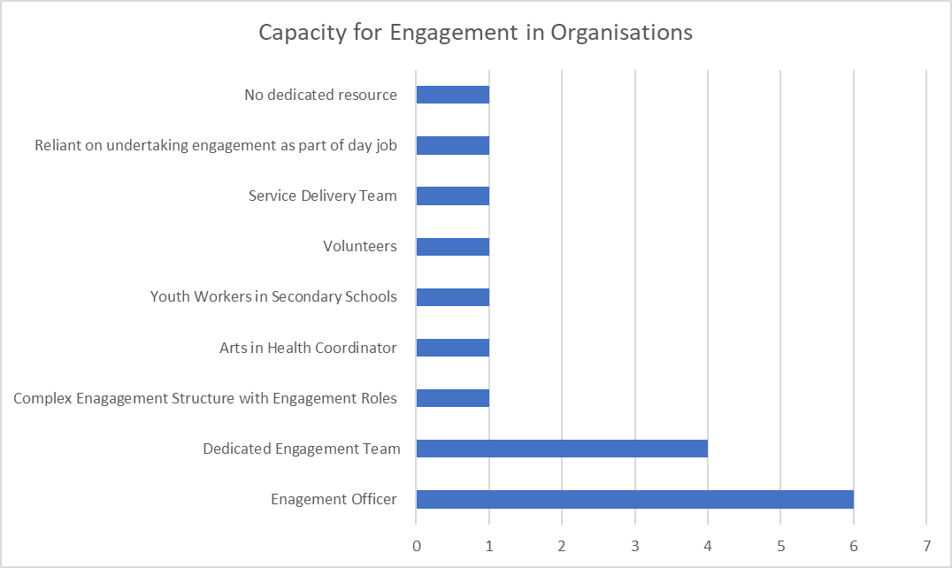
The data gathered provided the researcher information not previously gathered by conversations in the steering group. Out of the 17 responses, each organisation had a different approach to engagement utilising existing staff, as part of their role, and using volunteers. This resonated with the researcher as it evidenced inconsistencies across the region in terms of their approach to engagement. It also made the researcher feel that if organisations were relatively active with their engagement approach, is that because they have a dedicated team or resource? whereby if an organisation were dependent on people engaging with the population as part of their daily role; is that why organisations don’t always do it to the best of their ability? This information was informative enough for the researcher to generate a possible action to take back to the steering group and Regional Partnership Board (summarised in action table below).
Figure 2 asks ‘what are the reasons for your engagement activity?’. Again, this question provided respondents with three structured answers 1. Gain a better understanding of the needs of people, 2. Inform our service planning, 3. Greater sense of common ownership and a space for organisations to state another reason.
Figure 2 – Reasons for engagement
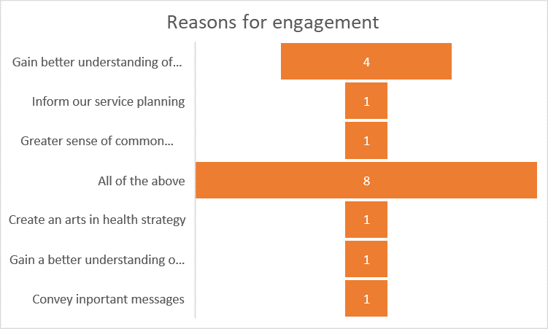

There are many reasons why organisations undertake engagement, as mentioned in the literature review, there is a vast amount of Welsh Legislation that underpins the need for engagement across Health and Social Care. This question demonstrated to the researcher that all organisations we were working towards the principles of legislation and using it to gain a better understanding of their populations needs and develop and plan services in line with population input. One organisation stated they used engagement to convey important messages, however the researcher felt that whilst this is important, this is not the sole purpose of engagement. Effective engagement requires projects to focus on understanding different perspectives and to address to achieve intended outcomes. Effective resource builds on the relationships. This question reassured the researcher that the reasons for engagement had good intent, however on reflection, the researcher felt that the question should have been narrowed down and more specific to extract more meaningful data.
The next question was intended to consider if the organisations consider what topics organisations engage on. Research suggests that engagement fatigue will occur when mass numbers of people are participating in social networking. Everyone who is making marketers salivate because they’re swarming to Facebook, twitter get tired of engagement marketing and tune out (Stoner, 2009). Community engagement is central to strategies to promote health and well-being and reduce health inequalities in many countries, particularly interventions which focus on improving health in disadvantaged populations (Attree 2011). This question had been touched during discussions as a steering group, and it was apparent from data gathered that organisations do not tend to consider what other organisations are engaging on. The steering group acknowledged because they don’t link with other organisations, the engagement responses are limited at times. This suggested this is because population groups could feel they are constantly being asked to have their say, but on similar questions. This could mean that population groups don’t trust the partnership as it suggests, they are not working together to share the information they gather, and then lose interest.
This question was intended to understand why organisations may not work together by asking ‘when you undertake engagement, do you consider other organisation engagement activity to avoid duplication?’ the participants were offered yes or no as a response as well as a space to add a comment. The results were interesting with 5 responding to yes and 2 responding to no. However other comments provided further information to better understand their reasoning. These included:
- We try to but the way finding is set up true partnership is difficult because of the competitive and exclusive nature of some organisations.
- I think that this can be an issue for teams within the same organisations.
- Work regional on some projects.
- As much as possible but we need to do better.
Analysing the results, this led the researcher to consider an action of how engagement duplication could be avoided? What would be the best method to increase partnership working relationships? The researcher considered the purpose of the steering group and whether a digital platform could be created for the partnership to state their reasoning for engagement to find out if there are other areas of the region who could benefit from the results, therefore promoting joint working and reducing the need for duplication.
Figure 3 demonstrates the tools used across the partnership for engagement.
Figure 3 – tools for engagement
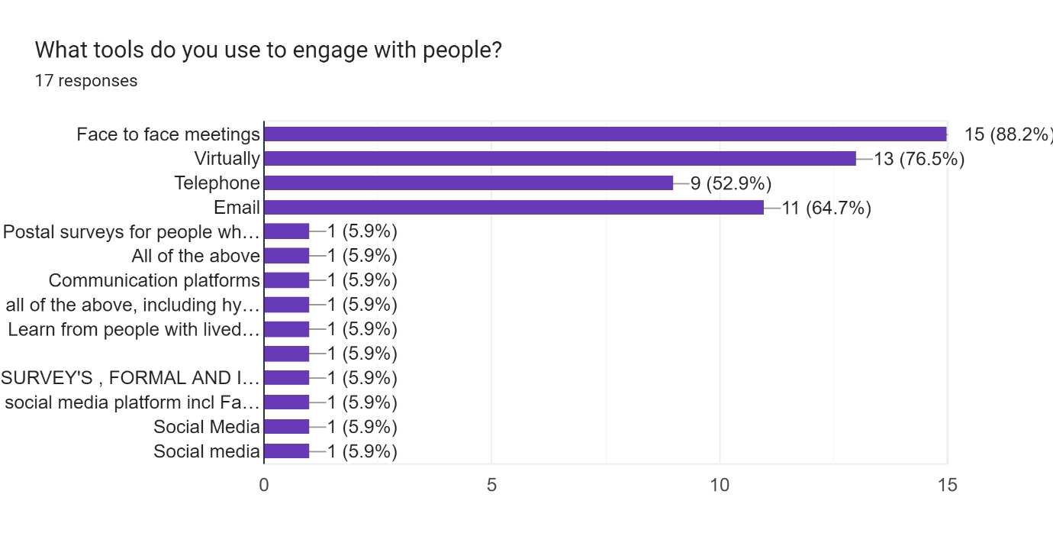
This provided the respondents select more than one option. The researcher identified that face to face meetings was the preferred choice for engagement. The response demonstrated that whilst virtually was a popular choice, it couldn’t assess how successful each of the tools selected were. This was an area the researcher wanted to delve into deeper through the steering group by discussion. It is apparent that organisations have a variety of tools to engage with people, but further understanding was required to establish what works the best.The data gathered from 17 organisations provided the researcher with the knowledge that organisations use more than one tool for engagement but limited information from this questionnaire could determine its success and the preferred choice for the population group. The researcher thought about how different tools are used, with older people potentially preferring face to face meetings and young people opting for social media. Further work was required to understand this and ensure that when organisations are engaging, they are using the best tool suitable for their audience.
What happens with the data gathered after engagement has taken place is always a topic the researcher has considered during the continuous engagement steering group. There is great emphasis on the need for engagement, to shape our services. But there is always a fine balance when it comes to what happens to the information gathered? Where is it stored? Can it be shared due to GDPR regulations? The researcher wanted to find out more about what do organisations do with the information gathered via engagement. 16 organisations completed this question and 43.8% of responses suggested information is collated and presented to the senior management team.
Figure 4 – Information gathered via engagement.
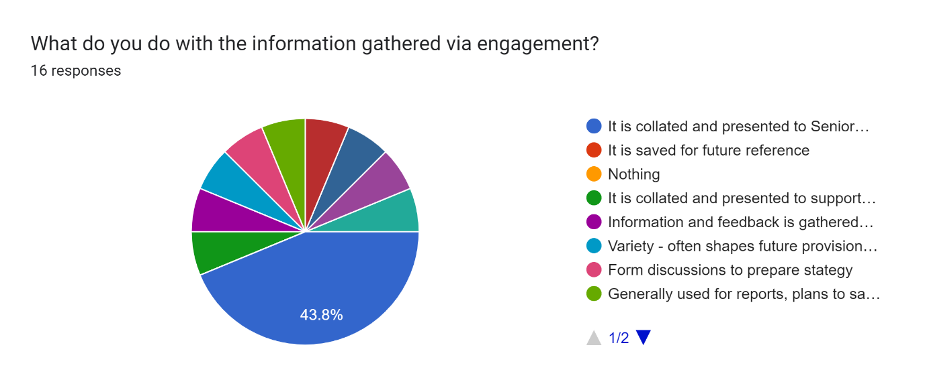

Narrative was provided with this response, also suggested several other actions are completed after engagement has taken place generating some qualitative data, including:
- It is saved for future reference.
- It is collated and presented to support political decision making and scrutiny.
- Variety – often shapes future provision for young people, or feed into wider engagement work locally of nationally.
- Forms discussions to prepare strategy.
- Generally used for reports, plans to save future reference and reuse.
- Shared internally.

There appeared to be multiple responses to this question, and this presented the steering group with a discussion on the process for using population engagement responses to inform service planning resulting in a suggestion by the research to standardise the approach in a regional engagement strategy, therefore reducing the risk of engagement as a tokenistic action.
Figure 5 provides a response to the question ‘do organisations have stakeholder groups established?’ It was pleasing to see that over half of the responses did have stake holder groups.
Figure 5 – stakeholder groups
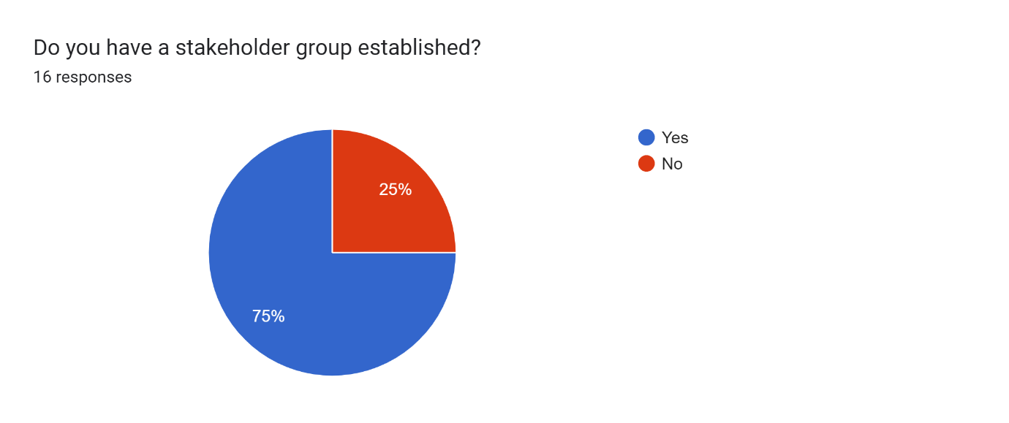
Qualitative data was then generated in the next question, when asking if they answered yes could they provide more information about them. This will be covered in the qualitative section.
Overall the questionnaire produced less qualitative data, the researcher felt that this maybe because most of the questions were to gather information about what was going on across the region that would be conveyed in descriptions, therefore generating qualitative data, that could be made sense of and understood.
The researcher reflected on the quantitative data and thought about how they could have devised questions generating more numerical data to analyse, this included generating questions such as ‘ if your organisation uses a specific tool to engage e.g. website – how many hits do you get per month’. This is something the researcher felt could be an action in future to establish the effectiveness of their engagement activity.

Qualitative Data
Analysing the qualitative data was undertaken by using a table and populating the responses highlighting similar texts in colour. The researcher’s intention was to use the method described by Braun and Clarke (2006) and the six phases of thematic analysis:
Phase 1: Familiarisation
Phase 2: Coding
Phase 3: Generating themes
Phase 4: Reviewing themes
Phase 5: Defining and naming themes
The researcher began to analyse each response to the qualitative questions asked.
The first question asked, ‘what does the term co-production mean to you?’ the researcher gene

What does the term 'co-production' meant to you? | Working with the key population group and involving them on all work
 | Greater involvement of those who can affect and are affected being actively engaged in the decision making process.
 | Working collaboratively and as equal partners with your core community, to come up with solutions
 | Co production means working with the service users and wider community on an equal basis to shape your service
 | Working collaboratively to produce and deliver for the benefit of young people.
 | Working together with individuals who use services in order to develop them to meet their needs
 | Engagement with key stakeholders early in process to co-design strategies, proposals, interventions etc.
 | Collaboration with others
 | Working together to find solutions that suit the situation in which we are living/working.
 | Co-production = involving existing/future service beneficiaries/users in the design, development, delivery, and evaluation of services
 | The term co-production to me means a group of individuals or organisations working together to achieve better outcomes for identified stakeholders.
 | Working with others to jointly produce a product
 | Co-production is where people, family members, carers, organisations and commissioners work together in an equal way, sharing influence, skills and experience to design, deliver and monitor services
 | Co-production at Area 43 means working with our client group to shape and deliver services. This means that all elements of service design and delivery are decided upon by young people in partnership with trusted professionals. We also have a youth management committee who meet once a month, between them and consultation with the wider client group they make decisions on everything from which services they would like to see, and funding pots to apply for to furniture, who works here etc.
 | Working jointly or collaborating on certain projects
 | Codes
 | Working Together
 | Collaboratively
 | Working with

Themes were generated during the reviewing phase and words we generated such as ‘working together’ ‘collaboratively’ and ‘working with’. The range of comments made against this question clearly evidenced that organisations had a sound understanding of what co production means. However, the question failed to ask for examples where there were examples of true co production achieved. The researcher felt this is an area to explore as part of the steering group that would generate areas on good practice, regional understanding and be incorporated into a regional engagement strategy.
The researcher had, had a positive experience developing new services using a co production approach as part of a previous role and understood the principles of co production that you need to invest to get it right.
It takes time and a great deal of time and listening skills to do it well. The researched wanted to understand how they think co-production can be achieved? All 17 organisations responded to this question and had a slightly different interpretations to how it can be achieved. This question was difficult to code given the difference of opinion. So phase 1 of the thematic analysis was key to understand the responses. The researcher expected to see more than one response stating investment as a key aspect of achieving coproduction; but only 1 response mentioned ‘investment’.
“Extremely challenging for local authorities which have political decision making at their core. Political decision has traditionally been built on elective rather than participatory democracy, so it sits uneasily with co-production”
This particular response suggested the participant had not fully understood this questionnaire and implied there was more behind achieving co production at a political level. The researcher felt this was interesting and was keen to meet with the participant to find out what barriers in specific could affect engagement using a co productive approach.
“Through the sharing of ideas, different ways of working and resources”.
“Through effective collaboration”
“Real co-production means that people are truly involved in planning and designing services from the very beginning”.
“Co-production requires trust and transparency; we have found young people can achieve amazing things when given an opportunity and the support to do so”.
99% of the responses demonstrated to the researcher that organisations had a sound understanding of co production and how it could be achieved, however the collation of data made the researcher think about how organisations could benefit from co production training and generate a regional approach and vision for engagement across the region, whilst strengthen engagement practice across all population groups.
Having the appropriate method of engagement will vary dependent on what population group you are wishing to engage with. Who you are planning to engage with should be a key determining factor when choosing your method, and it can help to be specific about who could or should be involved. People often talk about engaging with the public, but who are the ‘general public’ and how can you ensure you engage with them effectively? (National Coordinating Centre for Public Engagement 2023)
For example, Children and Young People tend to opt for Social Media campaigns and Older people prefer events set up where they can attend and meet face to face. It is important that population groups are aware of what they can get involved with and there should be relevant platforms set up. The next question, the researcher wanted to understand ‘how does their target audience know they have opportunity to contribute and actively engage?’. Again, it was pleasing to the researcher that all organisations had provided a detailed response and was able to code and theme the responses to provide greater analysis.
How does your target audience know they have opportunity to contribute and actively engage? | Multiple methods ranging from social media to posters and events in village halls
 | ACTIVE MARKETING, SOCIAL MEDIA, RELATIONSHIPS DEVELOPED, ETC
 | from the outset of any/all engagement process, audience is made aware that they can feedback their experiences / comments on nhs services via a variety of ways : social media (incl app), website, at our meetings in public, phone, email, letter and through their community groups. Audience is reminded that they may contribute through their language of choice, Welsh, English, BSL or other
 | We use a variety of engagement methods, our engagement team organise events at which they engage with young people to discuss how services can be improved (wrapped in a fun activity) we also hold monthly young people's management committee meetings, run polls on social media and ensure this is part of our everyday conversations.
 | We promote through the media, social media and via email to our contact list
 | Through face to face contact with us / partners mostly at events or meetings - social media and websites seem of limited use, especially when recruiting
 | Advertised
 | They would be invited
 | We have undertaken significant consultation over the past few years, as part of planning for our capital project. We regularly promote opportunities to engage in coproduction, through WOM via our various activities and in written communications.
 | As a small charity we are able to communicate this personally and through our volunteers who can be fully supported. Also the recruitment of volunteers and trustees who don't provide the service but using their specific skills engage and support with engagement events
 | Youth Council / Youth Forums / Consultation Work - generally it is standard practice when planning / delivering / evaluating youth work provision with and for young people.
 | Attending stakeholder groups, email address available on NAT website, attending parent/carer run coffee mornings
 | Multiple mechanisms - Majority online
 | Dedicated engagement platform
 | Information in libraries and leisure centres, social media campaigns, our website, targeted emails (including to town and community councils), announcements at meetings
 | Mainly online - website, social media, Have your Say (PCC), face-to-face contact through our Community Connectors, or specific projects like Preseli Cares in north-east Pembrokeshire which is all about co-production and community-led action
 | Through promotion of the consultation on our social media channels, news outlets, website, webinars and internal comms.
The key these from this question indicated the popularity of social media used with engagement. Whilst in a modern world, the researcher couldn’t help thinking are we ‘inclusive’? And where there is reliance on social media and virtual platforms are we missing the opportunity to engage with people who are not so familiar with technology. An area the researcher was keen to explore is the response relating to ‘dedicated engagement platform’ this would be explored further through the steering group to establish its benefits and determine if this is a regional tool that could be hosted by the Regional Partnership Board for all organisations to use.
The researcher has mentioned about engagement fatigue, as we shift our working practice to involve our population groups more, this is an area we are beginning to experience. However, their voices are important to avoid creation of services that will not be suitable to the user. Often, where there are regular groups of people meeting, we see the same people week in, week out. The researcher wanted to understand how organisations make sure other people have their voices heard? 16 responses were received to this question and there were different variations to the answers. The researcher felt that each organisation had wanted to say something to answer the question in a positive light, whereas for the purpose of this project, it would have been fine to state this is an area they are struggling with and find it difficult to reach people.
“For us as a Service this can be incredibly challenging, as often, the people who choose to engage with us have an invested interest in the future of the Fire and Rescue Service, and for the majority of our stakeholders there is often little to no change in our proposals, and also nothing overly contentious such as a change to provided services. Involvement needs to be at the heart of public sector organisations and understanding the ways in which people want to be consulted upon and engaged with”.
“Good Facilitation !! Need to watch out for facial expressions, gestures, posture, and tone of voice are all powerful communication tools”
Were examples of answers the researcher did not feel answered the question. Reflecting on this particular question, the researcher felt it was important to take back to the steering group and have a discussion to better understand and think creatively as a regional partnership board how we can we promote engagement opportunities and encourage people to have their say.
One of the main aspects of the questionnaire was to establish what stakeholder groups are currently in place and so the next question built upon the quantitative question and asked ‘if you have a stakeholder group established, who are they and how do people know about the group, how often do you meet and how? Out of the 17 organisations who completed the questionnaire only 12 responded to say they had an established group. The researcher was impressed by this response, and it indicated there are platforms already created that could enhance the work regarding stakeholder representation and the Regional Partnership Board Meetings.
Finally, the researcher asked ‘what are the barriers to engagement?’
“We deal with many complex issues - it is a lot of work for people on the receiving end to be continually engaged. We have not budget to help support keep them interested / motivated”
“Funding every penny we get in funding is needed to provide the service and there is no capacity to have dedicated engagement resource , lack of understanding from statutory sector on the value of third sector ( I believe that it is not helpful calling it Third Sector as it sounds as something third rate and can be viewed as such by statutory service, as a service that is good enough take up any slack in statutory services but not seen as professional. In most cases any third sector organisation has the same if not more understanding of the issues they are supporting and on a regular bases get better feedback and better engagement than statutory sector as they are viewed more favourably by the service users) . Comments such as "Volunteers can be used for x or y" with no thought that this is not a free resource volunteers are no different to employees in that they need support, training, expenses etc. The only thing volunteers give for free is time and they save the statutory sector huge amounts of resources which are not redirected back to the third sector”
“Not sure - maybe different priorities at different times etc”
“Resources within the 'team' (one officer). Requires significant amount of resource for each individual project”
“Time and human resources to manage”
“Resources - PSB engagement officers are so busy doing statutory consultation that they do not have the time to step outside of this work to carry out continuous engagement. Funding is also an issue - resources do need to be made available to carry out continuous engagement - it will not just happen by chance. It would be great if elected members and town & community councils could take this on for their constituents and then groups working with communities of interest could have those conversations. The trick then is to bring the outcomes of these conversations together in a sensible way that influences policy & practice. If done properly, continuous engagement will lead to an increase in active citizenship and contributions of time/money to get things happening on the ground and enable co-production to truly happen”
“Too many separate organisations and groups all working independently trying to continuously engage on plethora of topics. This results in overload for stakeholders. Trying to reach those who tend not to engage. Resource to devote to continuous engagement due to competing priorities. Effective communication of complex subject matter to usefully inform so that engagement response is as helpful as possible”.
On reflection, the researcher felt this question should have been targeted to generate numerical data with a series of options and using a thematic analysis to undertake this was difficult as it was hard to break it down into manageable pieces. Braun and Braun (2006) said that it is vital to immerse yourself in the data to familiarise yourself with the breadth and depth of the content, this involves repeated reading and searching for meaning and patterns. Where Gray (2018) states that this method can be highly subjective and seen as bias by the researcher and that they may influence the data.

Lessons Learnt
Engagement is an important aspect to the work we do across the partnership and is at the heart of our work. Based on the evidence, it is important the researcher considers the lessons learnt by undertaking this work-based project. This was the researchers first time undertaking a piece of research using a mixed method approach and feels there is so much more to learn when generating both quantitative and qualitative data to analyse. On reflection and having absorbed the information provided, the researcher felt that questionnaire was perhaps too vague and didn’t generate the volume of numerical data the researcher had hoped. The work based project has provided the researcher an insight into a mixed methods approach to research. Based on this exercise and the remit of my role in the team, the researcher will be involved in further pieces of work where undertaking research is required, the researcher will hopefully develop confidence and a better understanding of the techniques used.
The researcher feels that due to lack of experience, more time is required at the early stages, when forming and structuring the questionnaire. Taking time to develop and test the questions used, will evidently provide the researcher with a better data set, that is less complicated to evaluate and interpret.
The volume of qualitative data was good, however the researcher felt at times, the participant completing on behalf of the organisation may not have fully understood the questionnaire and therefore generating an answer that was not always easy to understand and interpret. That said, the researcher has considered the evidence collated by completion of the questionnaire and was extremely pleased to see a good response. The researcher will recommend building on the information gathered in the steering group and structure further questions based on the answers received to better understand the organisational response.
This piece of work has focused on how organisations engage with population groups. The researcher will make a recommendation to the steering group that evaluates how the population feel organisations are performing in terms of engagement. The researcher feels this will give a different perspective and test the responses provided in this exercise. This additional piece of research will test whether the level of engagement undertaken by organisations currently is sufficient and whether it further demonstrates a need for improvement.
There researcher identified a number of themes from the information gathered in the questionnaire and has generated actions as a result to be endorsed by the Steering Group:
- Good level of understanding of co-production
Action: develop a regional vision and understanding of co-production by undertaking national training facilitated by co-pro net Wales
- Wider representation at Continuous Engagement Steering Group
Action: Present a table of respondents to the steering group and seek approval to include them at future meetings. Consider whether the current membership is a true reflection of all population groups and provide organisations verbal opportunity to contribute to this work in future who did not respond. E.g Dementia organisations
- Consider resource available for engagement
Action: Does the steering group and Regional Partnership Board support the request for a dedicated resource to work across organisation and support their engagement strategies?
- Reasons for organisation strategy
Action: Agree vision for engagement across the partnership and factor into creation of regional engagement strategy in future.
- Duplication of engagement activity
Action: Consider what platforms and methods may need to be created to share organisational engagement activity. For example: developing an engagement database.
- Communication & tools for engagement with population groups
Action: social media was the emerging theme for engaging with population groups. As a steering group forming an engagement strategy, agree key techniques and tools for engagement and follow the same principles across organisations to ensure clarity and alignment. Through the partnership board explore regional tools such as Engagement HQ.
- Gathering of information
Action: Seek guidance regarding GDPR regarding data sharing
- Stakeholder Groups
Action: Through creation of an engagement database for organisations to use, list groups taking place to maximise use and encourage working in partnership on joint projects.

- Barriers to engagement
Action: Through the Regional Partnership Board, highlight findings from research specifically on lack of resource to undertake engagement effectively and establish if further funding could be accessed to breakdown barriers and invest in regional resource supporting partners.

Overall Comments
This study has produced themes and actions from the responses provided in the questionnaire. The researcher feels that the module learning outcomes have been met by undertaking this study and it has developed the researchers understanding of a mixed method approach greatly. Although the researcher feels as though learning has been achieved and it has enabled the researcher to produce a set of actions (above) to take to the steering group for further reflection and establish a work plan for the region.
The researchers aims was to:
- Strengthen engagement practice across all population groups.
The researcher feels as though areas of good practice have been discovered as a result of the work-based project and as a steering group will make recommendations for improvement.
- Identify cross cutting themes.
The researcher discovered there are areas of consistency across organisations, such as their understanding of co production and similarity in tools used to engage with groups. However, the project allowed an opportunity for the researcher to discover there are discrepancies across organisations, relating to time and resource to prioritise this work and this is something that needs to be highlighted and raised to make improvements for the future.
- Improve engagement resource.
The researcher was able to extract different resources organisations use to engage.
This has been an interesting piece of work and the researcher has enjoyed this project. The researcher has learnt greatly the benefit of creating questions that are not open ended and will in future further consider the creation of questionnaires to extract data that is meaningful and lead to change in practice.

References
Attree, P., French, B., Milton, B., Povall, S., Whitehead, M., & Popay, J. (2011). The experience of community engagement for individuals: a rapid review of evidence. Health & social care in the community, 19(3), 250–260. https://doi.org/10.1111/j.1365-2524.2010.00976 (Accessed 07.04.23)
Allen, K. (2006). Community-based disaster preparedness and climate adaptation: local capacity building in the Philippines. Disasters, 30(1), 81–101
Department of Health and Social Care (2016). Care Act Factsheets. [online] GOV.UK. Availableat:https://www.gov.uk/government/publications/care-act-2014-part-1-factsheets/care-act-factsheets [Accessed 17.01.23
Bell, J., and Waters, S. (2018) Doing your research project. A guide for first-time researchers. 7th Eds. London: Oxford University Press.
Braun, V. and Clarke, V. (2006) “Using thematic analysis in psychology”. Qualitative Research in Psychology, 3(2): p. 77-101. (PDF) Thematic analysis. (researchgate.net) (accessed April 2023).
Bermingham, B. and Porter, A. (n.d.). Engaging with communities. Community health and wellbeing, pp.105–128. doi:https://doi.org/10.2307/j.ctt9qgq63.11 [Accessed 07.04.23]
Burgess, J. (2008) “Is a blended learning approach suitable for mature, part-time finance students”? Electronic Journal of E-Learning, 6(2), 131–138. Cited Mali, D. and Lim, H. (2021) “How do students perceive face-to-face / blended learning as a result of the COVID-19 Pandemic?” The international Journal of Management Education 19 100552.
Cohen, L., Manion, L. and Morison, K. (2018) Research Methods in Education 8th Edn. Routledge: Oxon
Deepika, V., Soundariya, K., Karthikeyan, K., and Kalaiselvan, G. (2020) “Learning from home: role of e-learning methodologies and tools during novel coronavirus pandemic outbreak”. Post Grad Medical Journal, 97, doi:10.1136/postgradmj-2020-137989. (Accessed April 2023).
Denscombe, M. (2014) The Good Research Guide. 4th Eds. Maidenhead: Open University Press. Cited in Cohen, L., Manion, L. and Morison, K. (2018) Research Methods in Education 8th Edn. Routledge: Oxon.
Ferriman, J. (2020). 7 Learning Engagement Techniques. [online] LearnDash. Availableat:https://www.learndash.com/7-learning-engagement-techniques/#:~:text=7%20Learning%20Engagement%20Techniques%201%201.%20Capture%20Attention [Accessed 17.01.23]
Fagan, A.A., Hawkins, J.D., Catalano, R.F. and Farrington, D.P. (2018). Improving Community Capacity to Conduct Comprehensive Prevention Needs Assessments. Oxford Scholarship Online. Oxford University Press. doi:https://doi.org/10.1093/oso/9780190299217.003.0005 [Accessed 07.04.23]
Gray, D. E. (2018) Doing Research in the real world, 4th Edn. Routledge: Oxon
Harvey, M. and Land, L. (2017) Research methods for nurses and midwives. Theory and practice. London: SAGE
Health and Social Care Partnership Strategic Clinical Networks – patients, carers and public engagement and participation strategy (2018), 5https://www.england.nhs.uk/north-west/wp-content/uploads/sites/48/2019/03/patients-carers-and-public-engagement-and-participation-strategy.pdf (accessed 17.01.23)
Harvard Catalyst (2022). Mixed Methods Research. [online] catalyst.harvard.edu. Available at: https://catalyst.harvard.edu/community-engagement/mmr/. [Accessed 17.01.23]
www.publicengagement.ac.uk. (n.d.). How to choose a method | NCCPE. [online] Available at:https://www.publicengagement.ac.uk/do-engagement/choose-method/how-choose-method [Accessed at 11.04.23)
Harjanto, T., Setiyarini, S. and Prihatiningsih, T. (2021) “Clinical Learning in Medical and Health professions Education amid COVID-19 Pandemic: A Literature Review of Various Methods and Innovations”. Open Access Maced Journal of Medical Science, 19(T5) 13-19
mStoner. (2009). Engagement Fatigue: The Ultimate Consumer Response to Irrelevant Engagement Marketing. [online] Available at: https://www.mstoner.com/blog/marketing-communications/engagement_fatigue_the_ultimate_consumer_response_to_irrelevant_engagement_/#:~:text=Engagement%20fatigue%20will%20occur%20when%20mass%20numbers%20of [Accessed 07.04.23].
Welsh Government, Well-being of future Generations (Wales) 2015 https://www.futuregenerations.wales/journey-checker-involvement/ [Accessed 12.01.23]
https://www.gov.uk/government/publications/integrated-care-partnerships-engagement-findings/integrated-care-partnership-icp-engagement-summary Integrated care partnership engagement summary (2022) (accessed 17.01.23)
Legislation.gov, Community Health Council Regulations (2010) The Community Health Councils (Constitution, Membership and Procedures) (Wales) Regulations 2010 (legislation.gov.uk) [Accessed 17.01.23]
Linnell, M. (2013). Community approaches involving the public in crisis management: a literature review. RCR Working Paper Series, 5.
Maile, Stella. “Social Science in the CityTM: Reflections on Public Engagement.” Public Engagement and Social Science, edited by Stella Maile and David Griffiths, 1st ed., Bristol University Press, 2014, pp. 29–44. JSTOR, https://doi.org/10.2307/j.ctt1ggjk8w.8. [Accessed 7 Apr. 2023]
Maguire, M., & Delahunt, B. (2017) “Doing a Thematic Analysis: A Practical, Step-by-Step Guide for Learning and Teaching Scholars”. All Ireland Journal of Higher Education (AISHE-J), 9, 3351. https://ojs.aishe.org/index.php/aishe-j/article/view/335/553 (accessed April 2023).
Newport J. K. Jawahar G. G. (2003). Community participation and public awareness in disaster mitigation.Disaster Prevention and Management: An International Journal, 12(1), 33–36. 10.1108/09653560310463838
Yodmani, S. (n.d.). Disaster risk management and vulnerability reduction: Protecting the poor. RetrievedAugust 30, 2021, from Adpc.net website: https://www.adpc.net/V2007/IKM/ONLINE%20DOCUMENTS/downloads/PovertyPaper.pdf
Social Care Wales, Social Care and Wellbeing Act (2014) https://socialcare.wales/resources-guidance/information-and-learning-hub/sswbact/overview [Accessed 18.02.23]
Saidin, K. (2017) Insider researcher: challenges & opportunities, (PDF) INSIDER RESEARCHERS: CHALLENGES & OPPORTUNITIES (researchgate.net) (accesses January 2023).
Small, M. L. (2011). How to Conduct a Mixed Methods Study: Recent Trends in a Rapidly Growing Literature. Annual Review of Sociology
Welsh Government, Guidance for Engagement and Consultation on Changes to Health Services (2011) https://www.gov.wales/sites/default/files/consultations/2022-12/guidance-for-engagement-and-consultation-on-changes-to-health-services-2022.pdf [Accessed 17.03.23]
Welsh Government 2015, Well-being of Future Generation (Wales) 2015: The Essentials https://www.gov.wales/well-being-future-generations-act-essentials-html [Accessed 17.01.23]
Appendices
Appendix I Gannt Chart
Appendix II Questionnaire (Excel Format)
https://docs.google.com/forms/d/19hP9pBw7qfgFbvnu2kUPBqjL0tY3iq-WSw4lgfmganY/edit#response=ACYDBNiVSt6pN2g3Kp735TFz93hcc8mMpF43yaa5NAWPkAXlfMHILOR16REDqJmGdXnGcRQ (to view on google forms)

Appendix III Thematic Analysis Example
Appendix IV Ethics Form

