Digital and skills in research methods
Tawhihur Rahman
1707410
Ze Zook
January 2018

Contents
Introduction 2
Effectiveness of the use of modern technology in the workplace 2
Importance of social media as marketing tool 3
Usefulness of social media for information gathering purpose 4
Impact of technology and social media in the workplace communication 5
Conclusion 6
References 7

Introduction
In this 21st century, every business organization implements technological stuff for the betterment of the whole procedure. By implementing technological tools, an improvement could be found in the organizational premises. After having the whole analysis and market research, it could be stated that technological platforms are used for increasing the performance and profitability of the organizational premises. Through implementing all the technological tools and techniques, a suitable evaluation in the business premises could be done. By the help of this whole technological evolution, an organization could prosper in the business premises. At this moment, every single organization can increase its brand image and valuation through technological advancements. According to the scholars, this is the time and era of social media where every single organization uses social media as the promotional tool and through using social media; management of organizations could share their views and ideologies with the consumers.

Effectiveness of the use of modern technology in the workplace
As discussed earlier, technology is used in different platforms of the business process in this modern day. Through judging different technological parameter, a firm or company could enhance its potential value in the marketplace. By evaluating different frameworks, applicability of technological parameters could be obtained. Here, some of the significant analyses on technological aspects have been made to justify the whole issue. After framing the whole fact, it could be stated that technology can play major role in the business process for increasing the organizational value. Moreover; technology has made overall operation of the business process very smooth and efficient. Ideologically, this platform gives a momentum towards the business process through which a significant outcome could be obtained in the business procedure. Technology is used for solving different purposes in the organizational procedure. By the help of this whole activities, management of a firm could easily execute activities in a simple and efficient manner (Van Deursen, et al., 2014). Mainly technology is used for information gathering process by which all sorts of relevant data could be fetched in the organizational process. Through database or related to that material, management of workplace can easily monitor all sorts of operations in a significant and effective way.
Technology can increase the potential value of the business process and through gathering information through technological parameter; a fruitful evaluation of the whole matter could be obtained. Financial planning is also a significant element which needs to be judged properly and due to this reason appropriate information needs to be obtained. Through appropriate understanding and technological usefulness, fruitful evaluation of the whole parameter could increase the strength of the business process. Appropriate financial proposition could be done through different management information system. By the help of financial proposition through technological elements; performance of the business could be flourished. It has been proved in the organizational premises that technology could easily help to monitor all sorts of activities in the business premises. After making a smooth and effective analysis, it is proved technology in workplace plays a significant and effective role in the organizational fundamental business expansion. This procedure should have to be implemented for the betterment of the whole business functionalities. Here some of the essential analyses have been made to justify the overall issue to gain a significant outcome in the organizational premises. Through this whole understanding, it could be evaluated that technology must have to be implemented in the organizational process for getting suitable result.

Importance of social media as marketing tool
Social media has huge effect on the organizational procedure and this new technological evaluation helps to increase the brand value of the organization. At this present moment, social media has been used in various purposes of the organizational procedure. Through this overall understanding, it could be evaluated that social media is being used in various purposes of the organizational procedure and through implementing this technological evolution a specific outcome and fruitful result could be obtained in the business process. Social media could be used as promotional media in the organizational process and by implementing social media organizational image could be improved. Organizational brand value plays significant role in the business evaluation and through making an efficient outcome an organization could make a specific growth. At this present moment, social media helps the organizational management to place their advertisements in the online portal. By the wide span of organizational network, most of the people could easily view the organizational goal and targets (Helsper, et al., 2016). Social media is accessed by every age and generation and this is the reason, this could be used as good marketing tool. The help of this overall process could obtain significant and efficient evaluation obtained very easily. Social media can easily forecast the business growth in the marketplace, by the help of this whole procedure, significant evaluation overall issue could be made very easily. After having the analysis, one thing could be stated that social media has changed the phase of modern marketing style. Now every business organization uses social media marketing for the betterment of whole business aspects. There are various social media present in the marketplace which could be utilized for the business process and through using this technique a suitable outcome can be obtained. Different types of social media present like Facebook, Twitter etc which could be used in this whole procedure in a significant and efficient manner. By implementing these elements in the business parameter, management of the organization could flourish the business process. According to the management of the business organization; social media helps to formulate all sorts of business activities in an efficient and effective manner and this thing can be helpful in improving the performance of the business process. Through this overall understandings and considerations, one thing could be categorized and observed that social media should have to be implemented in such a manner that fruitful evaluation could be made very easily. Social media is always helpful to portray the whole parameter of the business process. The help of this overall process could obtain significant and efficient evaluation in the marketplace. Through overall evaluation one thing could be stated that social media will surely change the business phase and by the help of using social media respective organizations could flourish the business aspects in the marketplace. Through making the business aspects smooth and efficient, one thing could be stated that social media has impressive and fruitful impact on the overall performance of the organization (Eynon & Geniets, 2016). Through making suitable understanding over the issue, importance of social media in the business process could be obtained very easily.

Usefulness of social media for information gathering purpose
Social media is mainly useful for making promotion of the business process but it also could be used in the information gathering process. By the help of social media, management of an organization could be able to gain huge information and this data would be helpful to justify all sorts of operational aspects in the marketplace. For example, Google is one of the famous and popular brand names of the world and that organization has worldwide popularity for its information fetching system. Information is required to everyone in this world and everyone is trying hard to gain data for enhancing the business value. Google analytics software is there that could be used for the information fetching purpose. Through implementing technological figures and aspects, organizations could find out a new pathway in the business process. At past management of the organizations found very difficult to collect data for any significant purpose. Here, some of the key elements have been discussed on this issue. Information could be on different aspects and through using these sources; an organization might gain huge advantages in the marketplace. Market penetration needs lots of information and by using that data, a fruitful and significant evaluation could be done. Social media in this world helps to judge the perception of consumers and normal people. They also could share their thoughts and ideologies through this process. By the help of this parameter, one thing must be said that social media needs to be implemented in the organizational process in such way that it could enhance the growth and prosperity of the business process. After having lots of analyses, it is proved that social media could improvise the business concept and aspect (Thornburg, 2015). This might be helpful for organizational value and demand. One of the famous researcher and market analysts stated that, in this modern era social media is mainly running wheel of the business.

Impact of technology and social media in the workplace communication
Communication is the primary tool that could be implemented in the organizational premises for gaining good advantage. Here, some of the effective and efficient aspects have been considered which would be beneficial for the understanding purpose. Social media is always being helpful to capitalize on the overall workplace communication channel. At past lots of problems were happened in workplace due to poor communication and now this communication barrier has been removed by the intervention of some of the efficient and effective tool like social media. At this moment; most of the people use social media like Facebook, Twitter etc and through these procedures they could be able to share their views and ideologies. After having the whole analysis, market observers thought this would be a very good option in the workplace where huge numbers of people are working. Reality could be seen in different organizations of workplace where employees communicated and stay connected with each other through social media. By the help of this overall process, it could be highlighted and stated that social media needs to be implanted in different other parts of the organizational process. Through using these tools, an effective workplace communication could be made. Through this process, it could be stated that technological advancement has changed the concept of making business. There are many other tools present which are used for making good communication among all the people. For example, every organization is using database in this present world and through database management could easily monitor all sorts of activities in an efficient and smooth manner. By the help of this overall understanding, it could be understood that this technological advancement helps the organization to manage all kinds of activities smoothly and efficiently.

Conclusion
By the help of this overall paper, benefits of technological advancement in the workplace could be understood. Workplace is the place where many people are coming to put their hard work so that an effective result could be obtained. Overall organizational growth and value is depended on this parameter. One thing could be stated that technology is the element that has the capability to enhance organizational prosperity and values. Through this overall understanding, it could be identified and evaluated that technology can execute a sound evaluation on the business performance. By introducing different technological aspects and parameters, significant outcome in the organizational premises could be obtained (Gekara, et al., 2017). The value of technology and social media could be found through this paper and through this overall understanding it could be stated that social media has huge impact on the modern day business process. Many of the organizations still don’t know about the process and in that case leaders should have to introduce this technique for the betterment of the whole process. Lastly, before implementing any kind of element security issue in the business premises must have to be evaluated so that significant outcomes could be obtained.

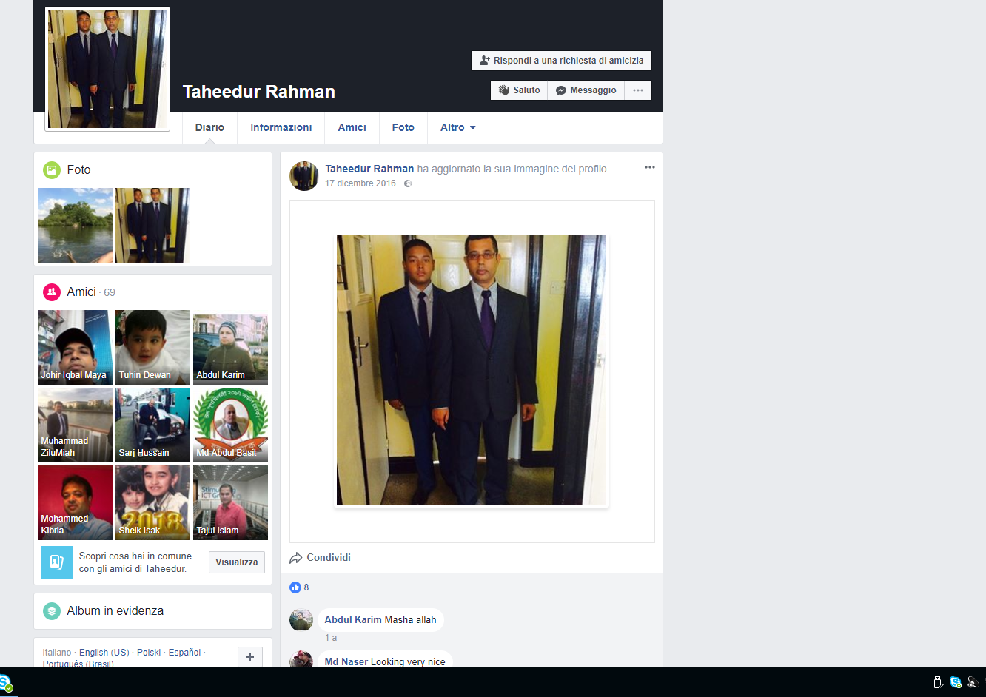
https://www.facebook.com/taheedur.rahman.3?fref=jewel

References
Van Deursen, A. J. A. M., Helsper, E. J., & Eynon, R. (2014). Measuring digital skills. From digital skills to tangible Outcomes project report.
Helsper, E. J., Deursen, A. J., & Eynon, R. (2016). Measuring types of internet use: from digital skills to tangible outcomes project report.
Van Deursen, A. J., & van Dijk, J. A. (2014). Digital skills: Unlocking the information society. Springer.
Léger, M. T., & Freiman, V. (2016). A narrative approach to understanding the development and retention of digital skills over time in former middle school students, a decade after having used one-to-one laptop computers. Journal of Research on Technology in Education, 48(1), 57-66.
Eynon, R., & Geniets, A. (2016). The digital skills paradox: how do digitally excluded youth develop skills to use the internet?. Learning, Media and Technology, 41(3), 463-479.
van Dijk, J. A., & van Deursen, A. J. (2014). Solutions: Learning Digital Skills. In Digital Skills (pp. 113-138). Palgrave Macmillan US.
Thornburg, R. (2015). Producing online news: Digital skills, stronger stories. CQ Press.
Helsper, E. J., & Van Deursen, A. J. (2015). Digital skills in Europe: research and policy. Digital divides: The new challenges and opportunities of e-inclusion, 195, 125.
Gekara, V., Molla, A., Snell, D., Karanasios, S., & Thomas, A. (2017). Developing appropriate workforce skills for Australia’s emerging digital economy.
Helsper, E. J., Deursen, A. J., & Eynon, R. (2016). Measuring types of internet use: from digital skills to tangible outcomes project report.
Helsper, E. J., Van Deursen, A. J., & Eynon, R. (2015). Tangible outcomes of Internet use: from digital skills to tangible outcomes project report.
van Deursen, A. J., Helsper, E., & Eynon, R. (2014). Measuring digital skills: From digital skills to tangible outcomes.
Deursen, A., Helsper, E., Eynon, R., & Dijk, J. A. (2016). Compound and Sequential Digital Exclusion: Internet Skills, Uses, and Outcomes.

