STUDENT 1806571
ANTHONY JACQUES
BMSW5102
TUTOR DR ZE ZOOK

Developing Relationships and Workplace Achievement

Executive summary
To run a business successfully, it is important to maintain some criterion such as developing relationship with the employees so that they can work together for the success of the business. Through workplace achievement, a business can make profit which eventually gears its progress. In this present work, how Tesco manages the issue of developing relationship and workplace achievement will be discussed.

Table of Contents
Introduction 4
1) Critical assessment of the potential benefits of Tesco and the personally developing individuals there 4
2) Critical evaluation of Tesco’s development vehicles to meet the needs of the employees 13
3) A plan to meet the identified development needs 17
Conclusion 18
References 19

Introduction
Developing relationship within a working environment is an important aspect, as with this policy employees feel more connected with the company. When a person starts to work for a company, initially he/she starts to feel shy or hesitant to speak or perform but with proper coaching, advising and interaction processes done by the company or by the co workers, it becomes easy (Itani et al., 2019). A supportive and free environment always helps employees to work with their best potential and this affects the overall performance and profit generation. The present work will discuss how Tesco has managed its employees and has built a strong and long relationship which has given them significant business achievements.

Critical assessment of the potential benefits of Tesco and the personally developing individuals there
Background of the organisation
Tesco Plc. or commonly known as Tesco is a UK based grocery and general merchandise retailer which have multinational connections. Apart from the UK, the company operates in 12 countries such as China, Japan and Turkey. The company was established by Jack Cohen in 1919 and now they have their head office situated in London. As per last year’s record, they are the 9th largest retailer of the world having approximately 7000 outlets, both small local Tesco Express sites to large Tesco Extras and superstores. Approximately worldwide 360,000 people are working for the company. The company is involved in retailing of grocery items, clothing, books, furniture, electronics, toys, software, petrol, financial, telecoms and internet services. In the year 2019, the company has registered an operating income of £2.206 billion, while the net income was £1.320 billion (Tescoplc.com.2020).
Recruitment policy of Tesco
As Tesco is one of the largest retailers of the world and is planning to extend their business, they are in urgent need of human resources. This will be a part of their business strategy to grow an diversify their business (Alamand Raut-Roy, 2019). As a retailer, they are in need of manpower for both of their store based and non-store based activities. The following table shows their requirement:

Job location | Requirement
Stores | Supervisors, Checkout staff, Stock handlers, bakers and pharmacists
Distribution depot | People with knowledge of stock management and logistics
Head offices | Managers, legal advisors, property management brokers, marketing executives, accountants and IT people.

Table 1: Job profiles at different stores of Tesco
(Source: created by the learner)
According to their workforce planning done by the senior managers, skilled people are welcome to work for them. The company through training and coaching modules will make them efficient employees. They recruit on a regular basis to run the food and non-food parts of the business (Samara and Arenas, 2017). The organisation is growing at a fast speed and with every new store; there is a scope for various people to be a part of this huge organisation. There is another factor working behind this. On a daily basis there are people who retire or resign from the company. This also creates a huge vacancy to be filled up on an immediate basis. Also, with the change of technology or processes, new knowledgeable persons are required to drive the company towards its better future.
Organisational structure of Tesco
Therefore, it becomes clear from the above layout that there are posts available for both managerial and non managerial posts in the company. From the February end, the planning for recruitment process starts and after quarterly reviews the company adjusts their staffing based on the requirement. The managers of the company identify the skills, competencies and needs that a designation requires and then proper advertisement is done where people from outside and within the company can apply. It is also a policy of Tesco to promote its existing employees from one level to another as an acknowledgement of their performance and this keeps them motivated to perform better with time. Employees thus set their ambition and through performance they try to reach their goal. There are six work levels within the company, which reflects not only the management and controlling system but also the progress path for the employees. The customers directly come in contact with level 1 employees who are engaged with front line jobs such as in store tasks. The level 2 is for the team leaders who motivate and set targets for his/her team members. Level 3 requires managers with operation management skills, while level 4 employees are those who recommend strategies that can help the company and its operations. Level 5 employees are the leaders responsible for the overall performance of Tesco and Level 6 are the employees who are the visionary leaders of the company and lead the whole organisation by creating purpose, values and goals (Tescoplc.com.2020).
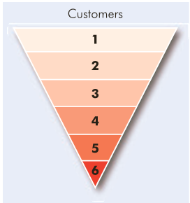
Figure 1: Organisational structure of Tesco
(Source: Tescoplc.com.2020)
To fill these categories, a level 1 employee is recruited by advertisement in newspaper, company website and through other media. Interviews followed by assessment and selection rounds need to be cleared by the aspirant. People from outside applies through proper channel after checking their eligibility criteria set by the company managers. This requires the use of internet and everyone can see these advertisements. In the advertisement, there are specification s for the candidates with the description of title of the job, to whom the person will be responsible to answer with a description of roles and responsibilities. Through this person specification the required set of skills, attributes and characteristics to do a particular job becomes clear to an aspirant (Ballantineet al., 2018). The selection procedure starts with a screening process where managers make a short list of suitable candidates based on their resume which shows the candidate’s education and job history. These people are then called for the interview. After passing the screening at the assessment centre, which are the store fronts, they are given tasks which includes team work and problem solving quick activities.
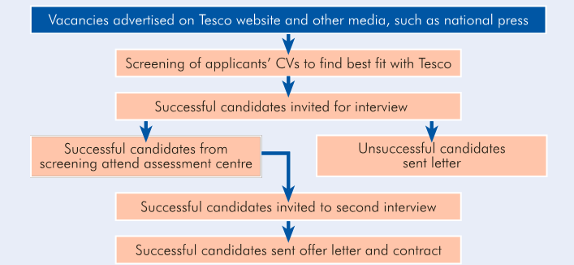
Figure 3: Stages of external management of candidates at Tesco
(Source: Tescoplc.com.2020)
For the other designations, there is the use of intranet, where advertisements are seen only by the existing company employees and they can apply within two weeks of job announcement. This way, existing employees can promote themselves from one level to the next.

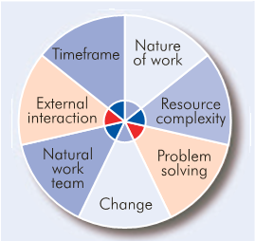
Figure 3: Talent plan management structure of Tesco
(Source: Tescoplc.com.2020)
Main goal (s) focus of Tesco
Apart from making the business successful in terms of revenue, there are other goals that the company aims and take measures to fulfil them. They are as follows:
The company wants to be the leader of the retail business world and for that they need excellent staff base. So acquiring the best man power from the industry is one of the major goals of the company
The leaders of the company believe that a good working culture is essential for both the employees and for the customers. As Tesco serves in the direct selling, so making customers happy with the products, services and behaviour of their staffs are immensely important. Through appropriate training Tesco wants to provide a world class and uniform service to its worldwide customer base.
As the company has multinational appearance and there are employees who come from different backgrounds, it is a challenge for Tesco to maintain equality and diversity within the organisation. Tesco have hired managers to look after this issue so that the company can set an example for the others.

Focus, aspirations and talent base of aspirants
As Tesco is an international brand and has a good organisational image, people from every category of the society aspires to work with them. But the organisation requires focused people for their company, so that they can mould themselves with the vision, mission and objectives of the company and transform themselves for the growth of the company (Dolanand Rajak, 2016). There are scopes of various posts in the organisation such as ranging from the store front executive, which requires a graduate degree to senior managers who need to have various management degrees. Not only the degrees but the persons should be sensible, patient in nature and have ability to solve any sudden situation.
Therefore, the aspirants require focusing on the fact that not only an educational degree can ensure a place in the company but they need to be out of the box in their thinking to be a valuable asset for the company. According to Othman (2017), here might be various background of a candidate but the aspirant has to come out of it and have the ability to change his perspective according to the nature of the job specifications. Aspiration is another criterion for this job seeking people. Without high aspiration, employees will lost the appetite for future missions and achievements and this will be reflected in their performance. Tesco understands that an employee who starts his/her career as a store front executive do not want to retire with the same designation. Therefore it is the self sense that can help an employee to move to next level. A person once join the company registers his profile as the talent base and with every achievement and target meet creates an up gradation in his profile.
Business model of Tesco
For achieving the goal of developing relationships and workplace achievement, Tesco follows several business models as stated below:
Hertzberg’s Two factor theory
Frederick Hertzberg in 1959 proposed a theory which was based on his research work which stated that there are two factors that can impact on the performance of the employees (Hoqueet al., 2016). The positive factors are called motivators or satisfiers whereas the negative factors are called hygiene factors which create dissatisfaction.
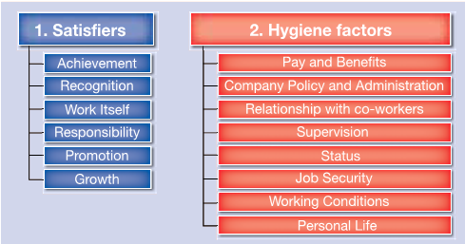
Figure 4: Hertzberg’s Two factor theory
(Source: Tescoplc.com.2020)
According to this theory the satisfier factors are:
Achievements: Every success of an employee within Tesco do not go unnoticed. The company is very much attentive to record such achievements and at times give the employees various benefits, perks etc so that the person feel motivate to do better in future (Bexheti. and Bexheti, 2016). Also who have not performed yet can aspire to make such an effort so that he can also make such an achievement.
Recognition: Tesco respects the efforts that an employee put for the betterment of the company. Therefore in business meetings, general discussions, they invite ideas from the employees and if any of them gets approval for the business, then the company give recognition to the employee through annual meetings, promotions, bonus etc.
Work itself:There are several jobs in the organisation to perform with. Everyone should not be categoriesd as same for any given job profile, as people have different qualities within them that can help a company grow in different ways. Tesco managers identify these qualities and assign work to them accordingly to make the best possible use of resources.
Responsibility: every designation in Tesco comes with great sense of responsibility. There are target meeting, completion and reporting with every assignment. Therefore an employee engages himself with the associated responsibilities of job performance.
Promotion and growth: In Tesco, there is an immense chance of growth through the performance of the employees. Tesco always motivates its employees to go for the next level. So the employees focus on their performance and through it, they achieve their personal goals.
There are also Hygiene factors which includes the following and the company management also keep a close watch so that these factors does not make problem for the employees. These are:
Pay and benefits:Tesco gives standard pay for its employees which make them happy. Other benefits, perks, chances of promotion, hikes are also there to keep them motivated.
Company policy and administration: Company policy balances the rights for both the employer and employees. It is the culmination of all government laws regarding employment, so that the employees feel safe.
Tesco encourages its employees to maintain good personal relationship with co-workers so that a healthy environment can help the company to grow. There are various levels of employees and all work under the next level (Ohana and Stinglhamber, 2019). So, proper supervision ensures the quality of the work. Tesco gives its employees chance to perform meaningful work, so that they could be aware of their status. All employees sign job contract before joining the company which gives them job security(Imam and Javed, 2019). Tesco also ensures good working conditions which helps the workers to work with peace of mind. Apart from organisational work, Tesco encourages its employee to maintain their personal life safe and joyful by allowing shifts, flexible working hours etc so that this can have a positive impact on the job role.
Maslow’s Needs Theory
According to Abraham Maslow’s ‘hierarchy of needs’ theory, there are five stages of motivation through which an employee could be motivated in a gradual form. The basic needs of an employee are assurance of regular pay, good working environment and essential facilities (Ghatakand Singh, 2019). Upon fulfilment of these, the employee seeks the next level which is regarding his job securities, need for pension and sickness schemes. Tesco’s ‘Steering Wheel’ fulfils the social needs through group activities, home-from-home working condition. The stage of self esteem is supported through self assessment, 360 degree feedback and appraisal system and the final stage of self fulfilment is done by Personal Development Plans, recognition of skills and talents, opportunity for promotion and career progression programme.

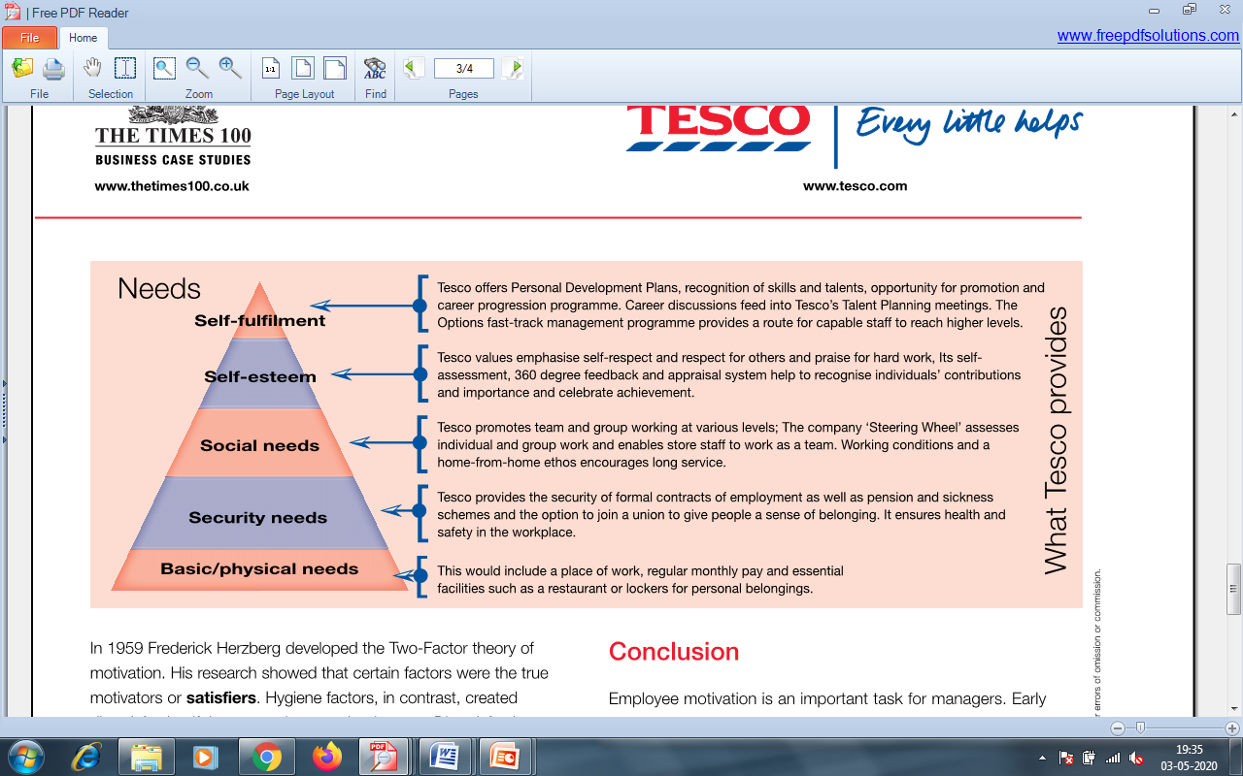
Figure 5: Maslow’s Needs Theory
(Source: Tescoplc.com.2020)

McClelland’s Needs –Power Theory
David McClelland in the year 1961 put forward his Needs –Power Theory which says that there are three motivators which are:
Achievement: With every success, Tesco ensures that the employee gets recognition and achieves successive benefits which make them happy.
Affiliation: With the help of good work culture Tesco promotes friendship and good relationship among the employees so that everyone can work in united way (Osemekeand Adegboyega, 2017).
Power: Tesco ensures that its employees use their power of designation to rightly execute things, which also gives them a sense of satisfaction (Doeze Jager-van Vlietet al., 2017).
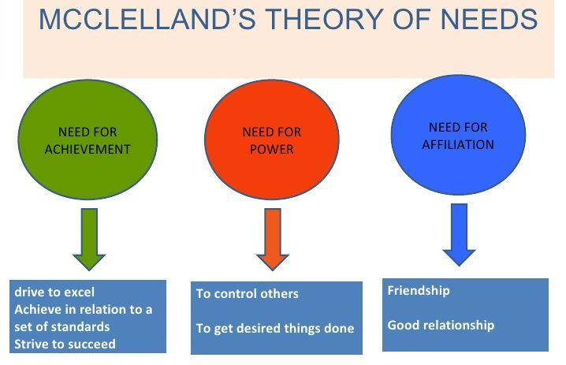
Figure 6: McClelland’s Needs –Power Theory
(Source:Doeze Jager-van Vlietet al., 2017)

2) Critical evaluation of Tesco’s development vehicles to meet the needs of the employees
Various training programmes
Tesco policies strongly support the need of training program before a selected candidate starts working for the company. Educated people generally are well aware about their role in a company. But the management keeps in mind that people comes from different backgrounds and various work experience. Also there lies a great difference between educational knowledge and practical experience (Keevy and Mare, 2018). While working for the company there may be certain situations where quick decisions needed to be taken. Therefore, management initiates training of the employees so that the candidate gets a fair idea how to deal with customers, co workers, seniors, vendors and other necessary job roles in the future. There may be needs of personal guidance from time to time, which could be arranged depending on the seriousness of the issue, but training in a bulk reduced the time consuming factor, which saves a lot of cost. Through training the management of Tesco ensures that employees know what to do, how to do and how can they solve a certain problem.
Through training the fresher can come across the required knowledge and skill to carry out his duty successfully. This connects them with the organisation and a sense of ownership develops in mind. Training helps them to be more organised, flexible as per the job needs and productive to meet the target (Plessis, 2016). Training also induces the hunger to develop new skills and abilities for decision making, which is very much required to progress in career. Therefore training not only helps the employees to be confident, but also to grow the repute of the company through their knowledge and competence of staff. The company arranges both on-the-job training and off-the-job training which are:
On-the-job training:
The fresher follows experienced employees and learns how to do work. This experience person acts as an advisor and shares his experience, so that the new member can get knowledge about the process. Coach or a trainer here helps the fresher to face challenges, find the solution and make confident moves to implement the right decisions (Vasanthi and Basariya, 2019). Also job rotation helps them to cover their targets and take small steps towards taking full responsibility.
Off-the-job training
Though is a cheaper version of training, but it has its own advantages. In this process managers keep a close watch over the performances and when required, they resolve them quickly. The employee in this method works for the company directly while carrying the training also. Therefore he can put his learning into direct practice (Aktheret al., 2019). It has been seen that in the area of team building, planning and organisation, this method is more productive in nature.
Talent Management plans
This is the application of integrated management practices for its people so that they can plan better for future issues. Through proper management the company can attract more skilled persons to the company and engage them in the right sectors (Cascioand Boudreau, 2016). This way a company can retain talented manpower which can bring success in no time for the company. Through the continuous process of identification, measurement and development, talents are recorded for individuals. The management of Tesco therefore goes through the following steps for executing their talent management plans:

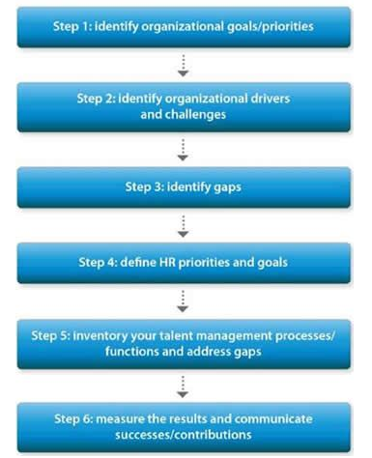
Figure 7: Talent Management plan of Tesco
(Source: Cascioand Boudreau, 2016)
STEP 1: Identify organizational goals/priorities: The managers, visionaries and leaders make strategic goals for the organisation and make easy planning to reach that target by directing the lower level employees. They find for any upcoming situation that may make impact on the business and therefore tries to find possible solution.
STEP 2: Identify organisational drivers and challenges: Key drivers of the business are identified which can directly make powerful impact on the business growth. Both internal and external challenges are taken into consideration such as business legislation, emerging new technologies, competitive job market, a survey result etc.
STEP 3: Conduct a gap analysis: there are always a set of goals for a company where the employees try to reach. Therefore there is always a gap in between the goal setting and the achievement of it. This requires the gap analysis considering all the positive factors and risks, which helps to calculate the necessity and practicality of that goal and fills the gap.
STEP 4: Define HR priorities and goals: The goals for Tesco always follow the SMART (specific, measurable, achievable, realistic and time-bound) objective method and therefore make them achievable in realistic time frames and with best processes. Therefore, through implementation and effectiveness, success is achieved.
STEP 5: Inventory your talent management processes/functions: Present HR talent management processes to determine there if there is any need for changes or not to meet the objective. If needs persists then plans are developed.
STEP 6: Measure the results and communicate successes: With the help of relevant metrics, progress and success are measured and the result is communicated to the different levels of the organisation. It helps to shift from previous target to the next one and work accordingly.
Mentorship programmes
Through different mentorship program Tesco tries to improve the status of the poor performers into a better one. A mentor is experienced people who through their own experience make the employees understand their roles in the organisation (Fooand Turner, 2019). There are the following steps that are adopted in Tesco’s mentorship program:
- Setting of objectives: Based on the underlying purposes, the objectives of mentoring programs are set so that the trainees can understand their roles and responsibilities.
- Mentor-Mentee Pairing Process: Qualified mentors need to pair with mentee on the basis of requirement and make a good relationship first to avoid any conflict.
- Formal training: Apart from this program, general training sessions continue, so that there remains no scope for lagging behind.
- Good communication plan: Only through proper communication channel the company goals could be cleared to the employee so that they can perform accordingly
- Evaluation: At the end of the tenure of mentorship program, the evaluation of the same is required to understand the fruitfulness of it.

So it becomes from the above discussion that training and mentorship program practiced in Tesco stores ensures apprenticeship for the fresher who aspires to be successful in life while serving Tesco, a leading and trusted name in retail business world.
Tesco work culture
Tesco is a famous company and so they have the pressure of maintaining their repute in an international basis. Their work culture includes:
- Tesco abides all government laws and regulation and signs contract with their employees before they join the company.
- Also the company acknowledges that their employees come from different cultural background that causes great cultural diversity within the company. Therefore, company practices mixed culture environment, which makes every employee happy and satisfied.
- Tesco promotes CSR practices through various environmental and social campaigns. This makes the employees proud about their company and creates a good will for the company.
- The company also has scopes for disable of physically challenged people to work with them. This gives a boost to the company and makes them ahead of their rivals.

A plan to meet the identified development needs

The Personal Development Plan
A personal development plan for a fresher is shown below so that the person can help himself to improve their skill and be an asset for the company:
Objectives | Required skills | How it can be processed | Monitoring and evaluation | Timeline
To improve communication skill | Clear articulation with proper pronouncing of words | Through more communication practices with friends, family and co workers | Through weekly self evaluation using various online applications | 1 month
To make strategic business plan | Reasoning, planning, management skills | By more learning on the subject and shadowing mentors at the organisation | Assessment of panning done by trainers and mentors on monthly basis | 3 months
Teamwork management | Good communication skills, co operation, helping attitude, | Making good relationship with the co workers, so a team could be formed | Assessment on team works | 2 months
Table 2: PDP of a trainee
(Source: created by the learner)
This PDP plan wasapproved with the line manager and other key senior staff as it shows the complete route of being a successful executive for the company. This plan also ensures the responsibility, satisfaction and success of the employeebased on his intentions , aspirations and interest.

Conclusion
In conclusion, it could be said that for developing relationship with employers Tesco applies several theories models and plans, so that the organisation can make progress towards a better future. Starting from the recruitment process, Tesco ensures the quality of the employee through training and mentorship. Not only for the external candidates, but the internal employees also get benefitted from their work culture. The company tries to make a significant business environment through workplace achievement to set an example for other business houses.

References
Akther, S., Javed, T. and Islam, N., 2019. Measurement of the Effectiveness of Off-the-Job Training Methods in Commercial Banks of Bangladesh. International Journal of Business and Management, 14(9).
Alam, S. and Raut-Roy, U., 2019. Evaluating the Effectiveness of Reward Strategy at Tesco: Evidence from Selected Stores in UK. Indian Journal of Industrial Relations, 55(1).
Ballantine, J.A., Guo, X. and Larres, P., 2018. Can future managers and business executives be influenced to behave more ethically in the workplace? The impact of approaches to learning on business students’ cheating behavior. Journal of Business Ethics, 149(1), pp.245-258.
Bexheti, L. and Bexheti, A., 2016. The Impact of Herzberg's Two Factor Theory and Efficiency at Work. European Journal of Multidisciplinary Studies, 1(2), pp.378-385.
Cascio, W.F. and Boudreau, J.W., 2016. The search for global competence: From international HR to talent management. Journal of World Business, 51(1), pp.103-114.
Doeze Jager-van Vliet, S., Born, M. and Van der Molen, H., 2017. Self-other agreement between employees on their need for achievement, power, and affiliation: A social relations study. Scandinavian Journal of Work, Environment and Health, 2(9), pp.1-12.
Dolan, C. and Rajak, D., 2016. Remaking Africa’s informal economies: Youth, entrepreneurship and the promise of inclusion at the bottom of the pyramid. The Journal of Development Studies, 52(4), pp.514-529.
Foo, H.Y. and Turner, J.J., 2019. Entrepreneurial learning’–the role of university led business incubators and mentors in equipping graduates with the necessary skills set for industry 4.0. Int. J. Educ, 4(30), pp.283-298.
Ghatak, S. and Singh, S., 2019. Examining Maslow’s Hierarchy Need Theory in the Social Media Adoption. FIIB Business Review, 8(4), pp.292-302.
Hoque, F., Rabbany, G., Anny, S.A. and Akhter, A., 2016. Level of job satisfaction in agribusiness sector in Bangladesh: An application of Hertzberg two factors motivation theory. International Journal of Economics, Commerce and Management, 4(6), pp.419-445.
Imam, S. and Javed, T., 2019. Job Security, Organizational Support and Employee Performance: Mediating role of Employee Satisfaction in Medical Sector of Pakistan. International Journal Of Academic Research In Business And Social Sciences, 9(3).
Itani, O.S., Jaramillo, F. and Chonko, L., 2019. Achieving top performance while building collegiality in sales: It all starts with ethics. Journal of Business Ethics, 156(2), pp.417-438.
Keevy, M. and Mare, D.J., 2018. Pervasive skills development for aspirant chartered accountants: Academic versus training programmes. Journal of Economic and Financial Sciences, 11(1), pp.1-9.
Ohana, M. and Stinglhamber, F., 2019. Co‐workers' voice climate and affective commitment towards the team: A test of mediation and moderation. Human Resource Management Journal, 29(3), pp.395-412.
Osemeke, M. and Adegboyega, S., 2017. Critical Review and Comparism between Maslow, Herzberg and McClelland's Theory of Needs. Funai Journal of Accounting, Business and Finance, 1(1), pp.161-173.
Othman, S., 2017. Job localization policy in Saudi Arabia: Determining its effect on employment and Economy. Business and Management Horizons, 5(1), pp.12-29.
Plessis, A.J., 2016. The importance of training and education for New Zealand entrepreneurs to be successful: some empirical evidence. Jurnalul Practicilor Comunitare Pozitive, 16(2), pp.18-38.
Samara, G. and Arenas, D., 2017. Practicing fairness in the family business workplace. Business Horizons, 60(5), pp.647-655.
Tescoplc.com.2020. About us. Available on: https://www.tescoplc.com/about/ (accessed on: 3rd may, 2020)
Vasanthi, S. and Basariya, S.R., 2019. On The Job Training Imlementation And Its Benefits. International Journal of Research and Analytical Reviews (IJRAR), 6(1).

