Application Development Assignment Using ASP.NET
Gemma Dunlop (1801285)
Application Development
Kemi Ademoye
University of Wales Trinity Saint David
4th May 2020

Table of Contents
1. Introduction 2
2. Requirements 2
3. Design and Implementation 3
3.1. Models 3
3.2. 4.2. Views 5
3.2.1. Product details 5
3.2.2. Order details 10
3.3. View models 11
3.4. Controllers 12
4. Evaluation 0
4.1. Testing 0
4.2. Evaluation 22
4.2.1. Accessibility 22
4.2.2. Responsiveness 22
4.2.3. Content 23
4.2.4. Layout and Navigation 23
4.2.5. Errors 23
4.2.6. User Testing 23
5. Conclusion 23
References 24
Images 25
Home Page 25
Products 25

Table of Figures
Figure 1: Filter products options. 4
Figure 2: Bags filtered to only show bags of the range Hype. 4
Figure 3: Sorting products options. 5
Figure 4: Product Details page. 5
Figure 5: Product details page displaying items and giving admin the option to add new stock. 6
Figure 6: Product details page showing admin options below the details. 6
Figure 7: Product details page showing option to edit the product shown. 7
Figure 8: Edit product details view. 7
Figure 9: Product details page showing option to delete the product shown. 8
Figure 10: Message asking user if they are sure they want to delete the product. 8
Figure 11: Bags filtered to only show bags of the range Hype. 9
Figure 12: Screenshot showing pagination of products. 9
Figure 13: Orders page when logged in as admin. 10
Figure 14: Edit orders page when logged in as admin. 10
Figure 15: Details of orders accessible for customers and admins. 11
Figure 16: Delete orders page when logged in as admin. 11

Introduction
The project discussed in this report involved creating an ASP.NET MVC e-commerce web application to advertise and sell bags, which integrates an SQL Server Express LocalDB to store and manage product, orders, and customer data. The web application was created using MVC controllers and Razor.

Requirements
A website was created for the fictitious e-commerce company Bags are Us using Microsoft’s ASP.NET web application framework. The purpose of the website was to display the company’s wide range of products and allow users to purchase bags. The website will also help promote the company Bags are Us, as the URL can be shared amongst family and friends. The target audience is all ages; however, the website is mostly targeted at teenagers as many of the products that Bags are Us sell are backpacks which are typically used for school and college.
The website consists of:
- Home page
- Attributions Page
- Privacy Policy Page
- Product details pages – Create, Delete, Details, Edit, Index pages
- Order details page – Create, Delete, Details, Edit, Index pages
- Signup Page
- Login Page
The home page contains a bootstrap carousel displaying three images in a loop. The carousel gives the visitor a clear idea of what the website is about and showcases the product range. The homepage is regarded as the most fundamental aspect of the web site. When visitors land on a website, the homepage is the first page they view. A well-designed homepage is essential for the success of an online business [1] as new visitors will leave the site if it does not engage their interest.
As the Bags are Us website is an ecommerce website, the site contains a product details page listing the bags that the company sell; displaying an image, the name, and the price of each product in rows of four. If a visitor selects a product, the user is taken to another page providing more information about the product with a button giving the user the option to purchase the item. To purchase an item, the user is asked for the quantity. Once selected, the user is taken to a final page showing a summary of their order which is a necessary feature for an ecommerce website. All orders placed by the customer will be displayed on the admin view of this page.
The website gives users a choice of options to sign: using an email or by linking their Microsoft account, Google account or Facebook account. Once logged in, they can edit their personal details, e.g. name, email address.
Admin features can be accessed within the website if the user logs in with their admin login details to enable products to be added, edited, or deleted. An admin can also edit or delete order details placed by customers if required.

Design and Implementation
Model View Controller is a “user interface (view), data (model), and application logic (controller) design pattern” [2].
- The model consists of the data and the logic behind the web app.
- The view displays data and enables modification of data.
- The controller interprets user inputs, telling the model and/or view to modify as
appropriate.

Models
Nine models were created in the web application:
- Addresses
- Bag Type
- Colour
- Customer Addresses
- Order Details
- Payment Type
- Product Details
- Product Order Details
- Range Type
However, views were only created from the Bag Type, Colour, Order Details, Product Details and Range Type models. With more time, views could be created from the Addresses, Customer Addresses and Payment Type models so customers can fill in their payment details, home and delivery address.
The Bags are Us website gives the user the option to filter and sort the products displayed to make it easier for the user to browse through the products.

Filtering results:
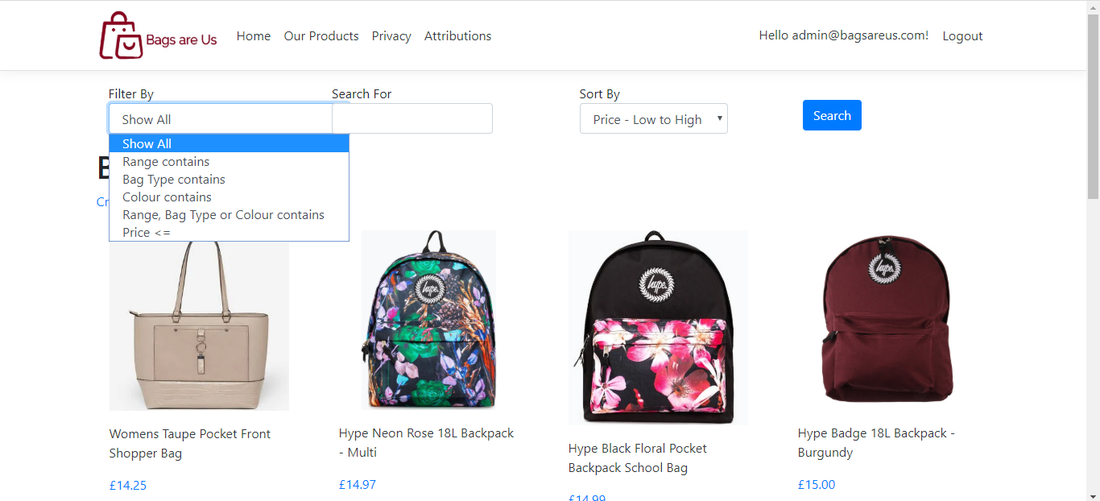
Figure 1: Filter products options.
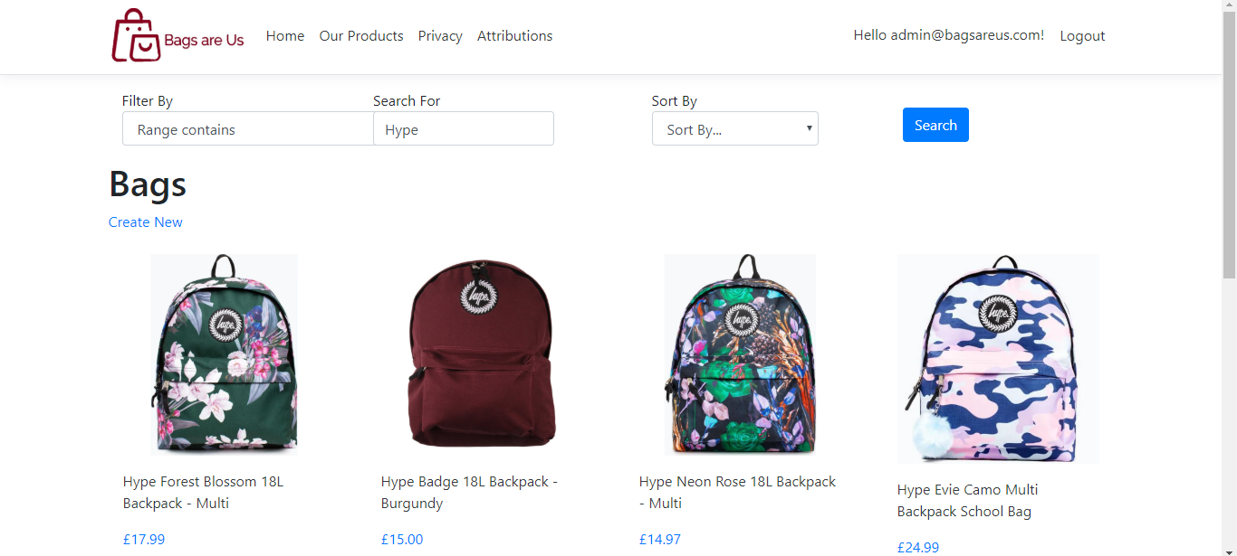
Figure 2: Bags filtered to only show bags of the range Hype.

Sorting results:
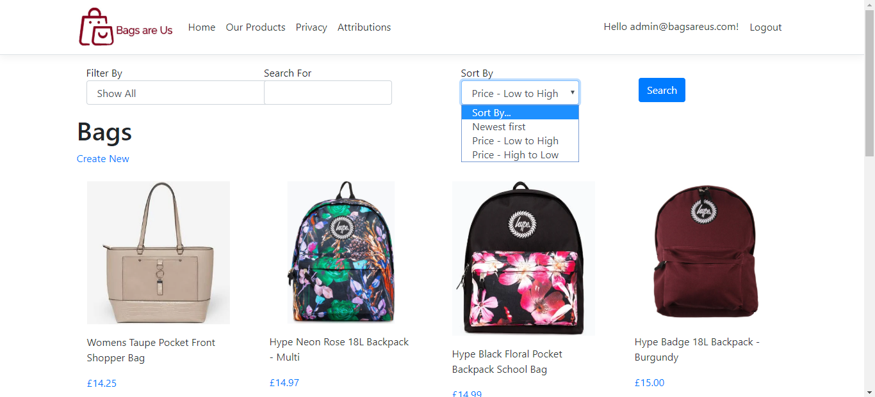
Figure 3: Sorting products options.
Enums were created to search the bags. The enums created were ProductFilterColumns and ProductSortOptions. The ProductFilterColumns enum defined the columns in the Product details table that the user can apply filter search strings to. The ProductSortOptions enum defined the columns in the Product Details table which the user can apply sort strings to.

4.2. Views

Product details
Views were created for the product details table to allow customers to view product details.
Index view
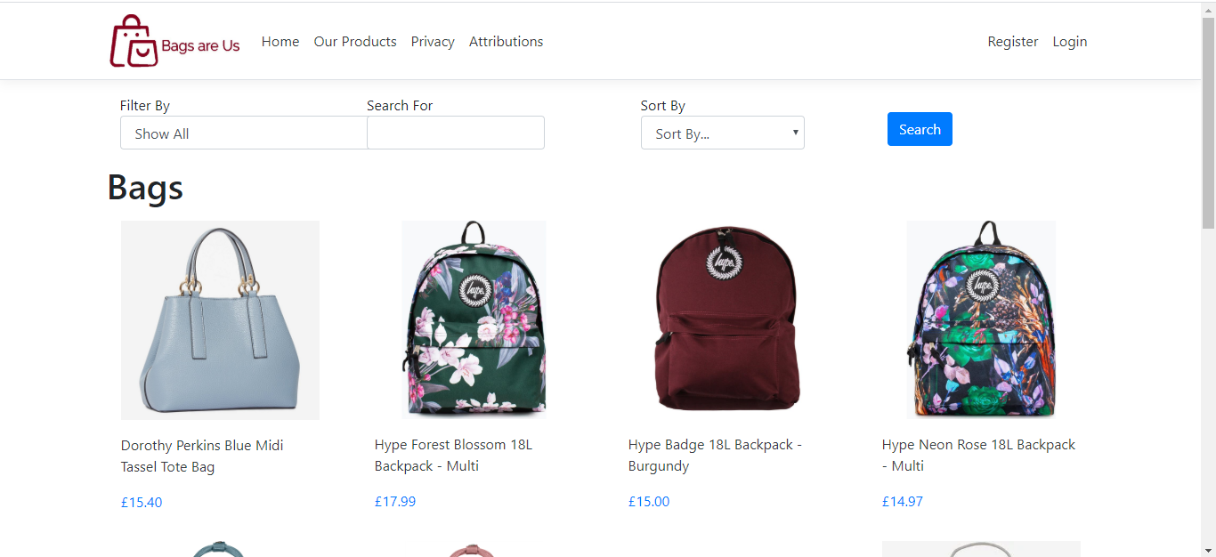
Figure 4: Product Details page.
The views enable Admin users to perform CRUD functions.
Creating new items of stock on the Product Details page and reading existing stock
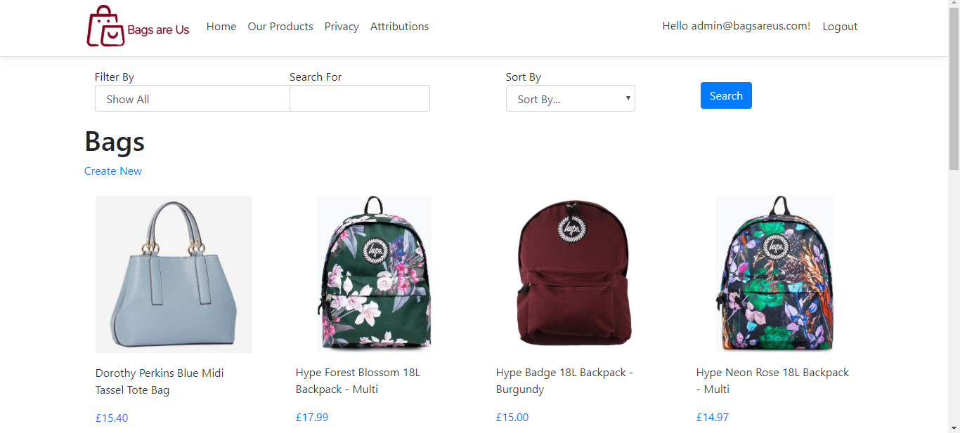
Figure 5: Product details page displaying items and giving admin the option to add new stock.

Viewing an item of stock in more detail
A create button is also available on this page for admin to add a new product to the range.

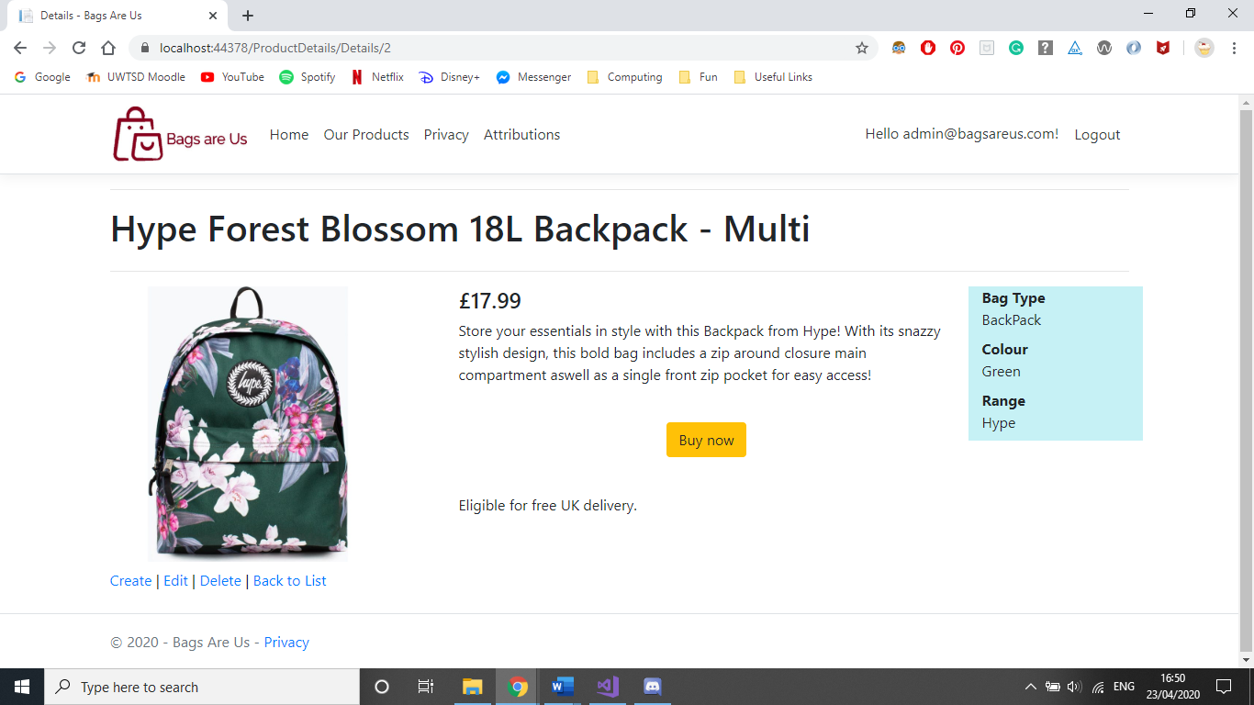
Figure 6: Product details page showing admin options below the details.

Updating items of stock
Edit button for admin to edit and update details of an item of stock such as the price or description.
Figure 7: Product details page showing option to edit the product shown.

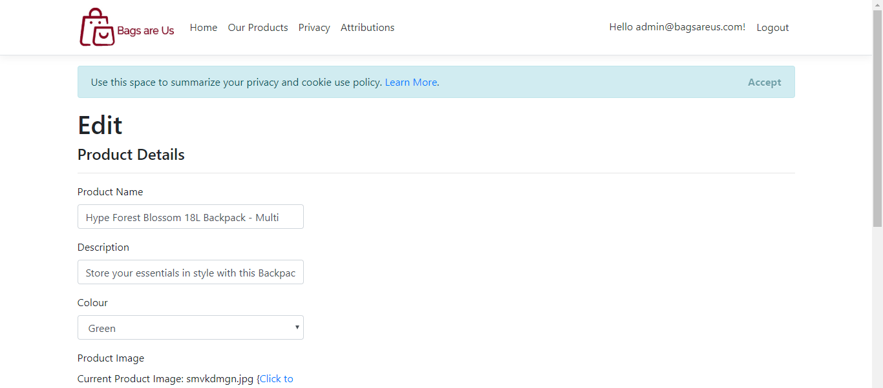

Figure 8: Edit product details view.
Deleting stock
Delete button for admin to delete an item of stock.
Figure 9: Product details page showing option to delete the product shown.

Admin is prompted with a message confirming they would like to delete the product before proceeding.
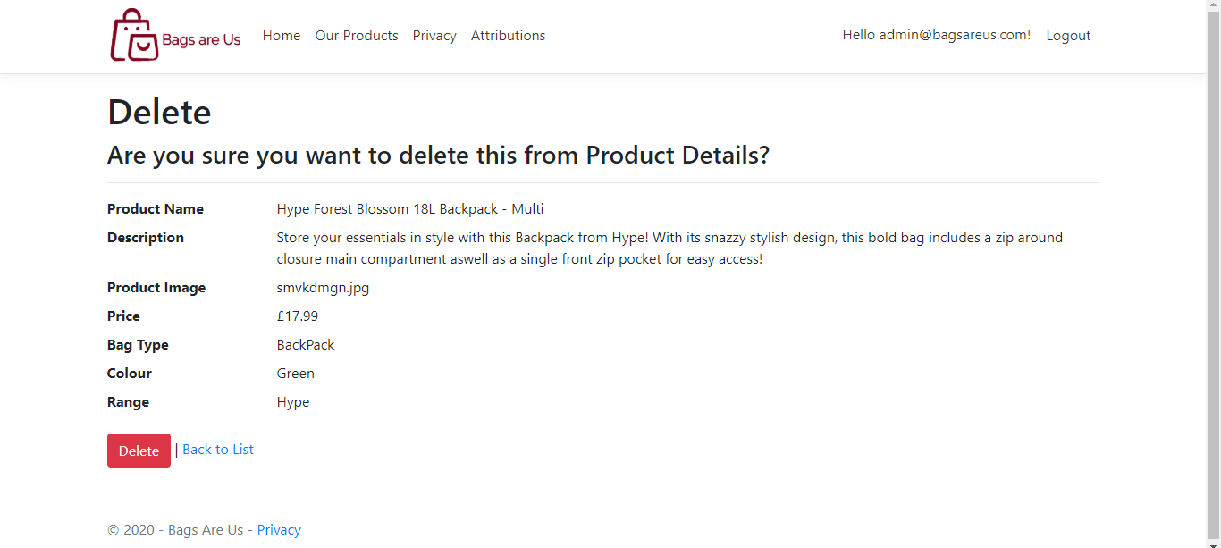
Figure 10: Message asking user if they are sure they want to delete the product.

Partial views were created to display the results of customer search queries and pagination.
For example, the search result from searching the bags by the range Hype is shown in Figure 2.
Figure 11: Bags filtered to only show bags of the range Hype.

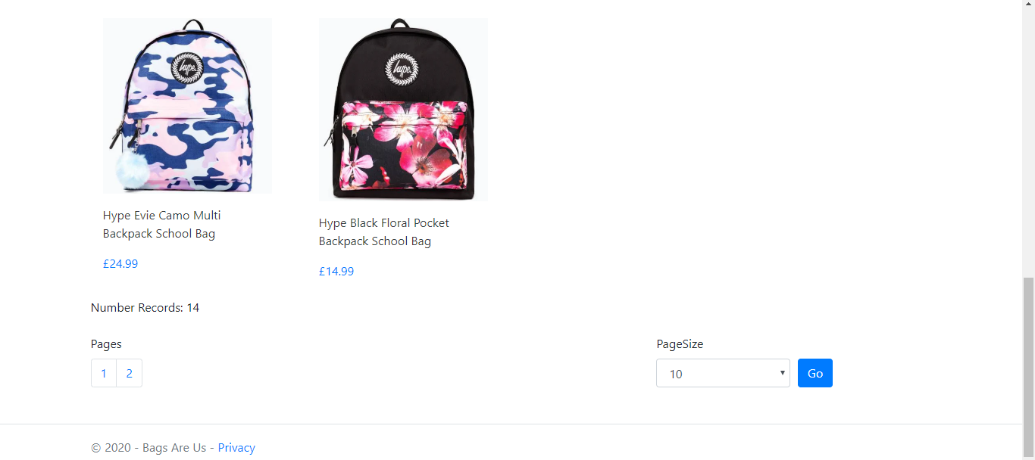
Figure 12: Screenshot showing pagination of products.

Order details
CRUD functions were created to allow customers to order bags and view details of their order. Admins can create, view, edit and delete customer orders.
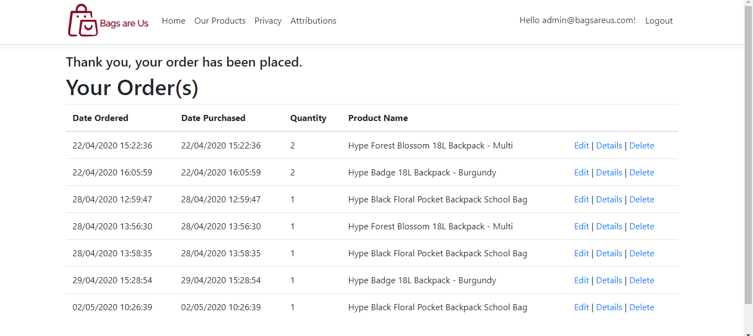
Figure 13: Orders page when logged in as admin.

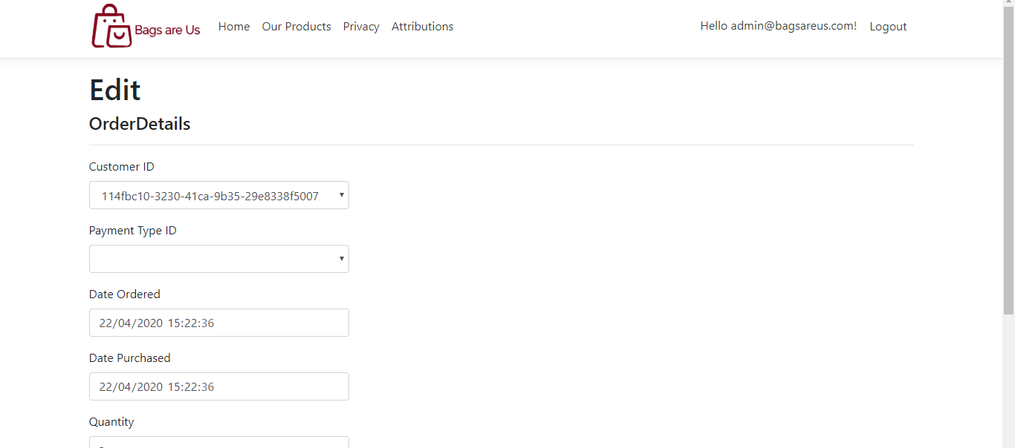
Figure 14: Edit orders page when logged in as admin.
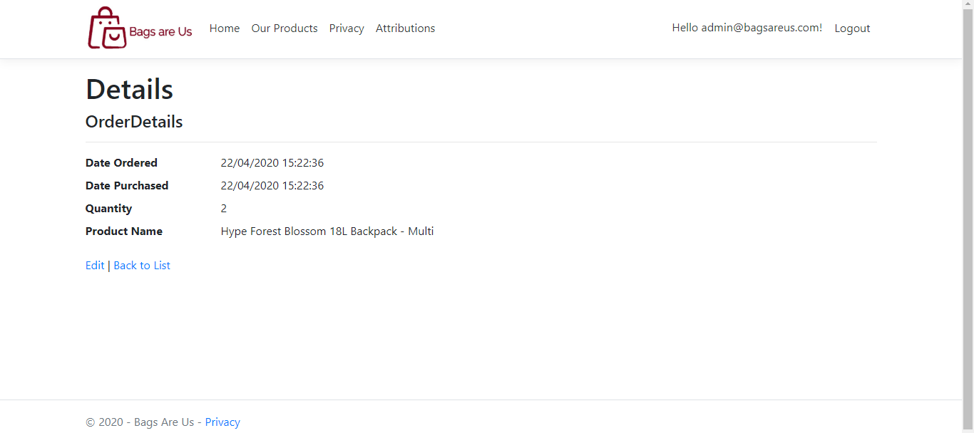
Figure 15: Details of orders accessible for customers and admins.

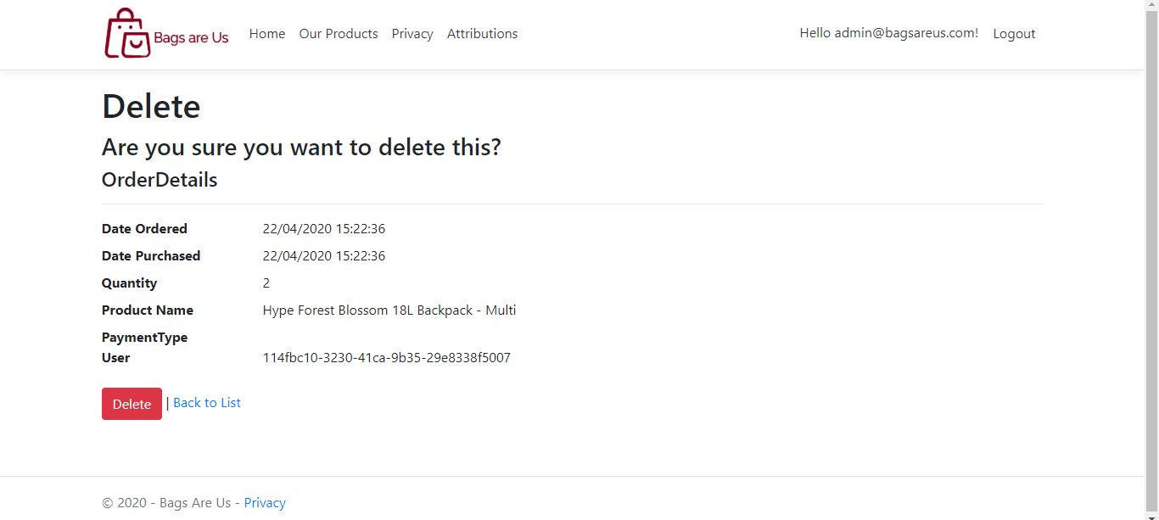
Figure 16: Delete orders page when logged in as admin.

View models
A Products Filter View model was created to allow the customer to filter the products by bag type, range type or colour, and then search for that specific bag type, range or colour as shown in Figure 1 and Figure 2. It also gives the customer the option to sort the products by Newest first, Price (low to high) or Price (High to low).
A base filter view model was made to specify the query criteria for filtering and to create pagination. The Products Filter View model inherits from BaseFilterView and is responsible for the filtering functionality.

Controllers
Product Details and Order Details controllers are responsible for the logic – handling the user inputs and sending the views the appropriate data.

Evaluation

Testing
Test case summary/  description | Preconditions or prerequisites | Test Steps | Test Data | Expected result | Actual Result | Pass/  Fail
Test if admin can add products to website. | User must be logged into website as an admin. | Click ‘Create New’ on the Product Details page.  Fill in fields about new product. | 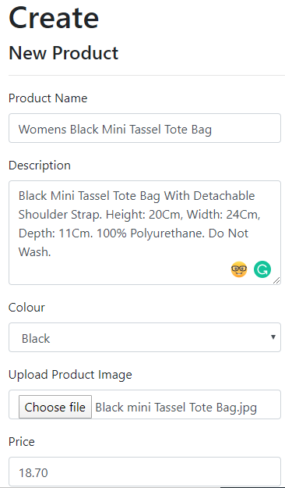 | A new product is created and displayed on the Product Details page. | 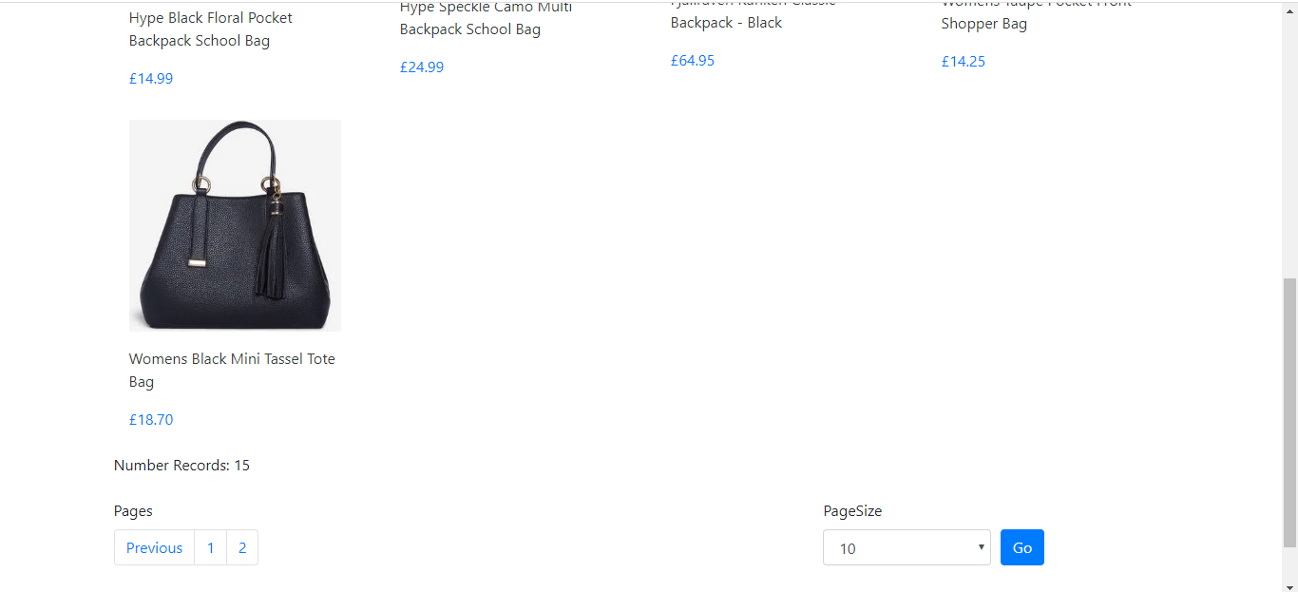 | Pass

Test if product name field is required. | User must be logged into website as an admin. | Click ‘Create New’ on the Product Details page.  Leave product name field empty. | 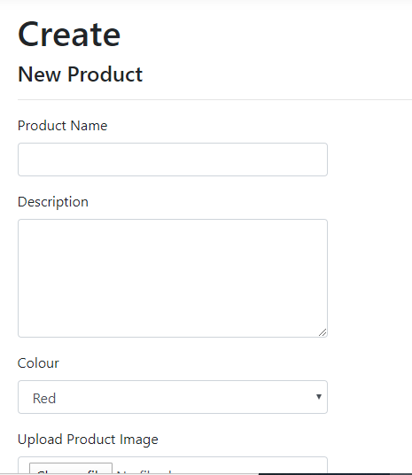 | A validation message appears saying “The Product Name field is required.” | 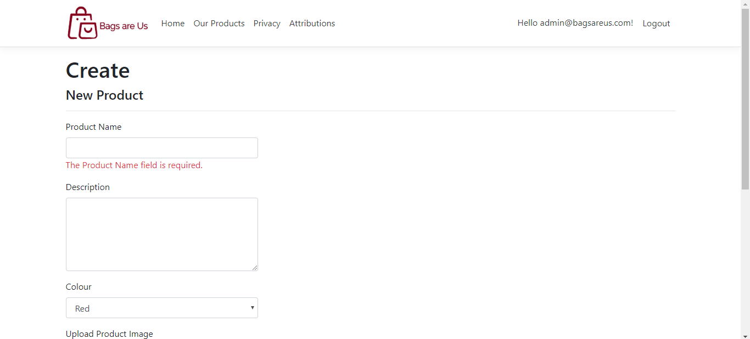 | Pass
Test if price field is required. | User must be logged into website as an admin. | Click ‘Create New’ on the Product Details page.  Leave price field empty. |  | A validation message appears saying “The value '' is invalid.” | 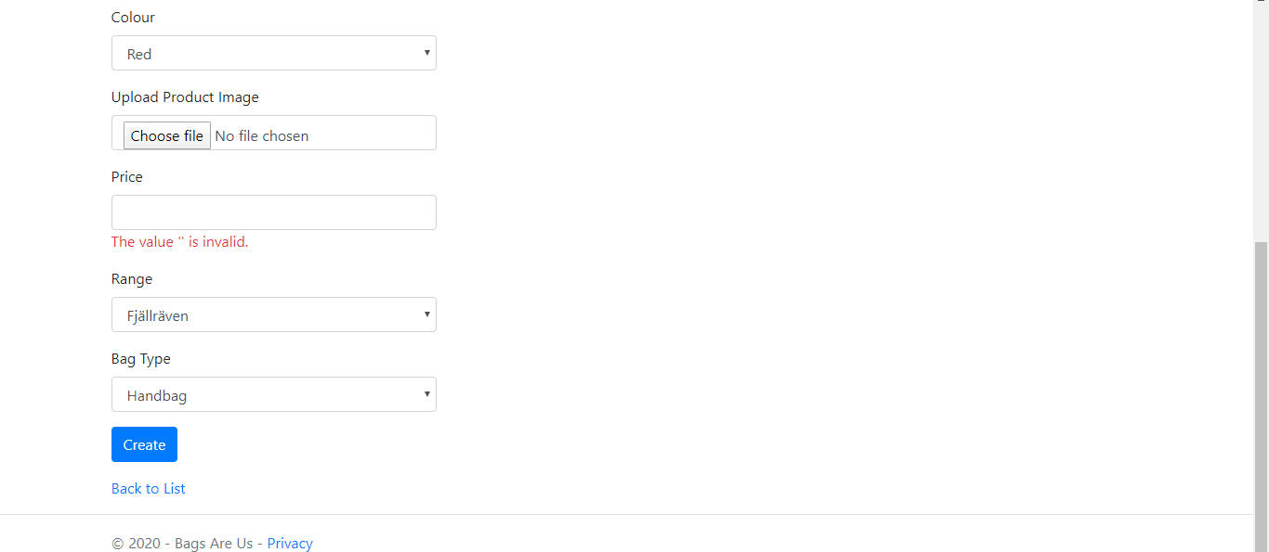 | Pass

Test if description is limited to 255 characters. | User must be logged into website as an admin. | Click ‘Create New’ on the Product Details page.  Try and type more than 255 characters. | 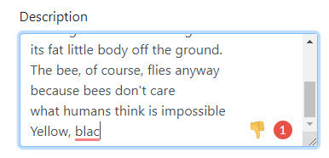 | Does not let user type more than 255 characters. |  | Pass

Test if admin can edit products. | User must be logged into website as an admin.  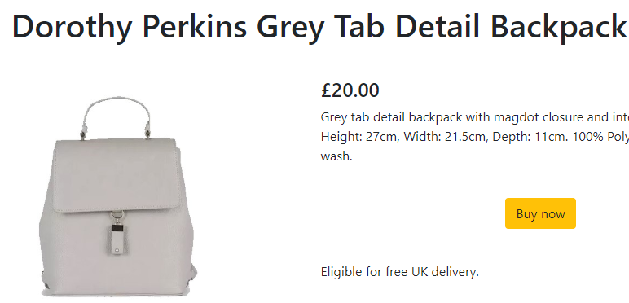 | Select a product,  Click ‘edit’,  Change image and the price from £20.00 to £17.99 | 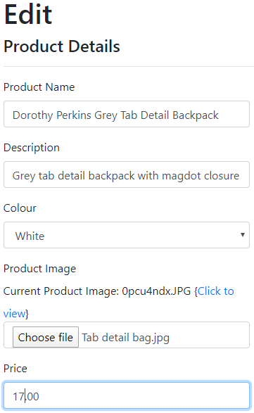 | The price and image changes. | 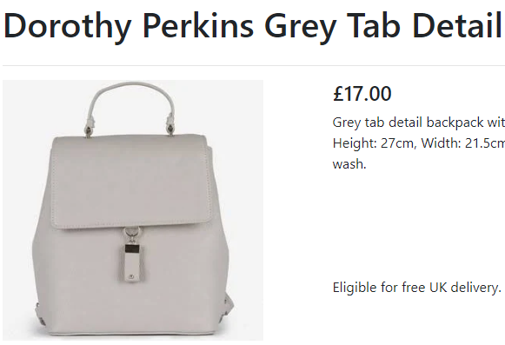 | Pass
Test if admin can delete products from website. | User must be logged into website as an admin.   | Delete Oasis products from product list. | 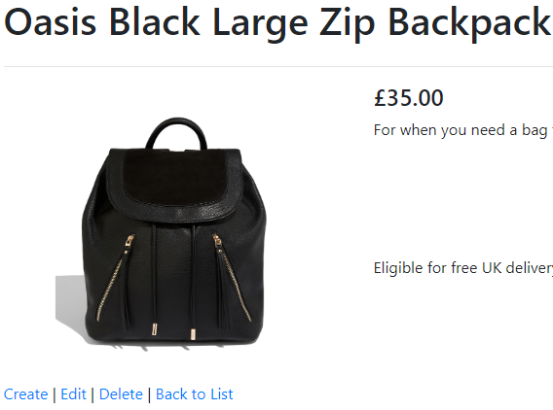 | The product is removed from the product list and the product number decreases from 15 to 14. | 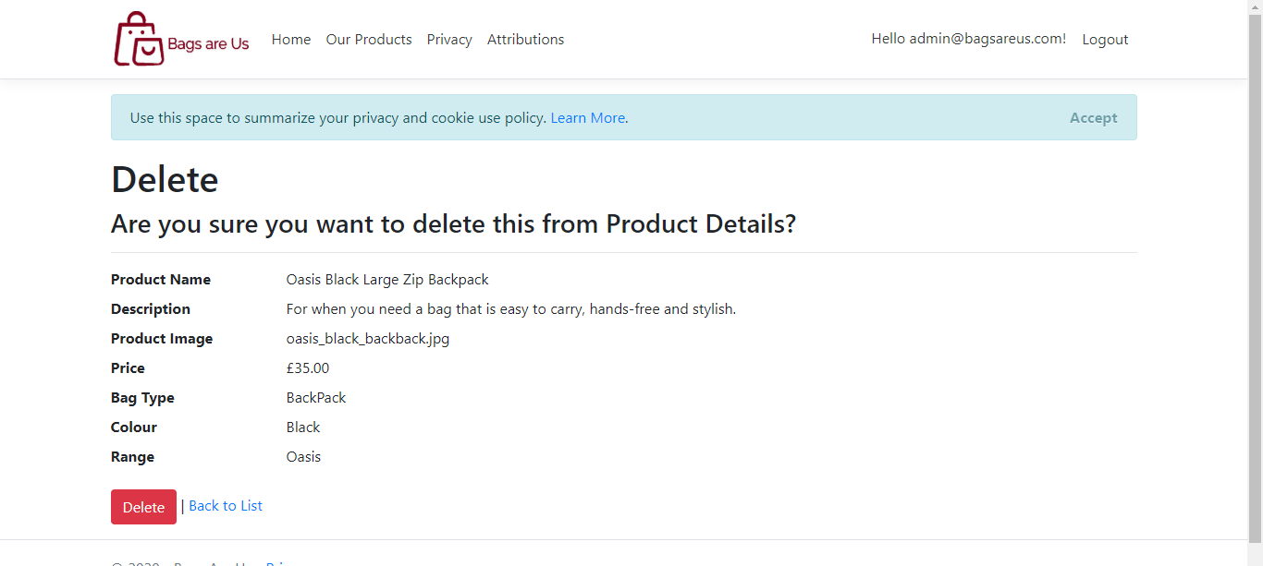   | Pass

Test if customer can order a bag. | User must be logged in. | Click ‘Buy now’ and purchase a bag. | 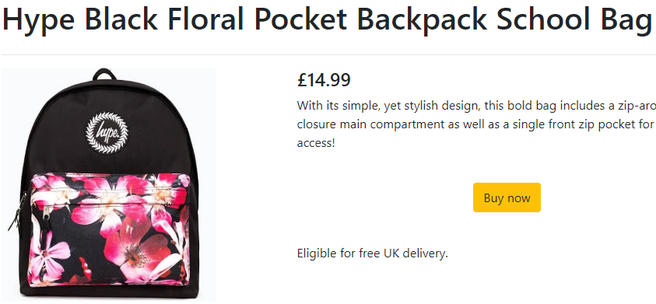  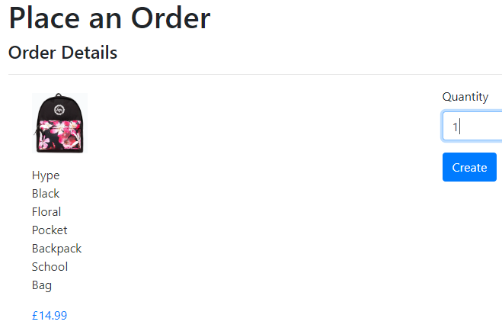 | The bag is ordered by the customer. | 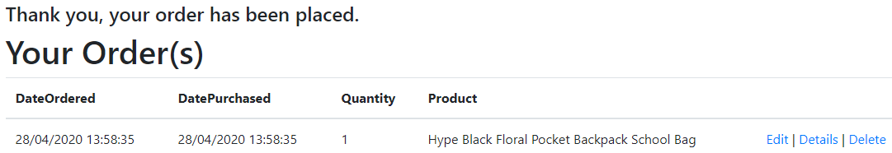 | Pass
Can a customer edit their order after they have placed it? | User must be admin. | Click ‘Edit’ beside the customer order. | N/A | Access is denied. | 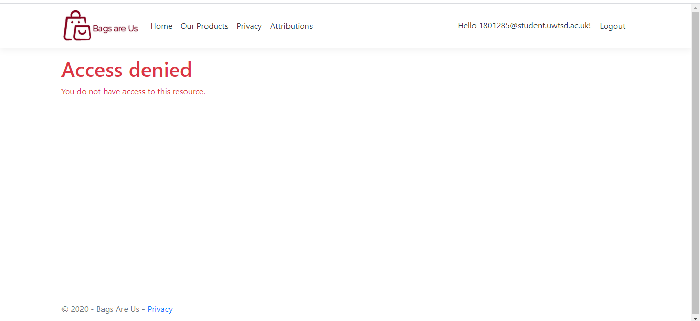 | Pass
Can a customer delete their order after they have placed it? | User must be admin. | Click ‘Delete beside the customer order. | N/A | Access is denied. | 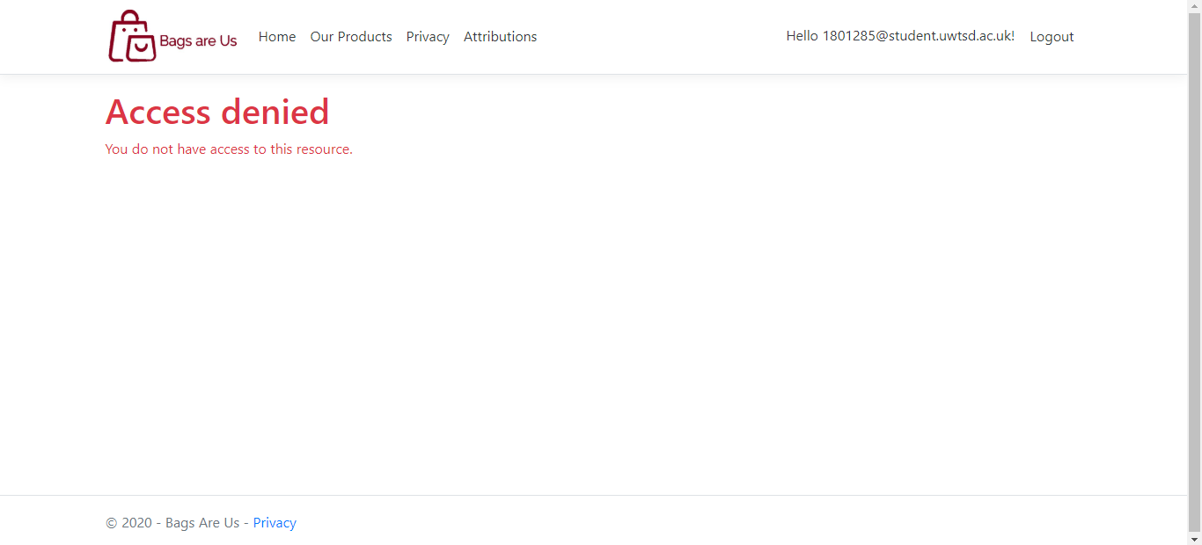 | Pass

Can admin see all orders placed by all customers? | User must be logged in as admin. | Access the order details page whilst logged in as admin. | N/A | All the orders are displayed. | 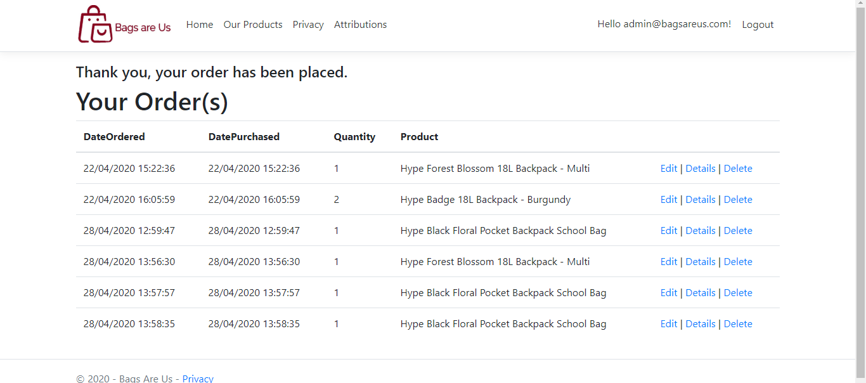 | Pass

Can an admin edit a customer order? | User must be logged in as admin. | Change the quantity from 1 to 2. | 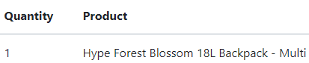 | The quantity is changed from 1 to 2. | 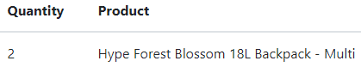 | Pass
Can an admin delete a customer order? | User must be logged in as admin. | Delete the 5th customer order from the list. | 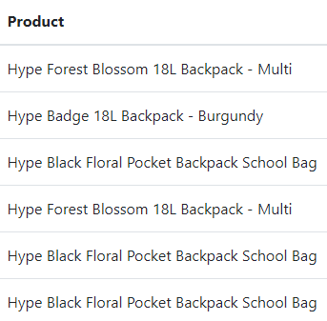 | The order is removed from the list of orders. | 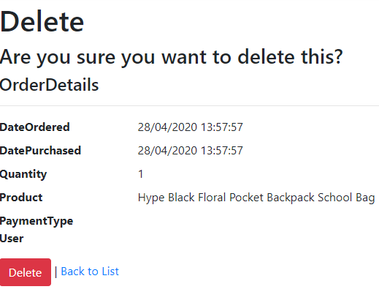  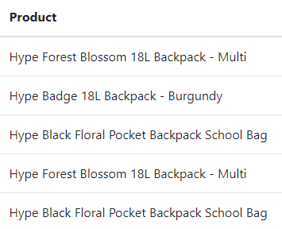 | Pass

Can a visitor create an account and log in? | N/A | Create an account and log in with that account. | 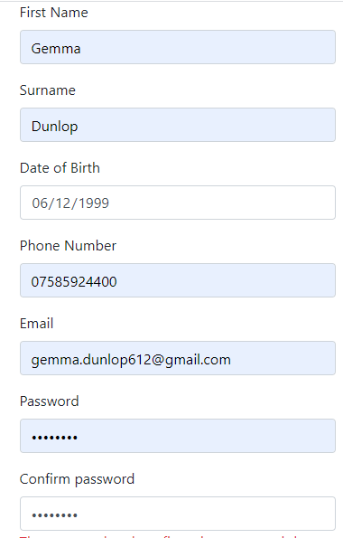 | Account is created and user can log in. | 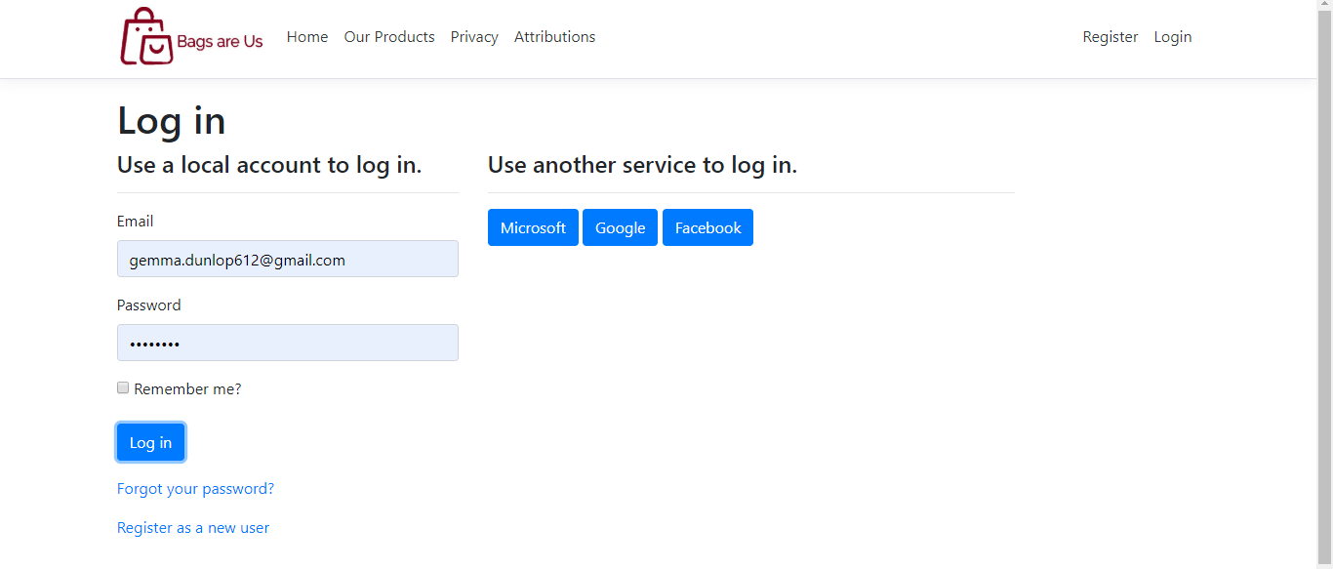  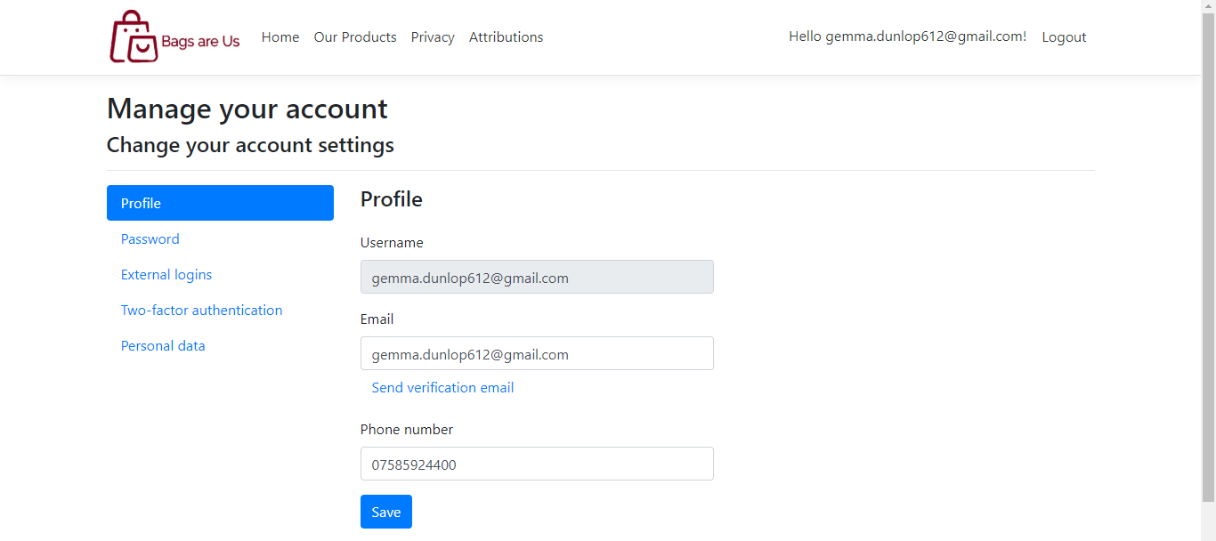 | Pass
Do validations messages appear when visitor is creating an account? | N/A | Go to the sign in page and leave the fields blank. | 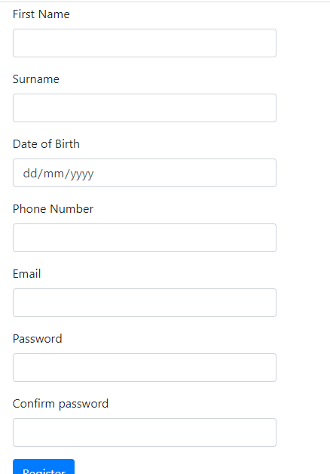 | The validation messages appear. | 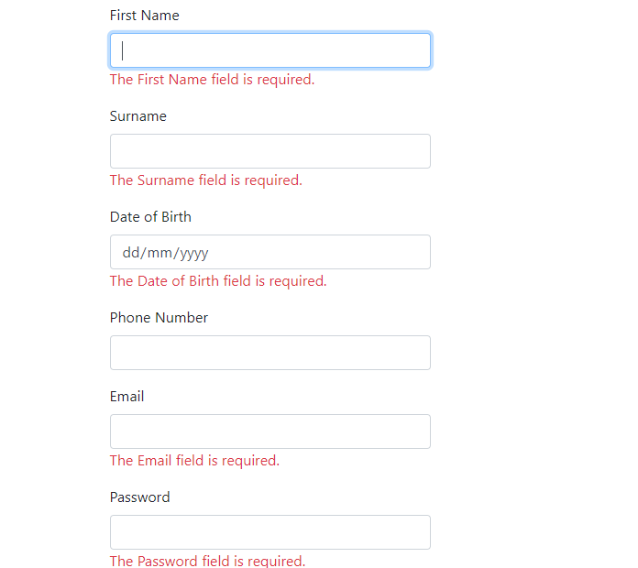 | Pass

Does a validation message appear if the confirm password field does not match the password field? |  | Type two different passwords in the fields. | 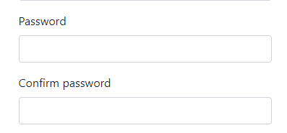 | The validation message appears | 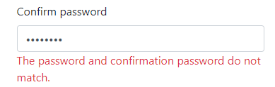 | Pass

Evaluation
The effectiveness of an e-commerce website lies in optimizing user experience, keeping things straightforward and gaining consumer trust. This will not only persuade customers to shop at a website, but it will also persuade the customer to revisit the site in the future.
The Bags are Us website was created with the user in mind, consisting of a simplistic design and easy to use layout. It is an online bag company and the aim of the site is to persuade visitors to purchase items. The website gives a new visitor a good picture of who Bags are Us are and what products they sell.
User friendliness is an essential factor when creating a website. If the site user is unable to locate content, they will typically leave and there will be a high bounce rate. To improve the homepage, more time could be spent perfecting the layout and images to avoid a high bounce rate [3]. The Product Details page consists of a search bar and filter fields for visitors to quickly search through the products, and once they have selected a bag, an option for purchasing the bag is presented. The button to purchase the bag is bright yellow, attracting the user’s attention.
Customer satisfaction is essential for an e-commerce website. The following factors outline the main considerations that affect usability helping customers to fulfil their needs:

Accessibility
The Web is built to function for all users, irrespective of their equipment, software, language, location, or capability. Web accessibility ensures that individuals with disabilities can view, recognise, work, and communicate with the website [4]. Web accessibility also helps non-disabled users, such as elderly people with abilities that have changed because of ageing or people with "temporary conditions" such as a fractured arm or missing glasses.
The Bags are Us website contains alt tags on each image for people who have a visual or hearing impairment. The website can be used exclusively using the keyboard to benefit users who cannot use a mouse. The website passes the software test for colour contrast [5], which would otherwise make reading difficult e.g. dyslexic and colour vision deficiency people.
To improve, further accessibility testing could be carried out to ensure the website is more accessible for all users, such as using accessibility testing software to determine whether web content satisfies accessibility criteria. If the website were hosted live on the web, more consideration could be done to ensure the text does not overlap each other when enlarged.

Responsiveness
Since we live in a multi-screen world, the Bags are Us website was designed so it is viewable on as many different sized screens as possible as Bootstrap was used, as there are many different devices a user may use to display the website. It is therefore wise to cater to both desktop and smartphone audiences. The number of mobile viewers currently exceeds the number of laptop viewers, and this figure will only continue to rise as global mobile connectivity increases [6].

Content
Users that will visit the Bags are Us e-commerce website would generally come to browse or with the intention of purchasing an item. The content was therefore written in a way that is clear, easy to interpret and understandable [7]. The fonts used are easy to read and the content is understandable and effective, although additional content could be added with more time, such as more bags on the products page and more promotional images on the homepage such as promoting summer ranges or back to school.

Layout and Navigation
It is essential for an e-commerce website to be efficient and allow its visitors to locate products they require as easily and efficiently as possible, without wasting time or energy. The Bags are Us website was designed with a simple and efficient navigation for the visitor to search through tools such as the navigation bar, menus, buttons, etc. This will help visitors find what they are looking for so they will be more likely to purchase items. To improve, breadcrumb navigation [8] could be used to show the visitors where they are on the website and how they got there which enhances user experience.

Errors
Errors produced by the code on the Bags are Us website are important, as they can be easily fixed. Manual testing was performed to identify and minimise errors [9]. To improve, software testing tools could be used to provide extra confirmation of potential errors so they can be corrected.

User Testing
Visual testing was performed on the Bags are Us website to ensure it is fast loading. To improve, testing could be carried out using website usability software to calculate the length of time it takes for a client to achieve his or her goals via the website compared to normal, i.e. the time it takes for a user to explore each product on the website and order products [10].

Conclusion
It is vital for an e-commerce company to have a good website design that is appealing and user-friendly, but the website is not effective if it does not satisfy the needs of the customer. Visitors to Bags are Us will have a good understanding about what the website is like and what it promises as they land on their webpage.
A well-designed website is essential for the success of a business such as Bags are Us. It is important to plan and create a website in the best way possible to guarantee the website is effective. The success of the website can only be measured by collecting accurate, credible statistics on user activity and by trying to continually enhance the website to the good of the client.

References

[1] | Pixus, “The importance of a good homepage | Pixus,” Pixus, 24 November 2016. [Online]. Available: https://www.pixus.uk/blog/importance-good-homepage/.
[2] | Microsoft, “ASP.NET MVC Pattern | .NET,” Microsoft, 2020. [Online]. Available: https://dotnet.microsoft.com/apps/aspnet/mvc.
[3] | Google Support, “Bounce rate - Analytics Help,” Google, [Online]. Available: https://support.google.com/analytics/answer/1009409?hl=en.
[4] | Mozilla, “What is accessibility?,” MDN contributors, [Online]. Available: https://developer.mozilla.org/en-US/docs/Learn/Accessibility/What_is_accessibility. [Accessed 7 January 2020].
[5] | “WebAIM: Contrast Checker,” WebAIM, [Online]. Available: https://webaim.org/resources/contrastchecker/.
[6] | Hosting Tribunal, “What Percentage of Internet Traffic Is Mobile in 2020?,” 2020. [Online]. Available: https://hostingtribunal.com/blog/mobile-percentage-of-traffic/#gref.
[7] | D. G. a. E. Turban, “Determinants of successful Website design: relative importance and recommendations for effectiveness,” in Proceedings of the 32nd Annual Hawaii International Conference on Systems Sciences, Maui, HI, USA, 1999.
[8] | M. Levene, An Introduction to Search Engines and Web Navigation, 2 ed., London: John Wiley & Sons, 2011.
[9] | T. T. William Albert, Measuring the User Experience: Collecting, Analyzing, and Presenting Usability Metrics, Waltham, Massachusetts: Newnes, 2013.
[10] | usability.gov, “Usability Testing,” usability.gov, [Online]. Available: https://www.usability.gov/how-to-and-tools/methods/usability-testing.html. [Accessed 2020].

Images

Home Page
https://cdn.shopify.com/s/files/1/0071/3637/8998/articles/the-history-of-fjallraven_1024x1024.jpg?v=1547040928

https://t3.ftcdn.net/jpg/01/10/88/00/240_F_110880067_ij00vMzUpjKAt3d4Lbvw2SYG4riZfpsD.jpg

https://www.happyjute.com/wp-content/uploads/2017/03/Embroidery-Bags-background.jpg

https://www.xupes.com/magazine/Content/Images/Media/3905/MultiImages/Original/HERMES-NAVY-BOX-CALF-LEATHER-MINI-KELLY-and-HERMES-CELESTE-MYKONOS-EPSOM-LEATHER-KELLY.jpg?w=925
https://www.one-goodthing.com/wp-content/uploads/2018/06/4.Thursday-600x600.jpg
https://www.firstpres-charlotte.org/wp-content/uploads/2017/08/backpack-blessing.jpg

Products Page
https://images.dorothyperkins.com/i/DorothyPerkins/DP18712015_F_1.jpg?$w700$&qlt=80
https://www.fjallraven.com/globalassets/catalogs/fjallraven/f2/f235/f23510/f519/7323450315016_ss18_a_kanken_21.jpg?width=600&height=600&mode=BoxPad&bgcolor=fff&quality=80
https://www.fjallraven.com/globalassets/catalogs/fjallraven/f2/f235/f23510/f312/7392158680955_ss18_a_kanken_21.jpg?width=600&height=600&mode=BoxPad&bgcolor=fff&quality=80
https://cdn.shopify.com/s/files/1/0098/8990/6788/products/BTS19018_170x170_crop_center.jpg?v=1559227396
https://skatehut.images.blucommerce.com/skatehut/product/HYP-217-BAD-BPK-BUR.jpg?auto=format%2Ccompress&bluhash=972cf384452488e580cb02e02bf60a01&w=750&h=750&fit=fillmax&fill=solid&s=e672b4cc5cde48e65ea616c5e126cd9d
https://skatehut.images.blucommerce.com/skatehut/product/hype-forest-blossom-18l-backpack-multi-04.jpg?auto=format%2Ccompress&bluhash=1d85975bff169a7ff7fc0fcdf296bc4c&w=750&h=750&fit=fillmax&fill=solid&s=c06ca6f2be30b8170356454bbd995818
https://cdn.shopify.com/s/files/1/0098/8990/6788/products/YYF468.jpg?v=1565973149
https://images-na.ssl-images-amazon.com/images/I/910TQhj-2hL._AC_SY741_.jpg
https://dynamic.zacdn.com/63DOdgkdBBffmLQ-QNW1wIKexbc=/fit-in/346x500/filters:quality(95):fill(ffffff)/http://static.hk.zalora.net/p/dorothy-perkins-1818-9478735-1.jpg
https://cdn.shopify.com/s/files/1/0098/8990/6788/products/BTS19018_170x170_crop_center.jpg?v=1559227396
https://images.dorothyperkins.com/i/DorothyPerkins/DP18726811_F_3.jpg?$2col$
https://m.media-amazon.com/images/I/71oWq0Vah2L._AC_UL320_.jpg
https://media.real-onlineshop.de/images/items/original/aec650889de6f3f5608322f5926c6a88.jpg

marking criteria and Student FEEDBACK

This section details the extent to which the assessment criteria are demonstrated by you, which in turn determines your mark. The marks available for each category of skill are shown. Lecturers will use the space provided to comment on the achievement of the task(s), including those areas in which you have performed well and areas that would benefit from development/improvement.

Common Assessment Criteria Applied (Assignment 2) | Marks available | Marks  awarded
1. Engagement with Literature Skills

2. Knowledge and Understanding Skills

3. Cognitive and Intellectual Skills

A very good set of test cases have been developed. What I would, however, have liked to see from your test cases is suggested improvements observed based on the results of the test cases. If you had looked at the link to example test cases provided in the assignment brief, you would have observed that most have an additional column for comments. A very good evaluation has been provided but it needs to be expanded upon to provide a more critical evaluation of the application's functionality too, highlighting its limitations and practical recommendations for improvements. (Grade mark: 76.67%) | 30 | 23
4. Practical Application Skills

A very good attempt featuring a simple application based on the class tutorial exercise. Overall, a very good and well-thought-out database design and well done for implementing the ordering process. My minor comment would have been to include the price in the order table. Yes, I know you intended to use the ProductOrderDetails for this, but when you decided not to, then you should have updated this. You could have also asked me how to implement either option. Some other comments to note: You should have added a notification to the product buy now page to inform the user that they needed to be logged in to purchase an item. In addition, add another menu item called Orders/My Orders so users and admin could see past orders. The home page was well designed but there were no clickable links on it - I kept trying to click on things, which is what users would do too. Also, be mindful of the "above-the-fold" content in particular on web pages - see comments in main report. (Grade mark: 76.67%) | 60 | 46
5. Transferable Skills for Life and Professional Practice

The report is very well written and presented. (Grade mark: 80.00%) | 10 | 8

Assignment Mark (Assessment marks are subject to ratification at the Exam Board. These comments and marks are to give feedback on module work and are for guidance only until they are confirmed. ) | Late Submission Penalties (tick if appropriate) |  | 77%
 | Up to 1 week late (40% Max) |  | 77%
 | Over 1 week late (0%) |  | 77%

