LCBB5003

Management Economics

Name : Ivana Desevova

Studednt ID: 2027510

Lecture: Vasilios Tavlaridis

What is perfect competition?

Although perfect competition rarely occurs in real-world markets, it provides a useful model for explaining how supply and demand affect prices The term perfect competition refers to a theoretical market structure. and behavior in a market economy.
Under perfect competition, there are many buyers and sellers, and prices reflect supply and demand. Companies earn just enough profit to stay in business and no more. If they were to earn excess profits, other companies would enter the market and drive profits down.

KEY TAKEAWAYS
- Perfect competition is an ideal type of market structure where all producers and consumers have full and symmetric information and no transaction costs.
- There are a large number of producers and consumers competing with one another in this kind of environment.
- Perfect competition is theoretically the opposite of a monopolistic market.
- Since all real markets exist outside of the plane of the perfect competition model, each can be classified as imperfect.
- The opposite of perfect competition is imperfect competition, which exists when a market violates the abstract tenets of neoclassical pure or perfect competition.

How Perfect Competition Works
Perfect competition is a benchmark or ideal type to which real-life market structures can be compared. Perfect competition is theoretically the opposite of a monopoly, in which only a single firm supplies a good or service and that firm can charge whatever price it wants since consumers have no alternatives and it is difficult for would-be competitors to enter the marketplace.
In a perfect competition model, there are no monopolies. This kind of structure has a number of key characteristics, including:
- All firms sell an identical product (the product is a commodity or homogeneous).
- All firms are price takers (they cannot influence the market price of their products).
- Market share has no influence on prices.
- Buyers have complete or perfect information (in the past, present, and future) about the product being sold and the prices charged by each firm.
- Capital resources and labor are perfectly mobile.
- Firms can enter or exit the market without cost.
This can be contrasted with the more realistic imperfect competition, which exists whenever a market, hypothetical or real, violates the abstract tenets of neoclassical pure or perfect competition.
Since all real markets exist outside of the plane of the perfect competition model, each can be classified as imperfect. The contemporary theory of imperfect versus perfect competition stems from the Cambridge tradition of post-classical economic thought.

Do Firms Profit in Perfect Competition?
Profits may be possible for brief periods in perfectly competitive markets. But the market’s dynamics cancel out the effects of positive or negative profits and bring them toward an equilibrium. Because there is no information asymmetry in the market, other firms will quickly ramp up their production or reduce their manufacturing costs to achieve parity with the firm which made profits.
The average revenue and marginal revenue for firms in a perfectly competitive market are equal to the product’s price to the buyer. As a result, the perfectly competitive market’s equilibrium, which had been disrupted earlier, will be restored. In the long run, an adjustment of supply and demand ensures all profits or losses in such markets tend toward zero.
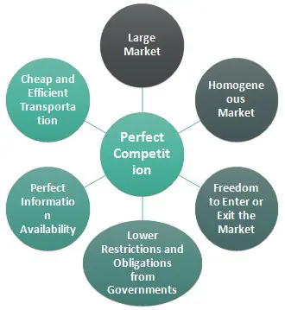

Perfect Competition vs Monopoly
We refer to a popular market structure called a monopoly to understand perfect competition better. A monopoly is theoretically opposed to perfect competition, characterized by a single product seller with no close substitutes. Monopoly provides full power over prices, and consumers cannot shift to another seller in case of a price rise because there might be no other option available. High barriers to entry and exit result in a negligible competition. E.g., Intel in the microprocessor industry has a 90% market share.

