hotel grand london

Syed gous uddin 2110027
Understanding and servicing guests from an Islamic country
  - Hand book for employees

Executive summery
The content of this code of conduct summery will explain the differences employees will face serving and interacting with Muslim guests that will be arriving at the grand London hotel.
The grand London hotel specializes in entertaining guests from the middle east specially Saudi Arabia, as the hotel is based in the capital of England it is mainly a British orientated hotel.
The hotels main guests are from an Islamic country and understand Islamic customs is key to keeping guests happy and not to offend and one or anyone’s religious believes. The report will be examining the different types of food and beverages that Muslims eat and drink what is forbidden and what it is meant by only eating halal meat, how to greet and how you will be greeted, men are greeted in one way and woman are greeted in a different way, understanding and respecting the holy month of Ramadan, hotel procedures and any changes that will be made to accommodate fasting through the holy month of Ramadan having the understand of the culture will help employees deliver a better service and make the guests stay more pleasant.
A brief explanation on Hofstede’s insights talking about the three main finds power distance, individualism and indulgence the three main finds that are very different between the to countries and cultures

Content
About Saudi Arabia
Halal food and beverage
Meeting and greeting
Hofstedes insights
The holy month of Ramadan

ABOUT THE GUEST AND WHERE THEY ARE FROM.
Visit Saudi.com (2022) answers a lot of questions around how to greet, greeting in Saudi arabia and other Islamic countries are done the same by saying the Islamic greeting word ‘salam alaykum’ which means “ peace be upon you” the greeting is the same to male and female the only difference is that male guests will sake your hand as well as saying “salam alaykum” but female guests will stay at least a meter way while saying the greeting word, this is due to the rule that male and female touching is forbitten in the Islamic religion and culture.
Male guests will interact talk and male guests will wear white robes called Juba male guests will shake hand even while walking may put the hand on your back as a sign that they feel relaxed around employees and other people, all obscene language will offend specially and word regarding male or female private parts.
Female guests are different as they will wear a face covering called a hijab some will only show their eyes and this is due to religious rules that woman abide by.
Madinahcollage.com (2022) explains that when greeting you must no mumble you must be clear as this can offend Muslims from Saudi Arabia male and female, waving is known to be rude.
All Muslims follow teachings of their holy prophet Muhammad (peace be upon him) at no time should any member of staff talk about the religion or mention anything about the prophet it is highly offensive to all Muslims. To truly understand the Muslim culture is to understand Hadith ( the teachings of the prophet and his companions) all aspects of Saudi Arabia and other Muslim countries are from the books and scholars of Islam, we haven’t got the time to read all the books of hadith but we can do some online research’s https://archive.siasat.com/news/spread can help understand where the culture gets its rues ad regulations, the hotel could advise to take the time to look through this website to get more of an understanding of the culture and customs.

FOOD
All Muslims eat halal food, halal means what is lawful to Muslims to eat as explained in www.sofht.co.uk (2022) the Quran ( the Islamic holy book says)” oh people! Eat of what is on earth, lawful and good” . halal applies to all food and not just meat as is sometimes thought, halal is an Arabic word that means lawful and permissible.
The hotel will provide halal meat and the kitchen management will be trained in the handling of halal foods, front of house and any member of staff serving will need to understand that all food served to and of the guests from Saudi Arabia must not come in any cross contamination situations with halal food and beverage’s.
Hofstedes insights explains the differences between the two countries and as the table below shows that Saudi Arabia is not as much in individualism as the united kingdom is, they like to work together be more of a connected society compared to the united kingdom its more about the actions and thoughts about being individual and thinking about each other.
Power distance this is all about a culture recognises encourages authority and what goes with that a command and control approach, Hofstedes table shows that compared to the united kingdom Saudi Arabia scored high compared to the united kingdom showing that the culture is driven by authority and high Racky.
As the table shows that Saudi Arabia is not a that allows its society to relatively enjoy a free natural basic fun style of living compared to the united kingdom where culture and society is more free and open to enjoyments, taking Hofstedes dimensions into consideration one must understand that the two countries are very different in manys ways,life style to food and the way each live.
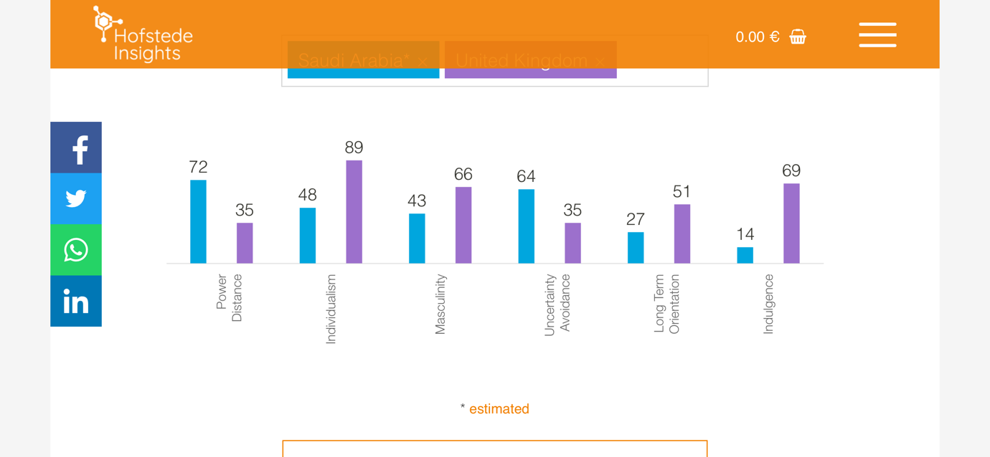

The grand London hotel is a multi-cultural hotel that caters for all cultures with respect and dignity as a member of the staff we all have to learn from each other and treat each guest with the respect and make there stay as special as possible being a Christian country some aspects of English culture may offend a guest from Saudi Arabia, understanding of holy month of Ramadan were all Muslims fast for 30 days (this does not mean the full 30 days) there is a certain time in the 24 hour that’s Muslims can eat or drink it is very important to understand this and the hotel will be facilitating for this holy month, key facts that will need to be understood, from sun sunrise till sun set all Muslim guests will not eat or drink the hotel will provide a time table to accommodate this in due time, the breaking of fast will very each day and as time arrives all guests will be notified and the dining room staff and management will be briefed on the arrangements made, food will be available for all Muslim guests at the time of breaking fast and a section of the dining area will be free from none halal food and alcohol. Through the month of Ramadan kitchen staff will be on call to accommodate last meal before fasting starts extra information will be available in due time on Ramandan.
Any additional information will be emailed I.E Ramadan

Reference list
https://www.visitsaudi.com/en/do/culture/saudi-culture-and-customs

https://academic.oup.com/edited-volume/34370/chapter-abstract/291501704?redirectedFrom=fulltext

https://academic.oup.com/search-results?qb=%7b%22Keywords1%22:%22women%22%7d

https://www.madinahcollege.uk/salams-how-to-greet-and-how-not-to-greet-another-muslim/

https://www.halalorigins.com/?gclid=Cj0KCQiApb2bBhDYARIsAChHC9tfkGI9uIwoB3fUTY7IL6WcOBNbOENhxa5lrLam7dN3w0EoYuo6aDsaAl59EALw_wcB

http://www.sofht.co.uk/wp-content/uploads/2016/hifs/understanding-halal/Understanding-Halal.pdf

https://www.hofstede-insights.com/fi/product/compare-countries/

https://youtu.be/Fwa1tkH7LEI

https://www.saudiembassy.net/culture-art

https://archive.siasat.com/news/spreading-salaam-greeting-peace-806518/

