October 29, 2021
andreea loredana mirica
University of Wales Trinity Saint David
2028692
problem solving and decision making bmsk4004
the decline of john Lewis

Abstract

The current document is focused on analysing the internal and external factors that led to the John Lewis Partnerships’ decline. The internal factors will be represented in a SWOT Analysis, with a focus on the strengths and the weaknesses of the company, while the external factors will be represented by a PESTLE analysis, with a focus on opportunities and threats. From the SWOT it can be deducted that the company has a lot of potential on the market especially because of their branding and relationship with the customers and the employees but on the other hand, the weaknesses showed a lack of leadership and a missing international presence. At the same time, from the PESTLE we can see the business was negatively impacted by Brexit and Pandemic, but they have a few opportunities to redeem themselves by investing in technology and sustainability.

Contents
Abstract 1
Introduction 3
Main Findings 4
Nature 4
Scope 4
Impact 5
SWOT analysis 6
PESTLE analysis 8
CONCLUSION 9
Appendices 10
SWOT analysis 10
PESTLE analysis 11
Reference List 12

Introduction

There are businesses that can maintain their reputation and be profitable over the years, but there is other that are starting to fail. This report is looking to analyse the reasons behind John Lewis’ decline. The report will start with a brief presentation of John Lewis, then it will identify the current problem while explaining its nature, scope, and impact. After those are presented, the report will identify the internal factors that led to the decline by using the SWOT Analysis, and the external factors, by using the PESTLE Analysis. All these are important to be able to determine the future of the company and to see if the decline will still be present in the future or if the company can redeem itself.

Main Findings

The John Lewis Partnership is represented by two large stores: John Lewis and Waitrose, and it is a UK-based company. The company pride itself for being the largest employee-owned organisation within the UK and has 34 John Lewis stores and 331 Waitrose shops across the country. On LinkedIn, the company describes itself as a ‘continuing experiment to create a better way of doing business’ and highlights the idea that their purpose is their members’ happiness (LinkedIn, 2021). By this, it can be deducted that the company truly values the customer experience and happiness, while also trying to create a better environment for its employees. At the same though, the company started to decline a few years ago, and it is clear that the decline didn’t stop yet.

Nature
The biggest problem that John Lewis Partnership is facing now is the stores closure. This was a huge surprise at the beginning of 2021 when the company announced that they will close 8 John Lewis stores from 42 that they had, and they only remained with 34 John Lewis stores across the UK (BBC, 2021). Unfortunately, the closure of 8 store was not enough for the company to recover the losses, and it is predicted that the Partnership will continue to close more stores. Even though this was a good year for Waitrose, especially because customers needed food and other essentials due to the pandemic, the John Lewis’ stores were affected the most, especially the Home and Electricals departments, which didn’t represent a priority in customers’ needs (NFU, 2020). This problem is the most important now because it is decisive in the company’s future on the market, because if it will not be solved as soon as possible, more stores will continue to close until the company will need to file for a bankruptcy (Hardcastle, 2021).

Scope
According to The Guardian (2021), there are multiple implications for this problem, and many factors that contributed to this situation. Apart from the pandemic which affected every business in the world, John Lewis Partnership had to watch how the needs of its customers changed in the global context, meaning that if two years ago, more than half of their revenue were made by a visit in store, after the lockdown, people started to focus only on the essential buys and online shopping, making the sales to decrease considerably. The same source argues that the fact that the company is owned by the employees makes it harder for good business decisions to be made, and the source described the management as being ‘pessimist’ because they are currently trying to focus on offering other services to the customer, such a gardening, financial services, or social housing, instead of focusing of their actual needs. All these had either a bigger or lower impact to the problem, but they affected not only the business, but also the employees, which are also the shareholders, and the customers as well.

Impact
Being a major organisation with more than 90000 employees which also own shares within the business (Storey, Salaman, 2017), John Lewis Partnership’s decline has a serious consequence for the employees. For starter, after 67 years of the traditional annual bonuses, the company announced that the employees will not benefit of one in 2021, as the revenue was lower than expected, with £517 million loss (Butler, 2021). On the other hand, the employees that were working in the now closed stores lost their jobs, and the number was around 2500 people, with the potential of growth in the upcoming months if the situation will not improve for the company (Butler, 2021). The impact for the former employees is bigger than usual, because the pandemic made the economy to be affected in every industry, and finding a job nowadays gets harder, and all the expenses started to grow, especially because people are still affected by the virus, and they are risking of not having an income (Freedman, 2020). Additionally, some customers are impacted as well by the closure, especially the small cities such as Peterborough, where the customers said that John Lewis is the only big store in the city, and that it was more than a store for them, with them even writing an open letter to the head office with reasons to keep the store open (Scotter, Lewis, 2021).

SWOT analysis

The company’s strengths are represented by 3 factors.
The first one is the fact that the company is employee-owned, which means that the company cares for its members, and it is seen as a positive attitude towards the customers as well, implying that the employees are closer to the customers since they are working with them daily, and the relationship between the company and the customers is more special (Salaman, Storey, 2016).
Another strength is the strong branding of the company, which makes the brand recognised by everyone and making it a traditional British store, with high-quality products and dedicated to a certain type of customer (Valentine, 2020).
The fact that the partnership offers an extensive range of products is an advantage, making the customers more likely to shop for all their needs from a single store, making the sales increasing as well, because everyone can find things to buy from either John Lewis or Waitrose.
While the strengths make the company recognised and appreciated by the customers, the weaknesses have the opposite effect, and they let the company become vulnerable in front of the threats. The company does not have an international presence, and this is limiting the company’s potential sales and revenue, because they only offered delivery, but the costs were too high and they stopped (Read, 2021). Moreover, the company has inconsistent sales, and they took some poor business decisions in the past, and this is mainly because the company is employee-owned, and they need someone with more experience in the business are to lead the business through a new way of increasing the sales.
The partnership has a few opportunities to take to get over this hard period.
The first one would be e-commerce, because the customers are now more used to the online shopping and to have their groceries delivered directly to their home, it would be great for the business to use this to grow its online presence (Rigby, 2020).
Additionally, the partnership can focus on other markets as well, because customers are starting to have other needs, and the partnership can be the first to offer a range of solutions for their customers and attract new customers on the way as well (John Lewis Partnership, 2021).
Lastly, the global focus is now on sustainability, and it would be a great opportunity for John Lewis Partnership to explore more this area (Brady, 2020).
Even though the change in customer needs’ is a huge opportunity for the company, it can also be a great threat if the company will fail to meet those needs, which can cause further store closures (Rigby, 2021). At the same time, the economic crisis as a result of the most recent pandemic can change the way people are spending their money, making John Lewis’ stores to be inaccessible for customers (Wright, 2021). All these can make the competitors be more affordable for John Lewis’ customer, and they can attract customer, which will make the company lose customers and sales in front of their direct competitors (Mustoe, 2019).
The SWOT analysis identified some interesting opportunities for the company, which in the long term can make the profits flourish and, at the same time, can make the threats disappear over time. However, it is mandatory for the company to try to use its strengths in a smarter way, so that the weaknesses to not affect the company as much as they are doing in the present.

PESTLE analysis

All the external factors that affect the company now and it is predicted to affect it in the next 5 years are explained in the partnerships’ plan for the next 5 years (Fish, 2020).
The political factor is the Brexit, which implemented new trade taxes between UK and the rest of the world, making the situation of import and export uncertain. This affects the company because some products might not be available at all, or because they will be forced to increase their prices to cover all the expenses, which is not favourable for a company that cannot afford to keep all its stores open.
From an economical perspective, the Brexit and the Pandemic had a major impact over the business. The Brexit came with a tax increase which made the prices increase as well, and the pandemic creates an economic crisis and made all the customer to spend only on essential. As a result, the partnership lost revenue and employees.
The pandemic impacted the business from a social perspective too, making the customers more focus on other things rather than buying things and spending money, and this is again a negative impact over the business.
On a positive side, from a technological perspective, the online shopping saw a major growth during the pandemic, and this is an opportunity for the company to save money from the closed stores and invest in its online presence.
Environmentally, the company has a few opportunities to invest in become more sustainable because the customers are now interested in more healthy foods, sustainable products that will last them longer and they are focused on the impact that they have on the planet and its resources.
From a legal perspective though, the Brexit came with new regulations which impacted the business.
As it can be seen, there are external factors that have a negative impact on the business such as Brexit or the Pandemic, but there are opportunities to grow as well, especially if the business will focus on becoming more sustainable for the customers and to offer them more online interactions.

CONCLUSION

The John Lewis Partnership has a strong brand and is focused on the relationship between the company and the customers. Being an employee-owned business, the expectations are high for the company to meet all the needs of their customers and to make them happy. In the last couple of years, the company tried their best to honour that but unfortunately, they ended by having to close several their stores and to leave more people without jobs. This is a result of multiple factors, both internal and external.
Despite of its decline from the last few years, the conclusion is that the business has a lot of opportunities to overcome this situation. It is predicted that the customers will focus more on sustainability, which is a potential thing to invest in for the company, as well as e-commerce, which will make the John Lewis Partnership’s products closer to the customers. However, if the business will continue to focus on the wrong things, the problem will become wider, resulting in more store closing, with a potential of bankruptcy.

Appendices

SWOT analysis
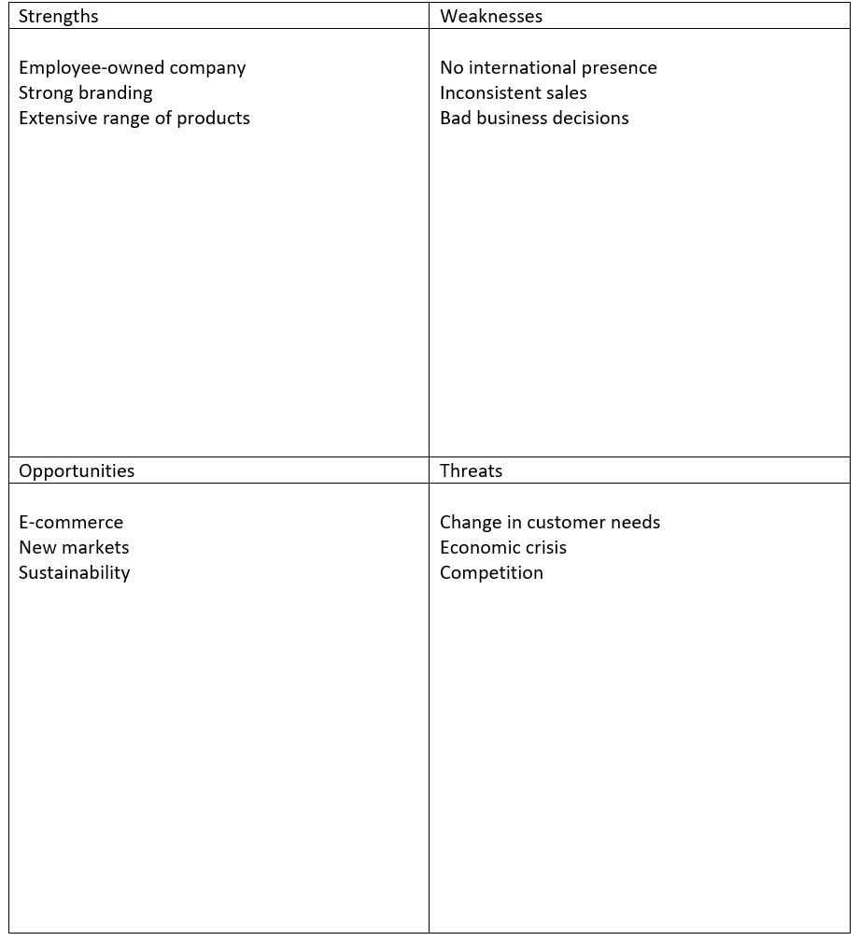

PESTLE analysis

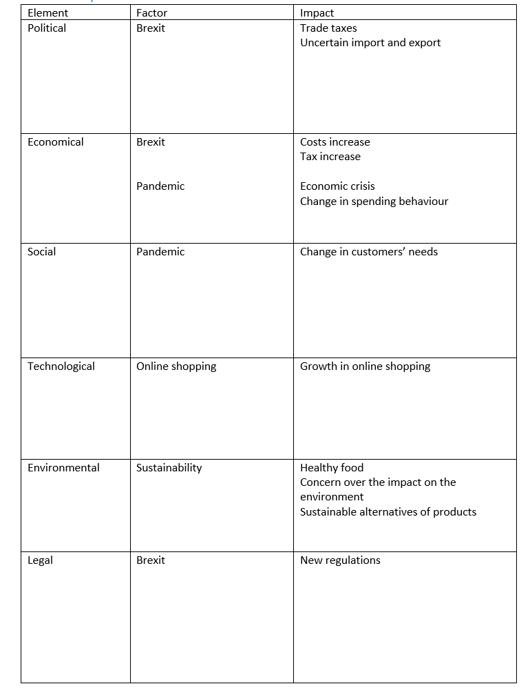

Reference List

- BBC (2021) John Lewis warns of 'painful' store closures. Available at: https://www.bbc.co.uk/news/business-56357412 (Accessed: 20 October 2021).
- Brady, C. (2020) How we helped John Lewis with future visioning for sustainability. Available at: https://www.bioregional.com/projects-and-services/case-studies/how-we-helped-john-lewis-with-future-visioning-for-sustainability (Accessed: 22 October 2021).
- Butler, S. (2021) John Lewis cuts losses to £29m but warns of Christmas uncertainty. Available at: https://www.theguardian.com/business/2021/sep/16/john-lewis-losses-store-closures-waitrose (Accessed: 20 October 2021).
- Butler, S. (2021) John Lewis to close more stores as Covid crisis wipes out profits. Available at: https://www.theguardian.com/business/2021/mar/11/john-lewis-may-not-reopen-some-stores-as-chain-slumps-to-517m-loss (Accessed: 20 October 2021).
- Fish, I. (2020) John Lewis reveals new five-year plan. Available at: https://www.drapersonline.com/news/john-lewis-five-year-plan (Accessed: 22 October 2021).
- Freedman, L. (2021) Strategy for a Pandemic: The UK and COVID-19. Survival: Global Politics and Strategy, Vol. 62, Issue 3, pp. 25-30.
- Hardcastle, K. (2021) After its most challenging period in over 157 years, John Lewis Partnership confirms not all stores will open. Available at: https://www.forbes.com/sites/katehardcastle/2021/03/11/the-most-challenging-year-in-157-year-history-john-lewis-partnership-confirms-not-all-of-our-stores-will-reopen/?sh=2deb02a86541 (Accessed: 20 October 2021).
- John Lewis Partnership (2021) Our Future. Available at: https://www.johnlewispartnership.co.uk/about/who-we-are/our-future.html (Accessed: 22 October 2021).
- LinkedIn (2021) John Lewis Partnership. Available at: https://www.linkedin.com/company/john-lewis-partnership (Accessed: 20 October 2021).
- Mustoe, H. (2019) Four reasons John Lewis is under pressure. Available at: https://www.bbc.co.uk/news/business-47470703 (Accessed: 22 October 2021).
- NFU (2020) The John Lewis Partnership suffer a 23% reduction in profits. Available at: https://www.nfuonline.com/sectors/food-chain/food-chain-news/the-john-lewis-partnership-suffer-a-23-reduction-in-profits/ (Accessed: 20 October 2021).
- Read, S. (2021) John Lewis among UK firms scrapping overseas deliveries. Available at: https://www.bbc.co.uk/news/business-55576571 (Accessed: 21 October 2021).
- Rigby, C. (2020) John Lewis Partnership outlines a digital-first strategy for world where 20% of Waitrose sales and 60% of John Lewis’ are made online. Available at: https://internetretailing.net/strategy-and-innovation/strategy-and-innovation/john-lewis-partnership-outlines-a-digital-first-strategy-for-world-where-20-of-waitrose-sales-and-60-of-john-lewis-are-made-online-21785 (Accessed: 22 October 2021).
- Rigby, C. (2021) How John Lewis customers bought differently during the Covid-19 pandemic – and beyond. Available at: https://internetretailing.net/customer/customer/how-john-lewis-customers-bought-differently-during-the-covid-19-pandemic--and-beyond-23830 (Accessed: 22 October 2021).
- Salaman, G., Storey, J. (2016) A better way of doing business? Lessons from the John Lewis Partnership, Oxford University Press, pp. 10-12
- Scotter, K., Lewis, C. (2021) John Lewis is 'pretty much all we've got in Peterborough. Available at: https://www.bbc.co.uk/news/uk-england-cambridgeshire-56511616 (Accessed: 20 October 2021).
- Storey, J., Salaman, G. (2017) Employee ownership and the drive to do business responsibly: a study of the John Lewis Partnership. Oxford Review of Economic Policy, Volume 33, Issue 2, pp. 339–354.
- The Guardian (2021) With no certainty over retail's future, are John Lewis staff now being undersold? Available at: https://www.theguardian.com/business/2021/mar/14/with-no-certainty-over-retails-future-are-john-lewis-staff-now-being-undersold (Accessed: 20 October 2021).
- Valentine, M. (2020) John Lewis poised to unveil ‘modernised brand purpose’. Available at: https://www.marketingweek.com/john-lewis-modernised-brand-purpose/ (Accessed: 21 October 2021).
- Wright, G. (2021) John Lewis online sales surge alongside skincare, air fryers & tents. Available at: https://www.retailgazette.co.uk/blog/2021/10/john-lewis-online-sales-surge-alongside-skincare-air-fryers-tents/ (Accessed: 22 October 2021).

