

Predictive Analytics in Digital Marketing: Evaluating the Impact of AI Marketing on Consumer Behaviour, Engagement and Conversion Rates in the Tourism Industry.

Student Name: Dewan Ashrafi
Student ID: 1916230

Dissertation submitted as part of the requirements for the award MBA (Marketing)


Master’s Degrees by Examination and Dissertation
Declaration Form.
1. This work has not previously been accepted in substance for any degree and is not being concurrently submitted in candidature for any degree.
Signed…….………. Dewan Ashrafi………………………………………...
Date ………………13-02-2024………………………………………………....

2. This dissertation is being submitted in partial fulfilment of the requirements for the degree of master’s in business administration.
Signed…….………. Dewan Ashrafi………………………………………...
Date ………………13-02-2024………………………………………………....
3. This dissertation is the result of my own independent work/investigation, except where otherwise stated.
Other sources are acknowledged by footnotes giving explicit references.
A bibliography is appended.
Signed candidate: …………………Dewan Ashrafi……………….………….
Date ………………13-02-2024……………………………………....

4. I hereby give consent for my dissertation, if accepted, to be available for photocopying, inter- library loan, and for deposit in the University’s digital repository
Signed (candidate)…………Dewan Ashrafi…………………….……...
Date ………………13-02-2024……………………………………....
Supervisor’s Declaration.
I am satisfied that this work is the result of the student’s own efforts.
Signed: ……………Tushara Balendran…………………………………….
Date ………………13-02-2024……………………………………....

ACKNOWLEDGEMENTS

I would like to extend my heartfelt gratitude to Prof. Tushara Brenden, my esteemed teacher, for her invaluable guidance, enlightening teaching methods, and extensive expertise, which she graciously shared without hesitation. Her mentorship and encouragement have played a pivotal role in shaping my research and academic development.
I am also immensely grateful to Prof. Jayalakshmi Gopalkrishnan for nurturing my interest in Digital Marketing. I owe a debt of gratitude to Dr. Audsin Das, whose unwavering availability and support have been invaluable whenever I sought advice or guidance.
My sincere thanks go out to all the survey participants whose valuable insights and cooperation were essential in gathering data and enriching the findings of this study.
I deeply appreciate my parents' steadfast belief in my abilities, which has served as a constant source of support throughout my academic journey. Furthermore, I express profound gratitude to my wife, whose understanding and unwavering support have alleviated numerous household responsibilities, affording me the necessary time to dedicate to this project.
Lastly, I would like to express my gratitude to the University of Wales Trinity Saint David for providing a nurturing learning environment and the resources essential for undertaking this research endeavour. The university's commitment to academic excellence and research innovation has shaped my educational journey.
Abstract
This dissertation delves into the transformative influence of AI marketing on consumer behaviour within the dynamic landscape of the tourism industry. Through a comprehensive analysis, this study investigates the efficacy of AI-powered predictive analytics in understanding and predicting consumer preferences, engagement patterns, and conversion rates. By utilizing a mixed-methods approach, the research explores the adoption and utilization of AI-infused travel services, personalized recommendations, and the perceived accuracy and influence of these recommendations on travel decisions. The study also examines the factors consumers consider when evaluating the usefulness of travel recommendations and their concerns and expectations regarding the implementation of AI in the travel and tourism sector. Findings reveal a significant uptake of AI-powered travel services, with most respondents acknowledging the influence of personalized recommendations on their travel decisions.
Moreover, the research identifies vital factors such as relevance, accuracy, and personalized touch that shape consumers' perceptions of travel recommendations. However, concerns regarding data privacy, biases, and the lack of human interaction in AI-driven services highlight the need for ethical and transparent practices in AI marketing. Ultimately, this study contributes to a deeper understanding of the evolving dynamics between AI technology, consumer behaviour, and marketing strategies in the tourism industry, offering insights to practitioners and policymakers for enhancing the effectiveness and ethical implementation of AI-powered predictive analytics in digital marketing.

Table of Contents
ACKNOWLEDGEMENTS 3
Chapter 1: Introduction 7
1.1 Background 7
1.2 Rationale 12
1.3 Research Gap 14
1.4 Aim 15
1.5 Objectives 15
1.6 Research Questions 15
1.7 Dissertation Outline 16
Chapter 2. Literature Review 18
2.1 Introduction 18
2.2 Literature Gap 19
2.3 Literature Review 20
2.3.1 Current landscape of AI predictive analytics 20
2.3.2 Impact of AI marketing on consumer behaviour 22
2.3.3 AI marketing in driving engagement and conversion rates 23
2.3.4 Opportunities and Challenges 24
2.4 Marketing Models 26
2.4.1 RACE Model 26
2.4.2 Honeycomb Model 31
2.4.3 Consumer Behaviour 43
There are four types of consumer behaviours (AMA, 2024): 43
2.4.4 Consumer Decision-Making Process 46
2.4 Customer Lifetime Value (CLTV) Prediction Model 52
2.4.1 GBM Model 54
2.5 Conclusion 55
Chapter 3. Research Methodology 55
3.1 Research Philosophy 56
3.2 Research Approach 58
3.3 Research Strategy 59
3.4 Types of Investigation 59
3.5 Choice of Method 62
3.6 Time Horizon 62
3.7 Data Collection and Analysis 63
3.7.1 Sampling 63
3.7.2 Data Collection Method 65
3.7.3 Analysis of Data 65
3.8 Ethical Considerations 65
Chapter 4. Analysis of Data 66
4.1 Introduction 66
4.2 Questionnaire Analysis and Discussion 66
Chapter 5. Conclusion and Recommendations 83
5.1 Conclusion 83
5.2 Recommendations 84
5.3 Limitations 85
Chapter 6. Future Research 86
References 88
Appendix 115

Chapter 1: Introduction

In the swiftly changing technological landscape, Artificial Intelligence (AI) has emerged as a powerful force behind ground-breaking progress, reshaping numerous facets of modern business sectors. Its integration has become an essential element in business operations and has also played a central role in fostering innovative strategies, particularly within marketing. Despite apprehensions regarding AI's effects on employment, ethical considerations, and privacy issues, its incorporation into business practices appears unavoidable.
This dissertation aims to delve into the profound implications and intricate dynamics woven within this intersection, explicitly focusing on the impact of AI-powered marketing on consumer engagement and conversion rates. By leveraging predictive analytics, this study endeavours to dissect the evolving landscape where advanced technology meets consumers' nuanced preferences and behaviours in the travel and tourism industry context. Through a meticulous evaluation, this research seeks to illuminate the far-reaching effects of AI marketing strategies, unveiling their influence on shaping consumer decisions and industry paradigms.

1.1 Background

The travel and Travel and Travel and Tourism industry comprises businesses and services facilitating, promoting, and organising travel for various purposes. It includes transportation, accommodation, attractions, and hospitality-related services, contributing substantially to global economies through job creation, revenue generation, and cultural exchange (Marketline, 2024). In 2022, the worldwide travel and tourism industry expanded by 41.4%, reaching a total value of $3.17 trillion. Projections suggest that by 2027, the industry will achieve a value of $6.29 trillion, reflecting a substantial increase of 98.5% compared to 2022 (Marketline, 2024).

Figure 1: Projected value of the global travel and tourism industry
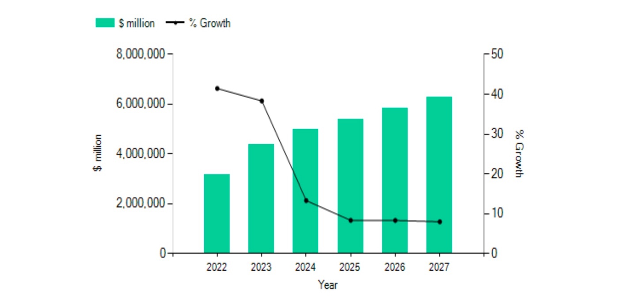
Source: (Marketline, 2024)
The forecast anticipates that the revenue in the Travel & Tourism sector will hit $927.30 billion by 2024. Furthermore, it is predicted that 76% of the total revenue in the Travel & Tourism market will be derived from online sales by 2028 (Statista, 2023b). The projected increase in revenue and the substantial portion expected from online sales by 2028 highlight the crucial role that digital marketing plays in reaching and engaging consumers in this sector. As the majority of revenue is anticipated to come from online channels, it underscores the importance of leveraging digital marketing strategies to effectively connect with and cater to the target audience's needs in the travel and tourism market.
Marketing has evolved from traditional, mass communication methods to a more targeted, personalised, and technology-driven approach, reflecting the changing dynamics of consumer behaviour and the business landscape (Faruk, Rahman and Hasan, 2021). According to S Pascalau and R. Urziceanu (2021), traditional marketing is associated with higher resource costs, time-consuming processes, and less activity, and it generally operates locally. In contrast, online marketing is cost-effective, time-saving, and offers greater interactivity, allowing real-time updates and personalised interactions and promoting customer loyalty. Moreover, traditional marketing, while once dominant, has limitations compared to digital methods. It often involves broad-reaching campaigns without specific targeting, incurring high costs and lacking interactivity. It also has less precise Key Performance Indicators (KPIs), limited segmentation, less adaptability, and potential environmental impact (Birt, 2021). These drawbacks have prompted a shift towards digital marketing, which offers precise targeting, cost-effectiveness, interactivity, and better measurability, aligning more closely with the preferences and behaviours of today's consumers.
Digital marketing refers to the section of marketing that promotes products and services using the Internet and online-based digital technology, including smartphones, computers, and other digital media and platforms (Aaker, 2016). There were 5.3 billion internet users globally as of October 2023, or 65.7% of the world's population (Petrosyan, 2023). This highlights the crucial role of digital marketing, offering an unparalleled platform to connect with a diverse audience. Given most of the global population's internet access, digital marketing becomes essential for businesses to effectively engage and promote products or services globally. The widespread internet usage emphasises the need for companies to establish a robust digital presence and employ digital marketing strategies for effective communication and resonance with their target audiences on a global scale.
AI is a branch of computer science that concentrates on crafting machines and software capable of emulating human-like abilities, encompassing problem-solving, reasoning, language comprehension, pattern recognition, and decision-making skills. (Goodfellow, Bengio and Courville, 2016). Alan Turing is widely considered the founding figure of theoretical computer science and artificial intelligence. In the early 50s, he was the first to conduct substantial research in the field of 'Machine Intelligence', a pivotal advancement in its early study (Turing, 1950) (B. Jack. Copeland, 2004). The concept of Artificial intelligence first appeared in Academia in 1956. Still, it was not until 2012 that the superior capabilities of deep learning compared to earlier AI methods garnered amplified funding and attention (Russel and Norvig, 2020).
Today, advanced systems with artificial intelligence capabilities utilise machine learning (ML). Machine learning refers to systems learning from specific training data to automate the creation of analytical models and tackle associated tasks. Deep learning (DL), a subset of machine learning, revolves around artificial neural networks (Janiesch, Zschech and Heinrich, 2021).
Machine Learning (ML): ML involves algorithms that enable machines to learn patterns and make predictions or decisions without being explicitly programmed. It focuses on developing techniques that allow computers to improve their performance on a task through experience, using data to train models. ML algorithms include regression, decision trees, support vector machines, and clustering algorithms (Koza et al., 1996) (IBM, 2024).
Deep Learning (DL): DL is a specialised field within ML that deals with artificial neural networks—specifically, deep neural networks composed of multiple layers (hence the term "deep"). These networks can automatically learn data representations, extracting intricate patterns and features through successive processing layers. DL has shown exceptional performance in tasks like image and speech recognition, natural language processing, and other complex pattern recognition tasks (Criddle, 2023).
Both ML and DL are integral parts of AI. They provide the mechanisms through which AI systems can learn, reason, and make decisions by analysing and understanding vast amounts of data. AI encompasses various techniques and approaches. ML, particularly DL, serves as a crucial component within the broader field of AI, enabling machines to exhibit intelligent behaviour and perform tasks that typically require human intelligence (IBM, 2023). Extensive and intricate datasets, known as big data, play a crucial role in advancing AI technology, surpassing the capacities of conventional processing methods. These datasets, characterised by their volume, variety, velocity, and veracity, significantly drive technological advancements and continual innovation.
The digital era has ushered in a revolutionary paradigm shift in marketing strategies, significantly influenced by the synergy between predictive analytics and artificial intelligence (AI). The travel and tourism industry has undergone a remarkable evolution catalysed by the digitisation of consumer touchpoints. From the early days of online travel agencies (OTAs) and travel forums to the current era of immersive online experiences, the industry has embraced digital platforms as integral components of its operations. The advent of AI marks the next chapter in this evolution, introducing predictive analytics to anticipate and meet consumer needs at unprecedented levels of precision.
Within the intricate tapestry of industries, the travel and tourism sector is a focal point where these technologies hold immense potential to reshape marketing approaches. As per a global survey of marketers in 2022, 62% of participants acknowledged the integration of artificial intelligence into their digital marketing strategies (Dencheva, 2023b). In 2021, the artificial intelligence (AI) market in marketing was valued at approximately $15.84 billion. Forecasts anticipate a significant rise, projecting the value to exceed $107.5 billion by 2028 (Dencheva, 2023a).
Li and Karahanna (2015) and Verhoef et al. (2017) describe predictive analytics harnessing advanced statistical models and machine learning algorithms to extract actionable insights from the vast troves of available data. Its capabilities encompass understanding consumer behaviour, forecasting trends, enabling personalised recommendations, and optimising marketing initiatives. By comprehensively analysing historical and real-time data, predictive analytics empowers marketers to tailor strategies, ultimately enhancing consumer engagement and influencing conversion rates.

Figure 2: Predictive Analytics
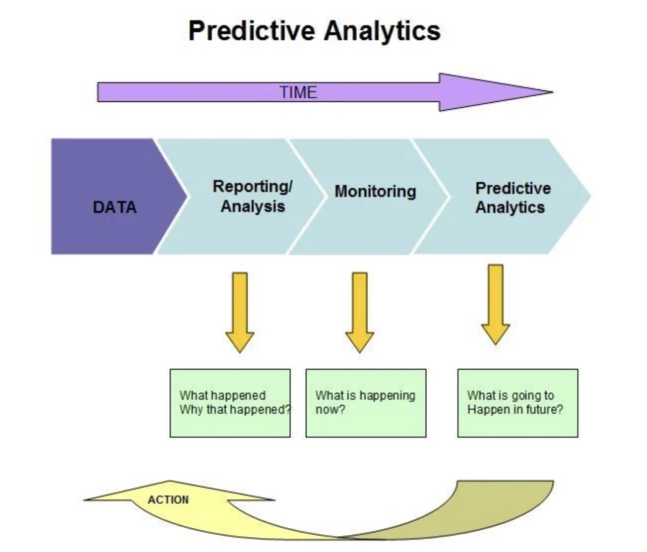
Image source: (PAT RESEARCH, 2019)
However, despite the remarkable potential of these technologies, their specific impact and strategic implications within the travel, tourism, and hospitality industry still need to be explored. This industry thrives on consumer experiences and perceptions, making it a fertile ground for applying predictive analytics and AI in marketing strategies.
This dissertation aims to bridge this gap by exploring the interplay between predictive analytics and AI-driven marketing in the travel and tourism industry.
Through a comprehensive analysis of empirical data and theoretical frameworks, this study seeks to provide actionable insights and strategic recommendations. By exploring how predictive analytics and AI influence consumer engagement and conversion rates, it aims to offer a roadmap for industry stakeholders navigating the transformative digital landscape within the travel, tourism, and hospitality domain.
This comprehensive exploration intends to contribute to academic discourse and provide practical guidance for industry practitioners looking to harness the potential of predictive analytics and AI-driven marketing strategies to optimise consumer engagement and conversion rates in this ever-evolving sector.

1.2 Rationale

The rationale for this study lies in the evolving landscape of digital marketing within the travel, tourism, and hospitality industry, marked by the increasing integration of artificial intelligence (AI) and predictive analytics.

Figure 3: Revenue share of sales channels
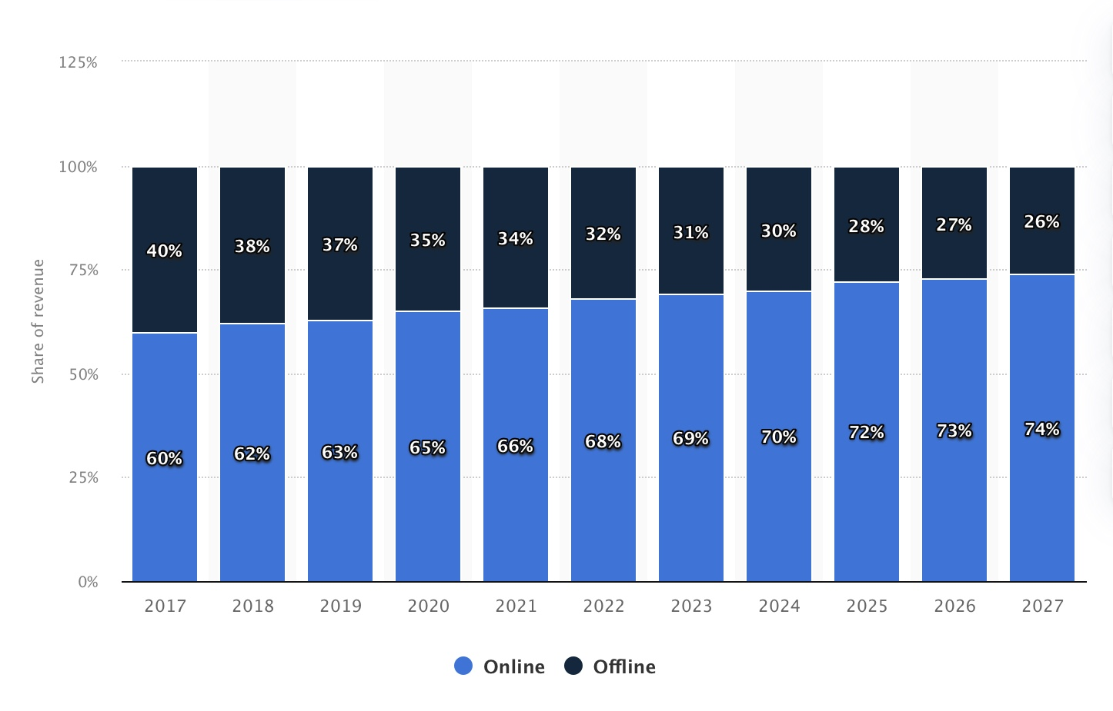
Source: (Department, 2023)
Online sales channels accounted for over two-thirds of the revenue generated in the global travel and tourism market (Department, 2023). The global online travel industry, valued at approximately $475 billion in 2022, was projected to surpass $521 billion in 2023 and exceed $1 trillion by 2030 (Statista, 2023).
The travel industry is rapidly adopting AI technologies to enhance marketing strategies. As businesses increasingly invest in predictive analytics, understanding the implications and effectiveness of these technologies is crucial for staying competitive (Almasi et al., 2023). According to Krey et al. (2021), The travel, tourism, and hospitality industry present distinctive challenges, such as complex consumer decision-making processes and diverse touchpoints. Examining how predictive analytics addresses these challenges is essential for tailoring strategies to the specific needs of this dynamic sector.
Businesses in the travel industry are making substantial investments in AI marketing, aiming to optimise consumer experiences and drive conversions. Understanding the impact of predictive analytics has strategic implications for businesses seeking to refine their marketing strategies and achieve a competitive edge (Bulchand-Gidumal et al., 2023).
The travel industry revolves around consumer experiences and preferences. Predictive analytics in the travel industry has transformative potential, aligning marketing with evolving consumer expectations by anticipating preferences. The study also addresses the growing ethical and privacy concerns associated with AI adoption in marketing, providing valuable insights for navigating these dimensions. Additionally, it contributes to the evolving academic discourse on AI's impact on marketing within the travel and tourism sector, offering nuanced insights for industry professionals to inform marketing strategies and decision-making processes.

1.3 Research Gap

While extensive research exists on the application of predictive analytics and AI in various industries, there remains a notable gap in understanding the specific impact of AI marketing on consumer behaviour, engagement, and conversion rates within the context of the tourism industry. While studies have explored the adoption of AI-infused travel services and personalized recommendations, limited research comprehensively examines the interplay between AI technology, consumer behaviour, and marketing strategies in the tourism sector. Additionally, existing literature often lacks a nuanced understanding of the factors influencing consumers' perceptions of AI-driven recommendations and subsequent decision-making processes. Furthermore, there is a need to address concerns regarding data privacy, biases, and the ethical implications of AI marketing practices in the tourism industry. Thus, this dissertation aims to bridge this research gap by providing insights into the effectiveness and ethical implementation of AI-powered predictive analytics in digital marketing within the tourism context, thereby contributing to a deeper understanding of the evolving dynamics between AI technology and consumer behaviour in the tourism industry.
In essence, the rationale for this study is grounded in the imperative to comprehensively explore and understand the implications of predictive analytics in AI marketing within the unique context of the travel industry. By addressing this research gap, the study aims to provide valuable insights that contribute to academic knowledge and offer practical guidance for businesses navigating the transformative landscape of digital marketing in travel, tourism, and hospitality.

1.4 Aim
To evaluate the impact of predictive analytics, powered by AI algorithms, on consumer engagement and conversion rates in digital marketing campaigns for the Travel and Tourism Industry.

1.5 Objectives

- To assess the current landscape of predictive analytics implementation in digital marketing within the travel and tourism industry.
- Investigate the impact of AI marketing on consumer behaviour in the Travel and Tourism Industry.
- Evaluate the effectiveness of AI marketing in driving engagement and conversion rates.
- Identify Opportunities and challenges utilising AI-powered marketing in Travel, tourism, and hospitality.

1.6 Research Questions
1. What is the current landscape of predictive analytics implementation in digital marketing within the travel and tourism industry?
2. How does AI marketing impact consumer behaviour in the Travel and Tourism Industry?
3. To what extent is AI marketing effectively driving engagement and conversion rates within the travel and tourism sector?
4. What opportunities and challenges are associated with AI-powered Travel, tourism, and hospitality marketing?

1.7 Dissertation Outline

Figure 4: Dissertation outline in Flow chart

Research Flowchart
Introduction
Literature Review
Methodology
Analysis of Data
Discussion
Conclusion
New Research Opportunities
Recommendations

Chapter 1: Introduction

This introductory chapter provides background context on the research topic, elucidating the rationale behind conducting this study and highlighting its unique aspects. Additionally, it outlines the research objectives and questions, serving as guiding principles for the researcher to navigate the study and achieve its aims.

Chapter 2: Literature Review
This chapter delves into pertinent scholarly literature to provide a contextual backdrop for future research within well-established theoretical frameworks while highlighting areas warranting deeper exploration. It will develop a conceptual framework integrating recognized Digital Marketing models like RACE and Honeycomb alongside the CLTV prediction model (GBM) and insights into the Customer decision-making journey to underscore the research's significance and align with its objectives. Additionally, a thorough analysis of existing secondary data will be conducted to extract insights into critical issues, benefits, and limitations of various models, complemented by synthesizing discussions from diverse authors to shed light on relevant debates in the field.

Chapter 3: Research Methodology
Chapter three of the dissertation provides a detailed overview of the research methodology, beginning with an introduction to the chosen approach and research philosophy. It outlines whether the research design is quantitative, qualitative, or mixed methods and justifies the selection based on the research objectives. Methodological choices, including sampling techniques, data collection instruments, and analysis procedures, and considerations regarding the study's timeframe are explained. The chapter also discusses data collection methods and addresses ethical concerns to ensure participant rights are safeguarded throughout the research process.

Chapter 4: Data Analysis
Chapter four of the dissertation is focused on analyzing the data obtained from the survey questionnaire, which was developed using the JotForm software. The survey findings are meticulously examined, and connections to existing research and literature are established. The survey primarily investigates the effects of AI-driven Predictive Analytics in the travel and tourism industry, explicitly emphasising their impact on customer behaviour, engagement levels, and conversion rates.

Chapter 5: Conclusion
This section will offer a comprehensive overview of the research, focusing on attaining research objectives by examining primary data collected and exploring the literature concerning the influence of AI on consumers within the travel industry. Furthermore, it will provide recommendations tailored for AI applications and the travel tourism industry, discuss the study's limitations, and propose avenues for future research.

Chapter 2. Literature Review

2.1 Introduction
AI is regarded as one of the most potentially ground-breaking and inventive technologies within the tourism sector (Obschonka and Audretsch, 2020). According to Harvard Business School (2021), Predictive analytics involves utilising data to anticipate future trends and occurrences, drawing on historical data to predict possible scenarios that can inform strategic decision-making. Predicting customers' behaviour is a strategic capability that empowers businesses in a dynamic marketplace. Predictive analytics proves valuable in marketing by predicting sales trends and enabling strategic campaign planning (Elalem, Maier and Seifert, 2022). Furthermore, leveraging historical behavioural data allows the anticipation of a lead's progression through the sales funnel, with models indicating the likelihood of conversion based on engagement with content offerings. This insight empowers planning targeted advertisements at different stages in the customer's journey. As it constitutes a significant subset of applications within machine learning, it is interchangeable with machine learning in specific contexts (Siegel, 2015). By understanding and anticipating customer actions, businesses can increase conversion rates and maintain a competitive edge (Kalaivani and Sumathi, 2018). Ultimately, this strategic capability contributes significantly to overall business success and enhances customer satisfaction.

Consumer behaviour refers to individuals' cognitive, emotional, and physical actions when selecting, purchasing, using, and disposing of products and services to meet their needs and desires (Priest, Carter and Statt, 2013). However, Studies have indicated that predicting consumer behaviour remains a challenging task, even for experts in the field (Schivinski, 2019). Predicting customer behaviour in traditional marketing poses challenges due to limitations in data collection and analysis (Shlomo, 2022). The travel and tourism sector's marketing often deals with large amounts of data. The complexity of predicting consumer behaviour and engagement in this context, coupled with the need to analyse and interpret extensive datasets, can make predictive analytics in travel and tourism marketing a complex task.
Moreover, the substantial expansion of high-dimensional big data poses a heightened challenge for data scientists in extracting valuable insights efficiently because conventional data mining techniques are inadequate for processing big data (Oo and Thein, 2022). Integrating Artificial Intelligence (AI) in predictive analytics can significantly enhance the efficiency and accuracy of travel and tourism marketing predictions. AI technologies, such as machine learning algorithms, excel at processing large and complex datasets, identifying patterns, and making predictions based on historical and real-time data.
AI denotes the capacity of a digital computer to execute tasks typically associated with human capabilities, encompassing reasoning, generalisation, deriving meaning, and the ability to learn from prior experiences (ZULAIKHA et al., 2020). In essence, artificial intelligence (AI) pertains to machines endowed with the capability to acquire knowledge and emulate or simulate intelligent human behaviours. The digital transformation has redefined marketing strategies, leveraging predictive analytics and artificial intelligence (AI) to enhance consumer engagement and conversion rates. This literature review explores existing research on the impact of AI-driven predictive analytics on consumer behaviour, engagement, and conversion rates within the Travel and Tourism industry.

2.2 Literature Gap

While there is an increasing fascination with AI and the integration of service robots in the travel and tourism industry (TTI), current academic literature remains theoretical (Filieri et al., 2021). Even though there is a wealth of literature on AI in marketing (Chintalapati and Pandey, 2021) (García-Madurga and Grilló-Méndez, 2023), there is a scarcity of research focusing on predictive marketing based on customer behaviour and engagement in the travel and tourism sector. This study aims to fill this gap by providing targeted insights into how predictive analytics influences consumer behaviour, engagement, and conversion rates within travel-related contexts.
The existing studies in the field of predictive analytics in the travel industry often focus on its potential to reshape marketing strategies and enhance consumer experiences. However, a noticeable research gap exists regarding a comprehensive examination of the ethical implications and privacy concerns associated with adopting AI in marketing (Ibáñez and Olmeda, 2021). Additionally, there is a lack of in-depth studies providing nuanced insights into the evolving academic discourse on the impact of predictive analytics on consumer behaviour, engagement, and conversion rates within the unique context of the travel sector. Bridging these gaps is essential for a holistic understanding of the challenges and opportunities at the intersection of predictive analytics and consumer dynamics in the travel industry.

2.3 Literature Review

2.3.1 Current landscape of AI predictive analytics
AI technologies have completely revolutionised the travel and tourism sector, presenting numerous new opportunities and advantages. While the terms "AI," "automation," and even "robotics" are often used interchangeably, they encompass distinct concepts. Specifically, AI predominantly employs algorithms for process learning, engaging in logical reasoning, learning, and problem-solving. In contrast, automation and robotics rely on sensors and manual programming for their operations (Mascarenhas, 2018). In the travel and tourism sector, substantial data volumes are generated by service providers and customers. Tourism companies, destination managers, and consumers use a lot of data and data analytics to make better decisions at different levels of their operations (Li et al., 2018).

Research by Kishan, K. et al. (2024) highlights the increasing adoption of predictive analytics tools by significant players in the travel and hospitality sector. These tools aid in predicting historical data, industry trends, and external factors to predict demand for travel destinations, accommodations, and services, consumer preferences, optimise pricing strategies, and personalise marketing campaigns. Using machine learning algorithms allows businesses to analyse vast datasets, including customer behaviours, seasonal trends, and external factors, providing a comprehensive understanding of the market landscape. Li et al. (2022) conducted a meta-analysis examining the efficacy of AI-driven marketing strategies in the tourism industry. Their findings revealed positive outcomes linked to adopting AI technology for predictive analytics, dynamic pricing, and personalised marketing. AI technologies cited included machine learning algorithms and natural language processing. The study underscored the significance of continual evaluation and enhancement of AI models to maximise their impact on marketing endeavours.

Moreover, the study by Lee, Kwon and Back (2021) on the implementation of predictive analytics underscores its role in enhancing customer experience. Businesses tailor their marketing strategies to meet evolving consumer expectations by analysing historical booking patterns and customer reviews. The current landscape suggests a paradigm shift in how companies within the tourism sector harness predictive analytics to gain a competitive edge. The study by Kazak, Chetyrbok and Oleinikov (2020) highlights how AI streamlines operational processes in the tourism sector. Chatbots and virtual assistants powered by AI handle routine customer queries, reservation management, and other operational tasks, freeing human resources to focus on more complex and value-driven activities.
In predicting customer behaviour, the application of supervised learning becomes imperative, serving as a foundation for subsequent data processing. As Kotu and Deshpande (2019) described, supervised learning constitutes a predictive model designed to anticipate outcomes when confronted with novel input instances. This model employs algorithms to interact with datasets, constructing a classification model conducive to future data processing. Consequently, the integration of machine learning, particularly supervised learning, facilitates the automation of real-time processes, furnishing valuable data for predicting customer behaviours. Numerous forward-looking applications of AI in marketing operations focus on enhancing personalised experiences and engaging customers, along with progressively refining the customer value proposition by leveraging AI-driven data to offer tailored product and service recommendations (Faggella, 2019) (Kumar et al., 2019).

2.3.2 Impact of AI marketing on consumer behaviour

Studies by Wang et al. (2020) underscore the unique characteristics of consumer behaviour in the travel industry. Understanding these behaviours is crucial for tailoring predictive analytics models. Concurrently, integrating AI technologies has catalysed a paradigm shift in marketing dynamics within the travel and tourism industry.
AI-powered algorithms can pinpoint the ideal audience for a campaign, eliminating wasted impressions and focusing on users who are most likely to convert. This leads to increased efficiency and a higher return on investment (ROI) (Huang and Rust, 2020) (Kovalenko, 2023). However, Huang and Rust (2020) question AI's capability to understand and analyse human emotion. While contemporary mechanical AI exhibits robust autonomy in gathering and consolidating diverse data sources, it frequently loses the data context, posing challenges in modelling, particularly for emotional data. The automated data collection process can hinder achieving customer intimacy as it involves machines communicating with machines. And, Current thinking AI, though powerful, may not be neutral and transparent, which can result in biased recommendations or entail unintended consequences. According to Prayag et al. (2016), emotions significantly impact different phases of the tourist experience. During the pre-travel stage, emotions are crucial in motivating tourists and influencing destination selection processes. Moreover, there is a pressing need to anticipate forthcoming changes in strategic decision-making, planning, forecasting, policy/ strategy recommendations, and transformative decision-making related to AI, with a specific focus on the cultural implications of such scenarios (Stone et al., 2020). Lastly, evaluating marketing's ability to enhance outcomes by integrating products with intelligent technology (SHIH-YU, 2019) is a strategic imperative for further research exploration.
Kong et al. (2023) conducted extensive research focusing on the influence of AI on destination marketing within the tourism sector. Their analysis highlighted the potential of AI-driven recommendation systems, chatbots, and virtual assistants in offering personalised travel recommendations, addressing consumer inquiries, and improving engagement with prospective travellers. The study also emphasised integrating human expertise with AI technologies to create seamless and personalised experiences. AI marketing has the potential to revolutionise the Travel and Tourism Industry by providing personalised experiences, optimising operations, and driving customer engagement and loyalty. As technology advances, AI's impact on consumer behaviour in this industry is expected to grow, shaping the way travellers plan, book, and experience their journeys.

2.3.3 AI marketing in driving engagement and conversion rates

Approximately 40% of users leave a website due to feeling overwhelmed by excessive choices or information (Interactive, 2024). Therefore, numerous touchpoints lack effectiveness in influencing consumer purchasing decisions. AI can analyse vast user data to understand individual preferences and behaviours. This allows for creating highly personalised ads, content, and recommendations, which are more likely to resonate with users and lead to conversions (Alqurashi et al., 2023). Research by Sivarajah et al. (2017) describes how AI, through its machine learning algorithms and natural language processing capabilities, enables marketers to automate processes, analyse intricate datasets, and deliver highly personalised experiences across diverse digital touchpoints. This level of personalisation augments engagement and significantly impacts consumer decision-making processes, thereby influencing conversion rates.
Using AI algorithms and machine learning to support models diminishes the risk of human error, enhances the efficiency of audience data, and enables the scalability of display advertising (Haleem et al., 2022). People prefer to engage with marketing campaigns that are pertinent to their interests or address their needs. Marketers can enhance the effectiveness of their advertising by developing targeted strategies for specific customer segments, ensuring they reach the most relevant consumer groups likely to respond positively. This optimisation can be achieved by harnessing the digital superintelligence provided by AI models and algorithms (Hermann, 2021) (Kühl, Mühlthaler and Goutier, 2019) (Yau, Saad and Chong, 2021). So, AI-powered algorithms can pinpoint the ideal audience for a campaign, eliminating wasted impressions and focusing on users who are most likely to convert. This increases efficiency and a higher return on investment (ROI).
Incorporating AI in marketing strategies presents a spectrum of opportunities and challenges within the travel, tourism, and hospitality industry. The study by (Hermann, 2021) meticulously examines these facets, shedding light on the nuanced landscape of AI-powered marketing.

2.3.4 Opportunities and Challenges

Opportunities
Enhanced/ Hyper Personalisation: One of the primary opportunities identified by Bulchand-Gidumal et al. (2023) is the ability of AI to deliver highly personalised experiences. AI tailored marketing messages and recommendations to individual preferences through data analysis and machine learning, fostering a deeper connection between the consumer and the brand (Deloitte, 2024).
Predictive Customer Insights: AI's capacity to analyse vast datasets enables businesses to gain predictive insights into consumer behaviour (Gkikas and Theodoridis, 2021). This predictive capability allows for proactive decision-making, such as anticipating travel trends, optimising pricing strategies, and customising marketing campaigns to align with evolving consumer preferences.
Predictive travel trends: According to García-Madurga and Grilló-Méndez (2023), AI can analyze historical data and user behaviour to predict future travel trends, allowing destinations and tourism businesses to prepare for peak seasons proactively, adjust marketing strategies, and optimize resource allocation.
Virtual and augmented reality experiences: Research by Han et al. (2019) proved that virtual and augmented reality technologies elevate the visitor experience within cultural tourism, adding emotional engagement layers that enrich the overall visit to cultural heritage sites. AI can enhance virtual and augmented reality experiences, allowing potential travellers to explore destinations virtually before booking. This can increase engagement and bookings, especially for younger generations seeking immersive experiences.
Dynamic pricing based on real-time data: Research by Pillai (2023) demonstrates how businesses can leverage AI to enhance real-time pricing, gaining a competitive edge while enhancing consumer value. AI can dynamically adjust pricing for flights, hotels, and other travel services based on demand, weather conditions, and competitor pricing. This can optimize revenue for travel businesses while offering competitive deals to travellers.
Challenges
Data Privacy Concerns: The research by Bulchand-Gidumal et al. (2023) emphasises the critical issue of data privacy in AI-powered marketing. The collection and utilisation of extensive consumer data raise concerns about privacy infringement. Due to legal and ethical concerns, the study participants also expressed grievances regarding the complexities encountered in various phases of AI implementation and deployment, from data collection and processing to job restructuring. They attributed the inadequacy of legacy legislation in providing a conducive legal framework for the AI-driven industry. Moreover, participants noted an excessive level of respect among users spurred by regulators and the media. Additionally, they highlighted the overly restrictive nature of European and Spanish data protection and privacy laws, such as the European General Data Protection Regulation (GDPR). Striking a balance between personalisation and respecting user privacy emerges as a critical challenge for tourism businesses.
Implementation Costs: While AI holds transformative potential, the initial investment required for infrastructure, training, and integration can be significantly challenging to Implement AI systems. These include the requirement for top-notch data quality (Paschen, Pitt and Kietzmann, 2020), which can be both arduous and costly to obtain (Sivarajah et al., 2017) alongside the intricacy of aligning AI systems with human workers effectively (Thiebes, Lins and Sunyaev, 2020).
Consumer Trust: The study underscores the importance of building and maintaining consumer trust in the context of AI marketing. Transparency in how AI is used, ethical considerations, and clear communication about data usage are essential for fostering trust. Lalicic and Weismayer (2021) recommend that businesses actively address these concerns to prevent potential backlash.
Research provides a comprehensive analysis of the opportunities and challenges associated with AI-powered Predictive marketing in the travel and tourism sector. This examination equips businesses with valuable insights for navigating the dynamic landscape of AI implementation.

2.4 Marketing Models
Marketers must examine how marketing communication models impact consumers in a rapidly changing and intensely competitive global market. Marketing models are essential for businesses as they enable strategic decision-making, provide insights into consumer behaviour, optimise marketing efforts, measure performance, and predict future trends. These models help companies to develop comprehensive marketing strategies, understand how consumers interact with marketing stimuli, allocate resources efficiently, evaluate campaign effectiveness, and anticipate market changes (Montazeribarforoushi, Keshavarzsaleh and Ramsøy, 2017).

2.4.1 RACE Model
The concept underlying the RACE marketing planning model is to offer a straightforward framework for organisations to create a digital marketing or omnichannel communications strategy that addresses the complexities of reaching and captivating online audiences to encourage sales conversions. This model offers a strategic blueprint delineating the fundamental phases of a digital marketing strategy: Reach, Act, Convert, and Engage, presenting a methodical approach for conceptualising and implementing digital marketing initiatives, with emphasis on addressing each stage of the customer journey (Chaffey, 2019).

Figure 5: AI for Tourism Marketing (RACE Model)
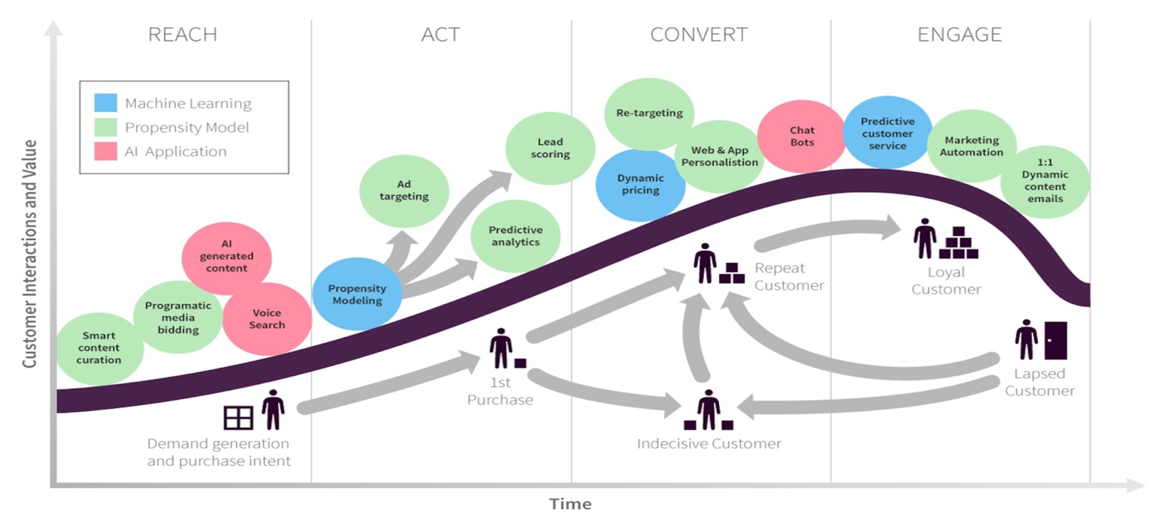
Source: (Chaffey, 2019)
Aligning tourism companies' marketing with the RACE model ensures a comprehensive approach to engaging users, guiding them from awareness to advocacy and retention.
The customer life journey encompasses a few phases. These phases are (Chaffey, 2019) (Chaffey, 2022) (CIM, 2022):
Reach (Awareness): The Reach stage involves expanding the audience reach through targeted digital marketing efforts. AI-powered Marketing plays a pivotal role here, enabling businesses to identify and engage with potential customers more precisely. Research by scholars like Huang and Rust (2020) highlights the effectiveness of AI in segmenting target audiences based on behavioural patterns and preferences, thus enhancing the reach of marketing campaigns. Tourism businesses often cater to a diverse global audience (Liu, Fan and Qiu, 2020). Therefore, marketing for tourism businesses involves a vast amount of data. The "Reach" stage, to create demand and purchase intent, utilises AI to identify target audiences by analysing vast data sets such as demographics, travel history, and online behaviour, enabling the pinpointing of ideal customer segments for specific offerings, personalised ad targeting, and the delivery of highly relevant ads across various channels based on individual profiles and preferences to attract potential travellers effectively, while also optimising content marketing by analysing user engagement data to create personalised content recommendations that attract tourists with content relevant to their interests and travel intent.
Act (Consideration): In the Act phase, the focus shifts to investigating the impact of AI marketing on consumer behaviour in the travel and tourism industry. This involves analysing how AI-driven marketing initiatives prompt consumers to take action. The objective is to prompt target customers to take action, such as visiting a website or engaging with promotional content. AI marketing tools facilitate this process by delivering personalised recommendations and targeted messaging to individual consumers. Studies by Zhao, Lyu and Luo (2022) underscore the role of AI in driving consumer engagement through dynamic pricing strategies and personalised marketing communications. By analysing consumer data in real time, AI algorithms can identify actionable insights and deliver relevant content that encourages consumers to interact with the brand (Varsha P. S. et al., 2021). Research proves the use of AI-powered chatbots and AR (Augmented Reality) improve user experience and conversion rates (Sidlauskiene, Joye and Auruskeviciene, 2023) (Shah and Shay, 2019). Utilise AI-powered chatbots for round-the-clock traveller assistance, including answering queries, offering recommendations, facilitating real-time bookings, and leveraging augmented reality (AR) experiences to provide immersive virtual tours of destinations, accommodations, and attractions, enhancing user engagement and driving informed booking decisions.
Convert (Decision/ Purchase): The Convert phase delves into evaluating the effectiveness of AI marketing in driving engagement and conversion rates within the travel and tourism sector. This entails measuring how AI-powered marketing strategies influence consumers' decision-making processes and lead to desired outcomes, such as bookings, reservations, or purchases. Conversion is the pivotal stage where engaged prospects transition into paying customers. AI marketing techniques, backed by predictive analytics, optimise the conversion process by anticipating consumer needs and preferences. Bag et al. (2022) emphasise the importance of high-quality data in facilitating AI-driven conversion optimisation strategies. Personalised recommendations, Dynamic package creation, Risk assessment and fraud prevention powered by AI are the vital elements of the concert stage. (De Bruyn et al., 2020) (Gajdošík and Marciš, 2019) (Haleem et al., 2022). AI can analyse past behaviour and preferences to suggest relevant destinations, activities, and travel packages, increasing booking conversions. Secondly, AI enables the dynamic creation of personalised travel packages based on individual budgets, interests, and travel styles, exceeding customer expectations and driving conversions. Finally, AI algorithms can analyse booking data to identify potentially fraudulent transactions, reducing risks and enhancing security for travelers and businesses. By leveraging predictive models, travel businesses can tailor their offerings and promotional incentives to match the specific preferences of individual consumers, thereby increasing the likelihood of conversion.
Engage (Post-purchase/ Retention & Advocacy): The Engage stage focuses on nurturing long-term customer relationships and fostering brand loyalty. AI-powered marketing initiatives enable continuous consumer engagement through personalised interactions and tailored communications. Research by Trunk, Birkel, and Hartmann (2020) highlights the significance of blending human expertise with AI technologies to deliver seamless and individualised experiences that resonate with people and result in more effective decision-making. Travel brands can cultivate lasting customer relationships by leveraging predictive analytics to anticipate consumer behaviour and preferences, driving repeat business and brand advocacy. Additionally, AI enables the dynamic creation of personalised travel packages based on individual budgets, interests, and travel styles, exceeding customer expectations. Furthermore, AI algorithms can analyse booking data to identify potentially fraudulent transactions, reducing risks and enhancing security for travellers and businesses (Haleem et al., 2022).

Advantages of the RACE Model
Structured Approach and Comprehensive Analysis: The RACE model offers a structured approach to digital marketing strategy, dividing it into Reach, Act, Convert, and Engage phases. This breakdown aids marketers in setting clear objectives for each stage, facilitating focused and tailored strategies. (Fedoryshyna et al., 2021). The RACE model thoroughly evaluates AI marketing strategies' effectiveness across stages in attracting, engaging, and converting tourists. Progression through these stages yields valuable insights for refining tactics and enhancing overall campaign performance. This iterative process, informed by data, enables marketers to optimize strategies, leading to more impactful campaigns and improved ROI.
Fostering Customer-Centricity: The RACE model emphasizes customer-centricity and relationship-building, encouraging continuous engagement throughout the marketing process to foster lasting connections (Fedoryshyna et al., 2021). This focus on interaction cultivates brand loyalty, trust, and advocacy, which are vital for marketing achievements.
Integration of Data: The RACE model integrates data from various digital channels, aligning well with predictive analytics in digital marketing for a holistic evaluation of AI marketing efforts (Chaffey and Smith, 2022). Its versatility extends across sectors and platforms, adaptable to diverse industries like e-commerce, B2B services, or non-profits. Marketers can personalize strategies to meet specific audience needs; for example, Google might suggest tailored travel itineraries and flight options based on a user's YouTube exploration and related searches.

Disadvantages of the RACE Model
Oversimplistic Representation: The RACE model provides a simplified representation of the customer journey, which may overlook the complexity of consumer behaviour and engagement in the tourism industry (Rautela, 2021).
Limited Focus: The model primarily focuses on digital marketing channels, potentially neglecting the influence of offline touchpoints and traditional marketing strategies on consumer behaviour and conversion rates.
Lack of Flexibility: The rigid structure of the RACE model may limit its adaptability to specific research contexts or variations in consumer behaviour within the tourism industry.
Overemphasis on Conversion: While the model emphasises the conversion stage, it may not adequately address the importance of long-term engagement and customerwhich are critical factors in the tourism sector.
Overall, while the RACE model offers a valuable framework for analysing the impact of AI marketing on consumer behaviour and conversion rates in the tourism industry, researchers should be mindful of its limitations and consider complementing it with other analytical approaches for a more comprehensive understanding.

2.4.2 Honeycomb Model

The Honeycomb model, alternatively referred to as the Kietzmann Honeycomb model, delineates seven fundamental functional media components to analyse the factors shaping user engagement on social platforms; this model aims to gauge the efficacy of social media platforms (Kietzmann et al., 2011).

Figure 6: Honeycomb Model
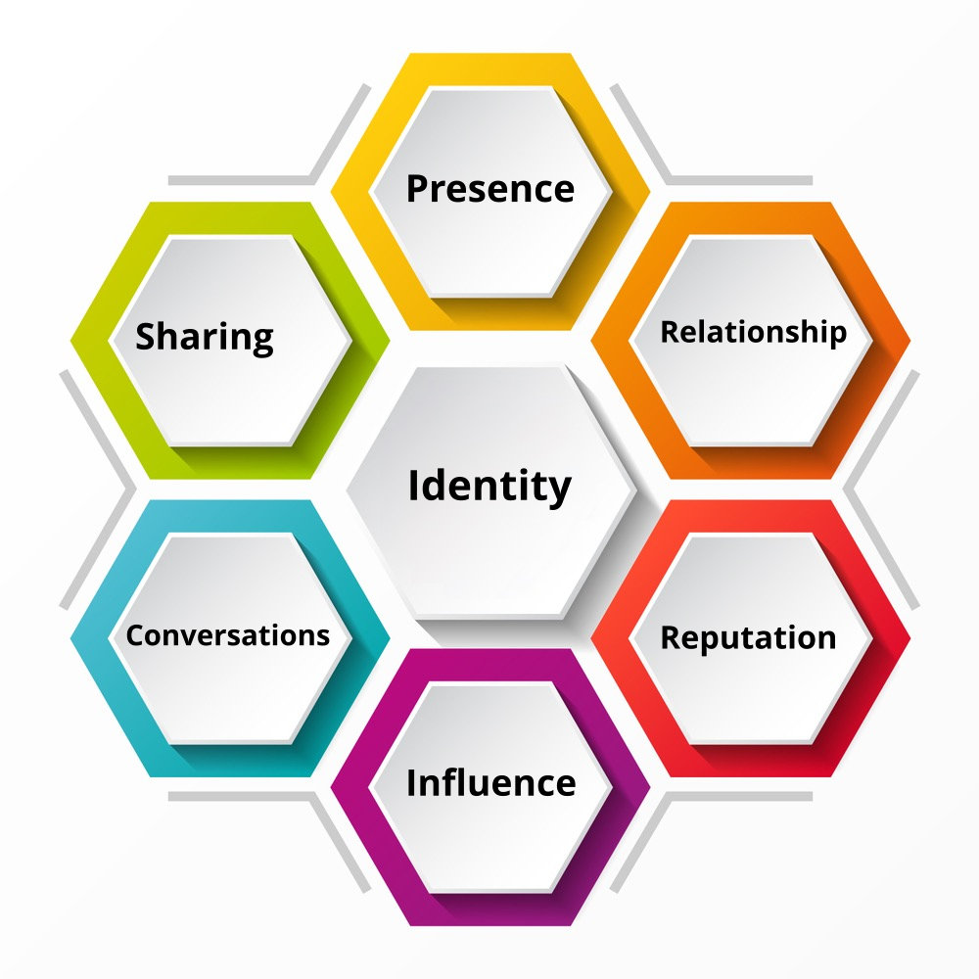

The Honeycomb Model can be applied to AI and digital marketing contexts. While initially illustrating the components of social media engagement, the principles underlying the model can be extended to encompass various aspects of AI-driven digital marketing strategies. BBothsocial media and AI-powered predictive analytics share similarities in their reliance on data utilisation, focus on personalisation, aim to enhance user engagement, facilitate targeted marketing efforts, and optimise performance metrics. Both play crucial roles in understanding user behaviour, personalising experiences, and optimising marketing strategies to drive business results. The utilisation of the Honeycomb model for evaluating AI marketing in the tourism industry presents a compelling argument due to its multifaceted analytical framework. By dissecting social media into seven vital functional components, the model offers a nuanced lens to scrutinise the impact of AI-driven strategies. Its emphasis on user-centricity aligns well with the objective of AI marketing, which aims to enhance user experiences through personalised interactions. Moreover, the model's versatility enables researchers to assess the effectiveness of AI initiatives by measuring metrics such as customer engagement and conversion rates within the tourism sector. Through a thorough analysis of these components, the Honeycomb model provides insights into the current landscape and offers actionable recommendations for optimising AI marketing strategies to drive meaningful outcomes in the tourism industry.
Identity: This block encompasses personal details like name, age, and interests (Kietzmann et al., 2011). In the context of predictive analytics in digital marketing, the identity aspect of the Honeycomb model relates to establishing a brand's online presence through AI-driven strategies.

Figure 7: Leading AI user comapnies in the Travel and Tourism Industry
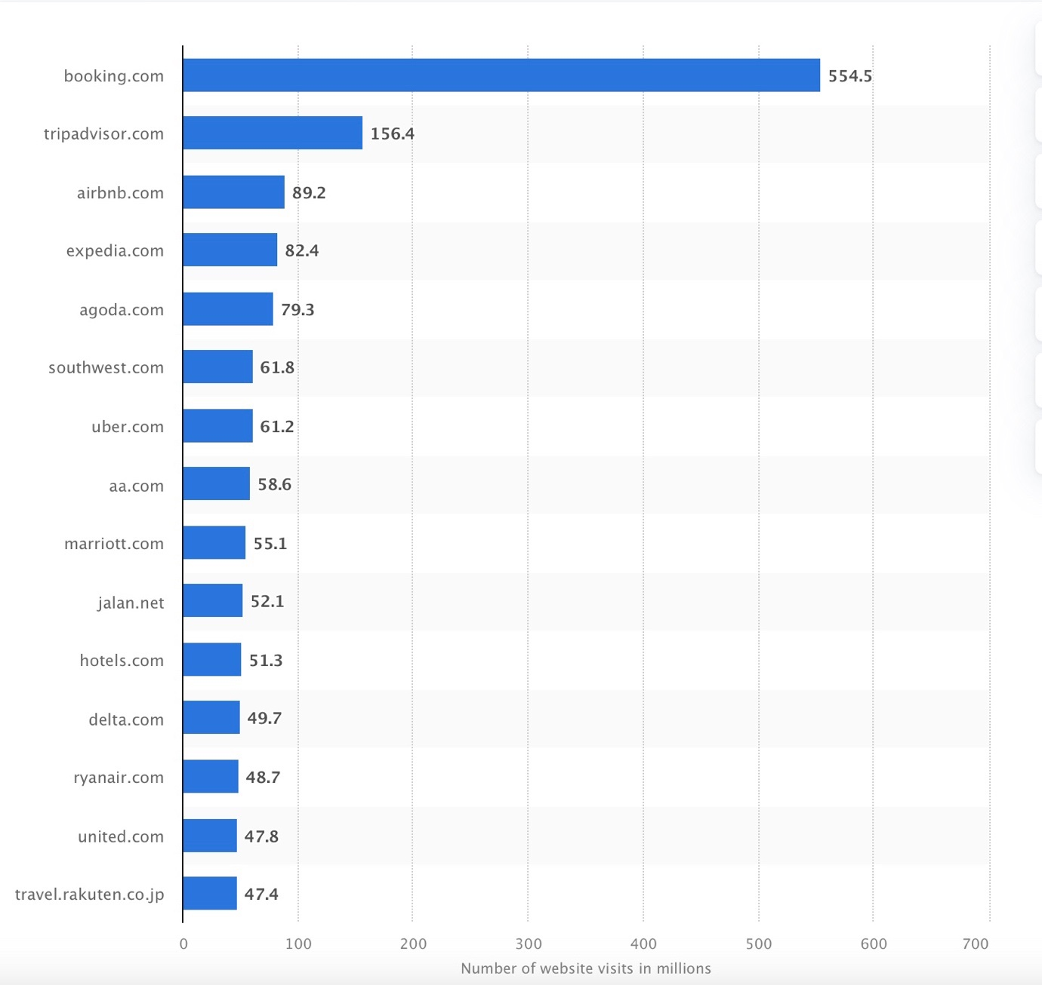
Source: (Statista, 2023)
The global online travel market reached $1.3 trillion in 2020 despite experiencing a decline attributed to the COVID-19 pandemic (Statista, 2024a). By 2022, online sales channels constituted approximately two-thirds of the total revenue generated in the global travel and tourism sector (Statista, 2024b).

Image 1: Booking.com account (Profile) page
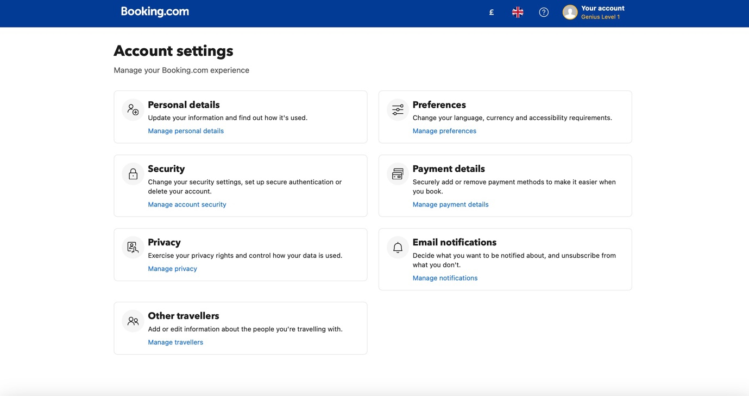
Source: (Booking.com, 2024)
Major players in the travel industry maintain a robust online presence, often encouraging customers to create accounts where they provide personal details. Furthermore, travel and tourism providers boast substantial followings across their social media channels, affording them access to extensive datasets encompassing users, viewers, subscribers, and followers (Airbnb, 2024) (TripAdvisor, 2024).

Image 2: Homepage of Airbnb.com on YouTube
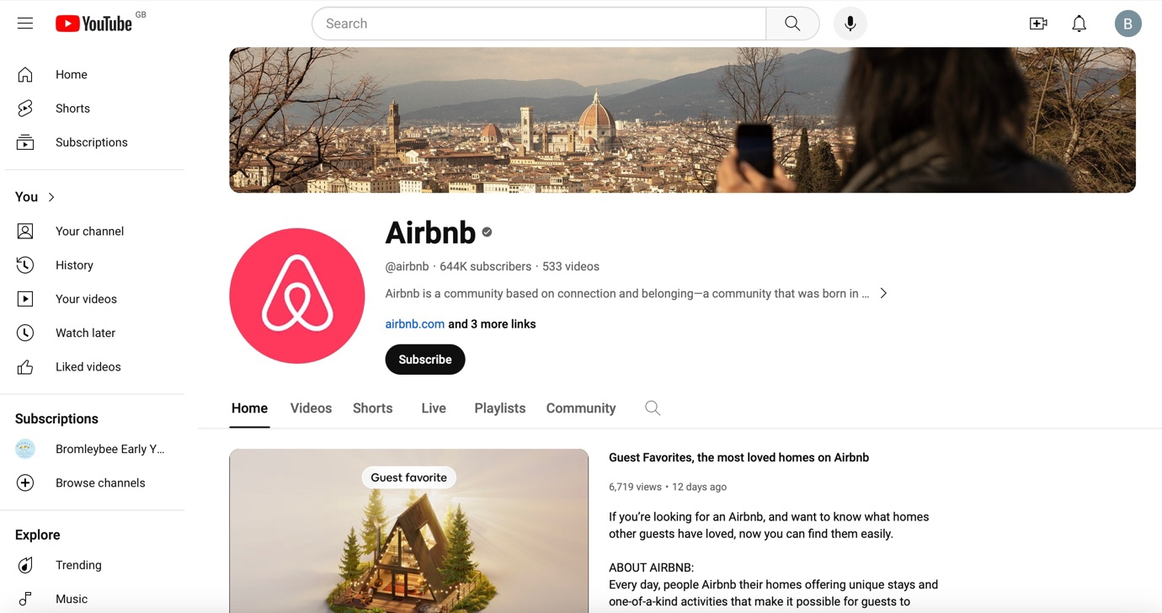
Source: (Airbnb, 2024)

Image 3: Facebook page of Tripadvisor.com
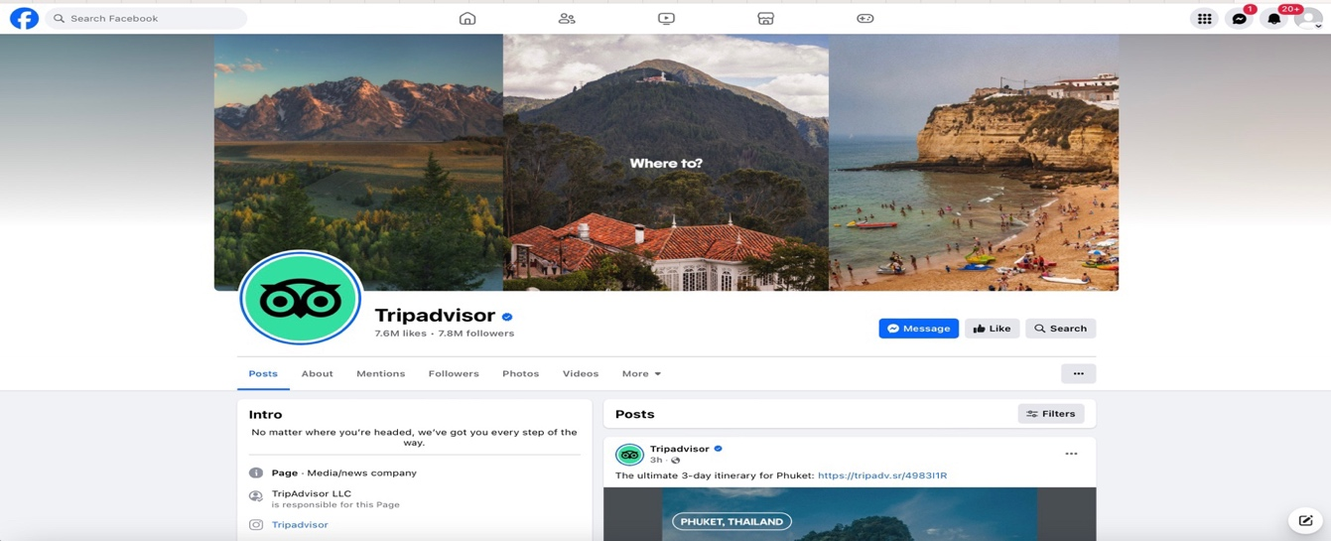Source: ((TripAdvisor, 2024)
Using AI, companies can leverage this wealth of customer data from their profiles and browsing behaviour to craft personalised marketing initiatives tailored to individual preferences and behaviours, thereby bolstering brand recognition and identity.
Conversations: This stage fosters meaningful dialogues and interactions between consumers and brands through various digital channels (Kietzmann et al., 2011). Specifically, within the tourism industry, the Conversation Stage entails leveraging AI-powered tools such as chatbots, virtual assistants, and personalised messaging systems to engage with potential travellers and existing customers (Kong et al., 2023). Tourism businesses can address customer inquiries through these AI-driven communication channels, provide real-time assistance, offer personalised recommendations, and gather feedback.
Moreover, the conversation Stage also encompasses social media interactions, where AI algorithms analyse user-generated content, comments, and messages to understand consumer sentiment, preferences, and trends (Zachlod et al., 2022) (Liu, Gupta and Patel, 2021). By actively participating in conversations on social media platforms, tourism businesses can build stronger relationships with their audience, enhance brand loyalty, and gather valuable insights for refining their marketing strategies.
Sharing: The Sharing stage, per the Honeycomb Model, refers to disseminating content and information among users on social media platforms (Kietzmann et al., 2011). This stage encompasses sharing posts, retweeting, forwarding messages, and spreading user-generated content. Sharing plays a crucial role in the tourism industry as travellers often share their experiences, photos, reviews, and recommendations with their social networks.
Analyzing the Sharing stage within the context of AI marketing in tourism, predictive analytics can provide valuable insights into the sharing behaviour of consumers (Babu and Kanaga, 2021). By leveraging AI algorithms, marketers can analyze vast amounts of social media data to identify patterns and trends related to sharing behaviour. For instance, AI-powered sentiment analysis can determine which types of content are more likely to be shared based on users' emotional responses. Natural language processing (NLP) techniques can also help identify influential users and critical topics that drive sharing activity within the tourism industry (Khurana et al., 2022).
Furthermore, predictive analytics can enable marketers to predict content virality and anticipate the impact of sharing on consumer engagement and conversion rates. By understanding the factors influencing sharing behaviour, such as the appeal of visual content, storytelling narratives, or unique experiences, marketers can tailor their content strategies to encourage more sharing among target audiences.
Moreover, AI-driven personalization techniques can enhance the sharing experience by delivering relevant and timely content based on user preferences, behaviours, and past interactions. By leveraging predictive analytics, marketers can identify the most effective channels and formats for sharing content, optimize content delivery schedules, and measure the impact of sharing on key performance indicators (KPIs) such as website traffic, brand awareness, and conversion rates (Gołąb-Andrzejak, 2023).
Presence: The Presence stage in the Social Media Honeycomb Model refers to establishing an online presence by individuals or organizations on social media platforms (Kietzmann et al., 2011). It encompasses creating profiles, pages, or accounts on platforms like Facebook, Instagram, Twitter, and LinkedIn. In the tourism industry context, establishing a solid presence on social media platforms is essential for reaching and engaging with potential travellers, building brand awareness, and influencing consumer decision-making.
Analyzing the Presence stage within the framework of predictive analytics and AI marketing offers valuable insights into how tourism businesses can optimize their online presence to enhance consumer engagement and drive conversion rates. Predictive analytics help marketers identify their target audience's most relevant social media platforms based on demographic, psychographic, and behavioural data (Nair and Gupta, 2021). By leveraging AI algorithms, marketers can analyze historical data to predict which platforms will most likely yield high engagement and conversion rates for specific segments of travellers.
Moreover, AI-powered personalization techniques can enhance the presence of tourism businesses on social media platforms by delivering tailored content and experiences to users based on their preferences and interests (Kumar et al., 2019). For example, AI algorithms can analyze user interactions and engagement metrics (Bag et al., 2022) to dynamically adjust content strategies, recommend personalized travel itineraries, and offer targeted promotions or discounts.
Furthermore, predictive analytics help tourism businesses track and measure their online presence across various social media platforms, enabling them to identify strengths, weaknesses, and opportunities for improvement. According to Schrage et al. (2023), by monitoring key performance indicators (KPIs) such as follower growth, engagement rates, sentiment analysis, and brand mentions, marketers can optimize their social media strategies in real time to maximize the impact of their presence on consumer behaviour and conversion rates.
Relationships: The Relationships stage refers to the interactions and connections between users on social media platforms (Kietzmann et al., 2011). In the tourism industry context, building and nurturing relationships with consumers is paramount to fostering brand loyalty, driving repeat business, and generating positive referrals. Analyzing the Relationships stage within predictive analytics and AI marketing framework offers valuable insights into how tourism businesses can cultivate meaningful connections with their target audience.
Predictive analytics can be crucial in identifying and segmenting target audiences based on their preferences, behaviours, and demographics (Nair and Gupta, 2021). By leveraging advanced data analytics techniques, marketers can personalize their messaging and communication strategies to resonate with consumer segments, strengthening relationships and driving engagement (Kumar et al., 2019). AI-powered chatbots and virtual assistants can enhance the customer experience by providing personalized recommendations, addressing inquiries, and resolving issues in real-time, fostering more profound connections with consumers (Chaturvedi and Verma, 2023).
Predictive analytics help marketers track and measure the effectiveness of relationship-building initiatives across various touchpoints and channels. By analyzing metrics such as customer satisfaction scores, Net Promoter Scores (NPS), and sentiment analysis data, marketers can improve the health of customer relationships and identify improvement areas (Rallis et al., 2022). AI algorithms can also predict customer churn and identify at-risk segments, enabling proactive intervention strategies to retain valuable customers and enhance overall logarithm Banu et al., 2022).
Furthermore, AI-driven predictive analytics can anticipate consumer needs and preferences, enabling marketers to deliver personalized offers, incentives, and rewards that strengthen relationships and drive repeat business. By utilising predictive analytics to anticipate consumer behaviour and sentiment, marketers can proactively engage with customers at key touchpoints throughout the customer journey, thereby deepening relationships and increasing brand affinity (Gkikas and Theodoridis, 2021). By leveraging advanced analytics and AI technologies, marketers can personalize interactions, optimize engagement strategies, and foster brand loyalty in the competitive landscape of the tourism industry.
Reputation: The Reputation stage in the Social Media Honeycomb Model refers to the perception and image of a brand or organization within the online community (Kietzmann et al., 2011). In the tourism industry, a positive reputation is crucial for attracting new customers, retaining existing ones, and building long-term trust and credibility.
AI-powered predictive analytics' impact extends beyond the purchase or booking process, encompassing customer satisfaction, which is related to reputation and plays a crucial role in retaining customers and driving additional sales. Personalised post-booking communication enhances traveller experiences and drives engagement (Barnes et al., 2020). By leveraging, businesses can unlock additional revenue streams by AI to recommend relevant add-ons and activities aligned with user profiles and booking details; business, AI-powered travel guides tailored to individual interests and booking specifics can elevate the entire experience.
Predictive analytics can be crucial in monitoring and analysing online sentiment, customer reviews, and social media conversations related to tourism businesses. By leveraging sentiment analysis algorithms and natural language processing techniques, marketers can gain valuable insights into consumer perceptions, opinions, and attitudes towards their brand (Schrage et al., 2023). AI-powered reputation management tools can help identify and address negative feedback and sentiment in real time, enabling proactive reputation management strategies to mitigate potential damage and protect brand reputation. AI can monitor online reviews and social media mentions, identifying emerging issues and allowing businesses to respond promptly and professionally, mitigating potential damage and showcasing responsiveness (Khurana et al., 2022).
Moreover, predictive analytics can help tourism businesses identify key influencers and advocates within their target audience who can positively impact brand reputation and credibility (Sands et al., 2022) (Harrigan et al., 2021). By analyzing social media engagement metrics, audience demographics, and content preferences, marketers can identify influencers who align with their brand values and engage them in collaborative campaigns and partnerships. AI algorithms can also predict influencer-generated content's potential reach and impact, enabling marketers to optimize their influencer marketing strategies for maximum effectiveness.
Furthermore, AI-driven predictive modelling techniques can anticipate shifts in consumer preferences and market trends that may impact brand reputation and perception (Haleem et al., 2022). Marketers can proactively adjust their messaging and positioning strategies to maintain a positive reputation and capitalize on emerging opportunities by analysing historical data and external factors such as industry trends, competitor activities, and socio-economic factors. AI-powered sentiment analysis tools can also help identify emerging issues or crises that may impact brand reputation, enabling swift response and crisis management strategies to minimize reputational damage (Babu and Kanaga, 2021).
Influence: The Influence stage of the Social Media Honeycomb Model refers to the ability of individuals or entities to affect the opinions, attitudes, and behaviours of others within the online community (Kietzmann et al., 2011). In the tourism industry context, influencers wield significant power in shaping consumer perceptions, preferences, and purchase decisions. Analyzing the Influence stage within predictive analytics and AI marketing framework provides valuable insights into how tourism businesses can leverage influencer marketing strategies to drive engagement and conversion.
Predictive analytics help identify and evaluate potential influencers within the tourism industry by analyzing social media engagement metrics, audience demographics, and content preferences (Kennedy, Kunkel and Funk, 2020). Marketers can use machine learning algorithms and predictive modelling techniques to identify influencers who align with their brand values and target audience demographics. AI-powered influencer identification tools can also assess the authenticity and credibility of influencers, enabling marketers to collaborate with individuals who have genuine influence and impact within their niche.
Furthermore, predictive analytics can optimize influencer marketing campaigns by forecasting influencer-generated content's potential reach, engagement, and conversion impact (Harrigan et al., 2021). By analysing historical data and performance metrics, marketers can identify critical success factors and optimize their influencer marketing strategies for maximum effectiveness. AI algorithms can also predict consumer response to influencer content, enabling marketers to tailor messaging and creative assets to resonate with their target audience and drive desired actions.
Moreover, predictive analytics can measure the ROI and effectiveness of influencer marketing campaigns by tracking key performance indicators such as engagement rates, click-through rates, and conversion metrics. By analyzing campaign data in real-time, marketers can identify trends, insights, and opportunities for optimization to maximize the impact of influencer collaborations on consumer behaviour and conversion rates.
Advantages and Disadvantages of the Honeycomb Model
The Honeycomb Model, proposed by Kietzmann et al. (2011), presents a holistic framework encompassing various dimensions of social media engagement, including identity, conversations, sharing, presence, relationships, reputation, and influence. By leveraging this model, researchers can systematically assess the multifaceted impact of AI marketing strategies on consumer behaviour and engagement within the tourism domain.
The adaptability of the Honeycomb Model allows for tailored insights specifically tailored to the intricacies of the tourism industry. This adaptability ensures that analyses remain relevant and contextualized, shedding light on how AI-driven marketing initiatives uniquely influence each facet of social media engagement in the tourism sector (Senadheera, Warren and Leitch, 2016). However, The Honeycomb Model's static nature may not keep pace with the dynamic evolution of social media platforms and consumer behaviour, potentially leading to outdated insights. According to Effing and Spil (2016), the framework offers a solid basis for exploring the various roles of social media. Still, its scope is constrained as it solely concentrates on the operational aspect.
The practical application of the Honeycomb Model is underscored by its ability to inform actionable digital marketing strategies (Talwar et al., 2020). By dissecting the effects of AI-powered marketing interventions on consumer identity, conversations, and engagements, among other dimensions, marketers can fine-tune their campaigns to maximize engagement and conversion rates.
Integrating predictive analytics with the Honeycomb Model adds another layer of analytical prowess (Latib, Bolong and Ghazali, 2014). By melding insights from the model with algorithms, researchers can forecast future consumer behaviour trends in tourism, empowering stakeholders with a foresight to steer marketing endeavours effectively. On the contrary, Booij and Spruit (2012) contend that a downside of the Honeycomb model is its failure to consider crucial content-related and time-related attributes of social media.
Based on the above discussion, here is a comparison between the Honeycomb Model for Social Media and the RACE Model for AI-powered digital marketing, detailing their resemblances, definitions, and principal components.

Comparison between RACE and the Honeycomb models
Aspect | Honeycomb | RACE
Framework | Also known as the Social Media Honeycomb delineates seven key functional blocks of social media: Identity, Conversations, Sharing, Presence, Relationships, Reputation, and Influence. | Stands for Reach, Act, Convert, and Engage. It provides a structured approach to digital marketing, emphasizing the stages of a customer's journey through awareness, engagement, conversion, and retention.
Focus | Focuses on understanding the various functions and attributes of social media platforms. | Focuses on guiding marketers through the customer journey stages, from initial contact to conversion and retention.
Applicability | Suitable for analysing and understanding the different dimensions of social media platforms and user interactions. | Well-suited for planning and executing digital marketing strategies to achieve specific business objectives.
User Engagement | Emphasizes conversations, sharing, relationships, and influence to gauge user engagement on social media. | Highlights user engagement as a crucial component, particularly in the "Engage" phase, where the focus is building relationships and fostering customer interactions.
Measurement and Evaluation | It provides a framework for assessing various aspects of social media presence and activity but may lack specific metrics for measuring campaign effectiveness. | Offers a structured approach to measurement and evaluation at each stage of the customer journey, facilitating tracking of key performance indicators (KPIs) and ROI.
Adaptability | It offers flexibility in analysing different facets of social media but may require adaptation to suit specific marketing objectives. | Highly adaptable to different industries and campaign goals, allowing marketers to tailor strategies based on the desired outcomes.
Integration with Predictive Analytics and AI | AI can facilitate personalized engagement and content recommendations in line with the dimensions outlined in the Honeycomb model. | It can integrate predictive analytics and AI tools to enhance digital marketing efforts. Predictive analytics can inform decision-making at each stage of the RACE model,

Overall, while both models share the goal of guiding marketers in effectively engaging and converting customers, they differ in complexity, flexibility, and scope of application.

2.4.3 Consumer Behaviour

According to Hawkins, Mothersbaugh and Best (2007), all marketing strategies are founded upon predictions and a thorough comprehension of consumer behaviour. According to the American Marketing Association (AMA, 2024), consumer behaviour critically examines how individuals and organisations satisfy their desires and needs by selecting, acquiring, using, and disposing of goods, ideas, and services. Kardes, Cronley, and Cline (2014) further elaborate that consumer behaviour encompasses the entirety of actions related to obtaining, utilising, and discarding products and services, including the emotional, cognitive, and behavioural responses consumers exhibit before or after these actions. According to Kotler and Keller (2012), consumer purchasing behaviours are shaped by a blend of cultural, social, and individual elements, with culture, subculture, and social status exerting significant sway over consumer behaviour. The notion of consumer extends beyond individual purchasers to include organisational consumers, highlighting the significance of the ultimate user within the product or service supply chain (Dictionary, 2024).

There are four types of consumer behaviours (AMA, 2024):
- Habitual buying behaviour
- Variety-seeking Buying behaviour
- Complex buying behaviour
- Dissonance-reducing buying behaviour
Habitual Buying Behaviour: According to Wood and Neal (2009), Habitual buying behaviour involves consumers repeating past actions automatically, primarily influenced by contextual cues associated with previous performance. These habits are characterised by their quick activation in memory and slow modification, compounded by daily demands. Still, they can be influenced by deliberate processes and broken through effortful self-control, ultimately shaping individuals' perceptions of their behaviour.
Predictive analytics powered by AI analyses consumer data to identify patterns of habitual behaviour, such as frequent purchases of travel packages to specific destinations or consistent booking behaviours. By recognizing and understanding these habits, marketers can tailor their digital marketing strategies to target consumers more effectively, offering personalized recommendations and promotions that align with their habitual preferences. Additionally, predictive analytics can forecast future consumer behaviour based on past habits, enabling marketers to anticipate and adapt to changing consumer needs and preferences in the tourism industry.
Variety-seeking behaviour: Individuals engage in variety-seeking behaviour in consumption by switching between different products, categories, or brands to avoid the reduction in satisfaction caused by continually purchasing or consuming the same items (Ratner, Kahn and Kahneman, 1999). Over time, people usually switch between possibilities or choose various alternatives within a given set of options (Shaddy, Fishbach and Simonson, 2021). In marketing, variety-seeking behaviour extends to shifting between marketing tactics and offerings. Previous studies have revealed that consumers opt for a range of diverse products, even when they can repeatedly purchase their preferred items from a specific set of choices (Ratner and Kahn, 2002). Repeated buying or consumption of a product reduces its marginal utility, diminishing its attractiveness and leading to customer boredom (McAlister, 1982; McAlister and Pessemier, 1982); existing items no longer meet consumers' need for stimulation (Choi, 1991). Consequently, customers seek freshness, diversity, and variety by engaging with objects of different qualities to attain satisfaction. This pattern highlights the common variety-seeking behavior among consumers when making purchasing decisions (McAlister, 1982).
Repeated buying or consumption of a product reduces its marginal utility, diminishing its attractiveness and leading to customer boredom (McAlister, 1982; McAlister and Pessemier, 1982); existing items no longer meet consumers' need for stimulation (Choi, 1991). Consequently, customers seek freshness, diversity, and variety by engaging with objects of different qualities to attain satisfaction. This pattern highlights the common variety-seeking behaviour among consumers when making purchasing decisions (McAlister, 1982).
Predictive analytics helps identify patterns in consumer behaviour related to variety-seeking, such as shifts in preferences for different types of travel experiences or destinations. Research suggests using AI technology in service marketing influences consumers' decision-making by increasing variety-seeking behaviour. (Zhang, Yang and Zhang, 2022). AI-powered marketing strategies can be tailored to target consumers exhibiting variety-seeking behaviour by offering them a diverse range of travel options or personalized recommendations based on their past choices. Additionally, understanding how variety-seeking behaviour influences engagement and conversion rates in the tourism industry can provide valuable insights for marketers aiming to optimize their digital marketing efforts using AI technologies.
Complex Buying Behaviour: Complex buying decisions involve extensive consumer involvement and research into the product or service before making a purchase, distinguishing them from other types of buying behaviour. These decisions are often unfamiliar due to the infrequency of purchases, leading to longer purchase cycles and changes between purchases. However, readily available product attributes, benefits, and pricing information can simplify the complex buying process (Syed Zeeshan Zahoor and Shah, 2023).
Complex buying behaviour arises when individuals make high-value purchases and are presented with numerous alternatives. Marketers focusing on this segment must thoroughly understand their offerings to ensure their marketing efforts furnish consumers with comprehensive information necessary for informed decision-making (Lincoln, 2022). Formulating effective marketing strategies becomes challenging for marketers due to the many factors involved in complex buying behaviour (Xhema, 2019). AI demonstrates remarkable proficiency in managing extensive datasets (Rahmani et al., 2021), a capability particularly beneficial for the data-intensive travel and tourism industry (Agrawal et al., 2022). Consequently, AI proves adept at addressing complex buying behaviour within this sector.
Dissonance-reducing buying behaviour: Dissonance-reducing buying behaviour, characterized by significant consumer involvement, often accompanies substantial purchases. Consumers face difficulty discerning differences between brands or their offerings in this situation, leading to limited pre-purchase research or investigation commonly observed in complex buying situations. Consumers exhibit high involvement in the purchase process yet struggle to discern brand distinctions. This lack of clarity can lead to post-purchase dissonance, where consumers fret over the possibility of making an erroneous decision. They often initially select products based on price or convenience, seeking reassurance after purchasing that their decision was correct. Consequently, consumers may experience unease, fearing potential post-purchase regret. (University, 2024)

2.4.4 Consumer Decision-Making Process
Customer decision refers to the process by which individuals or organisations choose from various alternatives to satisfy their needs or desires. It involves a series of mental activities and evaluations undertaken by consumers before purchasing or taking a specific action (Stankevich, 2017).

Figure 8: Traditional Purchase Funnel
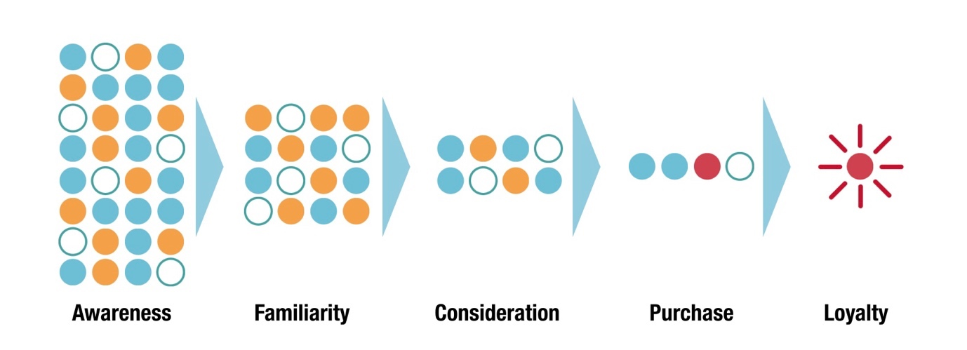
Source: (Court et al., 2009)
Philosopher John Dewey initially outlined the five phases of a decision-making process in his work "How We Think," published in 1910 (Dewey, 2008). Subsequent research further developed Dewey's original concepts, laying the groundwork for analysing consumer buying decision processes (Simpson, 2019). The customer decision-making process often called the consumer buying process, describes the steps individuals go through when making a purchase decision. The Five-Stage Model is widely recognized as a prevalent framework for understanding the consumer decision-making process, delineating five distinct stages: recognizing a need or problem, conducting an information search, evaluating alternatives, purchasing, and conducting post-purchase evaluation (Kotler and Keller, 2012). This straightforward model effectively elucidates the steps involved in consumer purchasing decisions.

Figure 9: Stages of consumer’s decision making
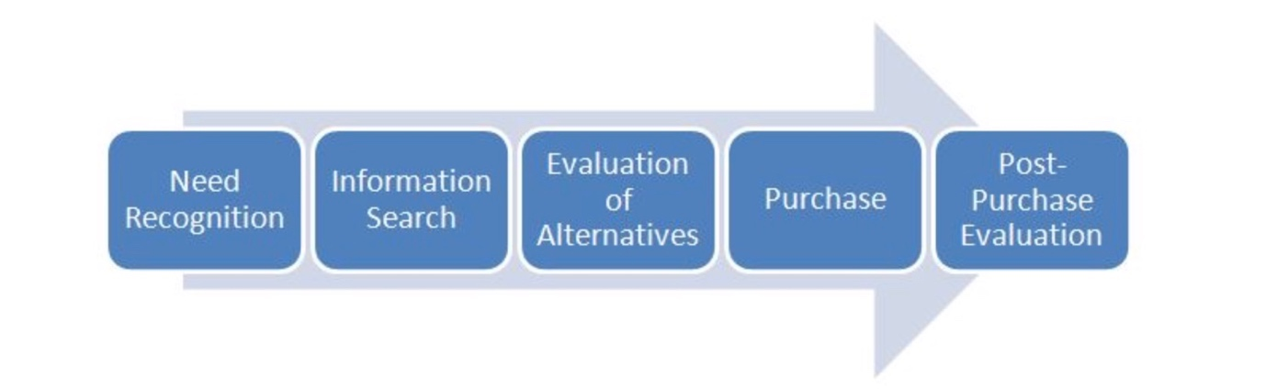
Source: Author
Recognition of Need or Problem: This is when consumers identify a need or problem that requires a solution. For example, consumers may need a vacation to relieve stress and explore new destinations.
The initial phase of the model is the recognition of needs or problems, where consumers become aware of their requirements (Babin and Harris, 2023). Marketers aim to deliberately create a discrepancy between consumers' current and desired states to incite a need, prompting consumers to identify and acquire a product or service. This disparity can arise spontaneously and may be a fundamental urge, termed as an internal stimulus. Conversely, external stimulation occurs when external factors influence individuals. Marketers induce a sense of imbalance or need through advertising and promotional activities. Once consumers acknowledge an unmet need and recognize that a product can fulfil it, they develop a desire (Stankevich, 2017).
Additionally, providing information about offerings, pricing, and packages empowers potential buyers to make well-informed purchasing decisions (CFI, 2024) (Indeed, 2022). According to Cohen, Prayag and Moital (2013), Tourism consumer behaviour entails a lot of factors, including decision-making, values, motivations, self-concept, personality, expectations, attitudes, perceptions, satisfaction, trust, and loyalty. Consequently, marketing within the tourism industry to create a desire or need for specific consumer products and services necessitates handling extensive volumes of data. Through predictive analytics, marketers can analyse vast amounts of data to understand consumer behaviour, interests, and past interactions with travel-related content. By leveraging AI algorithms, personalised recommendations and promotions can be delivered to potential travellers, enticing them with compelling offers and experiences that align with their needs (ZULAIKHA et al., 2020).
In this stage, AI tools track online activities, such as search queries on search engines or websites, social media interactions, and browsing behaviour, to identify signals of travel-related interests or intentions. For instance, predictive analytics may recognize patterns suggesting an upcoming vacation plan, a desire for adventure travel experiences, or an interest in specific destinations based on previous online interactions (Huang and Rust, 2020). With predictive analytics, AI algorithms can analyse vast amounts of data, including demographics, browsing history, and online behaviour, to identify audiences effectively (ZULAIKHA et al., 2020). By leveraging AI marketing techniques, such as personalized recommendations, targeted advertisements, and customized promotions, tourism businesses can effectively respond to these identified needs and problems.
Information Search: Consumers search for information about potential solutions after recognising a need. In the context of tourism, this might involve researching destinations, accommodations, activities, and travel options online. AI-powered digital marketing plays a crucial role by providing personalised recommendations, suggesting travel destinations based on past behaviour or preferences, and presenting targeted ads for relevant products and services.
From the perspective of information value, factors influencing online consumer search behaviour include relevance, accuracy, depth, timeliness, clarity, accessibility, variety, personalization, interactivity, privacy, security, and social influence (Grant, Clarke and Kyriazis, 2007). These factors collectively shape consumers' online search behaviour and influence their decisions and actions. According to Wang et al. (2016), contemporary travellers possess more individualised preferences and prioritise personalised services, a shift from the preferences observed in the pre-Internet and social media era. A study involving 6,661 tourists and analysing data from 244,980 travel instances revealed robust correlations between tourists' interests and their chosen travel destinations (Sohrabi et al., 2020). This research underscores the efficacy of marketing strategies tailored to promote goals aligned with traveller's specific interest categories, offering valuable insights for marketers in the tourism industry. By analysing big data encompassing demographics, browsing behaviours, and past interactions, AI algorithms identify patterns and trends indicative of individual interests and preferences (Singh, Bansal and Sharma, 2022). AI-driven algorithms analyze vast datasets comprising consumer preferences, historical behaviour, and real-time interactions across digital platforms to provide tailored and relevant information to consumers seeking travel-related services. Through predictive analytics, AI models anticipate the specific information needs of consumers based on their past behaviour and preferences, thereby presenting them with personalized recommendations, curated content, and targeted advertisements that align with their interests and intentions.
Moreover, AI-powered chatbots and virtual assistants are crucial in assisting consumers during the information search process. By leveraging natural language processing and machine learning algorithms, these AI-driven tools can engage and interact with consumers, address their queries, provide assistance, and offer information about travel destinations, accommodations, activities, and pricing options (Chaturvedi and Verma, 2023).
Additionally, predictive analytics enables tourism businesses to optimize their digital marketing efforts by identifying the most effective channels, content types, and messaging strategies to reach and engage their target audience during the information search stage (Alqurashi et al., 2023). Through data-driven insights derived from AI algorithms, marketers refine their content strategies, allocate resources effectively, and deliver timely and impactful information to consumers at various touchpoints across their digital journey.
Evaluation of Alternatives: Once consumers gather information, they evaluate various alternatives to satisfy their needs. This stage is crucial as it influences consumer behaviour, engagement, and conversion rates. This could involve comparing different travel packages, reading reviews, and considering cost, convenience, and amenities in tourism. For instance, in the tourism industry, consumers look at various things when considering and booking hotels online, using quick decision-making methods at first and then considering all factors before making a final booking, which has implications for how hotels set prices and online platforms are designed (Hu and Yang, 2020).
Consumers exploring market alternatives often seek distinguishing factors among offerings, including price, quality, features, customization options, brand recognition, industry trends, and availability (Indeed, 2023). A study highlights how the internet has reduced the distinction between search and experience goods by making information more accessible and enabling consumers to research products before purchasing (Huang, Lurie and Mitra, 2009). It found that although consumers spend similar amounts of time researching both types of goods online, there are differences in browsing and purchasing behaviours. In this phase, consumers utilize AI-powered tools and predictive analytics to assess travel destinations, accommodation options, activities, and other relevant factors based on their preferences, budgets, and needs. Product reviews and interactive multimedia significantly influence consumer behaviour for experience goods compared to search goods (Kim, 2020). AI marketing influences consumers' evaluations by highlighting unique selling points, offering discounts or personalised deals, and providing real-time pricing predictions. (Goh, Hui and Png, 2014)
Purchase Decision: After evaluating alternatives, consumers make a purchase decision. This could involve booking a flight, hotel room, or tour package.
Crucially, the purchase decision can be influenced by evaluating alternatives or situational factors such as effective point-of-sale marketing techniques and environmental factors at the point of sale. According to Evans, Jamal and Foxall (2009), the outcome of evaluating alternatives may change, even in the final moments before the purchase, due to the influence of other people's attitudes or a combination of other factors. AI marketing facilitates the purchase decision by streamlining the booking process, offering incentives like loyalty rewards or limited-time offers, and providing seamless integration across multiple platforms for a hassle-free experience (Hu and Yang, 2020).
Post-Purchase Evaluation: Consumers assess their experience and satisfaction with the chosen product or service after the purchase. Tourism involves reflecting on the travel experience, accommodations, activities, and customer service. AI marketing can enhance post-purchase evaluation by sending follow-up emails or surveys to gather feedback, offering personalised recommendations for future trips based on past experiences, and addressing any concerns or issues to improve customer satisfaction and loyalty.
Customers' perceptions of a product's performance can lead to either satisfaction or dissatisfaction, significantly impacting their level of loyalty. The opinions of peers, friends, and family regarding purchases play a pivotal role in post-purchase evaluations (Dudovskiy, 2013). Throughout these stages, AI-powered predictive analytics can analyse consumer behaviour, preferences, and engagement patterns to tailor marketing strategies, optimise content delivery, and predict future trends. By leveraging AI marketing effectively, businesses in the tourism industry can better understand consumer needs, enhance engagement, and improve conversion rates.
Cognitive dissonance is the psychological discomfort experienced when incoming information conflicts with one's established beliefs. It prompts individuals to utilize defensive strategies to mitigate the pain and uphold consistency in their perception of the world and self (Britannica, 2023). In consumer behaviour, cognitive dissonance occurs after a purchase decision when the consumer experiences doubt or regret about their choice (Marikyan, Papagiannidis and Alamanos, 2020). Cognitive dissonance is strongly related to brand loyalty and customer retention (Yakın et al., 2023).
Marketers in the Travel and Tourism industry minimise cognitive dissonance by employing many strategies.
Providing Clear and Accurate Information: Predictive analytics lets marketers personalize marketing communications by aligning messages closely with consumers' preferences and past behaviours, thereby providing precise and accurate information. (Bulchand-Gidumal et al., 2023). By delivering tailored recommendations and offers, marketers reduce the likelihood of post-purchase dissonance by enhancing perceived satisfaction with the chosen tourism products or services.
Reviews and Loyalty Programmes: AI-driven loyalty programs are another potent tool for boosting engagement and fostering repeat business (Chaturvedi and Verma, 2023). Personalised rewards and promotions based on specific actions, such as early booking, positive reviews, or referrals, incentivise desired behaviours and demonstrate appreciation for high-value customers. Dynamically adjusting program benefits based on individual behaviour and engagement levels ensures that loyalty programs remain relevant and rewarding for each customer, maximising their impact.
Optimising customer experience: AI is being utilized to optimize the overall customer experience across various touchpoints in the tourism industry (Forbes, 2023). By analysing vast amounts of data, AI algorithms can identify potential pain points or areas of friction in the consumer journey and recommend proactive interventions to address them (Edelman and Abraham, 2022). This proactive approach helps mitigate discrepancies between consumers' expectations and their actual experiences, thus reducing cognitive dissonance.
Follow-Up Communication and Additional Support: Many companies, with the help of AI, follow up with customers after a purchase to thank them for their business and address any questions or concerns they may have (Mckinsey, 2023). This proactive approach demonstrates care and support for the customer's post-purchase experience. Clear and transparent communication can help set realistic expectations and reduce the likelihood of post-purchase dissatisfaction. Additional support or resources, such as tutorials, troubleshooting guides, or customer service assistance, help consumers feel more confident and satisfied with their purchase, knowing that help is available to mitigate concerns and reduce cognitive dissonance.

2.4 Customer Lifetime Value (CLTV) Prediction Model

Customer lifetime value (CLTV), or simply lifetime value, represents the cumulative revenue anticipated from a customer throughout their association with a company. This computation incorporates customer acquisition expenses and operational and production costs related to the goods or services offered. While often underestimated, understanding the lifetime value of customers is pivotal for a company's expansion (CFI, 2023).

Figure 10: Customer Lifetime Value Calculation
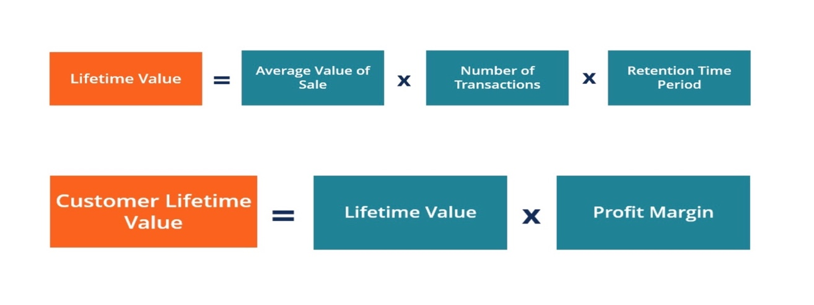
(CFI, 2023)

Customer lifetime value (CLTV) holds significant importance within predictive analytics in digital marketing, particularly in assessing the impact of AI marketing on consumer behaviour, engagement, and conversion rates in the tourism industry. CLTV provides invaluable insights into the long-term revenue potential of individual customers, enabling marketers to tailor their strategies to maximize customer retention, engagement, and satisfaction. Customer lifetime value (CLTV) holds significance as it prompts companies to prioritize the longevity of their customer relationships over short-term gains. It serves as a crucial metric, setting a threshold for the investment required to acquire new customers. (Bendle et al., 2010).
When predicting Customer Lifetime Value (CLTV), the factors to consider include data availability, industry segmentation, business goals, and model interpretability. Limited datasets may benefit from simpler models like RFM, while richer datasets may require more complex models such as Gradient Boosting Machines (GBM) or Recurrent Neural Networks (RNNs). Industry segmentation helps tailor the model to capture segment-specific nuances, aligning with business objectives and prioritising high-spending customers or frequent travellers. Additionally, choosing models based on their interpretability and opting for transparent models like decision trees or "black box" models like neural networks impacts understanding and application. By considering these factors, organizations can develop CLTV models suited to their specific needs and objectives (Sun, Liu and Gao, 2023).

2.4.1 GBM Model
Gradient Boosting Machine (GBM) is a powerful predictive modelling technique widely used in various industries, including digital marketing and tourism. It is a machine-learning technique used for both regression and classification tasks. It is an ensemble learning method that builds multiple decision trees sequentially, with each tree attempting to correct the errors of the previous one. In the GBM model, each tree is trained on the residuals (the difference between the actual and predicted values) of the earlier trees, thereby improving the overall predictive accuracy (Wang and Ross, 2018).

Figure 11: Gradient Boosting Machine (GBM) Model
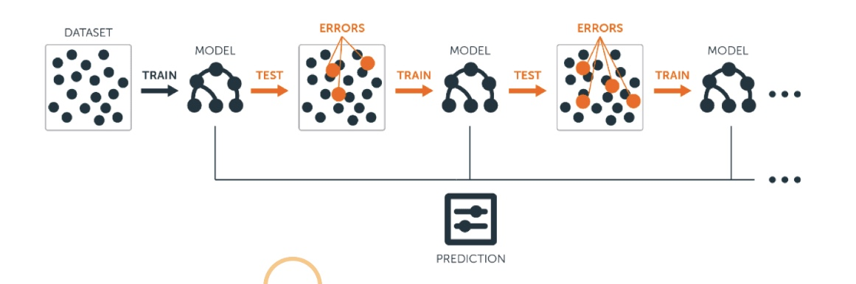
Source: (xialod, 2024)
GBM combines multiple weak predictive models, typically decision trees, to create a robust ensemble model. It builds trees sequentially, with each tree focusing on the mistakes made by the previous ones, gradually reducing prediction errors. This iterative process allows GBM to learn complex relationships and patterns in the data, making it highly effective for predictive analytics tasks (Piryonesi and El-Diraby, 2019).
In the tourism industry, GBM can be used to predict various outcomes, such as customer preferences, booking likelihood, and lifetime value. By analysing historical data on customer interactions, demographics, and past behaviours, GBM can identify key factors influencing consumer decisions and engagement. This insight enables marketers to tailor their strategies more effectively, personalize marketing communications, and optimize resource allocation for maximum impact.
However, it's essential to note that GBM requires careful tuning and validation to avoid overfitting and ensure reliable predictions. Additionally, interpreting GBM models can be challenging due to their complexity, requiring expertise in data analysis and machine learning techniques (Piryonesi and El-Diraby, 2019). Despite these challenges, GBM offers significant potential for enhancing digital marketing efforts in the tourism industry, driving better engagement and conversion rates through data-driven insights and predictive analytics.

2.5 Conclusion

The literature review has provided a comprehensive overview of key concepts and models relevant to the study of predictive analytics in digital marketing within the tourism industry. The RACE and Honeycomb models offer structured frameworks for understanding and implementing digital marketing strategies, emphasizing the importance of customer engagement and relationship-building. Additionally, insights into consumer behaviour and the decision-making process highlight the significance of personalized and targeted marketing efforts in driving engagement and conversion rates. Moreover, the discussion on consumer lifetime value prediction models underscores the value of predictive analytics in optimizing marketing strategies and enhancing customer lifetime value. Overall, the literature review sets a solid foundation for the subsequent empirical investigation into the impact of AI marketing on consumer behaviour, engagement, and conversion rates in the tourism industry context.

Chapter 3. Research Methodology

The concept of 'Research', as defined by the Cambridge Dictionary (2023), involves a comprehensive examination of a topic to uncover new information or achieve a deeper understanding. As described by Panneerselvam (2014), research methodology encompasses a collection of principles, methods, and procedures utilised to address research inquiries. One approach to structuring research methodology is based on the theoretical framework known as the "Research onion," as Saunders et al. (2007) outlined. This research aims to explore the multifaceted layers of research methodologies encapsulated within the Research Onion framework to attain a holistic comprehension of the complex interplay between AI marketing strategies and consumer responses in the travel and tourism sector. By peeling back the layers of the research onion, this research endeavours to uncover insights that illuminate the efficacy and implications of predictive analytics in shaping marketing practices and consumer experiences within the digital domain of travel and tourism.

Figure 12: Research Onion (Saunders et al., 2019)

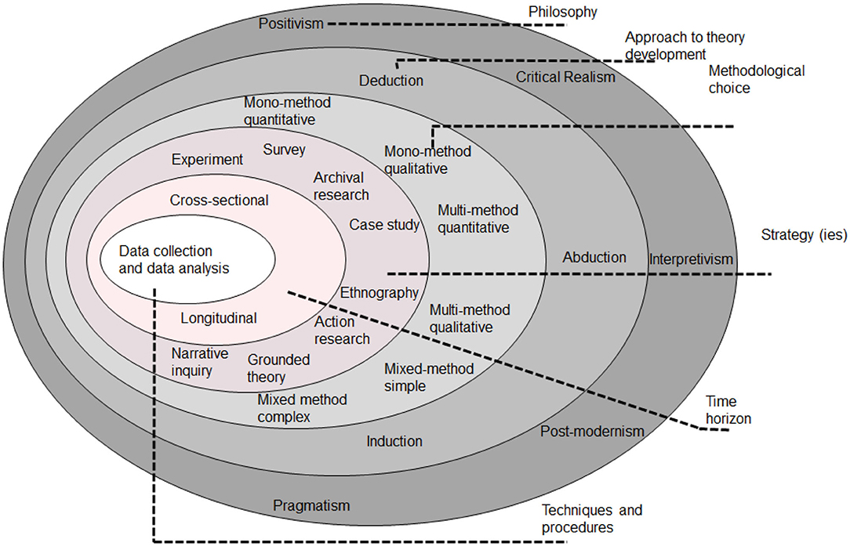

3.1 Research Philosophy
Research philosophy comprises a set of convictions concerning the nature of the reality being scrutinized (Becker et al., 2012), forming the bedrock of the study by delineating ontology (on the nature of reality), epistemology (concerning the nature of knowledge or facts), and axiology (encompassing the values, beliefs, and ethics of the study) (Winit-Watjana, 2016). As a philosophical discipline, epistemology delves into comprehending and elucidating the nature, origins, and progression of knowledge. It encompasses inquiries into perception, memory, insight, inference, and testimony (Martinich and Stroll, 2019). Axiology is concerned with the ethical considerations of research, exploring the philosophical principles behind making sound decisions. It involves the establishment, measurement, and comprehension of both favourable and unfavourable research conduct. Axiology also scrutinizes the researcher's deliberation on the significance attributed to participants, data, and audience (Kivunja and Kuyini, 2017). Ontology delineates the essence of reality, identifying the concepts arising from investigation and their societal and environmental ramifications (Steup, 2010). It distinguishes reality from experience, elucidating its influence on behaviour and separating reality from perception (Steup, 2010). In this study, the research ontology aligns with positivism.
Positivism entails deriving law-like generalizations from observed social reality. The term "positivism" originates from "posited" or "offered," highlighting approaches that prioritize presenting raw data and facts devoid of subjective interpretation or bias (Saunders et al., 2019). Saunders et al. (2019) define research philosophy as a framework of ideas and assumptions concerning the development and nature of knowledge in research. Positivism, as an epistemological stance, advocates for applying scientific methods to explore social reality and beyond (Bryman, 2016). The primary objective of positivist research is to establish explanatory connections or causal relationships to predict and control the phenomenon under study (Park, Konge and Artino, 2020).
Positivism favours quantitative research techniques such as experiments, surveys, and statistical analysis for measuring and analysing events (Saunders et al., 2019). Proponents of positivism argue that knowledge can and should be generated objectively, free from the influence of participants' or researchers' personal beliefs (Park, Konge, and Artino, 2020). Positivist research typically employs a deductive approach, where hypotheses and research objectives are formulated based on existing theories and then empirically tested to validate them. This process contributes to refining and expanding scientific knowledge (Saunders et al., 2019).
To address the research questions posed at the outset of this paper, positivism will serve as the guiding philosophy for this study. Adopting positivism will enable the researcher to develop explanations rooted in the commonly accepted worldview by collecting scientific data and information, which will then be analysed to confirm or refute the research objectives.

3.2 Research Approach
The research approach refers to the systematic and structured way researchers conduct their investigations, varying in fundamental reasoning and investigative techniques. Deduction, induction, and abduction are the primary approaches to theory development (Saunders et al., 2019).
The deductive approach involves verifying a theoretical proposition through a research strategy tailored for this purpose (Saunders et al., 2019). Commonly employed in quantitative research, it typically initiates a study proposal to test or validate a theory rather than originating it (Creswell, 2013). This entails proposing a hypothesis, gathering data for testing, and evaluating its affirmation or negation based on the outcomes (Creswell, 2013).
In the research onion framework, the "Research Approach" section constitutes a critical layer that outlines the overall strategy employed to address the research objectives. In the context of the study on "Predictive Analytics in Digital Marketing," the research approach involves selecting the appropriate methodology for investigating the impact of AI marketing on consumer behaviour, engagement, and conversion rates in the tourism industry.
Given the complexity of the research topic and the need to capture both quantitative and qualitative aspects, a mixed-methods approach may be suitable. This approach allows for the integration of numerical data, such as conversion rates and engagement metrics, and qualitative insights, such as consumer perceptions and attitudes towards AI marketing in tourism.
Furthermore, the research approach should consider factors such as data collection techniques, sampling methods, and data analysis procedures to ensure the reliability and validity of the findings. Additionally, the research approach should address ethical considerations regarding participant consent, data confidentiality, and researcher bias.

3.3 Research Strategy

The research strategy delineates the overarching course of the study and its execution methodology (Wedawatta, Ingirige, & Amaratunga, 2011). The deductive research approach is typically linked with the survey methodology (Saunders et al., 2019). This approach is commonly utilized in business and management research, primarily focusing on addressing questions related to "who," "what," "how much," "where," and "how many." Consequently, it is often applied in descriptive and exploratory research (Saunders et al., 2019). A survey is a systematic technique for gathering data from a group of individuals to describe, understand, or explain a larger population's characteristics, perspectives, actions, or attitudes (Fowler, 2013). For this study, a survey questionnaire approach has been employed to collect detailed, reliable, and easily understandable data from individuals to analyse the research problem.

3.4 Types of Investigation

The current study has employed primary and secondary research methodologies to gather and analyze data supporting the research objectives. These methodologies enabled the researcher to comprehensively understand the research topic from various sources, facilitating a more robust and dependable analysis.
Primary Research: According to (Saunders et al., 2019), primary research involves collecting new, original data tailored to a specific research project. Also known as field research, primary research allows researchers to address research questions or objectives through interviews, surveys, observations, or experiments (Saunders, Thornhill, and Lewis, 2015). The research "onion" provides a structured framework for conducting primary research, guiding the researcher in selecting appropriate methodologies aligned with their research questions and objectives. This structured approach ensures a coherent research methodology, enhancing the study's quality, validity, and reliability by addressing research philosophy, approach, strategy, choices, time horizon, and techniques.
In this study, primary research has been conducted through a survey questionnaire. The survey questionnaire is a popular and efficient method of collecting primary data from many respondents (Bryman, 2016). This approach enables the researcher to gather standardized data on attitudes, opinions, behaviours, or demographic characteristics related to the research topic (Fowler, 2013). In this case, the survey questionnaire has provided valuable insights into the impact of AI-powered predictive analytics in the travel and tourism industry marketing.
Advantages of Primary Research
Original Data: Primary research involves collecting first-hand data directly from the source, ensuring the information is original and specific to the research objectives (Saunders et al., 2019).
Control Over Data Collection: Researchers have control over the design, methodology, and execution of primary research, allowing them to tailor the process to meet the specific needs of the study (Taherdoost, 2021).
Specific to Research Objectives: Primary research enables researchers to gather data directly addressing their research questions or objectives, ensuring relevance and accuracy (Saunders, Thornhill, and Lewis, 2015).
Flexibility: Primary research methods offer flexibility in data collection approaches, such as surveys, interviews, experiments, or observations, allowing researchers to choose the most appropriate method for their study (Saunders et al., 2019).
Detailed Insights: Since primary research involves direct interaction with respondents, it often provides detailed insights into attitudes, behaviours, motivations, and opinions (Saunders et al., 2019).
Disadvantages of Primary Research
Time-Consuming and Costly: Primary research can be time-consuming, requiring significant planning, data collection, and analysis efforts, especially when conducting interviews or experiments (Bryman, 2016). Primary research can be expensive, particularly when involving large sample sizes, specialized equipment, or extensive data collection efforts, which may require funding and resources (Punch, 2013).
Potential Bias: Researchers conducting primary research may unintentionally introduce bias through their interactions with respondents, question formulation, or interpretation of results (Šimundić, 2013).
Secondary Research
Secondary research involves collecting, synthesising, and analysing existing data and literature compiled and published by other researchers (Church, 2002). This body of published primary literature, such as books and journal articles, constitutes secondary literature. Secondary data are initially gathered for different purposes but may be further examined to offer distinct insights, interpretations, or conclusions (Saunders, Lewis, and Thornhill, 2019).
In this research paper, secondary research has been conducted through a literature review. Incorporating the literature review showcases the author's comprehension of the existing knowledge base on the topic (Punch, 2013). It lays the groundwork for primary research, data analysis, and the conclusions drawn from the secondary data (Saunders, Lewis, and Thornhill, 2015).
Advantages of Secondary Research
Cost-effective and Time-saving: Secondary research is often more cost-effective than primary research because it involves using existing data and literature, eliminating the need for data collection from scratch (Saunders, Lewis, and Thornhill, 2015). Since secondary research utilizes pre-existing data and literature, it can be conducted relatively quickly compared to primary research methods, allowing researchers to obtain insights in a shorter time frame (Punch, 2013).
Wide availability: Secondary data and literature are widely accessible through various sources such as academic journals, books, government reports, and online databases, providing researchers with a vast pool of information to draw from(King, 2022).
Large sample sizes: Secondary research often involves large sample sizes, enabling researchers to analyse trends and patterns across broader populations or contexts (King, 2022).
Disadvantages of Secondary Research
Lack of control: Researchers have limited control over the quality and reliability of secondary data, as it is collected by other researchers or organizations for different purposes, potentially leading to biases or inconsistencies (Cheng and Phillips, 2014).
Data limitations: Secondary data may not always align perfectly with the researcher's specific research objectives or requirements, leading to gaps or inadequacies in the available information (Cheng and Phillips, 2014).
Lack of Context: Secondary data may lack the contextual information or nuances provided by primary data collection methods, making it challenging to fully understand the underlying reasons behind observed trends or phenomena (Saunders, Lewis, and Thornhill, 2015).

3.5 Choice of Method
Methodology choices encompass the methods and tools researchers select to conduct a study and address its research questions, aiming to ensure coherence in its research design. Methodology selection is influenced by various factors, including the research objectives and questions, goals, context, available resources, and the researcher's expertise (Saunders, Lewis, and Thornhill, 2019). Depending on the research philosophy, theory development approach, and research type, the researcher will opt for one of three methodological options: qualitative, quantitative, or mixed methods. Research is categorized into three main types based on the nature of the data collected: quantitative, qualitative, and mixed methods (University of Newcastle Library, 2022).
Quantitative research involves collecting and analysing data using statistically oriented methods such as polls or surveys, focusing on gathering extensive data from participants (Almalki, 2016).
On the other hand, qualitative methods, considered "inductive," operate under the assumption that reality is socially constructed, variables are intricate and challenging to measure, the subject matter is complex, and insights are derived from an insider's perspective (Rovai, Baker, and Ponton, 2014).
Lastly, mixed methods research integrates qualitative and quantitative approaches, encompassing various perspectives, data collection techniques, analysis methods, and interpretations to achieve comprehensive insights and validation (Johnson, Onwuegbuzie, and Turner, 2007).
This study adopts a mixed methods approach to analyse primary data sources, combining quantitative and qualitative research methodologies to attain precise results and fulfil research objectives.

3.6 Time Horizon
This study's time horizon is cross-sectional, as the research spans a limited duration of ten weeks, during which data collection occurs at a singular juncture within this timeframe. A cross-sectional approach offers insight into the investigated phenomenon by capturing data at a single time point. This methodology often employs survey techniques for data collection (Saunders, Lewis, and Thornhill, 2019).

3.7 Data Collection and Analysis

3.7.1 Sampling
Sampling in the research onion refers to selecting a subset of individuals or items from a larger population to participate in a study. It involves determining the characteristics of the sample that will adequately represent the population under investigation (Cooper and Schindler, 2014). Sampling methods vary depending on the research design, objectives, and constraints. The selection of the sampling technique is crucial for ensuring the reliability and validity of research findings (Saunders, Lewis, and Thornhill, 2019). It is an essential consideration in a research study's methodology section, helping researchers confidently generalize their findings to the broader population.

Sample Size: In this research focusing on evaluating the influence of AI marketing on consumer behaviour, engagement, and conversion rates within the tourism industry, the target population comprises individuals who engage with digital marketing content related to tourism offerings. Initially, a sample size of 50 respondents was deemed sufficient to address the research questions given the project's duration and scope. During the data collection phase, 55 responses were received. Although a larger sample could improve accuracy and generalizability, the researcher believes this size balances result reliability, data collection practicality, and project timeline. Access to respondents was facilitated through various digital platforms and tourism-related forums, ensuring a diverse pool of participants for comprehensive insights.

Sample Type: The study targets individuals within the tourism industry who interact with AI marketing on digital platforms. Participants were professionals with backgrounds aged 18 and above. The sample comprises individuals from diverse geographical locations, encompassing regions heavily involved in the tourism sector, such as Europe, North America, and Asia. Additionally, participants represent various demographic backgrounds, including different genders, ages, occupations, and levels of experience with AI marketing in the tourism industry.

Sampling Method: This study employed a non-probability sampling approach, specifically convenience sampling, to select participants. Convenience sampling is chosen for its efficiency in data collection, targeting respondents who are readily available and willing to engage in the study (Cooper and Schindler, 2014).
The decision to use convenience sampling was driven by the accessibility of potential participants through digital platforms, and the researcher efficiently reached a diverse pool of individuals involved in the tourism industry, influenced by AI marketing strategies. This method facilitated the attainment of the desired sample size within a shorter timeframe than anticipated.
Despite its limitations, convenience sampling was deemed suitable for achieving the research objectives of this study due to its practicality and effectiveness in capturing insights into consumer behaviour, engagement, and conversion rates influenced by AI marketing in the tourism sector.

Advantages of Convenience Sampling
Efficiency: Convenience sampling is quick and easy to implement, saving time and resources in participant recruitment (Saunders, Lewis, and Thornhill, 2019).
Cost-Effectiveness: It is a cost-effective method as it does not require extensive resources for participant recruitment (Saunders, Lewis, and Thornhill, 2019)
Accessibility and Feasibility: This method allows researchers to access participants who are readily available and accessible, primarily through digital platforms. Convenience sampling suits studies with limited resources or tight timelines, making it a practical option for many research projects (Saunders, Lewis, and Thornhill, 2019).

Disadvantages of Convenience Sampling
Sampling Bias: There is a risk of sampling bias as the sample may not be representative of the population, leading to results that are not generalizable (Etikan, Musa and Alkassim, 2016).
Limited Diversity: Convenience sampling may result in a lack of diversity among participants, as it tends to include individuals who are easily accessible or willing to participate (Bryrnan, 201 6).

3.7.2 Data Collection Method
This study collected data using an online survey questionnaire targeting a sample of 55 online users. The survey was administered between January 5th and 12th, 2024, with the survey link shared on platforms such as Instagram, Facebook, and WhatsApp. The questionnaire was developed in English using Jotforms.com and comprised 11 questions: 8 multiple-choice questions, two 5-point Likert scales, and one open-ended question. On average, participants took 2 minutes and 15 seconds to complete the survey.

3.7.3 Analysis of Data
Jotform (Survey software) was extensively utilized during the analysis phase of this study to derive conclusions from the gathered data. Various inferential and descriptive statistics, such as mean, standard deviation, frequency, reliability, regression, and correlation, were employed. Tables, figures, and charts were employed to represent the study findings visually.

3.8 Ethical Considerations

Gajjar (2013) outlined that research ethics are fundamental principles guiding research design and implementation. The adherence to British Educational Research Association (BERA) guidelines (2018) was rigorously followed throughout this study. The research upheld codes such as honesty, objectivity, integrity, carefulness, openness, acknowledgement of intellectual property, non-discrimination, and social responsibility, ensuring authenticity, impartiality, diligence, transparency, recognition, fairness, and societal benefit in the research process. When managing data collection for this study, adherence to the UK's Data Protection Act of 2018 (Government of UK, 2018) governing the processing of personal data was maintained.

Chapter 4. Analysis of Data

4.1 Introduction
This section presents an analysis of survey data to evaluate the impact of AI marketing on consumer behaviour, engagement, and conversion rates in the tourism industry. It explores respondents' utilization of online platforms for leisure travel, experiences with AI-powered features in travel services, and the frequency of personalized recommendations during travel planning. Additionally, it examines respondents' perceptions of recommendation accuracy, factors influencing travel decisions, and concerns regarding AI implementation in the tourism sector. By analysing these survey findings, this section aims to provide insights into the role of predictive analytics in digital marketing strategies within the tourism industry.

4.2 Questionnaire Analysis and Discussion

Question 1. Do you typically use online platforms or apps to research and book travel for leisure purposes? (e.g., booking platforms, Airlines, price comparison websites)
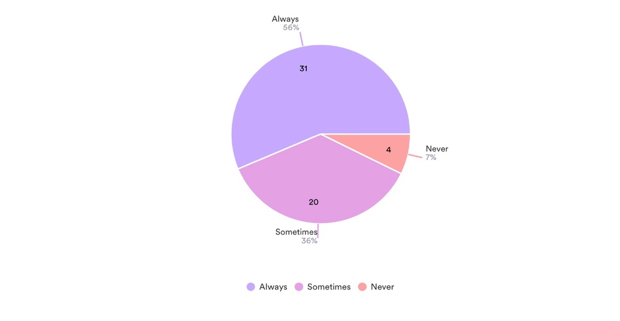
Result: The survey findings indicate that 96% of respondents have used online platforms to plan and book holidays, with 56% frequently using them for leisure travel. Additionally, 36% use these platforms occasionally, while only 4% never rely on them for leisure travel bookings.
Discussion: Most sectors have significantly shifted towards digitalization over the past decade. Specifically, the travel industry has actively nurtured its online visibility and is continuously advancing, as evidenced by the recent integration of Artificial Intelligence (AI) in travel and tourism operations. The first survey question regarding utilising online platforms or apps for leisure travel provides valuable insights into respondents' prevailing trends and behaviours. The findings reveal a widespread reliance on digital channels for travel planning and booking.
Firstly, 96% of respondents reported using online platforms or apps to plan and book their holidays, underscoring the ubiquitous nature of digital tools in the travel industry. This indicates a shift from traditional travel booking methods, such as visiting travel agencies or making phone reservations, towards more convenient and accessible online options. Furthermore, 56% of respondents stated that they often utilize online platforms or apps for leisure travel, highlighting the frequency individuals turn to digital channels when planning their trips. This suggests that online platforms have become integral components of the travel planning process, offering users convenience, flexibility, and a wide range of options.
Moreover, the 36% of participants indicating occasional use of these platforms underscore the continued preference for digital tools in travel planning, albeit with some still opting for alternative methods. Projections suggest a robust expansion of the global online travel industry, reaching an estimated market size of approximately $475 billion in 2022, with online channels contributing over 60% of the sector's revenue in 2017, expected to increase to 69% by 2023. Van Nuenen and Charles (2021) acknowledged the popularity of online travel platforms. They attributed much of this growth to the widespread adoption of interactive digital media, technology, and AI within the tourism sector.
However, the small minority of 4% indicating that they never rely on online channels for leisure travel booking highlights a potential segment that either prefers traditional booking methods or may have limited access to digital technologies. The global picture Understanding the reasons behind this reluctance or inability to use online platforms could provide valuable insights for businesses looking to cater to a diverse range of customers.
The survey results indicate most respondents strongly prefer online platforms and apps for leisure travel purposes. This underscores the importance for businesses in the travel and tourism industry to prioritize their online presence, invest in user-friendly digital platforms, and leverage digital marketing strategies to effectively reach and engage with consumers in today's increasingly digital landscape.
Question 2. Have you ever used any travel apps or services that use AI for features like chatbot assistance, itinerary optimisation, or in-destination recommendations?
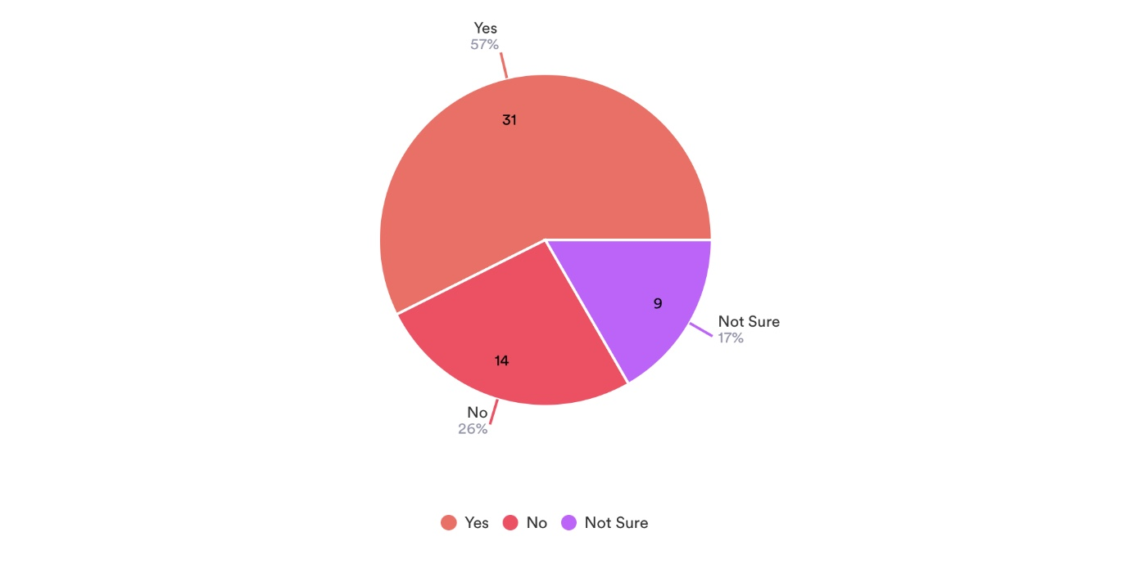
Result: The survey findings indicate a significant uptake of AI-infused travel services among respondents, with 57% affirming their use of such apps or services. In contrast, a smaller proportion of 26% reported not utilising any travel apps or services featuring AI functionalities.
Discussion: The survey results suggest a notable adoption of travel apps or services incorporating AI features among respondents, with 57% confirming their utilization of such technology. This finding underscores the growing integration of AI in the travel industry to enhance user experiences and streamline processes. AI-powered functionalities like chatbot assistance, itinerary optimization, and in-destination recommendations cater to the evolving needs of travellers by providing personalized and efficient services. According to the World Economic Forum, In the ever-evolving realm of travel, artificial intelligence (AI) serves as a guiding force of change, fundamentally altering our voyage from the inception of our decision to venture into the world (Sun, 2023).
The substantial percentage of respondents (57%) who have used AI-infused travel apps or services indicates a recognition of the benefits offered by AI technology in travel planning and management. Chatbot assistance, for instance, allows travellers to access instant support and information, enhancing convenience and responsiveness. Similarly, itinerary optimization features leverage AI algorithms to suggest tailored travel plans based on user preferences, optimizing time and resources during trip planning. Chaturvedi and Verma (2023) state that AI-driven chatbots and virtual assistants are pivotal in aiding consumers during the information search phase. Utilizing natural language processing and machine learning algorithms tools in conversational interactions, address queries, provide real-time assistance, and offer pertinent details on travel destinations, accommodations, activities, and pricing options.
However, it is worth noting that a significant proportion of respondents (43%) reported not knowing if they have used or have never utilized any travel apps or services with AI functionalities. This may stem from factors such as limited awareness of AI-powered offerings, preference for traditional travel planning methods, or concerns about privacy and data security associated with AI technologies. Similarly, in a larger-scale survey involving 6000 participants, it was discovered that while 34% of individuals believed they had interacted with AI, in reality, 84% had done so without realizing it, indicating a significant level of unawareness among respondents regarding their engagement with AI (Hyken, 2017).
The significant uptake of AI-infused travel services among respondents reflects a positive trend towards leveraging technology to enhance the travel experience. While AI offers numerous benefits regarding convenience, personalization, and efficiency, addressing concerns and ensuring transparent communication about AI implementation is essential to fostering further adoption and trust among travellers.
Question 3. How often have you encountered personalised recommendations for travel destinations, activities, or accommodations during your online travel planning? (e.g., Travel websites, Airlines, Booking platforms)
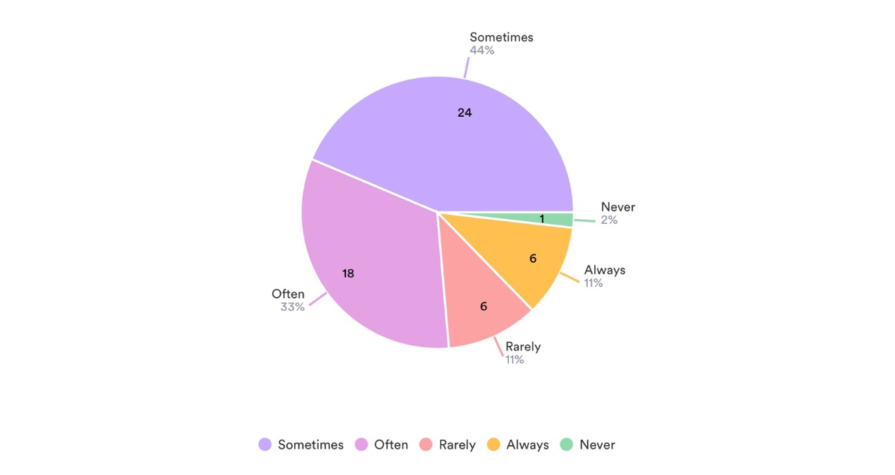
Result: Most respondents, constituting 11%, reported receiving personal recommendations and personalized advice for travel destinations, activities, or accommodations during online travel planning. Additionally, 44% of participants stated experiencing such recommendations sometimes, while a small minority of 13% indicated rare or no encounters with personalized suggestions.
Discussion: The survey findings suggest that many respondents frequently encounter personalized recommendations during online travel planning. Specifically, 11% of participants reported consistently receiving such offers, indicating a high level of personalization in their online travel experiences. This suggests that travel websites, airlines, and booking platforms effectively leverage data-driven algorithms to tailor recommendations based on individual preferences, behaviours, and past interactions.
The personalised travel and tourism market is growing fast. The demand for personalized travel and experiences was valued at $91.2 billion in 2020 and is projected to grow to $447.3 billion by 2030, with a compound annual growth rate (CAGR) of 17.8% from 2021 to 2030 (Research, 2021). The fact that 44% of respondents stated experiencing personalized recommendations sometimes highlights the widespread adoption of personalization strategies in the travel industry. This intermittent exposure to personalized suggestions suggests that while personalization efforts are prevalent, they may not always be consistently applied across all online travel platforms or interactions.
Conversely, the 13% of participants who indicated rare or no encounters with personalized suggestions underscore a potential area for improvement in personalization efforts within the travel sector. This minority of respondents may represent individuals who have yet to engage with platforms offering personalized recommendations fully or who may have specific preferences or behaviours not effectively captured by current personalization algorithms. Sivarajah et al. (2017) elucidate how artificial intelligence (AI), utilizing its machine learning algorithms and natural language processing functionalities, empowers marketers to automate tasks, analyse complex datasets, and provide tailored experiences across various digital channels.
Question 4. In which area or sector within the tourism industry have you encountered the application of AI? (e.g., Accommodation, Transportation, Food & Beverage?
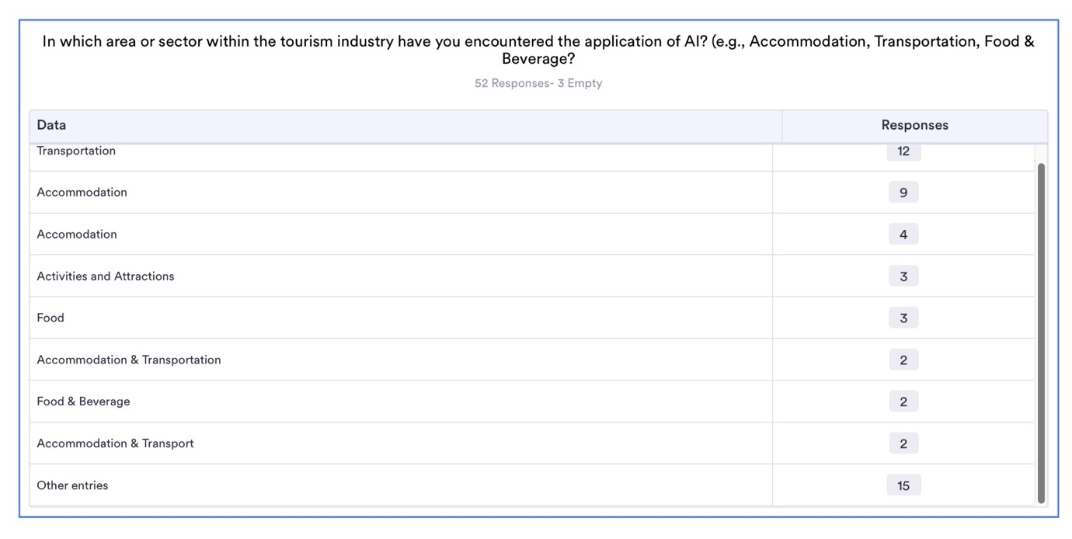
Result: This was an open-ended question. In the survey, respondents selected accommodation as most common in encountering the application of AI in the tourism industry, indicating a significant presence of AI in this area with 13. Transportation followed closely, with 12 respondents mentioning AI applications in this sector. 4 people chose both sectors. However, a smaller proportion, 3, reported encountering AI applications in activities and attractions, suggesting a relatively lower integration of AI in the tourism industry. The food and beverage sector had the lowest reported encounter rate, with only two respondents mentioning AI applications in this domain.
Discussion: The survey results provide valuable insights into the landscape of AI applications within the tourism industry, shedding light on the sectors where AI is most prevalent and its integration is relatively limited. The findings reveal that accommodation and transportation emerge as the leading sectors where respondents have encountered AI applications. This discovery aligns with prior research, indicating that the transportation and accommodation sectors are the primary domains leveraging AI technology (Research, 2024; Network, 2023). This prominence can be attributed to the widespread adoption of AI-driven technologies such as hotel booking platforms, property management systems, and ride-sharing services. The high frequency of AI encounters in these sectors underscores the pivotal role of AI in streamlining booking processes, optimizing service delivery, and enhancing customer experiences.
Conversely, the survey indicates a lower level of AI integration in activities and attractions and the food and beverage sector. This suggests that AI technologies may have yet to penetrate these tourism industry segments to the same extent as accommodation and transportation. The considerable expense associated with AI implementation poses a significant obstacle for sectors such as food services and activity-based attractions, mainly because many entities within these segments operate on a smaller scale (Blöcher and Alt, 2020). The relatively limited adoption of AI in activities and attractions could be attributed to these offerings' diverse and dynamic nature, which presents unique challenges for AI implementation. Similarly, the lower encounter rate of AI applications in the food and beverage sector may reflect the traditional character of dining experiences and the perceived complexity of incorporating AI into culinary services (Alejos, 2023).

Question 5. On a scale of 1 to 5, how accurate are these recommendations from websites and apps to predict your travel needs or preferences? (Fill only if you receive offers/ suggestions)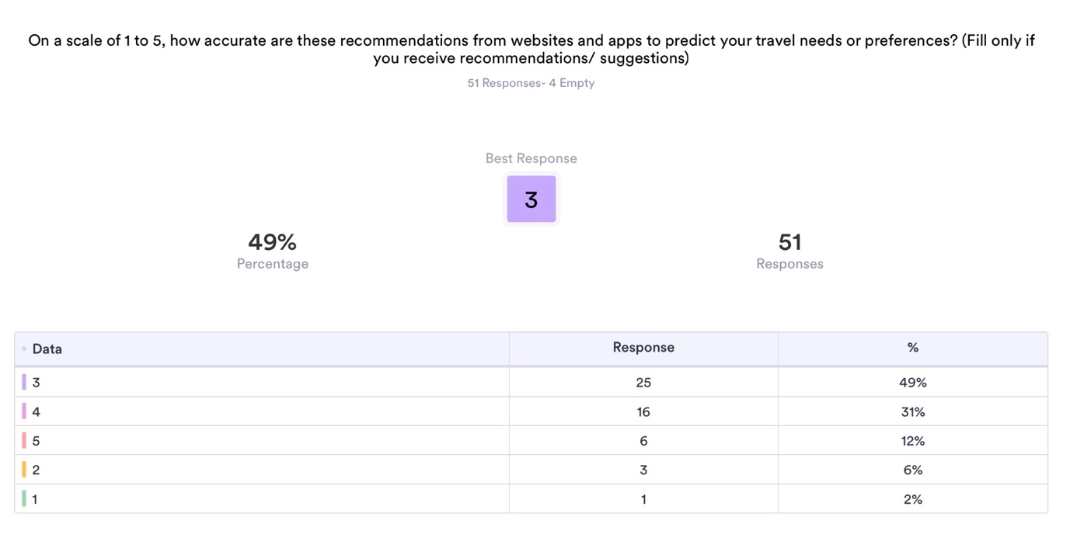
Result: The survey revealed that respondents rated the accuracy of travel recommendations based on an average of 3 on a scale of 1 to 5, suggesting a moderate level of perceived accuracy. 12% said their recommendations were accurate, and only 2% felt incorrect.
Discussion: The survey findings indicate that respondents generally perceive the accuracy of travel recommendations from websites and apps as moderate, with an average rating of 3 on a scale of 1 to 5. This suggests that while some individuals find the recommendations highly accurate, with 12% rating them as absolutely accurate, most respondents have a more neutral perception of their accuracy. Only a small proportion, 2%, felt that the recommendations were incorrect. This suggests that while travel recommendations may be generally reliable, there is room for improvement in enhancing their accuracy to meet users' diverse needs and preferences. Factors such as the quality of data inputs, the sophistication of the recommendation algorithms, and the level of personalization offered may all influence users' perceptions of recommendation accuracy. While scholars typically posit that AI technology is predominantly precise, public perceptions towards it remain ambiguous and sceptical (Candelon, Evgeniou and Martens, 2023) (Kashive, Powale and Kashive, 2020). This may cause the non-reliability of AI. Future research could delve deeper into these factors to better understand how to optimize travel recommendation systems for improved accuracy and user satisfaction.
Question 6. How often do these recommendations influence your travel decisions?
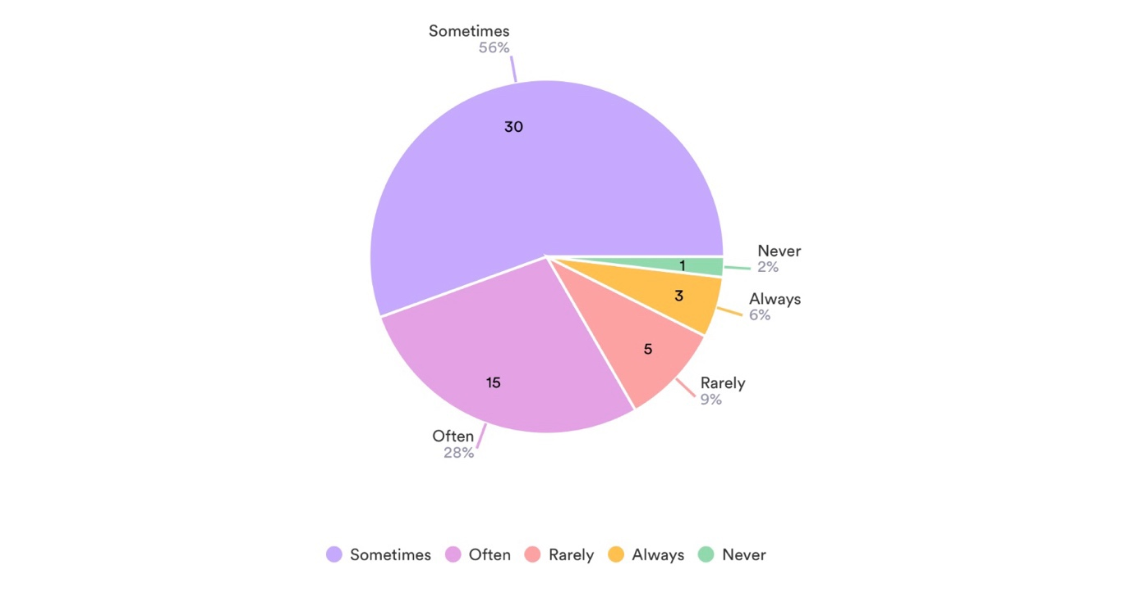
Result: The survey reveals varying influence of travel recommendations on decisions. 28% find them significant, 56% are occasionally influenced, 9% are rarely affected, and 2% are never influenced.
Discussion: The survey results reveal intriguing insights into the role of travel recommendations in influencing individuals' travel decisions. The finding that 28% of respondents acknowledge the significant influence of recommendations on their travel choices suggests that these suggestions hold considerable sway over a substantial portion of travellers. This could be attributed to the perceived value and relevance of the recommendations in aiding decision-making processes, as individuals may rely on them to discover new destinations, activities, or accommodations that align with their preferences and interests.
Moreover, most participants, comprising 56%, reported that while recommendations sometimes influence their decisions, they do not consistently dictate their travel plans. This nuanced response indicates that while recommendations may have some impact, individuals are not solely reliant on them and may consider various factors when making travel decisions. Such factors could include personal preferences, budget constraints, travel companions' preferences, and the availability of alternative options.
Conversely, a smaller proportion of respondents (9%) indicated that travel recommendations rarely influence them. This finding suggests that a segment of travellers are less responsive to recommendations, either due to a preference for independent decision-making or a perceived lack of trust in the accuracy or relevance of the suggestions provided by travel platforms.
Furthermore, the minimal percentage (2%) of respondents who reported never being influenced by travel recommendations highlights the limited impact of these suggestions on a small subset of travellers. While the reasons for this lack of influence may vary, it underscores the importance of recognizing individual autonomy and diverse decision-making processes in the travel context.
Overall, the discussion elucidates the multifaceted nature of how travel recommendations influence individuals' travel choices, encompassing factors such as perceived relevance, trust, autonomy, and the interplay of various decision-making considerations. Understanding these dynamics is crucial for travel businesses and marketers seeking to effectively leverage recommendations to enhance the travel experience and meet the diverse needs of travellers.
Question 7. What factors do you consider when evaluating the usefulness of travel recommendations?
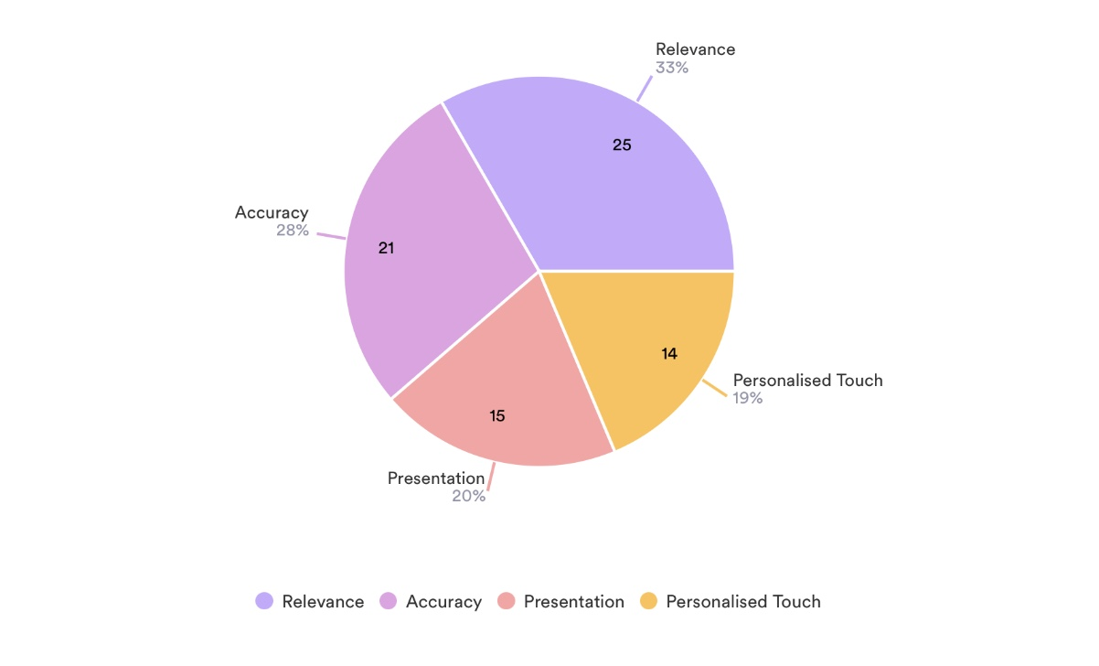
Result: The survey indicates that relevance (33%), accuracy (28%), personalization (19%), and presentation (20%) are key factors influencing the perceived usefulness of travel recommendations.
Discussion: The survey results provide valuable insights into the factors that respondents prioritize when assessing the usefulness of travel recommendations. Relevance emerges as a critical consideration for 33% of respondents, suggesting that recommendations must align closely with their specific travel needs, preferences, and interests to be deemed useful. This underscores the importance of tailored suggestions that cater to individual requirements, enhancing the overall travel experience.
Accuracy is another significant factor highlighted by 28% of participants. This emphasizes the importance of recommendations being reliable and precise, ensuring that travelers can trust the information provided to make informed decisions about their travel plans. Reliable suggestions instill confidence in travelers, enabling them to plan their trips more effectively and with greater peace of mind.
Personalization is also emphasized by 19% of respondents, indicating a desire for recommendations that are customized to their unique preferences and interests. Personalized recommendations demonstrate an understanding of individual needs and preferences, enhancing the relevance and effectiveness of the suggestions provided. This personal touch can significantly enhance the overall travel experience, making it more enjoyable and fulfilling for travelers.
Additionally, 20% of respondents consider the presentation of recommendations when evaluating their usefulness. This suggests that visually appealing and user-friendly interfaces play a crucial role in enhancing the overall user experience and engagement with travel platforms. Clear, intuitive presentation of recommendations can make it easier for travelers to access and evaluate relevant information, facilitating more informed decision-making.
These findings highlight the multifaceted nature of factors influencing the perceived usefulness of travel recommendations. By understanding and addressing these factors, travel platforms and businesses can better meet the needs and preferences of their customers, ultimately enhancing the overall travel planning and booking experience.

Question 8. Do you think these recommendations/ Suggestions are based on your Online activities or purchase history?
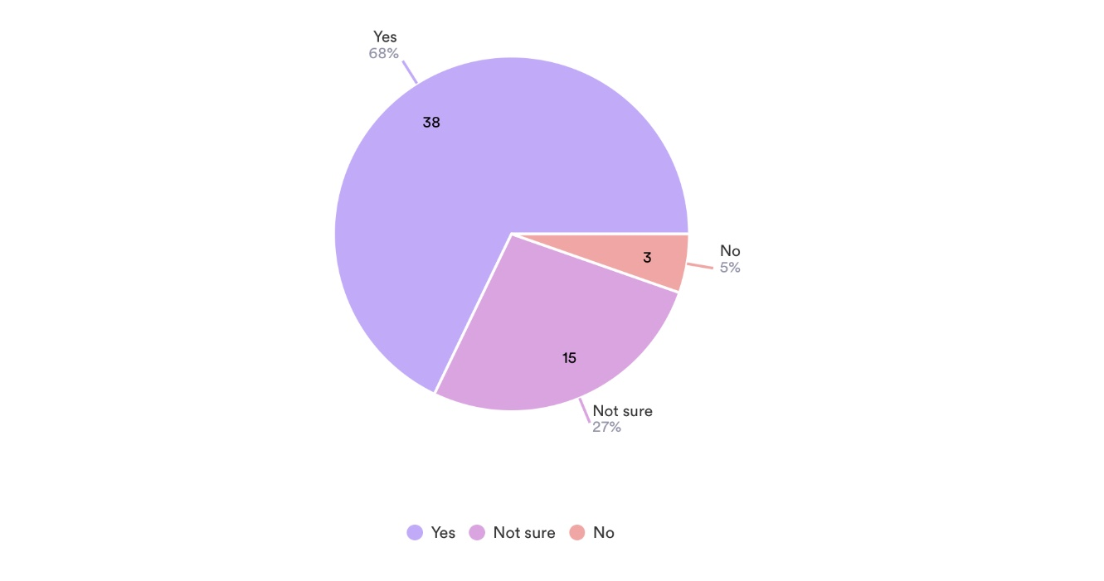
Result: The survey shows that 68% of respondents believe online recommendations are based on their past activities, indicating AI's success in personalized marketing. Only 5% think recommendations are not influenced by past actions, while 27% are unsure.
Discussion: The survey result regarding respondents' perceptions of the basis for online recommendations provides valuable insights into the effectiveness and trustworthiness of predictive analytics powered by AI in the travel industry.
The majority of respondents (68%) believe that the recommendations they receive are tailored based on their past online activities or purchase history. This finding suggests a high level of awareness among consumers regarding the use of predictive analytics to personalize recommendations. It also indicates a degree of trust in the accuracy and relevance of these personalized suggestions, as respondents recognize the alignment between their past behaviour and the recommendations they receive.
The small proportion (5%) of respondents who stated that their recommendations are not influenced by their past activities likely represent individuals who perceive the recommendations as generic or unrelated to their preferences. This minority viewpoint could stem from experiences where recommendations may not accurately reflect their interests or needs, leading to scepticism about the effectiveness of predictive analytics.
The significant segment (27%) expressing uncertainty about the basis for recommendations highlights a notable area for exploration. These respondents may lack clarity or awareness regarding how their online activities influence the recommendations they receive. Further investigation into this group's understanding of predictive analytics and their expectations regarding personalized recommendations could provide valuable insights for improving communication and transparency in AI-driven marketing efforts.
Overall, the survey result underscores the importance of transparency and communication in AI-driven recommendation systems. Businesses should strive to educate consumers about how predictive analytics work, assure them of data privacy safeguards, and provide clear avenues for opting in or out of personalized recommendations. By addressing uncertainties and building trust, companies can enhance the effectiveness and acceptance of AI-powered marketing strategies in the travel industry.
Question 9. On a scale of 1 to 5, how comfortable are you with travel platforms and businesses using your data for personalised marketing purposes?
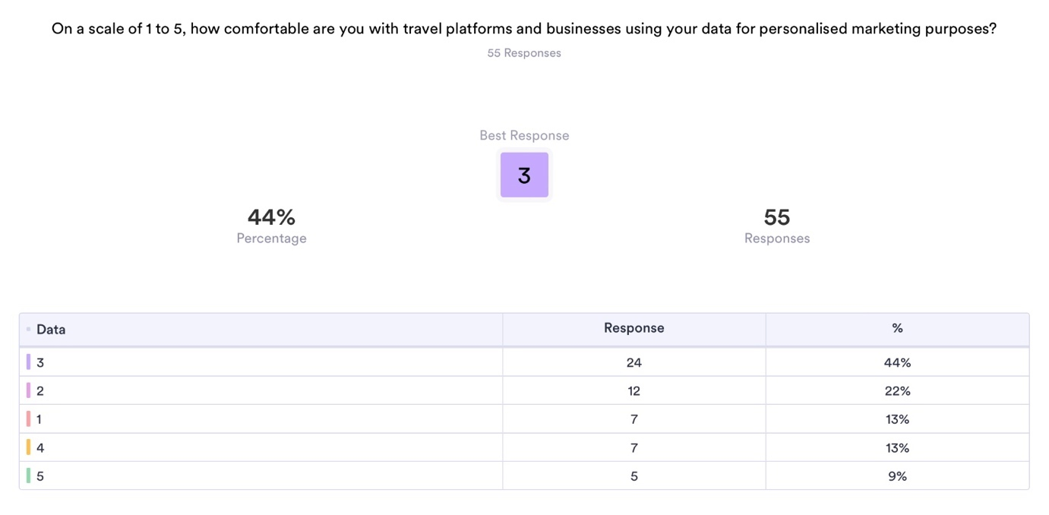
Result: The survey findings indicated that respondents rated their comfort level with travel recommendations at an average of 3 on a scale ranging from 1 to 5, suggesting a moderate level of perceived comfort. However, 9% of respondents expressed discomfort with using their data by travel platforms for personalized marketing purposes and felt that some recommendations were inaccurate.
Discussion: The survey results on respondents' comfort levels with travel platforms and businesses utilizing their data for personalized marketing purposes present a complex picture that warrants detailed analysis. While the average rating of 3 signifies a moderate level of perceived comfort, it's crucial to delve deeper into the factors influencing respondents' attitudes.
One possible explanation for the moderate comfort level could be the perceived benefits of personalized marketing, such as receiving tailored recommendations and offers. Respondents may appreciate the convenience and relevance of personalized content but still harbor reservations about the privacy implications and accuracy of such marketing efforts.
The 9% of respondents expressing discomfort with their data being used for personalized marketing purposes indicate a significant segment with apprehensions. These concerns could stem from various sources, including fears about data privacy and security, distrust in how their data is handled, or skepticism about the accuracy and relevance of personalized recommendations.
Demographic factors may also play a role in shaping comfort levels. For example, younger respondents may exhibit higher comfort levels with data sharing and personalized marketing due to their familiarity with digital technologies and online interactions (Business, 2022). Conversely, older respondents might be more cautious, reflecting generational differences in attitudes towards privacy and data sharing.
Overall, the survey findings underscore the importance of balancing the benefits of personalized marketing with addressing consumers' privacy concerns and ensuring transparent and ethical data practices in the travel industry. Strategies to enhance transparency, data protection measures, and communication about the value exchange between consumers and businesses may help alleviate concerns and foster greater trust in personalized marketing efforts.

Question 10. What are your biggest concerns about using AI in travel and tourism? (e.g., data privacy, bias, lack of human interaction, manipulation)
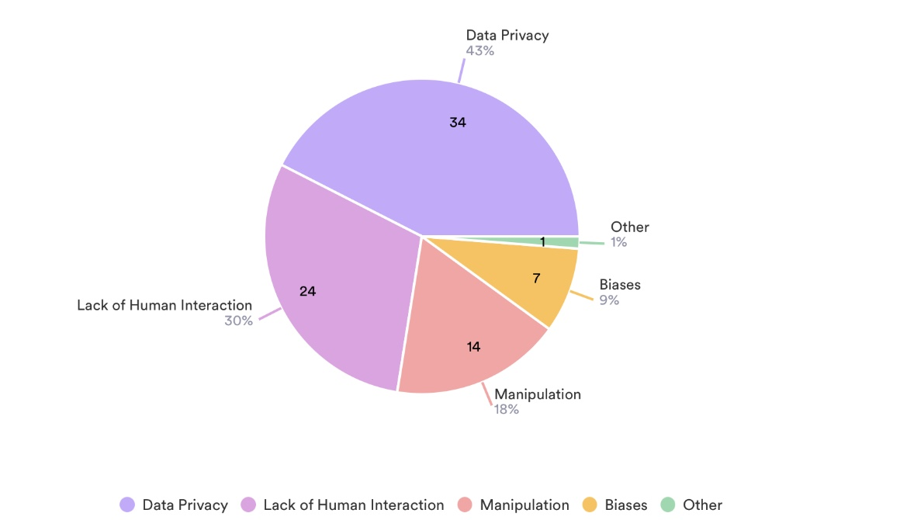
Result: The survey found that respondents have multiple concerns about AI in travel and tourism. Data privacy was the primary worry for 43% of respondents, followed by concerns about biases (9%), lack of human interaction (30%), and potential manipulation (14%).
Discussion: The survey findings shed light on the multifaceted concerns surrounding the integration of AI in the travel and tourism sector. Predominantly, data privacy emerged as the primary apprehension, with 43% of respondents expressing reservations regarding the safeguarding of their personal information. This concern underscores the significance of ensuring robust data protection measures to address consumer anxieties and uphold privacy standards in AI-driven systems. Study by Cardon, Ma and Fleischmann (2021) also identified data privacy concern as a biggest challenge. To ensure the effectiveness of technological integration, both companies and government agencies rely on access to traveller’s personal data and their willingness to share information. This poses a dilemma because while utilizing personal data can enhance tourism offers and streamline travel, it also introduces security risks and privacy concerns, potentially impeding data disclosure (Ioannou, Tussyadiah and Miller, 2020). Moreover, 38% of participants in a survey conducted in the UK expressed concern regarding privacy and data security issues related to AI (Hooson, 2023).
Moreover, biases in AI algorithms surfaced as a notable worry among 9% of participants, reflecting apprehensions about the fairness and impartiality of AI-generated recommendations. This concern underscores the imperative of implementing transparency and accountability mechanisms to mitigate biases and ensure algorithmic fairness in AI applications within the tourism domain.
Furthermore, 30% of respondents articulated concerns about the perceived lack of human interaction in AI-driven travel services. This apprehension underscores a growing consumer preference for personalized and human-centric experiences, indicating a need for AI technologies to complement rather than replace human touchpoints in the travel and tourism ecosystem.
Additionally, 14 % of respondents highlighted concerns about potential manipulation associated with AI usage in travel services. This apprehension underscores the importance of fostering trust and transparency in AI-driven platforms to mitigate risks of manipulation and ensure ethical and responsible deployment of AI technologies in the tourism industry. Addressing these varied concerns necessitates a comprehensive approach encompassing robust data protection measures, algorithmic fairness frameworks, human-centered design principles, and transparent communication strategies. By proactively addressing these apprehensions, stakeholders can foster greater consumer confidence in AI-driven innovations, thereby maximizing the potential benefits of AI in enhancing travel experiences while mitigating associated risks.
Question 11. How do you think AI-powered predictive Analytics can be used to enhance your travel planning and booking experience?
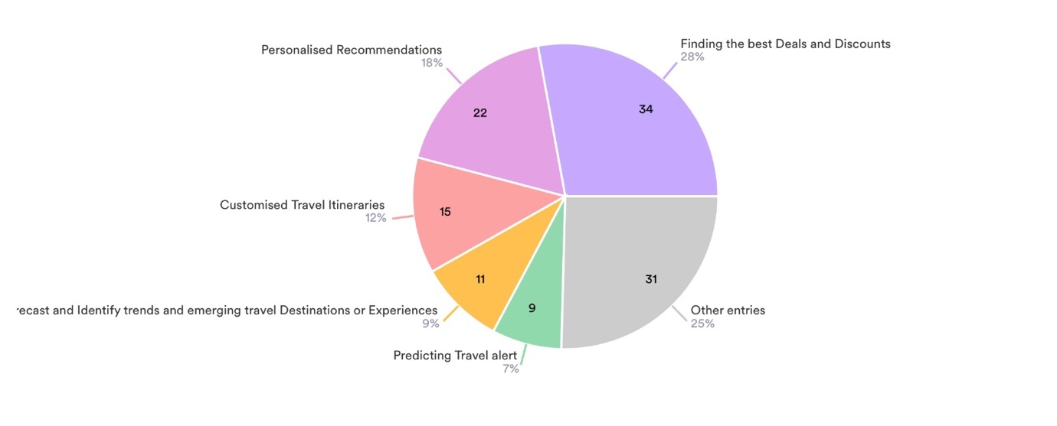
Result: The survey revealed that 28% of respondents value AI-driven platforms for finding the best deals and discounts, while 18% emphasized personalized recommendations. Real-time pricing predictions were deemed valuable by 7% of participants, and 12% mentioned the benefit of customizing travel itineraries. Additionally, 9% acknowledged AI's potential in forecasting emerging travel trends.
Discussion: The survey results indicate that respondents perceive various benefits associated with the utilization of AI-powered predictive analytics in enhancing their travel planning and booking experiences. Notably, a significant portion of participants, constituting 28%, recognize the advantage of AI-driven platforms in facilitating access to the best deals and discounts, highlighting the role of AI in optimizing cost-effective travel options.
Additionally, 18% of respondents emphasize the importance of personalized recommendations in enhancing their travel experiences, underscoring the value of AI in tailoring suggestions based on individual preferences and interests. Real-time pricing predictions emerge as a valuable benefit for 7% of respondents, indicating the role of AI in ensuring competitive pricing strategies and enhancing transparency in pricing.
Moreover, 12% of respondents mention the benefit of customizing travel itineraries, reflecting the desire for flexibility and personalized travel plans facilitated by AI technology. Lastly, 9% of respondents acknowledge the potential of AI in forecasting emerging travel trends, emphasizing its role in providing valuable insights into evolving consumer preferences and destination popularity, thereby enabling informed decision-making in travel planning. Overall, the survey results highlight the diverse ways in which AI-powered predictive analytics can positively impact travel planning and booking experiences by enhancing convenience, personalization, cost-effectiveness, and decision-making efficiency for travellers.
These finding are very similar to other research outcomes. Li et al. (2022), conducted a meta-analysis investigating the effectiveness of AI-based marketing strategies within the tourism sector. Their study uncovered favourable results associated with the implementation of AI technology for predictive analytics, dynamic pricing, and personalized marketing efforts.
These findings have several implications for stakeholders in the tourism industry. Firstly, they highlight the importance of continued investment in AI technologies to enhance efficiency and competitiveness, particularly in sectors where AI adoption remains relatively low. By leveraging AI for personalized recommendations, predictive analytics, and process automation, businesses in activities, attractions, and food and beverage can unlock new opportunities for growth and innovation. Additionally, the survey results underscore the need for targeted strategies to address any barriers to AI adoption, such as concerns about data privacy, technological complexity, and cultural resistance.

Chapter 5. Conclusion and Recommendations

5.1 Conclusion
The research has provided valuable insights into the evolving landscape of digital marketing strategies. Through a comprehensive literature review and empirical analysis, this study has contributed to a deeper understanding of how AI-driven predictive analytics shape consumer behaviour and influence key performance metrics in the tourism sector.
The findings of this study revealed several significant outcomes. Firstly, the integration of AI technologies in marketing efforts has led to more personalized and targeted consumer experiences. As indicated by (Haleem et al., 2022) AI-driven strategies such as dynamic pricing, personalized recommendations, and real-time predictions have demonstrated positive outcomes in enhancing consumer engagement and driving conversion rates. This aligns with previous research by Sivarajah et al. (2017), which highlights the transformative potential of AI in automating processes, analysing complex datasets, and delivering personalized experiences across digital touchpoints.
Furthermore, the survey results underscore the importance of relevance, accuracy, personalization, and presentation in evaluating the usefulness of travel recommendations. These factors play a crucial role in shaping consumer perceptions and influencing their decision-making process, as highlighted by the respondents' preferences and priorities.
Moreover, the application of the RACE (Reach, Act, Convert, Engage) model and Honeycomb model in digital marketing strategy formulation has provided a structured framework for understanding and optimizing consumer interactions across various touchpoints. By aligning marketing efforts with the customer decision-making process, businesses can enhance customer engagement, loyalty, and satisfaction, ultimately driving conversion rates and revenue growth.
In addition, consumer behaviour, the utilization of customer lifetime value (CLTV) and the Gradient Boosting Machine (GBM) model has enabled marketers to identify high-value customers, predict future purchasing behaviour, and optimize marketing campaigns for maximum return on investment. By leveraging advanced analytics techniques, businesses can enhance their understanding of customer preferences, personalize marketing communications, and improve customer lifetime value.
However, it is essential to acknowledge the challenges and limitations associated with the adoption of AI technologies in digital marketing. Concerns regarding data privacy, biases, lack of human interaction, and potential manipulation remain prevalent among consumers. Addressing these concerns and ensuring transparent and ethical AI practices are crucial for building trust and fostering long-term relationships with consumers.
This research contributes to the growing body of literature on predictive analytics and AI marketing in the tourism industry. By highlighting the benefits, challenges, and consumer perceptions associated with AI-driven marketing strategies, this study provides valuable insights for marketers, businesses, and policymakers seeking to leverage technology to enhance consumer experiences and drive business growth in the digital era.

5.2 Recommendations
Based on the findings and analysis conducted in this research several recommendations can be made:
Embrace AI-driven Predictive Analytics: Businesses in the tourism sector should embrace AI-driven predictive analytics technologies to personalize marketing efforts, optimize pricing strategies, and enhance customer engagement. By leveraging predictive analytics tools, businesses can gain valuable insights into consumer behaviour and preferences, allowing for more targeted and effective marketing campaigns.
Prioritise Data Privacy and Transparency: Given the concerns raised by consumers regarding data privacy and security, businesses should prioritize transparency and ethical practices in data collection and usage. Implementing robust data protection measures and providing clear communication about how consumer data is used can help build trust and mitigate concerns among consumers.
Enhance Personalization and Customer Experience: Businesses should focus on enhancing personalization and customer experience across all touchpoints, from initial research and booking to post-travel interactions. By leveraging AI-driven technologies to deliver personalized recommendations, tailored itineraries, and seamless customer support, businesses can differentiate themselves and foster long-term customer loyalty.
Optimise Marketing Strategies with Analytics: Utilize the insights gained from predictive analytics to optimize marketing strategies and allocate resources effectively. By identifying high-value customer segments, predicting future purchasing behaviour, and optimizing marketing channels, businesses can maximize return on investment and drive revenue growth.
Invest in Continuous Learning and Development: Given the rapid advancements in AI technology and predictive analytics, businesses should invest in continuous learning and development to stay updated with the latest trends and innovations. This may involve training employees on AI tools and techniques, collaborating with industry experts, and investing in research and development initiatives.
Monitor and Adapt to Consumer Preferences: Continuously monitor and adapt to changing consumer preferences and market dynamics. By staying agile and responsive to evolving consumer trends, businesses can maintain a competitive edge and effectively meet the needs of their target audience.
By implementing these recommendations, businesses and marketers in the tourism industry can harness the power of predictive analytics and AI-driven marketing to enhance customer experiences, drive engagement, and achieve sustainable business growth in the digital era.

5.3 Limitations
While this study provides valuable insights into the impact of AI marketing on consumer behaviour, engagement, and conversion rates in the tourism industry, it is important to acknowledge its limitations:
Sample Size and Representativeness: The study was limited by its sample size and representativeness. The survey sample may not fully capture the diversity of the target population, potentially leading to biased or skewed results.
Data Collection Method: The reliance on survey data for collecting information about consumer behaviour and perceptions may introduce response bias or social desirability bias. Additionally, self-reported data may be subject to inaccuracies or misinterpretations.
Scope and Generalisability: The study focuses specifically on the travel and tourism industry, which may limit the generalizability of findings to other sectors or industries. The findings may not be applicable to businesses operating in different contexts or regions.
Time Constraints: The study was limited by time constraints, which could impact the depth and breadth of data collection and analysis. A longer study duration or additional research methods could provide more comprehensive insights.
External Factors: External factors such as changes in market conditions, technological advancements, or regulatory policies may influence consumer behaviour and marketing effectiveness. These factors were not fully accounted for in the study.
Design of the Study: The use of a cross-sectional design in this study provides a snapshot of customer attitudes and behaviours at a specific point in time. However, it does not capture potential changes in consumer preferences, behaviour and perceptions over time, thus overlooking the dynamic nature of these factors. A longitudinal study could offer valuable insights into long-term trends and variations in customer engagement and perception.
While this study contributes valuable insights to the field of digital marketing and AI in the tourism industry, its limitations underscore the need for further research and methodological refinement to address these constraints and enhance the validity and reliability of findings.

Chapter 6. Future Research
This study offers valuable insights into the current state and potential of AI-powered marketing within the travel tourism sector. However, the field of AI and its applications are constantly evolving, necessitating further research to stay ahead of the curve and maximize its impact on the tourism industry. Future research could delve deeper into the specific mechanisms through which AI-driven predictive analytics influence consumer behaviour, engagement, and conversion rates in the tourism industry. This could involve conducting longitudinal studies to track changes in consumer perceptions and behaviours over time, as well as exploring the effectiveness of different AI marketing strategies across various segments of the tourism market. Additionally, investigating the role of emerging technologies such as augmented reality and virtual reality in enhancing the effectiveness of AI-driven marketing efforts could provide valuable insights for practitioners in the field. Moreover, examining the ethical implications of AI adoption in digital marketing within the tourism industry would be essential to ensure responsible and sustainable practices.

References

Aaker, D. (2016). The Four Faces of Digital Marketing. [online] American Marketing Association. Available at: https://www.ama.org/marketing-news/the-four-faces-of-digital-marketing/ [Accessed 21 Jan. 2024].
Agrawal, R., Wankhede, V.A., Kumar, A., Luthra, S. and Huisingh, D. (2022). Big data analytics and sustainable tourism: A comprehensive review and network based analysis for potential future research. International Journal of Information Management Data Insights, 2(2), p.100122. doi:https://doi.org/10.1016/j.jjimei.2022.100122.
Airbnb (2024). Airbnb - YouTube. [online] www.youtube.com. Available at: https://www.youtube.com/airbnb [Accessed 7 Feb. 2024].
Alejos, H.K. (2023). ‘AI cannot taste the way a chef can’: are chatbots a threat to fine dining?. The Guardian. [online] 16 Aug. Available at: https://www.theguardian.com/environment/2023/aug/16/ai-fine-dining-chefs-restaurants [Accessed 10 Feb. 2024].
Almalki, S. (2016). Integrating Quantitative and Qualitative Data in Mixed Methods Research—Challenges and Benefits. Journal of Education and Learning, 5(3), pp.288–296. doi:https://doi.org/10.5539/jel.v5n3p288.
Almasi, S., Cosmas, A., Ellencweig, B. and Cowan, S. (2023). The promise of travel in the age of AI. [online] www.mckinsey.com. Available at: https://www.mckinsey.com/industries/travel-logistics-and-infrastructure/our-insights/the-promise-of-travel-in-the-age-of-ai [Accessed 18 Jan. 2024].
Alqurashi, D.R., Alkhaffaf, M., Daoud, M.K., Al-Gasawneh, J.A. and Alghizzawi, M. (2023). Exploring the Impact of Artificial Intelligence in Personalized Content Marketing: A Contemporary Digital Marketing. Migration Letters, 20(S8), pp.548–560. doi:https://doi.org/10.59670/ml.v20iS8.4630.
AMA (2024). Consumer Behavior Archives. [online] American Marketing Association. Available at: https://www.ama.org/topics/consumer-behavior/# [Accessed 8 Feb. 2024].
Becker, S., Bryman, A., Ferguson, H. and Social Policy Association. Spa (2012). Understanding research for social policy and social work : Themes, methods and approaches. Bristol: Policy Press.
BERA (2018). Ethical Guidelines for Educational Research, fourth edition (2018). [online] Bera.ac.uk. Available at: https://www.bera.ac.uk/publication/ethical-guidelines-for-educational-research-2018-online [Accessed 24 Dec. 2022].
B. Jack. Copeland (2004). The Essential Turing. 1st ed. Oxford: Oxford University Press.
Babin, B.J. and Harris, E.G. (2023). CB Consumer Behaviour, 3rd Edition. Canada: Cengage.
Babu, N.V. and Kanaga, E.G.M. (2021). Sentiment Analysis in Social Media Data for Depression Detection Using Artificial Intelligence: A Review. SN Computer Science, 3(74). doi:https://doi.org/10.1007/s42979-021-00958-1.
Bag, S., Srivastava, G., Bashir, M.M.A., Kumari, S., Giannakis, M. and Chowdhury, A.H. (2022). Journey of customers in this digital era: Understanding the role of artificial intelligence technologies in user engagement and conversion. Benchmarking: An International Journal, 29(7), pp.2074–2098. doi:https://doi.org/10.1108/BIJ-07-2021-0415.
Barnes, S.J., Mattsson, J., Sørensen, F. and Jensen, J.F. (2020). Measuring employee-tourist encounter experience value: A big data analytics approach. Expert Systems with Applications, 154. doi:https://doi.org/10.1016/j.eswa.2020.113450.
Barry, T.E. (2012). The Development of the Hierarchy of Effects: an Historical Perspective. Current Issues and Research in Advertising, 10(1-2), pp.251–295. doi:https://doi.org/10.1080/01633392.1987.10504921.
Bendle, N.T., Farris, P.W., Pfeifer, P.E. and Reibstein, D.J. (2010). Marketing metrics : the definitive guide to measuring marketing performance. 2nd ed. Upper Saddle River, Nj Wharton School Publ. C.
Birt, J. (2021). 8 Types of Traditional Marketing Methods To Implement. [online] Indeed Career Guide. Available at: https://www.indeed.com/career-advice/career-development/traditional-marketing [Accessed 10 Jan. 2024].
Blöcher, K. and Alt, R. (2020). AI and robotics in the European restaurant sector: Assessing potentials for process innovation in a high-contact service industry. Electronic Markets, 31, pp.529–551. doi:https://doi.org/10.1007/s12525-020-00443-2.
Booij, R. and Spruit, E. (2012). Association for Information Systems AIS Electronic Library (AISeL) REACHING OUT: INVOLVING USERS IN INNOVATION TASKS THROUGH SOCIAL MEDIA. [online] Available at: https://core.ac.uk/download/pdf/301355571.pdf [Accessed 10 Feb. 2024].
Booking.com (2024). Booking.com. [online] account.booking.com. Available at: https://account.booking.com/mysettings [Accessed 5 Feb. 2024].
Britannica (2023). cognitive dissonance | Definition & Facts | Britannica. In: Encyclopædia Britannica. [online] Available at: https://www.britannica.com/science/cognitive-dissonance [Accessed 10 Feb. 2024].
Bryman, A. (2016). Social Research Methods. 5th ed. Oxford: Oxford University Press.
Bulchand-Gidumal, J., Secin, E.W., O’Connor, P. and Dimitrios Buhalis (2023). Artificial intelligence’s impact on hospitality and tourism marketing: exploring key themes and addressing challenges. Current Issues in Tourism, pp.1–18. doi:https://doi.org/10.1080/13683500.2023.2229480.
Business, P.L. and (2022). Young people less concerned about privacy than older generations. [online] Privacy Laws & Business. Available at: https://www.privacylaws.com/news/young-people-less-concerned-about-privacy-than-older-generations/ [Accessed 11 Feb. 2024].
Cambridge Dictionary (2023). RESEARCH | meaning in the Cambridge English Dictionary. [online] Cambridge.org. Available at: https://dictionary.cambridge.org/dictionary/english/research [Accessed 24 Dec. 2023].
Candelon, F., Evgeniou, T. and Martens, D. (2023). AI Can Be Both Accurate and Transparent. [online] Harvard Business Review. Available at: https://hbr.org/2023/05/ai-can-be-both-accurate-and-transparent [Accessed 10 Feb. 2024].
Cardon, P.W., Ma, H. and Fleischmann, C. (2021). Recorded Business Meetings and AI Algorithmic Tools: Negotiating Privacy Concerns, Psychological Safety, and Control. International Journal of Business Communication, 60(4). doi:https://doi.org/10.1177/23294884211037009.
CFI (2023). Lifetime Value Calculation. [online] Corporate Finance Institute. Available at: https://corporatefinanceinstitute.com/resources/valuation/lifetime-value-calculation/ [Accessed 27 Dec. 2023].
CFI (2024). AIDA Model. [online] Corporate Finance Institute. Available at: https://corporatefinanceinstitute.com/resources/management/aida-model-marketing [Accessed 2 Feb. 2024].
Chaffey, D. (2019). Artificial Intelligence for Marketing. [online] Davechaffey.com. Available at: https://www.davechaffey.com/wp-content/uploads/2019/10/Using-AI-for-marketing.png [Accessed 1 Feb. 2024].
Chaffey, D. (2019). Digital Marketing: Strategy, Implementation and Practice. 7th ed. Harlow, England: Pearson.
Chaffey, D. (2022). RACE marketing model definition - What is? | Digital marketing Glossary. [online] Dr Dave Chaffey: Digital Insights. Available at: https://www.davechaffey.com/digital-marketing-glossary/race-marketing-planning-model/ [Accessed 29 Aug. 2023].
Chaffey, D. and Smith, P. (2022). Digital Marketing Excellence. 6th ed. Oxfordshire: Routledge.
Chaturvedi, R. and Verma, S. (2023). Opportunities and Challenges of AI-Driven Customer Service. In: Springer eBooks. Palgrave Macmillan, pp.33–71. doi:https://doi.org/10.1007/978-3-031-33898-4_3.
Cheng, H.G. and Phillips, M.R. (2014). Secondary analysis of existing data: Opportunities and implementation. Shanghai Archives of Psychiatry, 26(6), pp.371–375. doi:https://doi.org/10.11919/j.issn.1002-0829.214171.
Cheng, Y. and Jiang, H. (2021). Customer–brand relationship in the era of artificial intelligence: understanding the role of chatbot marketing efforts. Journal of Product & Brand Management, 31(2), pp.252–264. doi:https://doi.org/10.1108/JPBM-05-2020-2907.
Chintalapati, S. and Pandey, S.K. (2021). Artificial intelligence in marketing: A systematic literature review. International Journal of Market Research, 64(1), pp.38–68. doi:https://doi.org/10.1177/14707853211018428.
Choi, S.C. (1991). Price Competition in a Channel Structure with a Common Retailer. Marketing Science, 10(4), pp.271–296. doi:https://doi.org/10.1287/mksc.10.4.271.
Church, R.M. (2002). The Effective Use of Secondary Data. Learning and Motivation, 33(1), pp.32–45. doi:https://doi.org/10.1006/lmot.2001.1098.
CIM (2022). Five Stages of Your customers’ Buying Journey | CIM Exchange. [online] www.cim.co.uk. Available at: https://www.cim.co.uk/content-hub/blog/five-stages-of-your-customers-buying-journey/ [Accessed 27 Apr. 2023].
Cohen, S.A., Prayag, G. and Moital, M. (2013). Consumer behaviour in tourism: Concepts, influences and opportunities. Current Issues in Tourism, 17(10), pp.872–909. doi:https://doi.org/10.1080/13683500.2013.850064.
Cooper, D.R. and Schindler, P.S. (2014). Business research methods. 12th ed. New York, Ny: Mcgraw-Hill Education.
Court, D., Elzinga, D., Mulder, S. and Vetvik, O.J. (2009). The consumer decision journey. [online] Mckinsey & Company. Available at: https://www.mckinsey.com/capabilities/growth-marketing-and-sales/our-insights/the-consumer-decision-journey [Accessed 9 Feb. 2024].
Creswell, J.W. (2013). Research Design: Qualitative, Quantitative, and Mixed Methods Approaches. 4th ed. London: Sage Publications Ltd.
Criddle, C. (2023). What is artificial intelligence and how does it work? Financial Times. [online] 20 Jul. Available at: https://www.ft.com/content/bde93e43-7ad6-4abf-9c00-8955c6a9e343 [Accessed 7 Jan. 2024].
De Bruyn, A., Viswanathan, V., Beh, Y.S., Brock, J.K.-U. and Von Wangenheim, F. (2020). Artificial Intelligence and marketing: Pitfalls and opportunities. Journal of Interactive Marketing, 51(1), pp.91–105. doi:https://doi.org/10.1016/j.intmar.2020.04.007.
Deloitte (2024). Connecting meaningfully in the new reality. [online] https://www2.deloitte.com, Canada: Deloitte, pp.1–34. Available at: https://www2.deloitte.com/content/dam/Deloitte/ca/Documents/deloitte-analytics/ca-en-omnia-ai-marketing-pov-fin-jun24-aoda.pdf [Accessed 26 Jan. 2024].
Dencheva, V. (2023a). Global AI in marketing revenue 2028. [online] Statista. Available at: https://www.statista.com/statistics/1293758/ai-marketing-revenue-worldwide/ [Accessed 17 Dec. 2023].
Dencheva, V. (2023b). Popularity of AI in marketing worldwide 2020. [online] Statista. Available at: https://www.statista.com/statistics/1203315/ai-marketing/ [Accessed 22 Jan. 2024].
Department, S.R. (2023). Global: travel & tourism sales channel share. [online] Statista. Available at: https://www.statista.com/forecasts/1239068/sales-channels-travel-tourism-worldwide [Accessed 18 Jan. 2024].
Department, S.R. (2024). Online travel market - statistics & facts. [online] Statista. Available at: https://www.statista.com/topics/2704/online-travel-market/#topicOverview [Accessed 8 Feb. 2024].
Dewey, J. (2008). How we think. New York: Cosimo.
Dictionary, B. (2024). What is a consumer? definition and meaning. [online] BusinessDictionary.com. Available at: http://www.businessdictionary.com/definition/consumer.html [Accessed 8 Feb. 2024].
Dudovskiy, J. (2013). Consumer Decision Making Process: a detailed analysis. [online] Business Research Methodology. Available at: https://research-methodology.net/consumer-decision-making-process-a-detailed-analysis/ [Accessed 11 Feb. 2024].
Edelman, D.C. and Abraham, M. (2022). Customer Experience in the Age of AI. [online] Harvard Business Review. Available at: https://hbr.org/2022/03/customer-experience-in-the-age-of-ai [Accessed 10 Feb. 2024].
Effing, R. and Spil, T.A.M. (2016). The Social Strategy cone: Towards a Framework for Evaluating Social Media Strategies. International Journal of Information Management, 36(1), pp.1–8. doi:https://doi.org/10.1016/j.ijinfomgt.2015.07.009.
Egan, J. (2022). Marketing Communications. 4th ed. London: Sage Publications Limited.
Elalem, Y.K., Maier, S. and Seifert, R.W. (2022). A machine learning-based framework for forecasting sales of new products with short life cycles using deep neural networks. International Journal of Forecasting, 39(4), pp.1874–1894. doi:https://doi.org/10.1016/j.ijforecast.2022.09.005.
Etikan, I., Musa, S.A. and Alkassim, R.S. (2016). Comparison of Convenience Sampling and Purposive Sampling. American Journal of Theoretical and Applied Statistics, 5(1), pp.1–4. doi:https://doi.org/10.11648/j.ajtas.20160501.11.
Evans, M., Jamal, A. and Foxall, G.R. (2009). Consumer behaviour. Chichester, England ; Hoboken, Nj: Wiley.
Faggella, D. (2019). Artificial Intelligence in Marketing and Advertising – 5 Examples of Real Traction | Emerj. [online] Emerj. Available at: https://emerj.com/ai-sector-overviews/artificial-intelligence-in-marketing-and-advertising-5-examples-of-real-traction/ [Accessed 24 Jan. 2024].
Faritha Banu, J., Neelakandan, S., Geetha, B.T., Selvalakshmi, V., Umadevi, A. and Martinson, E.O. (2022). Artificial Intelligence Based Customer Churn Prediction Model for Business Markets. Computational Intelligence and Neuroscience, 2022, pp.1–14. doi:https://doi.org/10.1155/2022/1703696.
Faruk, M., Rahman, M. and Hasan, S. (2021). How Digital Marketing Evolved over time: a Bibliometric Analysis on Scopus Database. Heliyon, 7(12). doi:https://doi.org/doi.org/10.1016/j.heliyon.2021.e08603.
Fedoryshyna, L., Halachenko, O., Ohiienko, A., Blyznyuk, A., Znachek, R. and Tsurkan, N. (2021). Digital Marketing in Strategic Management in the Field of the Tourism. Journal of Information Technology Management, 13(Special Issue: Role of ICT in Advancing Business and Management), pp.22–41. doi:https://doi.org/10.22059/jitm.2021.80735.
Filieri, R., D’Amico, E., Destefanis, A., Paolucci, E. and Raguseo, E. (2021). Artificial intelligence (AI) for tourism: an European-based study on successful AI tourism start-ups. International Journal of Contemporary Hospitality Management, 33(11), pp.4099–4125. doi:https://doi.org/10.1108/ijchm-02-2021-0220.
Forbes (2023). How AI In Travel And Hospitality Is Enhancing Experiences And Optimising Operations. [online] Forbes India. Available at: https://www.forbesindia.com/article/take-one-big-story-of-the-day/how-ai-in-travel-and-hospitality-is-enhancing-experiences-and-optimising-operations/87027/1 [Accessed 10 Feb. 2024].
Fowler, F.J. (2013). Survey Research Methods. 5th ed. London: Sage Publication, Cop.
Gajdošík, T. and Marciš, M. (2019). Artificial Intelligence Tools for Smart Tourism Development. In: Advances in Intelligent Systems and Computing. [online] Artificial Intelligence Methods in Intelligent Algorithms. Springer, pp.392–402. doi:https://doi.org/10.1007/978-3-030-19810-7_39.
Gajjar, D. (2013). Ethical Consideration in Research. International Journal for Research in Education, [online] 2(7). Available at: http://www.raijmr.com/ijre/wp-content/uploads/2017/11/IJRE_2013_vol02_issue_07_02.pdf.
Gan, M. and Ouyang, Y. (2022). Study on Tourism Consumer Behavior Characteristics Based on Big Data Analysis. Frontiers in Psychology, 13. doi:https://doi.org/10.3389/fpsyg.2022.876993.
García-Madurga, M.-Á. and Grilló-Méndez, A.-J. (2023). Artificial Intelligence in the Tourism Industry: An Overview of Reviews. Administrative Sciences, [online] 13(8), p.172. doi:https://doi.org/10.3390/admsci13080172.
Gkikas, D.C. and Theodoridis, P.K. (2021). AI in Consumer Behavior. Learning and Analytics in Intelligent Systems, 22, pp.147–176. doi:https://doi.org/10.1007/978-3-030-80571-5_10.
Goh, K.Y., Hui, K.-L. and Png, I.P.L. (2014). Newspaper Reports and Consumer Choice: Evidence from the Do Not Call Registry. SSRN Electronic Journal. doi:https://doi.org/10.2139/ssrn.1557519.
Goodfellow, I., Bengio, Y. and Courville, A. (2016). Deep Learning. 1st ed. Cambridge, Massachusetts: The Mit Press.
Gołąb-Andrzejak, E. (2023). Measuring the effectiveness of digital communication – social media performance: an example of the role played by AI-assisted tools at a university. Procedia Computer Science, 225, pp.3332–3341. doi:https://doi.org/10.1016/j.procs.2023.10.327.
Government of UK (2018). Data protection. [online] GOV.UK. Available at: https://www.gov.uk/data-protection#:~:text=The%20Data%20Protection%20Act%202018 [Accessed 25 Aug. 2023].
Grant, R., Clarke, R.J. and Kyriazis, E. (2007). A review of factors affecting online consumer search behaviour from an information value perspective. Journal of Marketing Management, 23(5-6), pp.519–533. doi:https://doi.org/10.1362/026725707x212801.
Haleem, A., Javaid, M., Qadri, M.A., Singh, R.P. and Suman, R. (2022). Artificial Intelligence (AI) Applications for marketing: a literature-based Study. International Journal of Intelligent Networks, [online] 3(3), pp.119–132. doi:https://doi.org/10.1016/j.ijin.2022.08.005.
Han, D.-I.D., Weber, J., Bastiaansen, M., Mitas, O. and Lub, X. (2019). Virtual and Augmented Reality Technologies to Enhance the Visitor Experience in Cultural Tourism. In: Augmented Reality and Virtual Reality. pp.113–128. doi:https://doi.org/10.1007/978-3-030-06246-0_9.
Harrigan, P., Daly, T.M., Coussement, K., Lee, J.A., Soutar, G.N. and Evers, U. (2021). Identifying influencers on social media. International Journal of Information Management, 56(102246), p.102246. doi:https://doi.org/10.1016/j.ijinfomgt.2020.102246.
Harvard Business School (2021). What Is Predictive Analytics? 5 Examples | HBS Online. [online] Business Insights - Blog. Available at: https://online.hbs.edu/blog/post/predictive-analytics [Accessed 22 Jan. 2024].
Hassan, S., Nadzim, S.Z.A. and Shiratuddin, N. (2015). Strategic Use of Social Media for Small Business Based on the AIDA Model. Procedia - Social and Behavioral Sciences, 172, pp.262–269. doi:https://doi.org/10.1016/j.sbspro.2015.01.363.
Hawkins, D.I., Mothersbaugh, D.L. and Best, R.J. (2007). Consumer behavior : building marketing strategy. Boston: Mcgraw-Hill/Irwin.
Heber, C. (2023). Council Post: The Role Of Chatbots In The Future Of The Travel Industry. [online] Forbes. Available at: https://www.forbes.com/sites/forbestechcouncil/2023/02/02/the-role-of-chatbots-in-the-future-of-the-travel-industry/ [Accessed 3 Feb. 2024].
Hermann, E. (2021). Artificial intelligence in marketing: friend or foe of sustainable consumption? AI & SOCIETY, 38, pp.1975–1976. doi:https://doi.org/10.1007/s00146-021-01227-8.
Hooson, M. (2023). UK Artificial Intelligence (AI) Statistics and Trends in 2023. [online] Forbes Advisor UK. Available at: https://www.forbes.com/uk/advisor/business/software/uk-artificial-intelligence-ai-statistics-2023/ [Accessed 10 Feb. 2024].
Hu, X. (Simon) and Yang, Y. (2020). Determinants of consumers’ choices in hotel online searches: A comparison of consideration and booking stages. International Journal of Hospitality Management, 86, p.102370. doi:https://doi.org/10.1016/j.ijhm.2019.102370.
Huang, M.-H. and Rust, R.T. (2020). A strategic framework for artificial intelligence in marketing. Journal of the Academy of Marketing Science, 49(1), pp.30–50. doi:https://doi.org/10.1007/s11747-020-00749-9.
Huang, P., Lurie, N.H. and Mitra, S. (2009). Searching for Experience on the Web: An Empirical Examination of Consumer Behavior for Search and Experience Goods. Journal of Marketing, 73(2), pp.55–69. doi:https://doi.org/10.1509/jmkg.73.2.55.
Hyken, S. (2017). Half Of People Who Encounter Artificial Intelligence Don’t Even Realize It. [online] Forbes. Available at: https://www.forbes.com/sites/shephyken/2017/06/10/half-of-people-who-encounter-artificial-intelligence-dont-even-realize-it/ [Accessed 10 Feb. 2024].
Ibáñez, J.C. and Olmeda, M.V. (2021). Operationalising AI ethics: how are companies bridging the gap between practice and principles? An exploratory study. AI & SOCIETY, 37, pp.1663–1687. doi:https://doi.org/10.1007/s00146-021-01267-0.
IBM (2023). AI vs. Machine Learning vs. Deep Learning vs. Neural Networks: What’s the difference? [online] IBM Blog. Available at: https://www.ibm.com/blog/ai-vs-machine-learning-vs-deep-learning-vs-neural-networks/ [Accessed 8 Jan. 2024].
IBM (2024). What is Machine Learning? [online] IBM. Available at: https://www.ibm.com/topics/machine-learning [Accessed 6 Jan. 2024].
Indeed (2022a). 5 Stages of a Sales Funnel (Plus Steps and Examples). [online] Indeed Career Guide. Available at: https://www.indeed.com/career-advice/career-development/sales-funnel-stages [Accessed 2 Feb. 2024].
Indeed (2022b). What Are AIDA Pros and Cons? (With Tips and Definition). [online] https://ca.indeed.com. Available at: https://ca.indeed.com/career-advice/career-development/aida-pros-and-cons [Accessed 5 Feb. 2024].
Indeed (2023). The Consumer Decision-Making Process: Definition and Examples. [online] Indeed Career Guide. Available at: https://www.indeed.com/career-advice/career-development/consumer-decision-making-process [Accessed 9 Feb. 2024].
Interactive, A. (2024). Marketing Personalization | Accenture Interactive. [online] www.accenture.com. Available at: https://www.accenture.com/us-en/services/interactive/propelling-growth-personalization [Accessed 20 Jan. 2024].
Ioannou, A., Tussyadiah, I. and Miller, G. (2020). That’s Private! Understanding Travelers’ Privacy Concerns and Online Data Disclosure. Journal of Travel Research, 60(7). doi:https://doi.org/10.1177/0047287520951642.
Janiesch, C., Zschech, P. and Heinrich, K. (2021). Machine learning and deep learning. Electronic Markets, 31, pp.685–695. doi:https://doi.org/10.1007/s12525-021-00475-2.
Johnson, R.B., Onwuegbuzie, A.J. and Turner, L.A. (2007). Toward a Definition of Mixed Methods Research. Journal of Mixed Methods Research, 1(2), pp.112–133. doi:https://doi.org/10.1177/1558689806298224.
Kishan, K. et al. (2024) ‘Artificial Intelligence: The Next Frontier for Marketing in the Tourism Industry’, Academy of Marketing Studies journal, 28(1).
Kivunja, C. and Kuyini, A.B. (2017). Understanding and Applying Research Paradigms in Educational Contexts. International Journal of Higher Education, 6(5), pp.26–41. doi:https://doi.org/10.5430/ijhe.v6n5p26.
K. Sudhir and Olivier Toubia (2023). Artificial Intelligence in Marketing. 1st ed. Bingley: Emerald Group Publishing.
Kalaivani, D. and Sumathi, P. (2018). Factor based prediction model for customer behavior analysis. International Journal of System Assurance Engineering and Management, 10(4), pp.519–524. doi:https://doi.org/10.1007/s13198-018-0739-4.
Kardes, F.R., Cronley, M.L. and Cline, T.W. (2014). Consumer behavior. Stamford: Cengage Learning.
Kashive, N., Powale, L. and Kashive, K. (2020). Understanding user perception toward artificial intelligence (AI) enabled e-learning. The International Journal of Information and Learning Technology, 38(1), pp.1–19. doi:https://doi.org/10.1108/ijilt-05-2020-0090.
Kazak, A.N., Chetyrbok, P.V. and Oleinikov, N.N. (2020). Artificial intelligence in the tourism sphere. IOP Conference Series: Earth and Environmental Science, 421(4), p.042020. doi:https://doi.org/10.1088/1755-1315/421/4/042020.
Kennedy, H., Kunkel, T. and Funk, D. (2020). Using Predictive Analytics to Measure Effectiveness of Social Media Engagement: A Digital Measurement Perspective. Sport Marketing Quarterly, 30(4). doi:https://doi.org/10.32731/smq.304.1221.02.
Khurana, D., Koli, A., Khatter, K. and Singh, S. (2022). Natural Language processing: State of the art, Current Trends and Challenges. Multimedia Tools and Applications, 82(3), pp.3713–3744. doi:https://doi.org/10.1007/s11042-022-13428-4.
Kietzmann, J.H., Hermkens, K., McCarthy, I. and Silvestre, B.S. (2011). Social media? Get serious! Understanding the functional building blocks of social media. Business Horizons, 54(3), pp.241–251.
Kim, R.Y. (2020). When does online review matter to consumers? The effect of product quality information cues. Electronic Commerce Research, 21, pp.1011–1030. doi:https://doi.org/10.1007/s10660-020-09398-0.
King, N. (2022). LibGuides: Research Methods: Secondary Research. [online] libguides.tees.ac.uk. Available at: https://libguides.tees.ac.uk/researchmethods/secondary [Accessed 10 Feb. 2024].
Kong, H., Wang, K., Qiu, X., Cheung, C. and Bu, N. (2022). 30 years of artificial intelligence (AI) research relating to the hospitality and tourism industry. International Journal of Contemporary Hospitality Management. doi:https://doi.org/10.1108/ijchm-03-2022-0354.
Kotler, P. and Keller, K.L. (2012). Marketing Management. 14th ed. Pearson Education.
Kovalenko, M. (2023). Council Post: AI’s Influence On The Programmatic Advertising Industry. [online] Forbes. Available at: https://www.forbes.com/sites/forbestechcouncil/2023/12/05/ais-influence-on-the-programmatic-advertising-industry/ [Accessed 23 Jan. 2024].
Koza, J.R., Bennett, F.H., Andre, D. and Keane, M.A. (1996). Automated Design of Both the Topology and Sizing of Analog Electrical Circuits Using Genetic Programming. Artificial Intelligence in Design ’96, pp.151–170. doi:https://doi.org/10.1007/978-94-009-0279-4_9.
Krey, N., tom Dieck, M.C., Wu, S. and Fountoulaki, P. (2021). Exploring the Influence of Touch Points on Tourist Experiences at Crisis Impacted Destinations. Journal of Travel Research, 62(1), p.004728752110536. doi:https://doi.org/10.1177/00472875211053657.
Kühl, N., Mühlthaler, M. and Goutier, M. (2019). Supporting customer-oriented marketing with artificial intelligence: automatically quantifying customer needs from social media. Electronic Markets, 30(2). doi:https://doi.org/10.1007/s12525-019-00351-0.
Kumar, V., Rajan, B., Venkatesan, R. and Lecinski, J. (2019). Understanding the Role of Artificial Intelligence in Personalized Engagement Marketing. California Management Review, 61(4), pp.135–155. doi:https://doi.org/10.1177/0008125619859317.
Lalicic, L. and Weismayer, C. (2021). Consumers’ reasons and perceived value co-creation of using artificial intelligence-enabled travel service agents. Journal of Business Research, 129, pp.891–901. doi:https://doi.org/10.1016/j.jbusres.2020.11.005.
Latib, L.A., Bolong, J. and Ghazali, A.H.A. (2014). Facebook Usage and Functionality as the Predictive Factors in Contributing towards Employee Engagement. Procedia - Social and Behavioral Sciences, 155, pp.289–294. doi:https://doi.org/10.1016/j.sbspro.2014.10.294.
Lee, M., Kwon, W. and Back, K.-J. (2021). Artificial intelligence for hospitality big data analytics: developing a prediction model of restaurant review helpfulness for customer decision-making. International Journal of Contemporary Hospitality Management, 33(6). doi:https://doi.org/10.1108/ijchm-06-2020-0587.
Li, J., Xu, L., Tang, L., Wang, S. and Li, L. (2018). Big data in tourism research: A literature review. Tourism Management, 68, pp.301–323. doi:https://doi.org/10.1016/j.tourman.2018.03.009.
Li, N., Yang, X., IpKin Anthony Wong, Law, R., Jing Yang Xu and Zhang, B. (2022). Automating tourism online reviews: a neural network based aspect-oriented sentiment classification. Journal of Hospitality and Tourism Technology, 14(1), pp.1–20. doi:https://doi.org/10.1108/jhtt-03-2021-0099.
Lincoln, U. of (2022). What is consumer behaviour? [online] University of Lincoln. Available at: https://online.lincoln.ac.uk/what-is-consumer-behaviour [Accessed 9 Feb. 2024].
Liu, A., Fan, D.X.F. and Qiu, R.T.R. (2020). Does Culture Affect Tourism Demand? A Global Perspective. Journal of Hospitality & Tourism Research, 45(1), p.109634802093484. doi:https://doi.org/10.1177/1096348020934849.
Liu, R., Gupta, S. and Patel, P. (2021). The Application of the Principles of Responsible AI on Social Media Marketing for Digital Health. Information Systems Frontiers, 25, pp.2275–2299. doi:https://doi.org/10.1007/s10796-021-10191-z.
Marikyan, D., Papagiannidis, S. and Alamanos, E. (2020). Cognitive Dissonance in Technology Adoption: A Study of Smart Home Users. Information Systems Frontiers, 25, pp.1101–1123. doi:https://doi.org/10.1007/s10796-020-10042-3.
Marketline (2024). Global - Travel & Tourism. Manchester: Marketline, p.7.
Martinich, A.P. and Stroll, A. (2019). Epistemology | Definition, Nature, Problems, & History. In: Encyclopædia Britannica. [online] Available at: https://www.britannica.com/topic/epistemology [Accessed 12 Dec. 2022].
Mascarenhas, O.A.J. (2018). Corporate ethics for turbulent markets : the market context of executive decisions. Bingley, Uk: Emerald Publishing Limited.
Mauro, A.D., Sestino, A. and Bacconi, A. (2022). Machine learning and artificial intelligence use in marketing: a general taxonomy. Italian Journal of Marketing, 2022, pp.439–457. doi:https://doi.org/10.1007/s43039-022-00057-w.
McAlister, L. (1982). A Dynamic Attribute Satiation Model of Variety-Seeking Behavior. Journal of Consumer Research, 9(2), p.141. doi:https://doi.org/10.1086/208907.
McAlister, L. and Pessemier, E. (1982). Variety Seeking Behavior: An Interdisciplinary Review. Journal of Consumer Research, 9(3), p.311. doi:https://doi.org/10.1086/208926.
Mckinsey (2023). AI customer service for higher customer engagement | McKinsey. [online] www.mckinsey.com. Available at: https://www.mckinsey.com/capabilities/operations/our-insights/the-next-frontier-of-customer-engagement-ai-enabled-customer-service [Accessed 9 Feb. 2024].
Montazeribarforoushi, S., Keshavarzsaleh, A. and Ramsøy, T.Z. (2017). On the hierarchy of choice: An applied neuroscience perspective on the AIDA model. Cogent Psychology, 4(1). doi:https://doi.org/10.1080/23311908.2017.1363343.
Nair, K. and Gupta, R. (2021). Application of AI technology in modern digital marketing environment. World Journal of Entrepreneurship, Management and Sustainable Development, 17(3), pp.318–328. doi:https://doi.org/10.1108/wjemsd-08-2020-0099.
Network, H. management (2023). Artificial intelligence in the travel & tourism industry: analyzing innovation, investment and hiring trends. [online] Hotel Management Network. Available at: https://www.hotelmanagement-network.com/data-insights/artificial-intelligence-in-travel-tourism/#:~:text=Walt%20Disney%2C%20Uber%20Technologies%2C%20Deutsche [Accessed 10 Feb. 2024].
Obschonka, M. and Audretsch, D.B. (2020). Artificial intelligence and big data in entrepreneurship: a new era has begun. Small Business Economics, 55(3), pp.529–539. doi:https://doi.org/10.1007/s11187-019-00202-4.
Oo, M.C.M. and Thein, T. (2022). An efficient predictive analytics system for high dimensional big data. Journal of King Saud University - Computer and Information Sciences, 34(1), pp.1521–1532. doi:https://doi.org/10.1016/j.jksuci.2019.09.001.
Panneerselvam (2014). Research methodology. 2nd ed. Delhi: Phi Learning.
Panneerselvam (2014). Research methodology. 2nd ed. Delhi: Phi Learning.
Park, Y.S., Konge, L. and Artino, A.R. (2020). The Positivism Paradigm of Research. Academic Medicine, 95(5), pp.690–694.
Paschen, U., Pitt, C. and Kietzmann, J. (2020). Artificial intelligence: Building blocks and an innovation typology. Business Horizons, 63(2), pp.147–155. doi:https://doi.org/10.1016/j.bushor.2019.10.004.
PAT RESEARCH (2019). Big data Analytics and Predictive Analytics. [online] PAT RESEARCH: B2B Reviews, Buying Guides & Best Practices. Available at: https://www.predictiveanalyticstoday.com/big-data-analytics-and-predictive-analytics/ [Accessed 25 Jan. 2024].
Petrosyan, A. (2023). Internet and social media users in the world 2023. [online] Statista. Available at: https://www.statista.com/statistics/617136/digital-population-worldwide/#:~:text=Worldwide%20digital%20population%202023&text=As%20of%20October%202023%2C%20there [Accessed 21 Jan. 2024].
Pillai, K.A. (2023). AI-DRIVEN DYNAMIC PRICING STRATEGIES FOR SUBSCRIPTION FEATURES: LEVERAGING ARTIFICIAL INTELLIGENCE FOR REAL-TIME PRICING OPTIMIZATION. INTERNATIONAL JOURNAL OF COMPUTER ENGINEERING AND TECHNOLOGY (IJCET), [online] 14(3), pp.98–103. Available at: https://iaeme.com/Home/article_id/IJCET_14_03_010 [Accessed 10 Feb. 2024].
Piryonesi, S.M. and El-Diraby, T.E. (2019). Data Analytics in Asset Management: Cost-Effective Prediction of the Pavement Condition Index. Journal of Infrastructure Systems, 26(1), p.04019036. doi:https://doi.org/10.1061/(asce)is.1943-555x.0000512.
Prayag, G., Hosany, S., Muskat, B. and Del Chiappa, G. (2016). Understanding the Relationships between Tourists’ Emotional Experiences, Perceived Overall Image, Satisfaction, and Intention to Recommend. Journal of Travel Research, 56(1), pp.41–54. doi:https://doi.org/10.1177/0047287515620567.
Priest, J., Carter, S. and Statt, D. (2013). Consumer Behaviour. [online] Edinburgh: Edinburgh Business School, p.26. Available at: https://ebs.online.hw.ac.uk/documents/course-tasters/english/pdf/h17cb-bk-taster.pdf [Accessed 28 Dec. 2023].
Punch, K. (2013). IntroductIon to Social Research QuantItatIve & QualItatIve approaches. [online] https://www.sagepub.com, pp.1–33. Available at: https://www.sagepub.com/sites/default/files/upm-assets/58966_book_item_58966.pdf.
Rahmani, A.M., Azhir, E., Ali, S., Mohammadi, M., Ahmed, O.H., Yassin Ghafour, M., Hasan Ahmed, S. and Hosseinzadeh, M. (2021). Artificial intelligence approaches and mechanisms for big data analytics: a systematic study. PeerJ Computer Science, 7, p.e488. doi:https://doi.org/10.7717/peerj-cs.488.
Rallis, I., Markoulidakis, Y., Georgoulas, I., Kopsiaftis, G., Kaselimi, M., Doulamis, N. and Doulamis, A. (2022). Interpretation of net promoter score attributes using explainable AI. In: The15th International Conference on PErvasive Technologies Related to Assistive Environments. pp.113–117. doi:https://doi.org/10.1145/3529190.3529212.
Ratner, R.K. and Kahn, B.E. (2002). The Impact of Private versus Public Consumption on Variety-Seeking Behavior. Journal of Consumer Research, 29(2), pp.246–257. doi:https://doi.org/10.1086/341574.
Ratner, Rebecca K., Kahn, Barbara E. and Kahneman, D. (1999). Choosing Less‐Preferred Experiences For the Sake of Variety. Journal of Consumer Research, 26(1), pp.1–15. doi:https://doi.org/10.1086/209547.
Rautela, S. (2021). Social Media for New Product Launch: A Study of Social Media Platforms Across the RACE Planning Framework. International Journal of Interactive Mobile Technologies (iJIM), 15(05), p.187. doi:https://doi.org/10.3991/ijim.v15i05.18147.
Research, A.M. (2021). Personalized Travel and Experiences Market Size, Share & Forecast, 2030. [online] Allied Market Research. Available at: https://www.alliedmarketresearch.com/personalized-travel-and-experiences-market-A12540 [Accessed 10 Feb. 2024].
Research, S. (2024). Expected use of AI to plan travel worldwide 2022. [online] Statista. Available at: https://www.statista.com/statistics/1381319/expected-use-artificial-intelligence-for-travel-planning-worldwide/ [Accessed 10 Feb. 2024].
Rovai, A.P., Baker, J.D. and Ponton, M.K. (2014). Social Science Research Design and Statistics : a practitioner’s Guide to Research Methods and IBM SPSS Analysis. 2nd ed. Chesapeake, Va: Watertree Press.
Russel, S. and Norvig, P. (2020). Artificial Intelligence: a Modern approach. 4th ed. London: Pearson.
Saunders, M., Lewis, P., Thornhill, A. and Bristow, A. (2019). ‘Research Methods for Business students’ Chapter 4: Understanding Research Philosophy and Approaches to Theory Development. [online] ResearchGate. Available at: https://www.researchgate.net/publication/330760964_Research_Methods_for_Business_Students_Chapter_4_Understanding_research_philosophy_and_approaches_to_theory_development [Accessed 1 Jan. 2023].
S Pascalau and R Urziceanu (2021). Traditional Marketing Versus Digital Marketing. AGORA INTERNATIONAL JOURNAL OF ECONOMICAL SCIENCES, 14. doi:https://doi.org/10.15837/aijes.v14i0.4202.
Sands, S., Campbell, C.L., Plangger, K. and Ferraro, C. (2022). Unreal influence: leveraging AI in influencer marketing. European Journal of Marketing, 56(6). doi:https://doi.org/10.1108/ejm-12-2019-0949.
Saunders, M., Lewis, P. and Thornhill, A. (2007). Research methods for business students. 4th ed. Harlow: Pearson Education.
Saunders, M., Lewis, P. and Thornhill, A. (2015). Research methods for business students. 7th ed. Harlow, United Kingdom: Pearson.
Schivinski, B. (2019). Eliciting brand-related social media engagement: A conditional inference tree framework. Journal of Business Research, 130. doi:https://doi.org/10.1016/j.jbusres.2019.08.045.
Schrage, M., Kiron, D., Candelon, F., Khodabandeh, S. and Chu, M. (2023). Improve Key Performance Indicators With AI. [online] MIT Sloan Management Review. Available at: https://sloanreview.mit.edu/article/improve-key-performance-indicators-with-ai/ [Accessed 10 Feb. 2024].
Senadheera, V., Warren, M. and Leitch, S. (2016). Social media as an information system: improving the technological agility. Enterprise Information Systems, 11(4), pp.512–533. doi:https://doi.org/10.1080/17517575.2016.1245872.
Shaddy, F., Fishbach, A. and Simonson, I. (2021). Trade-Offs in Choice. Annual Review of Psychology, 72(1), pp.181–206. doi:https://doi.org/10.1146/annurev-psych-072420-125709.
Shah, D. and Shay, E. (2019). How and Why Artificial Intelligence, Mixed Reality and Blockchain Technologies Will Change Marketing We Know Today. [online] https://www.researchgate.net. Available at: https://www.researchgate.net/publication/335749445_How_and_Why_Artificial_Intelligence_Mixed_Reality_and_Blockchain_Technologies_Will_Change_Marketing_We_Know_Today [Accessed 4 Feb. 2024].
Shah, S.S. and Asghar, Z. (2023). Dynamics of social influence on consumption choices: A social network representation. Heliyon, 9(6), pp.e17146–e17146. doi:https://doi.org/10.1016/j.heliyon.2023.e17146.
SHIH-YU, C. (2019). The Era of Artificial Intelligence: Relationship Between Taiwan’s Machine Tool International Trade Show Marketing and International Agents. International Journal of Business and Economic Affairs, 4(3). doi:https://doi.org/10.24088/ijbea-2019-43002.
Shlomo, M. (2022). Council Post: Why Limited Data Is Limiting Traditional Marketing Strategies. [online] Forbes. Available at: https://www.forbes.com/sites/forbestechcouncil/2022/09/16/why-limited-data-is-limiting-traditional-marketing-strategies/ [Accessed 17 Jan. 2024].
Sidlauskiene, J., Joye, Y. and Auruskeviciene, V. (2023). AI-based chatbots in conversational commerce and their effects on product and price perceptions. Electronic Markets, 33(1). doi:https://doi.org/10.1007/s12525-023-00633-8.
Siegel, E. (2015). Predictive analytics : the power to predict who will click, buy, lie, or die. Hoboken, New Jersey Wiley.
Simpson, F. (2019). Know Your Buyer: Franchisee Recruitment And Understanding The Buying Decision Process. [online] Forbes. Available at: https://www.forbes.com/sites/fionasimpson1/2019/01/13/know-your-buyer-franchisee-recruitment-and-understanding-the-buying-decision-process/ [Accessed 10 Feb. 2024].
Steup, M. (2010). Epistemology. [online] plato.stanford.edu. Available at: https://plato.stanford.edu/archives/spr2010/entries/epistemology/ [Accessed 13 Dec. 2022].
Šimundić, A.-M. (2013). Bias in Research. Biochemia Medica, 23(1), pp.12–15. doi:https://doi.org/10.11613/BM.2013.003.
Singh, A., Bansal, R. and Sharma, S. (2022). Big Data. Berlin: Walter de Gruyter GmbH & Co KG, p.244.
Sivarajah, U., Kamal, M.M., Irani, Z. and Weerakkody, V. (2017). Critical analysis of Big Data challenges and analytical methods. Journal of Business Research, 70(1), pp.263–286. doi:https://doi.org/doi.org/10.1016/j.jbusres.2016.08.001.
Sohrabi, B., Raeesi Vanani, I., Nasiri, N. and Ghassemi Rudd, A. (2020). A predictive model of tourist destinations based on tourists’ comments and interests using text analytics. Tourism Management Perspectives, 35, p.100710. doi:https://doi.org/10.1016/j.tmp.2020.100710.
Stankevich, A. (2017). Explaining the Consumer Decision-Making Process: Critical Literature Review. Journal of International Business Research and Marketing, 2(6), pp.7–14. doi:https://doi.org/10.18775/jibrm.1849-8558.2015.26.3001.
Statista (2023a). Global online travel agent market size 2023. [online] Statista. Available at: https://www.statista.com/statistics/1179020/online-travel-agent-market-size-worldwide/ [Accessed 18 Jan. 2024].
Statista (2023b). Travel & Tourism - Worldwide | Statista Market Forecast. [online] Statista. Available at: https://www.statista.com/outlook/mmo/travel-tourism/worldwide?currency=usd [Accessed 22 Jan. 2024].
Statista (2024a). Global tourism industry market size 2021. [online] Statista. Available at: https://www.statista.com/statistics/1220218/tourism-industry-market-size-global/ [Accessed 3 Feb. 2024].
Statista (2024b). Topic: Online travel market. [online] Statista. Available at: https://www.statista.com/topics/2704/online-travel-market/#topicOverview [Accessed 6 Feb. 2024].
statista (2023). Most visited travel & tourism websites worldwide 2021. [online] Statista. Available at: https://www.statista.com/statistics/1215457/most-visited-travel-and-tourism-websites-worldwide/ [Accessed 5 Feb. 2024].
Stone, M., Aravopoulou, E., Ekinci, Y., Evans, G., Hobbs, M., Labib, A., Laughlin, P., Machtynger, J. and Machtynger, L. (2020). Artificial intelligence (AI) in strategic marketing decision-making: a research agenda. The Bottom Line, 33(2), pp.183–200. doi:https://doi.org/10.1108/bl-03-2020-0022.
Sun, Y., Liu, H. and Gao, Y. (2023). Research on customer lifetime value based on machine learning algorithms and customer relationship management analysis model. Heliyon, 9(2), p.e13384. doi:https://doi.org/10.1016/j.heliyon.2023.e13384.
Syed Zeeshan Zahoor and Shah, A. (2023). Impact of Social Media on Users’ Complex Buying Behaviour: Analysing the Mediating Effect of Perception and Moderating Effect of Extended Social Media Usage. Management and Labour Studies, 49(1), pp.119–148. doi:https://doi.org/10.1177/0258042x231167315.
Taherdoost, H. (2016). Sampling Methods in Research Methodology; How to Choose a Sampling Technique for Research. [online] papers.ssrn.com. Available at: https://papers.ssrn.com/sol3/papers.cfm?abstract_id=3205035 [Accessed 10 Feb. 2024].
Taherdoost, H. (2021). Data Collection Methods and Tools for Research; A Step-by-Step Guide to Choose Data Collection Technique for Academic and Business Research Projects. [online] papers.ssrn.com. Available at: https://papers.ssrn.com/sol3/papers.cfm?abstract_id=4178676 [Accessed 10 Feb. 2024].
Talwar, S., Dhir, A., Singh, D., Virk, G.S. and Salo, J. (2020). Sharing of fake news on social media: Application of the honeycomb framework and the third-person effect hypothesis. Journal of Retailing and Consumer Services, 57(102197), p.102197. doi:https://doi.org/10.1016/j.jretconser.2020.102197.
Thiebes, S., Lins, S. and Sunyaev, A. (2020). Trustworthy artificial intelligence. Electronic Markets, 31. doi:https://doi.org/10.1007/s12525-020-00441-4.
TripAdvisor (2024). TripAdvisor Official Page. [online] www.facebook.com. Available at: https://www.facebook.com/Tripadvisor/?locale=en_GB [Accessed 5 Feb. 2024].
Trunk, A., Birkel, H. and Hartmann, E. (2020). On the current state of combining human and artificial intelligence for strategic organizational decision making. Business Research, 13(1), pp.875–919. doi:https://doi.org/10.1007/s40685-020-00133-x.
Turing, A. (1950). Computing Machinery and Intelligence. Mind, LIX(236), pp.433–460. doi:https://doi.org/10.1093/mind/lix.236.433.
University of Newcastle Library (2022). LibGuides: Research Methods: What are research methods? [online] Newcastle.edu.au. Available at: https://libguides.newcastle.edu.au/researchmethods [Accessed 13 Dec. 2022].
University, T.O. (2024). OLCreate: NNCO_SMB Small business and marketing: 2.2 Dissonance-reducing buying behaviour. [online] www.open.edu. Available at: https://www.open.edu/openlearncreate/mod/oucontent/view.php?id=81567&section=2.2 [Accessed 8 Feb. 2024].
Vakratsas, D. and Ambler, T. (1999). How Advertising Works: What Do We Really Know? Journal of Marketing, 63(1), pp.26–43. doi:https://doi.org/10.2307/1251999.
van Nuenen, T. and Scarles, C. (2021). Advancements in technology and digital media in tourism. Tourist Studies, 21(1), pp.119–132. doi:https://doi.org/10.1177/1468797621990410.
Varsha P. S., Akter, S., Kumar, A., Gochhait, S. and Patagundi, B. (2021). The Impact of Artificial Intelligence on Branding. Journal of Global Information Management, 29(4), pp.221–246. doi:https://doi.org/10.4018/jgim.20210701.oa10.
Vijay Kotu and Balachandre Deshpande (2019). Data science : concepts and practice. Cambridge, Ma: Morgan Kaufmann Publishers.
Wang, F. and Ross, C.L. (2018). Machine Learning Travel Mode Choices: Comparing the Performance of an Extreme Gradient Boosting Model with a Multinomial Logit Model. Transportation Research Record: Journal of the Transportation Research Board, 2672(47), pp.35–45. doi:https://doi.org/10.1177/0361198118773556.
Wang, X., Li, X. (Robert), Zhen, F. and Zhang, J. (2016). How smart is your tourist attraction?: Measuring tourist preferences of smart tourism attractions via a FCEM-AHP and IPA approach. Tourism Management, 54, pp.309–320. doi:https://doi.org/10.1016/j.tourman.2015.12.003.
Wedawatta, G., Ingirige, B. and Amaratunga, D. (2011). Title Case Study as a Research strategy: Investigating Extreme Weather Resilience of Construction SMEs in the UK. [online] http://usir.salford.ac.uk, Manchester: University of Salford, pp.1–10. Available at: http://usir.salford.ac.uk/id/eprint/18250/1/6_Wedawatta_Case_study_as_a_research_strategy_Investigating_extreme_weather_resilience_of_construction_SMEs_in_the_UK.pdf [Accessed 13 Dec. 2022].
Winit-Watjana, W. (2016). Research philosophy in pharmacy practice: necessity and relevance. International Journal of Pharmacy Practice, 24(6), pp.428–436. doi:https://doi.org/10.1111/ijpp.12281.
Wood, W. and Neal, D.T. (2009). The habitual consumer. Journal of Consumer Psychology, 19(4), pp.579–592. doi:https://doi.org/10.1016/j.jcps.2009.08.003.
Xhema, J. (2019). Effect of Social Networks on Consumer Behaviour: Complex Buying. IFAC-PapersOnLine, [online] 52(25), pp.504–508. Available at: https://www.sciencedirect.com/science/article/pii/S2405896319325157 [Accessed 5 Feb. 2024].
xialod (2024). Top 10 Machine Learning Algorithms for ML Beginners [Updated]. [online] www.xialod.top. Available at: https://www.xialod.top/ProductDetail.aspx?iid=1086745012&pr=39.88 [Accessed 10 Feb. 2024].
Yakın, V., Güven, H., David, S., Güven, E., Bărbuță-Mișu, N., Güven, E.T.A. and Virlanuta, F.O. (2023). The Effect of Cognitive Dissonance Theory and Brand Loyalty on Consumer Complaint Behaviors: A Cross-Cultural Study. Sustainability, 15(6), p.4718. doi:https://doi.org/10.3390/su15064718.
Yau, K.-L.A., Saad, N.M. and Chong, Y.-W. (2021). Artificial Intelligence Marketing (AIM) for Enhancing Customer Relationships. Applied Sciences, 11(18), p.8562. doi:https://doi.org/10.3390/app11188562.
Zachlod, C., Samuel, O., Ochsner, A. and Werthmüller, S. (2022). Analytics of social media data – State of characteristics and application. Journal of Business Research, 144, pp.1064–1076. doi:https://doi.org/10.1016/j.jbusres.2022.02.016.
Zhang, Y., Yang, M. and Zhang, Z. (2022). Uncertainty of Artificial Intelligence Assistant: The Effect of Assistant Type on Variety Seeking. Frontiers in Psychology, 13. doi:https://doi.org/10.3389/fpsyg.2022.904302.
Zhao, H., Lyu, F. and Luo, Y. (2022). Research on the Effect of Online Marketing Based on Multimodel Fusion and Artificial Intelligence in the Context of Big Data. Security and Communication Networks, 2022, pp.1–9. doi:https://doi.org/10.1155/2022/1516543.
ZULAIKHA, S., MOHAMED, H., KURNIAWATI, M., RUSGIANTO, S. and RUSMITA, S.A. (2020). Customer Predictive Analytics Using Artificial Intelligence. The Singapore Economic Review, pp.1–12. doi:https://doi.org/10.1142/s0217590820480021.
.

Appendix


