

- SAMSUNG -

Assignment Title: Marketing Fundamentals Analysis and Evaluation - Assessment 1

Module Code: LCBB 4004

Module Lecturer’s Name: Dr Rexon Nting

Students Name : Ionela Nicoleta Ciuplea 1906526

Denisa Halip 1906818

Giorgiana Andone 1818677

Dragos Neculai 1907709

Simona Mocanu 1905164

Contents

Background/ History of the Company 3
Blog 1 - Samsung - Organisational background 3
Blog 2 - History of the Company 5
References 6
Product 7
Blog 1- Products of Samsung 7
Blog 2 8
References 9
Price 10
Blog 1 - Pricing strategy of Samsung 10
Blog 2 12
References 13
Place 14
Blog 1 14
Blog 2 15
References 16
Promotion 17
Blog 1 17
Blog2 18
References 19

Background/ History of the Company
Student Name: Ionela Nicoleta Ciuplea
Student ID: 1906526

Blog 1 - Samsung - Organisational background

Samsung is the one of the largest companies specialised in electronics and various other heavy industries. The company is from South Korean and headquartered in the capital city Seoul.
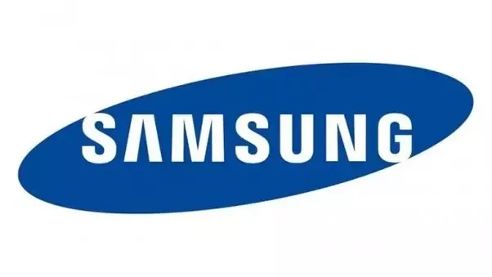

Key issues of the organisation of is given as follows:
Founding times
In 1938 the founder Lee Byung-chul envisioned the company with view that it will become the largest trading company in Korea. Initially the company only dealt with exporting agro products (Samsung, 2019). Within years, the company started to have own factories and moved to production of various agro products. The real growth and expansion started after almost 2 decades when they expanded their business to financial service, retail business.

Entering the electronic industry
At the end of 1960s the company started to expand in the electronics sector. It mainly focused on electronic devices such as calculator, watches, fax machines and similar type products. Kovach (2013) mentioned that eventually they also started to manufacture TV, radios and various other home electronics products. Around 1980s the company also started to export in various European countries such as Span and Germany.
1980s and 1990s
In this period, Samsung became very successful and also recognised as capable company to manufacture electronics products. Also, in this period the company expanded its focus. One thing that really changed was that the founder of this company actually died in the 1987 and after that it was divided into different divisions (Chang, 2011).
One of the notable behaviour of Samsung is that during the period they acquired lots of tech companies in USA and these acquision actually made a company ‘s foundation of electric empire .
In the early period of 1980s,the company focused on research and development and that also led to development of various electronic items. These came under company’s patent. One of the successful outcomes that was led by this research and development was the company’s entry into computer memory chips production .Today the company is considered as the largest manufacturer of memory chips which is a fundamental component of computing.

Blog 2 - History of the Company

In global tech industry Samsung is the manufacturer of not only finished products but they are also one of the biggest suppliers in various aspects of electronics industry. In semiconductor industry its supply makes a major contribution to fulfill world’s demand. Its collective contribution in the electronics industry make it one it of the most influential company of current times. In the early 1990s the company started to manufacture personal computers and selling that in the mass market around the world. By the end period of 1990s the company fully concentrated on mobile handsets and became very successful
After 2000-present
Lee (2011) found that the development of smartphone began with opening a new research center in Poland. From this research center the company developed its smart TV and Smart Phone components. In the 2010ish period, the company manufactured and distributed its android operating system-based smartphones and made the company very successful in this market.
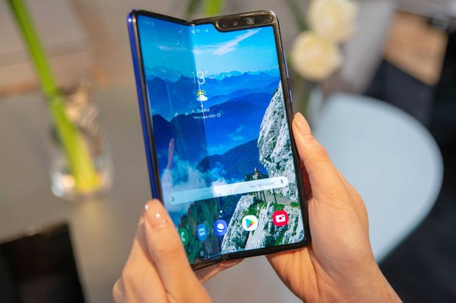
Though it came to disputed clashes with Apple Inc. in 2012 and the American court made the company pay a large sum of money (Cusumano, 2013). However, after few years the company changed and made a successful comeback with thousands of innovation patents.
Other areas of Samsung
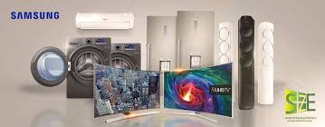
Though electronic is the largest branch of Samsung group but they also have massive presence in chemical industry, ship building industry, transportation sector, real estate, tourism sector and energy sector.

References

Chang, S.J., 2011. Sony vs Samsung: The Inside Story of the Electronics Giants' Battle For Global Supremacy. John Wiley & Sons.
Lee, S.J., 2011. Dynamic capabilities at Samsung electronics: analysis of its growth strategy in semiconductors. Available at SSRN 1914116.
Cusumano, M.A., 2013. The apple-samsung lawsuits. Communications of the ACM, 56(1), pp.28-31.
Samsung (2019). History. Available at: https://www.samsung.com/us/aboutsamsung/company/history/ [Accessed April 22, 2020]
Kovach, S. (2013). How Samsung Went From A Dried Fish Exporter To One Of The Top Names In Tech. Available at: https://www.businessinsider.com/history-of-samsung-2013-2
[Accessed April 22, 2020]

Product
Student Name: Halip Denisa Ioana
Student ID: 1906818

Blog 1- Products of Samsung

Many people think Samsung is only a smartphone manufacturing company. But Samsung is way more than a smartphone company, in fact, smartphone is a single division of the pf the company. The name Samsung is used as branded house of many products and services of the Samsung group. Each different unit are specialised in manufacturing of different products and services. Samsung telecommunication is the business segment of the group which is involved in smartphone manufacturing and distribution. In this issue of the blog series, we will be talking about Samsung electronics and its smartphone products.
Samsung currently have a lots of smartphone brands targeting various customer groups around the world. For each target group the company also offers a variety of smartphones with various features. To a techie, the inherent feature of a smartphone matters. But to a person who isn’t much aware of technologies and need smartphones for basics communication, inherent functions isn’t always important.
According to Kotler’s suggestion, there are 3 levels of a product such as – Core products, Actual/Basic product and Augmented products (Kotler, 2007).
Core level
Before manufacturing android phones, Samsung used to have various flagship phones and some of them had various multimedia features. Those products are long gone but Samsung do manufacture some of the products that had only basic features such as calling, messaging, FM radio, music and video player (Jackson, 2019).
Later versions also allowed to insert memory disk, 2G internet, software and games installation. Samsung Metro series phones were some of the notable basic phones that are still memorable today. But compared to the modern smartphones, these phones are still at basic level. These products are a combination of core features and some basic features that satisfied the needs to people with lowest income level.

Blog 2

Basic level
After moving to Android phones, Samsung just moved into the highest potential market of mobile phones. The Galaxy series were the first phones to be sold to the mass market from 2009 and it actually made a huge success at that time. The first model was GT-i7500 and it was updated with the Spica version.
These phones were the start of a heritage and that turned out to be a long line of smartphones. However, compared to the most recent versions of the phones such as Galaxy 7, A50 etc. GT-i7500 is a pretty basic phone. As a result, it can be considered that basic and advanced level are actually determined by the level of technology developed and used in a smartphone.
However, one thing that must be clarified that i-7500 is still pretty advanced compared to basic phones. According to Elliott et al. (2017) in the last 4-6 years, the technology has developed so fast and that some fundamental issues have changed such as storage capacity, camera resolution, processors, touchscreen etc. as a result, once the iconic 2010sh era phones are very backdated compared to current phones that exist.
Augmented level
We live in the era of technological marvel where everything is possible. Grzybowski and Nicolle (20180, mentioned that currently the smartphones have developed so much that a medium-priced smartphone can perform as well as a medium price ranged personal computers. As a result, once a basic phone has become the all serving device for a person. We are talking about the most updated premium handsets that are currently a viable in market from Samsung. Samsung Galaxy S20, S10, and most interesting the galaxy Fold. These are some of the most advanced phones in the market and offers an extensive range of features and benefits. #
So, it clear that the company actually offers products based on different customer needs and with various features. It can be assumed that Samsung has the capacity to offer at a various range to serve the customer and compete in the market.

References

Elliott, J., Kor, A. and Omotosho, O.A., 2017. Energy consumption in smartphones: an investigation of battery and energy consumption of media related applications on android smartphones.
Grzybowski, L. and Nicolle, A., 2018. Estimating Consumer Inertia in Repeated Choices of Smartphones.
Jackson, W., 2019. Smartwatch Design History, Concepts, Terms, and Installation. In SmartWatch Design Fundamentals (pp. 1-32). Apress, Berkeley, CA.
Kotler, P., 2007. Marketing in the public sector. Pearson Education India.

Price
Student Name: Giorgiana Andone
Student ID : 1818677

Blog 1 - Pricing strategy of Samsung

In this part of the series, we will be talking about the pricing strategy of Samsung. As part of this part, we will first talk about what is pricing strategy from a marketing perspective, then we will focus on different ways to determine prices and then will move to discussing Samsung’s pricing strategy.
Pricing and different ways to determine prices
Many people assume price as a number put on a product and anyone who wants to buy, they will have to spend that amount to purchase it. Technically its okay. However, from a marketing perspective, price is the agreed upon amount on which a customer accepts the values of that products that marketers offer. So, it can be said that price is the amount of value of product/service on which a purchase can occur.
There are different ways to determine the price amount of a products. According to Kienzler and Kowalkowski (2017) small organisations actually follow simple ways to determine price such as cost based pricing where total cost is calculated and they add a mark-up and that gives a logical number which can be called price of that product or service. Small organisations also face competition and in order to compete they often follow a competition-based pricing method.
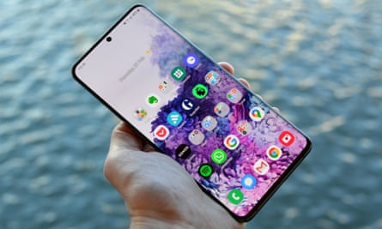

Source: theguardian.com
As the organisations become bigger and competition and market factors also create a new environment where simple pricing strategies often fail to work. As a result, more complex pricing strategies such as price skimming, values-based pricing, price skimming, penetration pricing etc (Zhong et al., 2018).
So, it looks like price skimming actually satisfies multiple customer groups. That means the pricing strategy of Samsung can be seen as very effective mode of pricing for the company. Let us know if there’s any other pricing strategy that you find more suitable to Samsung’s products and service.

Blog 2

Based on the changes made in pricing decisions, it can be assumed that Samsung follows two major pricing strategies - Skimming pricing strategy and Competition based pricing. If we go a little bit deeper, we will find that it actually follows a combination of premium, skimming and competition-based pricing.
Price skimming is used when a company bring a newer product and no other competitors are offering that products. Company offers at premium or higher price level at the beginning periods. Eventually the demand falls and competitors also bring similar products. And marketers eventually reduce the price based on the market conditions. Samsung has a huge research and development programs that regularly. As a result, they also bring new features in their products and service. So, eventually they can ask from premium price and reduce that over the time as the demand falls.
The following image shows the gradual price change over a period of 14 months since the launch. The model we are talking about here is Galaxy S6 Edge and the market is Germany. It shows that at the beginning the price was 849 Euros. After 6 months, at the end of the year, that price was reduced 549 Euros. Because, by that periods, other companies such as Apple’s iPhone 6 was operating in the market with a similar price range.
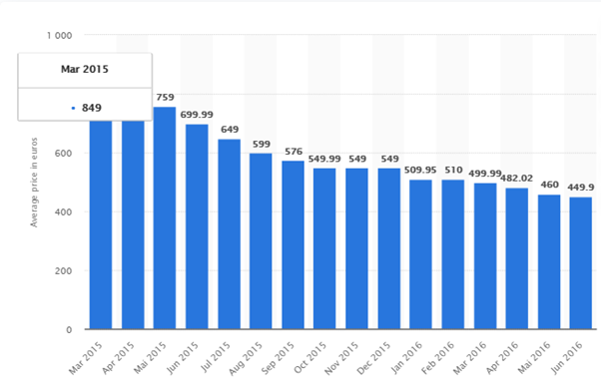
Price skimming has some benefits that can impact the company and its profitability. During the 2015sh period, Samsung was fighting to create a positive image of their brands. Because at that time Sony Xperia was more popular than Samsung, iPhone was even more popular. Here, price skimming gives a positive vibe about the brand in the initial period. As price gradually drops, it also becomes affordable to a newer customer group they get benefit from that values well.

Source: Statista (2020)

References

Kienzler, M. and Kowalkowski, C., 2017. Pricing strategy: A review of 22 years of marketing research. Journal of Business Research, 78, pp.101-110.
Zhong, X., Zhao, J., Yang, L.X., Yang, X., Wu, Y. and Tang, Y.Y., 2018. A dynamic discount pricing strategy for viral marketing. PloS one, 13(12).
Statista (2020). Price development of the Galaxy S6 Edge in Germany from March 2015 to June 2016. Available at: https://www.statista.com/statistics/642002/price-development-of-the-galaxy-s6-edge-in-germany/. [Accessed May 6, 2020]

Place
Student Name : Dragos Neculai
Student number: 1907709

Blog 1

Let's Talk, Samsung!
In the preparation of the launching of its upcoming flagship product. Samsung made an unexpected announcement. The news was to bring even more rumours and leave some room for speculation on what the next flagship from Samsung will be called.
But what is a flagship? According to the Cambridge Dictionary, flagship equals the best product, or the best or most famous product, idea, building that an organisation owns or produce. So there is no Captain on deck? We demand a mutiny!
A few days later, the Samsung Unpacked event took place. Samsung managed to bring hundreds of reports, analysts and essential representative of the industry into one big room in a super production. The 2020 event was held in San Francisco, United States.
TM Roh, President and Head of Mobile Communications, introduced the newest member of the Galaxy family - Samsung S 20. That's means that we will likely never see the Galaxy S11. Or the Galaxy S12-S19. But then again, we are talking about Samsung.
Creating this product, Samsung took a big step into an entirely new era of smartphone history. To achieve this, the company is driven by the converging of three most important technologies of today: 5G, AI and IoT. Another giant step forward, with the desire of changing the shape of the future with the revolutionary design.
It will come in there variant: the S20, S20+ and S20 Ultra. The products, three display sizes, here mind-blowing tech specifications. Tech experts believe the South Korean tech group will follow a similar marketing approach from 2019.
Pre-orders should start by February 21st, with the devices hitting shelves on March 6th.

Blog 2

Distribution channels – part of SAMSUNG Marketing Strategy
In the published literature, it is called the marketing mix. It is a crucial tool to help understand what the product or service can offer and how to design and implement a successful product offering. The marketing mix is most commonly known as the 4 P's of marketing: Price, Product, Place and Promotion. This is no new information for Samsung, and the company definitely knows how to handle all of them. The procedure of moving the product from the producer to its end-user is called the place. It is done through a combination of intermediaries such as distributors, wholesalers and retailers. Recently the Internet itself is seen as a fast-growing market. Moreover, distribution channels are divided into four different types: direct distribution indirect distribution, whereas a wholesaler and a retailer are involved, binary distribution and reverse circuit.
Furthermore, these strategies can be intensive designed systems, selectively designed systems, or exclusively designed systems. In recent years, SAMSUNG tries to show its product is more attractive to create a brand image and brand personality because a brand is a significant factor in attracting customers
For SAMSUNG, the distribution policy is not very flexible. Like any big company, it wants strict control in the distribution process of the services and products. In comparison with its big competitor Apple, the South Korean tech giant uses a slightly more relaxed approach. Whereas Apple products are placed on the market through selected channels, Samsung sells their products anywhere they want. Their requirements for that retailer is to take and maintain stock. As a result of this strategy, Samsung can trade directly or indirectly to customers.
Continuing the comparison with APPLE, Samsung can quickly expand and saturate the market with their products pretty much everywhere in the world. Samsung is benefiting from and existing distribution network from their existing business.
SAMSUNG is concentrated exclusively on a channel sales method and continuously look for ways to improve its channel contributions by identifying new tools, technical know-how and marketing strategies to help its partners raise their trades capabilities.

References

Brassington, Frances., and Stephen. Pettitt. Principles of Marketing. 4th ed. New York: Prentice-Hall, 2006
Kotler, Armstrong, Harris, He, Armstrong, Gary, Harris, Lloyd C., and He, Hongwei. Principles of Marketing. Eighth ed. 2020. Web.
SAMSUNG (2020), Samsung Galaxy Unpacked Conference, Available at https://www.samsung.com/uk/unpacked/ (accessed date 12.05.2020)

Kotler, Philip., Gary. Armstrong and Marc Oliver. Opresnik. Principles of Marketing. 17th, Global ed. Harlow: Pearson, 2018. Web.
Teimouri, Hadi, Nazila Fanae, Kouroush Jenab, Sam Khoury, and Saeid Moslehpour. "Studying the Relationship between Brand Personality and Customer Loyalty: A Case Study of Samsung Mobile Phone." International Journal of Business and Management 11.2 (2016): 1-10. Web.

SAMSUNG, (2014), SAMSUNG Introduces New Global Channel Program: SAMSUNG Team of Empowered Partners (STEP)
Available at https://www.samsung.com/us/news/newsRead.do?news_seq=22747&page=1 (accessed date 12.05.2020)

Promotion
Student Name: Simona Mocanu
Student ID: 1905164

Blog 1

Samsung is working on its Galaxy Fold sequel which will be a little cheaper and better than its other counterparts. The company has its transformed and user-friendly Facebook and Instagram pages, where customers can directly give their feedback regarding products and raise queries too (Ganzha, Paprzycki, and Sedukhin, 2014, p 198). The interactive social media pages and online accounts can allow customers to easily engage with company professionals.
The phone will be introduced along with the new Galaxy Note series. The company will offer this product over the counter across its flagship stores and over online platforms as well (Li, and Halfond, 2014, p 50). In case of any queries related to technical details and specifications regarding the product, drop a message with your contact details, we will revert as soon as possible. The new foldable screen will support the S Pen stylus. Its main display will measure 7.59" and measures up from 7.3". It will have 1,689 X 2,213 px resolution. It will be covered with Ultra-Thin Glass similar to Galaxy Z Flip (Rossi et al, 2013, p 232).
Samsung will engage its brand ambassador for the promotion of this product across various world markets. The mobile will come along with free content loaded with copyright content. There will be promotional offers to free shows and other tickets. Purchasing this phone will come with a feature to participate in contests for establishing a better relationship with customers (Ezeh, and Al-Azzawi, 2012). The company will offer free online software updates, customer service, and tutorials
The stores of Samsung will highlight this product to enhance the visibility of the brand. We will make use of direct and indirect methods in the advertisement. Indirect methods Samsung will be advertising its products through the television, internet, and also through online promotions (Ren et al, 2013, p 16). Indirect methods include word of mouth promotion through Samsung salesmen to showcase the benefits and features associated with the product. You can get any further details regarding the product over our websites or connect with us directly over chat in social media accounts.

Blog2

Samsung has been continuously innovating to provide its customers with creative products. Its foldable phone- Galaxy Fold comes with innovative flex display and its Hexa camera captures rich and minute details with close-up panoramic photos (Song et al, 2015, p 5). It can multitask up to 3 apps, providing resizable windows in a split-screen view to enable seamlessly from a single-handed usage to providing large-screen capabilities. The dynamic phone with its astonishing feature is designed to meet the specifications of new customers (Vashist et al, 2015, p 250). This product has been specifically designed to compete and establish a new direction in smartphones.
Customers can easily purchase this phone and get accustomed to its key features and also get promotional offers online as well as in stores (Dissanayake, and Amarasuriya, 2015, p 435). The phone will suit your budget and also help you become the owner of next-generation mobile phones. The phone comes with 12GB of RAM which can support intensive multitasking. Users can easily do gaming parallel with the streaming of live broadcasting of videos. The phone also has a built-in storage capability of 512GB that provides a huge space for media and app storage. You can easily walk-into our store for getting a close-up look for all the features and aspects of the phone (Muralidharan et al, 2014, p 5). You can also take the phone in your own hands for getting a closer look at the versatile features of its offer.
If you consider yourself different and smart, this is the correct smartphone to choose from. These phones feature comes with dual battery power for smarter power back-up facility. All details regarding the phone and its features are available across Samsung's website. So, don't wait for this exclusive experience and book your orders now (Hu, Sirlantzis, and Howells, 2015, p 30). In case of any service-related issues, we will be happy to assists you with our numerous service centers available across the globe. This will probably be one of the best product decisions you can take.

References
Dissanayake, R. and Amarasuriya, T., 2015. Role of brand identity in developing global brands: A literature based review on case comparison between Apple iPhone vs Samsung smartphone brands. Research journal of business and management, pp.430-440.
Ezeh, M.A.N. and Al-Azzawi, M., 2012. Students Brand Preferences Between Apple and Samsung Smartphone.
Ganzha, M., Paprzycki, M. and Sedukhin, S.G., 2014. Generalized matrix multiplication and its object oriented model. Scalable Computing: Practice and Experience, 15(2), pp.187-200.
Hu, Y., Sirlantzis, K. and Howells, G., 2015. Improving colour iris segmentation using a model selection technique. Pattern Recognition Letters, 57, pp.24-32.
Li, D. and Halfond, W.G., 2014, June. An investigation into energy-saving programming practices for android smartphone app development. In Proceedings of the 3rd International Workshop on Green and Sustainable Software (pp. 46-53).
Muralidharan, K., Khan, A.J., Misra, A., Balan, R.K. and Agarwal, S., 2014, February. Barometric phone sensors: More hype than hope!. In Proceedings of the 15th Workshop on Mobile Computing Systems and Applications (pp. 1-6).
Ren, J., Liu, L., Li, B., Zhao, L., Liu, X., Liu, H., Wei, C. and Wang, C., 2013. Measuring the Mobile Phone Video Service Utility Based on a Service Value Network Model. In Proc. 19th Americas Conference on Information Systems (AMCIS2013) (pp. 15-17).
Rossi, M., Feese, S., Amft, O., Braune, N., Martis, S. and Tröster, G., 2013, March. AmbientSense: A real-time ambient sound recognition system for smartphones. In 2013 IEEE International Conference on Pervasive Computing and Communications Workshops (PERCOM Workshops) (pp. 230-235). IEEE.
Song, Z., Wang, X., Lv, C., An, Y., Liang, M., Ma, T., He, D., Zheng, Y.J., Huang, S.Q., Yu, H. and Jiang, H., 2015. Kirigami-based stretchable lithium-ion batteries. Scientific reports, 5(1), pp.1-9.
Vashist, S.K., van Oordt, T., Schneider, E.M., Zengerle, R., von Stetten, F. and Luong, J.H., 2015. A smartphone-based colorimetric reader for bioanalytical applications using the screen-based bottom illumination provided by gadgets. Biosensors and Bioelectronics, 67, pp.248-255.

