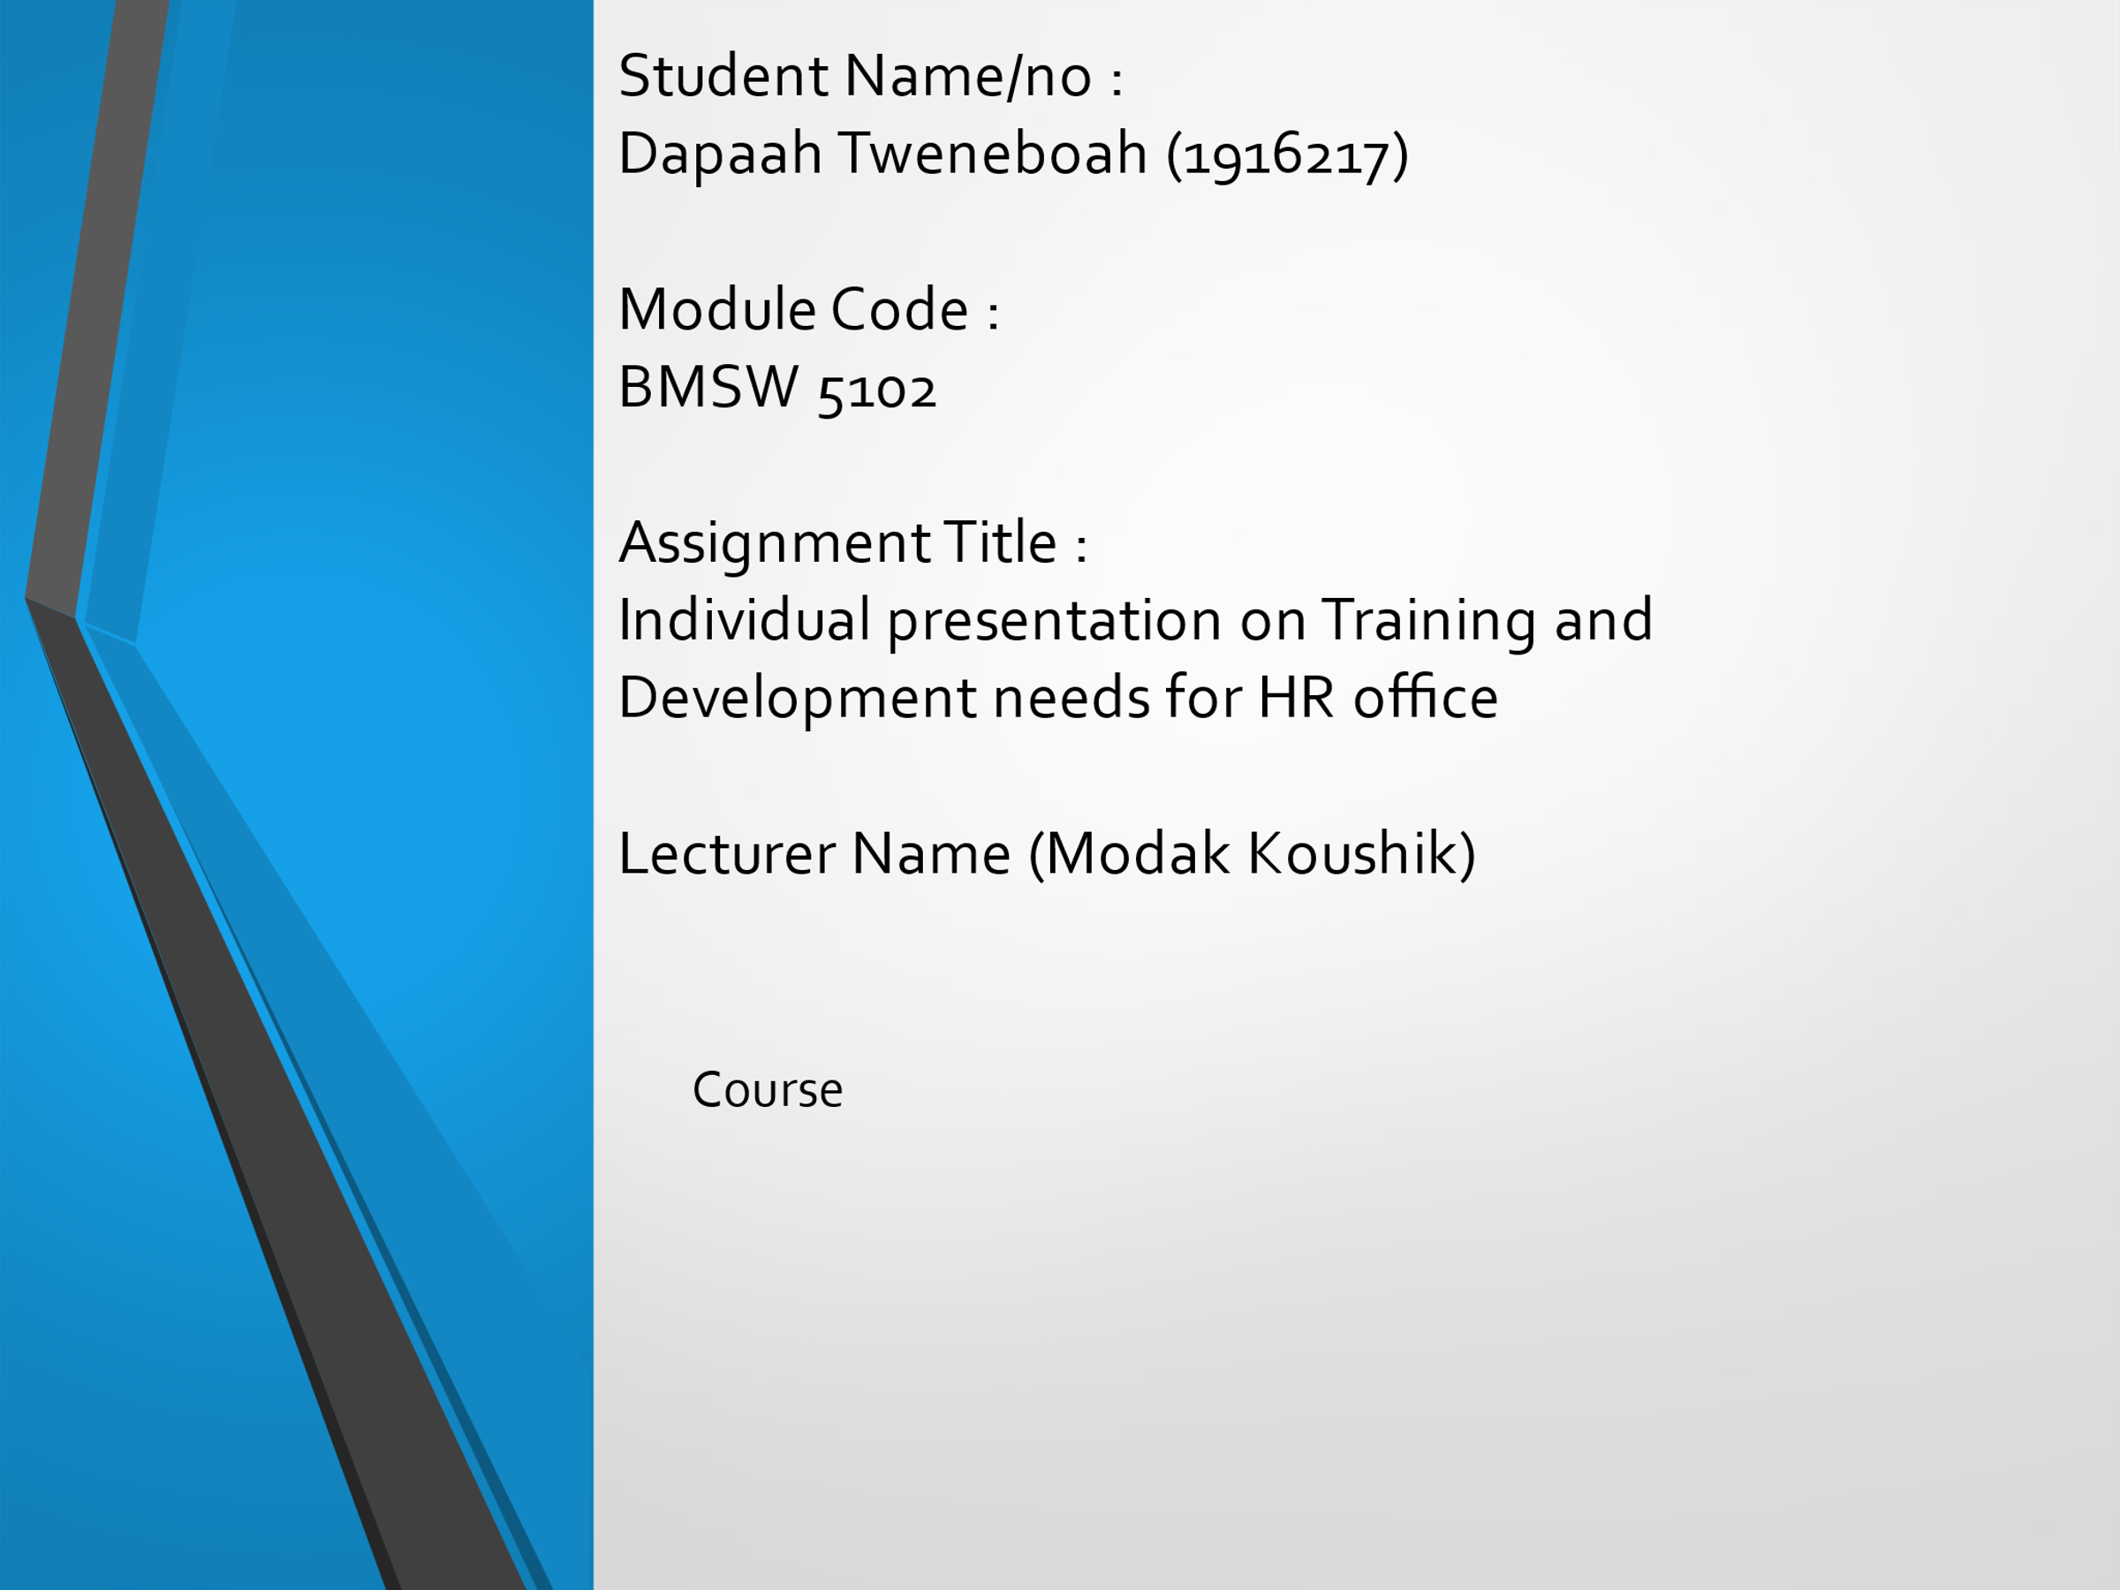

Slide 2

Knowledge, skills, and behaviours (KSB) are core attributes that an individual must possess, for him or her to be considered competent for a given profession, and in that regard, be able to meet the professional requirements of an organization. Every other organization has some set KSB that it desires its employees to possess. These skills are important in establishing the organizational culture of that organization, and they provide the basis, upon which it operates. In a continuously changing business environment, the need for businesses to adjust and be able to assemble a robust workforce has increased. This is the reason the KSB of an organization matter a lot because they can be very instrumental in determining how an organization operates and how it can survive in highly competitive environments. Often, the human resource (HR) department is tasked with ensuring that employees, including those working in the HR department have these KSB. This applies to McDonald’s where the HR department is responsible for ensuring a competent workforce. This means that the HR department and the organization are majorly responsible for my development as the company’s employee and particular my development into the HR officer role.

Slide 3

role in quelling tension and While the above is so, it is important to determine the appropriate KSB that are required by HR professionals across the department for McDonald’s. One is required to possess relevant knowledge regarding their specific roles and mandates as well as their state as an employee of the organization. Increased and appropriate knowledge empowers an employee to perform at their optimal best (Kim and Lee 2010). Among the knowledge that are required by HR professionals in the context of McDonald’s include being aware of cultural differences. This is important towards enabling a culturally diverse workplace which is important in enabling a cohesive workplace environment (Ghosh 2014). It is also important that one is develops knowledge on equality and how best to promote the same. This will help do away with unfairness such as gender bias in the workplace (Sharma 2016). It is also important that one gains knowledge and skills in recruiting staff. The process of recruiting staff members is important and increasingly demanding considering that organizations must go through a thorough process of vetting available candidates to find recruits who are job fit (Rozario, Venkatraman and Abbas 2019; Russo, Rietveld, Nijkamp and Gorter 1995). Without the right knowledge regarding this, it can be hard to find the right people for the job.

A good HR officer should also possess increased knowledge of the organizational environment, including on the issues influencing HR practices. It is through this that they can develop and implement important policies on issues such as equal opportunities, working conditions and performance management. Besides this, the HR officer should have conflict resolution and negotiation knowledge. This will play a crucial friction among employees (Van Gramberg and Teicher 2006). It is also with this knowledge that the officer can be able to better negotiate with staff on things such as wage demands and other incentives.

Slide 4

Besides knowledge, HR officers are also required to be characterized by certain skills. For instance, it is important that they have cultural competence skills. This will be important in implementing organizational policies that enable and support cultural diversity. They should also possess organizational and data management skills. The HR department requires that officers use data to understand and manage human resources (Nocker and Sena 2019). It is through data they track employee performance and realize their weaknesses. It is also through this that they also get to determine and note emerging departmental needs. In relation to this, they should also possess planning skills. Organizational skills are among some of the planning skills. Another planning skill that they should possess is the skill to analyze things, including data and challenges. Such, a skill is crucial in conducting effective diagnosis of issues and allocation of resources. It is also a requirement that an HR officer is characterized by particular behaviors. For instance, they should be purpose and solution driven. They should also be versatile and technology savvy.

Slide 5

The above skills audit suggest that I have weaknesses in using certain tools, particularly the excel spreadsheet.

Slide 6

The above skills audit suggests that while I possess good skills in taking notes of disciplinary, writing repots and providing material to support presentations, it is important to ensure that they are excellent.

Slide 7

From the above skills audit, I can conclude that I posses strong problem-solving skills

Slide 8

The given skills audit indicates that I have the potential to become an effective HR officer considering my budding experience in the field and the number of people I have managed.

Slide 9

The above skills audit suggest that I have weaknesses in using certain tools, particularly the excel spreadsheet.
Other areas that I need help with include:
- Writing reports
- Finding strong materials to support my presentation.
- Using a database
- Using specialist HR Software

Slide 10

There are significant potential benefits that the organization will gain in developing me as an HR officer through effective development. Foremost, the organization will experience enhanced effectiveness in the HR department. This is because with effective training and development, the company will ensure that I have the appropriate skills and knowledge to meet my mandate effectively. In relation to this, the organization will have an effective workforce. Another significant benefit it stands to experience is reduced misuse of resources. An effective HR officer in place means fewer mistakes which consequently help in reducing the miss use of resources in the effort to solve associated issues.

Slide 11
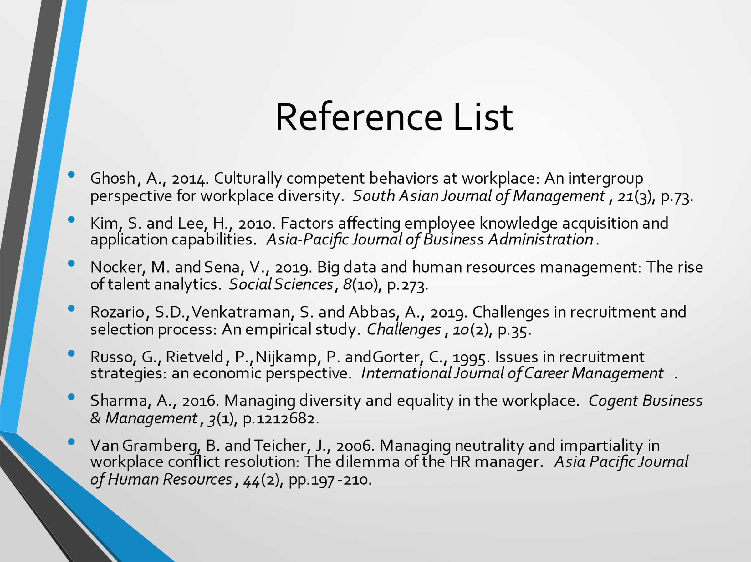

APPENDIX B

