

University of Wales Trinity Saint David
School of Engineering

Hybrid Powertrain & Control
ACEA7007

Jonathan Lloyd-Williams
1805620
24/12/2021
Table of Contents
1 Introduction 1
1.1 Series Hybrid Vehicles 2
2 Hybrid System Components & Specification 2
2.1 Internal Combustion Engine 2
2.2 Power Requirements 4
2.3 Motor & Controller 4
2.4 Generator 6
2.5 Energy Storage and Management 6
2.6 Final Drive 7
3 Results 7
3.1 Fuel Efficiency 7
3.2 CO2 Emissions 8
3.3 Outline of Costs & Savings 8
4 Conclusion 8
5 Bibliography 9

Introduction
The employment of ever more stringent emissions regulations, and innovative technological improvements are leading vehicle manufacturers towards a “greener,” more sustainable future. Manufacturers must be seen as keeping up with both competitors’ technologies and incoming regulations in a bid to secure their place in an ever-changing market. As these manufacturers must be seen to be making constant efforts towards moving to an improved business model with respect to output emissions, it is now becoming common place within industry to see various aspects of these improvements outsourced to engineering companies who will investigate ways of improving a manufacturers carbon-neutrality.
Blitzworld Buggies Ltd is a company that specialises in producing off road buggies for recreational and corporate events. The company is considering commissioning a series hybrid buggy and has indicated that they would like to better understand the typical duty cycle of one of their most popular vehicles.
A previous task provisioned by Blitzworld, involved developing geometry and conditions for an off-road track and producing a simulation of the given buggy’s typical duty cycle over a lap. A report was then complied outlining the methods used to produce the simulation and highlighting the produced results (Lloyd-Williams, 2021 ).
However, the original buggy investigated featured an internal combustion engine (ICE), and as such Blitzworld has requested that a simulation be produced for a proposed hybrid model. This report will focus on how a series hybrid solution may be proposed for development and the benefits of implementing such a solution. This will be achieved by analysing the peak power requirements of the buggy over the developed duty cycle and ensuring suitability of various components. The fuel usage and CO2 emissions over the previously developed duty cycle will be calculated and compared to the previously investigated ICE buggy. This will aid in determining whether the series hybrid solution provides a viable alternative to the traditional ICE models employed by Blitzworld.

Series Hybrid Vehicles
A series hybrid vehicle uses an ICE to drive a generator which subsequently provides energy to an energy storage device such as a battery or flywheel. The stored energy is then used to provide variable power to an electric motor used to drive the vehicle at the wheels, dependant upon operators torque demand (UCSUSA, 2015).
Converting an ICE vehicle to a series hybrid can prove to be an intricate and expensive process, which must be considered carefully. The series hybrid system should be capable of meeting power and torque demands’ and allow the converted vehicle to complete the same duty cycle in the same period of time. However, attention should also be carefully paid to the cost and increased weight of the system. It is not generally considered good practice to solely consider power requirements of the duty cycle in the selection of components as this can lead to unnecessary increases in the weight and cost aspects of the system (Auto Guide , 2009).

Hybrid System Components & Specification
This section of the report will focus on the components of the selected hybrid system for use in the proposed conversion of the DX-10 buggy.

Internal Combustion Engine
A series hybrid requires an internal combustion engine to drive the generator and provide energy for the vehicles motor. The specified engine must be capable of producing adequate power to drive the generator at a constant speed. Other aspects that should also be considered may include the size, shape and mass of the ICE. For the purposes of this report, the assumption has been made that Blitzworld intend to utilize the ICEs currently available to them within their supply of Renegade DX10 buggies, as opposed to sourcing and selection of an additional ICE for the conversion. This reduces the level of modification & cost required to convert the Renegade DX-10 buggy to a hybrid system.
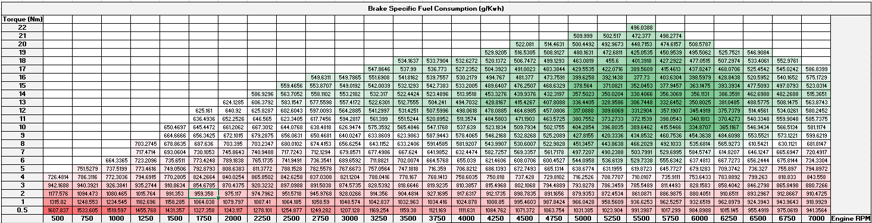
Table 1: A table showing the brake specific fuel consumption (BSFC) of the Renegade DX-10’s ICE.

Figure 1: A graph showing the brake specific fuel consumption (BSFC) of the Renegade DX-10’s ICE.
The 278cc single cylinder four stroke engine of the renegade DX-10 will be adapted to run at a constant RPM with a specified torque demand throughout the entirety of its operation. Examination of the brake specific fuel consumption of the ICE shown in Table 1 & Figure 1 shows that the most efficient operating conditions of the ICE are at 5500RPM with a torque demand of 13Nm. At this point of operation, the brake specific fuel consumption is lowest at 306.75g/KWh. By setting the operating conditions of the ICE at its most efficient point throughout its operation, the overall fuel usage and subsequent emissions of the vehicle over the drive cycle can be drastically reduced.

Power Requirements
In order to properly specify the components required to convert the selected vehicle to a series hybrid system, the average and peak power requirements of the vehicle over the given drive cycle must be calculated. The forces affecting the vehicles motion were analysed and used to establish the required power of the vehicle at each iteration throughout the duty cycle. This can then be further analysed to determine the peak and average power requirement values which will be used to inform choice regarding component selection for the conversion. These values can be used to inform the choice of motor & controller, energy storage and management systems, generator, and final drive system.
Drive Cycle Power Requirements - Renegade DX10-C Corporate 300cc Off-Road Buggy + Hybrid System
Average Power Required (KW) | 4.32
Peak Power Required (KW) | 11.40
Table 2: A table showing the calculated power requirements for the hybrid series over the produced drive cycle.

Motor & Controller
However, due to the energy losses present in an electric motor-controller configuration, the efficiency losses must be calculated and considered before component selection can be carried out. It is generally accepted that an electric motor-controller configuration can be considered to be approximately 90% efficient (Laskay, 2015). With this in mind the corrected values are displayed in Table 3 below.
Drive Cycle Power Requirements - Renegade DX10-C Corporate 300cc Off-Road Buggy + Hybrid System
Average Power Required (KW) | 4.75
Peak Power Required (KW) | 12.54
Table 3: A table showing the corrected power requirements for the hybrid series over the produced drive cycle.
On examination of the power requirements above, it can be determined that the specified electric motor must have a peak output power higher than 12.54 KW and be capable of providing an average of 4.75 KW throughout the entire drive cycle. With these requirements in mind, the AC-20 motor produced by High Performance Electric Vehicle Systems (High Performance Electric Vehicle Systems Ltd , 2022) was selected.
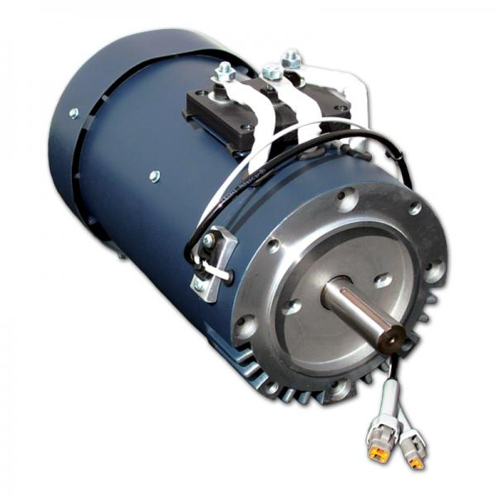
Figure 2: An image showing a HPEVS AC-20 motor (EV West, 2022).
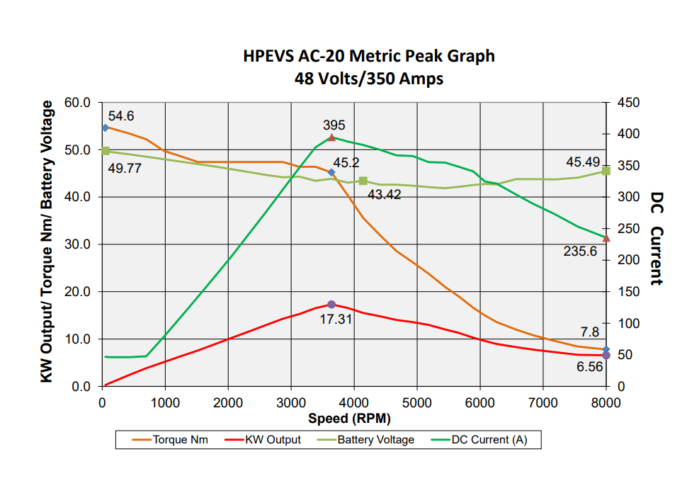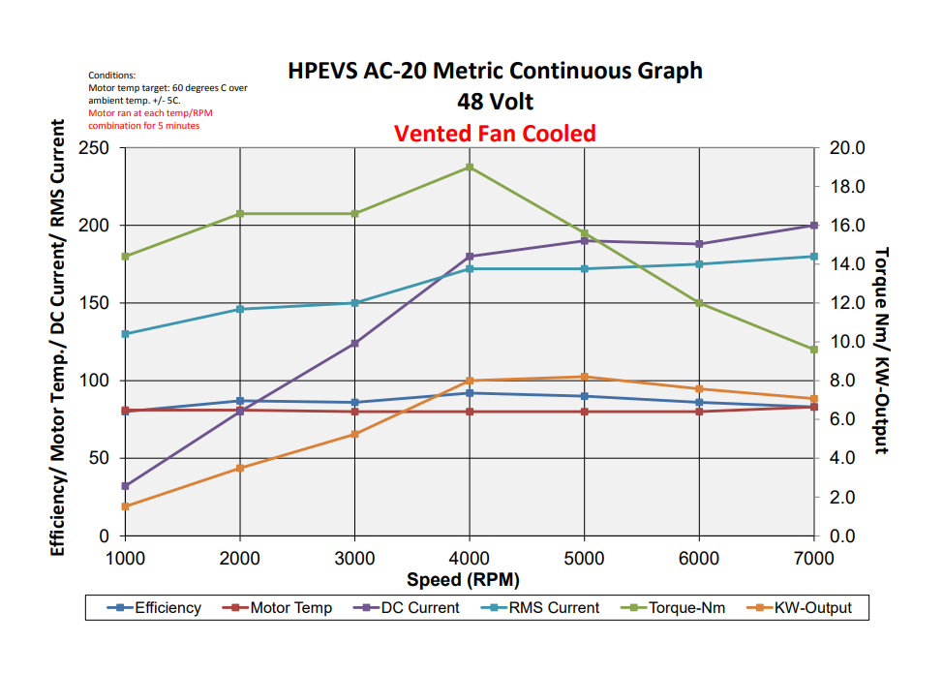
Figure 3: Graphs showing output results of the HPEVS AC-20 motor on a dynamometer (High Performance Electric Vehicle Systems Ltd, 2022)
HPEVS AC-20 Motor
Voltage (V) | 48
Current (A) | 350
Peak Power Output (KW) | 17.31
Peak Torque (Nm) | 54.6
Weight (Kg) | 27.2
Table 4: A table showing the specifications of the HPEVS AC-20 motor (High Performance Electric Vehicle Systems Ltd , 2022).
As can be seen above, the AC-20 motor selected has sufficient capabilities to cope with the given drive cycle. HPEVS recommend the Curtis 1236SE-5621 (48-80V 450A) motor controller to be used in conjunction with the AC-20 motor. It is the responsibility of the controller to regulate the electric motor. This ensures that the amount of power provided to the wheels is correct, and optimal traction maintained.

Generator
The generator is responsible for energy transfer from the ICE to the energy storage device. As such it is important that the selected generator be capable of providing a constant flow of energy that is greater than the system requirements. Although the main function of the generator is to transfer power to the energy storage device, it should be noted that it must also be capable of supplying direct power to the motor during periods of high load (Schofield, 2011). The selected generator should therefore be capable of supplying a 4.75KW at a constant motor speed and coping with peak outputs of over 12.54KW. As seen in the items below a smaller HPEVS AC-12 motor may be employed to act as a generator.
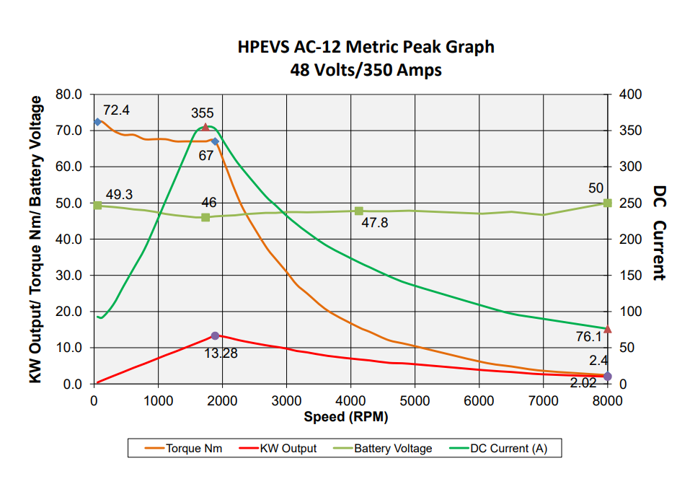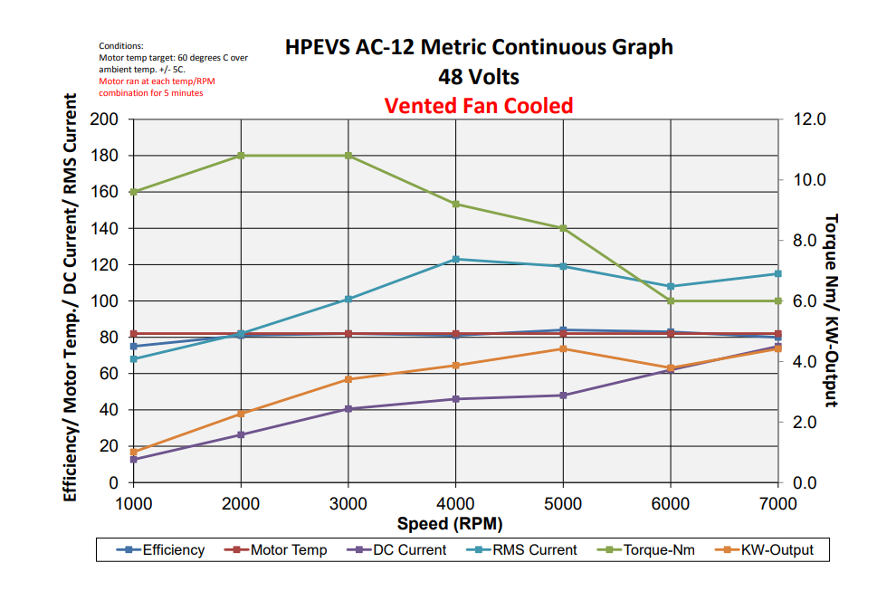
Figure 4: Graphs showing output results of the HPEVS AC-12 motor on a dynamometer (High Performance Electric Vehicle Systems Ltd , 2022).

HPEVS AC-12 Motor
Voltage (V) | 48
Current (A) | 350
Peak Power Output (KW) | 13.28
Peak Torque (Nm) | 72.4
Weight (Kg) | 22.7
Table 5: A table showing the specifications of the HPEVS AC-12 motor (High Performance Electric Vehicle Systems Ltd , 2022).

Energy Storage and Management
An energy storage device is implemented within series hybrid systems to store the energy produced by the generator, and later discharges energy to the electric motor to drive the vehicles wheels (Prajapati, 2014). Energy storage devices include systems such as flywheels and batteries. To maintain simplicity of design, and adhere to ergonomic restrictions it was decided a battery was the most suitable energy storage device for the proposed conversion.
The motor requirements specified indicate that for this system, the selected battery must be 48V at 50A. As such the selected battery for use in the buggy’s conversion was the Alithium 48V -100Ah 4 Cell Lithium Ion Battery produced by Electric Motorsport Ltd. This battery comprises of 4 cells with a voltage of 12V connected in series to produce the batteries 48V (Electric Motorsport Ltd , 2022).
The battery is capable of supporting 100Ah, which would power the AC-20 motor for over 10 minutes at 450A. However, as the battery is constantly charged by the generator it is unlikely circumstances would arise where the battery fully discharges.
Similarly to the motor, the battery requires implementation of a management system. This ensures the correct amount of energy transfer in and out. Electric Motorsport produce the EMUS battery management system for use with their Alithium 48V battery. However, as this management system is capable of supporting up to 250 cells at 5V, it is far more than capable of handling the system requirements, and may be later replaced for a management system that may result in mass or cost savings for the overall system. It should be noted that inclusion of the selected battery & management systems will increase the mass of the vehicle by approximately 24 Kg (Electric Motorsport Ltd , 2022).

Final Drive
As the Renegade DX-10 buggy selected for conversion is already fitted with an effective chain drive system, it may prove preferable for design and ergonomic reasons to configure a similar solution for the hybrid series. This also allows the vehicle to retain the benefits associated with a chain drive such as cost and ease of service. However, as with all chain drive systems, regular maintenance of the system is required to ensure the chain doesn’t become contaminated with debris, resulting in reduced performance.

Results

Fuel Efficiency
The ICE employed within the hybrid system is set to run at a constant speed correlating with its most efficient operating parameters as determined by the BSFC chart. This will improve the fuel efficiency of the vehicle as shown below in Table 6. However, it should also be noted that some of this improvement will be offset by the additional weight of the various hybrid system components.

Fuel Usage Per Lap (g)
ICE | 104.32
Series Hybrid | 55.62
Table 6: A table showing the fuel usage per lap of the two vehicles.
As can be seen from the results in table 6, the series hybrid uses 47% less fuel than the original ICE buggy.

CO2 Emissions
As expected, similarly to fuel usage, implementation of a hybrid series solution has resulted in a decrease in CO2 emissions of 47% as seen in Table 7.
CO2 Emissions Per Lap (Kg)
ICE | 0.32
Series Hybrid | 0.17
Table 7: A table showing the CO2 emissions per lap of the two vehicles.

Outline of Costs & Savings
Outline of Costs (£)
Motor & Controller | 3134
Generator | 2300
Energy Storage & Management | 2566
Installation Costs | 2000
Total | 10000
Table 8: A table showing the expected cost of various components needed for the hybrid system.
Table 8 indicates that incorporation of a hybrid series solution for the DX-10 buggy can be expected to cost approximately £10,000. This includes the system components and an estimation of installation costs. Fully electric vehicle conversions are often costed by companies such as Falcon Electric as being upwards of £25,000. (Falcon Electric Ltd, 2022).
The fuel saving provided by installing the hybrid solution equates to a cost saving of approximately £0.11 per lap, at today’s rate of £1.70/L. With this in mind over 90,000 drive cycles would need to be completed in order to recover the initial cost of conversion through fuel saving.

Conclusion
In summary, the viability of various hybrid components has been assessed with regards to their suitability to the system requirements. A proposed hybrid series system has been developed and modelling using the drive cycle previously developed for the ICE DX-10 buggies. To assess the suitability of the various components, the average and peak power requirements were calculated, and additional inefficiencies considered. The components of this system are listed below:
- ICE - 278cc Single Cylinder Four Stroke Engine
  - Motor & Controller – HPEVS AC-20 Motor & Curtis 1236SE-6521 (48-80V 450A) Motor Controller.
  - Generator –HPEVS AC-12 Motor.
  - Energy Storage & Management – Alithium 48V – 100Ah 4 Cell Lithium Ion Battery & EMUS Battery Management System.
  - Final Drive – Chain Drive
The benefits and costs of implementing a hybrid series solution have also been explored. It was shown that incorporation of the hybrid solution is expected to improve fuel efficiency and CO2 emissions by almost 50%. However, it was also determined that almost 75,000 duty cycles would need to be completed post conversion in order to recover initial costs of approximately £9500. With this in mind, it may be suggested that Blitzworld is unlikely to benefit largely from incorporating hybrid series vehicles, unless implementation substantially increased their customer base by improving their image. Other options such as carbon offsetting may act as a viable alternative.

Bibliography
Aschilean, I., 2018. Hybrid Elecrtic Powertrain with Fuel Cells for a Series Vehicle. Energies , 11(5).
Auto Guide , 2009. Top 7 Issues for an Electric Car Conversion. [Online]
Available at: https://www.autoguide.com/auto-news/2009/06/top-7-issues-for-an-electric-car-conversion.html
[Accessed 4 April 2022].
Barsali, S., 2004. A control Strategy to minimise fuel consumption of series hybrid electric vehicles , Chicago : IEEE.
Brahma, A., 2000. Optimal energy management in series hybrid electric cars , Chicago : IEEE.
Capta, R. & Coccia, A., 2010. Procedure for the Design of a Hybrid-Series Vehicle and the Hyridization Degree Choice. Energies, 3(3), pp. 450-461.
Electric Motorsport Ltd , 2022. Alithium 48V - 100Ah 4 Cell Modules Li-Ion Battery w/ EMUS MBS Mini & Charger. [Online]
Available at: https://www.electricmotorsport.com/batteries/ alithium-48v-100ah-4cell-li-ion-batttery-pack-w-emus-bms-mini-charger.html
[Accessed 4 April 2022].
EV West, 2022. Curtis 1236SE-5621 HPEVS AC-20 Brushless AC Motor Kit - 48 Volt. [Online]
Available at: https://www.evwest.com/catalog/product_info.php?products_id=286
[Accessed 4 April 2022].
Falcon Electric Ltd, 2022. Full Electric Vehicle Builds and Conversions. [Online]
Available at: https://falconelectric.co.uk/ev-conversions/
[Accessed 4 April 2022].
High Performance Electric Vehicle Systems Ltd , 2022. HPEVS AC Electric-Motor Drive Systems. [Online]
Available at: https://www.hpevs.com/hpevs-ac-electric-motors-ac12-for-golf-car-mining-utility-ground-support-vehicles.htm
[Accessed 4 April 2022].
High Performance Electric Vehicle Systems Ltd, 2022. HPEVS AC Electric-Motor Drive Systems (AC-20/AC-23). [Online]
Available at: https://www.hpevs.com/hpevs-ac-electric-motors-ac20-ac23-for-motorcycle-mining-utility-ground-support-vehicles.htm
[Accessed 4 April 2022].
Laskay, D., 2015. BLDC Motor Controllers for Maximum Efficiency, Newbury : UK Data Device Corp..
Lloyd-Williams, J., 2021 . Hybrid Powertrain & Control , Swansea : University of Wales Trinity St David .
Prajapati, K., 2014. Hyrbid Vehicle: A Study on Technology. International Journal of Engineering Research & Technology , 3(12), pp. 1076-1082.
Schofield, A., 2011. Operation of a Hybrid PM Generator in a Series Hybrid EV Power-Train, Manchester : University of Manchester.
UCSUSA, 2015. Series vs Parallel vs Series/Parallel Drivetrains. [Online]
Available at: https://www.ucsusa.org/resources/all-about-drivetrains
[Accessed 4 April 2022].
Verma, S., 2021. A comprehensive review on energy storage in hybrid electric vehicle. Journal of Traffic and Transportation Engineering , 8(5), pp. 621-637.

