ACCA4022

CertHE Computing Skills for Workplace

Computer Architecture and Operating Systems

Student ID:

Student Name: Bogdan

Word Count: 2000

Introduction
Currently, computing solutions need advanced systems for both graphical user interfaces (GUIs) and command-line interfaces (CLIs). These operating systems offer users the best of both worlds, providing them with the features they need to perform tasks while allowing administrators to maintain control over the systems' usage and settings. With computers becoming more complex and the workloads associated with them multiplying, modern operating systems, like Windows and Linux, are now providing additional features including advanced resource sharing; better process control. This report will identify the fundamental functional areas of operating systems and the practical implementation of Windows CLI tools for performing different types of tasks when managing a Windows-based operating system. By using CLI commands to perform these tasks, the user will understand what it means to manage a system in the “real world” and will appreciate how much faster and more efficient CLI commands are than regular user interfaces.

1. Key Functions of Operating Systems
One of these critical functions of operating system is process management. This involves the creation, scheduling and termination of processes within the operating system. Another essential role of the Operating System is memory management. This is where the OS will allocate and de-allocate memory to/from processes in a dynamic manner. Akhtar [1], identifies that the most modern Operating System architectures will utilise the technologies of virtual memory, which will allow/make it possible for the OS to increase system performance and capacity by enabling the concurrent execution of multiple applications in a non-conflicting manner. Process scheduling algorithms are used to determine the allocation of CPU time to each competing task, which, in turn, has a critical impact on the overall performance and responsiveness of the system [2]. In addition to this, Modern day Operating Systems use advanced process scheduling techniques to optimise system execution performance under multi-tasking [3].
The file managing feature allows for a systematic way of organizing, storing and accessing data within an organization. They allow for the use of different access control methods to protect the data and provide a way for the management of security and integrity of the data within that database. Iglesias [4], indicates that the purpose of file systems is to maximize storage efficiency while also providing fast access to that data, in large computing environments. The other function of operating systems includes managing devices, such as printers, disk drives, and network adapter devices, via device drivers. The proper management of devices provides for compatibility and usability to be enhanced for all computer hardware systems [5].
User interface management can take several forms but includes graphical user interface (GUI) management as well as command line interface (CLI) management. GUI management is more user-friendly, while CLI provides for greater control and efficiency for administrators. The efficiency of user interaction is affected by design when comparing GUI and CLI as experienced users typically prefer CLI environments for more complex operations [6].
Another important feature of operating systems is providing security and access controls over system resources to prevent unauthorised access to them. This can involve using authentication mechanisms, granting users permission to access certain system resources and providing some means of monitoring the system itself. Security features that can be incorporated into modern operating systems have been implemented to provide mitigation against risks such as malware and unauthorised changes to the system [7]. Task scheduling and resource allocation are two of the many important functions provided by the operating system to maintain system performance. Advanced scheduling techniques provide for the optimal usage of both CPU and resource utilisation, which becomes especially apparent in large-scale or heterogeneous environments [8]. In addition, using these mechanisms offer the ability to distribute system resources fairly between processes while avoiding resource contention; thus, allowing for optimal performance.

2. Windows OS CLI Commands

A. Process Management
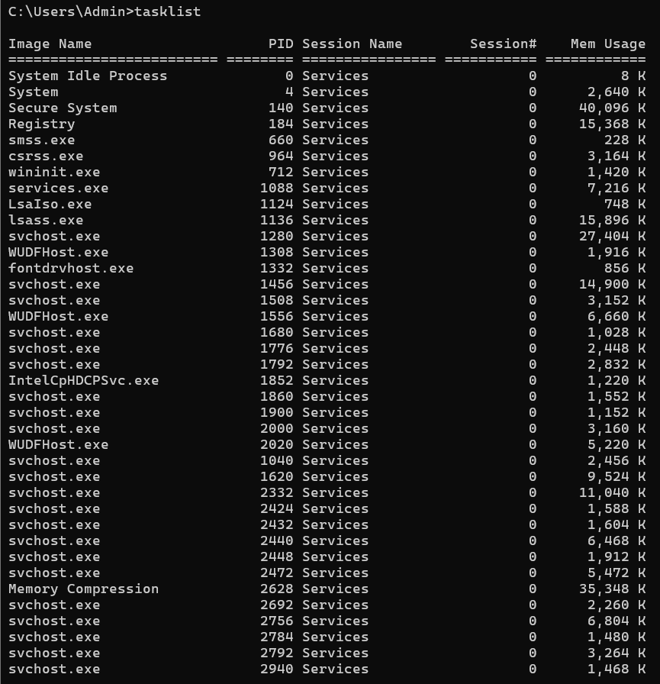
Figure 1: View running processes
(Source: Windows Shell)
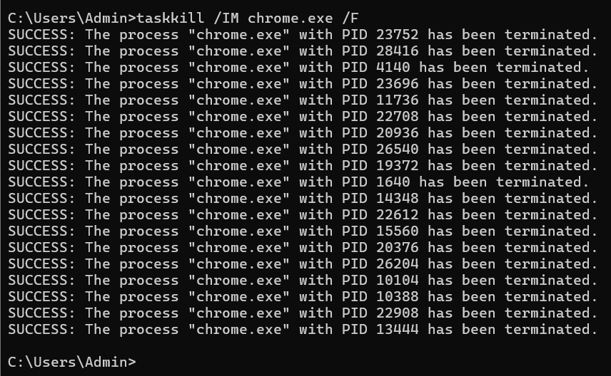
Figure 2: Kill/ Managing process using name
(Source: Windows Shell)
The tasklist and taskkill commands (see Figures 1-2 below) were used to manage processes on the system. The tasklist command provides the administrator with a list of all active or running processes and their corresponding process IDs (PIDs). The taskkill /IM processname /F command was used to kill individual processes (forcefully).

B. File and Directory Management
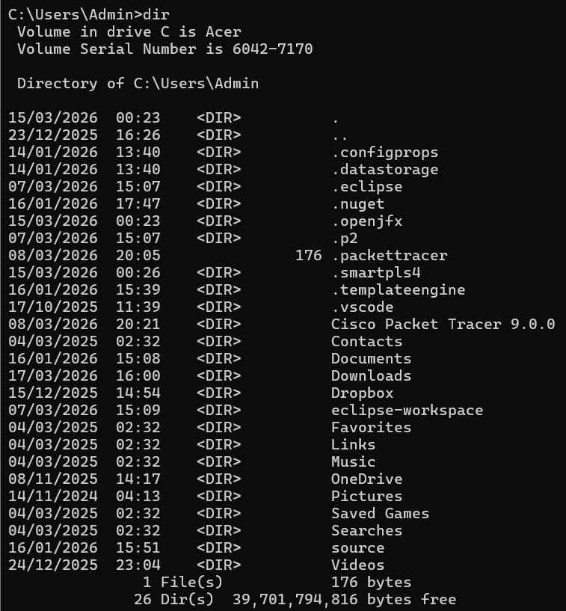
Figure 3: Viewing Directories/ Folders
(Source: Windows Shell)
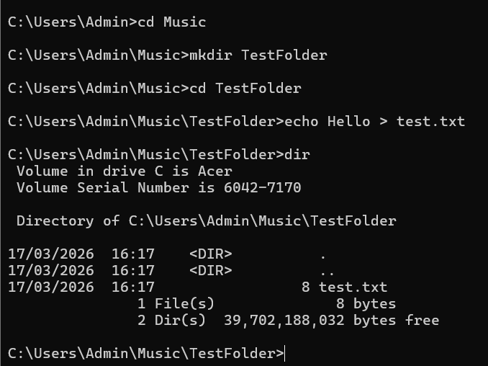
Figure 4: Creating a Test Folder and file
(Source: Windows Shell)
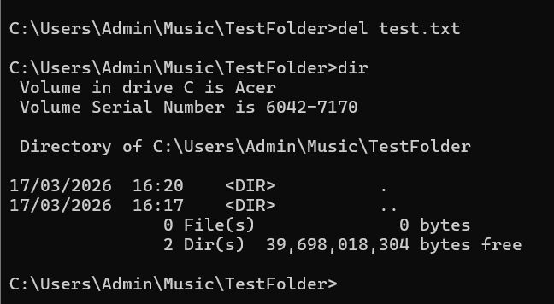
Figure 5: Deleting a File
(Source: Windows Shell)
The File commands (dir, mkdir, cd, echo and del) were executed, as depicted in Figures 3 - 5. The dir command provides a listing of all files and directories residing in a directory with respect to how those files are stored; therefore, an overview of the files is presented in an organised manner. The use of the mkdir command created a new folder, and the cd command allowed navigating between different directories. The echo command creates a text file to illustrate file creation through a command line interface (CLI).

C. Network Monitoring
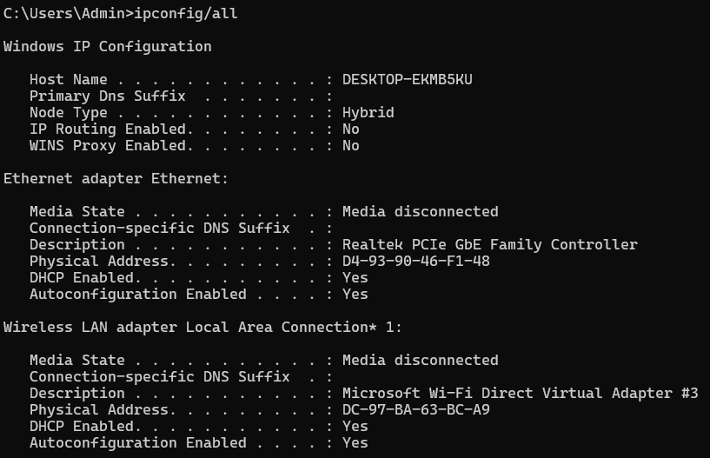
(a)
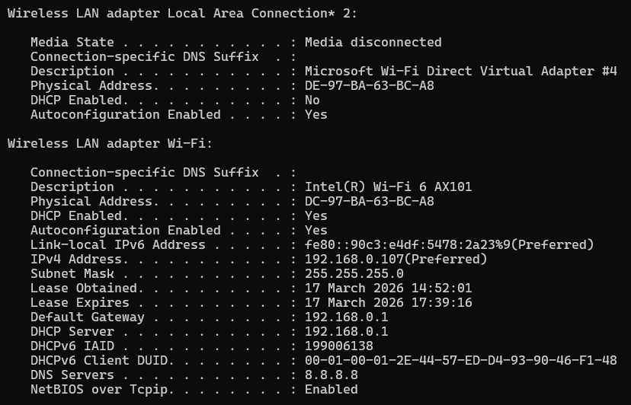
(b)
Figure 6 (a, b): Viewing all IP configurations
(Source: Windows Shell)
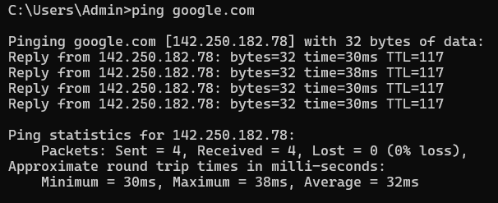
Figure 7: Pinging Browser/ Search Engine
(Source: Windows Shell)
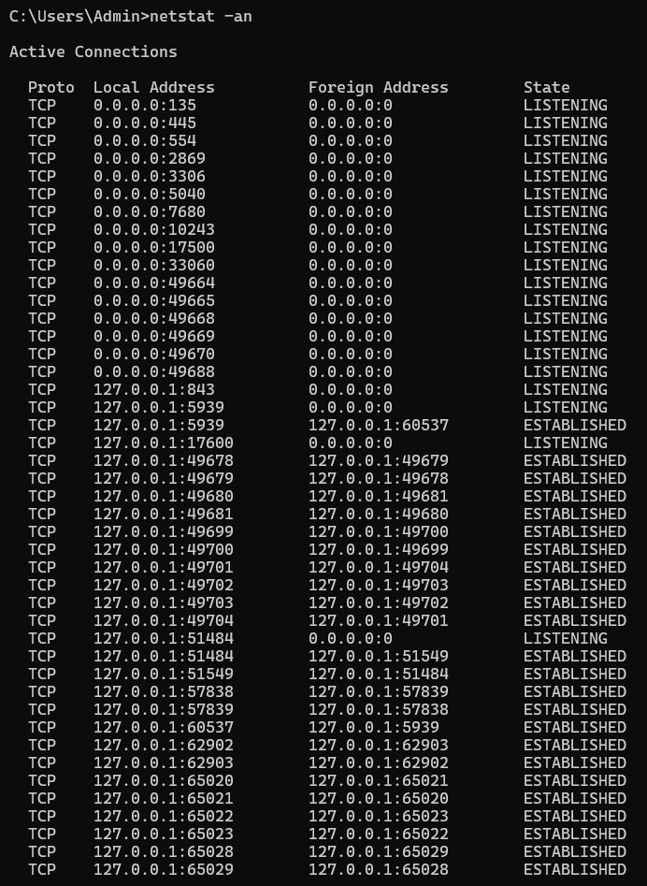
(a)
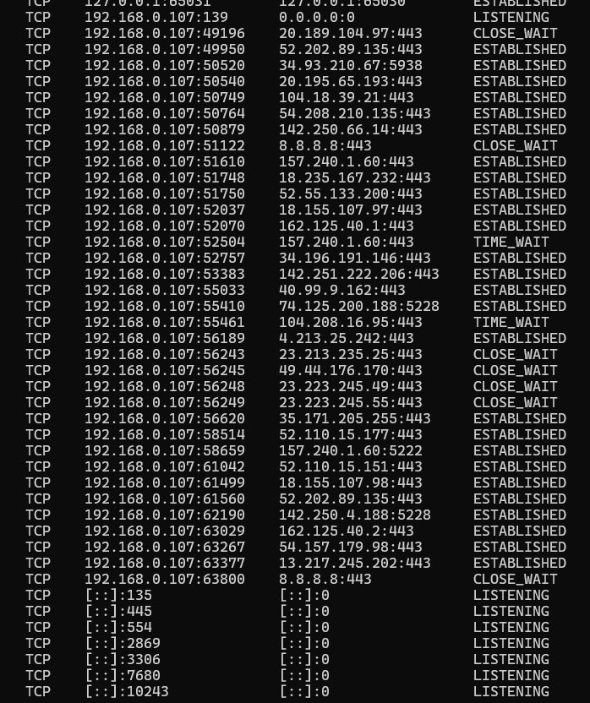
Figure 8 (a, b): Showing Network Statistics
(Source: Windows Shell)
Network monitoring has been accomplished by the utilization of tools including ipconfig, ping, and netstat found on Figures 6, 7 and 8, respectively. When utilizing the ipconfig/all command, it gives detailed information concerning the network’s configuration, including the IP address as well as the DNS (Domain Name Server) address(s) associated with that IP address (example: google.com). The use of the ping command shows successful communication with the server, known as latency.

D. User Management
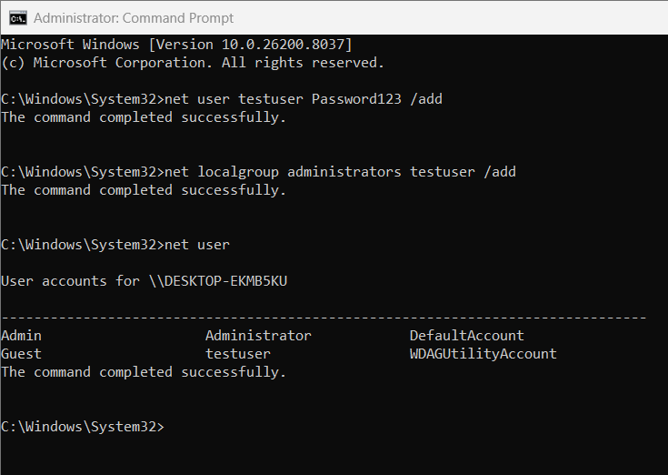
Figure 9: Creating a Test User
(Source: Windows Shell)
The net user command can create a test user account (Figure 9) via the command line interface (CLI). This capability provides administrators with a way to directly manage their entire user base.

E. Task Scheduling
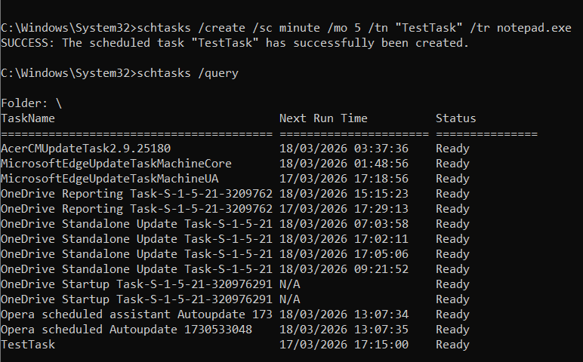
Figure 10: Scheduling Task
(Source: Windows Shell)
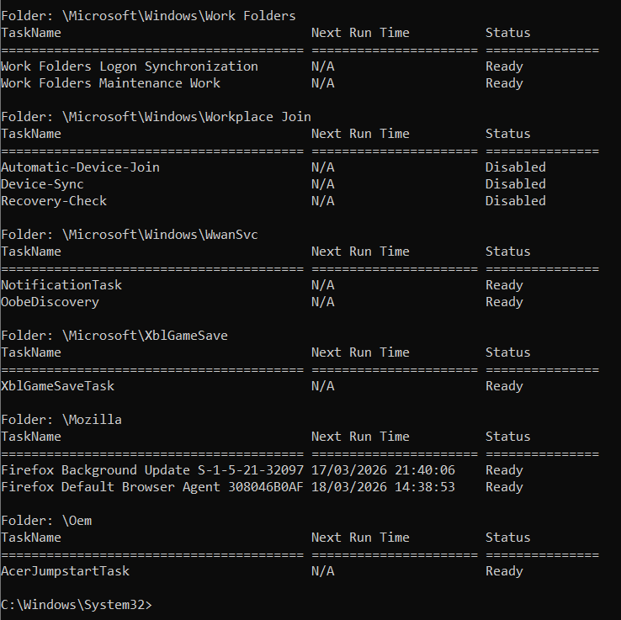
Figure 11: Sample of Task
(Source: Windows Shell)
Alternatively, administrators may use the schtasks command (Figures 10 and 11) to schedule tasks, automate scripts and execute them at predetermined intervals. Scheduling tasks reduces the need for human intervention to run scheduled tasks, which allows for predictability in terms of consistent execution of administrative duties.

3. Linux CLI Commands

Process management
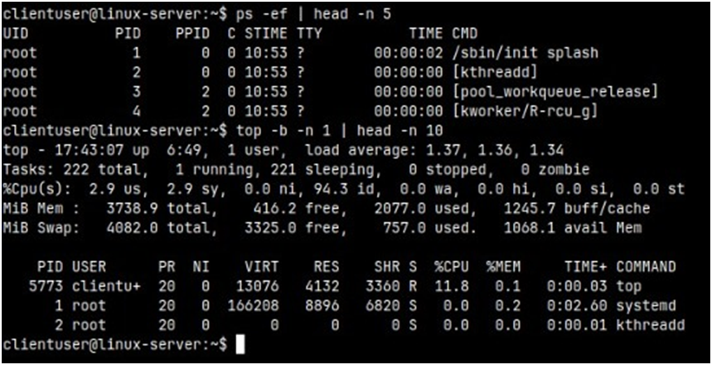
Figure 12: Process Management Code and output
(Source: Linux OS CLI commands)
To monitor process activity, the ps –ef command was used; this command offers a full-format reference for all processes in memory, including the parent process, the process ID (PID), and execution info. The ps command was piped with | head -n 5, which displayed only the first five lines of output, these commonly reflect system processes

File and directory management
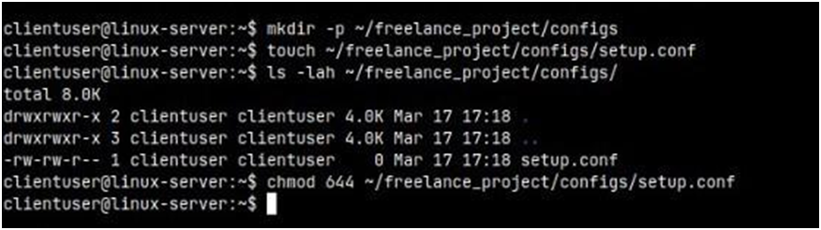
Figure 13: File and Directory management
(Source: Linux OS CLI commands)
Directory and file manipulation has been performed using mkdir -p ~/freelance_project/configs; the command with the –p switch ensures that all needing parent directories get created without error. The configuration file was created via the command touch setup.conf and then executed ls -lah to display the stored files in full detail. To set the created file's permissions, the command chmod 644 setup.conf was executed. user gets full access (rw) and all others only have read (r) access, this reflects controlled file security for the created configuration file.

Network testing/monitoring
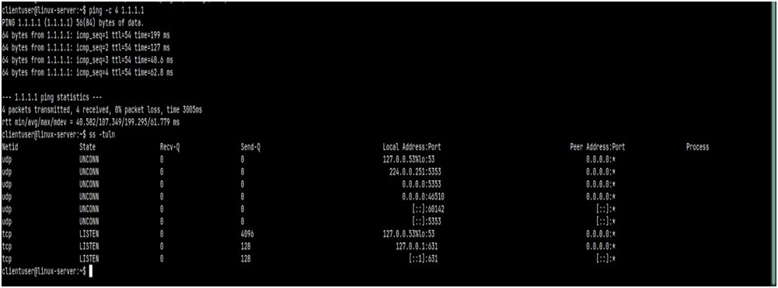
Figure 14: Network testing
(Source: Linux OS CLI commands)
Ping was used to check network connectivity by issuing ping -c 4 1.1.1.1 from the command line. This sends four ICMP request packets to the destination, then provides feedback on round_trip_time and packet loss.

User management
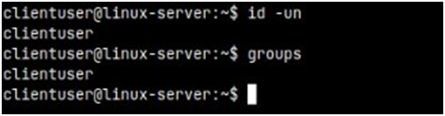
Figure 15: User management
(Source: Linux OS CLI commands)
The id -un command was issued by the user to identify the user they are currently logged in as. This is an output of both user ID and name options.

Task scheduling
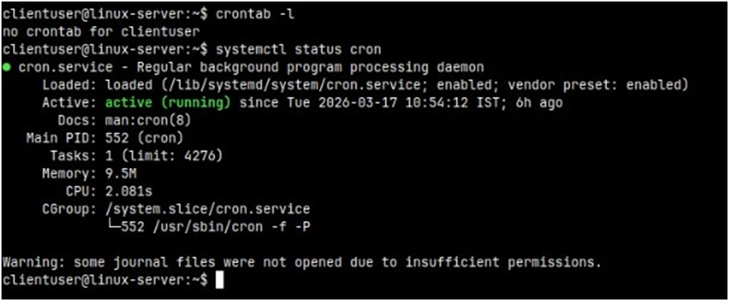
Figure 16: Task scheduling
(Source: Linux OS CLI commands)
Crontab -l was executed to view a list of all scheduled tasks that have been configured to run for the current user. The operational state of the cron scheduling service would be determined through the execution of the systemctl status cron command.

4. Windows Batch Scripts

Script 1: Mathematical Operation (Addition)
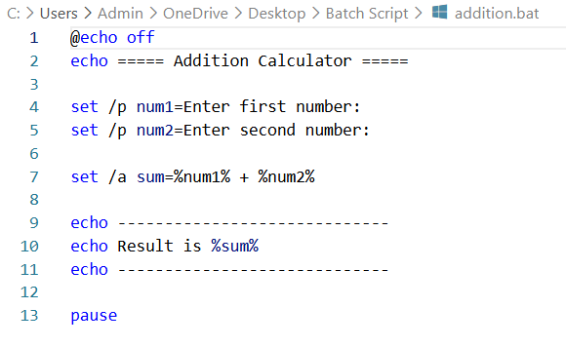
Figure 17: Code for Addition
(Source: VS Code)
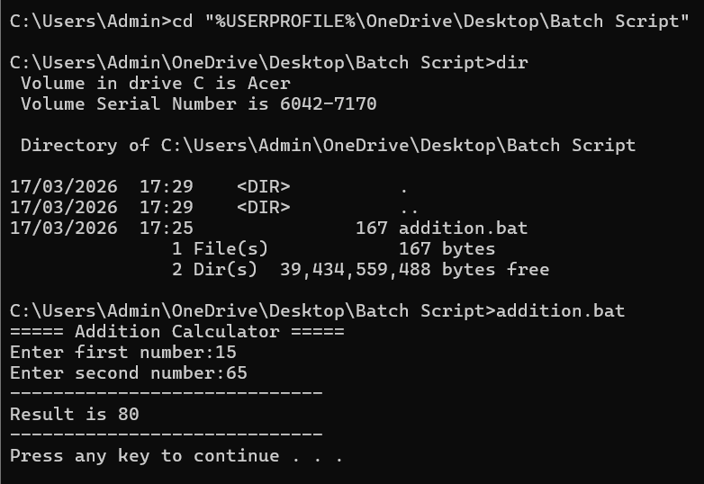
Figure 18: Output operation of Addition
(Source: Windows Shell)
User inputs two numbers; they are stored in variables. The result of adding them together is calculated through set /a using the following syntax (%num1% + %num2%). The final sum (or result) is displayed on the screen via echo.

Script 2: Loop and Automation
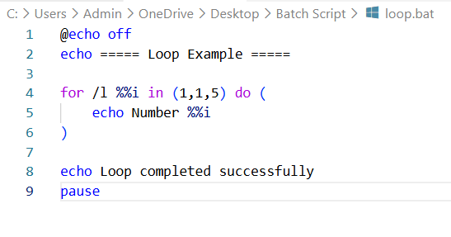
Figure 19: Automates repeated tasks
(Source: VS Code)
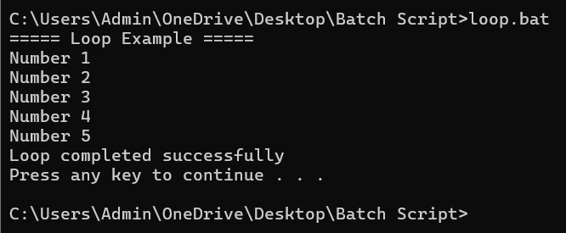
Figure 20: Output Loop and automation
(Source: Windows Shell)
This script will repeatedly run a for loop to display numbers in a specified numerical range. The range will be defined using the (start, increment, end) format. On every iteration of the for loop, the "loop" variable's value will be incremented automatically.

Script 3: Condition and User Input
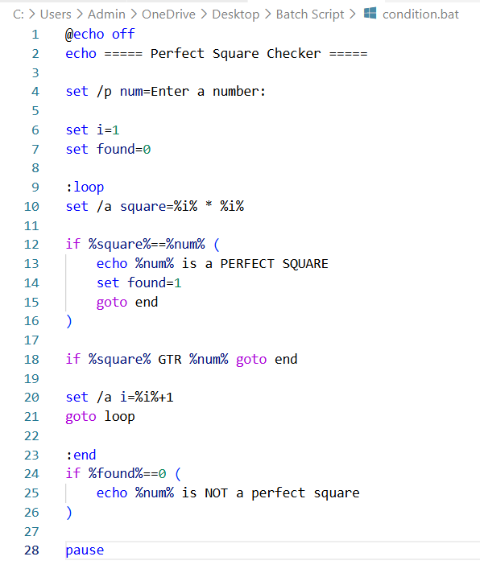
Figure 21: Code for Perfect Square Check condition
(Source: VS Code)
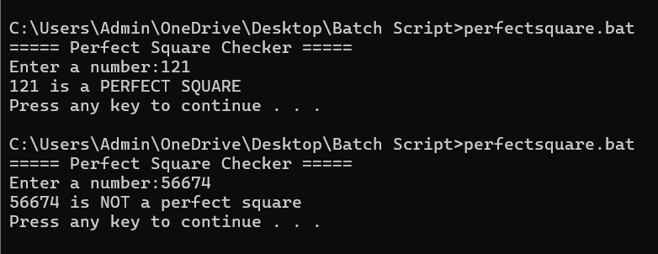
Figure 22: Output Perfect Square Check condition
(Source: Windows Shell)
This script determines whether a number is a perfect square through the use of a loop and conditional branch. As part of the loop's processing, the value of the counter variable will be squared (by running the code; set /a i * i) and will be compared to the original input number.

Script 4: File Automation
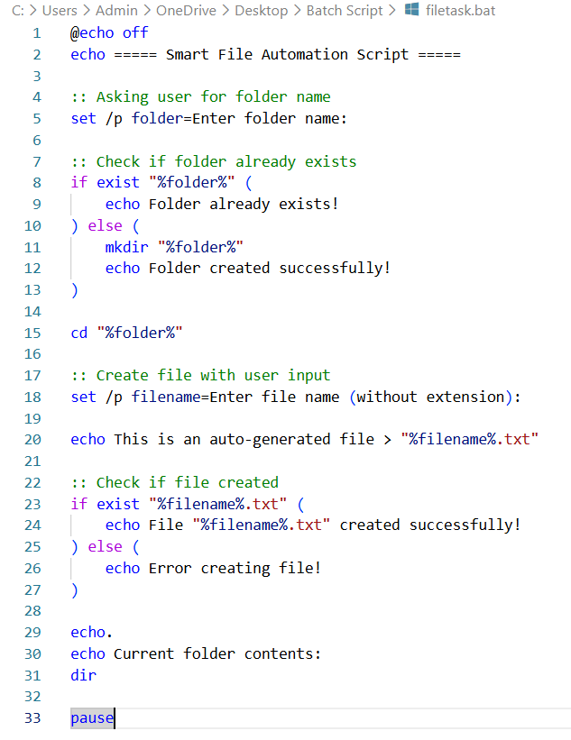
Figure 23: Creating a folder and a file
(Source: VS Code)
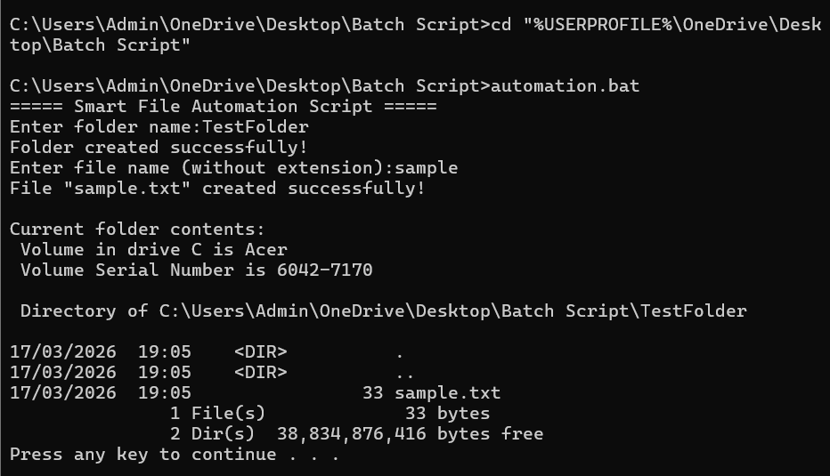
Figure 24: Output of File and folder creation
(Source: Windows Shell)
The creation of the folder and file(s) is achieved by using the set /p command line to record the folder name and file name. Then it navigate into the directory (using 'cd'), creating the file (using echo and output redirect '>' and finally verifying that the file has been created; also using 'if exist').

5. Linux Bash Scripts

Script 1: Storage Alert System
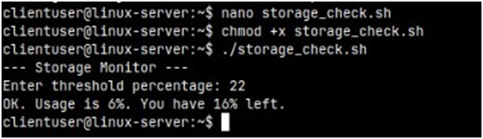
Figure 25: Storage Alert System
(Source: Linux OS CLI commands)
The script storage_check.sh is a disk usage checker that checks how much storage is available on a given partition, checks the total amount of space used on that partition as well as the percentage amount used to determine if it is below the threshold value. After assigning the root directory as the variable ($ROOT) next it asks the user for the threshold value by using the command 'read -p'. The command 'df -h' is used to obtain the amount of storage used on a partition. The percentage of space being used (total amount of space used divided by total amount of space on the partition) is then extracted by the use of awk to only the required field and then lastly using sed to remove the percent sign.

Script 2: Automated File Generator
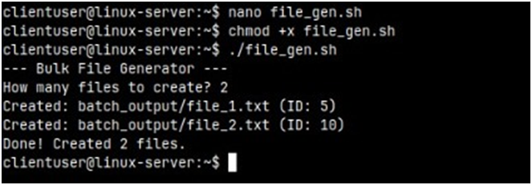
Figure 26: Automated File Generator
(Source: Linux OS CLI commands)
The file_gen.sh script automates creating files based on user defined input. The user is asked to enter the number of files by using read -p, which assigns the number of files to a variable. With a command of mkdir -p, the user can make sure there is an existing workspace without getting an error if one already exists. A for loop iterates from 1 to the number entered by the user, creating filenames based on the for-loop count. Each file is created with output redirection (>), and some example content written into them.

Conclusion
The application of operating systems and command line applications in real-life situations was demonstrated in both Microsoft Windows and Linux operating systems through this report. The author was able to carry out administrative operations such as file and directory management, process monitoring, user management, task scheduling and network diagnostics with command lines. The results from those command line operations showed proper command syntax and results of proper interactions between the operating system and the administrator through successful execution of commands. In addition, the creation of batch files and bash scripts illustrated how to utilize variables, loops, conditional statements and automation techniques when performing repeated tasks.

References
[1] Z. B. Akhtar, “Operating Systems (OS): An Insight Investigative Research Analysis and Future Directions,” Journal of Technology and Informatics (JoTI), vol. 6, no. 1, pp. 58–69, Oct. 2024, doi: https://doi.org/10.37802/joti.v6i1.637.
[2] N. Harki, A. Ahmed, and L. Haji, “CPU Scheduling Techniques: A Review on Novel Approaches Strategy and Performance Assessment,” Journal of Applied Science and Technology Trends, vol. 1, no. 2, pp. 48–55, May 2020, doi: https://doi.org/10.38094/jastt1215.
[3] T. Jeyaprakash and S. M, “Performance analysis of CPU scheduling algorithms – A problem solving approach,” International Journal of Science and Management Studies (IJSMS), vol. 4, no. 4, pp. 411–416, Aug. 2021, doi: https://doi.org/10.51386/25815946/ijsms-v4i4p138.
[4] M. J. F. Iglesias, “Operating Systems Concepts,” osf.io, pp. 1–38, Jun. 2023, doi: https://doi.org/10.17605/OSF.IO/38MKS.
[5] I. Odun-Ayo et al., “Comparative Study of Operating System Quality Attributes,” IOP Conference Series: Materials Science and Engineering, vol. 1107, no. 1, pp. 1–13, Apr. 2021, doi: https://doi.org/10.1088/1757-899x/1107/1/012061.
[6] K. Łazaruk, P. Tokarski, K. Rybak, M. Plechawska-Wójcik, and M. Dzieńkowski, “The Force of Habit: Comparing Graphical User Interfaces of Popular Operating Systems Using Eye-Tracking Analysis,” IEEE Access, vol. 13, pp. 169236–169261, 2025, doi: https://doi.org/10.1109/access.2025.3614018.
[7] M.-H. Wu et al., “MPSD: A Robust Defense Mechanism against Malicious PowerShell Scripts in Windows Systems,” Electronics, vol. 13, no. 18, pp. 1–26, Sep. 2024, doi: https://doi.org/10.3390/electronics13183717.
[8] Z. Miao, C. Shao, H. Li, and Z. Tang, “Review of Task-Scheduling Methods for Heterogeneous Chips,” Electronics, vol. 14, no. 6, pp. 1–25, Mar. 2025, doi: https://doi.org/10.3390/electronics14061191.
[8] H. Mohapatra, “Automation and Configuration Management Windows PowerShell,” ResearchGate, pp. 1–451, Mar. 2020, doi: https://doi.org/10.13140/RG.2.2.35853.90085.

