Global marketing strategy of Multinational Enterprises: a case study of Huawei
Ning Wang
ID: 2002088
BA International Business Management
Research Proposal
Word Count: 1404

Contents
Introduction 3
Background Literature 4
Rationale 5
Aims and Objectives 5
Aim 5
Objectives 5
Research Methodology 6
Ethical Considerations and Limitations 7
Resources and Planning 8
Gantt Chart 9
Reference List 10

Introduction
This dissertation will discuss how to effectively help enterprises to formulate business strategic planning when entering the global market. To investigate whether the global marketing strategy is helpful for enterprises to enter the global market, or whether it is helpful to the development of enterprises in some aspects. For example, it can help enterprises understand the market share of the international market, investigate the consumption tendency of major customers, understand the legal and ethical requirements of various countries, or develop unique product strategies for new competitors.

Background Literature
With the development of the world, the trade between countries is developing constantly. The tariff barrier of WTO is breaking. Although national borders still exist, barriers to the free flow of factors of production in the world are weakening. More and more multinational companies, from the global perspective, make use of the location comparative advantages of different countries and regions, disperse and allocate all links and functions in the value chain, combine them organically, implement integrated operation, and strive to reduce production and operation costs, so as to obtain long-term stable global competitive advantage and maximize global efficiency. Huawei, a multinational company from China, represents a form of globalization different from the traditional mode of internationalization. Only 14 years after its establishment in China, it began to try to develop globalization in Mexico. Before internationalization, Huawei formulated a series of strategies to ensure that Huawei can realize its globalization strategy. For example, based on the ability to cultivate the domestic market; in the market with less cultural, technological, economic and institutional barriers, accumulate experience and move up the value curve; use inward and outward linkages to supplement its advantages and offset its weaknesses in the global market. （Li Sun, S., 2009. ）

With the global expansion of Huawei, a multinational enterprise from China, people are paying more attention to multinational companies and how these companies formulate global business strategies. This paper aims to deeply understand Huawei's internationalization strategy through the in-depth study of Huawei, a Chinese high-tech company in the communication equipment industry. Through the research on Huawei's business strategy in recent years, this paper hopes to give a general description of the global business strategy of multinational enterprises and put forward some effective suggestions for the companies that want to implement the global business strategy. （Jordy Micheli &amp; Jorge Carrillo, 2016. ）

Rationale
The global marketing strategy refers to the enterprises from the global point of view, using the comparative advantages of different countries and regions, investigating the production, circulation and other marketing activities of enterprises, organizing different enterprises in different countries according to the principle of optimization, and meeting the market demand with the lowest cost and the best marketing scheme. Its purpose is to emphasize the international comparison of marketing. From a global perspective, enterprises use the comparative advantages of different countries and regions to disperse and allocate various links and functions in the value chain. The global marketing strategy breaks through the concept of national boundaries, and considers the development of the company's marketing strategy from the scope of the world market in order to obtain the comprehensive competitive advantage of the enterprise. （Minggang Yang，2000）

Aims and Objectives

Aim
The overall goal of this study is to give some effective suggestions to the enterprises who want to enter the global market, about "how to make business strategy when enterprises enter the global market".

Objectives
1. The first goal is to conduct a comprehensive and in-depth literature review on the existing global marketing strategy of Huawei.
2. Analyze and review which key marketing activities affect Huawei's development in the global market in the enterprise's global strategy.
3. Conduct preliminary research to study whether the strategy adopted by Huawei can be used as a standard reference by other companies.

Research Methodology
Collis and Hussey define research as, “a process of enquiry and investigation, it is systematic, methodical and ethical, and can help solve practical problems and increase knowledge” (Collis & Hussey, 2009, p. 3). It is very important to choose the right research method. Some research methods are considered. This paper mainly collects and analyzes the case of Huawei Company. So for this study, there are three types of research methods considered: case study, questionnaire survey and the research onion.

This paper intends to adopt the method of literature research. The method of literature research is a kind of method to obtain data through literature investigation according to a certain research purpose or topic, so as to comprehensively and correctly understand and master the problems to be studied. This paper will use this method to sort out and analyze the strategies used by Huawei in the development of Chinese market and global market respectively. This method is helpful to the analysis of Huawei's global marketing strategy.

This paper adopts the method of questionnaire survey. As a reliable measurement method for researchers to collect questions. This paper will use this method to collect surveys on Huawei's customer experience, which will help to study the impact of Huawei's strategy on Huawei in the process of globalization.

The research onion can help research to collect and analyze information in a systematic way. It can ensure that there is no missing information when collecting data and it is convenient for users to classify and check the information.

Figure 1: The Research Onion
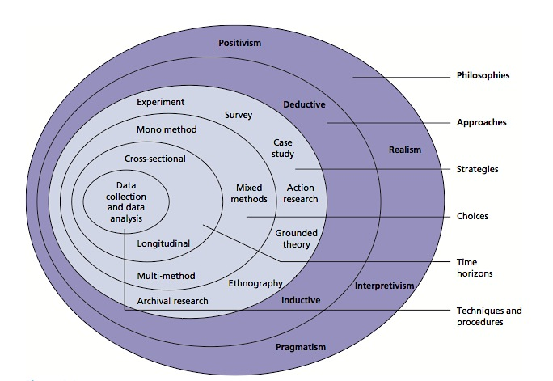
(Saunders, Lewis, & Thornhill, 2009)

Since this paper is a survey, this paper will use quantitative research methods. This paper will make a longitudinal comparison of Huawei's data for several consecutive years. Through the trend analysis, the development trend of the enterprise in specific aspects is obtained. Then, through the horizontal comparison between different enterprises in the same industry or compared with the standard value, this paper obtains the strategy gap between Huawei and other companies, and analyzes the reasons for the gap.

Data analysis is very important, the key of research is to analyze data effectively. (Albright & amp; Winston, 2011) due to the limitations of this study, the first-hand information obtained in this study will be used to support the conclusion. Therefore, the analysis of other questionnaires and interview information collected needs to be sorted out and drawn into tables to facilitate readers to watch. And after analyzing the first-hand information and second-hand information, the differences between the two will be further discussed and studied.

Ethical Considerations and Limitations
Ethical factors, such as discrimination, must be considered when conducting research. Whether it is a questionnaire survey or an interview, they need their own consent to disclose the information. At the same time, in order to avoid possible dishonest answers, both questionnaires and interviews should be anonymous and these interviewees should be informed. Moreover, these information will be informed to the interviewees before the questionnaire survey or interview starts, and the interviewees should be kept in a relatively relaxed state during the interview, and the researchers should keep objective and neutral in the whole process, so as to ensure that they will not give hints to the interviewees. At the same time, these research methods have many limitations, because for the interview, it is difficult for the interviewer to find a suitable target in an organization, and there are a large number of employees in the global organization. However, a small number of samples are obtained for analysis in this study, which can affect the accuracy of the research results. And because of covid-19, most of the activities can only be carried out in the network.

Resources and Planning
The project starts in October 2020 and ends in May 2021. In this period of time management plan, I made a detailed Gantt chart (see Figure 2).
In addition, in order to provide an effective paper, the following resources are needed. First, the document collection process will require a personal computer and various library resources (books, textbooks, newspapers and periodicals). Second hand information mainly comes from journals and papers. In order to better collect information, I purchased China National Knowledge Infrastructure account number. And in order to record the information collected and the progress of the research, a memorandum account will be prepared. And in China, I need to buy a VPN account to ensure that I can log on to websites in other countries to collect letters. Finally, I need to prepare a tape recorder to support possible interviews. The estimated cost is 100.

Gantt Chart
figure 2

Reference List
Alon, I. & McIntyre, J.R., 2008. Globalization of Chinese enterprises, Basingstoke: Palgrave Macmillan.

Anon, 2016. Globalization of Latecomer Asian Multinationals and Theory of Multinational Enterprise. In International Business: Concepts, Methodologies, Tools, and Applications. IGI Global, pp. 1813–1840.

Chang, Li-Chung et al., 2017. Dynamic organizational learning: a narrative inquiry into the story of Huawei in China. Asia Pacific business review, 23(4), pp.541–558.

Cooke, F.L., 2012. The globalization of Chinese telecom corporations: strategy, challenges and HR implications for the MNCs and host countries. International journal of human resource management, 23(9), pp.1832–1852.

Fey, Carl F et al., 2016. Internationalization Strategies of Emerging Market Multinationals. Journal of leadership & organizational studies, 23(2), pp.128–143.

Guo, Lei et al., 2018. Seizing windows of opportunity by using technology-building and market-seeking strategies in tandem: Huawei’s sustained catch-up in the global market. Asia Pacific journal of management, 36(3), pp.849–879.

Jordy Micheli & Jorge Carrillo, 2016. The Globalization Strategy of a Chinese Multinational: Huawei in Mexico /Huawei: Trayectoria global y estrategia para México de una empresa multinacional china. Frontera norte, 28(56), p.35.

Lee, Joonkoo & Gereffi, Gary, 2015. Global value chains, rising power firms and economic and social upgrading. Critical perspectives on international business, 11(3/4), pp.319–339.

Li Sun, S., 2009. Internationalization Strategy of MNEs from Emerging Economies: The Case of Huawei. Multinational business review, 17(2), pp.129–156.

Xu, Hui, Wan, Yiqian & Pei, Degui, 2008. A study on risk perception and risk identification in the internationalization process of chinese hi-tech enterprises. Frontiers of business research in China, 2(3), pp.458–481.

Yan, Jie, Wang, Le & Xiong, Jie, 2017. Alcatel-Lucent falls, Huawei ascends: new product development makes the difference. The Journal of business strategy, 38(1), pp.22–30.

