Che-Si Security Analysis
Iwan Dyke (1800933)

L4 – Network and Cybersecurity Essentials (ACCA4024)
03/01/2021

Contents
Abstract 1
Introduction 1
Current Networks and Devices 1
Possible Threats to the Network 2
Mitigations 2
Attack Demonstration 3
Policies and Awareness 5
Encryption 5
Digital Signatures 6
Conclusion 6
Bibliography 6

Figure 1 Simulation of the Che-Si Network with a Possible Attacker 3
Figure 2 Demonstration of Stolen Files from an Unsecured File Server 3
Figure 3 Hash Value File 4
Figure 4 Demonstration of using Tools4Noobs 4

Abstract
I have demonstrated the possible security flaws of the Che-Si system by analysing the network policies in place. I have detailed the networks and devices which would be essential for the network. I have also discussed the possible security threats in the form of Malware and user-based attacks. I have also used Cisco Packet Tracer to demonstrate a possible attack on a simulated Che-Si system using a sniffer device and how to validate files. I have also discussed the importance of security policies and how training employees and awareness of these security policies is essential to maintaining protected in the modern world. Included with this report will be an annexure detailing the new policies which I believe Che-Si should adopt to protect their systems.

Introduction
In the digital world a network is a method of transporting data between two different places. In the wider world a network can apply to any connected system or persons. Examples being railway networks, social networks, or transport networks. In the modern world digital networks have become invaluable and have allowed us to increase productivity, communicate and send information vast distances in seconds. Due to how essential these networks are, they must be protected. There are many threats which could be harmful to these networks and will need to be mitigated. This could be from malicious persons trying to gain access to a network manually or pieces of code which can cause damage to the data or obtain access for a malicious user.

Current Networks and Devices
The Che-Si company has a worldwide network to connect all sites from around the world. This means that there are multiple types of networks which are used by the company. A mixture of LAN (Local Area Networks) and WLAN (Wireless Local Area Networks) are used by each of the sites. Devices such as a desktop PC or a server would connect to the network via an ethernet cable. Whereas many portable devices such as a laptops, mobile phones or smart tablets would connect via the Wireless router in the WLAN while on site. Che-Si allows employees and clients to access their systems from any location. Which means that many people will also be connecting to the network via WAN (Wide Area Network) using an internet service provider. While being able to connect to the systems from any location is highly convenient and may increase productivity. Without appropriate safeguards on the systems, it may cause irreparable damage.

Possible Threats to the Network
By allowing employees and clients to access the network using any method, the attack surface for the company’s systems is very large. Many forms of malware would be able to infiltrate the systems and cause damage, steal information or otherwise perform a malicious action against the system or data. “Malicious software in the form of Internet worms, computer viruses, and Trojan horses poses a major threat to the security of networked systems.” (Konrad Rieck, 2008) If the employee has not adequately protected their devices malware could infect their personal device and would then have complete access to any shared business network. An example of this would be a virus, if it were to infect a personal device of an employee which had basic access to company systems. The virus could potentially have access to a business network shared drive, the cloud storage could be compromised if a user manually moves an infected file into storage there. The cloud storage provider may have mitigations to stop this, but this is not a 100% guarantee. This could then flood the network with traffic causing systems to slow down and work output come to a halt. This same scenario could be applied to many of the other forms of malware with the potential problems which trojans and worms could cause. Trojans are very adaptable on the possible damage which they could cause. They may delete files and cause immediate damage. Or may provide remote access for a user or backdoor. A worm may manipulate files or cause Denial of service attacks. It can also provide remote access for a malicious user. Along with possible malware attacks, users who are deceived by people via phishing emails, pre-texting or impersonation may compromise their personal devices and the company system. Once someone has access to these systems, they may try to accomplish further attacks such as denial of service which may cause loss of time and money. Other possible attacks which may occur are sniffer attacks. This is where an attacker intercepts and steals data while it is in transit over a network. This data can be stolen or in some cases tampered with and then sent to its intended destination. Other possible attack such as the following can occur “In the case of sniffing attacks the attacker can monitor and capture data from networks such as: Telnet Passwords, File Transfer Protocol Passwords, DNS traffic, Router Configuration, etc.” (Glăvan, Răcuciu, Moinescu, & Eftimie, 2020)

Mitigations
There are many mitigations which can be implemented to stop the afore mentioned attacks. Ensuring that all devices which will be used to access company systems should have secure passwords which are changed on a regular basis. All devices should have up to date anti-virus protection and anti-malware. This will prevent, locate, and remove any malicious code protecting the devices. Another mitigation strategy to improve security is to prevent the use of USB drives unless they have been formatted and protected for company use. This is another method of stopping malware from entering the system. A VPN should also be used when connecting to the company’s systems. A VPN provides many advantages in terms of security, firstly it will protect any data travelling over a network. This stops any attacks occurring while the data is in transit, stopping data being stolen or tampered with before it reaches its destination. It also protects the IP address of the device using it further increasing security.

Attack Demonstration
I will be demonstrating a sniffer attack on a system using Cisco Packet Tracer. I have simulated a version the Che-Si network with data being sent over the internet between different branches as shown in Figure 1. In our example we will have multiple branches and employees attempting to access files over the internet. The company file server is situated within the San Francisco branch, with an employee in the New York branch trying to access files on the server. A sniffer device will be checking the network activity on the internet and capturing any unsecured data.
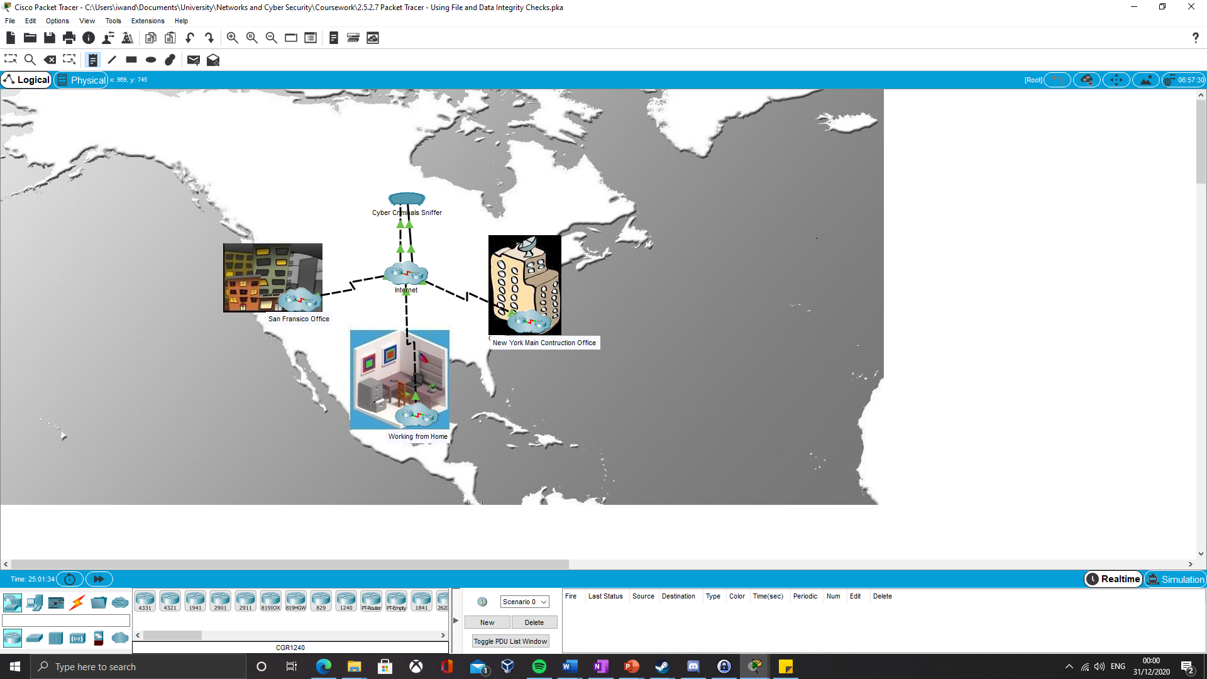
Figure 1 Simulation of the Che-Si Network with a Possible Attacker
There are many different types of sniffer attack such as MAC flooding, where the CAM (Content Addressable Memory) table is given too many requests and sniffing can occur. Others such as DNS cache poisoning where a user is redirected to a spoof website and their data can be captured or MAC spoofing where the attacker redirects incoming data to the sniffer by impersonating the intended MAC address. There are many different tools available on the market such as Wireshark, fiked and DNSChef. Due to how easily accessible these programs are it indicates a high likelihood of one of these attacks occurring on an unsecure network. This demonstration works on the assumption that the FTP server has been set up using a HTTP protocol. HTTP (Hypertext Transfer Protocol) transfers text over the internet in plaintext, meaning that anyone can intercept and steal this data as is shown in Figure 2.
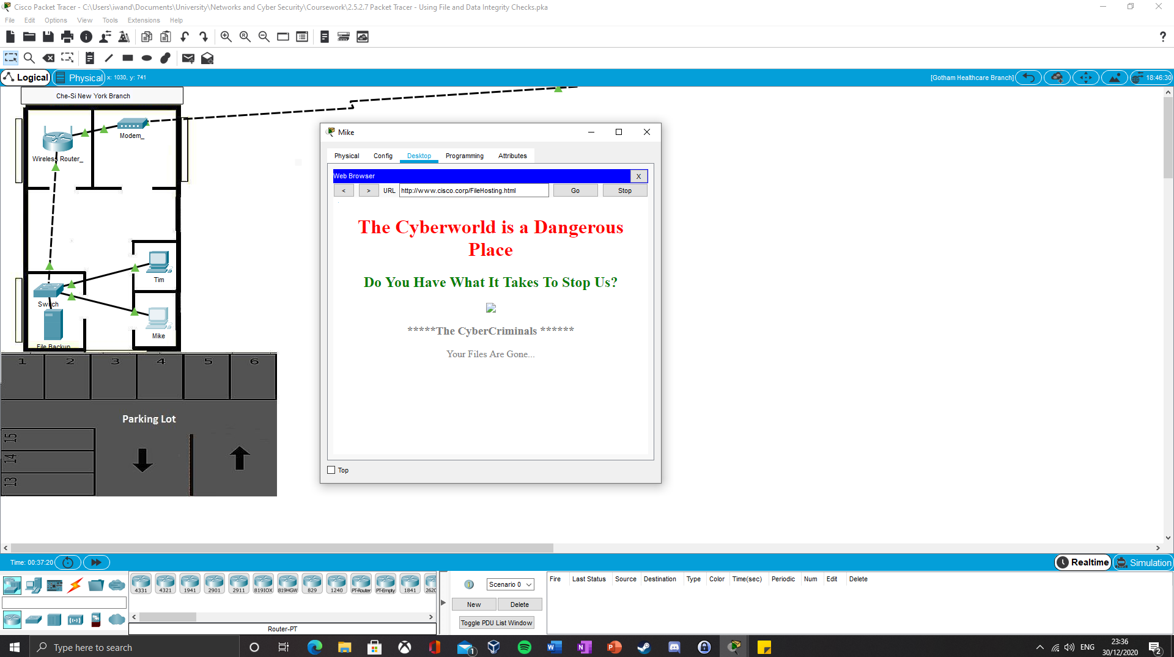
Figure 2 Demonstration of Stolen Files from an Unsecured File Server
This attack can easily be mitigated by using a different protocol on the File Server. Instead of using HTTP (Hypertext Transfer Protocol) the HTTPS (Hypertext Transfer Protocol Secure) should be used instead. This is the secure version of the protocol which encrypts the data as it is being sent stopping any attackers from intercepting that data along with the other security policies which should be implemented. In this demonstration the files which “Bob” was trying to access have hashes generated for each file. We can use this as a method of validating documents. The backup file server holds a secure file with the hash values of each of the files stolen in the demo. We can use these values to check the hash values of the files received after the attack to check if anything has been changed. Figure 3 shows the text file with the hashes of the required files before the attack.
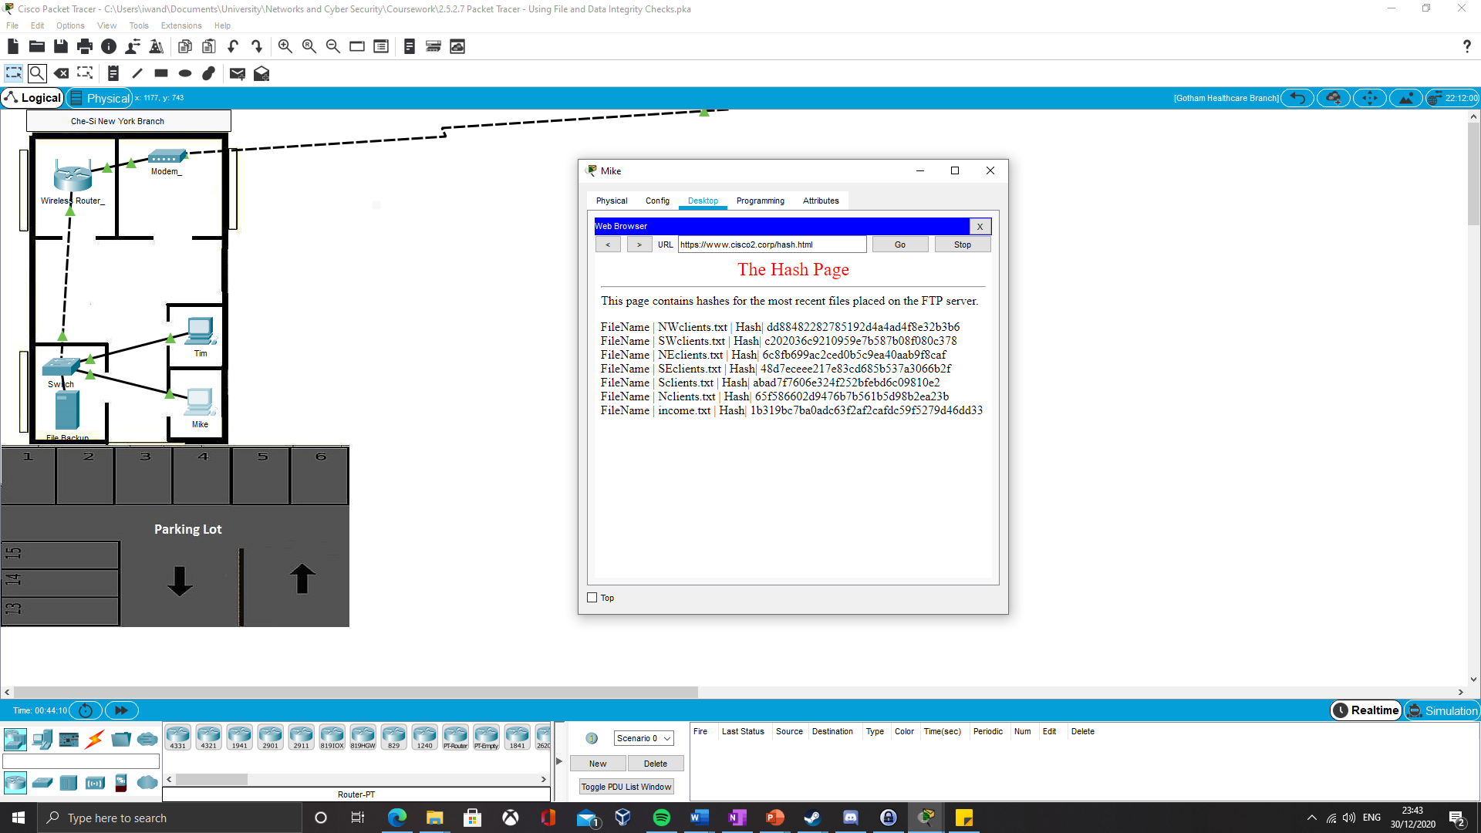
Figure 3 Hash Value File
We can then use a hashing tool to generate the hash values from the new files received. In this demonstration I will be using a free online tool to generate the hashes as shown in Figure 4.
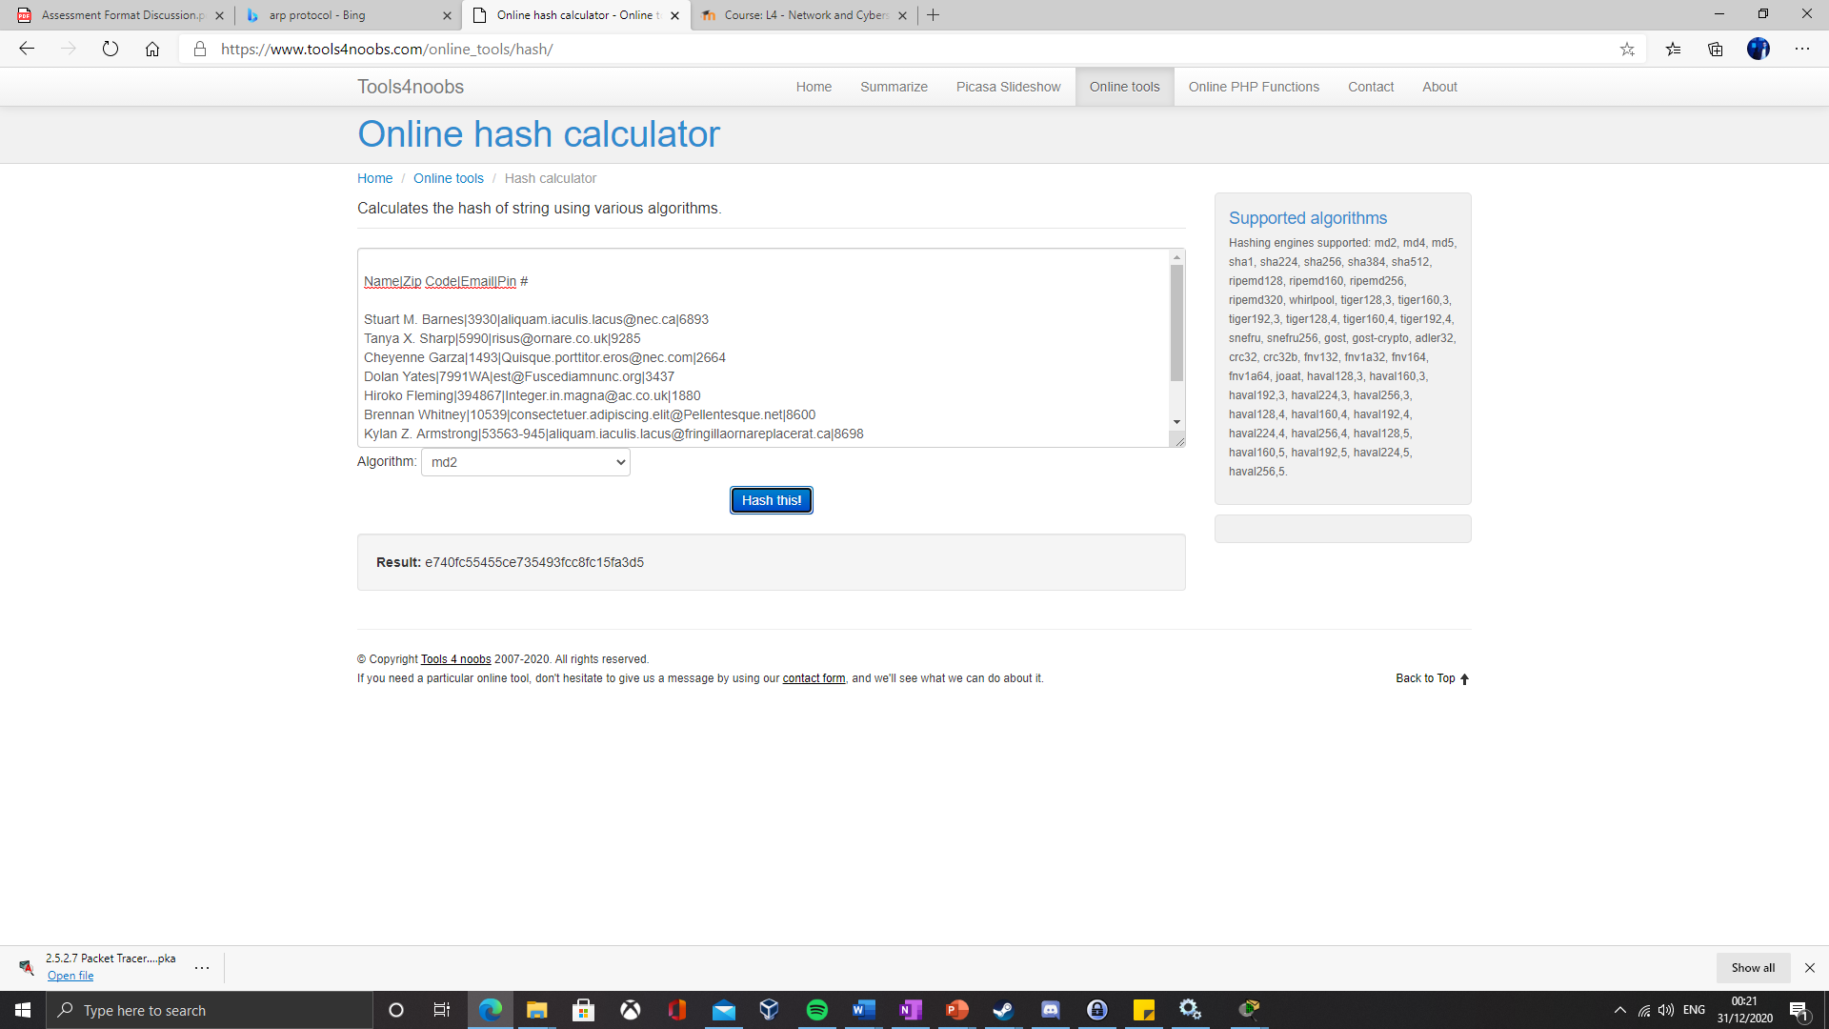
Figure 4 Demonstration of using Tools4Noobs
Figure 4 is the hash value for the NEclients.txt file, the has value of the file downloaded after the attack and before the attack are different. This indicates that the file has been altered in the attack. This is a way of validating files after they have been sent over a network. There are many sniffer detection tools available on the market such as ARP which can be used to monitor and detect attacks.

Policies and Awareness
Awareness of threats and security policies within an organisation are paramount. Users are the biggest vulnerability within any system and need to be educated on possible threats which they may be faced with. It is highly likely that a user will be faced with at least one phishing email in their life and they should be educated on how to spot and report them. Training for securely connecting to the systems via a VPN should be given during any employees’ induction into the business. Further training on any new threats and a reminder on how to spot attacks should be given on a frequent annual basis.

Encryption
When data is being stored on a secure database encryption is not entirely necessary. It does provide an extra layer of protection if the database has been compromised. Encryption should be used if sensitive data is being sent to someone via email or being stored on a shared area such as a network drive. The folder which this information is stored in should have very limited access and the data should be encrypted to protect its integrity. At least data should be encrypted with a symmetrical encryption key. This type of encryption uses a pre-shared public key which is used to encrypt and decrypt the data. It is possible for this data to be decrypted by an unauthorised user if they can obtain access to the encryption key, but it does provide an added layer of security. Asymmetrical encryption uses a pre-shared public key to encrypt the data, the same key is not used to decrypt the data. As a different key is used to decrypt the data it is not possible for an unauthorised user to decrypt the data without getting access to the specific decryption key. This is a more secure method of encryption and should be used where possible. There are some risks with this method as “A crucial aspect of asymmetric encryption is that the private key must be kept private. If the private key is compromised, an evil attacker can impersonate you and send and receive messages.” (Kaeo, 2003)

Digital Signatures
As the company has branches all over the world it will not always be possible to physically sign legal documents, digital signatures should be used in their place. A digital signature is used as an integrity check to flag if a document or message has been altered since it was digitally signed by a user. Digital signatures follow the same process as asymmetric encryption. Once a document has been signed it will generate a hash, this is then encrypted using a public key creating the digital signature. To validate the digital signature on the document, when it is next opened the digital signature will be decrypted using the private key included with the document. Both hash values should match, if this is the case the digital signature has been verified and the document is authentic.

Conclusion
The current Che-Si network security policies provide too much of an attack surface, these policies will need to be updated and appended to keep secure in the modern world. Existing policies will need to be changed to stop employees and clients from accessing the Che-Si systems via their personal devices. This will decrease the attack surface of the systems significantly. A full list of policies which should be implemented are listed in the annexure. Others such as using a VPN should be used when accessing Che-Si systems through the internet, this will protect data from attacks and keep data secure. I have demonstrated how using the Che-Si systems without the correct security precautions can leave data open to theft and tampering, I also demonstrated how to validate data being sent over the network. The importance of using digital signatures to verify legal documents has also been explained, with how digital signatures follows the same process as certain types of encryption.

Bibliography
Glăvan, D., Răcuciu, C., Moinescu, R., & Eftimie, S. Sniffing Attacks on a Computer Network. Scientific Bullentin "Mircea cel Batran" Naval Academy. (2020). Available from: ProQuest
Kaeo, M. Retrieved from Designing Network Security, 2nd Edition. (2003, October 30). Available from: Cisco Press
Konrad Rieck, T. H. Learning and Classification of Malware Behaviour. Springer, Berlin, Heidelberg (2008). Available from: Springer Link

Annexure

Che-Si Policies
The Che-Si policies will need to be amended to secure their data on the network. Below are example policies which can be used to secure the businesses network.

Appended Che-Si Policies
- Clients will be able to access the Che-Si systems via a new online portal. This protects both the Che-Si systems and the client’s systems ensuring protection for both.
- Personal devices should not be used to access company systems as this provides a greater attack surface for potential threats to exploit. Company specific devices should be issued to ensure maximum security within the company.
- Employees should try to use a home Wi-Fi network or a specific company branch Wi-Fi network to access the systems. This decreased the attack surface and possibility of an attack on data while in transit.

New Che-Si Security Policies
- When accessing a Che-Si system via the internet a VPN should be used to protect the data from theft or tampering while in transit.
- Personal USB devices should not be used within company systems unless they have been checked and approved by the network security team.
- All sensitive data should be encrypted when sent over email and password protected. Files should be shared via a network file share if possible.
- Clients should only be able to access certain files via a secure online portal. This protects the company’s systems by limiting the attack surface of the network.
- A website proxy will need to be implemented to ensure that only trusted websites are being accessed and will not compromise the Che-Si networks.
- Ensure that all company issued devices have up to date system software updates and anti-malware/virus.
- Create a secure password policy, ensuring that capital letters, numeric values and symbols are used. This should be coupled with a password expiration date to ensure that user accounts stay protected.
- A non-disclosure agreement should be created for employees who are dealing with sensitive data. This will ensure that there are no leaks within the business and that sensitive data is secured.

