Event Strategic Planning and Delivery Considerations for an International Meeting
Opening Skiing Season Poiana Brasov Romania

BMIH6007
International Meetings Management
for the Hotel Industry

Module Lead: Kathryn Flynn

Vasile Asmarandei
2212713
8th of November 2024
Wordcount : 2750

Executive Summary
The grand opening of the winter ski season in Poiana Brașov promises to be an unforgettable event, setting the tone for a vibrant winter holiday experience. This annual December celebration will transform the slopes into a festive wonderland, complete with a curated selection of souvenir shops, offering unique, locally inspired keepsakes for visitors. Guests can indulge in a variety of delicious food and beverages, catered by top local vendors, showcasing both traditional Romanian cuisine and popular seasonal treats (Bacoş, 2021). The highlight of the event will be an electrifying live concert, featuring renowned celebrities and musicians, guaranteed to captivate the crowd and create a lively, energetic atmosphere. This grand opening aims to attract winter sports enthusiasts, families, and travellers, enhancing Poiana Brașov’s reputation as a premier winter destination. It’s a unique opportunity to experience winter magic at its finest, combining entertainment, local culture, and spectacular scenery. All studies and research as follow, setting coordinates and key factors of event.

TABLE OF CONTENTS
Executive Summary 2
Introduction 3
Description and Background 3
Winter Ski Season Grand Opening as Event Cycle 4
Guest Experiences and Full Itinerary 5
AIM and SMART Objectives 5
Skills, Personnel, Resources 6
Event Budget 7
Cost Analysis 8
Funding Resources and Income Generation 9
Budget Sources, Collaborators 10
Industry Trends, Advantages, Competition Factors, potential Challenges 11
SWOT, PESTEL, SOAR, 5P’s 12
Conclusion 13
References List 14
Appendix 1, 2, 3, 4 16
Introduction
The proposed grand opening event for the winter ski season in Poiana Brașov is designed to celebrate the region’s rich winter sports culture while capitalizing on its stunning alpine setting. This annual event will take place in December, marking the start of the ski season and attracting both local residents and international tourists eager to experience the vibrant atmosphere (Cozac, 2015).
Feasibility studies highlight the growing popularity of winter tourism in Romania, with Poiana Brașov being a prime destination due to its world-class ski facilities and breathtaking scenery. The event will feature a variety of activities, including souvenir shops showcasing local crafts, food and beverage stalls offering regional delicacies, and a high-profile live concert with well-known celebrities to draw in large crowds (Herman, 2021).
By combining winter sports with entertainment and community engagement, the event aims to enhance the overall experience for visitors while supporting local businesses. The integration of modern marketing strategies and sustainable practices will ensure the event resonates with contemporary audiences (Matei, 2019), making it an anticipated highlight of the winter season. This initiative not only aims to boost the local economy but also seeks to establish a beloved tradition that showcases Poiana Brașov’s cultural and recreational offerings for years to come.

Description and Background of the Winter Ski Season Grand Opening in Poiana Brașov
The grand opening of the winter ski season in Poiana Brașov is an annual celebration that marks the commencement of winter sports activities in one of Romania's most cherished ski resorts. Nestled in the Carpathian Mountains, Poiana Brașov is renowned for its stunning landscapes, excellent ski slopes, and vibrant après-ski culture (Herman, 2021). The event aims to bring together skiing enthusiasts, families, and tourists for a festive atmosphere filled with entertainment, local traditions, and community spirit.
Event Description: Set against the picturesque backdrop of snow-covered slopes, the grand opening will feature a lively atmosphere with various attractions. Visitors can explore a curated selection of souvenir shops offering local crafts, ski gear, and holiday gifts (Erdeli, 2010). Food and beverage vendors will provide a diverse range of culinary delights, from traditional Romanian dishes to international cuisine, ensuring that there is something for everyone to enjoy.
The highlight of the event will be a live concert featuring popular celebrities, creating an electrifying ambiance on the ski slopes. This concert not only serves as a major entertainment draw but also emphasizes the festive spirit of the season, inviting attendees to gather and celebrate together.
Background: Poiana Brașov has a rich history as a winter sports destination, attracting visitors since the early 20th century. The ski resort has continually evolved, expanding its facilities and offerings to meet the demands of modern winter sports enthusiasts (Cozac, 2015). The grand opening event reflects the growing popularity of winter tourism in Romania, as more visitors seek to experience the charm and excitement of skiing in the Carpathians.
The event is designed to promote not only the ski season but also the local culture and hospitality of the region. By showcasing local artisans and businesses, the grand opening aims to boost the local economy and foster community engagement. This annual celebration not only marks the start of the skiing season but also reinforces Poiana Brașov's position as a leading winter sports destination in Romania, inviting visitors to create lasting memories in a breathtaking alpine setting (Cozac, 2015).

Application of the Event Cycle to the Winter Ski Season Grand Opening in Poiana Brașov
Definition of Event Cycle
The event cycle refers to the systematic process of planning, executing, and evaluating an event. It typically consists of several phases, including conceptualization, planning, execution, evaluation, and reporting (Bowdin, 2011). This cycle is essential for ensuring that events are organized effectively, meet their objectives, and provide valuable insights for future iterations.
Conceptualization:
Identify the vision for the grand opening event, emphasizing the celebration of winter sports, local culture, and community engagement (Salem, 2012). Define the target audience, key attractions (such as celebrity performances and local vendors), and overall goals for attendance and revenue.
Planning:
Develop a detailed project plan that includes securing permits, engaging vendors, and arranging logistics. This phase also involves marketing strategies to promote the event, securing sponsorships, and coordinating with local authorities for safety and compliance measures (Getz, 2012).
Execution:
Implement the event as planned, ensuring all components are in place on the day of the grand opening (Evans, 2015). This includes managing staff and volunteers, overseeing the setup of stalls and entertainment areas, and ensuring a smooth flow of activities for attendees.
Evaluation:
After the event, gather feedback from participants, vendors, and staff through surveys and informal discussions (Friedman, 2018). Assess attendance numbers, financial performance, and overall guest satisfaction to evaluate the success of the event against its objectives.
Reporting:
Compile a comprehensive report detailing the successes, challenges, and key learnings from the event (Salem, 2012). This documentation can inform future iterations of the grand opening and other events, allowing for continuous improvement in planning and execution.
By applying the event cycle to the winter ski season grand opening in Poiana Brașov, organizers can ensure a well-structured approach that maximizes the event's impact and sustainability, ultimately creating a memorable experience for all attendees and establishing a lasting tradition in the region.

Guest Experiences and Full Itinerary for the Winter Ski Season Grand Opening in Poiana Brașov
Guest Experiences
Skiing and Snowboarding: Attendees can enjoy the slopes, with designated areas for beginners and advanced skiers, ensuring an inclusive experience.
Local Craft and Souvenir Shopping: Explore stalls featuring handmade crafts, winter gear, and holiday gifts from local artisans.
Culinary Delights: Sample a variety of traditional Romanian foods and beverages, as well as international cuisines from food vendors.
Live Concert: Attend a high-energy concert featuring popular artists, creating a festive atmosphere and opportunities for communal celebration.
Workshops and Demonstrations: Participate in ski and snowboarding clinics, safety demonstrations, or workshops showcasing local crafts and traditions (Kim, 2016).
Full Itinerary Example in Appendix 1

Overarching Aim
To establish the Winter Ski Season Grand Opening in Poiana Brașov as an annual celebration that attracts local and international visitors, promotes winter sports, and enhances community engagement (Bladen, 2012), ultimately becoming a cherished tradition in the region.
SMART Objectives
Increase Attendance: Achieve an attendance of at least 10,000 guests during the inaugural event by implementing targeted marketing campaigns and community outreach efforts within six months prior to the event (Evans, 2015).
Vendor Participation: Secure participation from at least 30 local vendors and artisans by the event date, providing a diverse range of products and culinary offerings that reflect the local culture and enhance the guest experience (Bowdin, 2011).
Satisfaction Rate: Attain a guest satisfaction rate of 85% or higher, as measured through post-event surveys distributed to attendees, focusing on their overall experience, activities, and amenities offered during the event (Hudson, 2017).
These objectives are specific, measurable, achievable, relevant, and time-bound, providing a clear framework for evaluating the success of the event and guiding future planning efforts.

Required Skills, Personnel, and Resources for the Winter Ski Season Grand Opening
Skills
Project Management: Ability to coordinate various aspects of the event, including logistics, vendor relations, and timelines (Getz, 2012).
Marketing and Promotion: Skills in digital marketing, social media management, and public relations to effectively promote the event and engage the target audience.
Customer Service: Strong interpersonal skills to ensure a positive experience for guests, including managing inquiries and addressing concerns during the event (Nickson, 2013).
Sustainability Practices: Knowledge of eco-friendly practices to implement sustainable initiatives throughout the event.
Personnel
Event Coordinator: Oversees the entire event planning and execution process (Friedman, 2018).
Marketing Team: Responsible for promotional strategies and outreach to potential attendees.
Logistics Manager: Handles the setup and breakdown of infrastructure, including vendor stalls and entertainment areas (Nickson, 2013).
Volunteers: Recruits and trains volunteers for various roles, such as guest assistance, information booths, and activity coordinators.
Resources
Venue: A suitable location on the ski slopes of Poiana Brașov, accommodating the planned activities and guest flow (Bacoş, 2021).
Equipment: Tents, sound systems, lighting, and staging for the concert and vendor displays.
Marketing Materials: Flyers, banners, social media content, and press releases to promote the event.
Permits and Insurance: Necessary permits for public gatherings and insurance coverage to mitigate potential risks (Bladen, 2012).
These skills, personnel, and resources are essential to ensure the successful planning and execution of the winter ski season grand opening in Poiana Brașov (Ferdinand, 2012).
Operational activities for the Winter Ski Season Grand Opening include securing necessary permits, arranging vendor logistics, and setting up infrastructure on-site. Planning involves coordinating the event timeline, managing staffing needs, and organizing entertainment schedules (Popa, 2020). Marketing activities will focus on creating a comprehensive strategy, including digital campaigns, social media promotions, and partnerships with local influencers to reach a broader audience (Hudson, 2017). Engaging local media and distributing press releases will enhance visibility (Irina, 2012). Additionally, targeted outreach to ski enthusiasts and local communities will drive attendance. Post-event follow-ups, including surveys and feedback collection, will help evaluate success and inform future improvements.

Event Budget Breakdown for the Winter Ski Season Grand Opening (Bowdin, 2011)
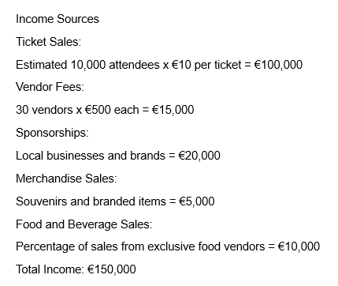
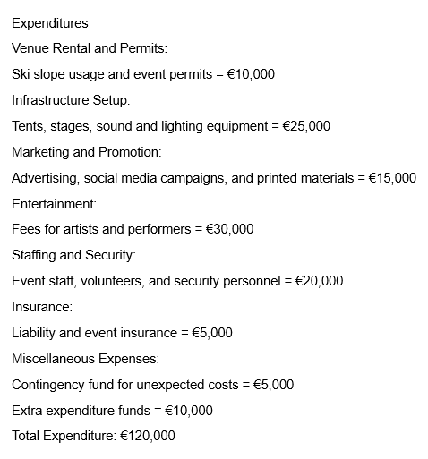
Profit Analysis
Projected Profit:
Total Income (€150,000) - Total Expenditure (€120,000) = €30,000
ROI (150,000€-120,000€)/150,000€ = 20%
Conclusion: To be successful, it's crucial to maintain a balance between income and expenditure while actively engaging the community and promoting the event (Bacoş, 2021). Regularly reviewing the budget and adjusting plans based on ticket sales and sponsorships will ensure financial viability and enhance the event's overall impact.

Cost Analysis
Understanding the costs associated with the Winter Ski Season Grand Opening is essential for ensuring profitability and sustainability. Each expenditure category should be evaluated to identify potential areas for cost-saving without compromising the quality of the event (Getz, 2012).
Venue Rental and Permits: Costs may vary based on the location and time of year (Bowdin, 2011). Early negotiations and securing necessary permits ahead of time can help reduce fees.
Infrastructure Setup: This includes renting tents, staging, sound systems, and lighting. Opting for local suppliers may reduce transportation costs and support the community (Bladen, 2012).
Marketing and Promotion: A well-planned marketing strategy should focus on digital channels to minimize costs while maximizing reach (Mahika, 2015). Collaborating with local influencers can provide affordable promotional opportunities (Hudson, 2017).
Entertainment: Investing in popular artists can significantly boost attendance. Securing a mix of local talent and well-known acts can create a balanced budget while appealing to a broader audience.
Staffing and Security: Utilizing volunteers can help minimize costs, but it’s essential to ensure adequate training and support to maintain a safe environment.
Insurance: It is crucial to include comprehensive insurance coverage to protect against potential liabilities and unforeseen events.

Funding Resources
Sponsorships: Engaging local businesses and brands as sponsors can provide significant financial support. Sponsorship packages should be clearly defined, offering visibility and promotional opportunities in return for their investment (Evans, 2015).
Grants and Local Government Support: Researching available grants for cultural or tourism-related events can provide additional funding. Local government support may also include financial assistance or logistical resources (Quick, 2020).
Crowdfunding: Utilizing crowdfunding platforms can engage the community and potential attendees while raising funds for the event. This method also creates a sense of ownership among supporters.
Income Generation
Ticket Sales: A primary source of revenue, ticket pricing should be competitive yet reflect the value of the experience. Offering early-bird pricing or family packages can drive sales.
Vendor Fees: Charging vendors for booth space not only generates income but also enhances the event experience with diverse offerings (Ferdinand, 2012).
Food and Beverage Sales: Collaborating with food vendors to share a percentage of sales can provide a steady income stream without upfront costs.
Merchandise Sales: Selling branded merchandise can be an effective way to promote the event and generate additional revenue.

Budget Sources
Detailed Budget Planning: Creating a line-item budget that outlines all expected income and expenses will help maintain financial control (Evans, 2015). Regularly reviewing this budget will allow for adjustments as necessary.
Financial Tracking: Implementing an accounting system to track expenses and revenues in real-time ensures transparency and accountability (Quick, 2020).
Collaborators
Local Businesses: Collaborating with local businesses for sponsorships, vendor participation, and cross-promotional opportunities can strengthen community ties and enhance the event's profile.
Tourism Boards: Partnering with regional tourism boards can aid in marketing efforts, providing additional resources and visibility for the event (Getz, 2012).
Community Organizations: Engaging local community groups can foster support and participation, ensuring the event reflects the local culture and values (Irina, 2012).
By carefully analysing costs, exploring diverse funding resources, and collaborating with local stakeholders, the Winter Ski Season Grand Opening can become a financially viable and culturally enriching event, solidifying its place as a cherished annual tradition in Poiana Brașov

Industry Trends Affecting the Winter Ski Season Grand Opening
Sustainability and Eco-Friendly Practices: There is an increasing demand for sustainable events as consumers become more environmentally conscious. Implementing eco-friendly practices, such as waste reduction, recycling, and utilizing renewable resources, can enhance the event's appeal and align it with current consumer values (Kim, 2016).
Digital Engagement: The rise of social media and digital marketing strategies allows for broader outreach and engagement with potential attendees (Hudson, 2017). Utilizing platforms like Instagram, Facebook, and TikTok to showcase event highlights and generate buzz can significantly increase visibility and attract a younger audience.
Experiential Marketing: Events that provide immersive experiences, such as interactive workshops, live demonstrations, and personalized activities, are increasingly popular. Incorporating unique experiences into the grand opening can differentiate it from competitors and enhance guest satisfaction.
Health and Safety: In the wake of the COVID-19 pandemic, health and safety protocols are paramount. Ensuring that the event adheres to public health guidelines can reassure attendees and encourage participation. Strategies could include crowd management, sanitation stations, and clear communication of safety measures.
Advantages in Context
Natural Beauty and Tourist Appeal: Poiana Brașov's stunning alpine environment and established reputation as a winter sports destination provide a strong foundation for attracting visitors (Mahika, 2015).
Local Community Support: Engaging local businesses and community organizations can foster a sense of ownership and pride in the event, ensuring widespread support and participation.
Cultural Heritage: Integrating local traditions and customs into the event can create a unique identity, making it more attractive to tourists seeking authentic experiences (Okoli, 2012).
Competition Factors
Competing Events: Other winter festivals or ski season openings in nearby regions may attract potential attendees. It’s crucial to identify and differentiate the Poiana Brașov event through unique features, such as celebrity performances or specific cultural offerings (Erdeli, 2010).
Weather Conditions: Weather can significantly impact the success of winter events. Unfavourable conditions, such as lack of snow or extreme temperatures, could deter attendance. Planning for contingencies, such as indoor activities, can mitigate this risk.
Potential Challenges
Logistical Challenges: Coordinating a large-scale event requires meticulous planning and resources. Issues related to transportation, access, and site management can arise, necessitating effective logistics management (Erdeli, 2010).
Financial Viability: Ensuring sufficient funding and generating revenue through ticket sales, sponsorships, and vendor fees can be challenging. Careful financial planning and diversified income sources are essential for sustainability (Ispas, 2011).
By staying attuned to industry trends and leveraging local advantages while addressing potential challenges (Postelnicu, 2018), the Winter Ski Season Grand Opening can successfully position itself as a leading winter event in Poiana Brașov.

SWOT Analysis for the Winter Ski Season Grand Opening
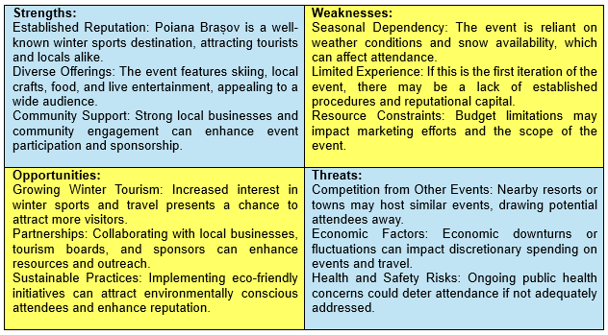
PESTEL Analysis for the Winter Ski Season Grand Opening (Popa, 2020)
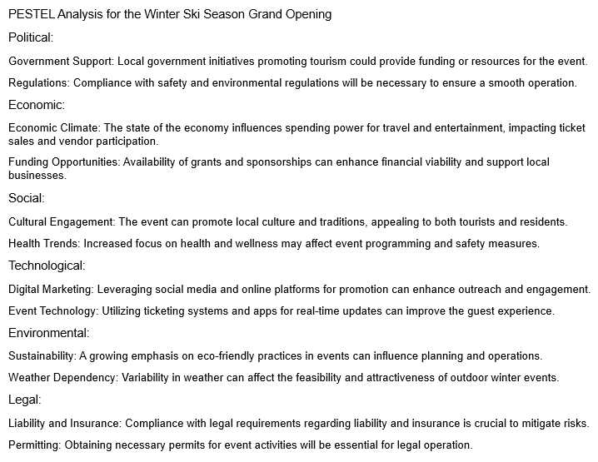

By considering these situational factors through the SWOT and PESTEL analyses, organizers of the Winter Ski Season Grand Opening can strategically navigate challenges and capitalize on opportunities (Tanase, 2020), enhancing the event's potential for success in Poiana Brașov.
SOAR Analysis for the Winter Ski Season Grand Opening
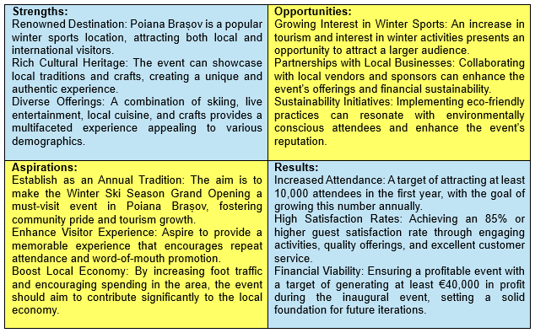
This SOAR analysis (Bowdin, 2011) helps to focus on strengths and aspirations while identifying opportunities that align with the desired results for the Winter Ski Season Grand Opening. By leveraging existing strengths and addressing opportunities (Tanase, 2020) , the event can build a successful legacy in Poiana Brașov.
5P’s full analysis in Appendix 2 (Hudson, 2017)
Risk Assessment (Balteanu, 2008) part 1 in Appendix 3 and part 2 in Appendix 4

Conclusion: Winter Ski Season Grand Opening in Poiana Brașov
The Winter Ski Season Grand Opening in Poiana Brașov holds the potential to become a beloved annual event that enriches the cultural landscape of the region while fostering community traditions. By showcasing local crafts, cuisine, and winter sports, the event not only celebrates the unique heritage of Poiana Brașov but also reinforces a sense of belonging and pride among residents.
Establishing this event as a yearly cycle will create a tradition that brings together locals and tourists alike, strengthening community ties and encouraging the sharing of cultural practices (Okoli, 2012). As it evolves, the event can adapt to reflect the changing dynamics of the community and the interests of attendees, ensuring relevance and continued engagement (Kim, 2016).
Through strategic planning (Bowdin, 2011) and collaboration with local businesses and organizations, the grand opening can serve as a catalyst for economic growth, enhancing visitor experience while preserving and promoting the rich cultural heritage of Poiana Brașov. Ultimately, this event has the potential to solidify itself as a cornerstone of the winter season, inviting all to partake in the festivities and the beauty of the surrounding landscape.

References list

Bacoş, I. B., & Gabor, M. R. (2021). Tourism economy. Mountain tourism: Quantitative analysis of winter destinations in Romania. Economics, 9(1), 143-159.
Bălteanu, D., Dincă, A. I., Surugiu, C., & Dragotă, C. (2008). Winter tourism in Prahova Valley–Poiana Braşov area an assessment of sectoral vulnerability to climate change on case study level.
Bladen, C. et al (2012) Events Management: An Introduction. Abingdon: Routledge Seven.
Bowdin, G., Allen, J., O’Toole, W., Harris, R. and McDonnell, I. (2011) Events Management. Oxford: Elsevier. (Chapter 11)
Cozac, E. (2015). Mountain tourism in Romania.
Erdeli, G., & Arsene, R. (2010). Market insights interest in Poiana Brasov Resort, during: 1990-2008.
Evans, N. G. (2015). Strategic management for tourism, hospitality and events. Routledge.
Ferdinand, N., & Kitchin, P. (2012). Events management: An international approach. Sage.
Friedman, B., (2018), "Hospitality, tourism, and events industry competency model: Human resource management implications." Strategic Innovative Marketing and Tourism: 7th ICSIMAT, Athenian Riviera, Greece, 2018. Springer International Publishing
Getz, D. (2012) Event Management & Event Tourism, 2nd ed. New York: Cognizant Communication.
Herman, G. V., Grama, V., Buhaș, S., Garai, L. D., Caciora, T., Grecu, A., ... & Peptenatu, D. (2021). The analysis of the ski slopes and the degree of economic dependence induced by winter sports tourism. The case of Romania. Sustainability, 13(24), 13698.
Hudson, S. (2017). Marketing for tourism, hospitality & events: a global & digital approach.
Irina POPESCU, R., & CORBOŞ, R. A. (2012). The Role of Festivals and Cultural Events in the Strategic Development of Cities. Recommendations for Urban Areas in Romania. Informatica Economica, 16(4).
Ispas, A., & Hertanu, A. (2011). Characteristics of event tourism marketing. Case study: the European Youth olympic Festival, Brasov 2013. Bulletin of the Transilvania University of Brasov. Series V: Economic Sciences, 127-134.
Kim, J. H. and Jang, S. (2016) ‘Memory Retrieval of Cultural Event Experiences, Examining Internal and External Influences’, Journal of Travel Research, Vol. 55(3).
Mahika, E. C., Rădulescu, R., & Aluculesei, A. C. (2015). The behaviour of Romanian tourists regarding the attendance at festivals. Procedia economics and finance, 23, 1239-1244.
Matei, E., Mika, M., Pawlusiński, R., Dinu, M., & Cioaca, A., (2019), Thematic session: Tourism (Re) development and Sustainability. Integrating Nature and Society Towards Sustainability, 117.
Nickson, D., (2013), Human resource management for hospitality, tourism and events. Routledge, 2013.
Okoli, C., (2012), "Impact of events management on hospitality and tourism." Journal of tourism and heritage studies 1.1 (2012): 26-36.
Popa, D. , (2020). Country Report: Romania.
Postelnicu, C., & Dabija, D. C., (2018), Romanian tourism: Past, present and future in the context of globalization. Ecoforum Journal, 7(1).
Quick, L., (2020), Managing Events, Real Challenges Real Outcomes, Sage
Salem, G., & Morgan, N. (2012). An overview of events management. Festival and events management, 14-31.
Tanase, M. O., & Nicodim, L. (2020). Mountain Tourism at the Beginning of the 21st Century. In New Trends and Opportunities for Central and Eastern European Tourism (pp. 94-107). IGI Global.

Appendix 1

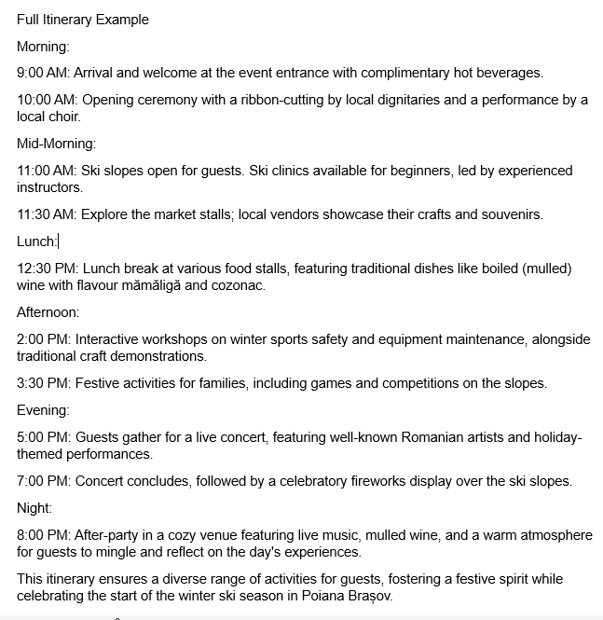

Appendix 2

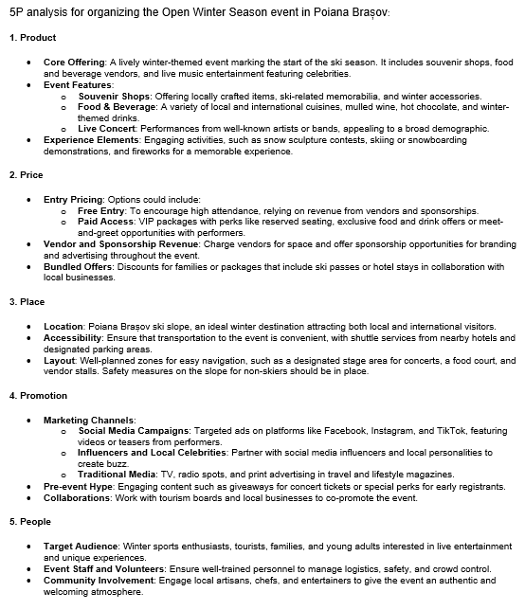

Appendix 3 Risk Assessment part 1

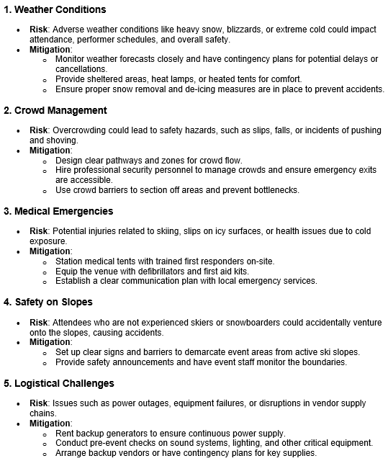

Appendix 4 Risk Assessment part 2



